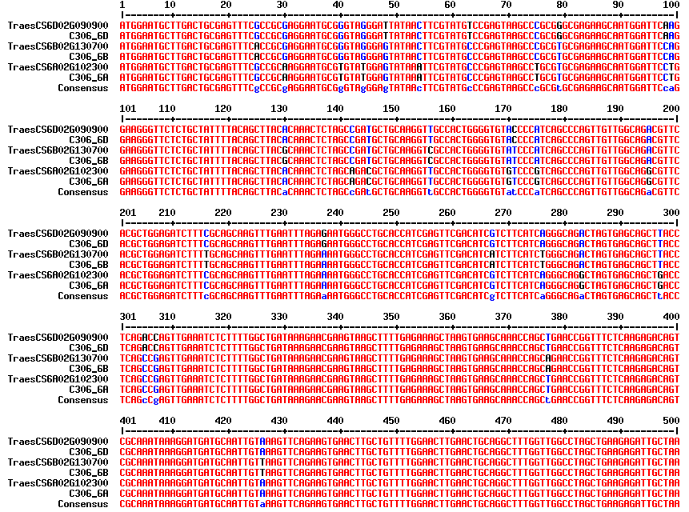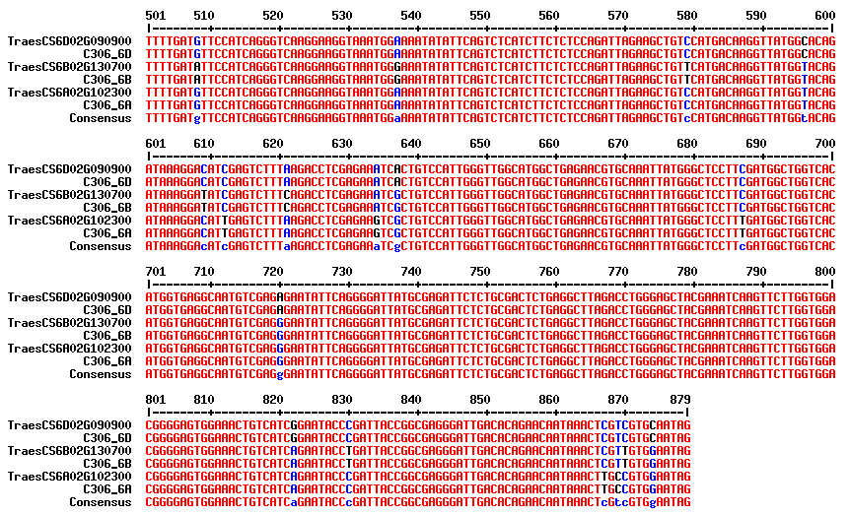Figure S1: nucleotide sequence alignment of TaPTST1 homeologues in ‘C306’ and ‘Chinese spring’.

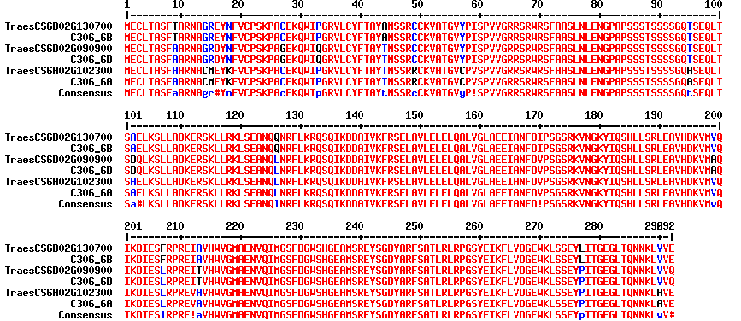
Figure S2: amino-acid sequence alignment of TaPTST1 homeologues in ‘C306’ and ‘Chinese spring’.

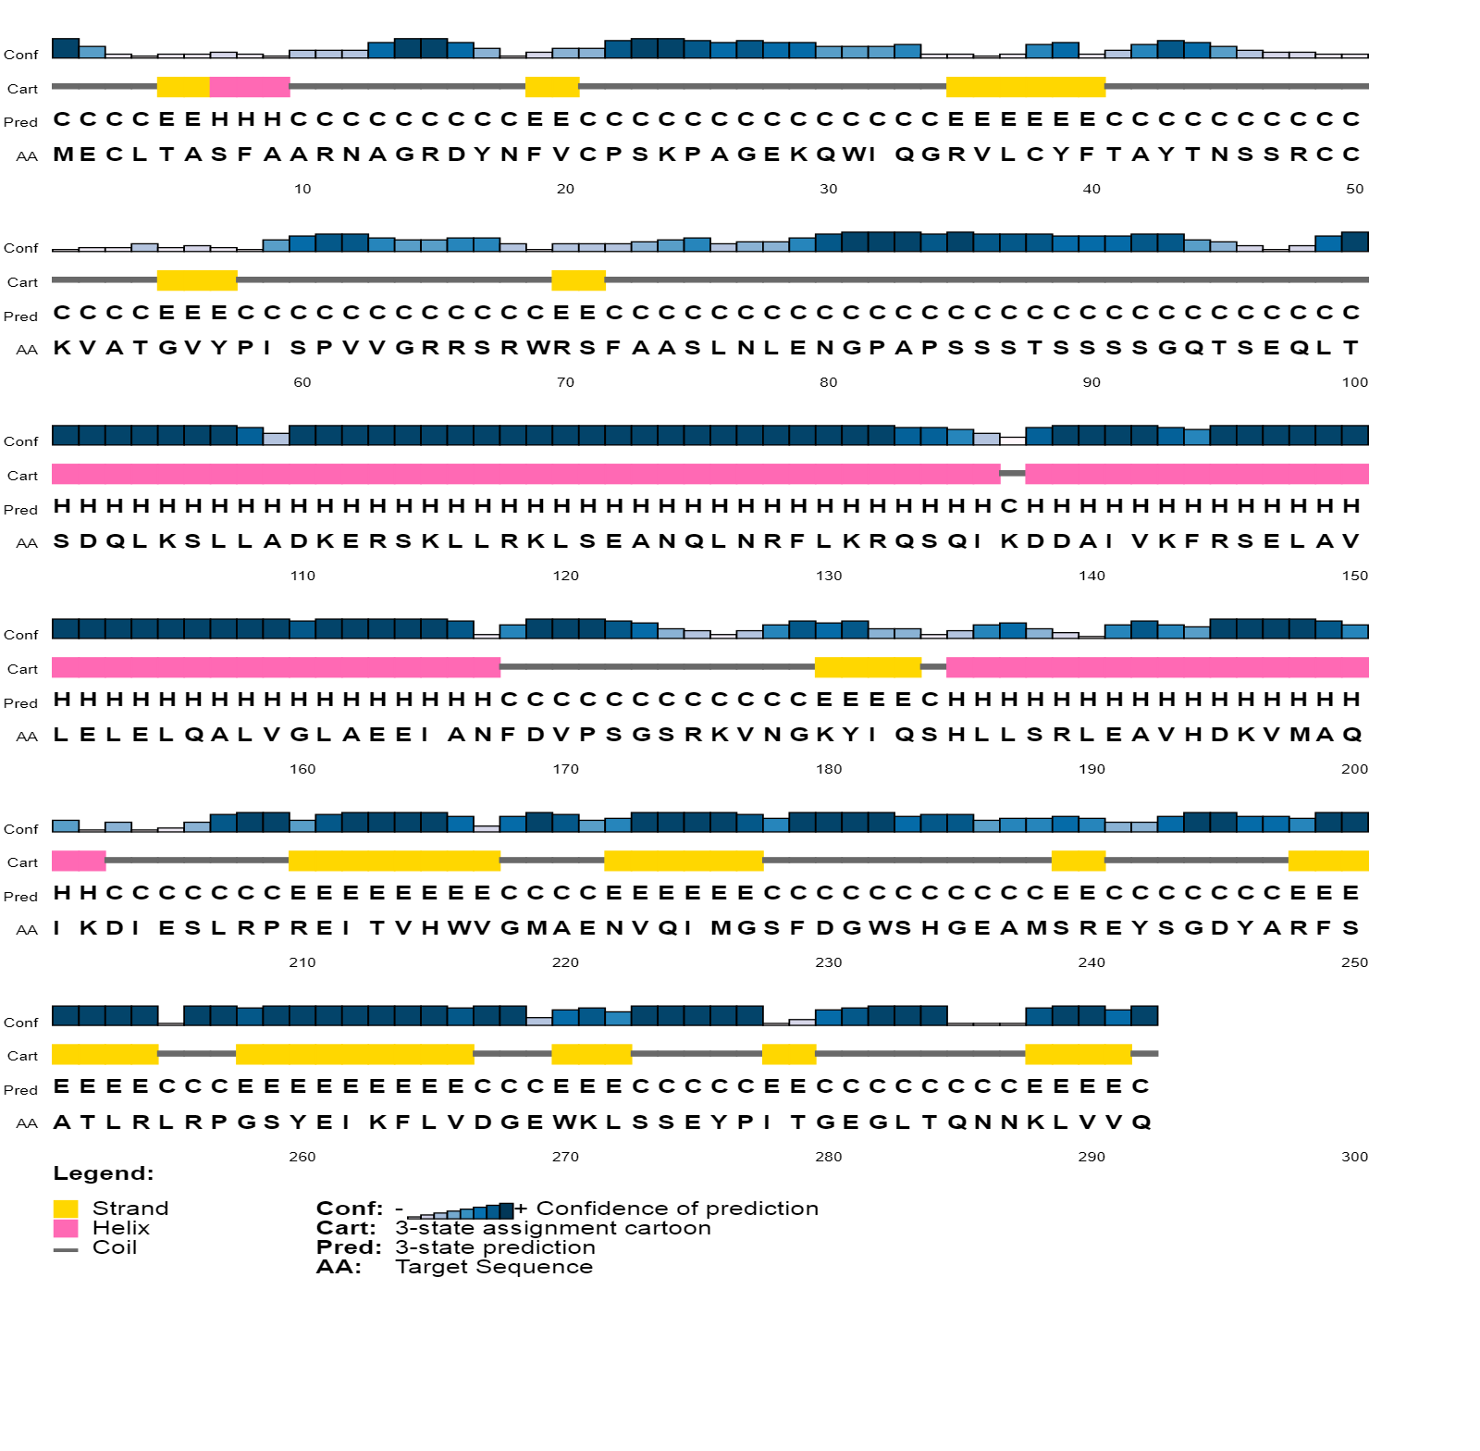Figure S3: depiction of predicted TaPTST1 secondary structure by psipred webserver.

Table S1: Primers used in the study.
Primers for qRT PCR
Identifier | Forward Primer (3’5’) | Reverse primer (3’5’) | Expected band size (bp)
PTST 6DS | AGCTACTGTTGGCATGATTGATGCTCT | TTCAATCCTATGGAGATATGGCATCAAG | 180
PTST 6BS | TAGCCTGACAACTGGAGACACCGCT | TTCCAGGAGTGCCTTGATGTCGCT | 90
PTST6AS | TATCAGTTCTGCGATGCTGCCGCG | CTTGATTTCGTAGCTTTATTATGCACACA | 91
GBSSI7AS | AGGAAGAAGAAGAAGAAGAAGAAGCAGAAG | GGAATCTGTCGGTGACGCTGAGGA | 165
GBSSI 4AL | CGCTTGTTGTAGTGAAGGGCCGATA | TCACAAGCACAACCCCTAACTTCTTACCTT | 130
GBSSI 7DS | TACATACAATCAGGAGCCTCTGCCAGT | ATCTGATCTCCTCTTCTTCTTGGACGGA | 137
Primers for cloning
TaPTST1 | GGATCCATGGAATGCTTGACTGCGAGTTT | GAGCTCCTATTGCACGACGAGTTTATTG | 879
TaPTST1-209 | ATCGAGAATTCATGGAATGCTTGACTGCGAGTT | GATACTCTCGAGAGGTCTTAAAGACTCGATGTCCT | 627
GBSSI WOTP_pET28a | GAATTCGCCACGGGCAGCGGCGGCATGAA | CTCGAGTCAGGGAGCGGCGACGTTCTCCAGGG | 1605
TaPTST1_BiFC construct | CCTGAGGATCCATGGAATGCTTGACTGCGAGTTT | ATTATCCCGGGTTGCACGACGAGTTTATTGTTCTGTGT | 879
GBSSI_BiFC construct | CCTGACTCGAGATGGCGGCTCTGGTCACGTCCCA | ATTATCCCGGGGGTAGCGGCGACGTTCTCCAG | 1815
Primers for sequencing
35S_promoter | AAGGAAGTTCATTTCATTTGGAGAGAA | - | -
Nos_terminator | - | CATGCTTAACGTAATTCAACAGAAAT | -
pJET1.2 | CGACTCACTATAGGGAGAGCGGC | AAGAACATCGATTTTCCATGGCAG | -
T7_promoter | TTAATACGACTCACTATAG | - | -
T7_terminator | - | ACCGCTGAGCAATAACTAGCA | -

