Supplementary Table 1. Data Sources
Data source | Population | Patients (millions) | History | Description
Taipei Medical University Clinical Research Database (TMUCRD) | Taiwan, general | 4.15 | 2004–2021 | Electronic health record database from academic medical centers (Taipei Medical University Hospital, Wanfang Hospital, and Shuang Ho Hospital)
Ajou University School of Medicine (AUSOM) | Korea, general | 2.8 | 1994–2023 | Electronic health record database from an academic medical center
Yonsei University Health System (YUHS) | Korea, general | 5.4 | 1997–2023 | Electronic health record database from an academic medical center

Supplementary Table S2. List of Concepts of Set Definitions
1. Oral antidiabetic agents
Concept ID | Concept name | Domain | Vocabulary | Excluded | Descendants | Mapped
1510202 | Miglitol | Drug | RxNorm | NO | YES | NO
1529331 | Acarbose | Drug | RxNorm | NO | YES | NO
19033909 | phenformin | Drug | RxNorm | NO | YES | NO
1503297 | metformin | Drug | RxNorm | NO | YES | NO
19122137 | vildagliptin | Drug | RxNorm | NO | YES | NO
1580747 | sitagliptin | Drug | RxNorm | NO | YES | NO
40166035 | saxagliptin | Drug | RxNorm | NO | YES | NO
40239216 | linagliptin | Drug | RxNorm | NO | YES | NO
43009089 | gemigliptin | Drug | RxNorm | NO | YES | NO
43009051 | evogliptin | Drug | RxNorm | NO | YES | NO
43013884 | alogliptin | Drug | RxNorm | NO | YES | NO
793143 | semaglutide | Drug | RxNorm | NO | YES | NO
44506754 | lixisenatide | Drug | RxNorm | NO | YES | NO
40170911 | liraglutide | Drug | RxNorm | NO | YES | NO
1583722 | exenatide | Drug | RxNorm | NO | YES | NO
45774435 | dulaglutide | Drug | RxNorm | NO | YES | NO
44816332 | albiglutide | Drug | RxNorm | NO | YES | NO
43009020 | ipragliflozin | Drug | RxNorm | NO | YES | NO
793293 | ertugliflozin | Drug | RxNorm | NO | YES | NO
45774751 | empagliflozin | Drug | RxNorm | NO | YES | NO
44785829 | dapagliflozin | Drug | RxNorm | NO | YES | NO
43526465 | canagliflozin | Drug | RxNorm | NO | YES | NO
1502855 | tolbutamide | Drug | RxNorm | NO | YES | NO
1502809 | tolazamide | Drug | RxNorm | NO | YES | NO
1559684 | glyburide | Drug | RxNorm | NO | YES | NO
40798860 | Glisoxepide | Drug | RxNorm | NO | YES | NO
19097821 | gliquidone | Drug | RxNorm | NO | YES | NO
1560171 | glipizide | Drug | RxNorm | NO | YES | NO
1597756 | glimepiride | Drug | RxNorm | NO | YES | NO
19059796 | gliclazide | Drug | RxNorm | NO | YES | NO
19001409 | glibornuride | Drug | RxNorm | NO | YES | NO
1594973 | chlorpropamide | Drug | RxNorm | NO | YES | NO
19033498 | carbutamide | Drug | RxNorm | NO | YES | NO
1530014 | acetohexamide | Drug | RxNorm | NO | YES | NO
1515249 | troglitazone | Drug | RxNorm | NO | YES | NO
1547504 | rosiglitazone | Drug | RxNorm | NO | YES | NO
1525215 | pioglitazone | Drug | RxNorm | NO | YES | NO

2. Type 2 diabetes mellitus
Concept ID | Concept name | Domain | Vocabulary | Excluded | Descendants | Mapped
45766052 | Type II diabetes mellitus in remission | Condition | SNOMED | YES | NO | NO
201826 | Type 2 diabetes mellitus | Condition | SNOMED | NO | YES | NO
43531010 | Pre-existing type 2 diabetes mellitus in pregnancy | Condition | SNOMED | YES | NO | NO
4063043 | Pre-existing type 2 diabetes mellitus | Condition | SNOMED | YES | NO | NO

3. Insulin
Concept ID | Concept name | Domain | Vocabulary | Excluded | Descendants | Mapped
1586369 | ultralente insulin, human | Drug | RxNorm | NO | YES | NO
19090221 | ultralente insulin, beef-pork | Drug | RxNorm | NO | YES | NO
19090226 | ultralente insulin, beef | Drug | RxNorm | NO | YES | NO
44506754 | lixisenatide | Drug | RxNorm | NO | YES | NO
40170911 | liraglutide | Drug | RxNorm | NO | YES | NO
1562586 | lente insulin, pork | Drug | RxNorm | NO | YES | NO
1513843 | lente insulin, beef-pork | Drug | RxNorm | NO | YES | NO
19090204 | lente insulin, beef | Drug | RxNorm | NO | YES | NO
1586346 | insulin, regular, pork | Drug | RxNorm | NO | YES | NO
1596977 | insulin, regular, human | Drug | RxNorm | NO | YES | NO
1590165 | insulin, regular, beef-pork | Drug | RxNorm | NO | YES | NO
19013951 | insulin, regular, beef | Drug | RxNorm | NO | YES | NO
19090187 | insulin, protamine zinc, pork | Drug | RxNorm | NO | YES | NO
19091621 | insulin, protamine zinc, human | Drug | RxNorm | NO | YES | NO
19013926 | insulin, protamine zinc, beef-pork | Drug | RxNorm | NO | YES | NO
19090180 | insulin, protamine zinc, beef | Drug | RxNorm | NO | YES | NO
19090249 | insulin, prompt zinc, pork | Drug | RxNorm | NO | YES | NO
19090247 | insulin, prompt zinc, human | Drug | RxNorm | NO | YES | NO
19090229 | insulin, prompt zinc, beef-pork | Drug | RxNorm | NO | YES | NO
19090244 | insulin, prompt zinc, beef | Drug | RxNorm | NO | YES | NO
42899447 | insulin, pork | Drug | RxNorm | NO | YES | NO
1513876 | insulin lispro protamine, human | Drug | RxNorm | NO | YES | NO
1550023 | insulin lispro | Drug | RxNorm | NO | YES | NO
46221581 | insulin isophane | Drug | RxNorm | NO | YES | NO
1588986 | insulin human, rDNA origin | Drug | RxNorm | NO | YES | NO
1544838 | insulin glulisine, human | Drug | RxNorm | NO | YES | NO
1502905 | insulin glargine | Drug | RxNorm | NO | YES | NO
1516976 | insulin detemir | Drug | RxNorm | NO | YES | NO
35602717 | insulin degludec | Drug | RxNorm | NO | YES | NO
1567198 | insulin aspart, human | Drug | RxNorm | NO | YES | NO
1531601 | insulin aspart protamine, human | Drug | RxNorm | NO | YES | NO
35198096 | insulin aspart | Drug | RxNorm | NO | YES | NO

4. Exclusion criteria
Concept ID | Concept name | Domain | Vocabulary | Excluded | Descendants | Mapped
4224940 | Schizoaffective disorder, depressive type | Condition | SNOMED | NO | YES | NO
4244078 | Schizoaffective disorder, bipolar type | Condition | SNOMED | NO | YES | NO
4332994 | Post-schizophrenic depression | Condition | SNOMED | NO | YES | NO
4133073 | Maternity blues | Condition | SNOMED | NO | YES | NO
436665 | Bipolar disorder | Condition | SNOMED | NO | YES | NO

5. Depression
Concept ID | Concept Name | Domain | Vocabulary | Excluded | Descendants | Mapped
440383 | Depressive disorder | Condition | SNOMED | NO | YES | NO

6. Depression medication
Concept ID | Concept name | Domain | Vocabulary | Excluded | Descendants | Mapped
44507700 | vortioxetine | Drug | RxNorm | NO | YES | NO
42899140 | Hypericum perforatum leaf extract | Drug | RxNorm | NO | YES | NO
42899139 | Hypericum extract | Drug | RxNorm | NO | YES | NO
40799195 | Zimeldine | Drug | RxNorm | NO | YES | NO
40798767 | Dimetacrine | Drug | RxNorm | NO | YES | NO
40234834 | vilazodone | Drug | RxNorm | NO | YES | NO
36878783 | Agomelatine | Drug | RxNorm | NO | YES | NO
19129635 | opipramol | Drug | RxNorm | NO | YES | NO
19128066 | nomifensine | Drug | RxNorm | NO | YES | NO
19127550 | nialamide | Drug | RxNorm | NO | YES | NO
19122204 | iprindole | Drug | RxNorm | NO | YES | NO
19110751 | melitracen | Drug | RxNorm | NO | YES | NO
19100775 | toloxatone | Drug | RxNorm | NO | YES | NO
19098514 | quinupramine | Drug | RxNorm | NO | YES | NO
19091830 | lofepramine | Drug | RxNorm | NO | YES | NO
19084693 | reboxetine | Drug | RxNorm | NO | YES | NO
19080226 | milnacipran | Drug | RxNorm | NO | YES | NO
19072123 | minaprine | Drug | RxNorm | NO | YES | NO
19072021 | medifoxamine | Drug | RxNorm | NO | YES | NO
19058055 | bifemelane | Drug | RxNorm | NO | YES | NO
19041910 | tianeptine | Drug | RxNorm | NO | YES | NO
19039883 | butriptyline | Drug | RxNorm | NO | YES | NO
19037989 | dothiepin | Drug | RxNorm | NO | YES | NO
19032424 | amineptin | Drug | RxNorm | NO | YES | NO
19023846 | dibenzepin | Drug | RxNorm | NO | YES | NO
19010652 | moclobemide | Drug | RxNorm | NO | YES | NO
19008261 | viloxazine | Drug | RxNorm | NO | YES | NO
19007737 | mianserin | Drug | RxNorm | NO | YES | NO
19006186 | tryptophan | Drug | RxNorm | NO | YES | NO
1366610 | esketamine | Drug | RxNorm | NO | YES | NO
1363516 | 5-hydroxytryptophan | Drug | RxNorm | NO | YES | NO
798834 | clomipramine | Drug | RxNorm | NO | YES | NO
797617 | citalopram | Drug | RxNorm | NO | YES | NO
794147 | maprotiline | Drug | RxNorm | NO | YES | NO
781705 | isocarboxazid | Drug | RxNorm | NO | YES | NO
778268 | imipramine | Drug | RxNorm | NO | YES | NO
755695 | fluoxetine | Drug | RxNorm | NO | YES | NO
754270 | protriptyline | Drug | RxNorm | NO | YES | NO
751412 | fluvoxamine | Drug | RxNorm | NO | YES | NO
750982 | bupropion | Drug | RxNorm | NO | YES | NO
743670 | venlafaxine | Drug | RxNorm | NO | YES | NO
739138 | sertraline | Drug | RxNorm | NO | YES | NO
738156 | doxepin | Drug | RxNorm | NO | YES | NO
733896 | phenelzine | Drug | RxNorm | NO | YES | NO
725131 | mirtazapine | Drug | RxNorm | NO | YES | NO
722031 | paroxetine | Drug | RxNorm | NO | YES | NO
721724 | nortriptyline | Drug | RxNorm | NO | YES | NO
717607 | desvenlafaxine | Drug | RxNorm | NO | YES | NO
716968 | desipramine | Drug | RxNorm | NO | YES | NO
715939 | escitalopram | Drug | RxNorm | NO | YES | NO
715259 | duloxetine | Drug | RxNorm | NO | YES | NO
714684 | nefazodone | Drug | RxNorm | NO | YES | NO
713109 | amoxapine | Drug | RxNorm | NO | YES | NO
710062 | amitriptyline | Drug | RxNorm | NO | YES | NO
705755 | trimipramine | Drug | RxNorm | NO | YES | NO
703547 | trazodone | Drug | RxNorm | NO | YES | NO
703470 | tranylcypromine | Drug | RxNorm | NO | YES | NO

7. Acute coronary syndrome
Concept ID | Concept name | Domain | Vocabulary | Excluded | Descendants | Mapped
312327 | Acute myocardial infarction | Condition | SNOMED | NO | YES | NO
315296 | Preinfarction syndrome | Condition | SNOMED | NO | YES | NO
434376 | Acute myocardial infarction of anterior wall | Condition | SNOMED | NO | YES | NO
438170 | Acute myocardial infarction of inferior wall | Condition | SNOMED | NO | YES | NO
444406 | Acute subendocardial infarction | Condition | SNOMED | NO | YES | NO

8. Myocardial infarction
Concept ID | Concept name | Domain | Vocabulary | Excluded | Descendants | Mapped
4329847 | Myocardial infarction | Condition | SNOMED | NO | YES | NO
314666 | Old myocardial infarction | Condition | SNOMED | YES | YES | NO

9. Stroke
Concept ID | Concept name |  | Domain | Vocabulary | Excluded | Descendants | Mapped
372924 | Cerebral artery occlusion | Condition |  | SNOMED | NO | NO | NO
375557 | Cerebral embolism | Condition |  | SNOMED | NO | NO | NO
376713 | Cerebral hemorrhage | Condition |  | SNOMED | NO | NO | NO
432923 | Subarachnoid hemorrhage | Condition |  | SNOMED | NO | NO | NO
439847 | Intracranial hemorrhage | Condition |  | SNOMED | NO | NO | NO
441874 | Cerebral thrombosis | Condition |  | SNOMED | NO | NO | NO
443454 | Cerebral infarction | Condition |  | SNOMED | NO | YES | NO
4148906 | Spontaneous subarachnoid hemorrhage | Condition |  | SNOMED | NO | NO | NO
43530727 | Spontaneous cerebral hemorrhage | Condition |  | SNOMED | NO | NO | NO

Supplementary Table S3. Patient-Level Characteristics Across Data Sources Before Propensity Score Matching
Data Source | TMUCRD |  |  | YUHS |  |  | AUSOM
Characteristic | No. of target subjects (%) | No. of comparator subjects (%) | Std. diff. | No. of target subjects (%) | No. of comparator subjects (%) | Std. diff. | No. of target subjects (%) | No. of comparator subjects (%) | Std. diff.
No. of Patients | 3095 | 24,759 |  | 2071 | 15,770 |  | 736 | 8370
Age group (years)
20–24 | 0.3 | 0.4 | -0.03 | 0.2 | 0.3 | -0.01 | <0.7 | 0.7 | -0.04
25–29 | 0.5 | 0.9 | -0.05 | 0.2 | 0.6 | -0.05 | 1 | 1.1 | -0.02
30–34 | 1.4 | 2 | -0.05 | 0.4 | 0.7 | -0.04 | 1.4 | 2.2 | -0.06
35–39 | 2.6 | 3.9 | -0.07 | 0.6 | 1.2 | -0.06 | 2.9 | 5 | -0.11
40–44 | 4.7 | 6.4 | -0.07 | 1.2 | 2.9 | -0.12 | 4.2 | 9.1 | -0.2
45–49 | 7 | 8.9 | -0.07 | 2 | 5.2 | -0.17 | 6.7 | 12.6 | -0.2
50–54 | 10.4 | 11.5 | -0.03 | 3.4 | 7.9 | -0.2 | 11 | 15 | -0.12
55–59 | 11.3 | 14.1 | -0.08 | 6.4 | 11.2 | -0.17 | 13.2 | 14.8 | -0.05
60–64 | 13.6 | 14 | -0.01 | 9.9 | 14.3 | -0.14 | 13.7 | 13.4 | 0.01
65–69 | 11.1 | 12.4 | -0.04 | 13.1 | 15.6 | -0.07 | 16.6 | 9.8 | 0.2
70–74 | 12.7 | 9.2 | 0.11 | 20.1 | 11.5 | 0.24 | 14.8 | 7.9 | 0.22
75–79 | 9.9 | 7 | 0.11 | 14.8 | 8.2 | 0.21 | 7.6 | 4.8 | 0.12
80–84 | 8.5 | 4.9 | 0.14 | 9.2 | 4.5 | 0.19 | 3.9 | 2.4 | 0.09
85–89 | 4 | 2.9 | 0.06 | 3.4 | 1.4 | 0.13 | 2.3 | 0.6 | 0.14
90–94 | 1.6 | 1.1 | 0.05 | 0.7 | 0.3 | 0.06 | <0.7 | 0.1 | 0.06
Female | 60.6 | 42.8 | 0.36 | 58.5 | 41.2 | 0.35 | 65.8 | 35.4 | 0.64
Medical history
Hyperlipidemia | 53.4 | 50.8 | 0.05 | 26.6 | 26.8 | 0 | 15.9 | 16 | 0
Hypertensive disorder | 35.8 | 31.4 | 0.09 | 60.7 | 51.6 | 0.18 | 47.8 | 37.2 | 0.22
Obesity | 2.7 | 2.9 | -0.01 | 1.5 | 1.4 | 0.01 | 2.6 | 1.7 | 0.06
Renal impairment | 6.9 | 5.3 | 0.06 | 10.6 | 7.2 | 0.12 | 5.3 | 2.4 | 0.15
Medication use
Agents acting on the renin-angiotensin system | 47 | 43.8 | 0.06 | 43.3 | 40.1 | 0.06 | 40.6 | 40.4 | 0
Antithrombotic agents | 42.4 | 30.2 | 0.26 | 51 | 41.5 | 0.19 | 48.9 | 39 | 0.2
Beta blocking agents | 38.7 | 29.3 | 0.2 | 24.3 | 19.9 | 0.11 | 22.1 | 18.9 | 0.08
Calcium channel blockers | 37.9 | 29.8 | 0.17 | 35.8 | 28.7 | 0.15 | 39.5 | 29.4 | 0.21
Diuretics | 20.8 | 15.4 | 0.14 | 26.9 | 17 | 0.24 | 30.8 | 18.5 | 0.29

Supplementary Table 4. Minimal Detectable Relative Risks (MDRRs) for the Main Analysis Across Three Observational Databases
 | TMUCRD | YUHS | AUSOM
Outcome
Insulin initiation | 1.27 | 1.21 | 2.75
Acute coronary syndrome | 1.45 | 1.84 | 2.69
Myocardial infarction | 1.54 | 2.43 | 4.68
Stroke | 1.36 | 2.00 | 3.49

Supplementary Figure S1. Covariate Balance Plot Before and After Propensity Score Matching for Databases Included in the Main Analysis.
A. TMUCRD
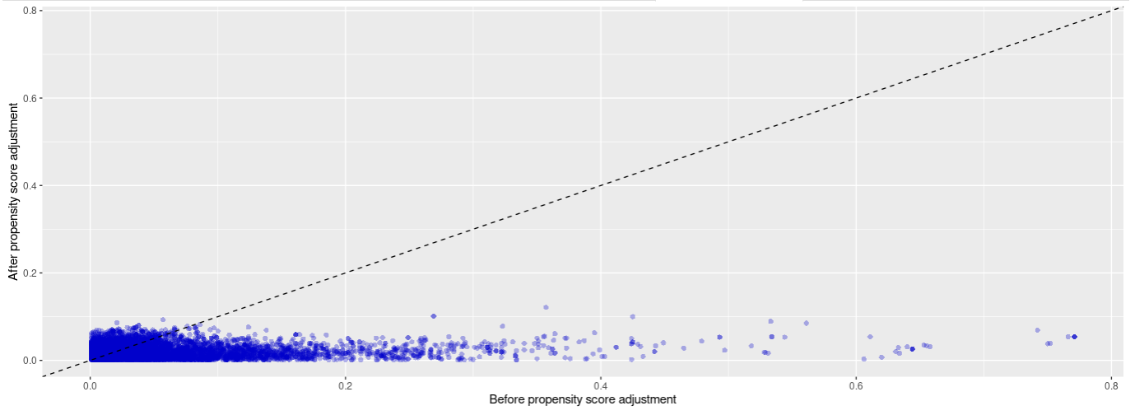

B. YUHS
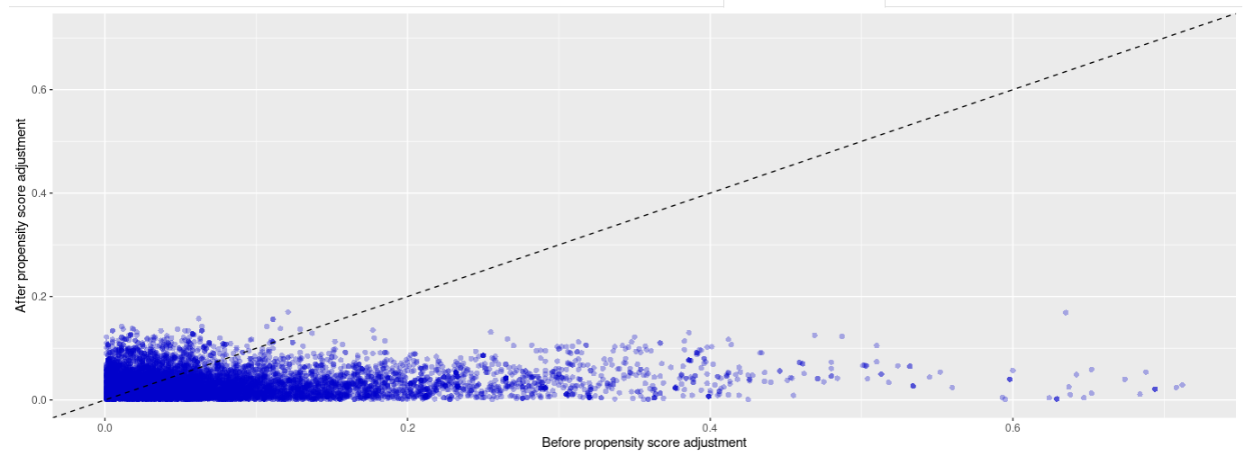

C. AUSOM
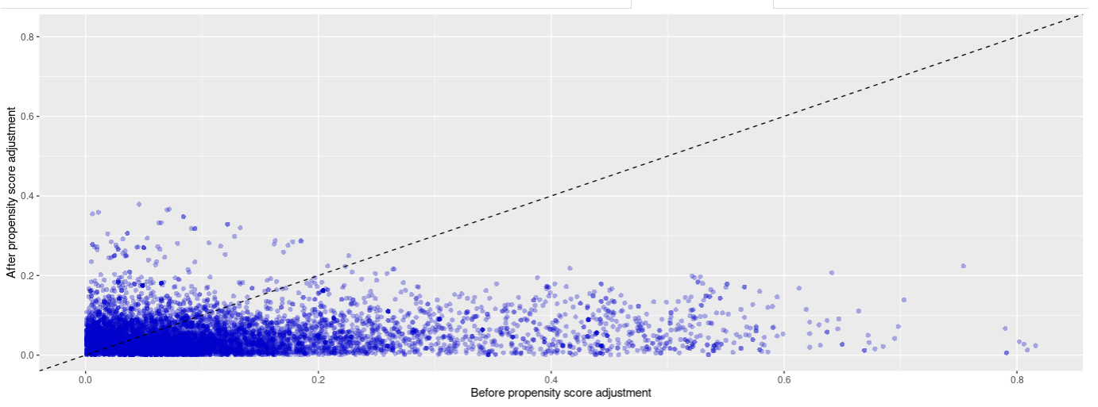
Abbreviations: TMUCRD, Taipei Medical University Clinical Research Database; YUHS, Yonsei University Health System; AUSOM, Ajou University School of Medicine.

