Electronic Supplementary Information (ESI)

Modular magnetic recyclable dual-Escherichia coli cell factory with in situ UDP-glucose cofactor regeneration for high-efficiency green biosynthesis of isovitexin
Shuangqing Fu¹, Chao Zhang², Yujie Yuan¹, Shuo Ma¹, Wei Li^{1*}, Honglei Zhang^{1*}
¹State Key Laboratory of New Pharmaceutical Preparations and Excipients, Laboratory of Medicinal Chemistry and Molecular Diagnosis of the Ministry of Education, Key Laboratory of Chemical Biology of Hebei Province, College of Chemistry and Materials Science, Hebei University, Baoding 071002, PR China.
² Department of Life Science, Hengshui University, Hengshui 053000, China.

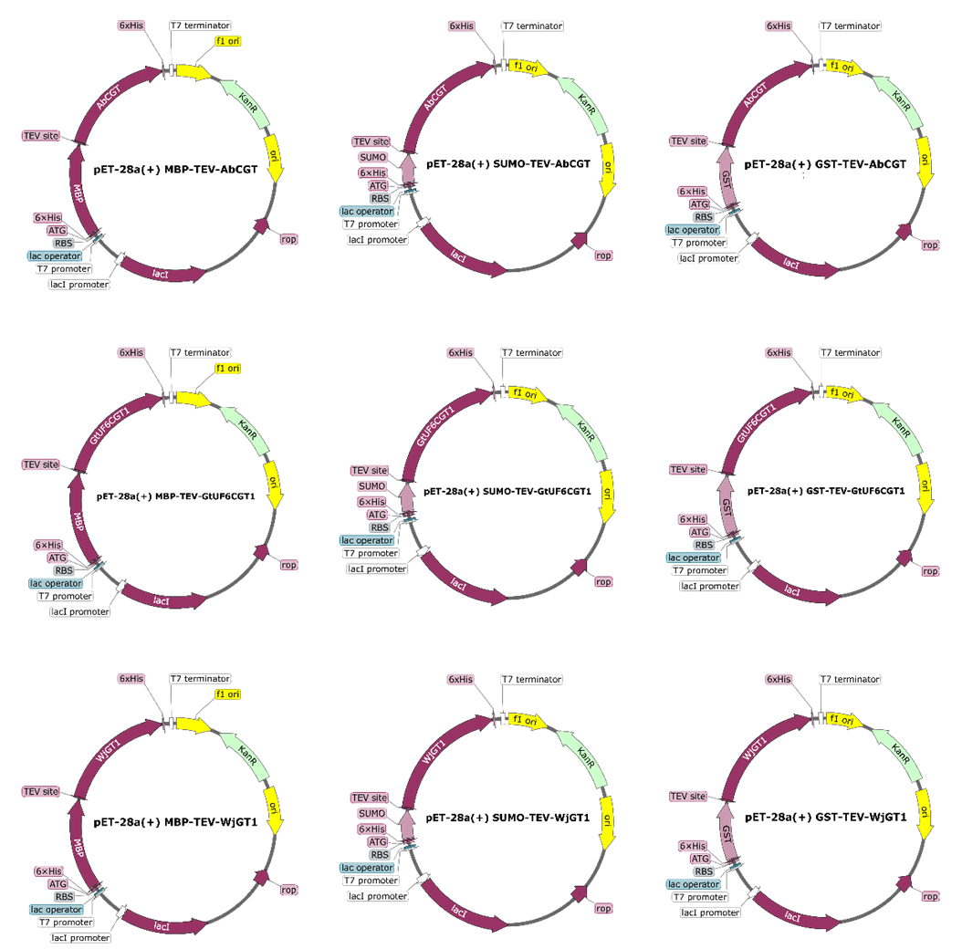
Fig. S1. Schematic diagrams of the recombinant plasmids constructed in this study. The C-glycosyltransferase genes (AbCGT, GtUF6CGT1, and WjGT1) were cloned into the pET-28a(+) vector. Each gene was fused with an N-terminal solubility-enhancing tag (MBP, SUMO, or GST) and a TEV protease cleavage site to facilitate subsequent protein expression and purification.

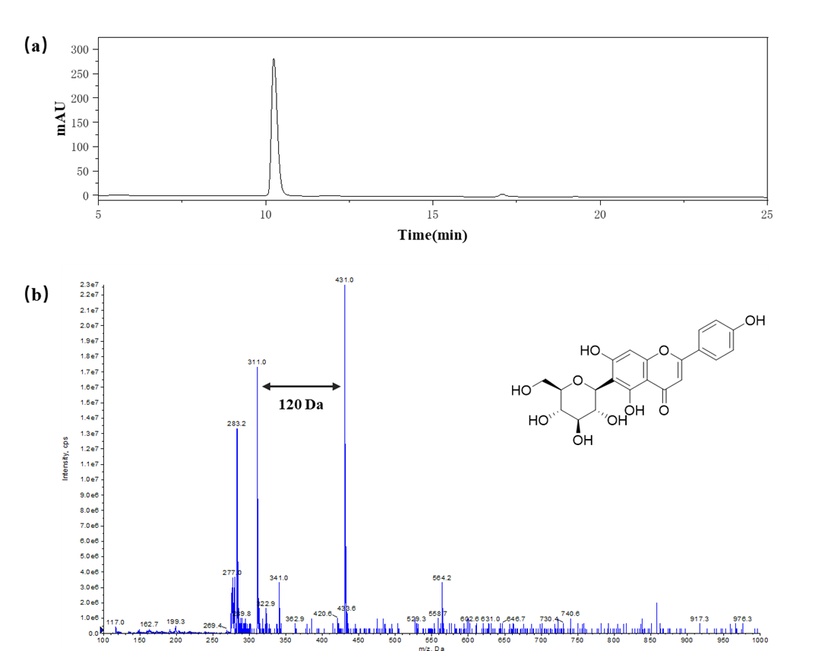
Fig. S2. Identification of the biosynthetic product isovitexin. (a) HPLC chromatogram of the product synthesized by the enzymatic reaction. (b) Mass spectrum (ESI-MS) analysis of the product. The characteristic molecular ion peak at m/z 431.0 [M-H]⁻ corresponds to isovitexin, and the fragmentation pattern confirms the structure of the C-glycoside.

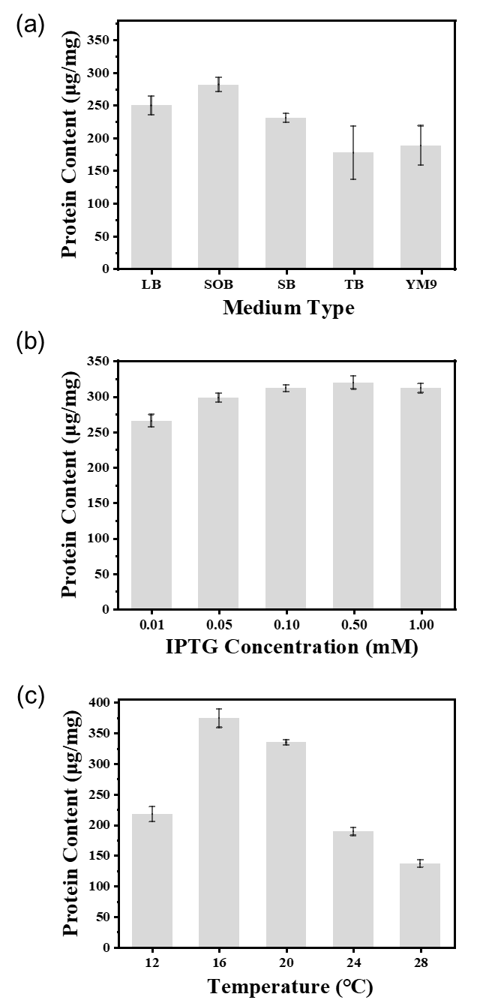
Fig. S3. Optimization of fermentation conditions for the soluble expression of recombinant MBP-WjGT1. The effects of different variables on the soluble protein content were investigated to maximize yield: (a) Screening of different culture media (LB, SOB, SB, TB, YM9). (b) Optimization of IPTG inducer concentration (0.01–1.00 mM). (c) Optimization of induction temperature (12–28 °C). Data are presented as mean ± SD (n = 3).

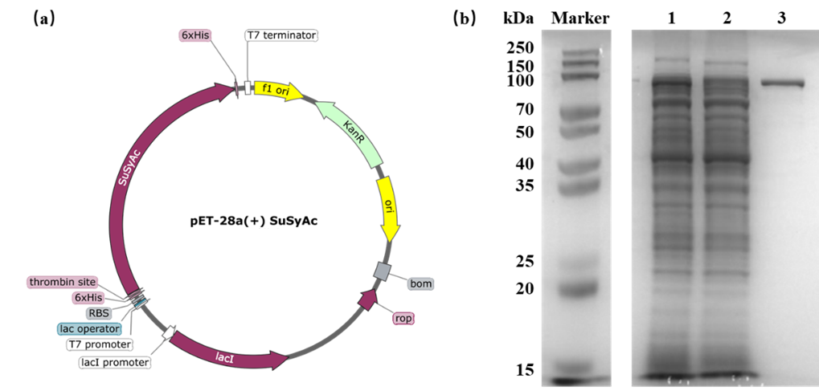
Fig. S4. Construction and expression analysis of the sucrose synthase strain. (a) Map of the recombinant plasmid pET-28a(+)-SuSyAc used for the expression of sucrose synthase from Acidithiobacillus caldus. (b) SDS-PAGE analysis of SuSyAc expression and purification. Lane M: Protein molecular weight marker; Lane 1: Total cell lysate of the induced strain; Lane 2: Soluble supernatant fraction; Lane 3: Purified SuSyAc protein using Ni-NTA affinity chromatography.

