Additional file 1: Supplementary materials
Supplementary methods
Data quality assessment and preprocessing. All candidate predictors were assessed for missingness, distributional plausibility, unit consistency, and clinically implausible values before model development. Values incompatible with physiological ranges or the clinical measurement context were treated as data-quality outliers and converted to missing values before imputation. All imputation, transformation, standardisation, encoding, and missingness-indicator rules were derived in the training cohort only and then applied unchanged to the locked internal-validation cohort.
Feature-pool definitions and model roles. Candidate predictors were organised into prespecified feature pools before modelling. Pool A contained routinely available predictors for compact interpretable clinical models. Pool B extended this set with additional prespecified metabolic, renal, hepatic, haematological, nutritional, and transformed variables. Pool C included broader candidate predictors and prespecified interaction terms for tree-based supervised-learning comparators. The locked internal-validation cohort was not used for feature screening, model selection, hyperparameter tuning, calibration fitting, threshold derivation, or risk-strata definition.
Risk-stratification and subgroup analyses. Risk strata were defined using tertiles of A2 training out-of-fold predicted risk and were applied unchanged to the locked internal-validation cohort and prespecified clinical subgroups. Subgroup and sensitivity analyses were descriptive. The A2 model was not refitted, recalibrated, or rethresholded within any subgroup.
Machine-learning explanatory analyses. Feature-importance and SHAP analyses for tree-based comparator models were performed only after model locking. These analyses were used to compare explanatory profiles with the primary A2 risk domains and did not influence predictor selection, model selection, threshold derivation, or the primary conclusions.
Figure S1. Training out-of-fold and locked internal-validation performance across prespecified models. Circles indicate locked internal-validation estimates with 95% bootstrap confidence intervals; diamonds indicate training out-of-fold estimates. The figure compares discrimination and precision-recall performance across prespecified candidate models and was not used for model selection after locked validation.
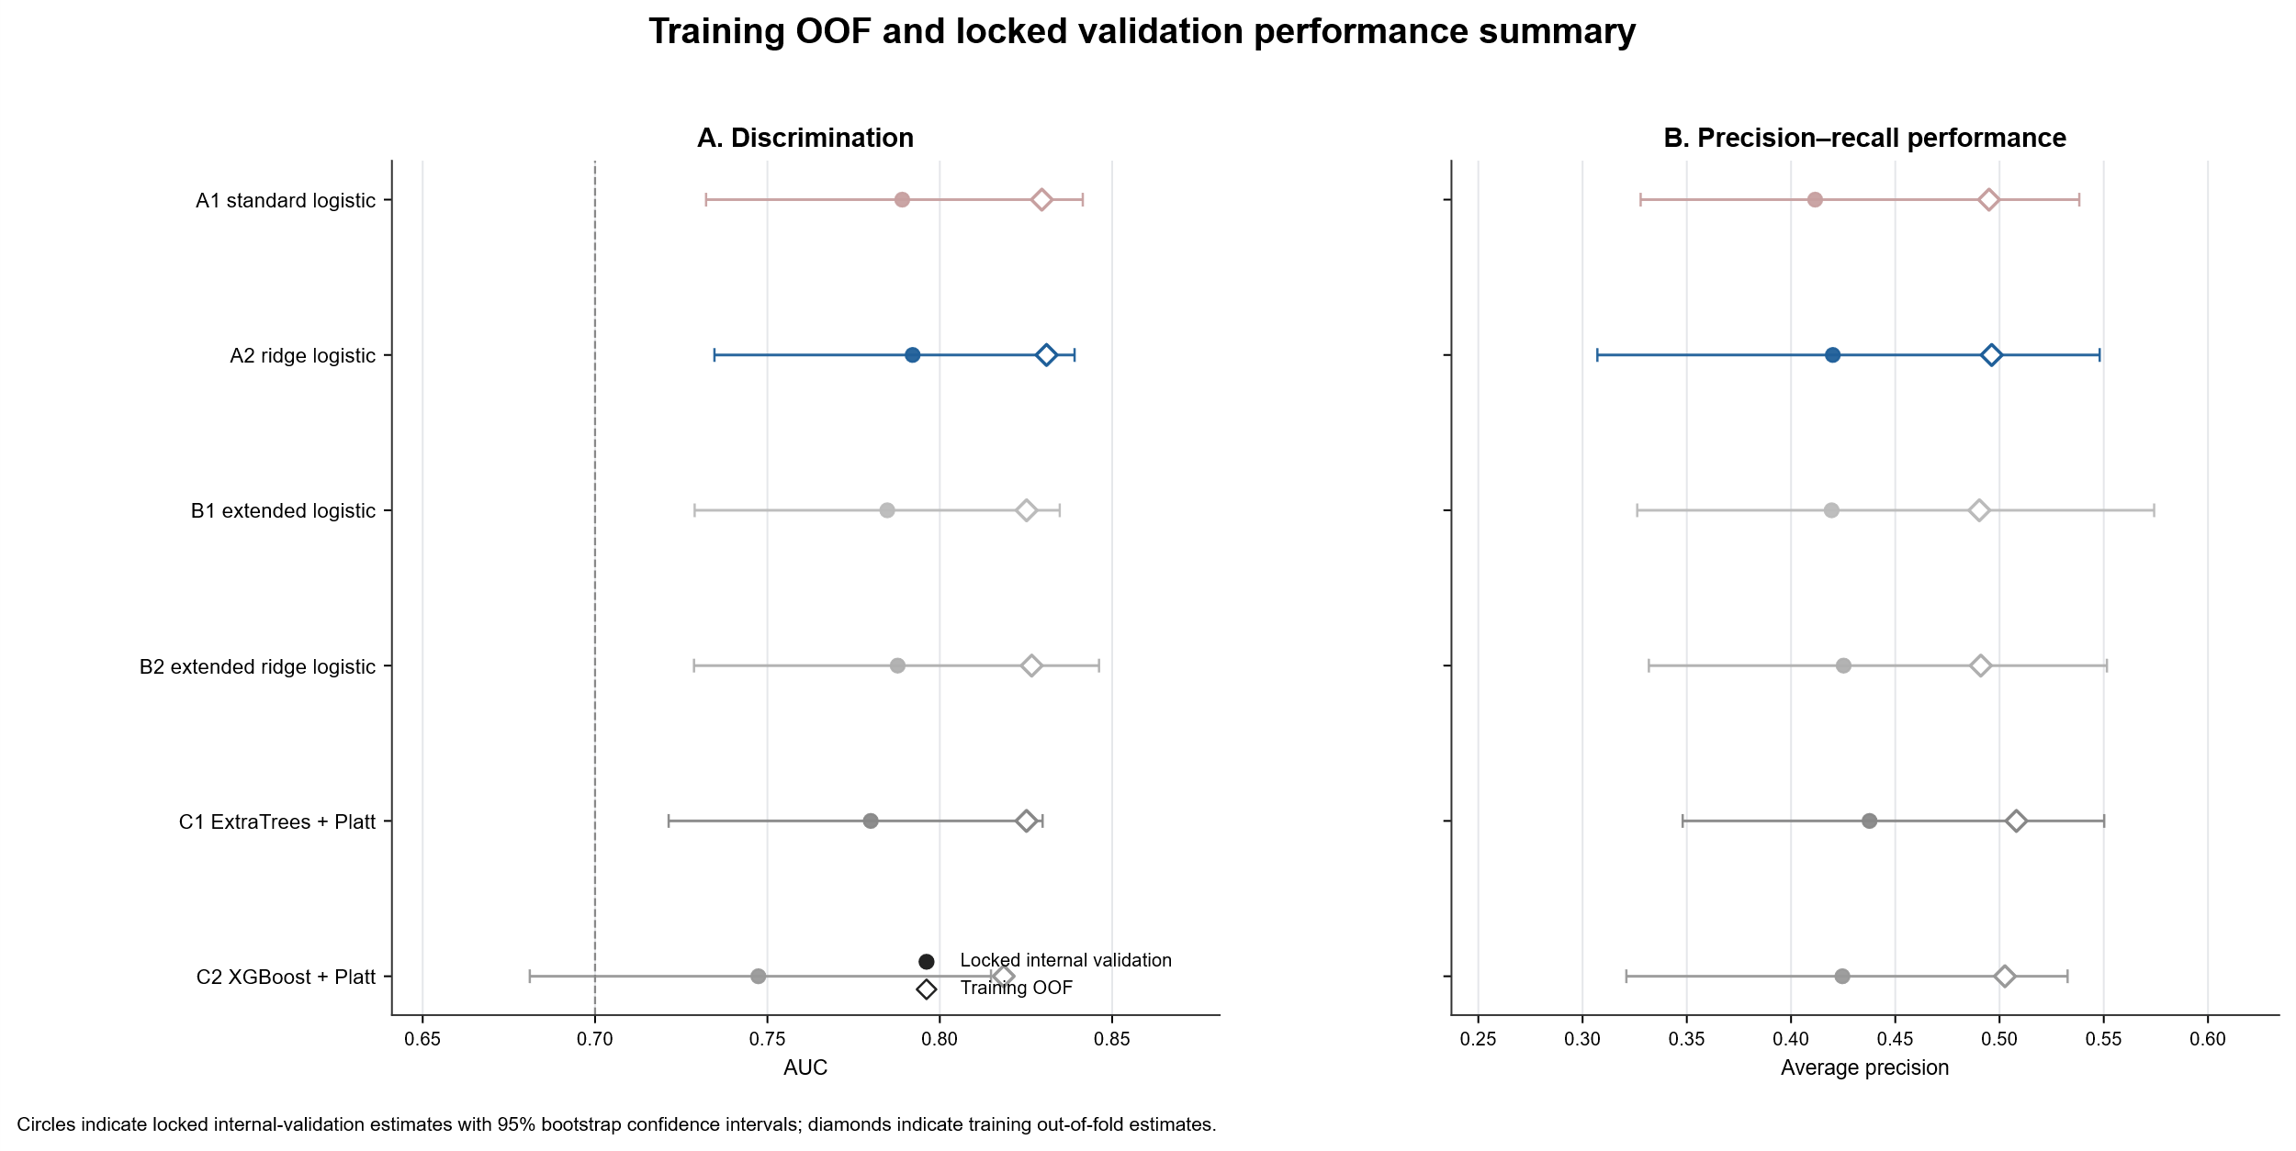
Figure S2. All-model decision-curve analysis in locked internal validation. Decision-curve analysis compared the net benefit of prespecified candidate models across threshold probabilities. Treat-all and treat-none strategies are shown as reference approaches. The shaded region denotes the prespecified clinically relevant threshold-probability range.

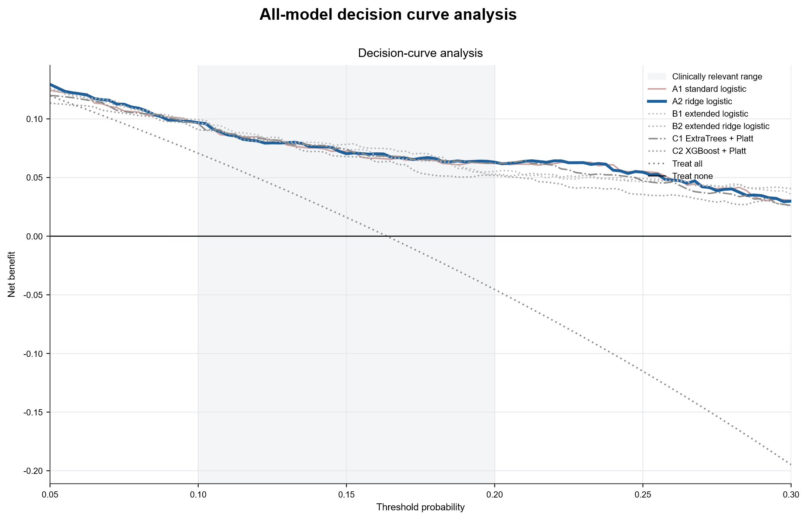

Figure S3. A2 risk stratification across BMI categories in locked internal validation. Low-, intermediate-, and high-risk strata were defined using tertiles of A2 training out-of-fold predicted risk and applied unchanged to BMI subgroups in the locked internal-validation cohort. Analyses are descriptive and were not used for threshold optimisation.
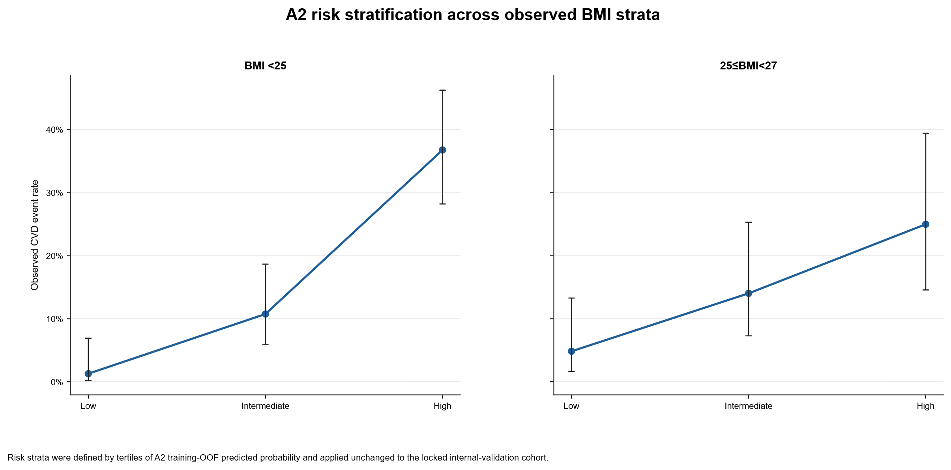

Figure S4. A2 discrimination across clinical subgroups. The locked A2 model was applied unchanged across prespecified clinical subgroups without subgroup-specific refitting, recalibration, or threshold optimisation. Subgroup estimates should be interpreted descriptively, particularly in event-limited strata.

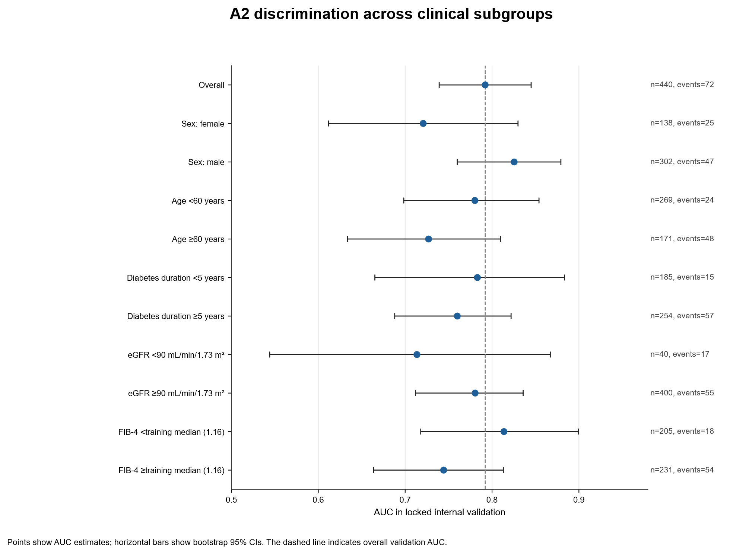

Figure S5. Tree-based comparator interpretation. Post hoc SHAP analyses were performed for tree-based comparator models after model locking. These analyses were used only to compare explanatory profiles with the A2 risk domains and did not influence feature selection, model selection, calibration, threshold derivation, or the primary conclusions.
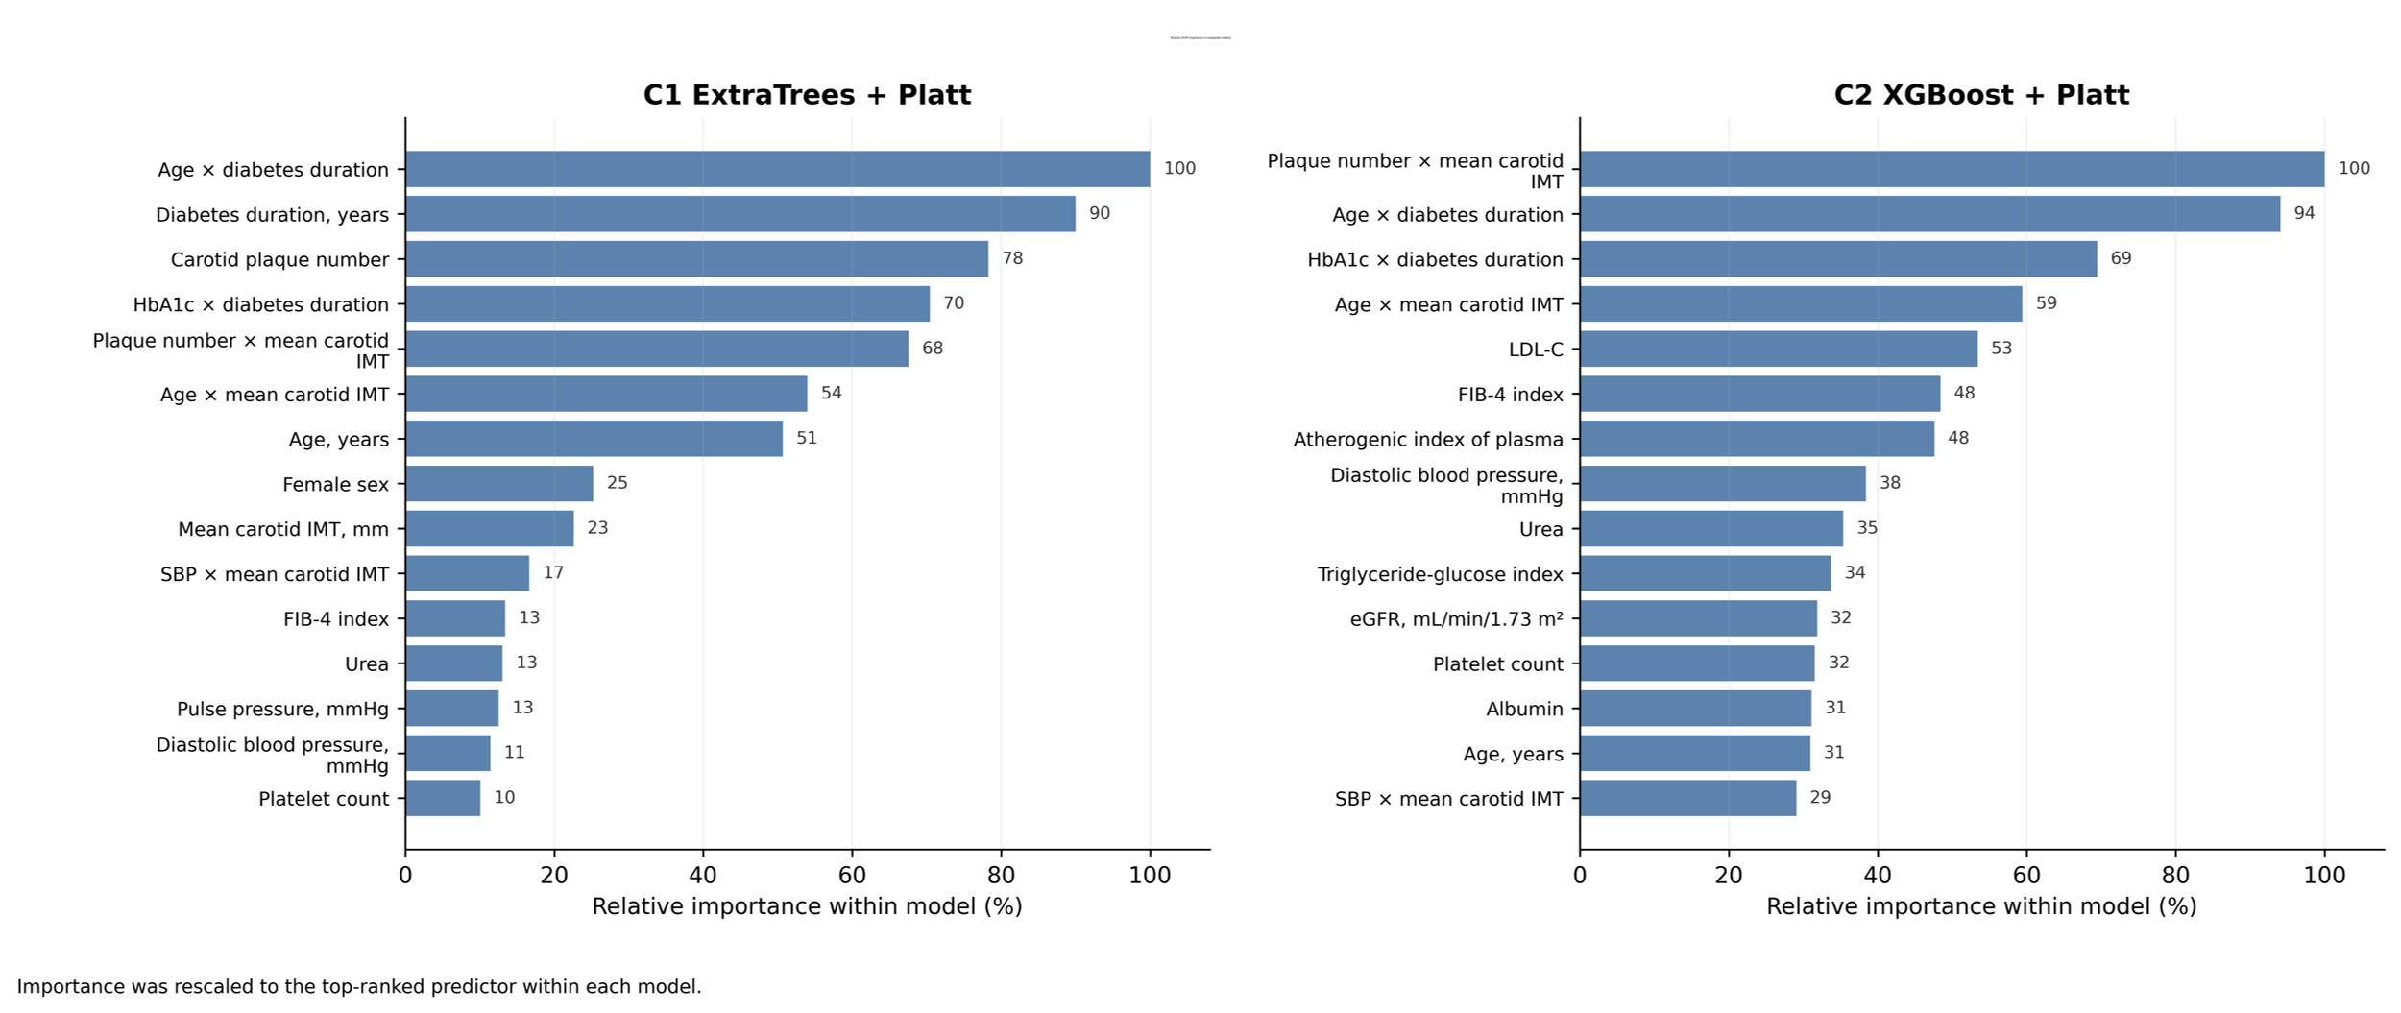
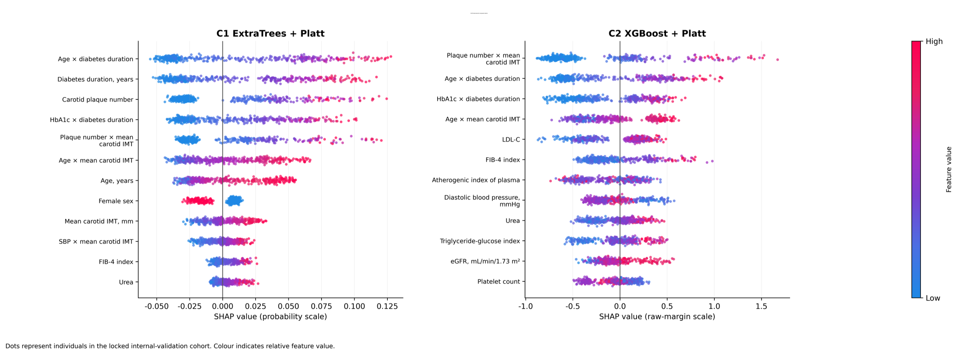

Table S1. Baseline balance between the training and locked internal-validation cohorts
Characteristics | All patients (n=1466) | Training (n=1026) | Internal validation (n=440) | P value | ASMD
Age, years | 55.03 ± 10.42 | 54.67 ± 10.41 | 55.88 ± 10.41 | 0.027 | 0.117
BMI, kg/m² | 24.11 ± 1.86 | 24.10 ± 1.90 | 24.14 ± 1.77 | 0.978 | 0.024
Diabetes duration, years | 5.00 (1.00–10.00) | 5.00 (1.00–10.00) | 6.00 (1.00–11.00) | 0.391 | 0.072
HbA1c, % | 8.46 (7.01–10.10) | 8.50 (7.00–10.10) | 8.40 (7.10–10.00) | 0.889 | 0.018
SBP, mmHg | 127.00 (117.00–139.00) | 127.00 (117.00–138.00) | 127.50 (118.00–140.00) | 0.371 | 0.008
DBP, mmHg | 83.74 ± 10.50 | 83.73 ± 10.44 | 83.77 ± 10.67 | 0.817 | 0.004
Pulse pressure, mmHg | 42.00 (35.00–52.00) | 42.00 (35.00–52.00) | 43.00 (35.00–53.00) | 0.377 | 0.007
FBG, mmol/L | 10.90 (8.68–13.50) | 10.90 (8.60–13.59) | 10.71 (8.80–13.36) | 0.8 | 0.017
TC, mmol/L | 4.53 (3.83–5.26) | 4.50 (3.78–5.24) | 4.60 (4.01–5.28) | 0.062 | 0.069
TG, mmol/L | 1.85 (1.28–2.83) | 1.84 (1.27–2.83) | 1.87 (1.30–2.83) | 0.693 | 0.013
HDL-C, mmol/L | 0.94 ± 0.19 | 0.94 ± 0.19 | 0.96 ± 0.20 | 0.005 | 0.132
LDL-C, mmol/L | 2.50 ± 0.79 | 2.48 ± 0.79 | 2.54 ± 0.79 | 0.136 | 0.074
TyG index | 9.77 ± 0.76 | 9.78 ± 0.76 | 9.77 ± 0.78 | 0.912 | 0.005
Atherogenic index of plasma | 0.34 ± 0.32 | 0.34 ± 0.32 | 0.33 ± 0.32 | 0.596 | 0.041
TC/HDL-C ratio | 4.86 (4.12–5.75) | 4.89 (4.11–5.79) | 4.85 (4.15–5.65) | 0.702 | 0.019
ALT, IU/L | 25.10 (18.12–36.65) | 25.70 (18.50–36.80) | 24.01 (17.28–35.59) | 0.066 | 0.061
AST, IU/L | 20.85 (16.94–26.30) | 20.88 (16.87–26.74) | 20.82 (17.03–25.61) | 0.769 | 0.054
Platelet count, ×10⁹/L | 207.20 ± 61.48 | 207.53 ± 59.86 | 206.44 ± 65.17 | 0.867 | 0.017
FIB-4 index | 1.17 (0.85–1.60) | 1.16 (0.84–1.57) | 1.19 (0.89–1.69) | 0.103 | 0.08
Albumin, g/L | 43.87 ± 4.11 | 43.80 ± 4.10 | 44.02 ± 4.11 | 0.115 | 0.055
Urea, mmol/L | 5.91 (4.93–7.06) | 5.87 (4.89–7.00) | 6.01 (5.02–7.12) | 0.134 | 0.041
Creatinine, μmol/L | 58.67 (50.24–68.44) | 58.74 (49.78–68.28) | 58.52 (51.11–68.64) | 0.462 | 0.036
eGFR, mL/min/1.73 m² | 106.71 ± 16.06 | 107.13 ± 16.41 | 105.74 ± 15.19 | 0.095 | 0.088
Urine albumin, mg/L | 10.44 (5.38–22.46) | 10.03 (5.44–21.54) | 11.75 (5.33–24.58) | 0.18 | 0.026
Left carotid IMT, mm | 1.00 (0.90–1.10) | 1.00 (0.90–1.10) | 1.00 (0.90–1.10) | 0.479 | 0.043
Right carotid IMT, mm | 1.00 (0.90–1.10) | 1.00 (0.90–1.10) | 1.00 (0.90–1.10) | 0.927 | 0.013
Mean carotid IMT, mm | 1.00 (0.90–1.10) | 1.00 (0.90–1.10) | 1.00 (0.85–1.10) | 0.712 | 0.009
Plaque number | 0.00 (0.00–1.00) | 0.00 (0.00–1.00) | 0.00 (0.00–1.00) | 0.555 | 0.026
Sex, n (%) | 469 (31.99%) | 331 (32.26%) | 138 (31.36%) | 0.76 | 0.019
BMI <25 kg/m², n (%) | 924 (63.03%) | 647 (63.06%) | 277 (62.95%) | 1 | 0.002
CVD event, n (%) | 240 (16.37%) | 168 (16.37%) | 72 (16.36%) | 1 | 0
BMI stratum, n (%) | — | — | — | 0.998 | 0.004
BMI<23 | 389 (26.53%) | 272 (26.51%) | 117 (26.59%) | — | —
23≤BMI<25 | 535 (36.49%) | 375 (36.55%) | 160 (36.36%) | — | —
25≤BMI<27 | 542 (36.97%) | 379 (36.94%) | 163 (37.05%) | — | —
Fatty liver grade, n (%) | — | — | — | 0.976 | 0.012
Mild fatty liver | 1277 (87.11%) | 893 (87.04%) | 384 (87.27%) | — | —
Moderate fatty liver | 171 (11.66%) | 120 (11.70%) | 51 (11.59%) | — | —
Severe fatty liver | 18 (1.23%) | 13 (1.27%) | 5 (1.14%) | — | —
Note: Continuous variables are presented as mean ± SD or median (IQR), and categorical variables as n (%). P values are provided for descriptive comparison only. Absolute standardised mean differences (ASMDs) were used to quantify balance between the training and locked internal-validation cohorts; values greater than 0.10 were considered potentially meaningful.

Table S2. Extended baseline characteristics across observed BMI strata
Characteristics | All patients (n=1466) | BMI<23 (n=389) | 23≤BMI<25 (n=535) | 25≤BMI<27 (n=542) | P value | Max pairwise ASMD
Age, years | 55.03 ± 10.42 | 56.25 ± 9.66 | 55.75 ± 10.15 | 53.45 ± 11.02 | <0.001 | 0.270
BMI, kg/m² | 24.11 ± 1.86 | 21.62 ± 1.18 | 24.09 ± 0.58 | 25.92 ± 0.57 | <0.001 | 4.661
Diabetes duration, years | 5.00 (1.00–10.00) | 6.00 (1.00–12.00) | 6.00 (2.00–11.00) | 5.00 (1.00–10.00) | 0.085 | 0.152
HbA1c, % | 8.46 (7.01–10.10) | 8.70 (7.10–10.48) | 8.43 (7.10–9.84) | 8.30 (7.00–10.10) | 0.132 | 0.146
SBP, mmHg | 127.00 (117.00–139.00) | 126.00 (115.00–136.00) | 127.00 (117.00–140.00) | 127.00 (119.00–140.00) | 0.047 | 0.065
DBP, mmHg | 83.74 ± 10.50 | 81.96 ± 10.20 | 83.48 ± 10.32 | 85.27 ± 10.70 | <0.001 | 0.316
Pulse pressure, mmHg | 42.00 (35.00–52.00) | 42.00 (35.00–52.00) | 43.00 (34.00–52.00) | 42.00 (35.25–52.00) | 0.979 | 0.070
FBG, mmol/L | 10.90 (8.68–13.50) | 11.30 (8.80–14.08) | 10.90 (8.80–13.23) | 10.68 (8.60–13.50) | 0.124 | 0.157
TC, mmol/L | 4.53 (3.83–5.26) | 4.59 (3.89–5.33) | 4.55 (3.85–5.23) | 4.49 (3.79–5.24) | 0.432 | 0.056
TG, mmol/L | 1.85 (1.28–2.83) | 1.78 (1.22–2.67) | 1.78 (1.29–2.80) | 1.96 (1.36–3.12) | 0.006 | 0.144
HDL-C, mmol/L | 0.94 ± 0.19 | 0.97 ± 0.20 | 0.95 ± 0.20 | 0.92 ± 0.18 | 0.005 | 0.234
LDL-C, mmol/L | 2.50 ± 0.79 | 2.52 ± 0.82 | 2.50 ± 0.79 | 2.47 ± 0.77 | 0.637 | 0.067
TyG index | 9.77 ± 0.76 | 9.73 ± 0.79 | 9.75 ± 0.74 | 9.83 ± 0.76 | 0.148 | 0.123
Atherogenic index of plasma | 0.34 ± 0.32 | 0.30 ± 0.33 | 0.33 ± 0.32 | 0.38 ± 0.31 | <0.001 | 0.244
TC/HDL-C ratio | 4.86 (4.12–5.75) | 4.88 (4.00–5.69) | 4.85 (4.17–5.68) | 4.89 (4.13–5.85) | 0.628 | 0.073
ALT, IU/L | 25.10 (18.12–36.65) | 23.30 (16.56–35.02) | 24.45 (17.95–35.44) | 27.13 (19.36–38.41) | <0.001 | 0.153
AST, IU/L | 20.85 (16.94–26.30) | 20.91 (16.63–26.50) | 20.84 (16.90–25.51) | 20.77 (17.05–27.00) | 0.595 | 0.116
Platelet count, ×10⁹/L | 207.20 ± 61.48 | 204.76 ± 62.22 | 208.46 ± 62.53 | 207.73 ± 59.94 | 0.425 | 0.059
FIB-4 index | 1.17 (0.85–1.60) | 1.26 (0.92–1.72) | 1.17 (0.90–1.59) | 1.12 (0.79–1.55) | 0.002 | 0.141
Albumin, g/L | 43.87 ± 4.11 | 43.67 ± 4.21 | 43.87 ± 4.25 | 44.00 ± 3.88 | 0.336 | 0.080
Urea, mmol/L | 5.91 (4.93–7.06) | 5.78 (4.91–6.93) | 6.00 (4.92–7.24) | 5.84 (4.97–6.97) | 0.154 | 0.113
Creatinine, μmol/L | 58.67 (50.24–68.44) | 55.09 (47.66–65.01) | 59.50 (51.22–69.27) | 59.82 (51.75–70.35) | <0.001 | 0.270
eGFR, mL/min/1.73 m² | 106.71 ± 16.06 | 107.48 ± 14.22 | 105.97 ± 15.56 | 106.89 ± 17.71 | 0.024 | 0.101
Urine albumin, mg/L | 10.44 (5.38–22.46) | 9.81 (5.33–17.99) | 11.21 (5.54–23.09) | 10.62 (5.42–25.51) | 0.169 | 0.093
Left carotid IMT, mm | 1.00 (0.90–1.10) | 1.00 (0.90–1.10) | 1.00 (0.90–1.10) | 1.00 (0.90–1.10) | 0.263 | 0.111
Right carotid IMT, mm | 1.00 (0.90–1.10) | 1.00 (0.90–1.10) | 1.00 (0.90–1.10) | 1.00 (0.90–1.10) | 0.171 | 0.107
Mean carotid IMT, mm | 1.00 (0.90–1.10) | 1.00 (0.85–1.10) | 1.00 (0.90–1.10) | 1.00 (0.90–1.10) | 0.226 | 0.105
Plaque number | 0.00 (0.00–1.00) | 0.00 (0.00–1.00) | 0.00 (0.00–2.00) | 0.00 (0.00–1.00) | 0.563 | 0.059
Sex, n (%) | 469 (31.99%) | 156 (40.10%) | 164 (30.65%) | 149 (27.49%) | <0.001 | 0.269
CVD event, n (%) | 240 (16.37%) | 69 (17.74%) | 97 (18.13%) | 74 (13.65%) | 0.097 | 0.123
Fatty liver grade, n (%) | — | — | — | — | 0.009 | 0.217
Mild fatty liver | 1277 (87.11%) | 352 (90.49%) | 474 (88.60%) | 451 (83.21%) | — | —
Moderate fatty liver | 171 (11.66%) | 32 (8.23%) | 57 (10.65%) | 82 (15.13%) | — | —
Severe fatty liver | 18 (1.23%) | 5 (1.29%) | 4 (0.75%) | 9 (1.66%) | — | —
Note: Continuous variables are presented as mean ± SD or median (IQR), and categorical variables as n (%). P values compare the three observed BMI strata. The maximum pairwise ASMD represents the largest absolute standardised difference between any two BMI strata for each variable. BMI strata were defined as BMI <23, 23–<25, and 25–<27 kg/m².

Table S3. Extended baseline characteristics according to cardiovascular event status
Characteristics | All patients (n=1466) | No CVD event (n=1226) | CVD event (n=240) | P value | ASMD
Age, years | 55.03 ± 10.42 | 53.74 ± 10.35 | 61.65 ± 8.00 | <0.001 | 0.855
BMI, kg/m² | 24.11 ± 1.86 | 24.14 ± 1.87 | 23.99 ± 1.84 | 0.179 | 0.08
Diabetes duration, years | 5.00 (1.00–10.00) | 5.00 (1.00–10.00) | 12.00 (6.75–18.00) | <0.001 | 0.902
HbA1c, % | 8.46 (7.01–10.10) | 8.43 (7.00–10.10) | 8.50 (7.20–9.92) | 0.559 | 0.003
SBP, mmHg | 127.00 (117.00–139.00) | 126.00 (116.25–138.00) | 129.00 (119.00–142.00) | 0.015 | 0.102
DBP, mmHg | 83.74 ± 10.50 | 84.07 ± 10.41 | 82.05 ± 10.85 | 0.002 | 0.189
Pulse pressure, mmHg | 42.00 (35.00–52.00) | 41.00 (35.00–51.00) | 47.50 (38.00–59.00) | <0.001 | 0.198
FBG, mmol/L | 10.90 (8.68–13.50) | 10.90 (8.60–13.60) | 10.80 (9.00–13.30) | 0.534 | 0.022
TC, mmol/L | 4.53 (3.83–5.26) | 4.53 (3.85–5.24) | 4.54 (3.78–5.30) | 0.945 | 0.036
TG, mmol/L | 1.85 (1.28–2.83) | 1.88 (1.28–2.86) | 1.73 (1.28–2.80) | 0.195 | 0.2
HDL-C, mmol/L | 0.94 ± 0.19 | 0.94 ± 0.19 | 0.96 ± 0.20 | 0.118 | 0.093
LDL-C, mmol/L | 2.50 ± 0.79 | 2.49 ± 0.78 | 2.54 ± 0.83 | 0.507 | 0.059
TyG index | 9.77 ± 0.76 | 9.78 ± 0.78 | 9.72 ± 0.66 | 0.409 | 0.084
Atherogenic index of plasma | 0.34 ± 0.32 | 0.35 ± 0.33 | 0.30 ± 0.28 | 0.115 | 0.136
TC/HDL-C ratio | 4.86 (4.12–5.75) | 4.88 (4.13–5.75) | 4.66 (4.03–5.71) | 0.263 | 0.11
ALT, IU/L | 25.10 (18.12–36.65) | 25.72 (18.62–37.05) | 21.91 (16.73–33.33) | <0.001 | 0.191
AST, IU/L | 20.85 (16.94–26.30) | 20.94 (16.93–26.63) | 20.45 (17.02–25.24) | 0.397 | 0.016
Platelet count, ×10⁹/L | 207.20 ± 61.48 | 209.51 ± 60.43 | 195.46 ± 65.43 | <0.001 | 0.223
FIB-4 index | 1.17 (0.85–1.60) | 1.13 (0.81–1.51) | 1.50 (1.09–1.94) | <0.001 | 0.186
Albumin, g/L | 43.87 ± 4.11 | 44.13 ± 4.05 | 42.53 ± 4.13 | <0.001 | 0.392
Urea, mmol/L | 5.91 (4.93–7.06) | 5.75 (4.87–6.91) | 6.52 (5.49–8.00) | <0.001 | 0.186
Creatinine, μmol/L | 58.67 (50.24–68.44) | 58.07 (49.67–67.91) | 61.49 (52.35–72.08) | 0.002 | 0.172
eGFR, mL/min/1.73 m² | 106.71 ± 16.06 | 108.12 ± 15.63 | 99.50 ± 16.31 | <0.001 | 0.54
Urine albumin, mg/L | 10.44 (5.38–22.46) | 9.91 (5.24–20.77) | 14.93 (7.48–39.80) | <0.001 | 0.132
Left carotid IMT, mm | 1.00 (0.90–1.10) | 1.00 (0.90–1.10) | 1.00 (1.00–1.10) | <0.001 | 0.559
Right carotid IMT, mm | 1.00 (0.90–1.10) | 1.00 (0.80–1.10) | 1.10 (1.00–1.20) | <0.001 | 0.625
Mean carotid IMT, mm | 1.00 (0.90–1.10) | 1.00 (0.85–1.10) | 1.05 (1.00–1.15) | <0.001 | 0.619
Plaque number | 0.00 (0.00–1.00) | 0.00 (0.00–1.00) | 1.00 (0.00–3.00) | <0.001 | 0.747
Sex, n (%) | 469 (31.99%) | 398 (32.46%) | 71 (29.58%) | 0.406 | 0.062
BMI <25 kg/m², n (%) | 924 (63.03%) | 758 (61.83%) | 166 (69.17%) | 0.034 | 0.155
BMI stratum, n (%) | — | — | — | 0.097 | 0.155
BMI<23 | 389 (26.53%) | 320 (26.10%) | 69 (28.75%) | — | —
23≤BMI<25 | 535 (36.49%) | 438 (35.73%) | 97 (40.42%) | — | —
25≤BMI<27 | 542 (36.97%) | 468 (38.17%) | 74 (30.83%) | — | —
Fatty liver grade, n (%) | — | — | — | 0.628 | 0.059
Mild fatty liver | 1277 (87.11%) | 1072 (87.44%) | 205 (85.42%) | — | —
Moderate fatty liver | 171 (11.66%) | 140 (11.42%) | 31 (12.92%) | — | —
Severe fatty liver | 18 (1.23%) | 14 (1.14%) | 4 (1.67%) | — | —
Note: Continuous variables are presented as mean ± SD or median (IQR), and categorical variables as n (%). The cardiovascular event variable represents the study-defined composite cardiovascular outcome. P values and ASMDs compare patients with and without documented composite cardiovascular events and are intended for descriptive baseline characterisation.

Table S4. Missingness summary
variable | Missing, n | Missing percent,%
ESR | 601 | 40.996
Lymphocyte | 551 | 37.585
Neutrophil count | 551 | 37.585
NT-proBNP | 453 | 30.900
Homocysteine | 423 | 28.854
D-dimer | 380 | 25.921
CRP | 373 | 25.443
Cardiac Troponin | 361 | 24.625
Creatinine clearance | 267 | 18.213
AST/ALT ratio | 118 | 8.049
CK-MB | 86 | 5.866
Left carotid IMT | 83 | 5.662
Vitamin D 25OH | 83 | 5.662
Urine albumin | 71 | 4.843
Right carotid IMT | 47 | 3.206
Mean carotid IMT | 47 | 3.206
Sodium | 41 | 2.797
Potassium | 41 | 2.797
GGT | 35 | 2.387
ALP | 33 | 2.251
E/A ratio | 33 | 2.251
EF | 31 | 2.115
Urea | 30 | 2.046
Hemoglobin | 28 | 1.100
Direct bilirubin | 27 | 1.842
Indirect bilirubin | 27 | 1.842
Albumin/globulin ratio | 25 | 1.705
Albumin | 25 | 1.705
Globulin | 25 | 1.705
Fasting c peptide | 17 | 1.160
Fasting insulin | 17 | 1.160
TyG | 14 | 0.955
FPG, mmol/L | 11 | 0.750
FIB4 | 9 | 0.614
AST | 8 | 0.546
HbA1c | 8 | 0.546
TC/HDL-C ratio | 6 | 0.409
HDL-C | 5 | 0.341
TC | 5 | 0.341
AIP | 5 | 0.341
Uric acid | 5 | 0.341
TG | 4 | 0.273
WBC | 4 | 0.273
LDL-C | 4 | 0.273
Serum creatinine | 3 | 0.205
Platelet | 3 | 0.205
eGFR | 3 | 0.205
ALT | 2 | 0.136
Diabetes duration | 1 | 0.068
Note: Missingness was summarised after data-quality review and before imputation. Clinically implausible or physiologically incompatible values were converted to missing values before imputation. Missing percentages were calculated using the full analytic cohort as the denominator (N=1466). Variables are listed in descending order of missingness. Missing values in modelling variables were imputed using training-set medians for numerical variables and training-set modes for categorical variables, with locked imputation rules applied unchanged to the internal-validation cohort.
Table S5. Candidate predictor pools, transformations, and locked feature sets

Predictor set | order | predictor | Raw name
Model A primary clinical | 1 | Diabetes duration, years | Diabetes duration
Model A primary clinical | 2 | Carotid plaque number | Plaque number
Model A primary clinical | 3 | Mean carotid IMT, mm | Mean carotid IMT
Model A primary clinical | 4 | Age, years | age
Model A primary clinical | 5 | FIB-4 index | FIB-4
Model A primary clinical | 6 | eGFR, mL/min/1.73 m² | eGFR
Model A primary clinical | 7 | LDL-C, mmol/L | LDL-C
Model A primary clinical | 8 | Albumin, g/L | albumin
Model B extended linear | 1 | Log-transformed Diabetes duration, years | log1p-diabetes duration
Model B extended linear | 2 | Log-transformed Carotid plaque number | log1p-plaque number
Model B extended linear | 3 | Age, years | age
Model B extended linear | 4 | Mean carotid IMT, mm | Mean carotid IMT
Model B extended linear | 5 | FIB-4 index | FIB-4
Model B extended linear | 6 | LDL-C, mmol/L | LDL-C
Model B extended linear | 7 | HbA1c, % | HbA1c
Model B extended linear | 8 | Log-transformed Urea, mmol/L | log1p-urea
Model B extended linear | 9 | Pulse pressure, mmHg | Pulse pressure
Model B extended linear | 10 | Female sex | Sex female
Model B extended linear | 11 | Log-transformed C peptide | log1p C peptide
Model B extended linear | 12 | Log-transformed Urine albumin, mg/L | log1p urine albumin
Model B extended linear | 13 | Albumin, g/L | albumin
Model B extended linear | 14 | Platelet count, ×10⁹/L | Platelet count
Model B extended linear | 15 | Log-transformed FPG | log1p-FPG
Model B extended linear | 16 | Log-transformed insulin | log1p-insulin
Model C tree comparator | 1 | Age×diabetes duration | Age×diabetes duration
Model C tree comparator | 2 | Diabetes duration, years | Diabetes duration
Model C tree comparator | 3 | HbA1c×diabetes duration | HbA1c×diabetes duration
Model C tree comparator | 4 | Carotid plaque number | plaque number
Model C tree comparator | 5 | Plaque × mean carotid IMT | Plaque × mean carotid IMT
Model C tree comparator | 6 | Age × mean carotid IMT | Age × mean carotid IMT
Model C tree comparator | 7 | Age, years | age
Model C tree comparator | 8 | Mean carotid IMT, mm | Mean carotid IMT
Model C tree comparator | 9 | SBP × mean carotid IMT | SBP × mean carotid IMT
Model C tree comparator | 10 | Urea, mmol/L | urea
Model C tree comparator | 11 | Pulse pressure, mmHg | Pulse pressure
Model C tree comparator | 12 | FIB-4 index | FIB4
Model C tree comparator | 13 | eGFR, mL/min/1.73 m² | eGFR
Model C tree comparator | 14 | Female sex | Sex-female
Model C tree comparator | 15 | Diastolic blood pressure, mmHg | DBP
Model C tree comparator | 16 | Platelet count, ×10⁹/L | Platelet count
Model C tree comparator | 17 | Albumin, g/L | albumin
Model C tree comparator | 18 | Atherogenic index of plasma | AIP
Model C tree comparator | 19 | Mean arterial pressure | Mean arterial pressure
Model C tree comparator | 20 | FPG | FPG
Model C tree comparator | 21 | HbA1c, % | HbA1c
Model C tree comparator | 22 | BMI, kg/m² | BMI
Model C tree comparator | 23 | TyG index | TyG
Model C tree comparator | 24 | LDL-C, mmol/L | LDL-C
Model C tree comparator | 25 | Alanine aminotransferase, IU/L | ALT
Note: Predictor pools and modelling roles were defined before locked internal validation. Pool A was used for the primary compact clinical models, Pool B for extended linear comparator models, and Pool C for tree-based comparator models. Log-transformed variables used the log1p transformation, defined as log(1+x). Interaction terms in Pool C were prespecified and were used only for tree-based comparator modelling. The locked internal-validation cohort was not used for predictor screening, feature-pool construction, or model tuning.
Table S6. Complete model-development and locked internal-validation performance summary
Model | Training OOF AUC | Internal validation AUC | Internal validation AUC (95% CI) | Internal-validation average precision | Internal-validation average precision (95% CI) | Internal validation Brier | Internal validation Brier (95% CI) | Calibration intercept | Calibration slope | Locked threshold | Sensitivity | Specificity | PPV | NPV | F1 score | Accuracy
A1 Standard logistic | 0.830 | 0.789 | 0.789 (0.733–0.843) | 0.412 | 0.412 (0.317–0.547) | 0.120 | 0.120 (0.099–0.141) | -0.521 | 0.684 | 0.145 | 0.722 | 0.677 | 0.304 | 0.926 | 0.428 | 0.684
A2 Ridge logistic | 0.831 | 0.792 | 0.792 (0.741–0.844) | 0.420 | 0.420 (0.319–0.549) | 0.116 | 0.116 (0.097–0.137) | -0.307 | 0.849 | 0.149 | 0.736 | 0.658 | 0.296 | 0.927 | 0.422 | 0.670
B1 Extended logistic | 0.825 | 0.785 | 0.785 (0.729–0.838) | 0.420 | 0.419 (0.320–0.544) | 0.120 | 0.120 (0.100–0.141) | -0.531 | 0.677 | 0.172 | 0.722 | 0.698 | 0.319 | 0.928 | 0.443 | 0.702
B2 Extended ridge logistic | 0.827 | 0.788 | 0.788 (0.732–0.840) | 0.425 | 0.425 (0.324–0.551) | 0.117 | 0.116 (0.097–0.135) | -0.318 | 0.856 | 0.160 | 0.778 | 0.671 | 0.316 | 0.939 | 0.450 | 0.689
C1 ExtraTrees + Platt | 0.825 | 0.780 | 0.780 (0.722–0.830) | 0.438 | 0.438 (0.330–0.554) | 0.119 | 0.119 (0.099–0.140) | -0.461 | 0.726 | 0.163 | 0.722 | 0.696 | 0.317 | 0.928 | 0.441 | 0.700
C2 XGBoost + Platt | 0.819 | 0.747 | 0.747 (0.678–0.811) | 0.425 | 0.425 (0.321–0.540) | 0.125 | 0.125 (0.106–0.145) | -0.644 | 0.656 | 0.170 | 0.708 | 0.679 | 0.302 | 0.923 | 0.423 | 0.684
Note: Training OOF denotes training out-of-fold performance estimated during internal cross-validation within the training cohort. Internal-validation estimates were obtained in the locked internal-validation cohort after all preprocessing rules, feature sets, model parameters, calibration procedures, and thresholds had been finalised. Average precision was used as the summary measure of precision–recall performance. Locked thresholds were derived from training out-of-fold predictions and applied unchanged to the internal-validation cohort. PPV and NPV depend on the observed event prevalence in the validation cohort.
Table S7. Final A2 risk-score components and score conversion
Clinical domain | Predictor | A1 OR per SD (95% CI) | A1 P value | A2 ridge coefficient | Nomogram scale shown in Figure 4A | Maximum nomogram points
Diabetes exposure | Diabetes duration, years | 2.12 (1.75–2.56) | <0.001 | 0.594 | 0.10, 6.32, 13, 19, 25 | 100.0
Subclinical atherosclerosis | Carotid plaque number | 1.66 (1.39–1.97) | <0.001 | 0.431 | 0, 2, 3, 4, 6 | 87.8
Vascular structural injury | Mean carotid intima–media thickness (IMT), mm | 1.42 (1.14–1.77) | 0.002 | 0.287 | 0.65, 0.82, 1.00, 1.18, 1.35 | 57.8
Age-related risk | Age, years | 1.50 (1.08–2.08) | 0.015 | 0.298 | 27, 38, 50, 61, 72 | 56.7
Liver fibrosis signal | Fibrosis-4 index (FIB-4) | 1.22 (1.05–1.43) | 0.010 | 0.169 | 0.34, 1.49, 2.65, 3.80, 4.95 | 34.4
Renal function | Estimated glomerular filtration rate (eGFR), mL/min/1.73 m² | 1.08 (0.85–1.38) | 0.529 | −0.017 | 139, 116, 93, 70, 46 | 4.3
Lipid burden | Low-density lipoprotein cholesterol (LDL-C), mmol/L | 1.21 (1.00–1.46) | 0.047 | 0.128 | 0.92, 1.81, 2.70, 3.59, 4.48 | 25.2
Albumin-related vulnerability | Albumin, g/L | 0.90 (0.75–1.09) | 0.302 | −0.099 | 51, 47, 43, 38, 34 | 20.2
A1 odds ratios were estimated from the standard logistic interpretation model and are reported per 1-SD increment for continuous predictors. A2 ridge coefficients were used for prediction and score construction and should not be interpreted as causal effects or inferential odds ratios. Continuous predictors were standardised using training-set parameters before ridge-logistic model fitting. Nomogram points were obtained by linearly rescaling predictor contributions so that the strongest score component contributed 100 points. The total A2 score was calculated as the sum of component points and mapped back to predicted cardiovascular event probability using the fitted logistic model.

Table S8. Secondary operating-point performance
Cohort | Model | Locked threshold | Sensitivity | Specificity | PPV | NPV | F1 score | Accuracy
Overall internal validation | A1 Standard logistic | 0.145 | 0.722 | 0.677 | 0.304 | 0.926 | 0.428 | 0.684
Overall internal validation | A2 Ridge logistic | 0.149 | 0.736 | 0.658 | 0.296 | 0.927 | 0.422 | 0.67
Overall internal validation | B1 Extended logistic | 0.172 | 0.722 | 0.698 | 0.319 | 0.928 | 0.443 | 0.702
Overall internal validation | B2 Extended ridge logistic | 0.16 | 0.778 | 0.671 | 0.316 | 0.939 | 0.45 | 0.689
Overall internal validation | C1 ExtraTrees + Platt | 0.163 | 0.722 | 0.696 | 0.317 | 0.928 | 0.441 | 0.7
Overall internal validation | C2 XGBoost + Platt | 0.169 | 0.708 | 0.679 | 0.302 | 0.923 | 0.423 | 0.684
BMI <25 kg/m² subgroup | A1 Standard logistic | 0.145 | 0.82 | 0.639 | 0.333 | 0.942 | 0.474
BMI <25 kg/m² subgroup | A2 Ridge logistic | 0.149 | 0.8 | 0.63 | 0.323 | 0.935 | 0.46
BMI <25 kg/m² subgroup | B1 Extended logistic | 0.172 | 0.78 | 0.687 | 0.355 | 0.934 | 0.487
BMI <25 kg/m² subgroup | B2 Extended ridge logistic | 0.16 | 0.82 | 0.67 | 0.353 | 0.944 | 0.494
BMI <25 kg/m² subgroup | C1 ExtraTrees + Platt | 0.163 | 0.8 | 0.665 | 0.345 | 0.938 | 0.482
BMI <25 kg/m² subgroup | C2 XGBoost + Platt | 0.169 | 0.78 | 0.648 | 0.328 | 0.93 | 0.462
Note: Operating thresholds were derived from training out-of-fold predictions and applied unchanged to the locked internal-validation cohort. These threshold-based metrics were secondary to the primary risk-stratification analysis. Sensitivity, specificity, PPV, NPV, F1 score, and accuracy are reported for descriptive operating-point interpretation. PPV and NPV depend on the observed event prevalence in the corresponding validation cohort or subgroup. No threshold was re-estimated within any subgroup.

Table S9. A2 performance across observed BMI categories in locked internal validation
BMI category | n | Events | Event rate | AUC (95% CI) | Average precision (95% CI) | Brier score (95% CI) | Calibration intercept | Calibration slope
BMI <25 kg/m² | 277 | 50 | 18.1% | 0.812 (0.752–0.866) | 0.464 (0.341–0.611) | 0.122 (0.099–0.148) | -0.114 | 0.968
BMI 25–<27 kg/m² | 163 | 22 | 13.5% | 0.741 (0.635–0.840) | 0.352 (0.193–0.573) | 0.107 (0.072–0.142) | -0.695 | 0.656
Note: Performance was evaluated using the locked A2 ridge-logistic model. The model was not refitted, recalibrated, or rethresholded within BMI categories. The BMI <25 kg/m² category combines patients with BMI <23 and 23–<25 kg/m². The BMI 25–<27 kg/m² category represents the upper BMI range of the analytic cohort. Average precision was used as the summary measure of precision–recall performance.

Table S10. A2 performance across clinical subgroups in locked internal validation
Group | Subgroup | n | Events | Event rate | AUC (95% CI) | Average precision (95% CI) | Brier score (95% CI) | Calibration intercept | Calibration slope
Overall | All patients | 440 | 72 | 16.40% | 0.792 (0.737–0.842) | 0.420 (0.329–0.549) | 0.116 (0.097–0.137) | -0.307 | 0.849
Sex | Male | 302 | 47 | 15.60% | 0.825 (0.766–0.882) | 0.438 (0.315–0.601) | 0.109 (0.086–0.131) | -0.338 | 0.896
Sex | Female | 138 | 25 | 18.10% | 0.721 (0.607–0.829) | 0.411 (0.246–0.605) | 0.134 (0.097–0.173) | -0.273 | 0.751
Age | <60 years | 269 | 24 | 8.90% | 0.780 (0.700–0.860) | 0.264 (0.155–0.467) | 0.076 (0.054–0.100) | -0.466 | 0.883
Age | ≥60 years | 171 | 48 | 28.10% | 0.727 (0.633–0.809) | 0.495 (0.367–0.656) | 0.180 (0.149–0.216) | -0.276 | 0.687
Diabetes duration | <5 years | 185 | 15 | 8.10% | 0.783 (0.666–0.879) | 0.313 (0.124–0.548) | 0.069 (0.041–0.101) | 1.438 | 1.525
Diabetes duration | ≥5 years | 255 | 57 | 22.40% | 0.761 (0.694–0.829) | 0.456 (0.348–0.594) | 0.151 (0.126–0.179) | -0.383 | 0.82
eGFR | <90 mL/min/1.73 m² | 40 | 17 | 42.50% | 0.714 (0.542–0.875) | 0.627 (0.427–0.872) | 0.225 (0.152–0.306) | 0.152 | 0.608
eGFR | ≥90 mL/min/1.73 m² | 400 | 55 | 13.80% | 0.781 (0.714–0.839) | 0.359 (0.259–0.499) | 0.106 (0.084–0.127) | -0.446 | 0.829
FIB-4 | <training median (1.16) | 205 | 18 | 8.80% | 0.814 (0.735–0.890) | 0.310 (0.141–0.523) | 0.074 (0.051–0.100) | -0.445 | 0.911
FIB-4 | ≥training median (1.16) | 235 | 54 | 23.00% | 0.748 (0.661–0.820) | 0.468 (0.349–0.622) | 0.153 (0.123–0.184) | -0.291 | 0.755
Note: Subgroup analyses were descriptive and used the locked A2 model without refitting, recalibration, or threshold optimisation within subgroups. Performance estimates should be interpreted in relation to subgroup sample size and event count, particularly for event-limited subgroups such as eGFR <90 mL/min/1.73 m². Average precision was used as the summary measure of precision–recall performance.

Table S11. A2 risk-stratification event rates across observed BMI strata
Observed BMI stratum | A2 risk stratum | Patients ,n | CVD events, n | Observed event rate (95% CI) | Mean A2 predicted risk
BMI<23 | Low | 42 | 0 | 0.0% (0.0–8.4) | 3.80%
BMI<23 | Intermediate | 31 | 3 | 9.7% (3.3–24.9) | 11.90%
BMI<23 | High | 44 | 18 | 40.9% (27.7–55.6) | 37.20%
23≤BMI<25 | Low | 36 | 1 | 2.8% (0.5–14.2) | 3.80%
23≤BMI<25 | Intermediate | 62 | 7 | 11.3% (5.6–21.5) | 10.90%
23≤BMI<25 | High | 62 | 21 | 33.9% (23.3–46.3) | 36.80%
25≤BMI<27 | Low | 62 | 3 | 4.8% (1.7–13.3) | 3.60%
25≤BMI<27 | Intermediate | 57 | 8 | 14.0% (7.3–25.3) | 11.40%
25≤BMI<27 | High | 44 | 11 | 25.0% (14.6–39.4) | 37.80%
Note: Low, intermediate, and high-risk strata were defined using tertiles of A2 training out-of-fold predicted risk and applied unchanged to the locked internal-validation cohort. Event rates are reported as observed proportions within each BMI and A2 risk stratum. Confidence intervals reflect binomial uncertainty around observed event rates. Mean A2 predicted risk refers to the average locked model-predicted probability within each stratum.

Table S12. A2 risk-stratification event rates across clinical subgroups
Group | Subgroup | Total n | Total events | Low risk, n/events | Low risk event rate | Intermediate risk, n/events | Intermediate risk event rate | High risk, n/events | High risk event rate | Trend P value
Overall | All patients | 440 | 72 | 140/4 | 2.9% | 150/18 | 12.0% | 150/50 | 33.3% | <0.001
BMI stratum | BMI <25 | 277 | 50 | 78/1 | 1.3% | 93/10 | 10.8% | 106/39 | 36.8% | <0.001
BMI stratum | BMI 25–27 | 163 | 22 | 62/3 | 4.8% | 57/8 | 14.0% | 44/11 | 25.0% | 0.003
Sex | Male | 302 | 47 | 103/2 | 1.9% | 94/9 | 9.6% | 105/36 | 34.3% | <0.001
Sex | Female | 138 | 25 | 37/2 | 5.4% | 56/9 | 16.1% | 45/14 | 31.1% | 0.002
Age | <60 years | 269 | 24 | 129/2 | 1.6% | 94/11 | 11.7% | 46/11 | 23.9% | <0.001
Age | ≥60 years | 171 | 48 | 11/2 | 18.2% | 56/7 | 12.5% | 104/39 | 37.5% | 0.003
Diabetes duration | <5 years | 185 | 15 | 113/4 | 3.5% | 64/8 | 12.5% | 8/3 | 37.5% | <0.001
Diabetes duration | ≥5 years | 255 | 57 | 27/0 | 0.0% | 86/10 | 11.6% | 142/47 | 33.1% | <0.001
eGFR | <90 mL/min/1.73 m² | 40 | 17 | 1/0 | 0.0% | 12/3 | 25.0% | 27/14 | 51.9% | 0.073
eGFR | ≥90 mL/min/1.73 m² | 400 | 55 | 139/4 | 2.9% | 138/15 | 10.9% | 123/36 | 29.3% | <0.001
FIB-4 | <training median (1.16) | 205 | 18 | 110/2 | 1.8% | 58/6 | 10.3% | 37/10 | 27.0% | <0.001
FIB-4 | ≥training median (1.16) | 235 | 54 | 30/2 | 6.7% | 92/12 | 13.0% | 113/40 | 35.4% | <0.001
Note: Risk strata were defined using tertiles of A2 training out-of-fold predicted risk and applied unchanged to all clinical subgroups. The model was not refitted, recalibrated, or rethresholded within subgroups. Trend P values are descriptive and should not be interpreted as subgroup-specific model optimisation or formal interaction testing. Estimates in smaller event-limited subgroups should be interpreted cautiously.

Table S13. SHAP-ranked predictors from tree-based comparators and overlap with A2 domains
Model | Predictor | Within-model relative importance (%) | Also in A2 primary model | A2-related clinical domain | Mean absolute SHAP value | Mean SHAP value | Spearman rho between feature value and SHAP value
C1 ExtraTrees + Platt | Age × diabetes duration | 100.0 | No | No | 0.0453 | 0.0067 | 0.931
C1 ExtraTrees + Platt | Diabetes duration, years | 90.0 | Yes | Yes | 0.0408 | 0.0054 | 0.943
C1 ExtraTrees + Platt | Carotid plaque number | 78.3 | Yes | Yes | 0.0355 | 0.0020 | 0.898
C1 ExtraTrees + Platt | HbA1c × diabetes duration | 70.4 | No | No | 0.0319 | 0.0044 | 0.937
C1 ExtraTrees + Platt | Plaque number × mean carotid IMT | 67.6 | No | Yes | 0.0306 | 0.0010 | 0.899
C1 ExtraTrees + Platt | Age × mean carotid IMT | 54.0 | No | No | 0.0245 | 0.0005 | 0.981
C1 ExtraTrees + Platt | Age, years | 50.7 | Yes | Yes | 0.0230 | -0.0010 | 0.972
C1 ExtraTrees + Platt | Female sex | 25.2 | No | No | 0.0114 | 0.0003 | -0.804
C1 ExtraTrees + Platt | Mean carotid IMT, mm | 22.6 | Yes | Yes | 0.0102 | 0.0002 | 0.975
C1 ExtraTrees + Platt | SBP × mean carotid IMT | 16.7 | No | No | 0.0075 | -0.0002 | 0.978
C1 ExtraTrees + Platt | FIB-4 index | 13.4 | Yes | Yes | 0.0061 | 0.0002 | 0.841
C1 ExtraTrees + Platt | Urea | 13.1 | No | Yes | 0.0059 | 0.0013 | 0.949
C1 ExtraTrees + Platt | Pulse pressure, mmHg | 12.5 | No | No | 0.0057 | -0.0002 | 0.893
C1 ExtraTrees + Platt | Diastolic blood pressure, mmHg | 11.4 | No | No | 0.0052 | -0.0005 | -0.441
C1 ExtraTrees + Platt | Platelet count | 10.1 | No | Yes | 0.0046 | -0.0005 | -0.810
C2 XGBoost + Platt | Plaque number × mean carotid IMT | 100.0 | No | Yes | 0.5329 | -0.2313 | 0.854
C2 XGBoost + Platt | Age × diabetes duration | 94.0 | No | No | 0.5012 | -0.1649 | 0.924
C2 XGBoost + Platt | HbA1c × diabetes duration | 69.5 | No | No | 0.3701 | -0.1461 | 0.944
C2 XGBoost + Platt | Age × mean carotid IMT | 59.4 | No | No | 0.3166 | -0.0984 | 0.901
C2 XGBoost + Platt | LDL-C | 53.4 | Yes | Yes | 0.2846 | -0.0599 | 0.793
C2 XGBoost + Platt | FIB-4 index | 48.4 | Yes | Yes | 0.2580 | -0.0608 | 0.591
C2 XGBoost + Platt | Atherogenic index of plasma | 47.6 | No | Yes | 0.2537 | -0.1195 | 0.049
C2 XGBoost + Platt | Diastolic blood pressure, mmHg | 38.4 | No | No | 0.2046 | -0.0641 | -0.347
C2 XGBoost + Platt | Urea | 35.3 | No | Yes | 0.1883 | -0.0661 | 0.889
C2 XGBoost + Platt | Triglyceride-glucose index | 33.7 | No | Yes | 0.1796 | -0.0342 | 0.763
C2 XGBoost + Platt | eGFR, mL/min/1.73 m² | 31.8 | Yes | Yes | 0.1697 | -0.0659 | 0.742
C2 XGBoost + Platt | Platelet count | 31.5 | No | Yes | 0.1680 | -0.0672 | -0.632
C2 XGBoost + Platt | Albumin | 31.1 | Yes | Yes | 0.1658 | -0.0885 | -0.498
C2 XGBoost + Platt | Age, years | 30.9 | Yes | Yes | 0.1648 | -0.0407 | 0.666
C2 XGBoost + Platt | SBP × mean carotid IMT | 29.1 | No | No | 0.1549 | -0.0843 | 0.335
Note: Feature-importance and SHAP analyses were performed after model locking and were used only for explanatory comparison of tree-based comparator models. These analyses did not influence feature selection, model selection, calibration fitting, threshold derivation, or the primary conclusions. Relative importance values are scaled within each model and should not be compared directly between C1 and C2. “A2-related clinical domain” indicates conceptual overlap with the final A2 risk domains and does not necessarily indicate that the exact feature was included in A2.

Table S14. Components of the composite cardiovascular outcome
Component | Patients with component, n | Among event-positive patients, % | Among total analytic cohort, %
Any composite cardiovascular outcome | 240 | 100 | 16.4
Coronary artery disease | 93 | 38.8 | 6.3
Heart failure | 17 | 7.1 | 1.2
Atrial fibrillation | 12 | 5.0 | 0.8
Stroke | 35 | 14.6 | 2.4
Aortic disease | 48 | 20.0 | 3.3
Peripheral arterial disease | 45 | 18.8 | 3.1
Abbreviations: CVD, cardiovascular disease.
Note: Cardiovascular outcome components are not mutually exclusive. Patients with more than one component were counted in each relevant component row, but were coded once as event-positive for the composite cardiovascular outcome. Percentages in the third column are calculated among patients with documented composite cardiovascular events (N=240). Percentages in the fourth column are calculated among the total analytic cohort (N=1466). Therefore, component percentages are not expected to sum to 100%.

