Appendices

Appendix 1. Data Derivative
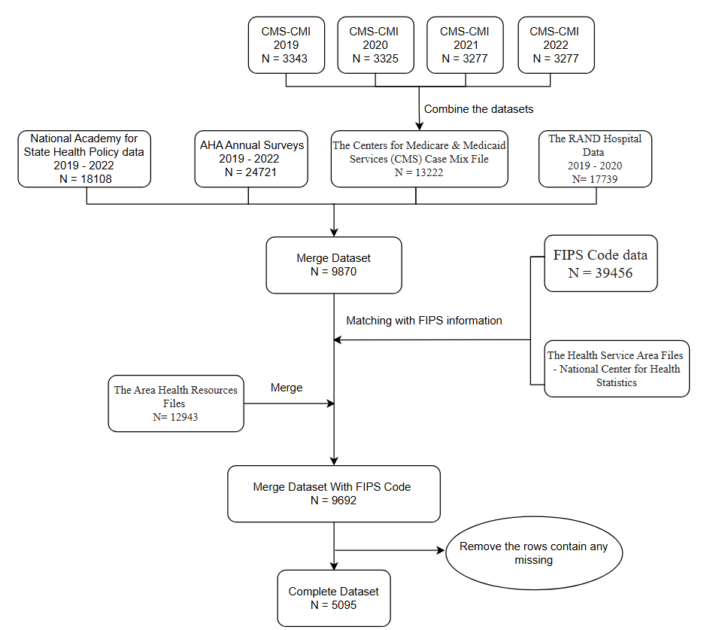

Appendix 2. AHA Definitions of Physician-Hospital Integration (PHI) Models
PHI Model | AHA Definition
Independent Practice Association | “A legal entity that holds managed care contracts, which then contracts with physicians.” (AHA, 2019, p.26).
Group Practice without Walls | “Hospital sponsors the formation of, or provides capital to physicians to establish, a "quasi" group to share administrative expenses while remaining independent practitioners.” (AHA, 2019, p.26).
Open Physician-Hospital Organization | “A joint venture between the hospital and all members of the medical staff who wish to participate,” which “acts as a unified agent.” (AHA, 2019, p.26).
Closed Physician-Hospital Organization | “A PHO that restricts physician membership to those practitioners who meet criteria for cost effectiveness and/or high quality.” (AHA, 2019, p.26).
Management Service Organization | “A corporation, owned by the hospital or a physician/hospital joint venture, that provides management services to one or more medical group practices.” (AHA, 2019, p.26).
Integrated Salary Model | “Physicians are salaried by the hospital or another entity of a health system to provide medical services for primary care and specialty care.” (AHA, 2019, p.26).
Equity Model | “Allows established practitioners to become shareholders in a professional corporation in exchange for tangible and intangible assets of their existing practices.” (AHA, 2019, p.26).
Foundation Model | “A corporation, organized either as a hospital affiliate or subsidiary, which purchases both the tangible and intangible assets of one or more medical group practices. Physicians remain in a separate corporate entity but sign a professional services arrangement with the foundation.” (AHA, 2019, p.26).

Appendix 3. PLS-SEM Individual Predictor Model Results
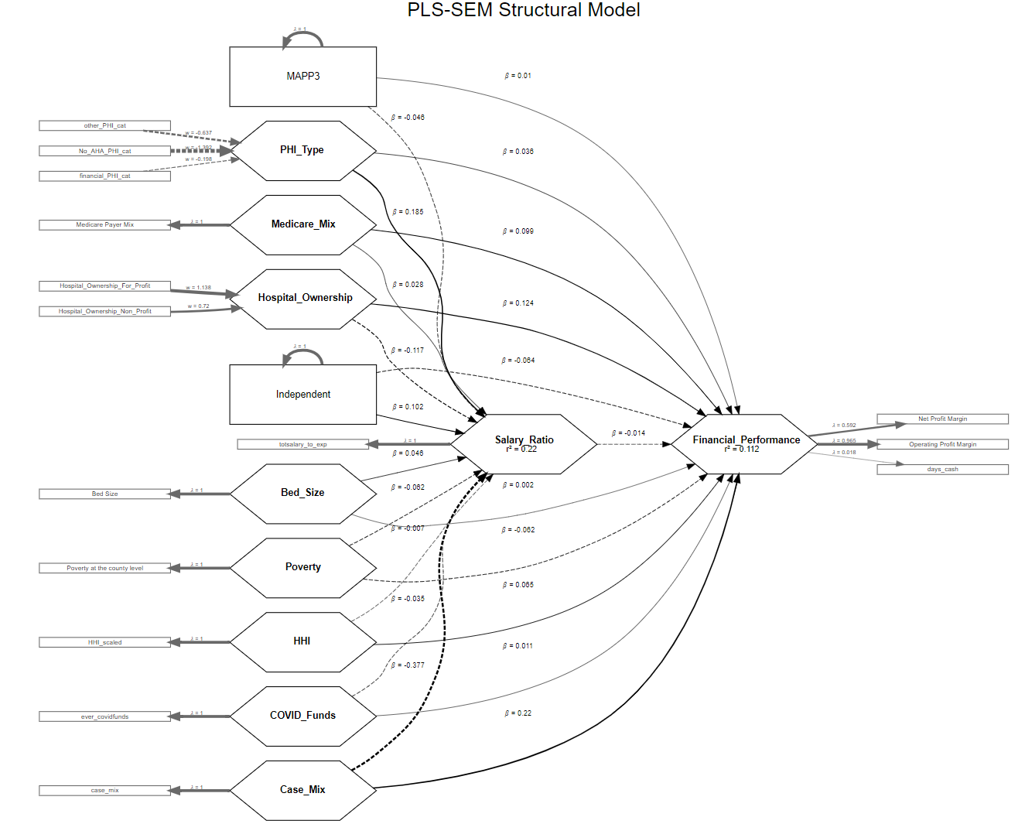
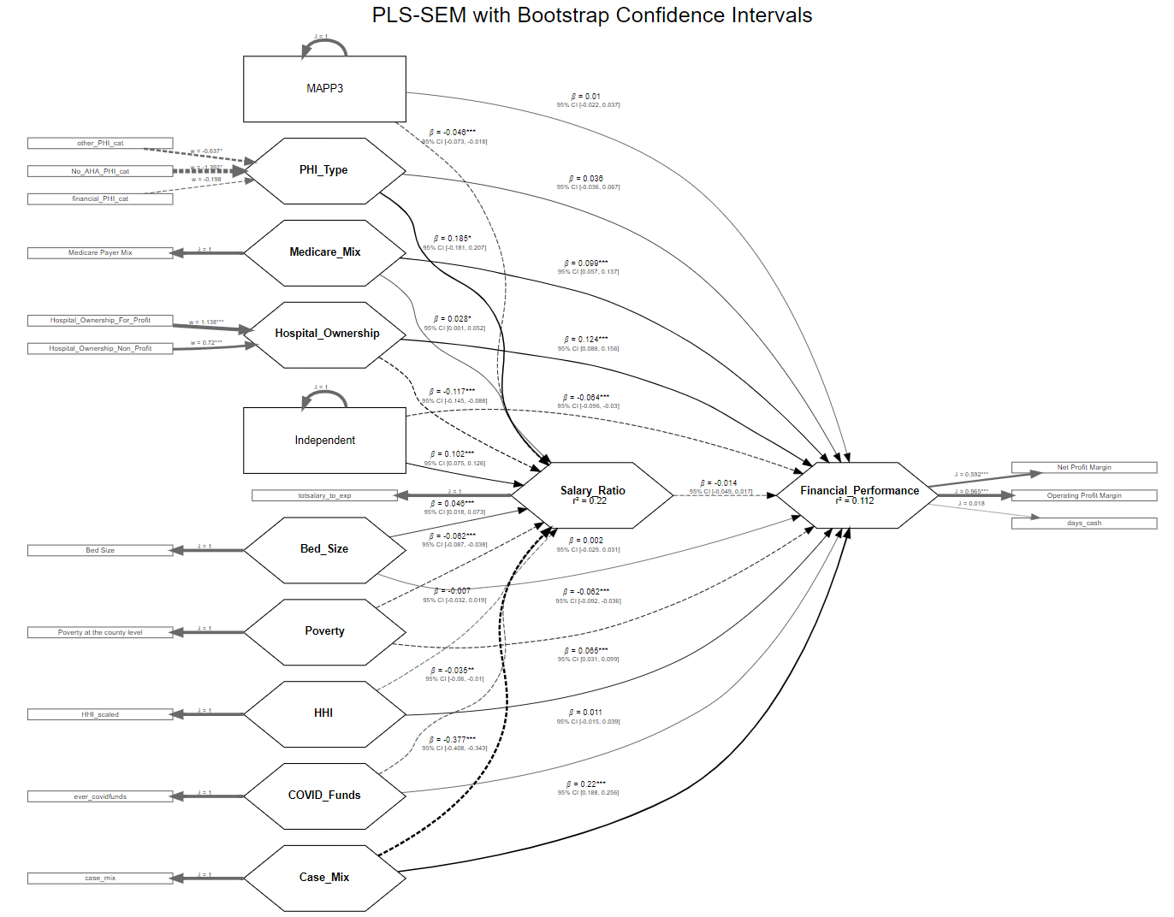

Appendix 4. PLS-SEM Group Predictor Model Results

