Supplementary Information

Title: Urban waste dominates microplastic pollution in Ethiopian irrigated farmlands: Evidence from FTIR spectroscopy, random forest classification, and farmer surveys

Authors:
Daniel Mulugeta^{1,}*, Yordanos Fekede¹, Hagos Tsegaye¹, Abebe Getachew¹

Affiliation:
¹Department of Physics, College of Natural and Computational Sciences, Hawassa University, Hawassa, Ethiopia

*Corresponding author:
Daniel Mulugeta (PhD)
Email: danielm@hu.edu.et
Phone: +251 995953250
ORCID: Daniel Mulugeta: http://orcid.org/0009-0002-2997-811X

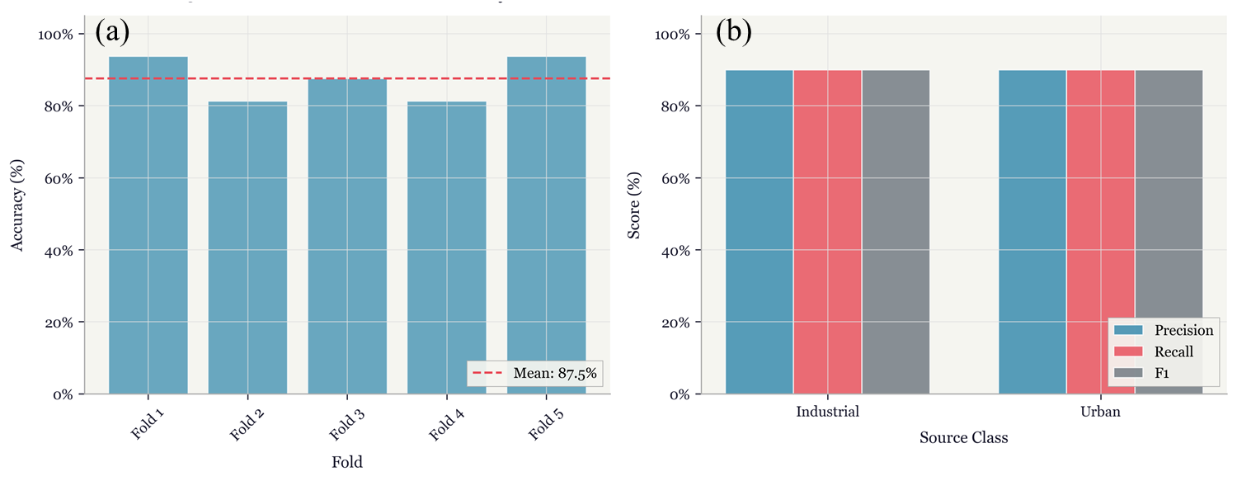
Supplementary Information

Supplementary Fig. S1. Model performance evaluation. (a) Five-fold stratified cross-validation accuracy scores for the RF classifier. Dashed line indicates mean accuracy across folds. (b) Precision, recall, and F1-scores for urban and industrial source classes on held-out test data (n=10 samples, 20% of the reference).

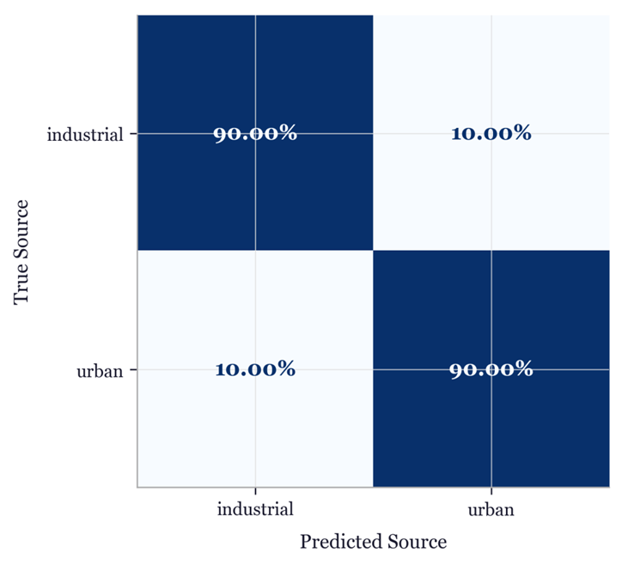

Fig. S2. Normalized confusion matrix for held out test set predictions. Values represent the proportion of correctly and incorrectly classified samples per true class. Diagonal cells (Blue) indicate correct classifications; off diagonal cells indicate misclassifications.

Supplementary Text S1. Survey questioner on MP pollution in irrigated farm lands around Hawassa City, Ethiopia

Survey on Microplastic Pollution in Irrigated Farmlands around Hawassa City, Ethiopia:
Introduction:
This survey aims to evaluate the impact of irrigation practices and urban/industrial waste on MP pollution in irrigated farmlands around Hawassa city, Ethiopia. The study will use FT-IR spectroscopy technique to analyze MPs in water and soil samples. Your responses will help understand farming practices, water quality perceptions, and awareness of MP pollution. Your participation is voluntary, and all answers will remain confidential.
Section 1: Demographic information
- Age:
[ ] below 30
[ ] 30 - 40
[ ] 41 - 50
[ ] 51 - 60
[ ] above 60
- Gender:
[ ] Male
[ ] Female
- Educational Background:
[ ] No formal education
[ ] Primary school
[ ] Secondary school
[ ] Higher education
[ ] Other (Please specify) ___________________________________
Section 2: Land use and farming practices
- How long have you been farming in this area?
[ ] Less than 1 year
[ ] 1 - 5 years
[ ] 6 - 10 years
[ ] 10+ years
- What type of crops do you grow? (Please select all that apply)
[ ] Cereals (eg., maiz, wheat, barley)
[ ] Vegetables (eg., tomatos, onions, cabbage)
[ ] Fruits (eg., mango, papaya, banana)
[ ] Cash crops (eg. Coffee, cotton)
[ ] Others (Please specify) ______________________________________
- What irrigation methods do you use on your farm?
[ ] Surface irrigation (eg., flood, furrow)
[ ] Drip irrigation
[ ] Sprinkler irrigation
[ ] Manual irrigation (eg., watering crops)
[ ] Others (Please specify)
- How frequently do you irrigate your crops?
[ ] Daily
[ ] Every 2 - 3 days
[ ] Weekly
[ ] Other (Please specify) _________________________________
- Where does the water for irrigation come from?
[ ] River or stream
[ ] Nearby lake
[ ] Well or borehole
[ ] Municipal water supply
[ ] Other (Please specify) _________________________________
Section 3: Water quality perception
- How would you rate the quality of the irrigation water you use?
[ ] Very good
[ ] Good
[ ] Fair
[ ] Poor
[ ] Very poor
- Have you noticed any of the following water-related problems in the past year? (Please select all that apply)
[ ] Water discoloration (eg., muddy, cloudy water)
[ ] Unpleasant odor
[ ] Presence of floating debris or particles
[ ] No problems observed
[ ] Other (please specify) ____________________________________
- Have you observed any change in water quality over the past few years?
[ ] Significant improvement
[ ] Some improvement
[ ] No change
[ ] Some decline
[ ] Significance decline
Section 4: Awareness and perception of MP pollution
- Are you aware of the issue of microplastic pollution in water and soil?
[ ] Yes
[ ] No
- Have you ever heard about microplastics being harmful to crop or soil quality?
[ ] Yes
[ ] No
- Do you think urban or industrial waste contributes the pollution of irrigation water in your area?
[ ] Yes
[ ] No
[ ] Not sure
- Have you noticed plastic materials (eg., bags, bottles, small particles) in the water used for irrigation?
[ ] Yes
[ ] No
[ ] Not sure
- In your opinion, how serious is the problem of microplastic pollution for farming in your area?
[ ] Very serious
[ ] Somewhat serious
[ ] Not serious
[ ] Not sure
Section 5: Practices and mitigation measures
- What steps, if any, do you take to mitigate or improve water quality on your farm? (Please select all that apply)
[ ] Regular cleaning of irrigation channels
[ ] Avoiding use of polluted water sources
[ ] No specific measures
[ ] Other (please specify) ___________________________________________
- Would you be interested in learning more about reducing microplastic pollution in irrigation water and soil?
[ ] Yes
[ ] No
- What kind of support or intervention would you suggest to improve water quality and reduce pollution?
[ ] Better waste management system in the area
[ ] Public education on microplastics and pollution
[ ] Apply water filtration or purification systems
[ ] Stricter regulations on industrial and urban waste disposal
[ ] Others (Please specify) ______________________________________
Section 6: Additional comments
- Do you have any additional comments or suggestions related to water quality, microplastic pollution, or farming practices? (Open-ended response)
Conclusion
Thank you for your time and participation in this survey. Your insights will contribute significantly to understanding the impact of MP pollution on irrigated farmlands and help develop strategies to improve water quality in the area and beyond.
Supplementary Table S1. Survey results on demographic information, farming practices, water quality perceptions, and awareness of MP pollution.
Section / Question | Response Options | Frequency (n=20) | Percentage (%)
1. Demographic Information
Age | < 30 | 3 | 15
Age | 30 - 40 | 5 | 25
Age | 41 - 50 | 7 | 35
Age | 51 - 60 | 5 | 25
Age | 60 | 0 | 0
Gender | Male | 16 | 80
Gender | Female | 4 | 20
Educational Background | No formal education | 13 | 65
Educational Background | Primary school | 3 | 15
Educational Background | Secondary school | 1 | 5
Educational Background | Higher education | 3 | 15
Educational Background | Other | 0 | 0
2. Land Use and Farming Practices
Years of farming in the area | < 1 year | 0 | 0
Years of farming in the area | 1 - 5 years | 3 | 15
Years of farming in the area | 6 - 10 years | 9 | 45
Years of farming in the area | 10+ years | 8 | 40
Type of crops grown (multiple answers possible)* | Cereals | 16 | 80
Type of crops grown (multiple answers possible)* | Vegetables | 19 | 95
Type of crops grown (multiple answers possible)* | Fruits | 3 | 15
Type of crops grown (multiple answers possible)* | Cash crops | 2 | 10
Type of crops grown (multiple answers possible)* | Others - herbs | 1 | 5
Irrigation method used (multiple answers possible)* | Surface irrigation | 18 | 90
Irrigation method used (multiple answers possible)* | Drip irrigation | 1 | 5
Irrigation method used (multiple answers possible)* | Sprinkler irrigation | 1 | 5
Irrigation method used (multiple answers possible)* | Manual irrigation | 1 | 5
Irrigation method used (multiple answers possible)* | Others | 0 | 0
Frequency of irrigation | Daily | 0 | 0
Frequency of irrigation | Every 2-3 days | 11 | 55
Frequency of irrigation | Weekly | 9 | 45
Frequency of irrigation | Other | 0 | 0
Source of irrigation water | River or stream | 6 | 30
 | Nearby lake | 8 | 40
 | Well or borehole | 6 | 30
 | Municipal water supply | 0 | 0
 | Other | 0 | 0
3. Water Quality Perception
Rating of irrigation water quality | Very good | 1 | 5
Rating of irrigation water quality | Good | 7 | 35
Rating of irrigation water quality | Fair | 11 | 55
Rating of irrigation water quality | Poor | 1 | 5
Rating of irrigation water quality | Very poor | 0 | 0
Observed water problems (multiple answers possible)* | Discoloration | 2 | 10
Observed water problems (multiple answers possible)* | Unpleasant odor | 1 | 5
Observed water problems (multiple answers possible)* | Floating debris | 14 | 70
Observed water problems (multiple answers possible)* | No problems observed | 6 | 30
Observed water problems (multiple answers possible)* | Other | 0
Perceived change in water quality | Significant improvement | 0 | 0
Perceived change in water quality | Some improvement | 1 | 5
Perceived change in water quality | No change | 14 | 70
Perceived change in water quality | Some decline | 4 | 20
Perceived change in water quality | Significant decline | 1 | 5
4. Awareness & Perception of MP Pollution
Aware of microplastic pollution issue | Yes | 3 | 15
Aware of microplastic pollution issue | No | 17 | 85
Aware of microplastics' harm to crops/soil | Yes | 1 | 5
Aware of microplastics' harm to crops/soil | No | 19 | 95
Think urban/industrial waste contributes to pollution | Yes | 8 | 40
Think urban/industrial waste contributes to pollution | No | 5 | 25
Think urban/industrial waste contributes to pollution | Not sure | 7 | 35
Noticed plastic materials in irrigation water | Yes | 13 | 65
Noticed plastic materials in irrigation water | No | 7 | 35
Noticed plastic materials in irrigation water | Not sure | 0 | 0
Opinion on seriousness of MP pollution for farming | Very serious | 0 | 0
Opinion on seriousness of MP pollution for farming | Somewhat serious | 7 | 35
Opinion on seriousness of MP pollution for farming | Not serious | 8 | 40
Opinion on seriousness of MP pollution for farming | Not sure | 5 | 25
5. Practices and Mitigation Measures
What steps, if any, do you take to mitigate or improve water quality on your farm? (Please select all that apply)* | Cleaning irrigation channels | 0 | 0
 | Avoiding polluted water sources | 0 | 0
 | No specific measures | 19 | 95
 | Other: water filtration | 1 | 5
Would you be interested in learning more about reducing microplastic pollution in irrigation water and soil? | Yes | 20 | 100
 | No | 0 | 0
Suggested support/intervention (multiple answers possible)* | Better waste management | 11 | 55
Suggested support/intervention (multiple answers possible)* | Public education | 3 | 15
Suggested support/intervention (multiple answers possible)* | Water filtration systems | 2 | 10
Suggested support/intervention (multiple answers possible)* | Stricter regulations | 4 | 20
Suggested support/intervention (multiple answers possible)* | Others | 0 | 0
6. Additional comments (Open-ended)
Do you have any additional comments or suggestions related to water quality, microplastic pollution, or farming practices? | No open-ended response
*For questions where multiple responses were possible, the percentages reflect the proportion of respondents who selected each option and may not necessarily sum up to 100%.

