SUPPLEMENTARY DATA
Table S1 Distribution of the samples per department of birth of the maternal grandmothers.
Numbers are given after individual quality control (QC) of the sequence data
Table S2 Number of SNVs and INDELs detected in the FGR panel, aligned on GRCh38

Table S3 Number of Structural Variants (SVs) detected in the FGR panel, aligned on GRCh38

Figure S1 Geographic location of the different departments of the maternal grandmother birthplaces

Figure S2 Minimum and Maximum distances (in kilometers) between the 4 grand-parents (GP) in the different regions.

Figure S3 Number of autosomal SVs per individual genome according to geographic origin. Colors indicate the decile to which each individual belongs, for both the total number of variants (A) and the number of variants absent from gnomAD v2.1 (B). Decile boundaries are provided in the legend. Each individual is mapped within France based on the mean longitude and latitude of their four grandparents’ birthplaces. Department-level details are shown in (C), with the total number of variants in the upper panel and the number of novel variants in the lower panel. The department corresponds to the birthplace of the maternal grandmother, and cohort membership is indicated by distinct colors.

Figure S4 Site Frequency Spectra for SNVs/INDELs and for SVs.

Figure S5 Detection of two common SVs, which are not reported in gnomAD.

Figure S6 Manhattan plots for the association of common variants with latitude and longitude.

The FranceGenRef Consortium

REGION |  |  | DEPARTEMENT |  |  | ALL |  |  |  | PER COLLECTION
 |  |  |  |  |  |  |  |  |  | GAZEL |  |  |  |  | PREGO |  |  |  |  |  |  |  | FINISTERE
NAME | CODE |  | NUM | NAME |  | TOTAL | Female | Male |  | TOTAL | F |  | M |  | TOTAL |  | F | M |  |  |  | TOTAL |  |  | F |  | M
Bretagne | BRI |  | 22 | Côtes d'Armor |  | 70 | 28 | 42 |  | 31 | 9 | 22 |  |  | 39 | 19 |  |  | 20
Bretagne |  |  | 29 | Finistère |  | 107 | 33 | 74 |  | 59 | 9 | 50 |  |  | 0 | 0 |  |  | 0 |  |  |  | 48 | 24 |  | 24
Bretagne |  |  | 35 | Ile et Vilaine |  | 63 | 23 | 40 |  | 23 | 3 | 20 |  |  | 40 | 20 |  |  | 20
Bretagne |  |  | 56 | Morbihan |  | 82 | 32 | 50 |  | 30 | 7 | 23 |  |  | 52 | 25 |  |  | 27
Centre Val de Loire | CEN |  | 18 | Cher |  | 1 | 0 | 1 |  | 1 | 0 | 1
Centre Val de Loire |  |  | 28 | Eure et Loir |  | 3 | 0 | 3 |  | 3 | 0 | 3
Centre Val de Loire |  |  | 36 | Indre |  | 7 | 2 | 5 |  | 7 | 2 | 5
Centre Val de Loire |  |  | 37 | Indre et Loire |  | 6 | 1 | 5 |  | 6 | 1 | 5
Centre Val de Loire |  |  | 41 | Loir et Cher |  | 7 | 1 | 6 |  | 7 | 1 | 6
Centre Val de Loire |  |  | 45 | Loiret |  | 5 | 0 | 5 |  | 5 | 0 | 5
Grand Est | GRA |  | 51 | Marne |  | 7 | 1 | 6 |  | 7 | 1 | 6
Grand Est |  |  | 54 | Meurthe et Moselle |  | 12 | 0 | 12 |  | 12 | 0 | 12
Grand Est |  |  | 57 | Moselle |  | 9 | 0 | 9 |  | 9 | 0 | 9
Grand Est |  |  | 67 | Bas Rhin |  | 4 | 0 | 4 |  | 4 | 0 | 4
Grand Est |  |  | 68 | Haut Rhin |  | 10 | 2 | 8 |  | 10 | 2 | 8
Grand Est |  |  | 88 | Vosges |  | 7 | 1 | 6 |  | 7 | 1 | 6
Hauts de France | HAU |  | 2 | Aisne |  | 2 | 0 | 2 |  | 2 | 0 | 2
Hauts de France |  |  | 59 | Nord |  | 45 | 2 | 43 |  | 45 | 2 | 43
Hauts de France |  |  | 62 | Pas de Calais |  | 33 | 4 | 29 |  | 33 | 4 | 29
Hauts de France |  |  | 80 | Somme |  | 6 | 1 | 5 |  | 6 | 1 | 5
Normandie | NOR |  | 50 | Manche |  | 9 | 1 | 8 |  | 8 | 1 | 7 |  |  | 1 | 0 |  |  | 1
Normandie |  |  | 76 | Seine Maritime |  | 10 | 5 | 5 |  | 10 | 5 | 5
Nouvelle Aquitaine | NOU |  | 16 | Charente |  | 4 | 0 | 4 |  | 4 | 0 | 4
Nouvelle Aquitaine |  |  | 17 | Charente Maritime |  | 2 | 0 | 2 |  | 2 | 0 | 2
Nouvelle Aquitaine |  |  | 19 | Corrèze |  | 12 | 4 | 8 |  | 12 | 4 | 8
Nouvelle Aquitaine |  |  | 23 | Creuse |  | 3 | 0 | 3 |  | 3 | 0 | 3
Nouvelle Aquitaine |  |  | 24 | Dordogne |  | 1 | 0 | 1 |  | 1 | 0 | 1
Nouvelle Aquitaine |  |  | 79 | Deux Sèvres |  | 7 | 3 | 4 |  | 6 | 2 | 4 |  |  | 1 | 1 |  |  | 0
Nouvelle Aquitaine |  |  | 86 | Vienne |  | 9 | 1 | 8 |  | 9 | 1 | 8
Nouvelle Aquitaine |  |  | 87 | Haute Vienne |  | 9 | 2 | 7 |  | 9 | 2 | 7
Pays de la Loire | PAY |  | 44 | Loire Atlantique |  | 88 | 34 | 54 |  | 34 | 7 | 27 |  |  | 54 | 27 |  |  | 27
Pays de la Loire |  |  | 49 | Maine et Loire |  | 68 | 26 | 42 |  | 20 | 2 | 18 |  |  | 48 | 24 |  |  | 24
Pays de la Loire |  |  | 53 | Mayenne |  | 46 | 21 | 25 |  | 4 | 2 | 2 |  |  | 42 | 19 |  |  | 23
Pays de la Loire |  |  | 72 | Sarthe |  | 25 | 14 | 11 |  | 1 | 0 | 1 |  |  | 24 | 14 |  |  | 10
Pays de la Loire |  |  | 85 | Vendée |  | 70 | 29 | 41 |  | 19 | 3 | 16 |  |  | 51 | 26 |  |  | 25
Other | OTH |  | 15 | Cantal |  | 2 | 0 | 2 |  | 2 | 0 | 2
Other |  |  | 46 | Lot |  | 1 | 0 | 1 |  | 1 | 0 | 1
Other |  |  | 90 | Territoire de Belfort |  | 1 | 0 | 1 |  | 1 | 0 | 1
Other |  |  | NA | NA |  | 3 | 0 | 3 |  | 3 | 0 | 3
 |  |  |  | TOTAL |  | 856 | 271 | 585 |  | 456 | 72 | 384 |  |  | 352 | 175 |  |  | 177 |  |  |  | 48 | 24 |  | 24
Table S1 Distribution of the samples per department of birth of the maternal grandmothers.
Numbers are given after individual QC of the sequence data.

 |  | Total |  |  |  |  | SNVs |  |  |  |  | INDELs
 |  | Autosomes | X | Y |  | Autosomes |  | X | Y |  |  |  | Autosomes | X | Y
QC PASS GnomAD covered regions - Refset
A -overall number of variants | N | 29 663 021 | 711 289 | 7 893 |  | 26 899 782 |  | 619 393 | 2 639 |  |  |  | 2 763 239 | 91 896 | 5 254
B - number of variants per individual | Average | 3 313 183 | 77 005 | 298 |  | 3 020 557 |  | 69 796 | 216 |  |  |  | 292 627 | 7 209 | 82
 | Minimum | 3 163 832 | 62 556 | 23 |  | 2 883 765 |  | 56 592 | 5 |  |  |  | 280 067 | 5 897 | 13
 | Maximum | 3 347 319 | 101 601 | 986 |  | 3 051 371 |  | 92 233 | 770 |  |  |  | 296 949 | 9 439 | 217
C - number of alleles per individual | Average | 4 525 498 | 133 023 | 508 |  | 4 127 955 |  | 120 632 | 364 |  |  |  | 397 543 | 12 391 | 144
 | Minimum | 4 471 877 | 123 046 | 37 |  | 4 079 422 |  | 111 413 | 8 |  |  |  | 390 962 | 11 480 | 24
 | Maximum | 4 571 175 | 142 206 | 1 751 |  | 4 169 691 |  | 128 911 | 1 365 |  |  |  | 401 853 | 13 297 | 403
Refset absent from gnomAD4.1 exome & genomes
A -overall number of variants | N | 4 586 857 | 89 280 | 3 988 |  | 4 193 533 |  | 76 277 | 1 050 |  |  |  | 393 324 | 13 003 | 2 938
B - number of variants per individual | Average | 5 559 | 110 | 51 |  | 5 079 |  | 94 | 29 |  |  |  | 480 | 16 | 22
 | Minimum | 4 383 | 6 | 4 |  | 3 988 |  | 1 | 0 |  |  |  | 363 | 3 | 0
 | Maximum | 6 307 | 393 | 169 |  | 5 773 |  | 367 | 112 |  |  |  | 596 | 43 | 62
Refset - absent from gnomAD4.1 exome & genomes and annotated as “no existing variation” by VEP v113
A -overall number of variants | N | 3 346 545 | 67 172 | 2 841 |  | 3 030 533 |  | 56 719 | 534 |  |  |  | 316 012 | 10 453 | 2 307
B - number of variants per individual | Average | 4 028 | 82 | 8 |  | 3 646 |  | 70 | 1 |  |  |  | 383 | 13 | 7
 | Minimum | 2 818 | 4 | 0 |  | 2 532 |  | 1 | 0 |  |  |  | 280 | 2 | 0
 | Maximum | 4 613 | 303 | 28 |  | 4 189 |  | 279 | 7 |  |  |  | 492 | 36 | 24
Table S2 Number of SNVs and INDELs detected in the FGR panel, aligned on GRCh38.

 |  | Total |  |  |  | DUP | DEL | INS |  | INV
 |  | Autosomes | X | Y |  | Autosomes | Autosomes | Autosomes |  | Autosomes
All SV |  | 94 665 | 3 868 | 258 |  | 10 313 | 50 845 | 30 828 |  | 2 679
QC1: FILTER=PASS |  | 34 372 | 1 140 | 32 |  | 4 280 | 21 495 | 8 031 |  | 566
QC2: < 10% missing |  | 44 821 | 1 447 | 7 |  | 5 617 | 26 678 | 10 297 |  | 2 229
QC3 : gnomAD covered |  | 92 590 | 3 805 | 258 |  | 9 867 | 49 521 | 30 575 |  | 2 627
QC1 + QC2 + QC3 (RefSet)
A -overall number of variants | N | 25 226 | 650 | 1 |  | 2 796 | 16 931 | 4 999 |  | 500
B - number of variants per individual | Average | 3 021 |  |  |  | 44 | 1 946 | 994 |  | 37
 | Minimum | 2 771 |  |  |  | 21 | 1 836 | 821 |  | 26
 | Maximum | 3 158 |  |  |  | 60 | 2 049 | 1 092 |  | 50
RefSet SVs absent from gnomAD genomes
A -overall number of variants | N | 8 247 | 211 | 1 |  | 1 193 | 5 723 | 855 |  | 476
B - number of variants per individual | Average | 507 |  |  |  | 15 | 365 | 91 |  | 34
 | Minimum | 453 |  |  |  | 5 | 321 | 58 |  | 24
 | Maximum | 553 |  |  |  | 27 | 410 | 117 |  | 47

Table S3 Number of Structural Variants (SVs) detected in the FGR panel, aligned on GRCh38, at the different QC steps.

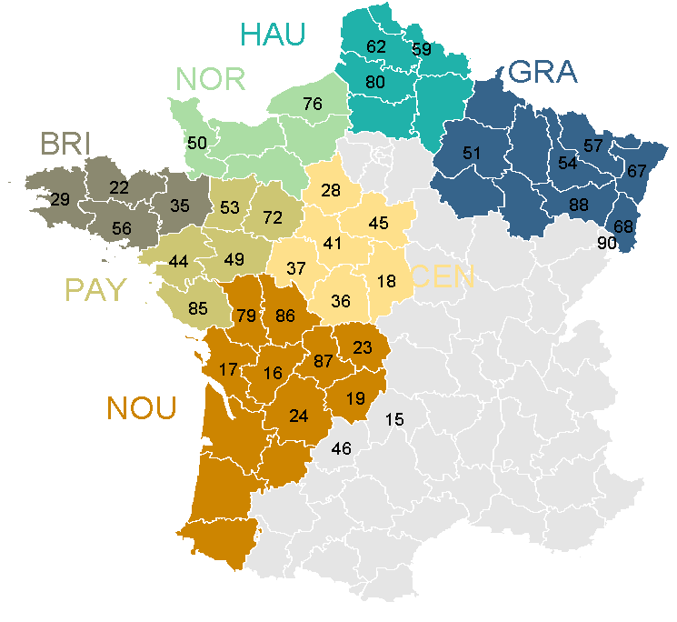

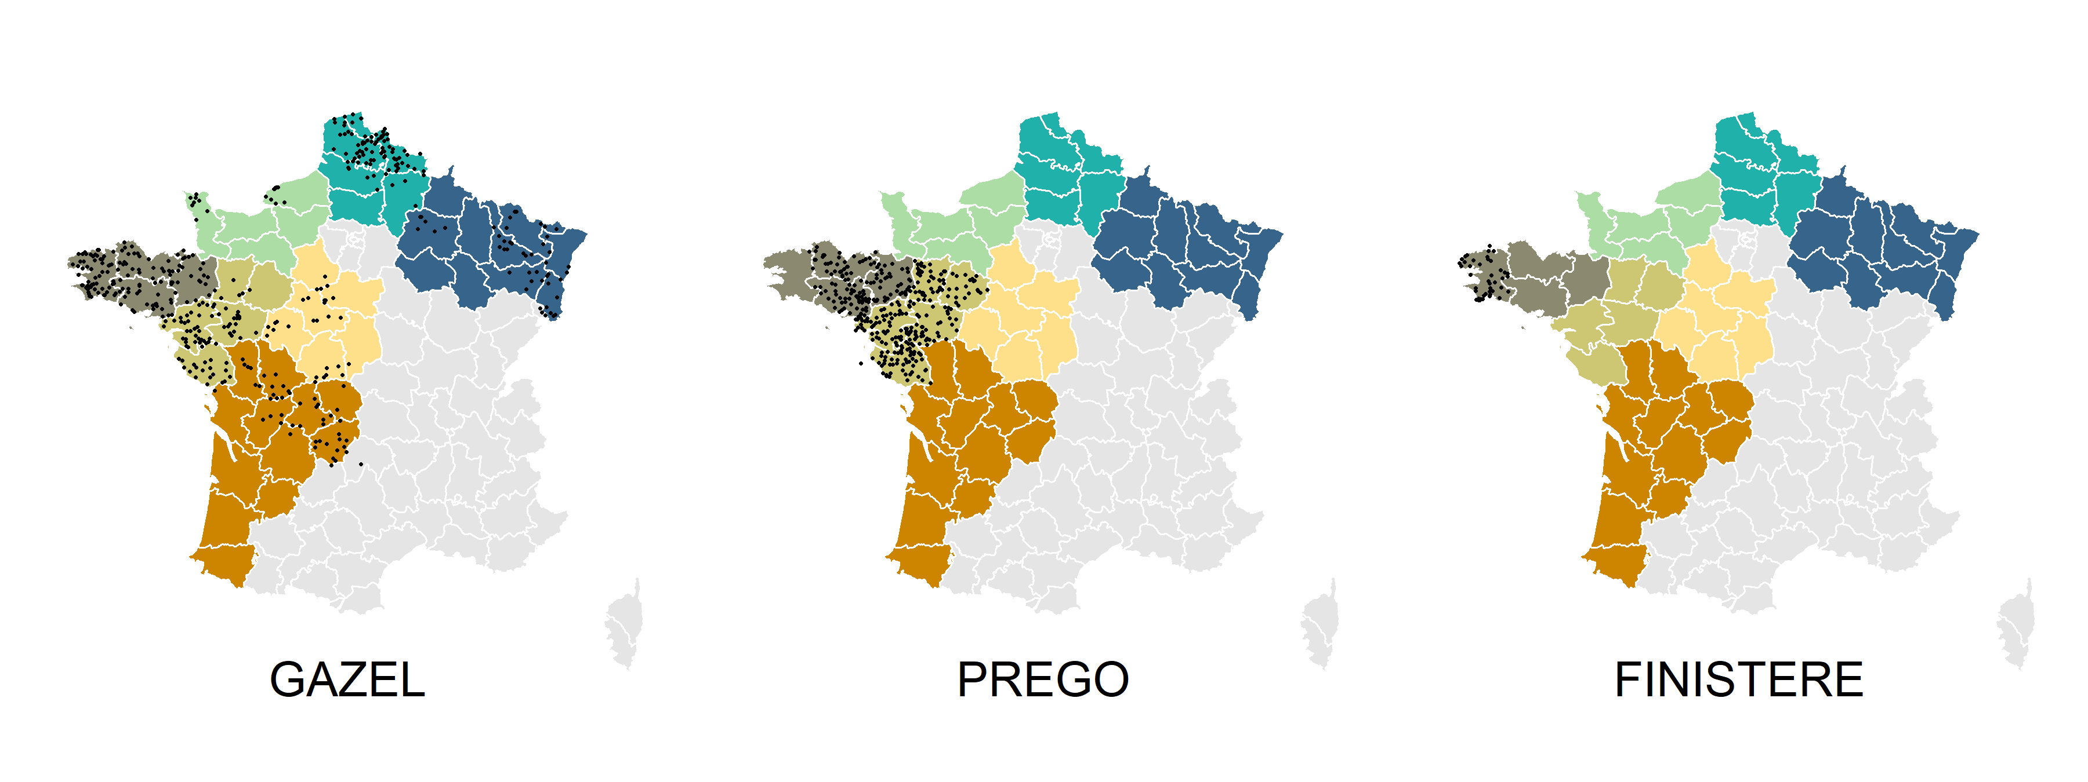

Figure S1 Geographic location of the different departments of the maternal grandmother birthplaces (department numbers are indicated only for the departments with available data) (top panel) and of the sampled individuals in the different collections (average coordinates of the four grandparent birthplaces) (bottom panel). Regions are colored as in Table S1 and their 3-letter code is indicated.

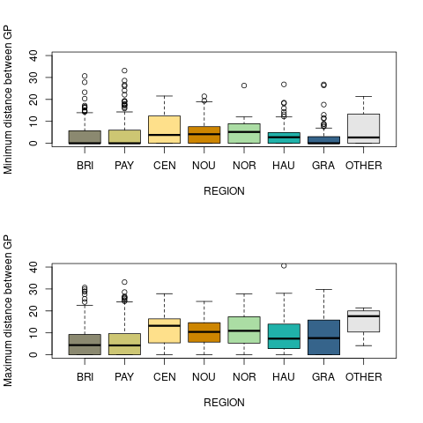
Figure S2 Minimum and Maximum distances (in kilometers) between the 4 grand-parents (GP) in the different regions.

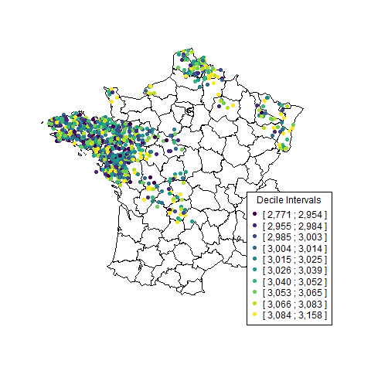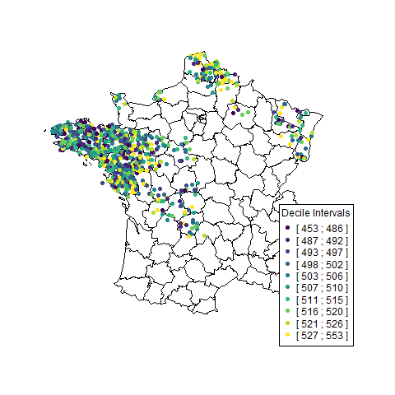
B
A
C
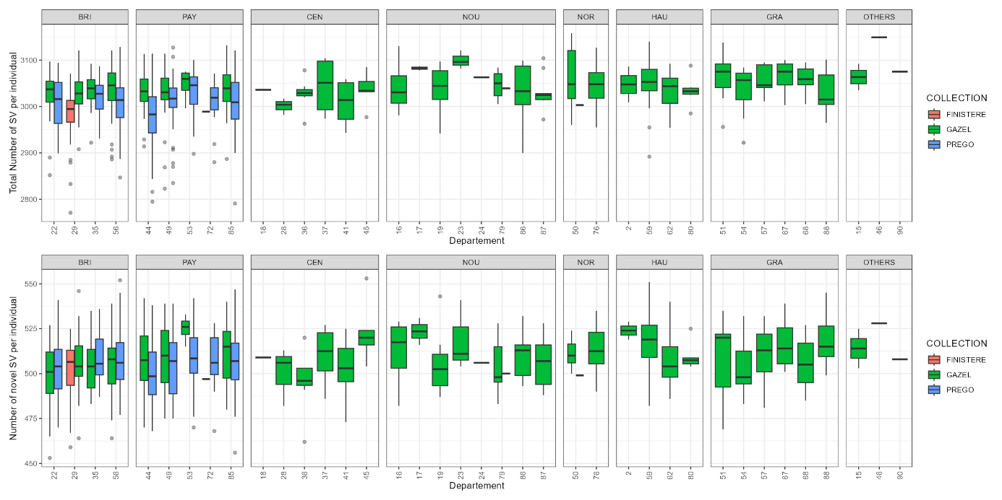
Figure S3 Number of autosomal Structural Variants (SVs) per individual genome according to geographic origin. Colors indicate the decile to which each individual belongs, for both the total number of variants (A) and the number of variants absent from gnomAD v4.1 (B). Decile boundaries are provided in the legend. Each individual is mapped within France based on the mean longitude and latitude of their four grandparents’ birthplaces. Department-level details are shown in (C), with the total number of variants in the upper panel and the number of variants absent from gnomAD in the lower panel. The department corresponds to the birthplace of the maternal grandmother, and cohort membership is indicated by distinct colors.

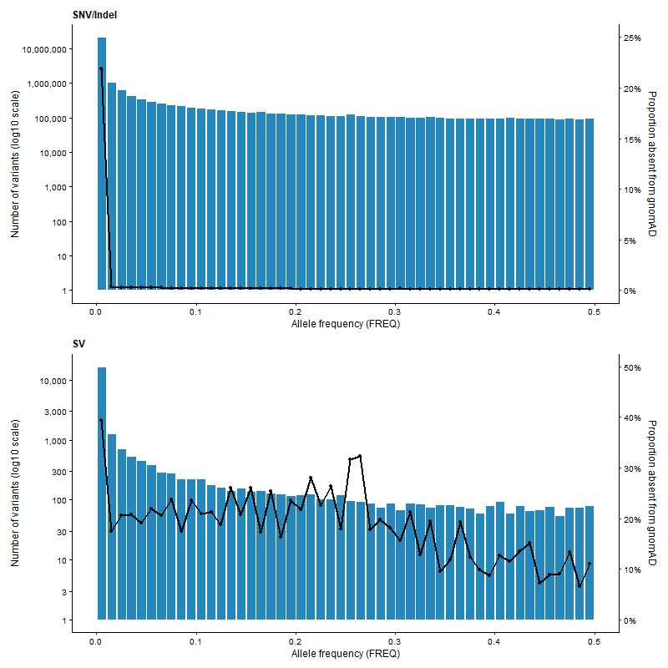

Figure S4 Number of variants (log10 scale – left axis) and proportion absent from gnomAD4.1 (right axis) in each allele frequency bin for SNVs/INDELs (top) and for SVs (bottom)

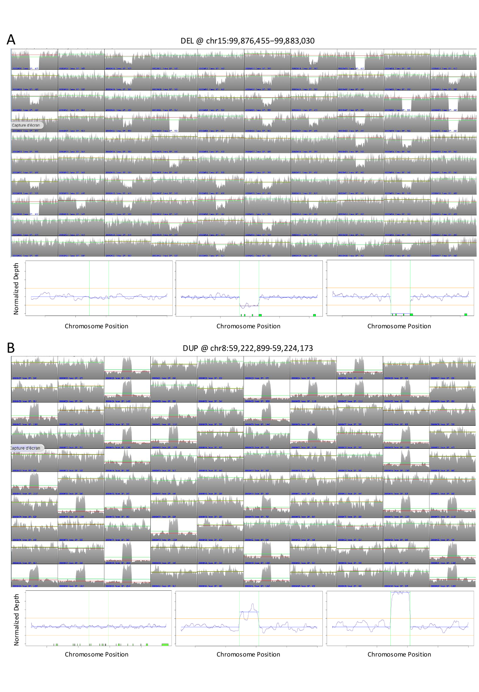

Figure S5 Detection of two common SVs not reported in gnomAD.
Top panels (A, B): random selection of 100 individual coverage-depth profiles indicating the detection of one common deletion on chromosome 15 (frequency 0.23 in FGR) (A) and one common duplication on chromosome 8 (frequency 0.35 in FGR)(B). Bottom panels (A, B): three individual coverage depth profiles corresponding to the absence (left), presence at the heterozygous state (center), and presence at the homozygous state (right) of the deletion (A) or duplication (B).
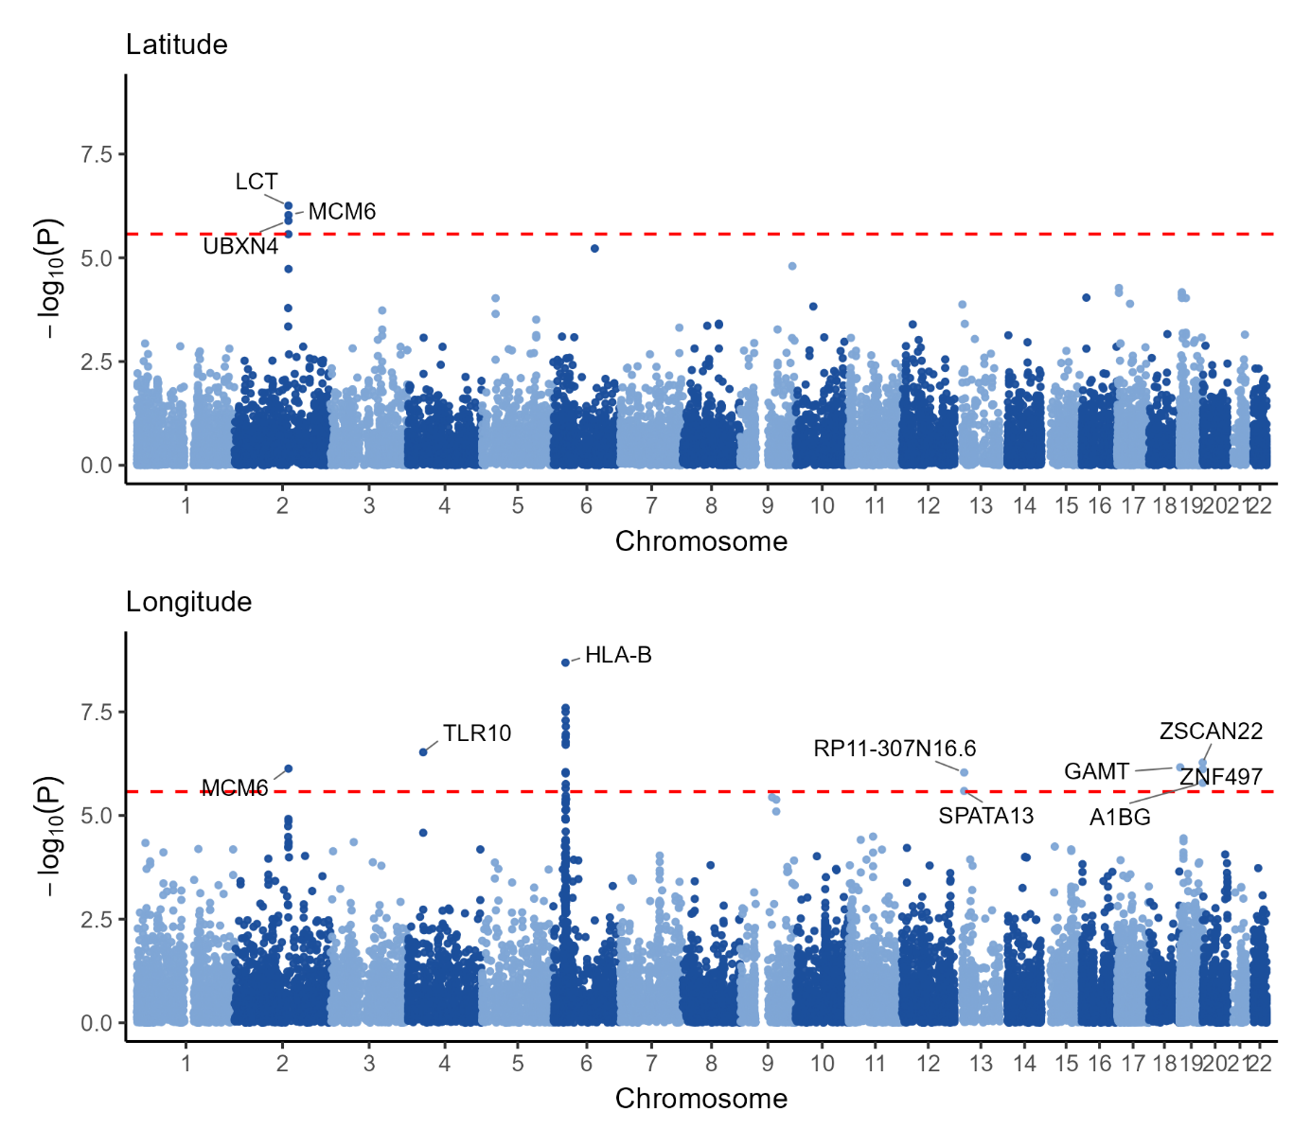

Figure S6 MAGMA Gene-based association study for common variants with latitude (left) and longitude (right).

The FranceGenRef Consortium

Principal Investigators
Jean-François Deleuze^{1,6}, deleuze@cnrgh.fr
Emmanuelle Génin^{2,7}, emmanuelle.genin@inserm.fr
Richard Redon³, richard.redon@univ-nantes.fr

Collaborators
Data collection: Chantal Adjou⁴, Stéphanie Chatel³, Claude Férec², Marcel Goldberg⁵, Philippe-Antoine Halbout⁴, Hervé Le Marec³, David L’Helgouach⁴, Karen Rouault^{2,7}, Jean-Jacques Schott³, Anne Vogelsperger⁴, Marie Zins⁵
Sequencing: Delphine Bacq¹, Céline Besse¹, Hélène Blanche⁶, Robert Olaso, ¹
Bioinformatics: Eric Charpentier³, Véronique Geoffroy², Pierre Lindenbaum³, Thomas Ludwig^{2,7}, Florian Sandron¹, Damien Delafoy¹, Nicolas Wiart¹, Pierrick Roger¹, Vincent Meyer¹, , Lourdes Velo Suarez²
Statistical Genetics: Isabel Alves³, Christian Dina³, Marc Gros La Faige², Maël Guivarch², Anthony Herzig², Matilde Karakachoff³, Gaëlle Marenne², Aude Saint Pierre², Claire Dandine-Roulland¹, Edith Lefloch¹

¹ Université Paris-Saclay, CEA, Centre National de Recherche en Génomique Humaine (CNRGH), Evry, France
² Univ Brest, Inserm, EFS, UMR 1078, GGB, Brest, France
³ Nantes Université, CHU Nantes, CNRS, Inserm, l’institut du thorax, F-44000 Nantes, France.
⁴ Etablissement Français du Sang
⁵ Université Paris Cité, Université Paris-Saclay, UVSQ, Inserm, Epidemiological Population Cohorts Unit (UMS11), Villejuif, France
⁶ Fondation Jean Dausset, CEPH, Paris, France
⁷ CHU Brest, France

