Variable | Category | Frequency  (n) | Percentage  (%) | Mean ± SD
Sex | Male | 48 | 60.0 | –
 | Female | 32 | 40.0 | –
Age (years) | – | – | – | 36.5 ±7.9
Professional Cadre | Theatre Nurse | 41 | 51.2 | –
 | Anaesthetist | 22 | 27.5 | –
 | Surgeon | 13 | 16.3 | –
 | Support Staff | 4 | 5.0 | –
Years of Experience in OR | <1 year | 9 | 11.3 | –
 | 1–5 years | 33 | 41.3 | –
 | 6–10 years | 24 | 30.0 | –
 | >10 years | 14 | 17.5 | –
Post-college Training in Sterile Techniques | Received post-college training | 23 | 28.7 | –
 | No post-college training | 57 | 71.3 | –
Detailed summary of the patients’ sociodemographic characteristics.

presents Institutional support for sterile practice at the facility
Criterion | Frequency (N) | Percentage (%)
Does your institution provide continuous training in sterile techniques?
Yes | 35 | 43.8%
Not sure | 10 | 12.5%
No | 35 | 43.8%
Does the management support strict adherence to sterile policies?
Yes | 59 | 73.8%
Not sure | 5 | 6.3%
No | 16 | 20.0%
Are adequate sterile supplies (gowns, gloves, drapes) always available in your theatre?
Yes | 43 | 53.8%
Sometimes | 13 | 16.3%
No | 24 | 30.0%

Frequency of knowledge levels of sterile techniques among the intraoperative staff
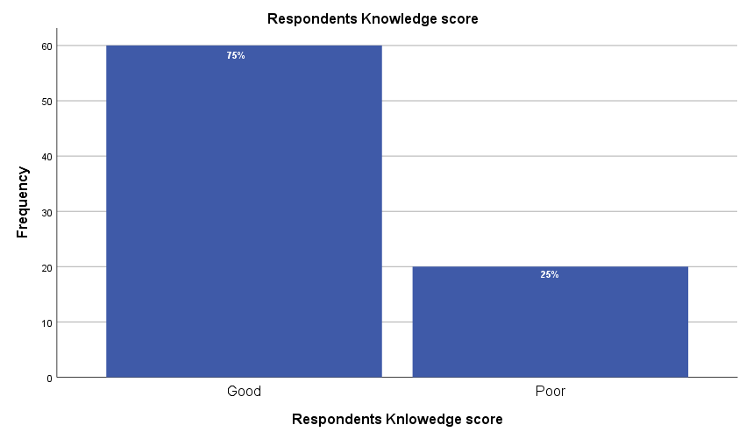

Frequency of attitude levels of sterile techniques among the intraoperative staff
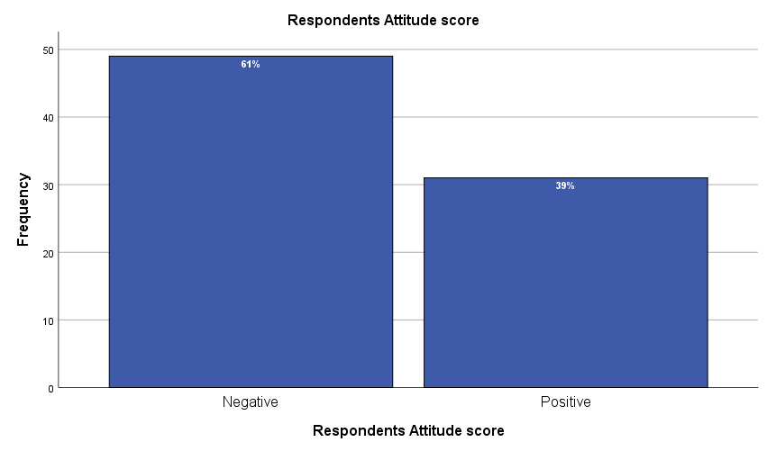

Frequency of perceived practice levels of sterile techniques among the intraoperative staff

