Supplementary Figures 1 ROI delineation on CT images and fECV calculation in a typical case of colon cancer with lymph node metastasis.

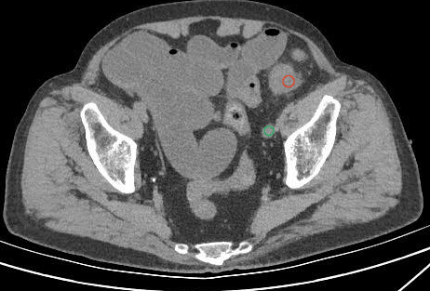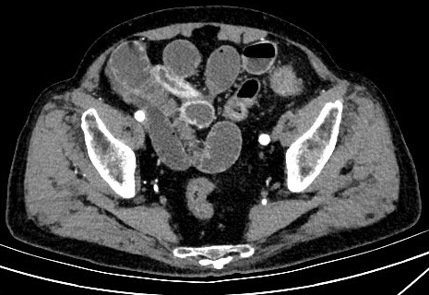
A B

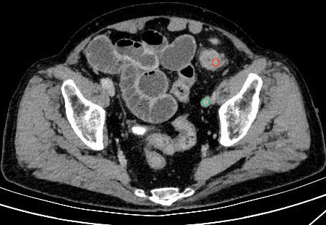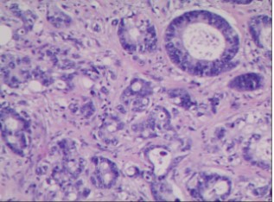
C D
A male patient aged 85 years with a hematocrit of 0.476. A. Conventional unenhanced CT image of the lesion; B. Conventional arterial-phase CT image of the lesion; C. Conventional delayed-phase CT image of the lesion. The red and green regions represent the regions of interest (ROIs) of the lesion and the aorta, respectively. The CT values of the red and green ROIs on unenhanced CT were 38 HU and 47 HU, respectively; the corresponding values on delayed-phase CT were 81 HU and 108 HU, respectively. The fECV of the lesion ROI was calculated as 36.94. D. Postoperative pathological diagnosis: colon cancer with lymph node metastasis.

Supplementary Figures 2 ROI delineation on CT images and fECV calculation in a typical case of colon cancer without lymph node metastasis.
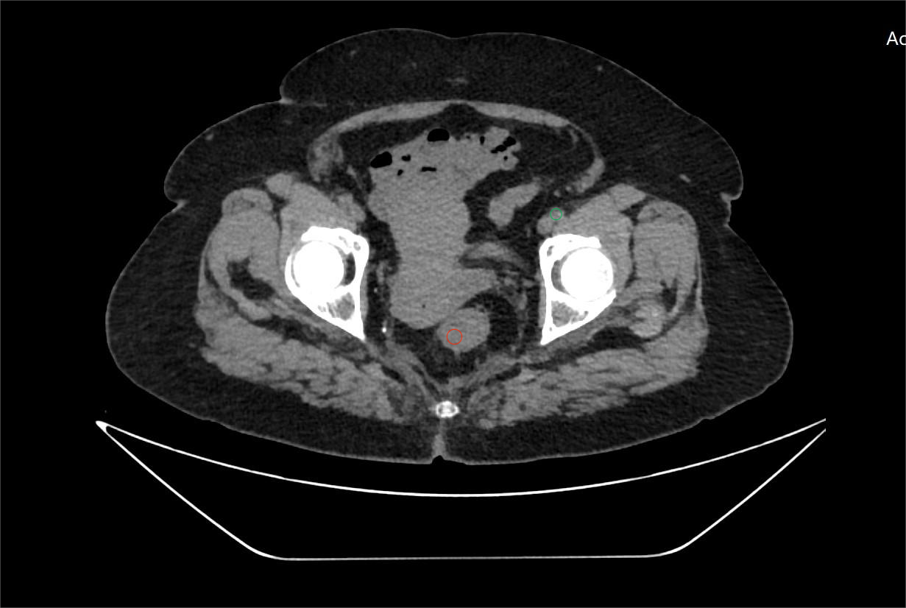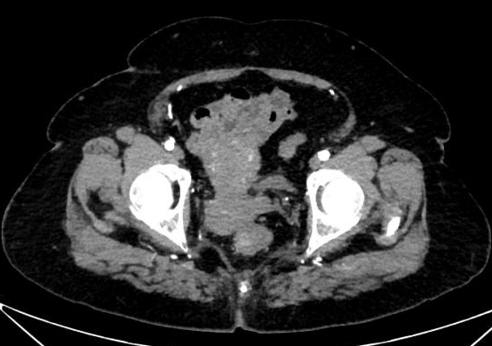
A B

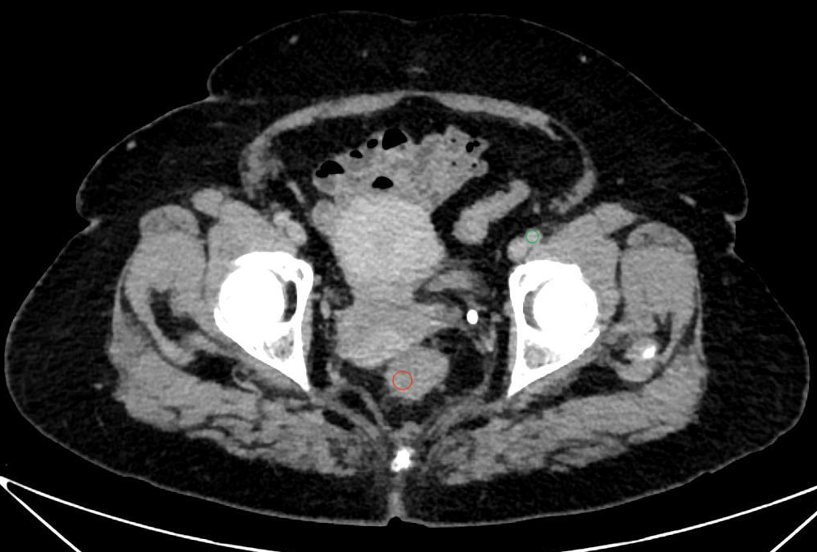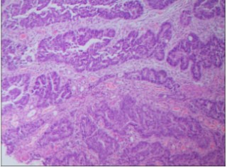
C D
A male patient aged 76 years with a hematocrit of 0.376. A. Conventional unenhanced CT image of the lesion; B. Conventional arterial-phase CT image of the lesion; C. Conventional delayed-phase CT image of the lesion. The red and green regions represent the regions of interest (ROIs) of the lesion and the aorta, respectively. The CT values of the red and green ROIs on unenhanced CT were 35 HU and 41 HU, respectively; the corresponding values on delayed-phase CT were 64 HU and 100 HU, respectively. The fECV of the lesion ROI was calculated as 30.67. D. Postoperative pathological diagnosis: colon cancer without lymph node metastasis.

