Supplementary Material

Movement Patterns and Habitat Use of Adult Giant Trevally (Caranx ignobilis) in the South China Sea
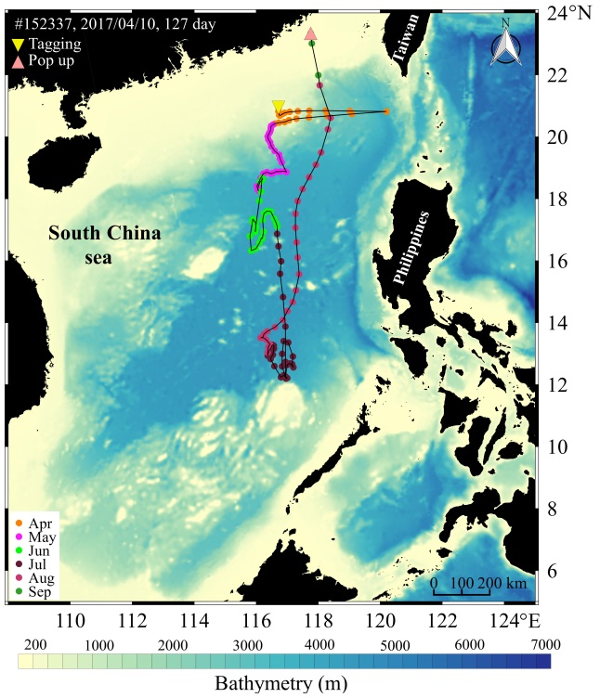
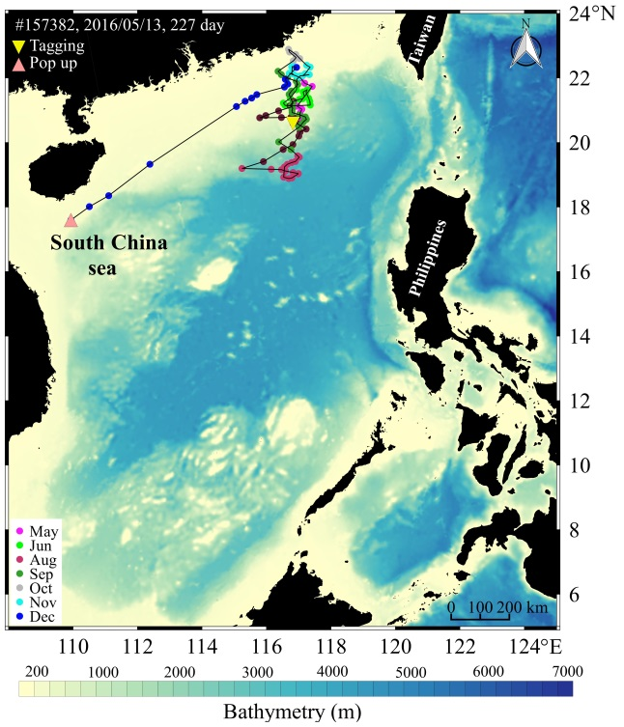
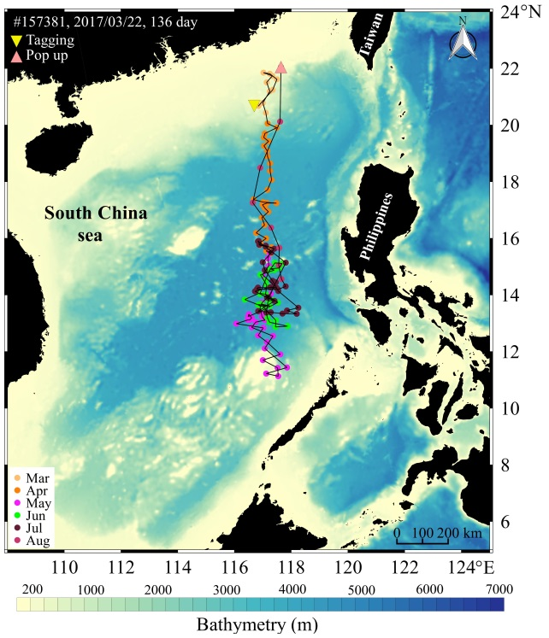
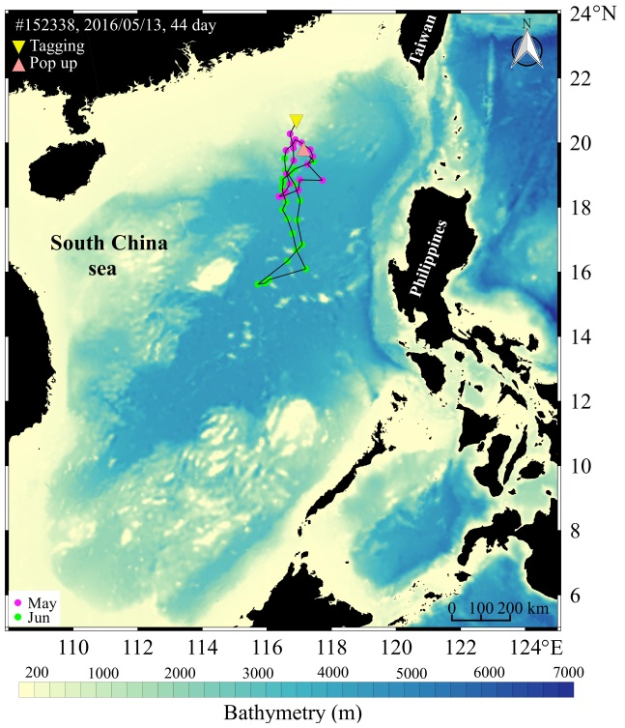
Fig. S1-1 Map of PSAT deployments on giant trevally (orange inverted triangles). Most probable track (circles and line) where colour indicates month and pop-up location (pink triangles).
(D)
(C)
(B)
(A)

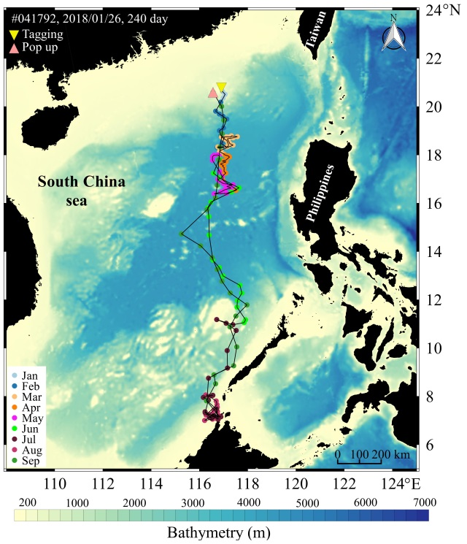
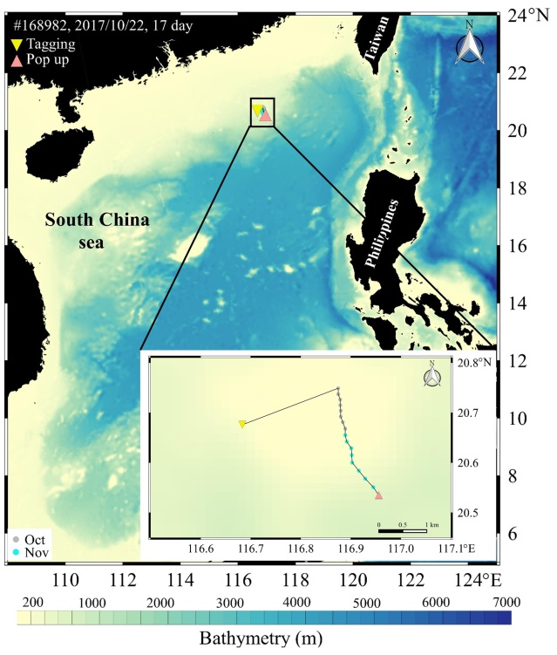
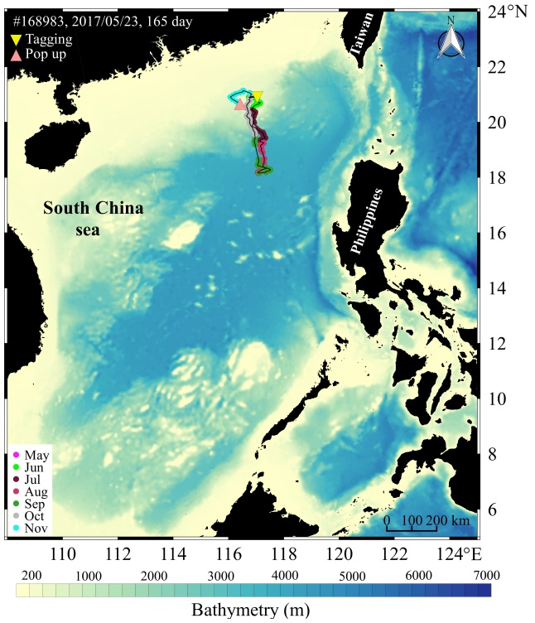
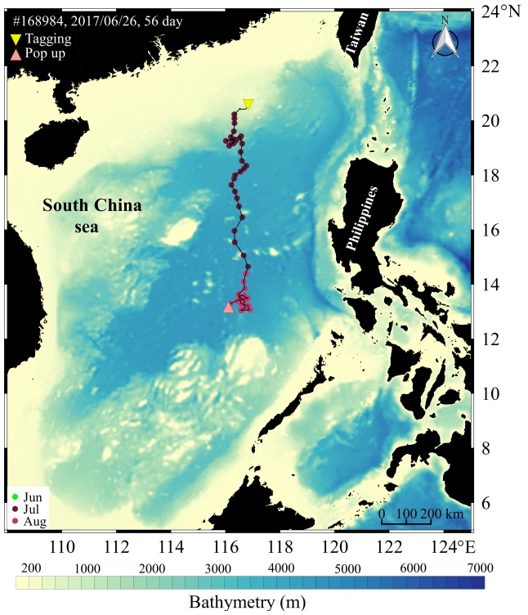
Fig. S1-2 Map of PSAT deployments on giant trevally (orange inverted triangles). Most probable track (circles and line) where colour indicates month and pop-up location (pink triangles).
(D)
(C)
(B)
(A)
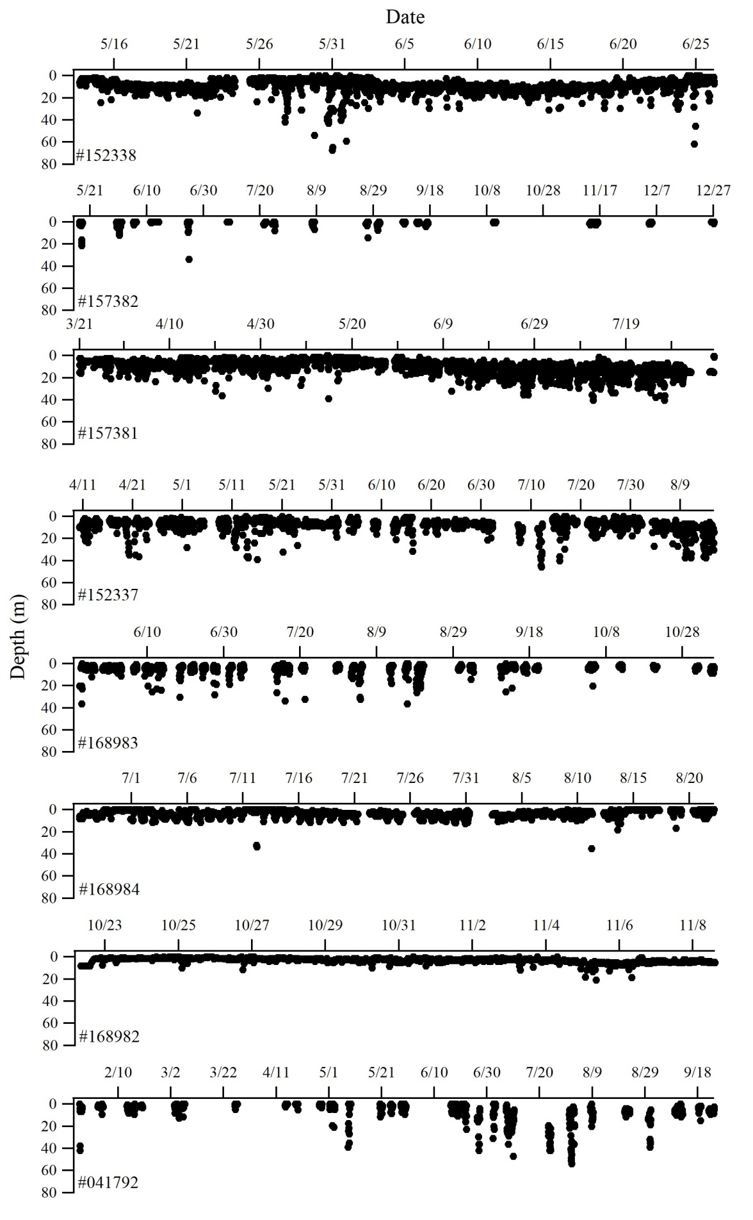
Fig. S2. Vertical movements with tag numbers provided.

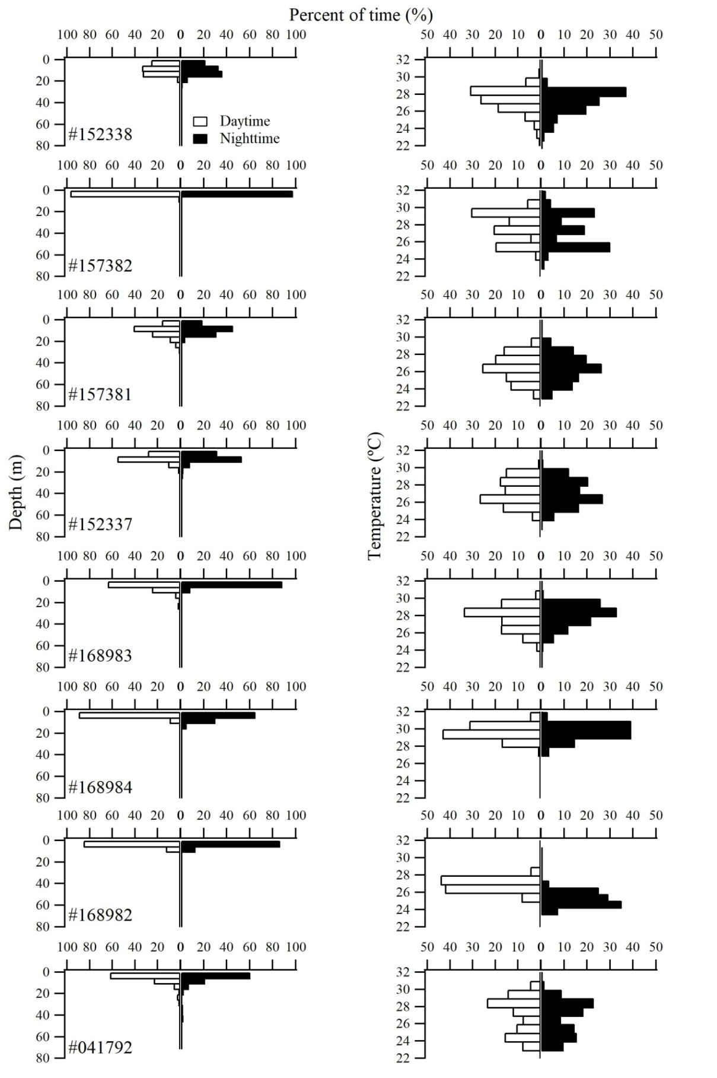
Fig. S3 Histograms showing percent of time spent at various depths and temperatures. Tag numbers are provided.

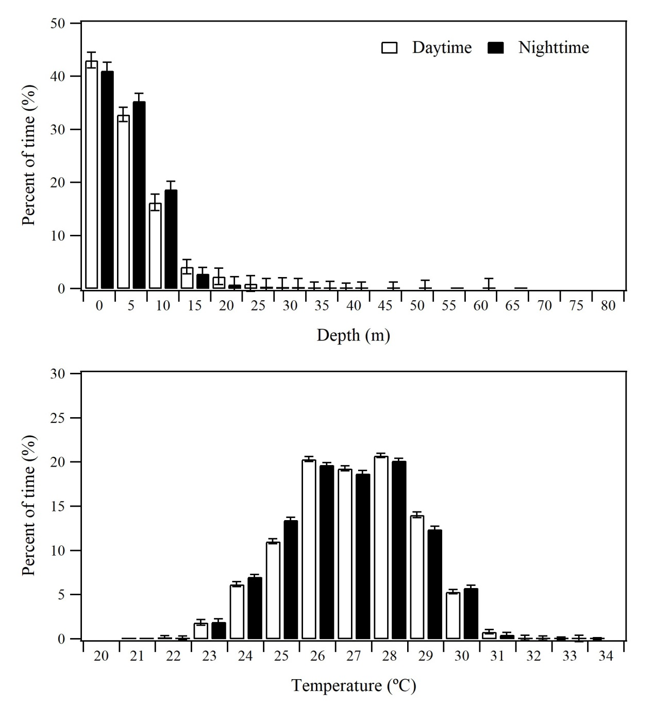
Fig. S4. Combined depth and temperature of giant trevally in the study. Fraction of time during daytime (white bars) and nighttime (black bars).

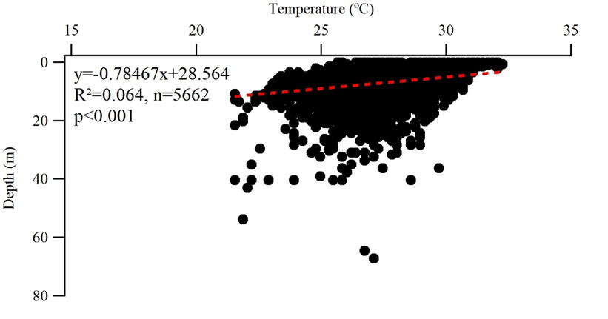
Fig. S5 Temperature-depth profile obtained from the aggregated PSAT data from giant trevally. The red dashed line is the fitted regression line (n = 5,662).

Table S1. Summary of the seasonal depth and temperatures obtained for pop-up satellite archival tags (PSATs) deployments on giant trevally.
Season | Day depth (m)  Min. – max.  (mean ±SD) | Night depth (m)  Min. – max.  (mean ±SD) | Day temp. (°C)  Min. – max.  (mean ±SD) | Night temp. (°C)  Min. – max.  (mean ±SD)
Spring  (Feb.-Apr.) | 0 – 36  (6.2±3.7) | 0 – 36  (6.3±3.9) | 22.9 – 28.2  (25.2±0.9) | 23 – 28.2  (25.2±0.9)
Summer  (May-Jul.) | 0 – 43  (7.8±6.2) | 0 – 67  (7.8±5.7) | 21.5 – 32  (27.7±1.5) | 21.5 – 32.3  (27.6±1.5)
Autumn  (Aug.-Oct.) | 0 – 36  (4.7±4.9) | 0 – 54  (5±6.7) | 24.1 – 35.4  (28.8±1.2) | 23.2 – 33.9  (28.7±1.4)
Winter  (Nov.-Jan.) | 0 – 42  (3.9±3.6) | 0 – 18  (3.4±2.1) | 23 – 28  (26.1±0.7) | 23.6 – 27.5  (25.7±0.6)
Grand  Average | 0 – 43  (6.9±5.7) | 0 – 67  (6.9±5.8) | 21.5 – 35.4  (27.5±1.7) | 21.5 – 33.9  (27.4±1.7)

