Supplementary Figure 1: Association between the levels of the proteins most strongly associated with FI and changes in FI
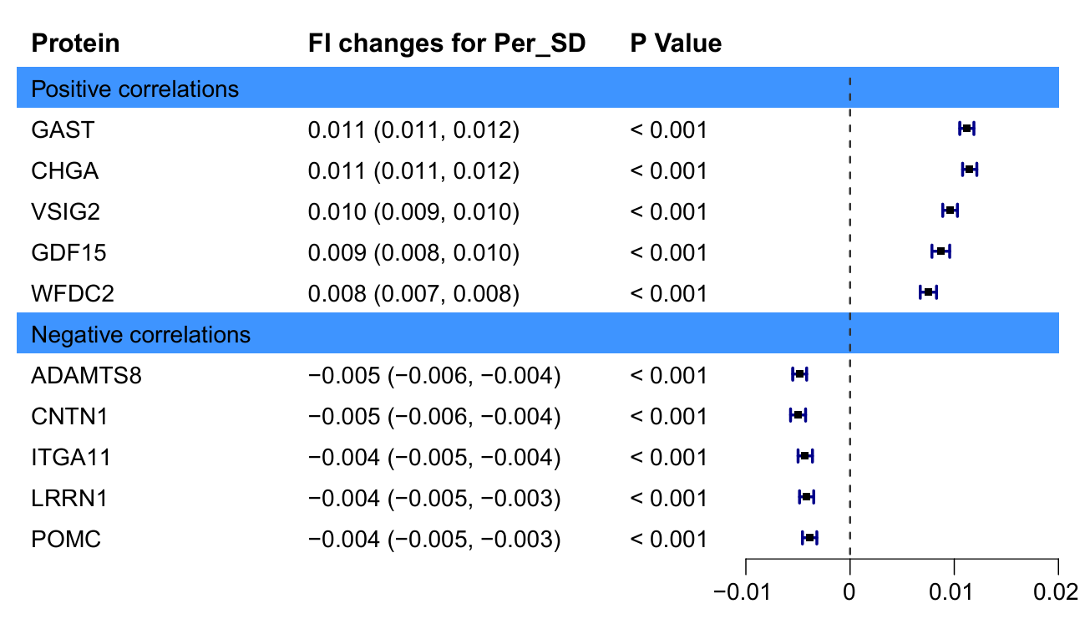
Model was based on multiple linear regression. The forest plot shows the magnitude of increase in the FI corresponding to a 1-SD increase in the respective proteins.
FI: Frailty index; AST: Gastrin, CHGA: Chromogranin-A, VSIG2: V-set and immunoglobulin domain-containing protein 2; GDF15: Growth/differentiation factor 15; FDC2: WAP four-disulfide core domain protein 2; ADAMTS8: A disintegrin and metalloproteinase with thrombospondin motifs 8; CNTN1: Contactin-1; Integrin alpha-11: ITGA11, Leucine-rich repeat neuronal protein 1: LRRN1, Pro-opiomelanocortin: POMC.

Supplementary Figure 2: Functional enrichment analysis of frailty-associated proteins.
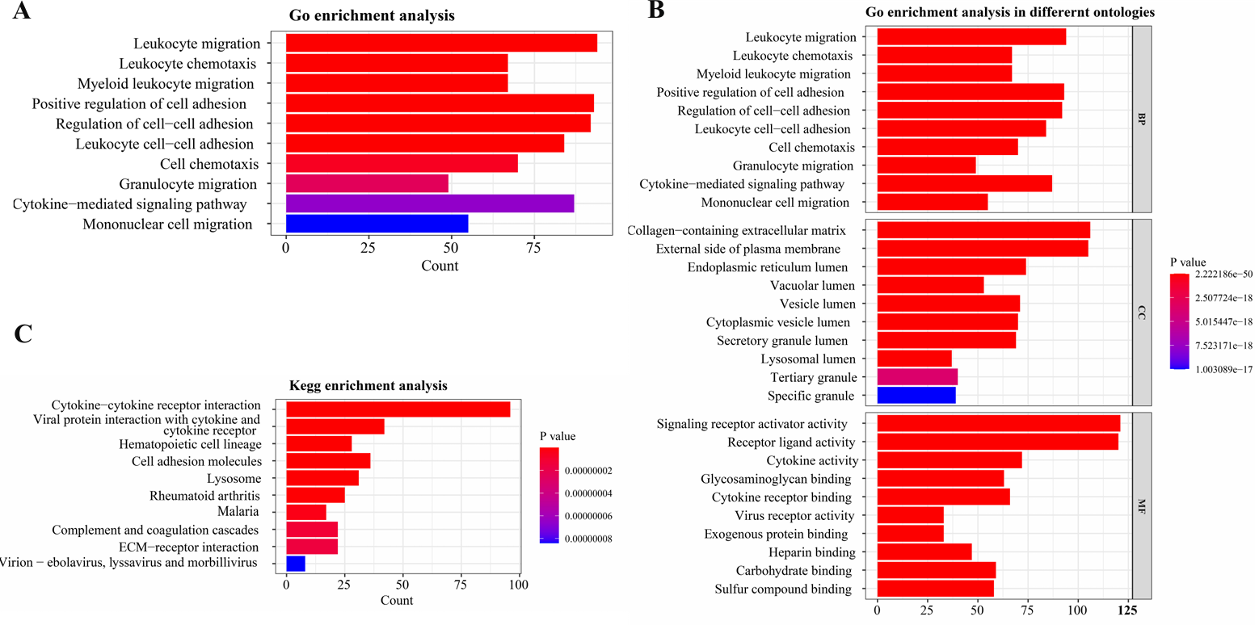
(A) GO enrichment analysis.​ The top significantly enriched GO terms are displayed, ranked by the number of associated proteins (Count). Key biological processes such as "Leukocyte migration" and "Cytokine-mediated signaling pathway" are highlighted.
(B) GO enrichment analysis across different ontologies.​ Enriched terms are categorized into Biological Process (BP), Cellular Component (CC), and Molecular Function (MF).
(C) KEGG pathway enrichment analysis.​ Significantly enriched pathways are shown. The color scale indicates the -log₁₀(P value), and the bar length represents the protein count. Key enriched pathways include "Cytokine-cytokine receptor interaction" and " virus protein-cytokine interaction pathways ".
Supplementary Figure 3: Comparison between FI-associated PPS and FI in risk prediction for mortality-related outcomes.
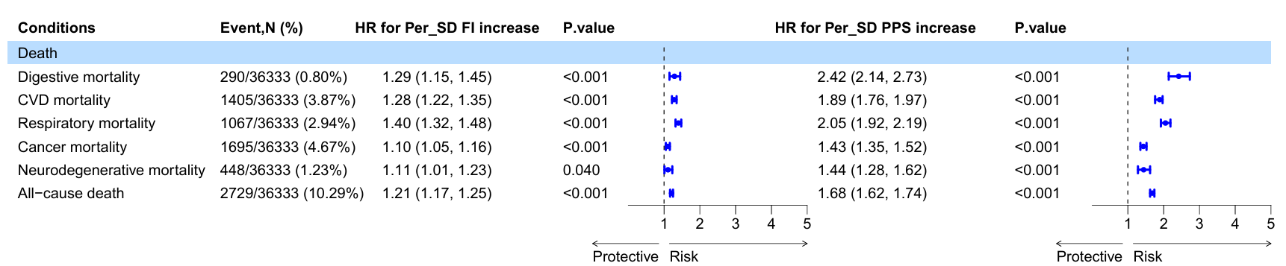
Model was based on multiple cox regression. The forest plot shows the magnitude of increase in risk of death for a 1-SD increase in the FI-PPS and FI.
FI: Frailty index; PPS: Frailty-associated Polyprotein Score; HR: Hazard ratio; SD: Standard deviation; CVD: Cardiovascular disease

Supplementary Figure 4: The performance of FI and FI-associated PPS in predicting death-related outcomes.
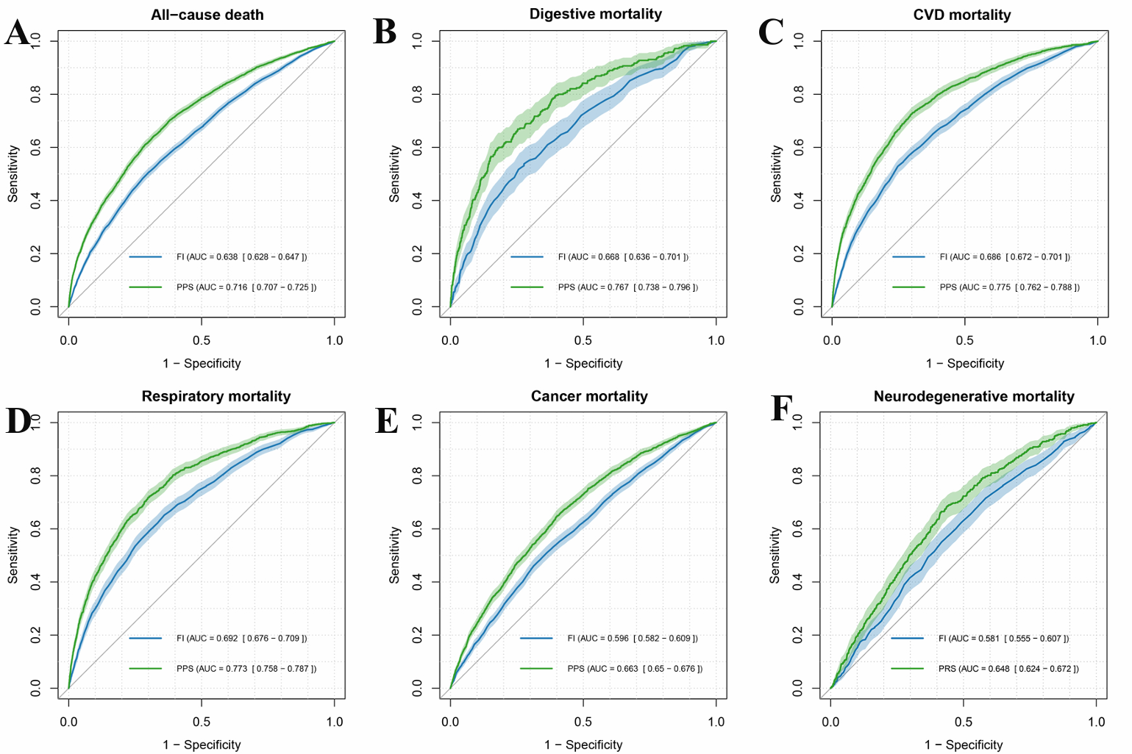
- The performance of FI and FI-PPS in predicting all-cause mortality.
- The performance of FI and FI-PPS in predicting digestive mortality.
- The performance of FI and FI-PPS in predicting CVD mortality.
- The performance of FI and FI-PPS in predicting respiratory mortality.
- The performance of FI and FI-PPS in predicting cancer mortality.
- The performance of FI and FI-PPS in predicting neurodegenerative mortality.
FI: Frailty index; PPS: Frailty-associated Polyprotein Score; ROC: Receiver Operating Characteristic; AUC: Area Under the Curve; CI: Confidence Interval; CVD: Cardiovascular disease.
Supplementary Figure 5: Association between FI-associated PPS and death-related outcomes across different frailty status.
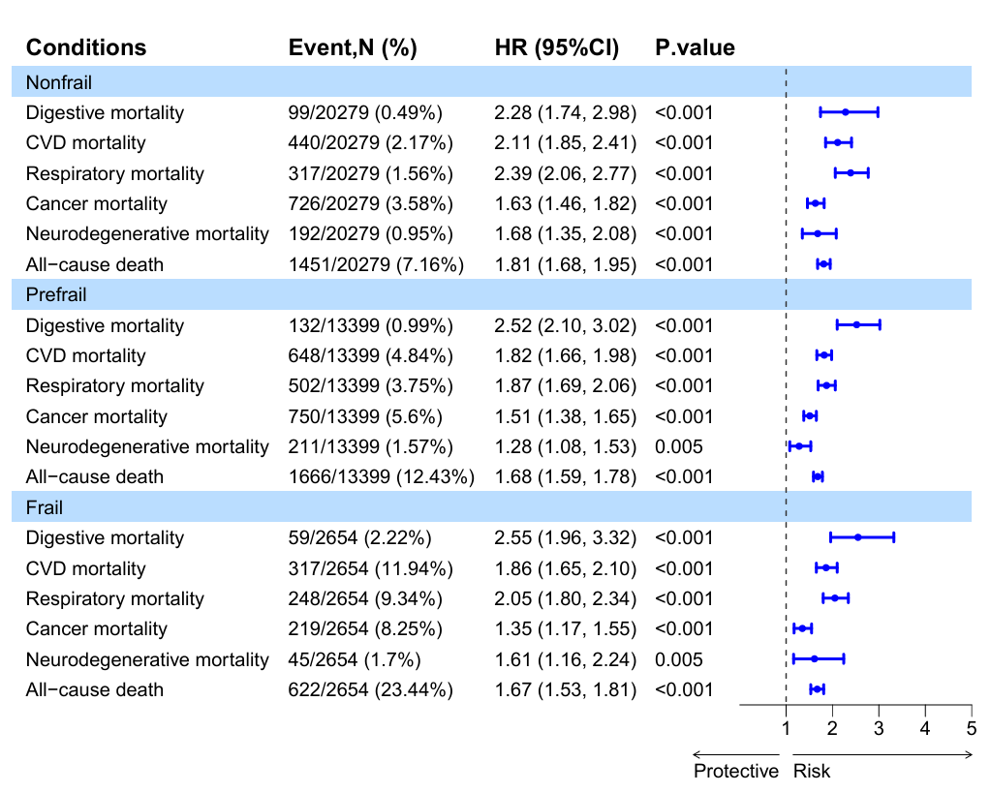
FI: Frailty index; PPS: Polyprotein Score; HR: Hazard ratio; CI: Confidence Interval; CVD: Cardiovascular disease.

Supplementary Figure 6: DCA curves to evaluate whether the FI-PPS could improve clinical decision-making compared to FI.
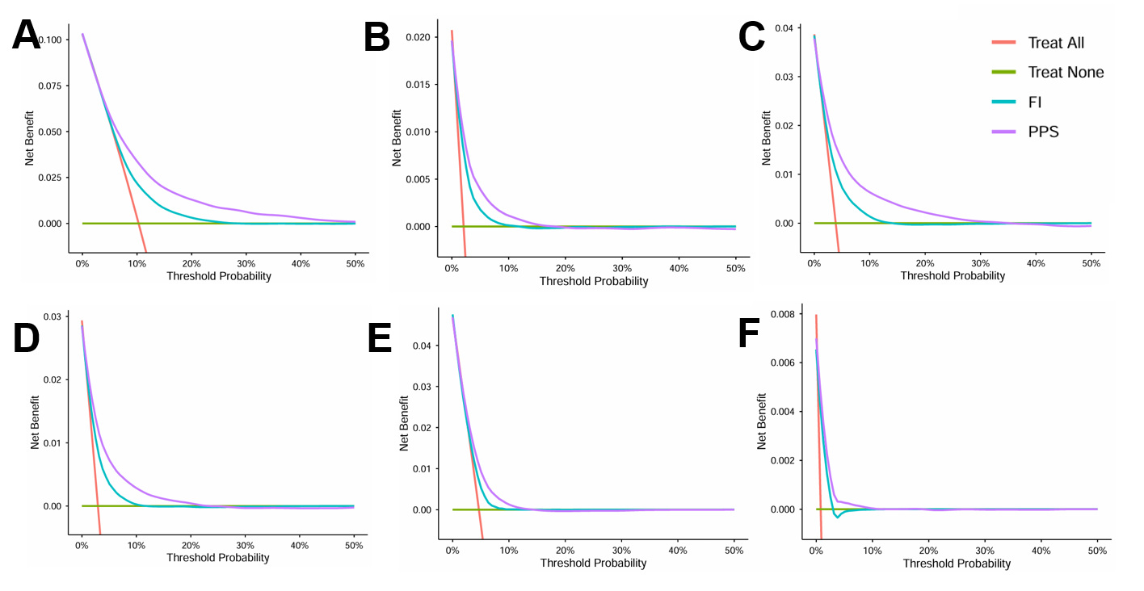
- DCA curves to evaluate whether the FI-PPS could improve clinical decision-making in predicting all-cause death compared to FI.
- DCA curves to evaluate whether the FI-PPS could improve clinical decision-making in predicting digestive mortality compared to FI.
- DCA curves to evaluate whether the FI-PPS could improve clinical decision-making in predicting CVD mortality compared to FI.
- DCA curves to evaluate whether the FI-PPS could improve clinical decision-making in predicting respiratory mortality compared to FI.
- DCA curves to evaluate whether the FI-PPS could improve clinical decision-making in predicting cancer mortality compared to FI.
- DCA curves to evaluate whether the FI-PPS could improve clinical decision-making in predicting neurodegenerative mortality compared to FI.
FI: Frailty index; PPS: Frailty-associated Polyprotein Score; CVD: Cardiovascular disease; DCA: decision curve analysis
Supplementary Figure 7: Nonlinear and linear relationship between FI-associated PPS and the risk of death-related outcomes in RCS analysis.
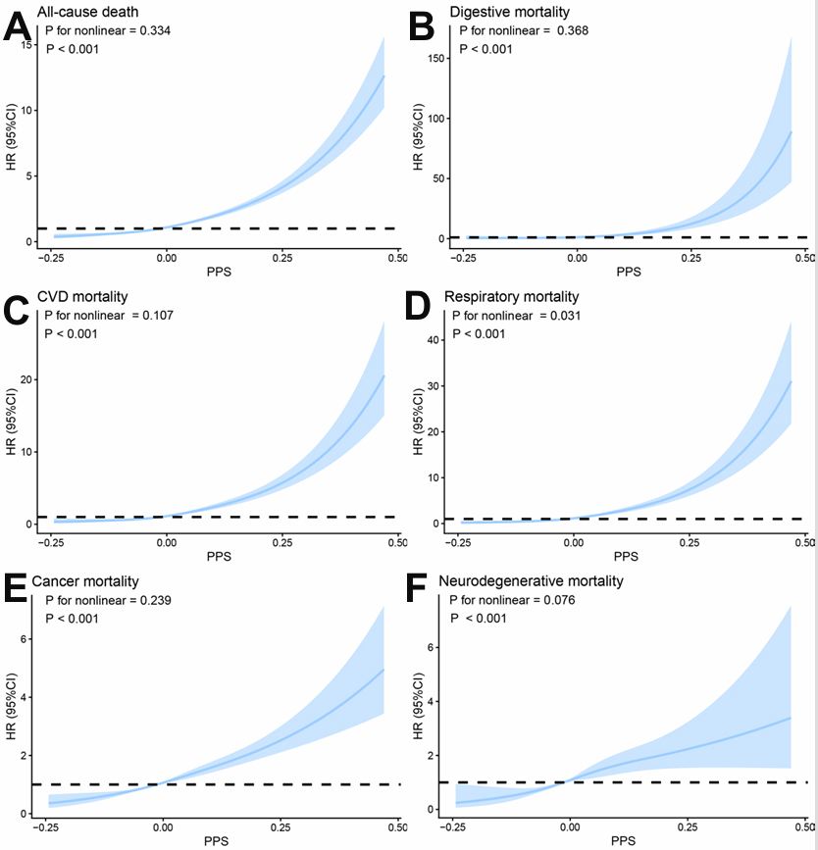
- RCS analysis for relationship between FI-associated PPS and the risk of all-cause mortality.
- RCS analysis for relationship between FI-associated PPS and the risk of digestive mortality.
- RCS analysis for relationship between FI-associated PPS and the risk of CVD mortality.
- RCS analysis for relationship between FI-associated PPS and the risk of respiratory mortality.
- RCS analysis for relationship between FI-associated PPS and the risk of cancer mortality.
- RCS analysis for relationship between FI-associated PPS and the risk of neurodegenerative mortality.
FI: Frailty index; PPS: Frailty-associated Polyprotein Score; CVD: Cardiovascular disease; RCS: restricted cubic spline; HR: Hazard Ratio; CI: Confidence Interval.

Supplementary Figure 8: Nonlinear and linear relationship between FI-associated PPS and the risk of cardiovascular disorders in RCS analysis.
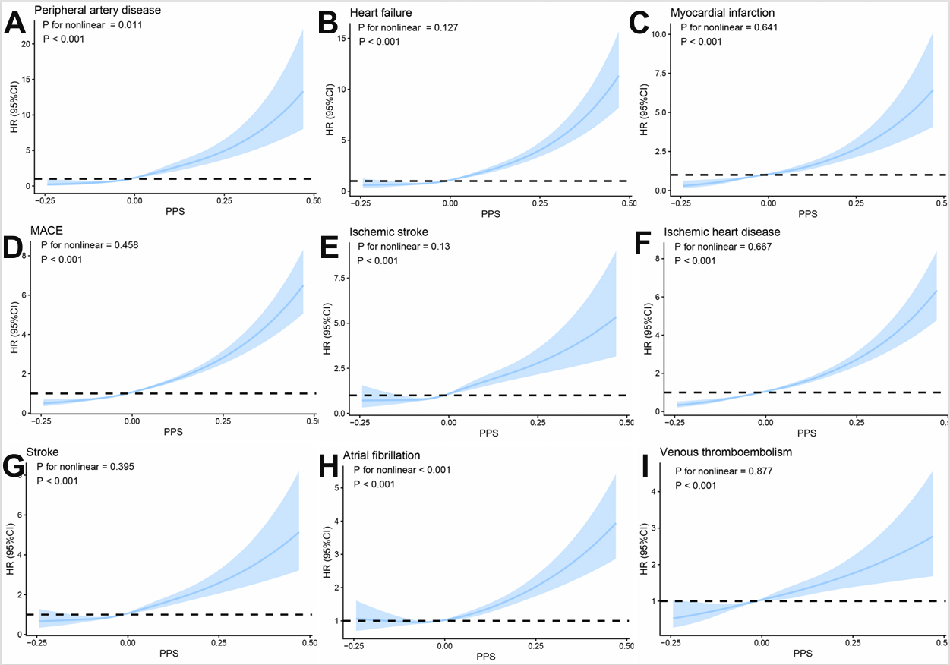
(A) RCS analysis for relationship between FI-associated PPS and the risk of peripheral artery disease.
(B) RCS analysis for relationship between FI-associated PPS and the risk of heart failure.
(C) RCS analysis for relationship between FI-associated PPS and the risk of myocardial infarction.
(D) RCS analysis for relationship between FI-associated PPS and the risk of MACE.
(E) RCS analysis for relationship between FI-associated PPS and the risk of ischemic stroke.
(F) RCS analysis for relationship between FI-associated PPS and the risk of ischemic heart disease.
(G) RCS analysis for relationship between FI-associated PPS and the risk of stroke.
(H) RCS analysis for relationship between FI-associated PPS and the risk of atrial fibrillation.
(I) RCS analysis for relationship between FI-associated PPS and the risk of venous thromboembolism.
FI: Frailty index; PPS: Frailty-associated Polyprotein Score; MACE: major adverse cardiac events; RCS: restricted cubic spline; HR: Hazard Ratio; CI: Confidence Interval;

Supplementary Figure 9: Nonlinear and linear relationship between FI-associated PPS and the risk of neurological and mental diseases in RCS analysis.
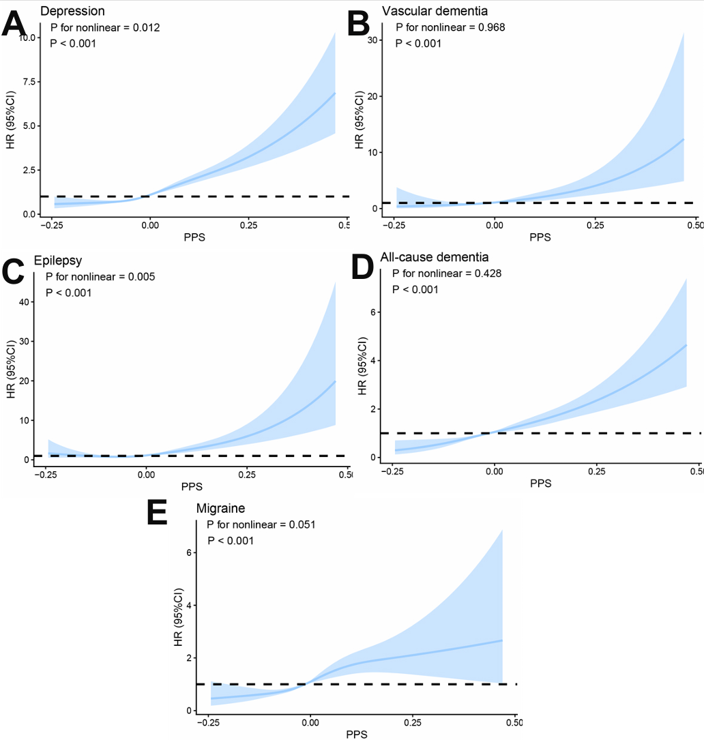
(A) RCS analysis for relationship between FI-associated PPS and the risk of depression.
(B) RCS analysis for relationship between FI-associated PPS and the risk of vascular dementia.
(C) RCS analysis for relationship between FI-associated PPS and the risk of epilepsy.
(D) RCS analysis for relationship between FI-associated PPS and the risk of all−cause dementia.
(E) RCS analysis for relationship between FI-associated PPS and the risk of Migraine.
FI: Frailty index; PPS: Frailty-associated Polyprotein Score; RCS: restricted cubic spline; HR: Hazard Ratio; CI: Confidence Interval;

Supplementary Figure 10: Nonlinear and linear relationship between FI-associated PPS and the risk of digestive system disorders in RCS analysis.
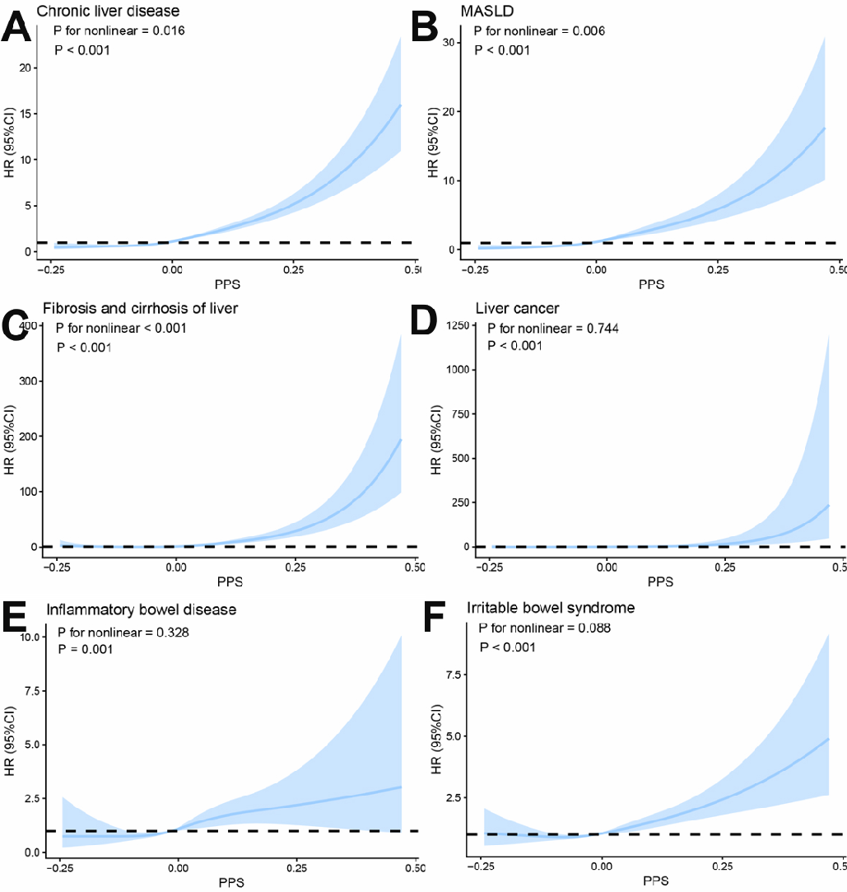
(A) RCS analysis for relationship between FI-associated PPS and the risk of chronic liver disease.
(B) RCS analysis for relationship between FI-associated PPS and the risk of MASLD.
(C) RCS analysis for relationship between FI-associated PPS and the risk of fibrosis and cirrhosis of liver.
(D) RCS analysis for relationship between FI-associated PPS and the risk of liver cancer.
(E) RCS analysis for relationship between FI-associated PPS and the risk of inflammatory bowel disease.
(F) RCS analysis for relationship between FI-associated PPS and the risk of irritable bowel syndrome.
PPS: Frailty-associated Polyprotein Score; HR: Hazard Ratio; CI: Confidence Interval; MASLD: Metabolic dysfunction-associated steatotic liver disease; RCS: restricted cubic spline;

Supplementary Figure 11: Nonlinear and linear relationship between FI-associated PPS and the risk of other disorders in RCS analysis.
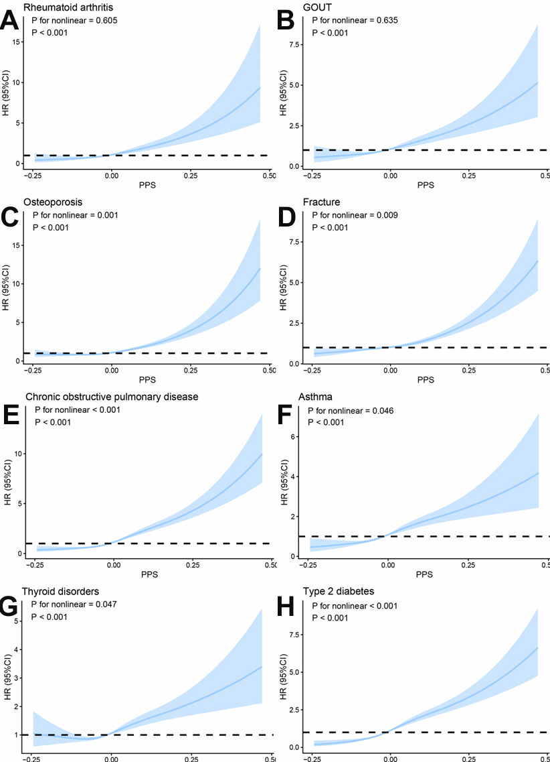
(A) RCS analysis for relationship between FI-associated PPS and the risk of rheumatoid arthritis.
(B) RCS analysis for relationship between FI-associated PPS and the risk of gout.
(C) RCS analysis for relationship between FI-associated PPS and the risk of osteoporosis.
(D) RCS analysis for relationship between FI-associated PPS and the risk of fracture.
(E) RCS analysis for relationship between FI-associated PPS and the risk of COPD.
(F) RCS analysis for relationship between FI-associated PPS and the risk of asthma.
(G) RCS analysis for relationship between FI-associated PPS and the risk of thyroid disorders.
(H) RCS analysis for relationship between FI-associated PPS and the risk of type 2 diabetes.
PPS: Frailty-associated Polyprotein Score; HR: Hazard Ratio; CI: Confidence Interval; RCS: restricted cubic spline;

Supplementary Figure 12: Temporal trajectory analyses to explore the level trajectories of PPS before the onset of cardiovascular disorders
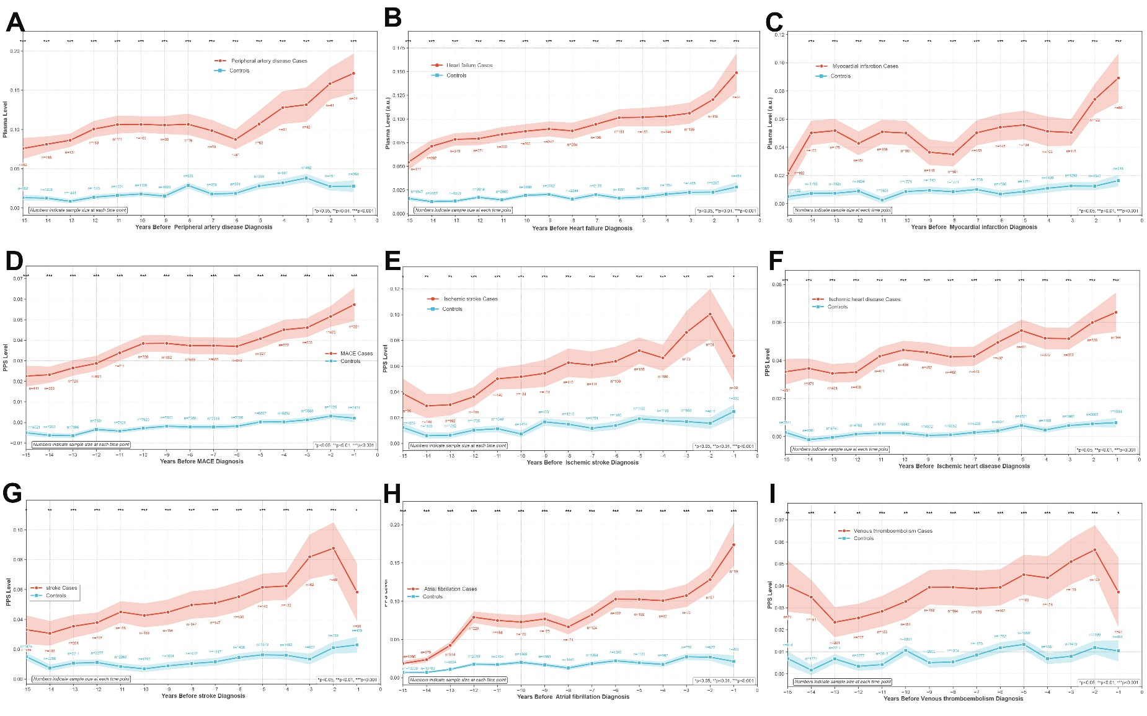
(A) Temporal trajectory analyses to explore the level trajectories of PPS before the onset of peripheral artery disease.
(B) Temporal trajectory analyses to explore the level trajectories of PPS before the onset of heart failure.
(C) Temporal trajectory analyses to explore the level trajectories of PPS before the onset of myocardial infarction.
(D) Temporal trajectory analyses to explore the level trajectories of PPS before the onset of MACE.
(E) Temporal trajectory analyses to explore the level trajectories of PPS before the onset of ischemic stroke.
(F) Temporal trajectory analyses to explore the level trajectories of PPS before the onset of ischemic heart disease.
(G) Temporal trajectory analyses to explore the level trajectories of PPS before the onset of stroke.
(H) Temporal trajectory analyses to explore the level trajectories of PPS before the onset of atrial fibrillation.
(I) Temporal trajectory analyses to explore the level trajectories of PPS before the onset of venous thromboembolism.
FI: Frailty index; PPS: Frailty-associated Polyprotein Score; MACE: major adverse cardiac events;

Supplementary Figure 13: Temporal trajectory analyses to explore the level trajectories of PPS before the onset of neurological and mental diseases
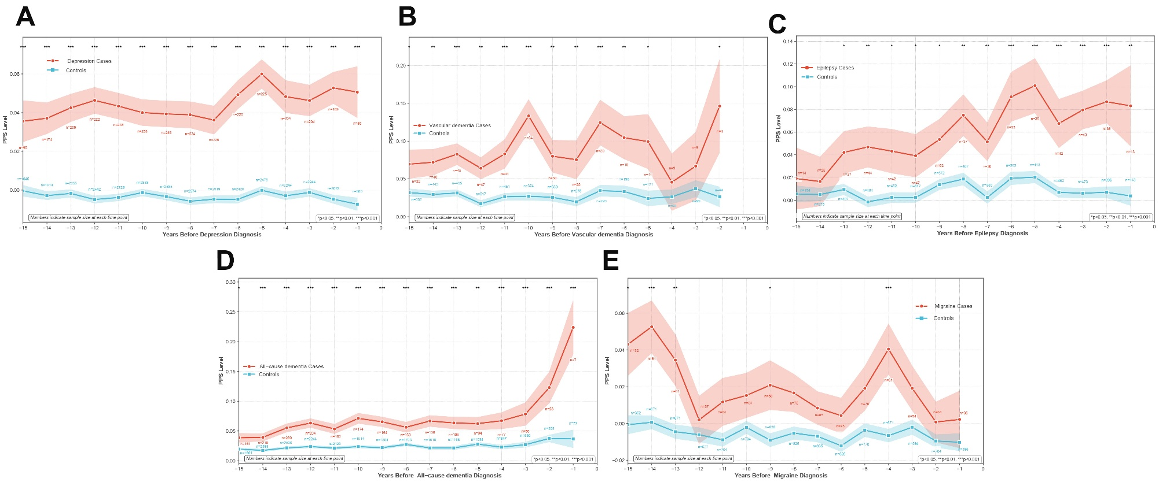
(A) Temporal trajectory analyses to explore the level trajectories of PPS before the onset of depression.
(B) Temporal trajectory analyses to explore the level trajectories of PPS before the onset of vascular dementia.
(C) Temporal trajectory analyses to explore the level trajectories of PPS before the onset of epilepsy.
(D) Temporal trajectory analyses to explore the level trajectories of PPS before the onset of all−cause dementia.
(E) Temporal trajectory analyses to explore the level trajectories of PPS before the onset of migraine.
(G) Temporal trajectory analyses to explore the level trajectories of PPS before the onset of stroke.
FI: Frailty index; PPS: Frailty-associated Polyprotein Score;
Supplementary Figure 14: Temporal trajectory analyses to explore the level trajectories of PPS before the onset of digestive system disorders
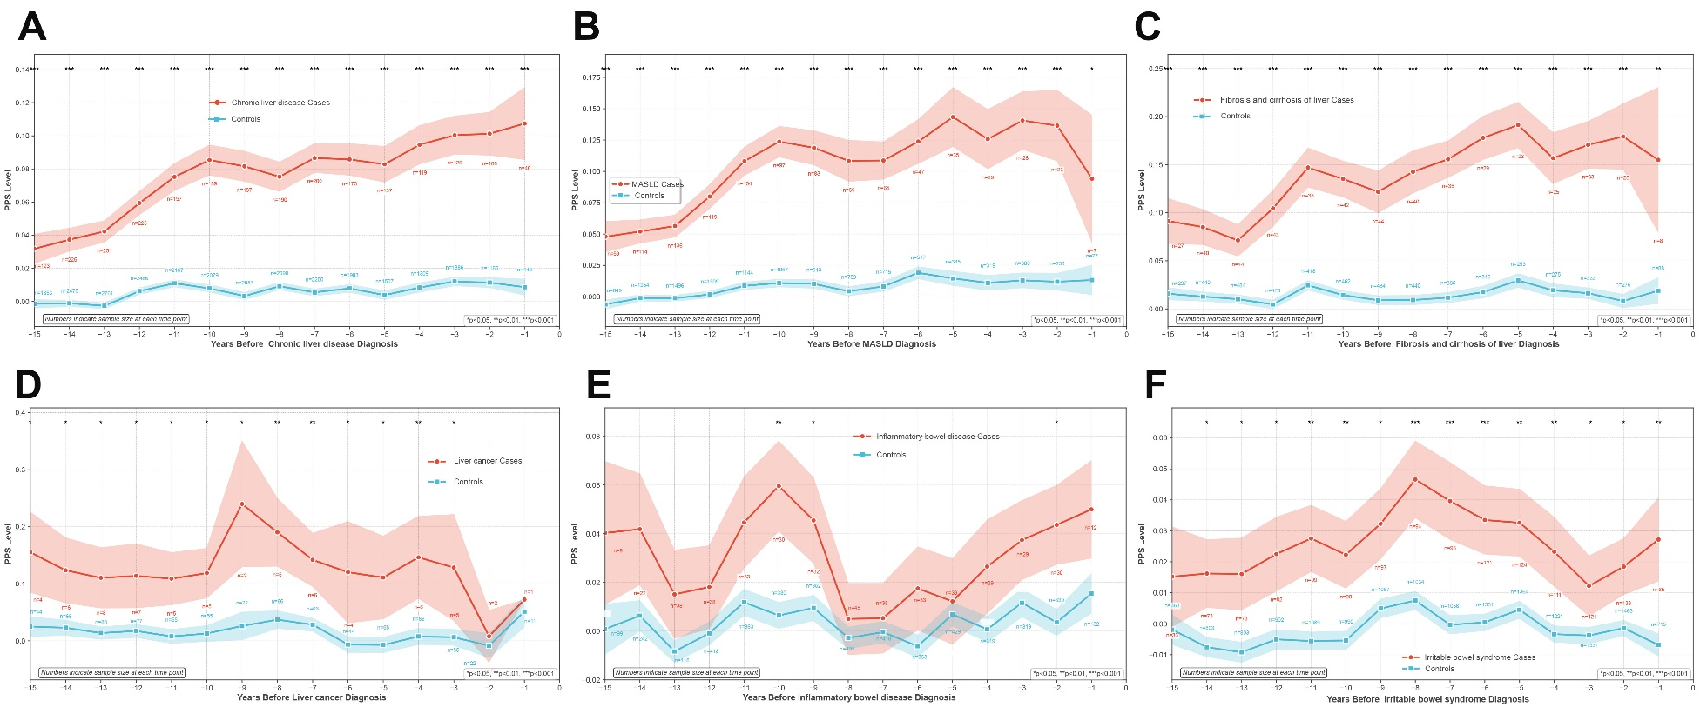
(A) Temporal trajectory analyses to explore the level trajectories of PPS before the onset of chronic liver disease.
(B) Temporal trajectory analyses to explore the level trajectories of PPS before the onset of MASLD.
(C) Temporal trajectory analyses to explore the level trajectories of PPS before the onset of fibrosis and cirrhosis of liver.
(D) Temporal trajectory analyses to explore the level trajectories of PPS before the onset of liver cancer.
(E) Temporal trajectory analyses to explore the level trajectories of PPS before the onset of inflammatory bowel disease.
(G) Temporal trajectory analyses to explore the level trajectories of PPS before the onset of irritable bowel syndrome.
FI: Frailty index; PPS: Frailty-associated Polyprotein Score; MASLD: Metabolic dysfunction-associated steatotic liver disease;
Supplementary Figure 15: Temporal trajectory analyses to explore the level trajectories of PPS before the onset of other disorders
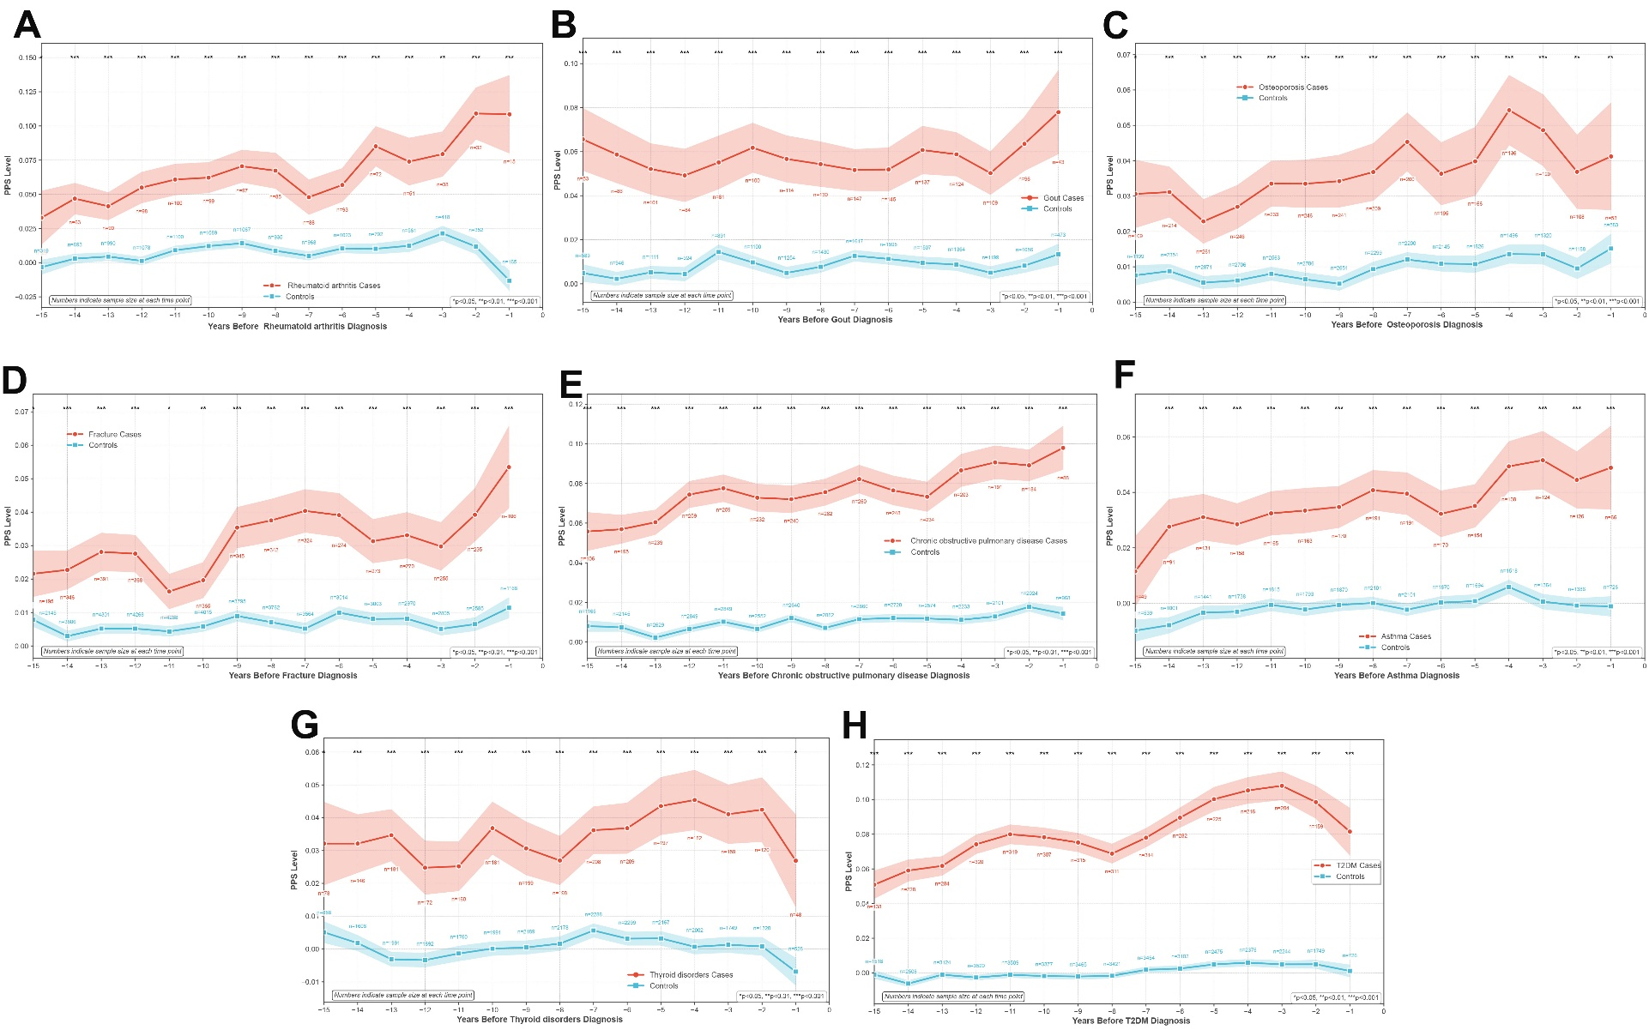
(A) Temporal trajectory analyses to explore the level trajectories of PPS before the onset of rheumatoid arthritis.
(B) Temporal trajectory analyses to explore the level trajectories of PPS before the onset of gout.
(C) Temporal trajectory analyses to explore the level trajectories of PPS before the onset of osteoporosis.
(D) Temporal trajectory analyses to explore the level trajectories of PPS before the onset of fracture.
(E) Temporal trajectory analyses to explore the level trajectories of PPS before the onset of chronic obstructive pulmonary disease.
(F) Temporal trajectory analyses to explore the level trajectories of PPS before the onset of asthma.
(G) Temporal trajectory analyses to explore the level trajectories of PPS before the onset of thyroid disorders.
(H) Temporal trajectory analyses to explore the level trajectories of PPS before the onset of type 2 diabetes.
FI: Frailty index; PPS: Frailty-associated Polyprotein Score.
Supplementary Figure 16: Functional enrichment analysis of PPS-associated proteins.
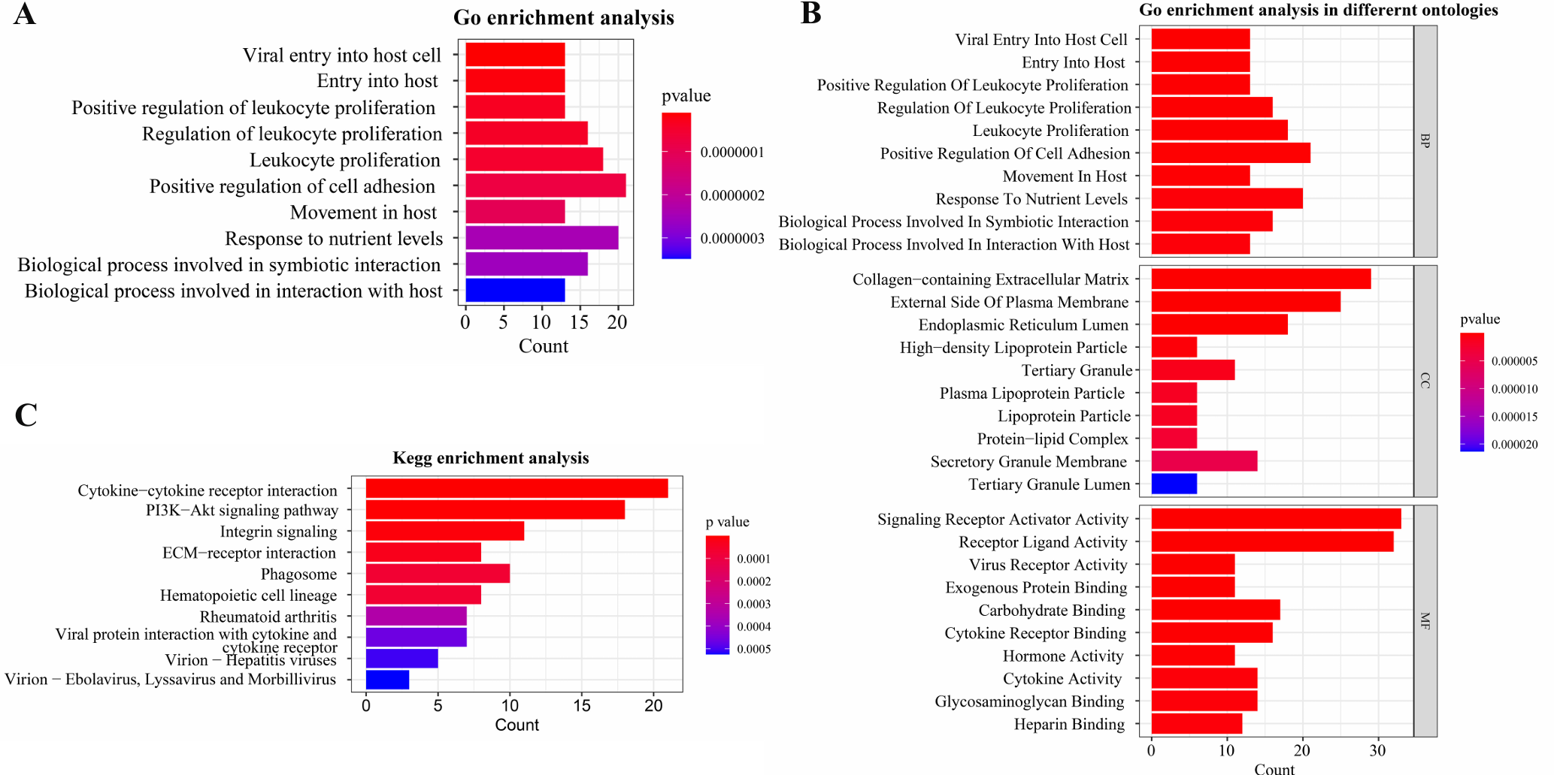
(A) GO enrichment analysis.​ The top significantly enriched GO terms are displayed, ranked by the number of associated proteins (Count). Key biological processes such as "Viral entry into host cell" and "Entry into host cell" are highlighted.
(B) GO enrichment analysis across different ontologies.​ Enriched terms are categorized into Biological Process (BP), Cellular Component (CC), and Molecular Function (MF).
(C) KEGG pathway enrichment analysis.​ Significantly enriched pathways are shown. The color scale indicates the -log₁₀(P value), and the bar length represents the protein count. Key enriched pathways include "Cytokine-cytokine receptor interaction" and "PI3K-Akt signaling pathway ".

