Supplemental Materials

Figure S1. Estimates for each fixed effect in linear mixed models of task performance. Lines represent 95% confidence interval.
***p < 0.001, **p < 0.01, *p < 0.05*; RCS = rate correct score; RT = reaction time, SD = standard deviation. Boxed and Sustained Attention performance scores have been transformed so that positive estimates indicate higher performance for all tasks and estimates are on similar scale across tasks.

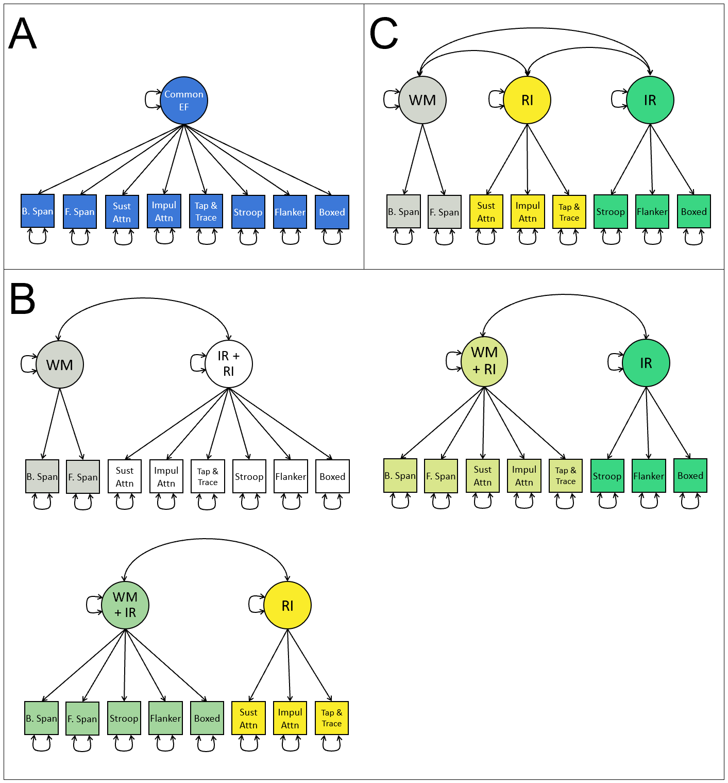
Figure S2. Potential organizations of executive function factor structure. EF = executive function; WM = working memory; IR = interference resolution; RI = response inhibition; B. Span = backward spatial span; F. Span = forward spatial span; Sust Attn = Sustained Attention; Impul Attn = Impulsive Attention; Tap & Trace = Tap and Trace. Panel A shows a 1-factor model where all tasks load onto a single factor of common EF; panel B shows three possible combinations of factors to form a 2-factor model; and panel C shows the 3-factor model of EF.
Table S1. Fit Indices for 1-, 2-, and 3-Factor Models of Executive Function
Cohort | Timepoint | Model | $$χ^{2}$$ | df | p | RMSEA (90% CI) | CFI | AIC | BICc
3rd-4th grade cohort | 1 | 1-Factor | 28.943 | 20 | 0.089 | 0.046 (0.000, 0.081) | 0.972 | 2091.300 | 2095.585
3rd-4th grade cohort | 1 | 2-Factor (IR with RI)^{a,b,c,d} | 16.535 | 19 | 0.621 | 0.000 (0.000, 0.052) | 1.000 | 2081.199 | 2085.663
3rd-4th grade cohort | 1 | 2-Factor (WM with RI) | 28.741 | 19 | 0.070 | 0.049 (0.000, 0.084) | 0.969 | 2093.155 | 2097.619
3rd-4th grade cohort | 1 | 2-Factor (WM with IR) | 28.850 | 19 | 0.068 | 0.050 (0.000, 0.084) | 0.969 | 2093.063 | 2097.527
3rd-4th grade cohort | 1 | 3-Factor^{a,b} | 16.417 | 17 | 0.495 | 0.000 (0.000, 0.061) | 1.000 | 2084.911 | 2089.731
3rd-4th grade cohort | 2 | 1-Factor | 42.714 | 20 | 0.002 | 0.074 (0.043, 0.104) | 0.899 | 2023.038 | 2027.210
3rd-4th grade cohort | 2 | 2-Factor (IR with RI) | 38.052 | 19 | 0.006 | 0.069 (0.036, 0.101) | 0.916 | 2020.373 | 2024.719
3rd-4th grade cohort | 2 | 2-Factor (WM with RI)^{c,d} | 22.255 | 19 | 0.272 | 0.029 (0.000, 0.070) | 0.986 | 2005.333 | 2009.678
3rd-4th grade cohort | 2 | 2-Factor (WM with IR) | 32.106 | 19 | 0.030 | 0.057 (0.018, 0.091) | 0.942 | 2015.492 | 2019.838
3rd-4th grade cohort | 2 | 3-Factor^{a,b} | 18.714 | 17 | 0.345 | 0.022 (0.000, 0.068) | 0.992 | 2005.715 | 2010.408
3rd-4th grade cohort | 3 | 1-Factor | 24.717 | 20 | 0.213 | 0.033 (0.000, 0.070) | 0.972 | 2020.510 | 2025.574
3rd-4th grade cohort | 3 | 2-Factor (IR with RI) | 24.868 | 19 | 0.165 | 0.038 (0.000, 0.075) | 0.965 | 2022.508 | 2027.783
3rd-4th grade cohort | 3 | 2-Factor (WM with RI)^{a,b,c,d} | 21.385 | 19 | 0.316 | 0.024 (0.000, 0.066) | 0.986 | 2019.120 | 2024.395
3rd-4th grade cohort | 3 | 2-Factor (WM with IR) | 23.274 | 19 | 0.226 | 0.032 (0.000, 0.071) | 0.974 | 2021.159 | 2026.435
3rd-4th grade cohort | 3 | 3-Factor | 21.154 | 17 | 0.220 | 0.034 (0.000, 0.074) | 0.975 | 2022.875 | 2028.573
3rd-4th grade cohort | 4 | 1-Factor | 46.286 | 20 | 0.001 | 0.075 (0.047, 0.103) | 0.885 | 2340.406 | 2347.265
3rd-4th grade cohort | 4 | 2-Factor (IR with RI) | 43.358 | 19 | 0.001 | 0.074 (0.045, 0.103) | 0.894 | 2339.014 | 2346.158
3rd-4th grade cohort | 4 | 2-Factor (WM with RI) | 42.241 | 19 | 0.002 | 0.072 (0.043, 0.102) | 0.898 | 2337.554 | 2344.698
3rd-4th grade cohort | 4 | 2-Factor (WM with IR)^{a,b,c,d} | 31.716 | 19 | 0.034 | 0.053 (0.015, 0.085) | 0.944 | 2327.555 | 2334.699
3rd-4th grade cohort | 4 | 3-Factor ª | 29.736 | 17 | 0.028 | 0.057 (0.018, 0.090) | 0.944 | 2328.394 | 2336.110
5th-6th grade cohort | 1 | 1-Factor | 29.209 | 20 | 0.084 | 0.047 (0.000, 0.081) | 0.962 | 1970.924 | 1975.322
5th-6th grade cohort | 1 | 2-Factor (IR with RI)^{c,d} | 19.271 | 19 | 0.440 | 0.008 (0.000, 0.061) | 0.999 | 1962.993 | 1967.574
5th-6th grade cohort | 1 | 2-Factor (WM with RI) | 27.444 | 19 | 0.095 | 0.046 (0.000, 0.081) | 0.965 | 1971.344 | 1975.925
5th-6th grade cohort | 1 | 2-Factor (WM with IR) | 25.715 | 19 | 0.138 | 0.041 (0.000, 0.078) | 0.972 | 1969.304 | 1973.885
5th-6th grade cohort | 1 | 3-Factor^{a,b} | 15.964 | 17 | 0.526 | 0.000 (0.000, 0.059) | 1.000 | 1963.640 | 1968.587
5th-6th grade cohort | 2 | 1-Factor | 39.379 | 20 | 0.006 | 0.069 (0.036, 0.101) | 0.897 | 1810.568 | 1813.811
5th-6th grade cohort | 2 | 2-Factor (IR with RI) | 29.892 | 19 | 0.053 | 0.053 (0.000, 0.088) | 0.942 | 1803.728 | 1807.107
5th-6th grade cohort | 2 | 2-Factor (WM with RI) | 26.580 | 19 | 0.115 | 0.045 (0.000, 0.081) | 0.960 | 1801.007 | 1804.386
5th-6th grade cohort | 2 | 2-Factor (WM with IR) | 33.281 | 19 | 0.022 | 0.061 (0.023, 0.095) | 0.924 | 1807.586 | 1810.964
5th-6th grade cohort | 2 | 3-Factor^{a,b,c,d} | 19.091 | 17 | 0.323 | 0.025 (0.000, 0.071) | 0.989 | 1798.013 | 1801.662

Table S1. Continued
Cohort | Timepoint | Model | $$χ^{2}$$ | df | p | RMSEA (90% CI) | CFI | AIC | BICc
5th-6th grade cohort | 3 | 1-Factor | 56.946 | 20 | < 0.001 | 0.081 (0.057, 0.106) | 0.863 | 2640.655 | 2651.872
5th-6th grade cohort | 3 | 2-Factor (IR with RI) | 45.768 | 19 | 0.001 | 0.071 (0.045, 0.097) | 0.901 | 2631.328 | 2643.013
5th-6th grade cohort | 3 | 2-Factor (WM with RI) | 55.164 | 19 | < 0.001 | 0.082 (0.057, 0.108) | 0.866 | 2639.165 | 2650.850
5th-6th grade cohort | 3 | 2-Factor (WM with IR) | 40.783 | 19 | 0.003 | 0.064 (0.037, 0.091) | 0.919 | 2626.634 | 2638.318
5th-6th grade cohort | 3 | 3-Factor^{a,b,c,d} | 28.833 | 17 | 0.036 | 0.050 (0.013, 0.080) | 0.956 | 2617.974 | 2630.593
5th-6th grade cohort | 4 | 1-Factor | 65.130 | 20 | < 0.001 | 0.091 (0.067, 0.116) | 0.846 | 2633.778 | 2644.307
5th-6th grade cohort | 4 | 2-Factor (IR with RI) | 55.518 | 19 | < 0.001 | 0.084 (0.059, 0.110) | 0.875 | 2626.287 | 2637.255
5th-6th grade cohort | 4 | 2-Factor (WM with RI) | 48.996 | 19 | < 0.001 | 0.076 (0.050, 0.103) | 0.898 | 2619.756 | 2630.724
5th-6th grade cohort | 4 | 2-Factor (WM with IR) | 42.308 | 19 | 0.002 | 0.067 (0.040, 0.094) | 0.920 | 2614.602 | 2625.570
5th-6th grade cohort | 4 | 3-Factor^{a,b,c,d} | 34.009 | 17 | 0.008 | 0.061 (0.030, 0.090) | 0.942 | 2608.652 | 2620.498
7th-8th grade cohort | 1 | 1-Factor | 45.447 | 20 | 0.001 | 0.053 (0.033, 0.074) | 0.917 | 3614.534 | 3636.829
7th-8th grade cohort | 1 | 2-Factor (IR with RI)^{d} | 33.551 | 19 | 0.021 | 0.041 (0.016, 0.064) | 0.953 | 3604.673 | 3627.897
7th-8th grade cohort | 1 | 2-Factor (WM with RI) | 43.105 | 19 | 0.001 | 0.053 (0.032, 0.075) | 0.922 | 3614.009 | 3637.233
7th-8th grade cohort | 1 | 2-Factor (WM with IR) | 39.692 | 19 | 0.004 | 0.049 (0.027, 0.071) | 0.933 | 3611.020 | 3634.244
7th-8th grade cohort | 1 | 3-Factor ^{a,b,c} | 27.932 | 17 | 0.046 | 0.038 (0.005, 0.062) | 0.965 | 3602.947 | 3628.029
7th-8th grade cohort | 2 | 1-Factor | 54.171 | 20 | < 0.001 | 0.061 (0.042, 0.081) | 0.918 | 3862.803 | 3885.417
7th-8th grade cohort | 2 | 2-Factor (IR with RI) | 40.494 | 19 | 0.003 | 0.050 (0.028, 0.071) | 0.948 | 3851.424 | 3874.980
7th-8th grade cohort | 2 | 2-Factor (WM with RI) | 48.839 | 19 | < 0.001 | 0.059 (0.039, 0.080) | 0.928 | 3859.354 | 3882.910
7th-8th grade cohort | 2 | 2-Factor (WM with IR) | 47.196 | 19 | < 0.001 | 0.057 (0.037, 0.078) | 0.932 | 3857.919 | 3881.475
7th-8th grade cohort | 2 | 3-Factor^{a,b,c,d} | 33.592 | 17 | 0.010 | 0.046 (0.022, 0.069) | 0.960 | 3848.422 | 3873.863
7th-8th grade cohort | 3 | 1-Factor | 74.929 | 20 | < 0.001 | 0.080 (0.061, 0.099) | 0.873 | 3895.076 | 3916.555
7th-8th grade cohort | 3 | 2-Factor (IR with RI) | 52.216 | 19 | < 0.001 | 0.064 (0.043, 0.085) | 0.923 | 3874.056 | 3896.431
7th-8th grade cohort | 3 | 2-Factor (WM with RI) | 66.530 | 19 | < 0.001 | 0.076 (0.057, 0.096) | 0.890 | 3887.093 | 3909.467
7th-8th grade cohort | 3 | 2-Factor (WM with IR) | 53.376 | 19 | < 0.001 | 0.065 (0.045, 0.086) | 0.921 | 3874.756 | 3897.131
7th-8th grade cohort | 3 | 3-Factor^{a,b,c,d} | 32.177 | 17 | 0.014 | 0.045 (0.020, 0.069) | 0.965 | 3856.736 | 3880.901
7th-8th grade cohort | 4 | 1-Factor | 98.614 | 20 | < 0.001 | 0.098 (0.079, 0.118) | 0.777 | 3828.726 | 3848.957
7th-8th grade cohort | 4 | 2-Factor (IR with RI) | 54.483 | 19 | < 0.001 | 0.067 (0.047, 0.089) | 0.899 | 3787.057 | 3808.131
7th-8th grade cohort | 4 | 2-Factor (WM with RI) | 74.563 | 19 | < 0.001 | 0.084 (0.065, 0.105) | 0.842 | 3806.099 | 3827.173
7th-8th grade cohort | 4 | 2-Factor (WM with IR) | 65.117 | 19 | < 0.001 | 0.077 (0.057, 0.098) | 0.869 | 3798.066 | 3819.140
7th-8th grade cohort | 4 | 3-Factor^{a,b,c,d} | 20.985 | 17 | 0.227 | 0.024 (0.000, 0.053) | 0.989 | 3758.072 | 3780.832
Note. ªModel with highest CFI; ^{b}Model with lowest RMSEA; ^{c}Model with lowest AIC; ^{d}Model with lowest BICc. CFI = comparative fit index; RMSEA = root mean square error of approximation; AIC = Akaike information criterion; BICc = sample-size adjusted Bayesian information criterion; IR = interference resolution; RI = response inhibition; WM = working memory.

Table S2. Factor Loadings from 1-Factor Model of Executive Function

 | 3rd-4th Grade Cohort |  |  |  | 5th-6th Grade Cohort |  |  |  | 7th-8th Grade Cohort
Task | Time-  point 1 | Time-  point 2 | Time-  point 3 | Time-  point 4 | Time-  point 1 | Time-  point 2 | Time-  point 3 | Time-  point 4 | Time-  point 1 | Time-  point 2 | Time-  point 3 | Time-  point 4
B. SPAN | 0.393 | 0.453 | 0.376 | 0.407 | 0.363 | 0.289 | 0.306 | 0.288 | 0.376 | 0.361 | 0.421 | 0.257
F. SPAN | 0.506 | 0.345 | 0.339 | 0.485 | 0.406 | 0.375 | 0.319 | 0.400 | 0.286 | 0.340 | 0.320 | 0.312
SUST ATTN | 0.491 | 0.406 | 0.297 | 0.340 | 0.358 | 0.461 | 0.311 | 0.255 | 0.382 | 0.260 | 0.407 | 0.406
IMPUL ATTN | 0.584 | 0.590 | 0.498 | 0.359 | 0.608 | 0.451 | 0.297 | 0.395 | 0.390 | 0.418 | 0.478 | 0.465
TAP & TRACE | 0.615 | 0.581 | 0.402 | 0.501 | 0.489 | 0.517 | 0.314 | 0.482 | 0.441 | 0.554 | 0.512 | 0.484
STROOP | 0.763 | 0.673 | 0.607 | 0.654 | 0.704 | 0.575 | 0.761 | 0.667 | 0.484 | 0.598 | 0.613 | 0.569
FLANKER | 0.664 | 0.638 | 0.664 | 0.662 | 0.724 | 0.657 | 0.666 | 0.704 | 0.780 | 0.771 | 0.736 | 0.701
BOXED | 0.380 | 0.307 | 0.441 | 0.437 | 0.350 | 0.441 | 0.609 | 0.582 | 0.397 | 0.528 | 0.407 | 0.387
Note. Factor loadings are standardized. B. SPAN = Backward Spatial Span; F. SPAN = Forward Spatial Span; SUST ATTN = Sustained Attention; IMPUL ATTN = Impulsive Attention.

Table S3. Factor Loadings and Correlations from 2-Factor Model of Executive Function Combining Response Inhibition and Interference Resolution

 |  | 3rd-4th Grade Cohort |  |  |  | 5th-6th Grade Cohort |  |  |  | 7th-8th Grade Cohort
Factor | Task | Time-  point 1 | Time-  point 2 | Time-  point 3 | Time-  point 4 | Time-  point 1 | Time-  point 2 | Time-  point 3 | Time-  point 4 | Time-  point 1 | Time-  point 2 | Time-  point 3 | Time-  point 4
Working Memory | B. SPAN | 0.528 | 0.613 | 0.373 | 0.483 | 0.532 | 0.459 | 0.509 | 0.427 | 0.581 | 0.537 | 0.672 | 0.528
Working Memory | F.SPAN | 0.711 | 0.449 | 0.336 | 0.589 | 0.606 | 0.630 | 0.534 | 0.631 | 0.421 | 0.503 | 0.477 | 0.690
Inhibitory Control | SUST ATTN | 0.488 | 0.405 | 0.297 | 0.343 | 0.365 | 0.462 | 0.318 | 0.255 | 0.383 | 0.261 | 0.408 | 0.408
Inhibitory Control | IMPUL ATTN | 0.588 | 0.588 | 0.498 | 0.358 | 0.612 | 0.441 | 0.297 | 0.386 | 0.388 | 0.421 | 0.482 | 0.469
Inhibitory Control | TAP & TRACE | 0.616 | 0.577 | 0.402 | 0.509 | 0.488 | 0.518 | 0.315 | 0.485 | 0.442 | 0.552 | 0.517 | 0.481
Inhibitory Control | STROOP | 0.771 | 0.680 | 0.607 | 0.656 | 0.703 | 0.577 | 0.762 | 0.663 | 0.479 | 0.595 | 0.607 | 0.570
Inhibitory Control | FLANKER | 0.665 | 0.649 | 0.664 | 0.664 | 0.729 | 0.670 | 0.668 | 0.716 | 0.794 | 0.780 | 0.750 | 0.710
Inhibitory Control | BOXED | 0.387 | 0.312 | 0.441 | 0.442 | 0.350 | 0.450 | 0.611 | 0.584 | 0.397 | 0.529 | 0.409 | 0.390
Factor Correlation
r(WM, IC) |  | 0.676 | 0.706 | 1.011 | 0.787 | 0.629 | 0.550 | 0.558 | 0.599 | 0.609 | 0.630 | 0.583 | 0.396
Note. Factor loadings are standardized. WM = working memory; IC = inhibitory control; B. SPAN = Backward Spatial Span; F. SPAN = Forward Spatial Span; SUST ATTN = Sustained Attention; IMPUL ATTN = Impulsive Attention.

Table S4. Factor Loadings and Correlations from 2-Factor Model of Executive Function Combining Working Memory and Response Inhibition

 |  | 3rd-4th Grade Cohort |  |  |  | 5th-6th Grade Cohort |  |  |  | 7th-8th Grade Cohort
Factor | Task | Time  point 1 | Time  point 2 | Time  point 3 | Time  point 4 | Time  point 1 | Time  point 2 | Time  point 3 | Time  point 4 | Time  point 1 | Time  point 2 | Time  point 3 | Time  point 4
Working Memory + Response Inhibition | B. SPAN | 0.398 | 0.481 | 0.413 | 0.401 | 0.368 | 0.331 | 0.334 | 0.362 | 0.401 | 0.397 | 0.435 | 0.281
Working Memory + Response Inhibition | F.SPAN | 0.509 | 0.377 | 0.349 | 0.522 | 0.420 | 0.425 | 0.366 | 0.397 | 0.300 | 0.362 | 0.329 | 0.295
Working Memory + Response Inhibition | SUST ATTN | 0.496 | 0.445 | 0.314 | 0.384 | 0.370 | 0.488 | 0.348 | 0.336 | 0.401 | 0.295 | 0.465 | 0.497
Working Memory + Response Inhibition | IMPUL ATTN | 0.587 | 0.655 | 0.565 | 0.430 | 0.633 | 0.527 | 0.371 | 0.549 | 0.423 | 0.460 | 0.539 | 0.548
Working Memory + Response Inhibition | TAP & TRACE | 0.618 | 0.624 | 0.418 | 0.523 | 0.506 | 0.553 | 0.363 | 0.557 | 0.468 | 0.592 | 0.550 | 0.569
Interference Resolution | STROOP | 0.769 | 0.764 | 0.611 | 0.667 | 0.714 | 0.608 | 0.772 | 0.668 | 0.478 | 0.597 | 0.616 | 0.598
Interference Resolution | FLANKER | 0.666 | 0.710 | 0.698 | 0.696 | 0.736 | 0.707 | 0.664 | 0.732 | 0.811 | 0.787 | 0.773 | 0.756
Interference Resolution | BOXED | 0.385 | 0.306 | 0.460 | 0.456 | 0.360 | 0.492 | 0.613 | 0.608 | 0.397 | 0.537 | 0.425 | 0.413
Factor Correlation
r(WM + RI, IR) |  | 0.979 | 0.708 | 0.827 | 0.824 | 0.920 | 0.730 | 0.818 | 0.708 | 0.883 | 0.861 | 0.829 | 0.700
Note. Factor loadings are standardized. WM = working memory; RI = response inhibition; IR = interference resolution; B. SPAN = Backward Spatial Span; F. SPAN = Forward Spatial Span; SUST ATTN = Sustained Attention; IMPUL ATTN = Impulsive Attention.

Table S5. Factor Loadings and Correlations from 2-Factor Model of Executive Function Combining Working Memory and Interference Resolution

 |  | 3rd-4th Grade Cohort |  |  |  | 5th-6th Grade Cohort |  |  |  | 7th-8th Grade Cohort
Factor | Task | Time-  point 1 | Time-  point 2 | Time-  point 3 | Time-  point 4 | Time-  point 1 | Time-  point 2 | Time-  point 3 | Time-  point 4 | Time-  point 1 | Time-  point 2 | Time-  point 3 | Time-  point 4
Working Memory + Interference Resolution | B. SPAN | 0.394 | 0.433 | 0.372 | 0.425 | 0.371 | 0.282 | 0.308 | 0.281 | 0.375 | 0.360 | 0.431 | 0.249
Working Memory + Interference Resolution | F.SPAN | 0.509 | 0.324 | 0.340 | 0.483 | 0.408 | 0.365 | 0.322 | 0.408 | 0.286 | 0.341 | 0.331 | 0.326
Working Memory + Interference Resolution | STROOP | 0.766 | 0.729 | 0.610 | 0.660 | 0.714 | 0.603 | 0.778 | 0.681 | 0.485 | 0.599 | 0.631 | 0.604
Working Memory + Interference Resolution | FLANKER | 0.665 | 0.687 | 0.674 | 0.689 | 0.730 | 0.678 | 0.657 | 0.707 | 0.795 | 0.778 | 0.746 | 0.735
Working Memory + Interference Resolution | BOXED | 0.383 | 0.306 | 0.451 | 0.443 | 0.360 | 0.467 | 0.613 | 0.605 | 0.399 | 0.534 | 0.422 | 0.414
Response Inhibition | SUST ATTN | 0.501 | 0.463 | 0.344 | 0.442 | 0.400 | 0.514 | 0.531 | 0.367 | 0.461 | 0.332 | 0.509 | 0.523
Response Inhibition | IMPUL ATTN | 0.594 | 0.679 | 0.560 | 0.521 | 0.680 | 0.497 | 0.496 | 0.547 | 0.469 | 0.509 | 0.602 | 0.591
Response Inhibition | TAP & TRACE | 0.623 | 0.631 | 0.423 | 0.612 | 0.514 | 0.574 | 0.415 | 0.641 | 0.503 | 0.623 | 0.597 | 0.575
Factor Correlation
r(WM + IR, RI) |  | 0.970 | 0.758 | 0.857 | 0.660 | 0.858 | 0.802 | 0.557 | 0.642 | 0.786 | 0.794 | 0.728 | 0.651
Note. Factor loadings are standardized. WM = working memory; RI = response inhibition; IR = interference resolution; B. SPAN = Backward Spatial Span; F. SPAN = Forward Spatial Span; SUST ATTN = Sustained Attention; IMPUL ATTN = Impulsive Attention.

Table 6. Factor Loadings and Correlations from 3-Factor Model of Executive Function

 |  | 3rd-4th Grade Cohort |  |  |  | 5th-6th Grade Cohort |  |  |  | 7th-8th Grade Cohort
Factor | Task | Time-  point 1 | Time-  point 2 | Time-  point 3 | Time-  point 4 | Time-  point 1 | Time-  point 2 | Time-  point 3 | Time-  point 4 | Time-  point 1 | Time-  point 2 | Time-  point 3 | Time-  point 4
Working Memory | B. SPAN | 0.524 | 0.606 | 0.382 | 0.490 | 0.539 | 0.458 | 0.520 | 0.428 | 0.579 | 0.536 | 0.673 | 0.495
Working Memory | F.SPAN | 0.717 | 0.453 | 0.327 | 0.580 | 0.598 | 0.631 | 0.522 | 0.631 | 0.422 | 0.504 | 0.476 | 0.736
Response Inhibition | SUST ATTN | 0.495 | 0.458 | 0.322 | 0.445 | 0.404 | 0.500 | 0.563 | 0.367 | 0.465 | 0.333 | 0.506 | 0.525
Response Inhibition | IMPUL ATTN | 0.597 | 0.680 | 0.580 | 0.525 | 0.681 | 0.517 | 0.473 | 0.550 | 0.466 | 0.512 | 0.603 | 0.593
Response Inhibition | TAP & TRACE | 0.622 | 0.628 | 0.419 | 0.608 | 0.510 | 0.568 | 0.407 | 0.638 | 0.504 | 0.621 | 0.598 | 0.572
Interference Resolution | STROOP | 0.771 | 0.761 | 0.612 | 0.665 | 0.713 | 0.601 | 0.774 | 0.675 | 0.478 | 0.594 | 0.618 | 0.600
Interference Resolution | FLANKER | 0.664 | 0.713 | 0.697 | 0.702 | 0.736 | 0.713 | 0.661 | 0.723 | 0.812 | 0.791 | 0.772 | 0.755
Interference Resolution | BOXED | 0.386 | 0.307 | 0.461 | 0.452 | 0.359 | 0.492 | 0.614 | 0.609 | 0.396 | 0.535 | 0.423 | 0.413
Factor Correlations
r(WM, RI) |  | 0.640 | 0.726 | 1.049 | 0.570 | 0.537 | 0.613 | 0.172 | 0.437 | 0.447 | 0.510 | 0.435 | 0.249
r(WM, IR) |  | 0.687 | 0.574 | 0.918 | 0.786 | 0.641 | 0.448 | 0.580 | 0.591 | 0.613 | 0.624 | 0.592 | 0.390
r(RI, IR) |  | 0.984 | 0.690 | 0.797 | 0.644 | 0.866 | 0.748 | 0.573 | 0.631 | 0.788 | 0.792 | 0.734 | 0.647
Note. Factor loadings are standardized. WM = working memory; RI = response inhibition; IR = interference resolution; B. SPAN = Backward Spatial Span; F. SPAN = Forward Spatial Span; SUST ATTN = Sustained Attention; IMPUL ATTN = Impulsive Attention

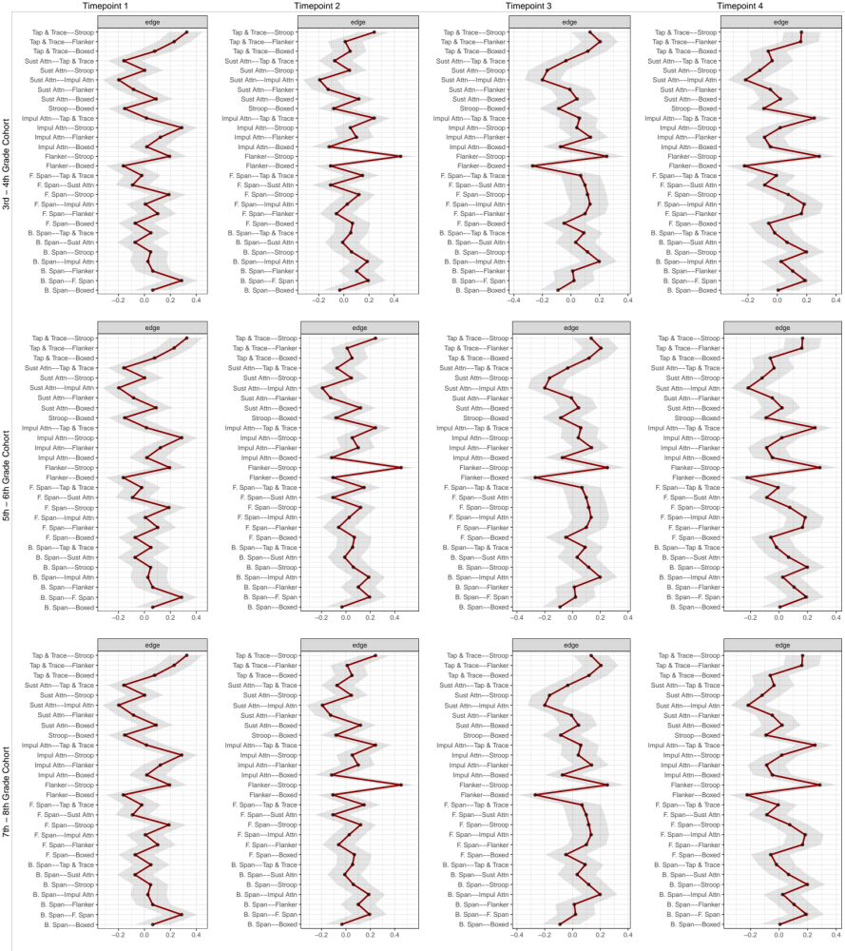Figure S3. Bootstrapped 95% Confidence Intervals of estimated edge-weights for each network of EF task performance. The red line indicates the sample values and the surrounding gray area the bootstrapped CIs. Each horizontal line represents one edge of the network. B. SPAN = Backward Spatial Span; F. SPAN = Forward Spatial Span; SUST ATTN = Sustained Attention; IMPUL ATTN = Impulsive Attention

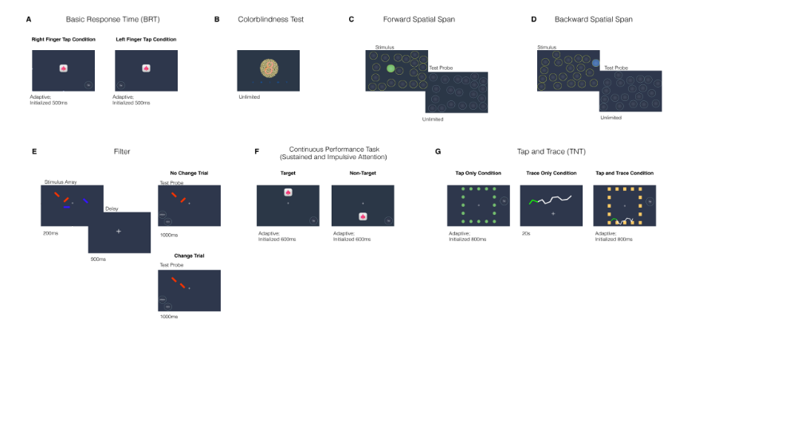
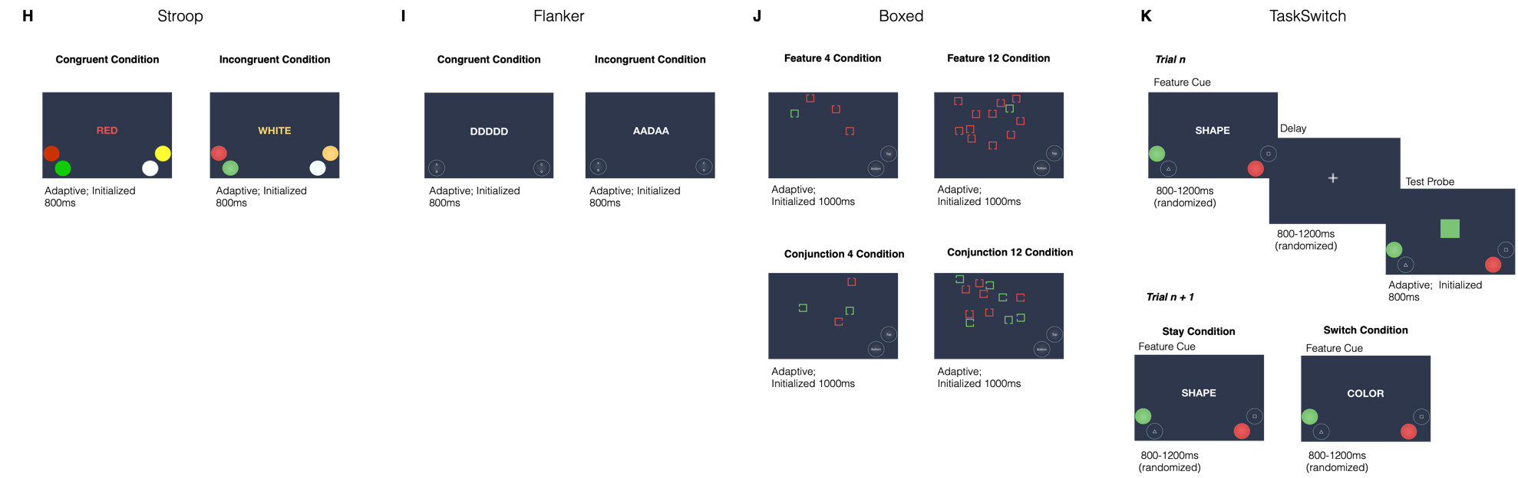
Figure S4. Example of stimuli and task schematics for each ACE task. All tasks had a trial result interval of 200ms and an inter trial interval of 1000ms following the target or probe. The trial result interval was 500ms for the Forward and Backward Spatial Span tasks.

