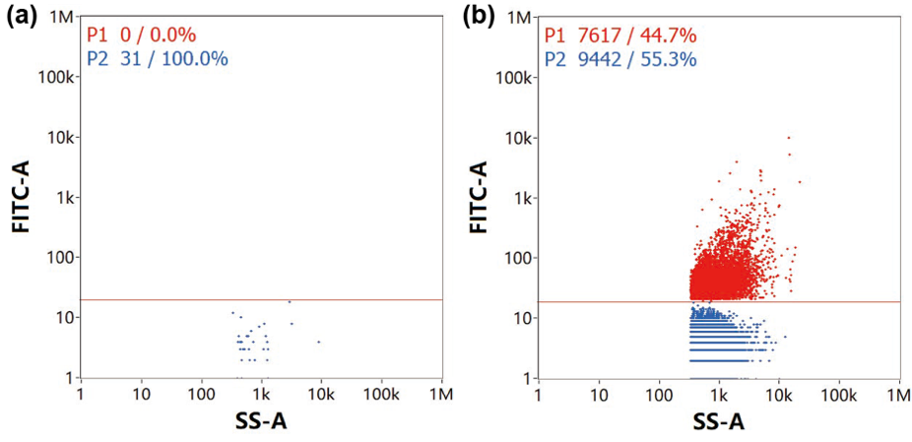
Extended Data Figure 1 | NanoFCM validation of CFSE-labelled EV purification. a, Dye-only control showing absence of fluorescence-positive particles. b, Purified CFSE-labelled EVs. P1 gate (red) indicates fluorescence-positive particles; P2 (blue) indicates non-fluorescent particles. This validation confirms that CFSE signal co-localizes with EV particles rather than free dye.

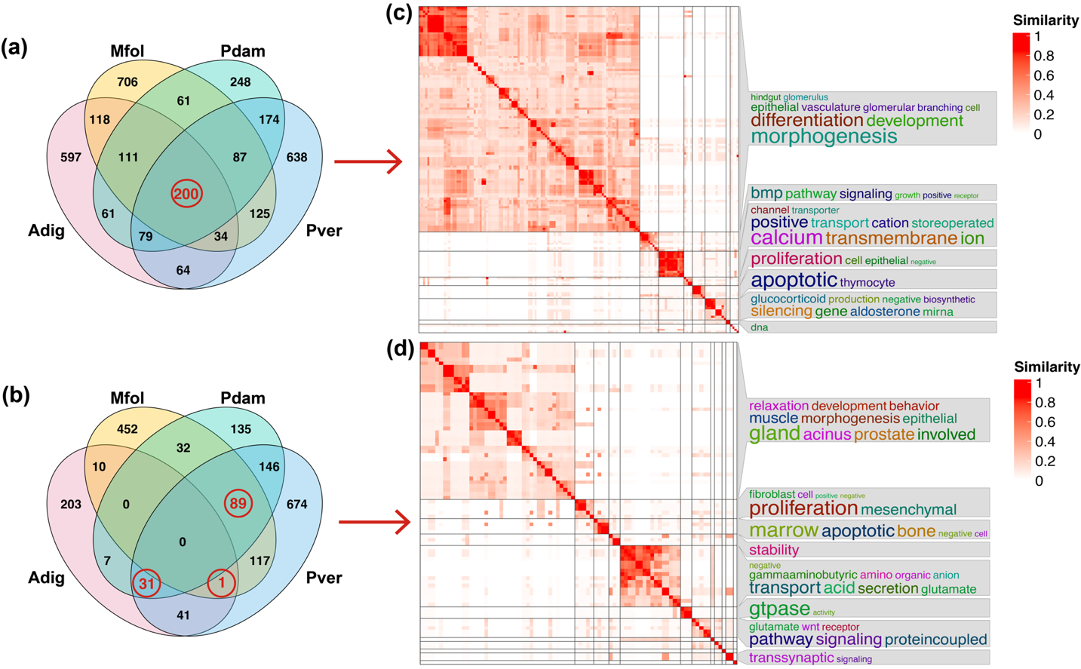
Extended Data Figure 2 | EV-miRNA target predictions across coral genomes. a-b, Venn diagrams showing significantly enriched GO terms among coral genes predicted to be targeted by EV-miRNAs from C. goreaui (a) and D. trenchii (b) across four coral host genomes. c-d, Semantic similarity clustering heatmaps and keyword clouds summarizing conserved GO terms for predicted coral target genes of EV-miRNAs from C. goreau (c) and D. trenchii (d). Color intensity of heatmaps indicates semantic similarity. Keyword size reflects relative representativeness.
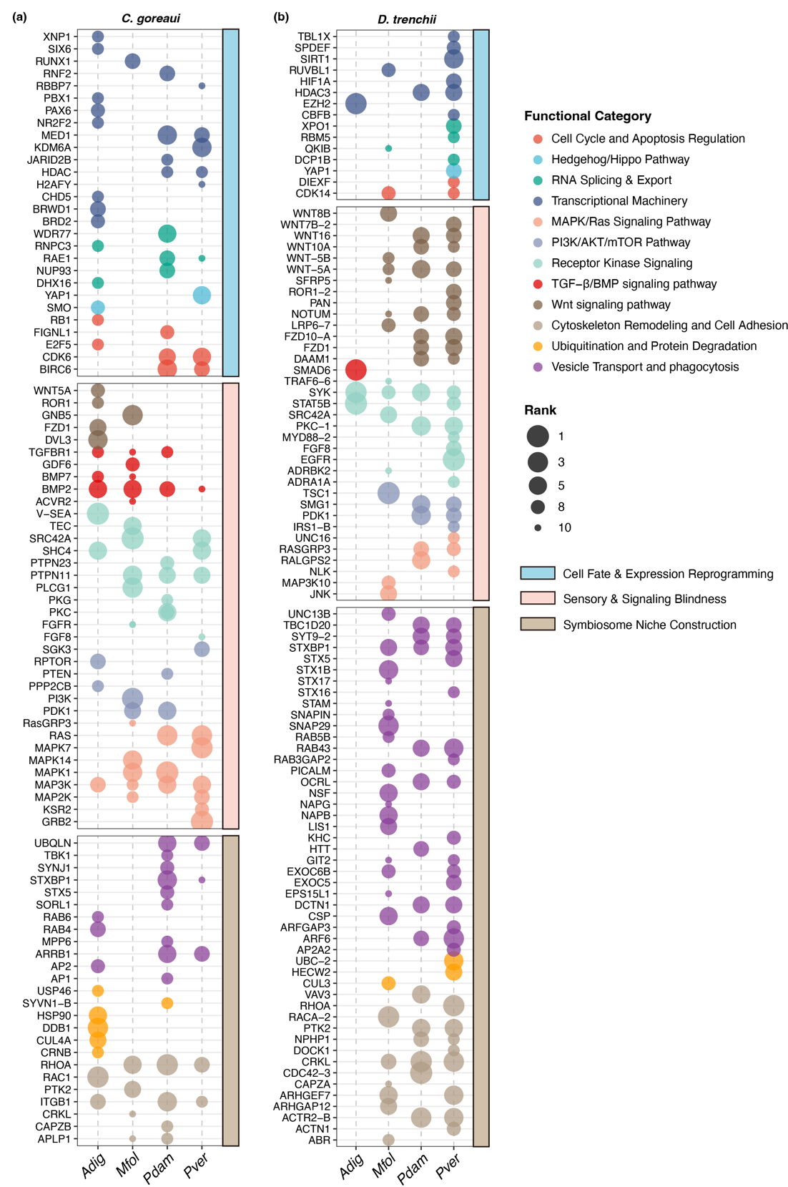
Extended Data Figure 3 | Hub target candidates of symbiont EV-miRNAs in coral hosts. a-b, coral hub genes predicted to be targeted by EV-miRNAs of C. goreaui (a) and D. trenchii (b) across four host species. Node size is proportional to the PPI degree connectivity rank. The candidate pool comprises nodes with degree connectivity ranking in the top 10 per host (allowing for ties), with a minimum degree threshold of 2.

Extended Data Table 1 | miRDeep2 prediction results of C. goreaui EV-miRNAs
miRNA name | miRDeep2 score | mature sequence | reported miRNA with same sequence
cgo-miR-tmp-2 | 1924.2 | acagauugcggcaaccgugc | cgo-miR-tmp-2
cgo-miR-EV-1 | 1890.4 | cgcacgcuauagacuccucu | -
cgo-miR-tmp-7 | 1009.8 | ugaaaaucuuugcucugaagugga | cgo-miR-tmp-7
cgo-miR-EV-16 | 485.7 | agcagguacgaucggggcagg | -
cgo-miR-tmp-4 | 375.4 | cgcgguugcugccaucuguu | cgo-miR-tmp-4
cgo-miR-EV-36 | 339 | cuccccuucaccgcacucauc | -
cgo-miR-EV-27 | 296.3 | acccaccgucuguccgcccug | -
cgo-miR-EV-4 | 199.5 | cgcacgcuauauacuccuug | -
cgo-miR-EV-6 | 158.8 | aacugcugaacucccuugcugugg | -
cgo-miR-EV-19 | 151.1 | uucccguucauugucuccgau | -
cgo-miR-EV-22 | 146 | ucuucacgugcggguccccug | -
cgo-miR-EV-15 | 135.6 | accgaagccaagaccugcu | -
cgo-miR-EV-17 | 130.8 | uacuucagguuguguggcgag | -
cgo-miR-EV-11 | 121.9 | gcuugagugucugcaguug | -
cgo-miR-EV-5 | 120.6 | cgcacgcuauauacuccucu | -
cgo-miR-EV-25 | 108.3 | agugaaaccccgugauggacu | -
cgo-miR-EV-18 | 97.7 | ucauccccucauccaaagcug | -
cgo-miR-EV-13 | 95.1 | gcucgaguuucugcaguug | -
cgo-miR-EV-29 | 77.8 | cgauguggccacuugcgcg | -
cgo-miR-EV-33 | 70.5 | cgccugggauccacagcuga | -
cgo-miR-EV-21 | 70.4 | ucccggaucgauaucagcc | -
cgo-miR-EV-14 | 64.5 | cuaagugauccggugguucug | -
cgo-miR-tmp-10 | 61.1 | ccuuggauucaucugccggcgu | cgo-miR-tmp-10
cgo-miR-EV-24 | 47.4 | aauacuccgcauugaaacug | -
cgo-miR-EV-28 | 35.4 | uuccagcgucgggcgcgccg | -
cgo-miR-EV-26 | 28.7 | ucgaucucucugcgugcccgac | -
cgo-miR-EV-23 | 28.4 | gguugugguucggccugc | -
cgo-miR-EV-20 | 28.1 | uguauuccccccuucgacgaaa | -
cgo-miR-EV-3 | 25.9 | ucuuguuucuacguggccuu | -
cgo-miR-EV-30 | 25.7 | gguugugugagcgaacuggagcgga | -
cgo-miR-EV-34 | 24 | uggaggaggguggugcuaggag | -
cgo-miR-EV-31 | 23.7 | ugauggcagagcugaagaa | -
cgo-miR-EV-2 | 21.2 | cuuugucagcuccgacuucuug | -
cgo-miR-EV-12 | 20.6 | agcucgaguuccugcaguug | -
cgo-miR-EV-10 | 20 | gucuggaacgaccucaucug | -
cgo-miR-EV-35 | 19.5 | ucauucugcugcaagaacaag | -
cgo-miR-EV-7 | 18 | ggacaaggcaguaggcaccu | -
cgo-miR-EV-8 | 16.1 | ccaucggcauggcggcuccg | -
cgo-miR-EV-9 | 16 | ccaucggcauggcggcuccgc | -
cgo-miR-EV-32 | 13.2 | ggcgggugcggcugcgggcguu | -

Extended Data Table 2 | miRDeep2 prediction results of D. trenchii EV-miRNAs
miRNA name | miRDeep2 score | mature sequence | reported miRNA with the same seed | reported miRNA sequence
dtr-miR-EV-1 | 417.1 | acagauugcggcaaccgugc | cgo-miR-tmp-2 | acagauugcggcaaccgugcag
dtr-miR-EV-2 | 296 | ugcuauguccggacagg | -
dtr-miR-EV-3 | 222.4 | uuuuccgguggccuuuuuuu | -
dtr-miR-EV-4 | 126.7 | gauuuguccggucggcgcg | -
dtr-miR-EV-5 | 13.2 | caaguuggcucagacgc | -
dtr-miR-EV-6 | 6.5 | ucacugcaggucaacgaa | -
dtr-miR-EV-7 | 5.5 | gugcugcgucucgguguguucu | -
dtr-miR-EV-8 | 3.3 | cauuuggugguugggcggg | -
dtr-miR-EV-9 | 3 | gcuugcuguacuuguuugcu | -
dtr-miR-EV-10 | 2.2 | agaccgugcugacugcagcgu | -
dtr-miR-EV-11 | 2.1 | acaugguuggaggugugga | -
dtr-miR-EV-12 | 1.3 | gguucgacgaccgccgcagcc | -
dtr-miR-EV-13 | 1.3 | uucgacgaccgccgcagccu | -
dtr-miR-EV-14 | 1.3 | ugaaaaucuuucuucugaggcggaa | cgo-miR-tmp-7 | ugaaaaucuuugcucugaagug
dtr-miR-EV-15 | 0.4 | ccgggggcggcgggcuc | -
dtr-miR-EV-16 | 0.4 | agugucggugguucgauu | -
dtr-miR-EV-17 | 0.3 | cggggcggacggggugg | -
dtr-miR-EV-18 | 0.3 | gcguuuggccguuggggaguugccu | -
dtr-miR-EV-19 | 0.3 | ggagaagaagccgggcuau | -
dtr-miR-EV-20 | 0.3 | cuccuggcgcugggccuggcgg | -
dtr-miR-EV-21 | 0.3 | acgcugcggcggcuggcg | -
dtr-miR-EV-22 | 0.3 | ugaaaaucuuucuucugaggc | cgo-miR-tmp-7 | ugaaaaucuuugcucugaagug
dtr-miR-EV-23 | 0.2 | guggaaaguccgggcucc | -
dtr-miR-EV-24 | 0.2 | cgugguggcggcugagcu | -
dtr-miR-EV-25 | 0.2 | cucgcuucggcgggcuuu | -
dtr-miR-EV-26 | 0.2 | gcggggcguccgggacca | -
dtr-miR-EV-27 | 0.1 | gcaaggccguggagagcuuccu | -
dtr-miR-EV-28 | 0.1 | augccgacggugcugcu | -
dtr-miR-EV-29 | 0.1 | uccaagcuccgggccgcu | -
dtr-miR-EV-30 | 0.1 | ucuccaagcuccgggccgcu | -
dtr-miR-EV-31 | 0.1 | cagcgguccggcuuuuc | -
dtr-miR-EV-32 | 0.1 | ugcgggugcgggugcucc | -
dtr-miR-EV-33 | 0.1 | guggguggccgggugggg | -
dtr-miR-EV-34 | 0.1 | guggguggccggguggggg | -
dtr-miR-EV-35 | 0.1 | gccggguguggacgugg | -
dtr-miR-EV-36 | 0.1 | ggcgugggagaguagguc | -
dtr-miR-EV-37 | 0.1 | aucgaccuggagcucga | -
dtr-miR-EV-38 | 0.1 | agugcuugaaauugcug | -
dtr-miR-EV-39 | 0.1 | cucucgggaguuggcggc | -
dtr-miR-EV-40 | 0.1 | acacccgucacgaccagaga | -

Extended Data Table 3 | Statistics of target candidates of EV-miRNAs from C. goreaui and D. trenchii in four coral genomes
Host | Target counts  in C. goreaui | Target counts  in D. trenchii | CDS counts | Target/CDS  in C. goreaui | Target/CDS  in D. trenchii
Adig | 2809 | 2596 | 33878 | 8.3% | 7.7%
Mfol | 7806 | 7711 | 46765 | 16.7% | 16.5%
Pdam | 2456 | 2024 | 25183 | 9.8% | 8.0%
Pver | 4763 | 4125 | 37406 | 12.7% | 11.0%

