Additional file 1.
Supplementary table 1. Mouse monoclonal Antibodies and reagents used for flow cytometry
Antibodies | Company | Reference No,
Surface marker of MSCs
FITC-conjugated -CD90 | Becton & Dickinson Bioscience (BD Bioscence, USA) | 555595
PerCP-anti-CD73 | Becton & Dickinson Bioscience (BD Bioscence, USA) | 561260
APC-anti-CD105 | Becton & Dickinson Bioscience (BD Bioscence, USA) | 562408
APC-anti-CD45 | Becton & Dickinson Bioscience (BD Bioscence, USA) | 555485
FITC-anti-CD44 | Becton & Dickinson Bioscience (BD Bioscence, USA) | 347943
FITC-anti-CD34 | Becton & Dickinson Bioscience (BD Bioscence, USA) | 348053
PE-anti-CD73 | Becton & Dickinson Bioscience (BD Bioscence, USA) | 550257
PE-anti-CD11b | Becton & Dickinson Bioscience (BD Bioscence, USA) | 561001
PE-anti-CD19 | Becton & Dickinson Bioscience (BD Bioscence, USA) | 561741
FITC-anti-HLA-ABC | Beckman Coulter (BC) Inc.; (BC, USA) | IM1838U
PE-anti-HLA-DR | BC | IM0464U
IOTest IgG FITC | BC | A07795
IOTest IgG PE | BC | A07796
IOTest IgG APC | BC | IM2475
mouse IgG PerCP Isotype | BD Bioscence | 4276971

Supplementary Table 2. Primers for qRT-PCR

 | Forward primer (5ʹ-3ʹ) | Reverse primer (5ʹ-3ʹ)
GAPDH | CACTGAGCATCTCCCTCACA | GTGGGTGCAGCGAACTTTAT
IL-6 | AGTTGCCTTCTTGGGACTGA | TCCACGATTTCCCAGAGAAC
TNF-α | CGTCAGCCGATTTGCTATCT | CGGACTCCGCAAAGTCTAAG
IL-1β | GCCCATCCTCTGTGACTCAT | AGGCCACAGGTATTTTGTCG
iNOS | GTTCTCAGCCCAACAATACAAGA | GTGGACGGGTCGATGTCAC
Arg1 | CTCCAAGCCAAAGTCCTTAGAG | AGGAGCTGTCATTAGGGACATC
NKCC1 | TCAGTCAGCCATACCCAAAGG | GAACAACACACGAACCCACAG
KCC2 | GGGCAGAGAGTACGATGGC | TGGGGTAGGTTGGTGTAGTTG

Additional file 2. Surface markers of UC-MSCs and differentiation potencies
Characterization of Passage 4 (P4) UC-MSCs used in this experiment was performed.
Flow cytometry analysis of UC-MSC surface antigens revealed positivity for CD105, CD73, CD90, CD44, and HLA-ABC and negativity for CD45, CD34, CD11b, CD19, and HLA-DR (A). UC-MSCs adhered to plastic dishes and proliferated with a spindle-shaped morphology (B). UC-MSCs differentiated into adipocytes(C), osteoblasts(D), and chondrocytes (E.F).

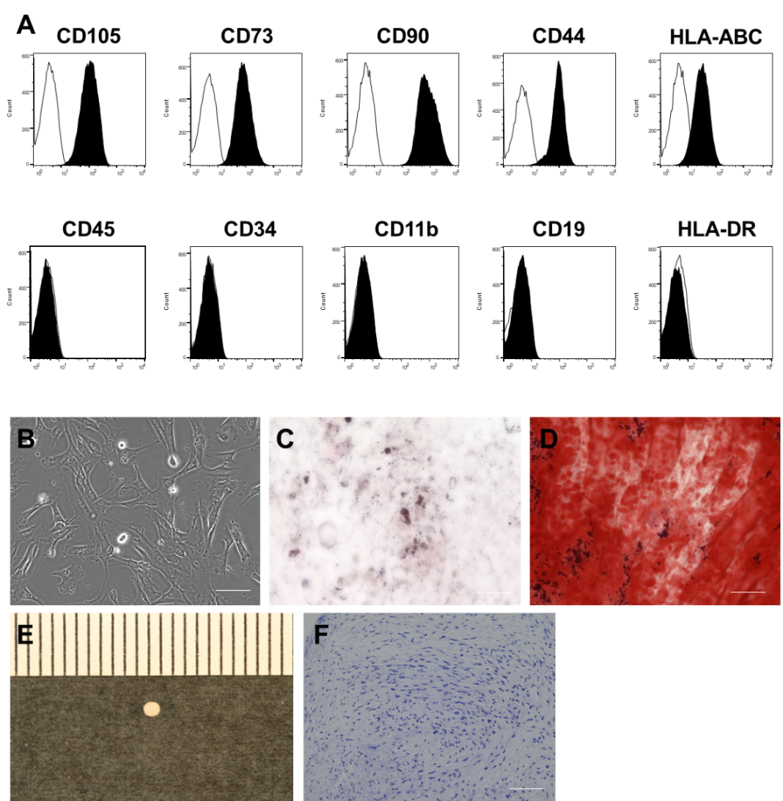

Additional file 3. Morphology and purity of primary microglial cells
Mixed glial cells were cultured from the cerebral tissue of 8 pups at P0-2, and CD11b-positive microglial cells were selectively isolated by MACS. Cells were seeded at a concentration of 1.0 × 10⁵ cells/mL in a 6-well plate and used for co-culture experiments with UC-MSCs (A). In mixed glial cells, microglia cells proliferate and form colonies as round cells in the upper layer (before MACS sorting) (B). After isolation by MACS, they adhere to a Poly-L-Lysine-coated plate and take on an elongated rod-type morphology (after MACS) (C). Iba1 staining showed a purity of 98.9% based on the Iba1/DAPI ratio (D). Red: Iba1 staining, Blue: DAPI staining, Scale bar = 100 µm

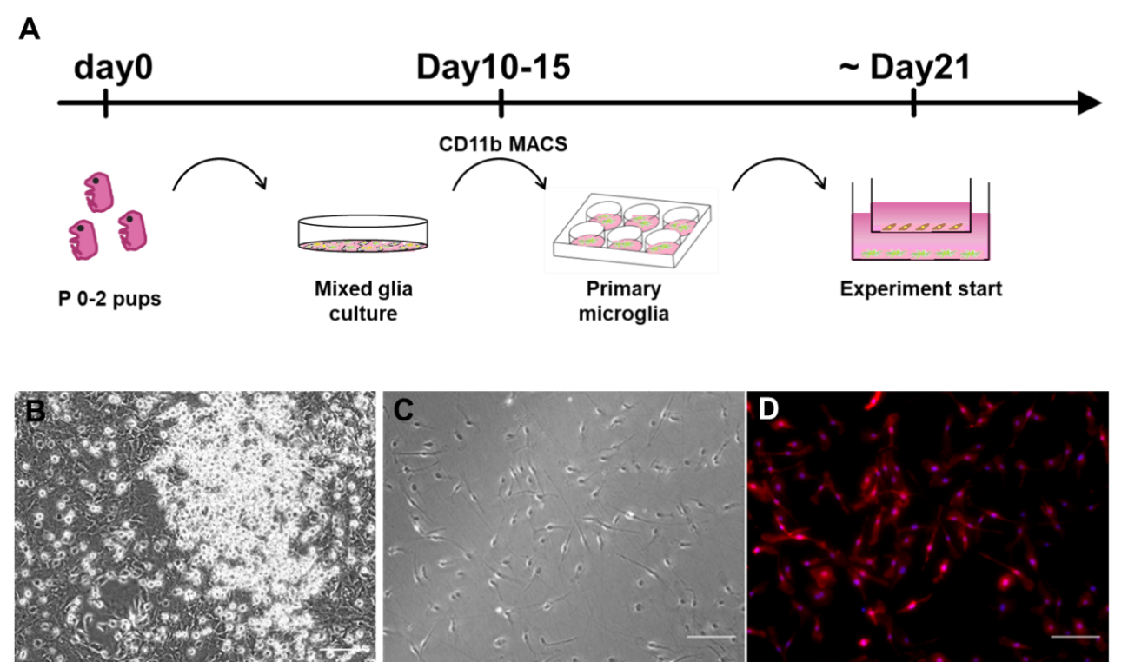

Additional file 4. Body temperature measurement before and after Poly(I:C) administration using a thermography camera

(A) Thermal imaging camera image, (B) Region of Interest (ROI) for MBST measurement, C) Changes in MBST before and after Poly(I:C) administration, (D-F) Images before Poly(I:C) administration including D) Control(D,H), SE(E,I), SE+MSC(F,J) group three hours before and after Poly (I:C) administration, respectively. Thermal image before after hot air exposure(G, K). No significant change in mean body surface temperature (MBST) was observed in any group following Poly(I:C) administration. The possibility of body temperature fluctuations contributing to seizure exacerbation was considered low.
Control n=4, SE n=6, SE + MSCs n=6. Values indicate means ± S.D.

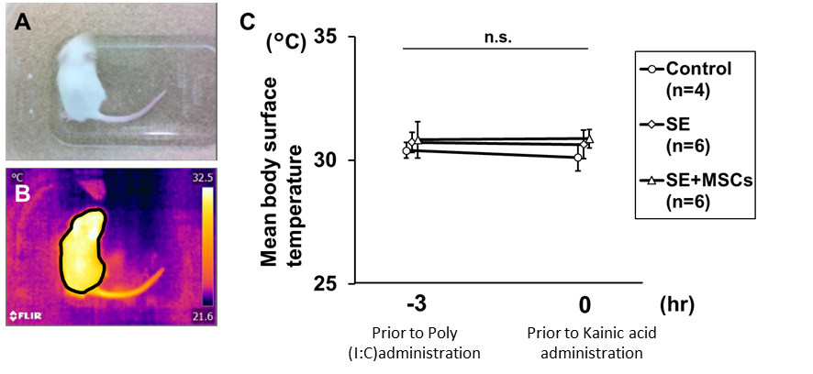

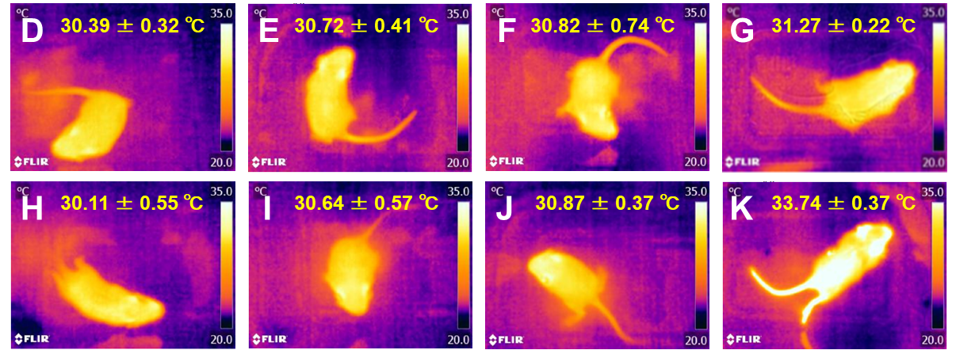

Additional file 5. KCC2 Ser940 / GAPDH Western blotting assay
Chemiluminescence was detected using ImmunoStar® LD (Wako Pure Chemical Industries, Japan) and visualized using a C-DiGit chemiluminescent scanner (LI-COR, US). Protein expression was normalized against expression using the Image Studio software (Control; n = 6, SE; n = 6, MSC;SE + MSCs; n = 6). Red squared part was presented in the manuscript (Figure 4C)
