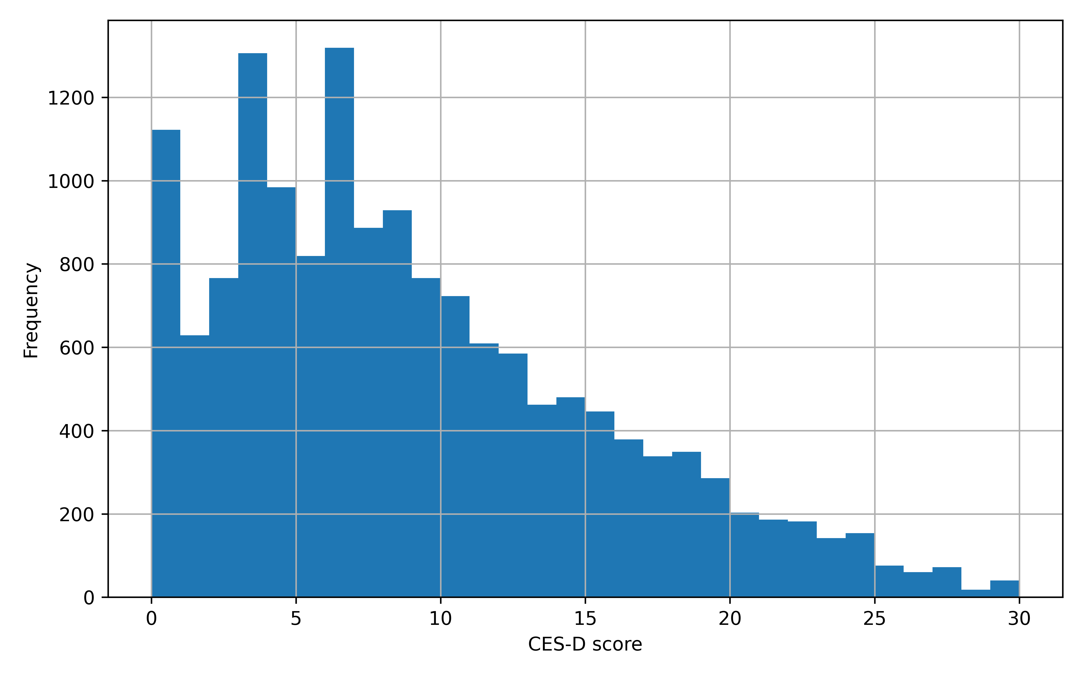
Supplementary Figure S1. Distribution of CES-D-10 scores among study participants
Note: Distribution of CES-D-10 scores among study participants.
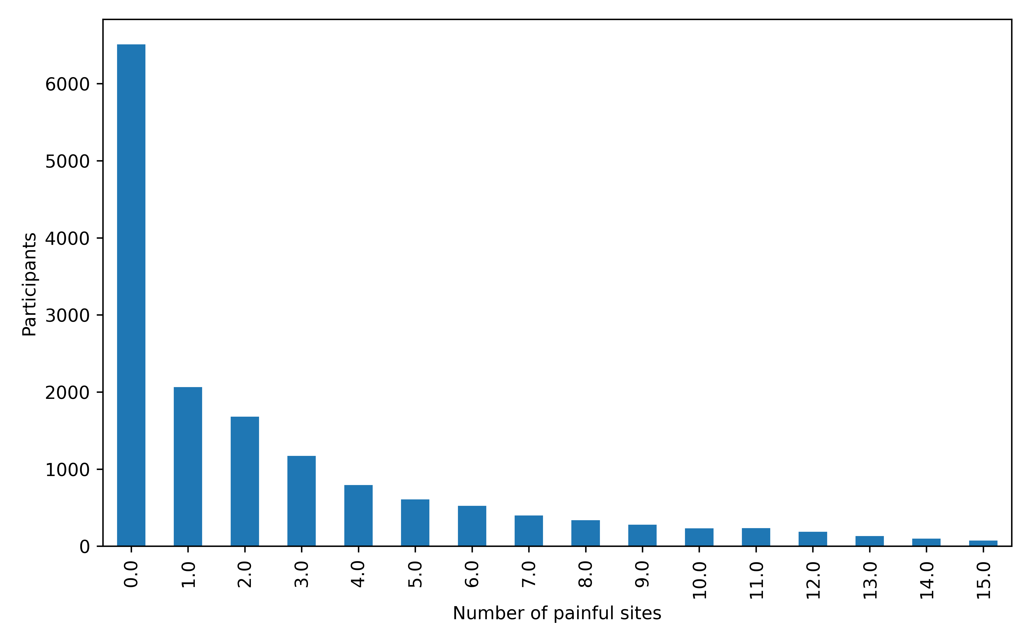
Supplementary Figure S2. Distribution of the number of painful body sites among study participants
Note: Histogram showing the distribution of pain burden, defined as the number of painful anatomical sites reported by each participant. Most participants reported pain at relatively few sites, whereas progressively fewer participants reported multiple painful sites.

Supplementary Table S1. Sensitivity analysis of the association between pain burden (per additional painful site) and depressive symptoms
Model | OR (95%CI) | P
Crude | 1.205 (1.192 - 1.218) | < 0.001
Model 1 | 1.187 (1.174 - 1.200) | < 0.001
Model 2 | 1.178 (1.165 - 1.191) | < 0.001
Model 3 | 1.177 (1.164 - 1.191) | < 0.001
Note: Odds ratios (ORs) represent the increase in the odds of depressive symptoms associated with each additional painful anatomical site. Model adjustments were identical to those described in Table 3.

Supplementary Table S2. Mediation analysis of sleep duration in the association between pain burden and depressive symptoms
Parameter | Estimate | 95% CI
Indirect effect | 0.020 | 0.017 – 0.023
Direct effect | 0.148 | 0.136 – 0.160
Total effect | 0.163 | 0.152 – 0.175
Proportion mediated | 12.1% | 10.3% – 14.3%
a path (Pain burden → Sleep duration) | −0.101 | −0.109 to −0.092
b path (Sleep duration → Depressive symptoms) | −0.197 | −0.221 to −0.175
Note: The mediation analysis was performed using bootstrap resampling (5,000 iterations). The indirect effect represents the effect of pain burden on depressive symptoms mediated through sleep duration. The direct effect represents the association between pain burden and depressive symptoms after accounting for sleep duration. The total effect is the sum of the direct and indirect effects. The proportion mediated was calculated as the indirect effect divided by the total effect. The a path denotes the association between pain burden and sleep duration, whereas the b path denotes the association between sleep duration and depressive symptoms after adjustment for pain burden.

