SUPPLEMENTARY MATERIAL

Manuscript Title: CT-DERIVED ENDOCRANIAL VOLUME AS A SURROGATE FOR MRI-DERIVED TOTAL BRAIN VOLUME IN DOMESTIC CATS
Authors: Nermin Cirak [1], Ceren Nur Giray Bektas [2], Muhammed Taha Temir [2], Eyup Fatih Elmas [3], Murat Karabagli [2], Mehmet Saadeddin Ozturk [4]*

Table of Contents for Supplementary Material
Supplementary Figure 1 Left panel presents a sagittal reference image of cat brain anatomy, provided by the IMAIOS site. It serves as an anatomical guide for the study from the sagittal perspective. Segmentation was verified by cross-checking with e-anatomy and with the help of experts. 3
Supplementary Figure 2 DICOM-format MRI scans of Cat 12, showing the brain in three planes: (a) transversal, (b) dorsal, and (c) sagittal. These raw images provide the anatomical basis for segmentation. 4
Supplementary Figure 3 Painted MRI scans of Cat 12 in (a) transversal, (b) dorsal, and (c) sagittal views. Manual region-of-interest (ROI) annotation highlights brain tissue in different colours to guide segmentation. 5
Supplementary Figure 4 Thresholded MRI scans displayed in (a) transversal, (b) dorsal, and (c) sagittal planes. Thresholding isolates brain tissue while excluding surrounding structures. 5
Supplementary Figure 5 MRI-derived TBV. Intermediate stages of segmentation are shown: (a) 3D rendering of painted mask, (b) interpolated mask after Fill Between Slices, (c) threshold-applied volume, and (d) final smoothed segmentation. 6
Supplementary Figure 6 DICOM-format CT scans of Cat 12, showing the brain and surrounding cranial structures (a) transversal, (b) dorsal, and (c) sagittal planes. 7
Supplementary Figure 7 Thresholded CT scans in (a) transversal, (b) dorsal, and (c) sagittal views. Thresholding isolates the endocranial cavity by excluding bone and dense tissue. 7
Supplementary Figure 8 CT-derived endocranial volume was shown in (a) transversal, (b) dorsal, and (c) sagittal planes. The green shades represent the endocranial cavity, while red structures correspond to adjacent osseous tissue. 8
Supplementary Figure 9 Segmentation workflow for CT-derived EV. Steps include (a) thresholding, (b) trimming of non-brain structures, and (c) solidified 3D reconstruction of the cranial cavity. 8

MATERIALS and METHOD
Clinical MRI and CT images of 15 cats, male/female, various weights and breeds were collected. Routine clinical imaging modalities delivered cross-section images of cat brain. These images were then processed and segmented using an open-source 3D visualization software 3D Slicer [1], enabling an accurate estimation of Endocranial Volume (EV).

Sample Preparation and Animal Selection
The study included 15 domestic cats of various breeds, including Russian Blue, Scottish Fold, British Shorthair and mixed/unknown breed. The subjects represented a diverse demographic, with ages spanning from 4 months to 13 years and body weights ranging from 0.4 kg to 5 kg. To ensure optimal scan quality and alignment, all cats were anesthetized before undergoing both MRI and CT imaging for comparative analysis.
Supplementary Table 1. Demographics of the feline cohort undergoing CT and MRI. Breed labels were standardized; coat/pattern information is preserved in a separate column. Ages are in months.
Patient ID | Breed | Coat/Notes | Age(months) | Sex | Weight(kg)
Cat 1 | British Shorthair | - | 108 | F | 4.0
Cat 2 | Mixed/Unknown | Tabby | 156 | M | 4.0
Cat 3 | Mixed/Unknown | Tabby | 36 | M | 3.0
Cat 4 | Mixed/Unknown | Tawny | 24 | M | 3.2
Cat 5 | Mixed/Unknown | Stray | 60 | M | 4.0
Cat 6 | Mixed/Unknown | Tabby | 36 | F | 3.0
Cat 7 | Mixed/Unknown | Tabby | 4 | F | 2.4
Cat 8 | Mixed/Unknown | Tabby | 4 | F | 0.4
Cat 9 | Mixed/Unknown | Stray | 11 | M | 6.8
Cat 10 | Mixed/Unknown | Tabby | 5 | F | 3.0
Cat 11 | Mixed/Unknown | Stray | 6 | M | 2.0
Cat 12 | Mixed/Unknown | Tabby | 24 | M | 4.0
Cat 13 | Mixed/Unknown | Tabby | 84 | F | 3.0
Cat 14 | Russian Blue | - | 30 | F | 5.0
Cat 15 | Scottish Fold | - | 6 | F | 3.0

Fifteen domestic cats (Felis catus) underwent both CT and MRI of the head (same anesthetic session). Demographic data are summarized in Table 1 (age range [4–156] months; weight [0.4–6.8] kg). Inclusion criteria: diagnostic-quality CT and MRI acquired; absence of prior cranial surgery. Exclusion criteria: motion artifact precluding segmentation; large mass lesions distorting the cranial vault.
Premedication with medetomidine (80 µg/kg IV) was administered. Anesthesia was induced using propofol (4 mg/kg IV) and maintained with isoflurane (2% in 100% oxygen) via an endotracheal tube. Ventilation was spontaneous, with EtCO₂ maintained between 35–45 mmHg. Temperature, SpO₂, ECG, and MAP were continuously monitored throughout the procedure. Ethical approval (İstanbul Üniversitesi-Cerrahpaşa Rektörlüğü Hayvan Deneyleri Yerel Etik Kurul Başkanlığı, Decision No: 2025/91) and owner consent were obtained. All cats were anesthetized and imaged under standardized clinical protocols to minimize motion and physiological variability. Imaging was performed during a single anaesthetic session with CT acquired first, followed by MRI.

CT protocol
Scans were obtained on a Siemens SOMATOM Scope (vc30b). Cats were positioned in sternal recumbency with neutral head alignment. Acquisition parameters were tube potential 110 kVp, exposure [28] mAs, collimation [0,6] mm, rotation time [14] s, and reconstruction with soft-tissue and bone kernels at 0.6 mm slice thickness and isotropic voxels 0.6 mm. Multiplanar reformats (axial, sagittal, dorsal) were generated.

MRI protocol
MRI was performed on a Siemens Symphony 1.5 T using a [small flex/head] coil. The protocol included a 3D T2-weighted sequence [SPACE/CUBE/FSE] with isotropic voxel size [0.8–1.0] mm (TR [3000-4500] ms, TE [80-120] ms,) and complementary T1-weighted and FLAIR sequences for anatomical delineation.

Segmentation Workflow
We defined EV as the volume of the intracranial cavity bounded by the inner table of the skull base and calvarium, including brain and spinal cord and cerebrospinal fluid (CSF) spaces, and excluding paranasal sinuses and tympanic bullae. All processing was performed in 3D Slicer (v5.8)[1].
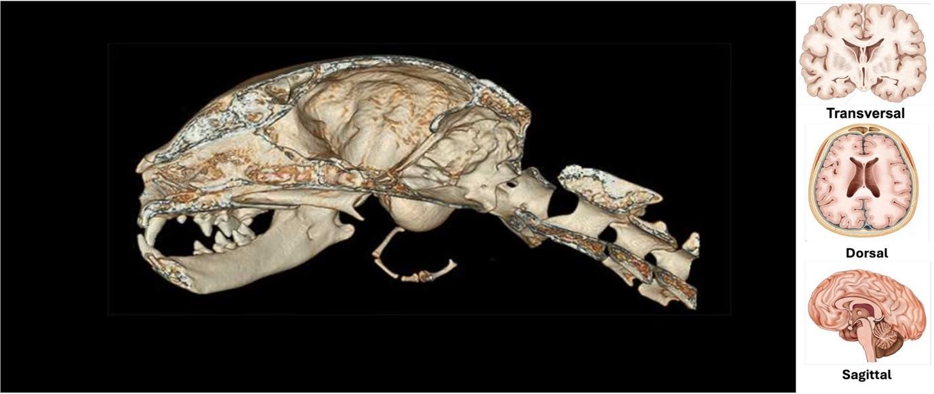
Supplementary Figure 1. Left panel presents a sagittal reference image of cat brain anatomy. It serves as an anatomical guide for the study from the sagittal perspective. Segmentation was verified by cross-checking with e-anatomy and with the help of experts. Image courtesy of IMAIOS; credit: vet-Anatomy: Micheau A, Hoa D, vet-Anatomy Atlas, www.imaios.com, DOI: 10.37019/vet-anatomy.

The labelled image (Supplementary Figure 1) serves as an anatomical guide for the study, illustrating key structures within the cat's brain from the sagittal perspective. Moreover, anatomical landmarks were cross-referenced with e-anatomy; final masks were reviewed by a veterinary radiology specialist.

MRI Brain Segmentation
DICOM MRI data were imported into 3D Slicer (v5.8). Among the available scans, only one dataset contained all three anatomical planes (transversal, dorsal, sagittal), allowing for complete segmentation. This dataset was used for further analysis.
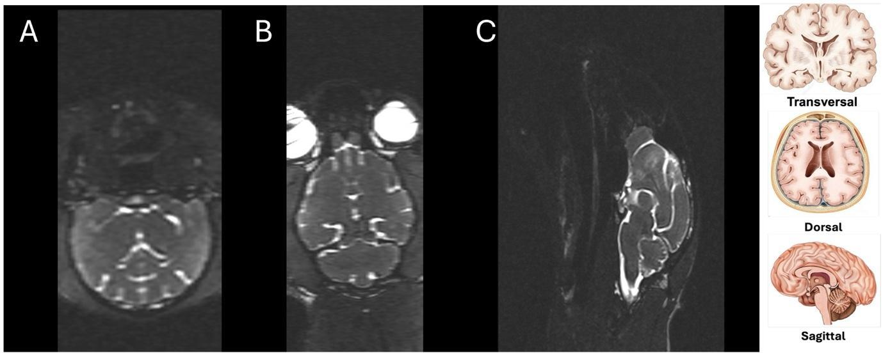
Supplementary Figure 2. DICOM-format MRI scans of Cat 12, showing the brain in three planes: (a) transversal, (b) dorsal, and (c) sagittal. These raw images provide the anatomical basis for segmentation.

The segmentation process began with manual tracing of brain boundaries across multiple slices using the Paint module in 3D Slicer (Supplementary Figure 2). These contours were interpolated with the Fill Between Slices tool to generate a preliminary 3D mask. MRI volumes were N4 bias-corrected to reduce intensity inhomogeneity; enable isotropic editing. Then the images were resampled to [1.0] mm isotropic voxels. When needed, rigid registration (BRAINSFit) aligned MRI to CT to propagate cavity boundaries. Threshold values and boundary rules used in subsequent segmentation steps are detailed in the following paragraphs.

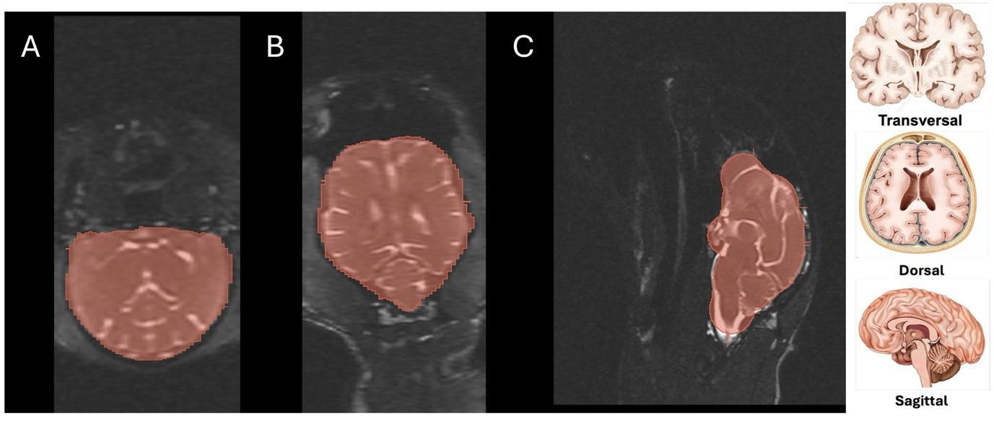
Supplementary Figure 3. Painted MRI scans of Cat 12 in (a) transversal, (b) dorsal, and (c) sagittal views. Manual region-of-interest (ROI) annotation highlights brain tissue in different colours to guide segmentation.

Using the CT endocast as an outer boundary prior when registered, the brain parenchyma was segmented on T2-weighted MRI by manual painting and Fill-between-slices; CSF spaces and dural sinuses were excluded as much as possible. The mask was smoothed with a median kernel [1–2] mm and quantified in Segment Statistics.
Thresholding was applied within the masked region to enhance brain tissue delineation, using signal intensity–based thresholding with values between 33–55 and up to 160 for brainstem fiducial markers (Supplementary Figure 3). These thresholds weren’t fixed; instead, for each subject, the cutoff was adjusted iteratively within this range to preserve as much true brain parenchyma as possible while excluding non-parenchymal areas. This case-by-case adjustment accounted for subtle session-to-session variations (things like scanner calibration differences or changes in ambient conditions). The result was a consistently defined brain region across all subjects. After thresholding, non-brain areas and imaging artefacts were removed using the Scissors tool, referencing anatomical landmarks visible on MRI (Supplementary Figure 4).
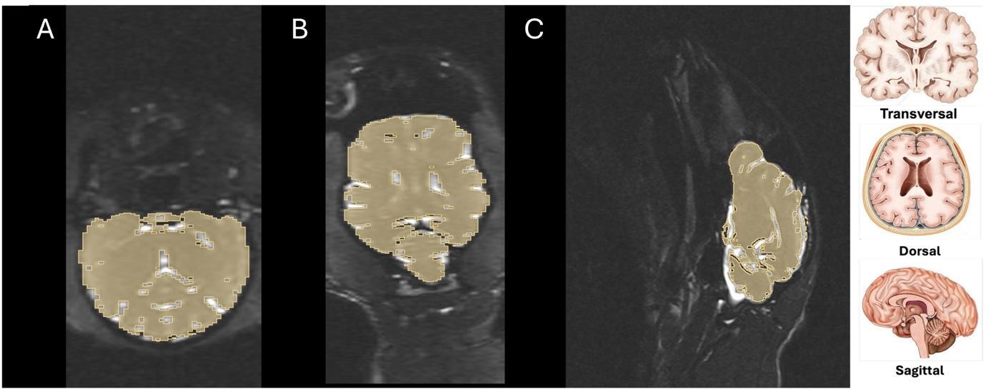
Supplementary Figure 4. Thresholded MRI scans.They displayed in (a) transversal, (b) dorsal, and (c) sagittal planes. Thresholding isolates brain tissue while excluding surrounding structures.

To refine the segmentation, a median smoothing filter with a kernel radius of [3 mm] was applied to eliminate minor irregularities around the brain surface. Additional trimming was performed to ensure anatomical accuracy and to remove residual non-brain voxels. For consistency between modalities, the brainstem was excluded from both CT- and MRI-derived segmentations.
The final 3D segmentation was visualized and quantified using the Segment Statistics module in 3D Slicer, yielding volumetric measurements of the total brain volume (TBV), including some CSF which could not remove exactly, while excluding ventricles, venous sinuses.
Representative steps of this workflow are illustrated in Supplementary Figure 5,showing the painted slices, interpolated volumes, threshold application, and the final smoothed segmentation and volumes were computed with Segment Statistics, function (3D Slicer).
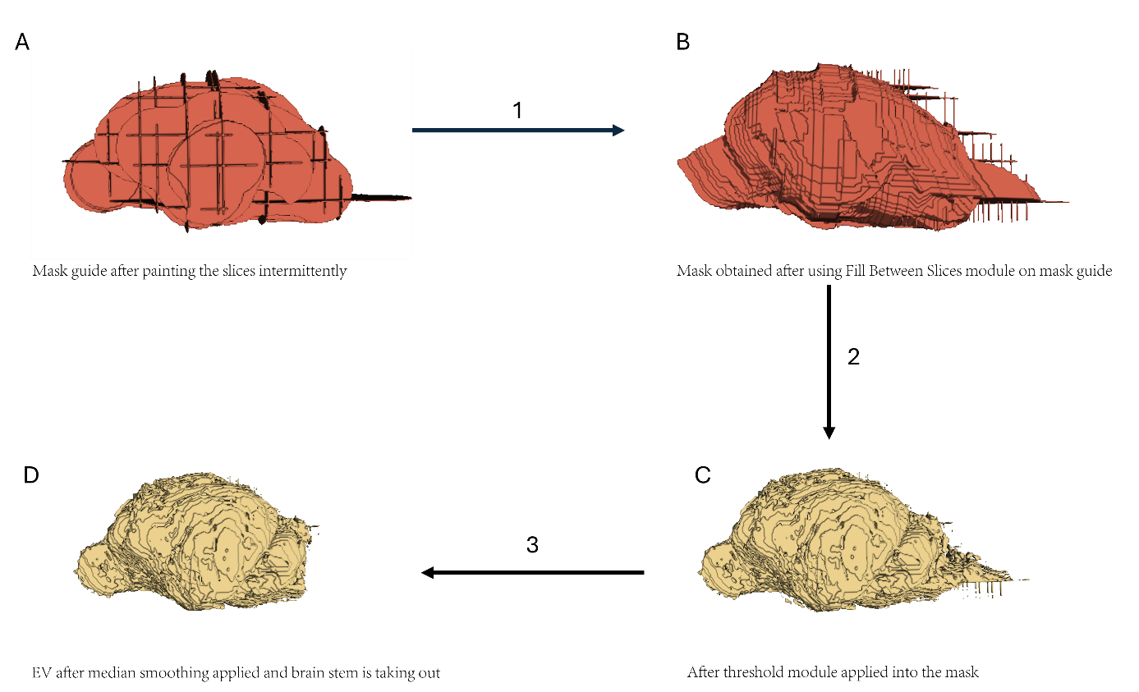
Supplementary Figure 5. MRI-derived TBV. Intermediate stages of segmentation are shown: (a) 3D rendering of painted mask, (b) interpolated mask after Fill Between Slices, (c) threshold-applied volume, and (d) final smoothed segmentation.

CT Brain Segmentation
CT DICOM data were imported into 3D Slicer (v5.8). A single dataset containing dorsal, transverse, and sagittal reconstructions was available and used for segmentation. Prior to segmentation, surface smoothing was disabled to preserve structural detail (Supplementary Figure 6).
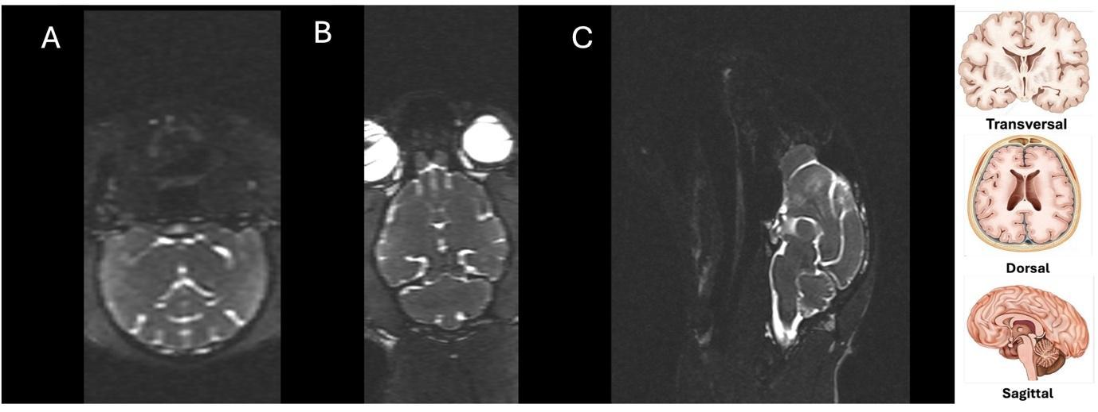
Supplementary Figure 6. DICOM-format CT scans of Cat 12. The images illustrate the brain and surrounding cranial structures in the (a) transversal, (b) dorsal, and (c) sagittal planes.

To guarantee uniform isolation of intracranial spaces from bone, segmentation started with fixed thresholding in the Segment Editor module, applying a fixed intensity cutoff of 300 HU across all cats (Supplementary Figure 7). Histogram analysis, which verified that all subjects had comparable intensity ranges within the same interval, was used to determine this value. In order to guarantee complete coverage of the endocranial region while avoiding the orbits, paranasal sinuses, and ear bullae, the intracranial spaces were then obtained by seeded region-growing, which was started from a manually placed intracranial seed positioned centrally within the cranial cavity, usually near the midline.
This procedure generated an initial mask of the endocranial cavity. Residual non-brain regions and imaging artifacts were manually removed using the Scissors tool, referencing anatomical landmarks in CT images (Supplementary Figure 7).
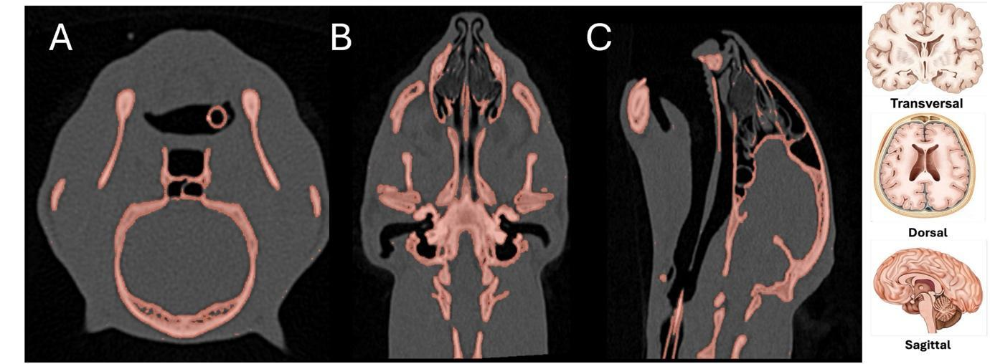
Supplementary Figure 7. Thresholded CT scans in (a) transversal, (b) dorsal, and (c) sagittal views. Thresholding isolates the endocranial cavity by excluding bone and dense tissue.

The Wrap Solidify extension was subsequently applied to the cropped mask, with split cavities set to [5 mm], yielding a seamless 3D reconstruction of the endocranial cavity. This model delineated the cranial EV with high fidelity, minimizing gaps and discontinuities. For consistency with MRI-derived segmentations, the brainstem region was excluded from the final volume.
The processed segmentation provided a 3D endocranial model suitable for volumetric analysis, closely resembling the morphology of MRI-derived segmentations (Supplementary Figure 7). Intermediate steps of the CT workflow, including thresholding, trimming, and surface solidification, are illustrated in Supplementary Figure 8.

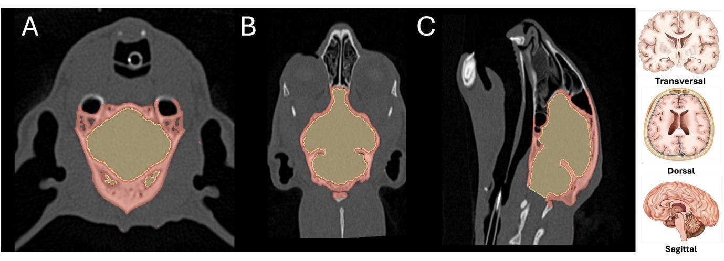
Supplementary Figure 8. CT-derived EV was shown in (a) transversal, (b) dorsal, and (c) sagittal planes. The green shades represent the endocranial cavity, while red structures correspond to adjacent osseous tissue.

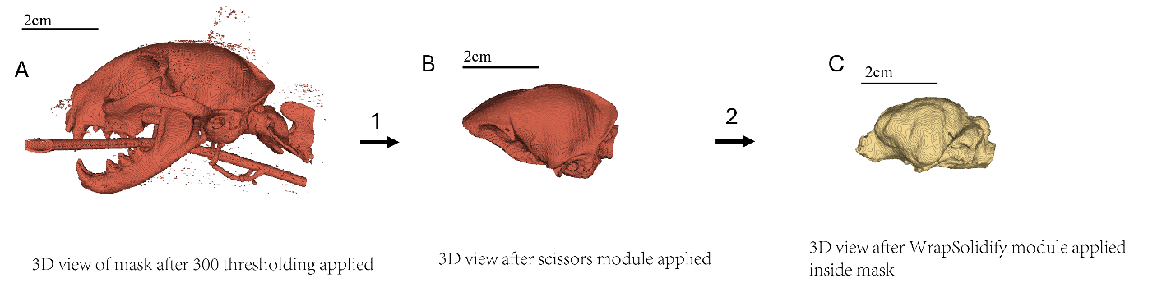
Supplementary Figure 9. Segmentation workflow for CT-derived EV. Steps include (a) thresholding, (b) trimming of non-brain structures, and (c) solidified 3D reconstruction of the cranial cavity.

Statistical analysis: Linear Regression Model
MRI and CT scans were obtained from 15 cats (ages 0.3–13 years, weights 0.4–6.8 kg) representing a range of breeds. MRI provided TBV, whereas CT provided EV. Demographic data (age, sex, weight) were recorded. Linear regression models were fit with TBV as the dependent variable and EV, age, log(weight), and sex as predictors. Leave-one-out cross-validation (LOOCV) was performed to evaluate predictive accuracy. Agreement was further assessed with Bland–Altman analysis.
The linear regression model was selected based on the biological and anatomical expectation that TBV scales approximately linearly with endocranial cavity size (EV). This relationship has been well described in comparative neuroanatomy, where EV is often used as a proxy for brain size across species. To account for individual variability, covariates including age, log-transformed body weight, and sex were included. Coefficient estimates were obtained using ordinary least squares (OLS) regression, implemented with the stats models library in Python. OLS minimizes the sum of squared residuals between observed TBV (MRI) and predicted TBV values from the linear combination of predictors.

Diagnostic Analysis
Linear regression rests on several assumptions—approximately normal, homoscedastic (constant-variance) errors, a correctly specified linear mean relation, and no extreme multicollinearity among predictors. With a small sample (n=15), violations can inflate uncertainty or allow single cases to dominate the fit. We therefore performed a standard diagnostic.
After our diagnostic analysis, residuals were approximately normal (Jarque–Bera p = 0.466; Omnibus p = 0.135) and showed no evidence of heteroscedasticity (Breusch–Pagan p = 0.331; White p = 0.890), supporting the use of OLS-based inference.
LOOCV confirmed good predictive accuracy: the full model (TBV ~ EV + age + log-weight + sex) yielded RMSE = 1.109 cm³ and MAE = 1.043 cm³; a parsimonious specification (TBV ~ EV + age + sex) improved to RMSE = 1.010 cm³ and MAE = 0.922 cm³; and an EV-only model performed best (RMSE = 0.901 cm³; MAE = 0.807 cm³).
We also screened for influential observations and multicollinearity: one high-leverage case (Cat 8) had Cook’s D = 0.285 (> 4/n) but a small studentized residual (0.57); retaining it altered the EV coefficient by only ~1.5% and preserved model fit. Variance inflation factors were borderline for EV and log-weight (~5), motivating the parsimonious model in the main analysis. To show the performance of the method, we reported the results of the full model, indicating the parsimonious model (EV only) will perform with better scores.
Supplementary Table 2. Individual Demographic and Volumetric Data of the Feline Cohort.
Patient ID | Breed | Age (months) | Sex | Weight (kg) | MRI-TBV (cm³) | CT-EV (cm³)
Cat 1 | British Shorthair | 108 | F | 4.0 | 30.54 | 27.05
Cat 2 | Mixed/Unknown | 156 | M | 4.0 | 28.43 | 24.64
Cat 3 | Mixed/Unknown | 36 | M | 3.0 | 30.61 | 27.26
Cat 4 | Mixed/Unknown | 24 | M | 3.2 | 27.99 | 25.27
Cat 5 | Mixed/Unknown | 60 | M | 4.0 | 32.42 | 27.68
Cat 6 | Mixed/Unknown | 36 | F | 3.0 | 27.41 | 25.06
Cat 7 | Mixed/Unknown | 4 | F | 2.4 | 28.26 | 24.37
Cat 8 | Mixed/Unknown | 4 | F | 0.4 | 26.31 | 23.5
Cat 9 | Mixed/Unknown | 11 | M | 6.8 | 34.74 | 29.52
Cat 10 | Mixed/Unknown | 5 | F | 3.0 | 31.03 | 28.0
Cat 11 | Mixed/Unknown | 6 | M | 2.0 | 35.58 | 30.58
Cat 12 | Mixed/Unknown | 24 | M | 4.0 | 33.22 | 30.0
Cat 13 | Mixed/Unknown | 84 | F | 3.0 | 30.45 | 26.62
Cat 14 | Russian Blue | 30 | F | 5.0 | 29.78 | 25.06
Cat 15 | Scottish Fold | 6 | F | 3.0 | 34.62 | 29.52

Detailed individual clinical, demographic, and volumetric data for the fifteen feline subjects included in the study. Patient ID corresponds to the anonymized identification of each subject. Age is reported in months, and Weight in kilograms. MRI-TBV represents the total brain volume measured via manual region-of-interest (ROI) annotation, while CT-EV indicates the EV calculated using the semi-automated thresholding workflow.
Supplementary Table 3. Observed and Predicted Brain Volumes of Cats Included in the Study.
Patient ID | Observed TBV (cm3) | Predicted TBV (cm3) | Difference (cm3) | Percent Error (%)
Cat 1 | 30.54 | 30.98 | -0.44 | -1.4
Cat 2 | 28.43 | 28.03 | 0.39 | 1.4
Cat 3 | 30.61 | 31.10 | -0.49 | -1.6
Cat 4 | 27.99 | 28.77 | -0.78 | -2.8
Cat 5 | 32.42 | 31.68 | 0.74 | 2.3
Cat 6 | 27.41 | 28.57 | -1.17 | -4.3
Cat 7 | 28.26 | 27.70 | 0.57 | 2.0
Cat 8 | 26.31 | 26.07 | 0.24 | 0.9
Cat 9 | 34.74 | 34.06 | 0.68 | 2.0
Cat 10 | 31.03 | 32.07 | -1.04 | -3.3
Cat 11 | 35.58 | 34.90 | 0.67 | 1.9
Cat 12 | 33.22 | 34.44 | -1.22 | -3.7
Cat 13 | 30.45 | 30.40 | 0.06 | 0.2
Cat 14 | 29.78 | 28.75 | 1.03 | 3.5
Cat 15 | 34.62 | 33.87 | 0.75 | 2.2

This table presents the comparison between observed and predicted brain volumes for each subject. MRI-TBV (Total Brain Volume) and CT-EV (Endocranial Volume) are measured in cubic centimetres (cm³). Difference represents the absolute residual value (cm³). Percent Error is calculated as the relative deviation from the MRI gold standard. M: Male, F: Female

REFERENCES
- Fedorov A, Beichel R, Kalpathy-Cramer J, Finet J, Fillion-Robin JC, Pujol S, et al. 3D Slicer as an image computing platform for the Quantitative Imaging Network. Magnetic resonance imaging. 2012;30(9):1323–1341. https://doi.org/10.1016/j.mri.2012.05.001.
- Ellis J. J. (2010). E-Anatomy. Journal of the Medical Library Association : JMLA, 98(3), 267. https://doi.org/10.3163/1536-5050.98.3.021

