Supplementary Information
for Topology-controlled frustrated solid state of ionic liquids without a detectable melting transition

Supplementary Figures
Figure S1 | Variable-temperature PXRD of neat pMBA.
Variable-temperature powder X-ray diffraction (VT-PXRD) patterns of neat poly(meta-benzamide) (pMBA) recorded over the same temperature range and under identical experimental conditions as those used for the pMBA/BMIM–PF₆ composite shown in Fig. 2. Upon heating and cooling, the diffraction peaks of pMBA exhibit only smooth and continuous thermal shifts, with no appearance of additional Bragg reflections or irreversible peak broadening. These data confirm that the reversible peak evolution observed in Fig. 2 originates from the confined BMIM–PF₆ lattice and not from thermally induced structural transitions within the pMBA matrix.
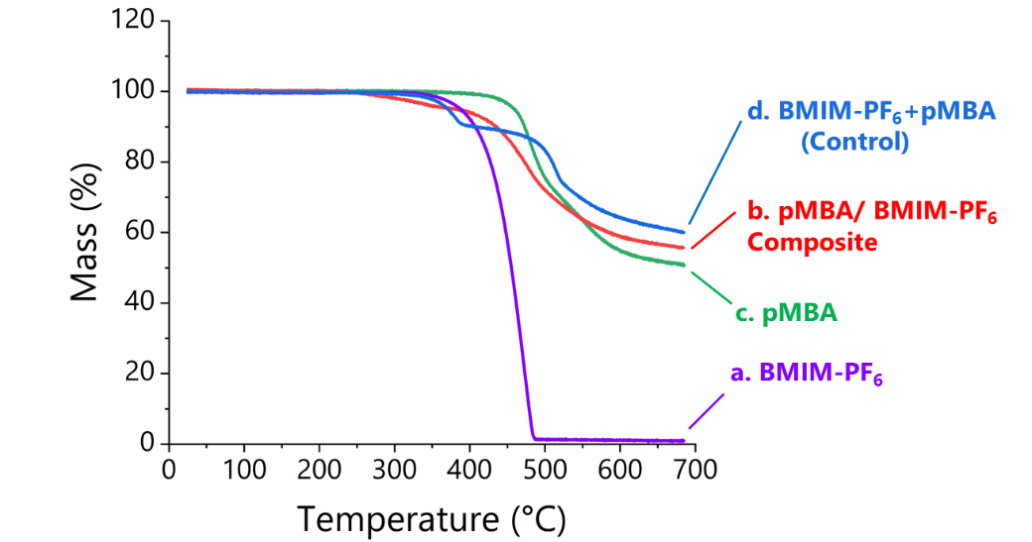

Figure S2 | Thermogravimetric analysis (TGA) of pMBA/BMIM–PF₆ composites and control samples.
a–c, TGA curves of pMBA/BMIM–PF₆ composites compared with neat pMBA and bulk BMIM–PF₆. The composites show a gradual, intermediate mass-loss behaviour with a single onset that is distinct from both neat pMBA and bulk BMIM–PF₆, consistent with a confined ionic phase rather than a simple superposition of the two components. From the relative mass loss attributable to BMIM–PF₆, the ionic-liquid content in the pMBA composites is estimated to be on the order of 10 wt %.
d, TGA curve of a simple physical mixture of preformed pMBA and bulk BMIM–PF₆ at the same ionic-liquid loading as the PCP-derived composites. Two distinct decomposition onsets corresponding to the individual components are observed, in contrast to the single, intermediate onset of the PCP-derived composites. These results indicate that confinement-induced crystallization of the ionic liquid within the polymer matrix produces decomposition behaviour that is no longer a simple sum of the pure components.

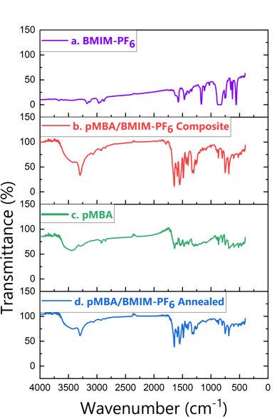
Figure S3 | Infrared spectra of confined ionic species before and after thermal cycling.
IR spectra of pMBA/BMIM–PF₆ composites without thermal history and after annealing to 300 °C at 10 °C min⁻¹ followed by cooling to room temperature. The characteristic vibrational bands of the imidazolium cation and PF₆⁻ anion remain unchanged upon thermal cycling, indicating the absence of thermal or chemical degradation of the ionic liquid. In contrast, the amide bands of pMBA show small, systematic frequency shifts relative to neat pMBA, reflecting specific polymer–ion interactions under confinement. In addition, a sharpening of the N–H stretching band was observed in the composite, although the origin of this feature remains unclear.

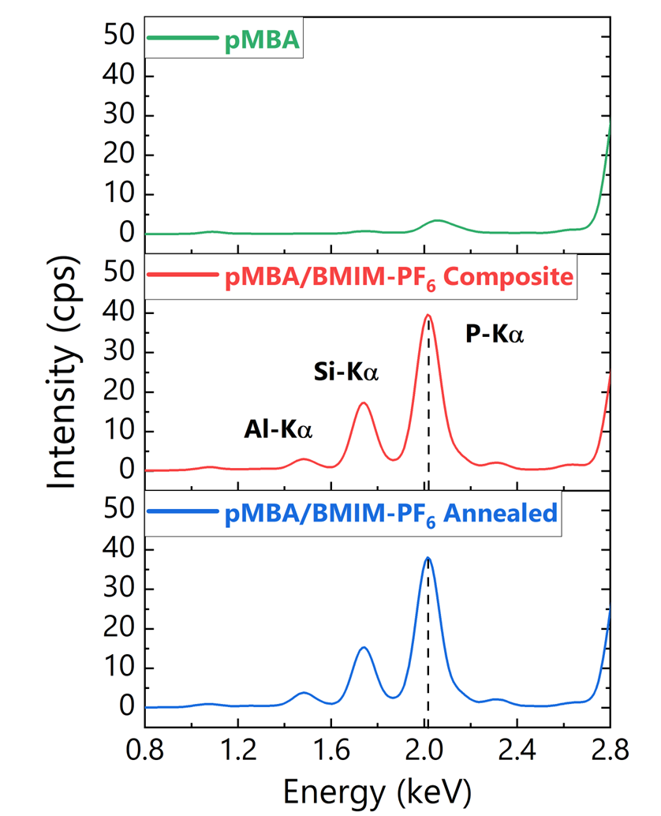
Figure S4 | X-ray fluorescence confirmation of ionic-liquid retention.
X-ray fluorescence (XRF) spectrum of the pMBA/BMIM–PF₆ composite showing the characteristic phosphorus (P) signal associated with the PF₆⁻ anion. The XRF measurement was performed by collecting fluorescence signals with energies higher than that of Na, ensuring reliable detection of heavier elements. The P signal is retained after thermal treatment up to 300 °C, indicating the presence and chemical stability of BMIM–PF₆ within the polymer matrix under thermal cycling conditions. Additional signals corresponding to Si and Al are also observed; these are attributed to minor contamination arising from corrosion of the glass reaction vessel by hydrofluoric acid generated during synthesis, rather than from the composite itself. This elemental analysis independently supports the infrared spectroscopy results and excludes depletion or decomposition of the ionic liquid as the origin of the suppressed thermal transitions observed in DSC.

Figure S5 | Para-linked aramid control experiment.
Room-temperature powder X-ray diffraction pattern of poly(para-benzamide) (pPBA) synthesized using BMIM–PF₆ as the polymerization medium under conditions otherwise identical to those applied for the pMBA system. Only diffraction peaks attributable to crystalline pPBA are observed, with no Bragg reflections corresponding to crystalline BMIM–PF₆. In contrast to the meta-linked pMBA matrix, the para-linked aramid does not stabilize a crystalline ionic-liquid phase, indicating that polymer topology plays a critical role in stabilizing the ordered confined ionic phase.

Supplementary Table

Table S1. Comparison of observed diffraction peak positions for bulk and confined BMIM–PF6 phases

