Supplementary figures

Figure 1.

Performance of kidney cancer risk prediction model in the validation cohort.
- Option 1; 6 variables: age, sex, BMI, hypertension, diabetes, VPA

(1) Discrimination assessed using receiver operating characteristic (ROC) analysis

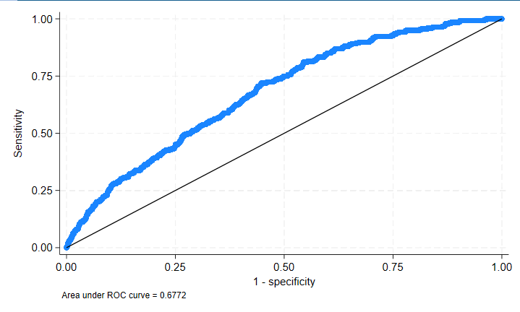

(2) Calibration plot comparing predicted and observed 10-year kidney cancer risk

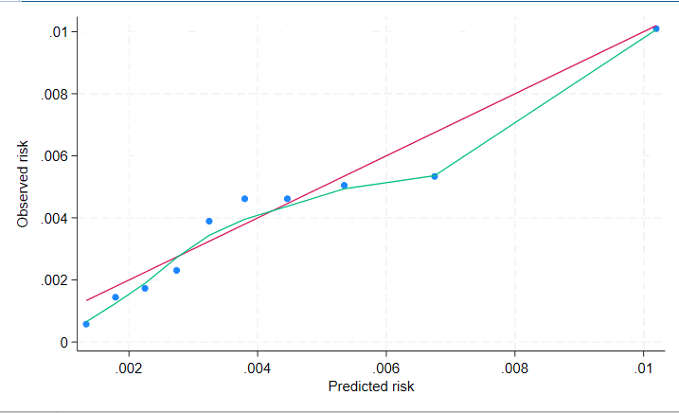

(3) Decision curve analysis (DCA) demonstrating net benefit across clinically relevant risk thresholds in (i) the entire validation cohort and (ii-iii) risk-stratified subgroups defined by predicted 10-year risk thresholds.
3A. Entire Test Population (N=69,314, Events=275, Prevalence=0.40%)
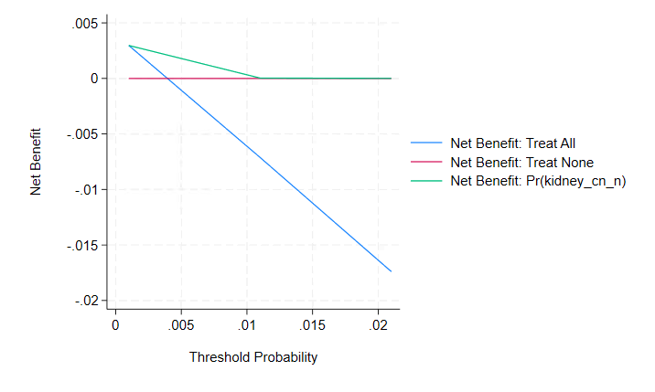

3B. High-Risk Subgroup with Predicted 10-year Risk ≥1.0% (N=2,902, Events=34, Prevalence=1.17%)

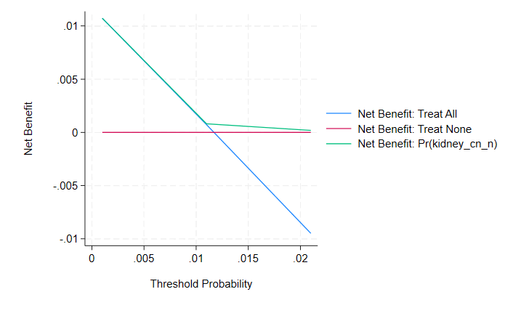
3C. High-Risk Subgroup with Predicted 10-year Risk ≥1.5% (N=259, Events=6, Prevalence=2.32%)

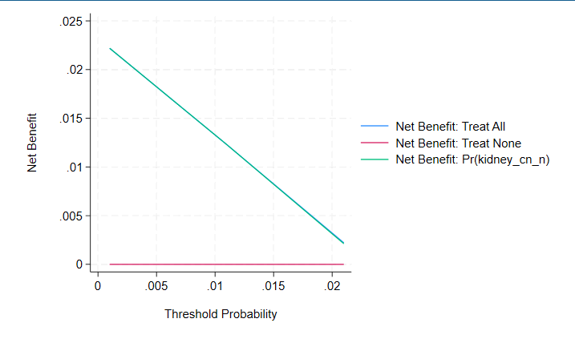

B. Performance of kidney cancer risk prediction model in the validation cohort.
- Option 2; 7 variables: age, sex, BMI, hypertension, diabetes, VPA, alcohol
(1) Discrimination assessed using receiver operating characteristic (ROC) analysis.
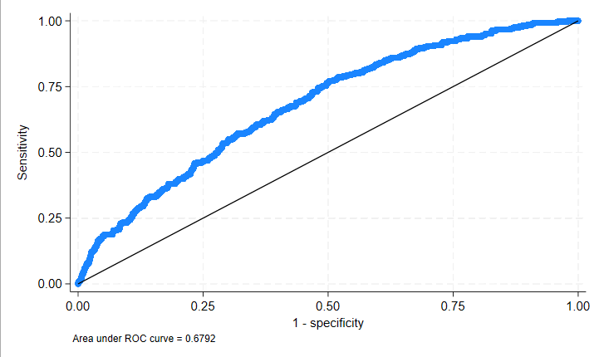
(2) Calibration plot comparing predicted and observed 10-year kidney cancer risk.
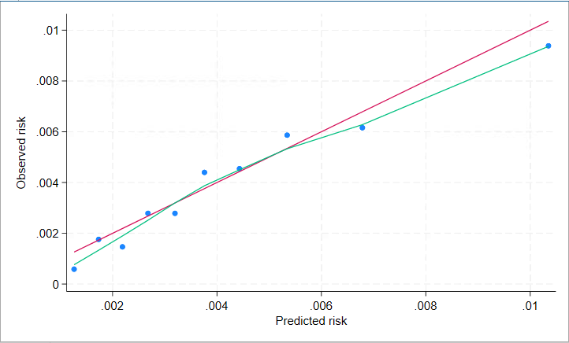

(3) Decision curve analysis (DCA) demonstrating net benefit across clinically relevant risk thresholds in (i) the entire validation cohort and (ii-iii) risk-stratified subgroups defined by predicted 10-year risk thresholds.

3A. Entire Test Population (N=68,203, Events=271, Prevalence=0.40%)

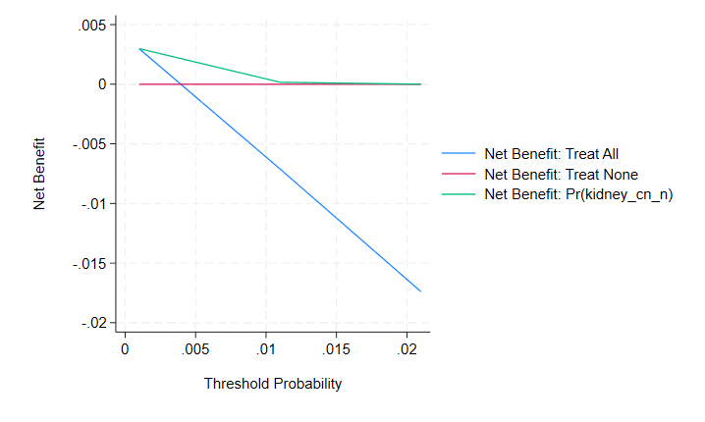

3B. High-Risk Subgroup with Predicted 10-year Risk ≥1.0% (N=3,014, Events=26, Prevalence=0.86%)

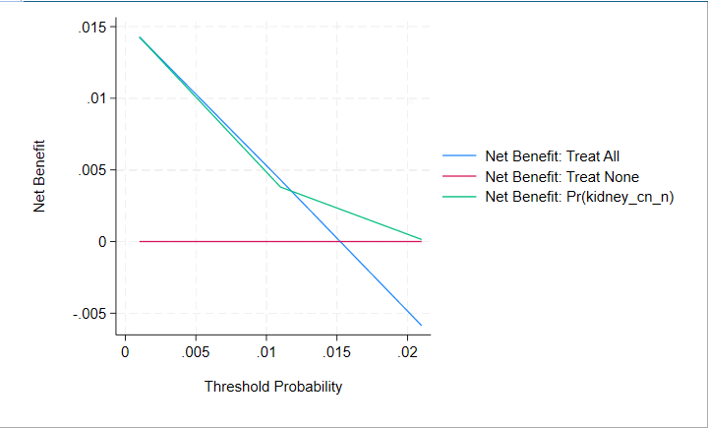

3C. High-Risk Subgroup with Predicted 10-year Risk ≥1.5% (N=333, Events=4, Prevalence=1.20%)

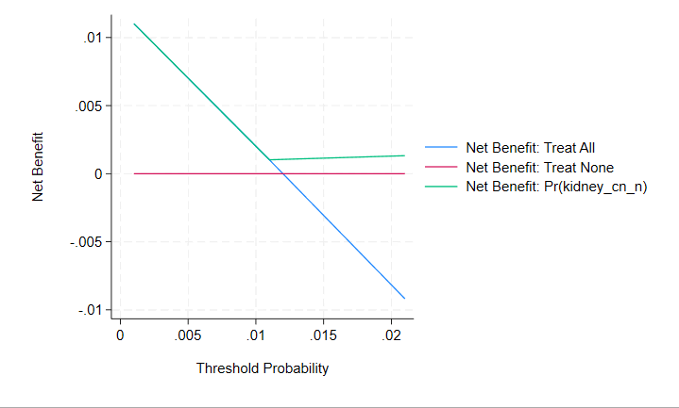

C. Performance of kidney cancer risk prediction model in the validation cohort.
- Option 3; 7 Variables: age, sex, BMI, hypertension, diabetes, VPA, European ancestry
(1) Discrimination assessed using receiver operating characteristic (ROC) analysis.

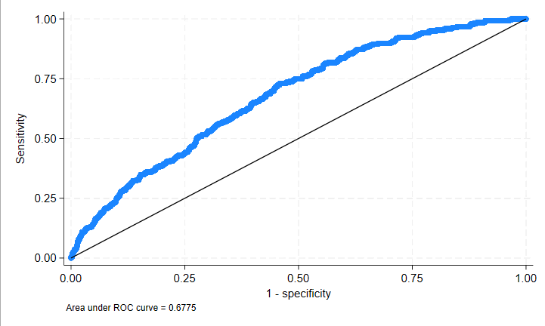

(2) Calibration plot comparing predicted and observed 10-year kidney cancer risk.

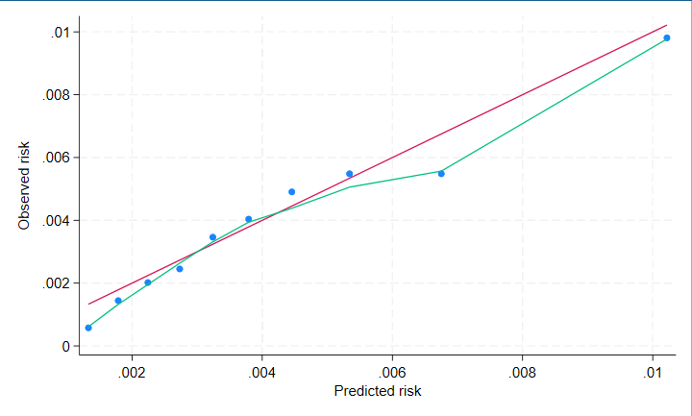

(3) Decision curve analysis (DCA) demonstrating net benefit across clinically relevant risk thresholds in (i) the entire validation cohort and (ii-iii) risk-stratified subgroups defined by predicted 10-year risk thresholds

3A. Entire Test Population (N=69,313, Events=275, Prevalence=0.40%)
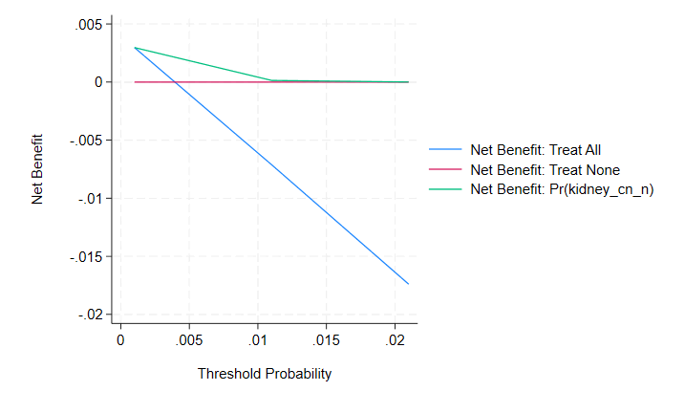

3B. High-Risk Subgroup with Predicted 10-year Risk ≥1.0% (N=2,897, Events=35, Prevalence=1.21%)

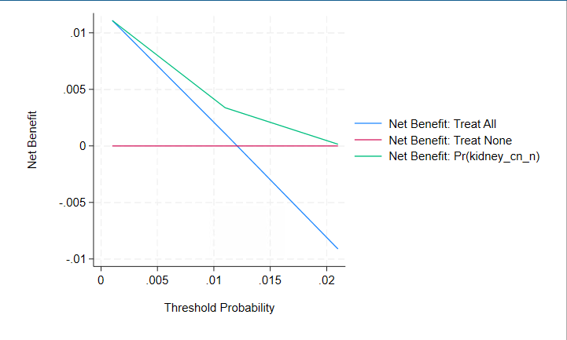

3C. High-Risk Subgroup with Predicted 10-year Risk ≥1.5% (N=276, Events=5, Prevalence=1.81%)

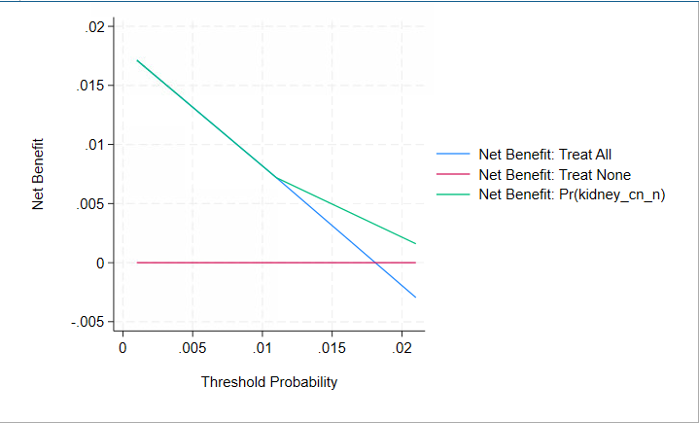

D. Performance of kidney cancer risk prediction model in the validation cohort.
- Option 4; 8 variables: age, sex, BMI, hypertension, diabetes, VPA, alcohol, European ancestry
(1) Discrimination assessed using receiver operating characteristic (ROC) analysis.

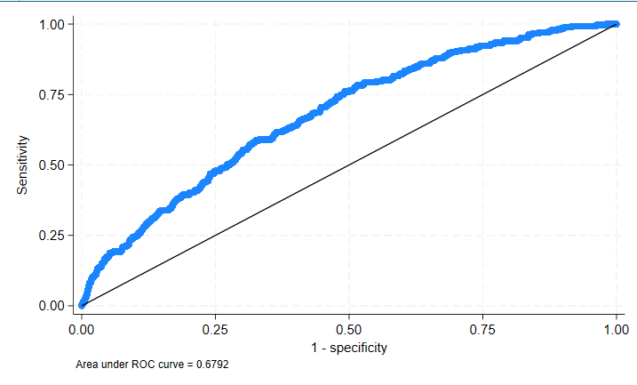

(2) Calibration plot comparing predicted and observed 10-year kidney cancer risk.
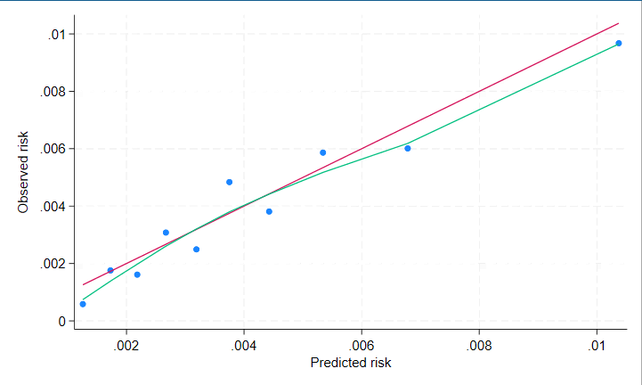

(3) Decision curve analysis (DCA) demonstrating net benefit across clinically relevant risk thresholds in (i) the entire validation cohort and (ii-iii) risk-stratified subgroups defined by predicted 10-year risk thresholds

3A. Entire Test Population (N=68,202, Events=271, Prevalence=0.40%)

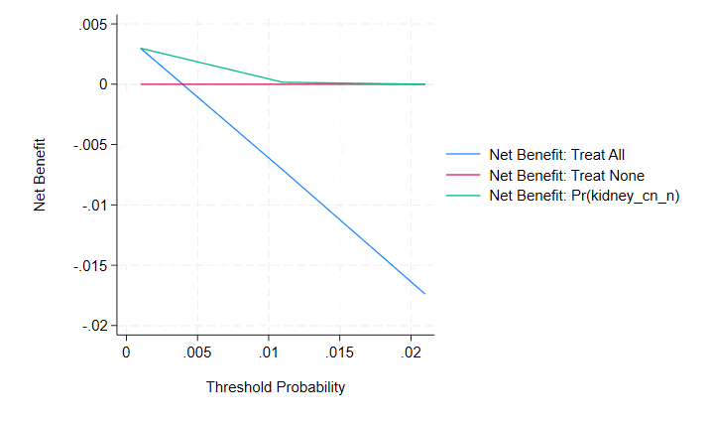

3B. High-Risk Subgroup with Predicted 10-year Risk ≥1.0% (N=3,004, Events=45, Prevalence=1.50%)
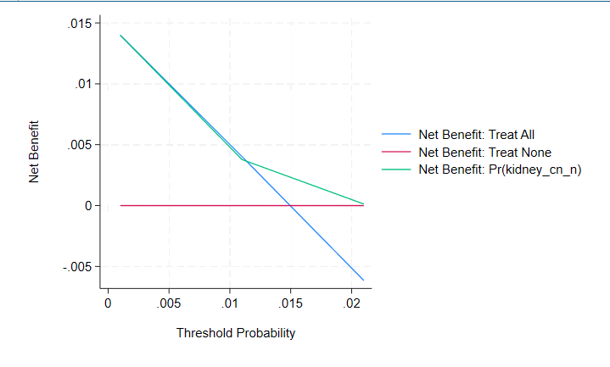

3C. High-Risk Subgroup with Predicted 10-year Risk ≥1.5% (N=335, Events=4, Prevalence=1.19%)

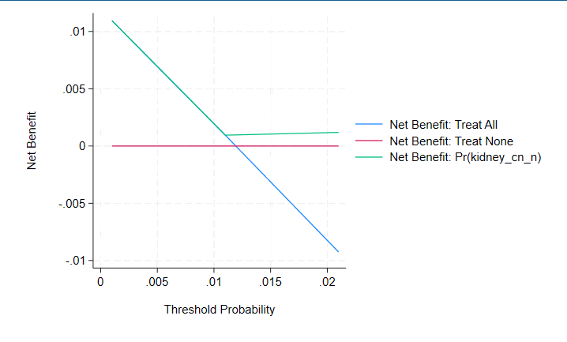

Supplementary Figure 2.

Sensitivity analyses using 10-year follow-up censoring
- Performance of kidney cancer risk prediction model in the validation cohort.
- Option 1; 6 variables: age, sex, BMI, hypertension, diabetes, VPA
(1) Discrimination assessed using receiver operating characteristic (ROC) analysis

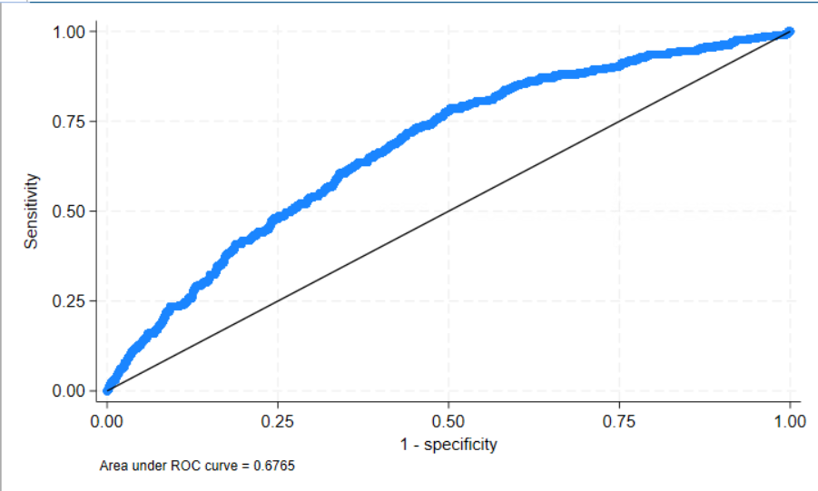

(2) Calibration plot comparing predicted and observed 10-year kidney cancer risk.

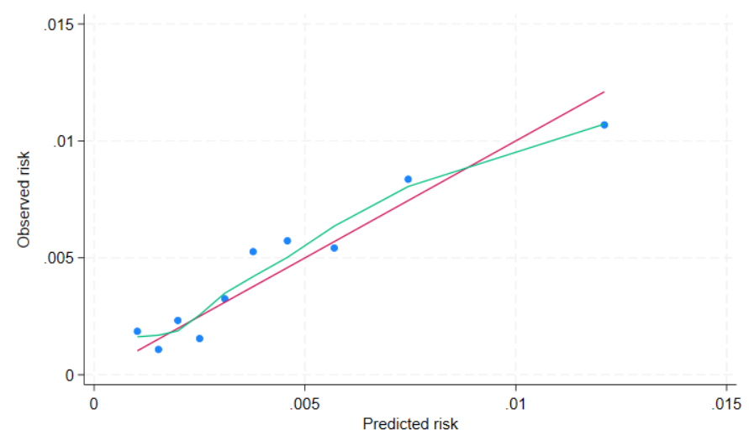

(3) Decision curve analysis (DCA) demonstrating net benefit across clinically relevant risk thresholds in (i) the entire validation cohort and (ii-iii) risk-stratified subgroups defined by predicted 10-year risk thresholds.

3A. Entire Test Population (N=64,579, Events=294, Prevalence=0.46%)
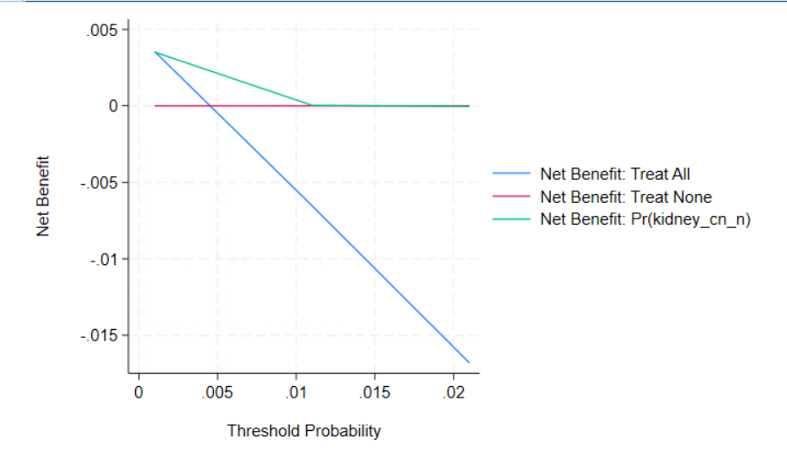

3B. High-Risk Subgroup with Predicted 10-year Risk ≥1.0% (N=4,572, Events=49, Prevalence=1.07%)

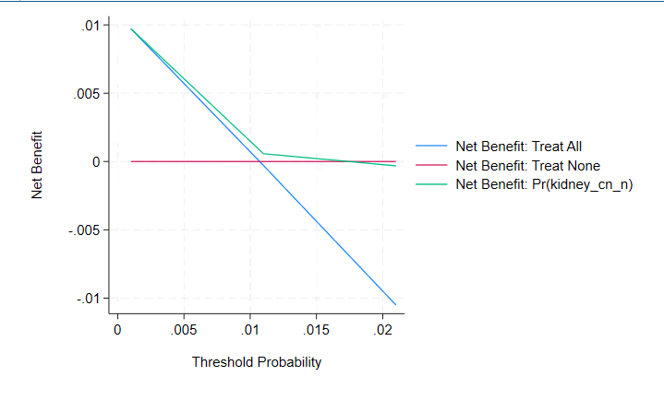

3C. High-Risk Subgroup with Predicted 10-year Risk ≥1.5% (N=952, Events=13, Prevalence=1.37%)

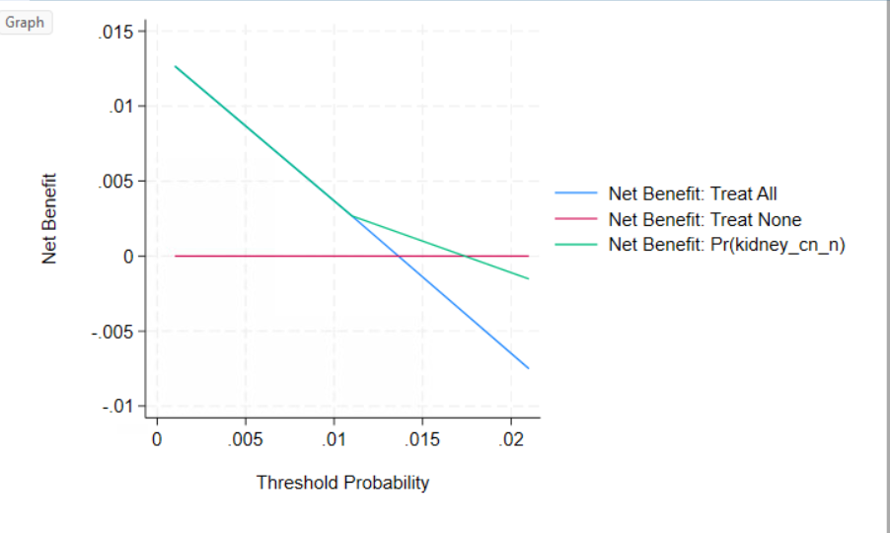

- Performance of kidney cancer risk prediction model in the validation cohort.
- Option 2; 7 variables: age, sex, BMI, hypertension, diabetes, VPA, alcohol
(1) Discrimination assessed using receiver operating characteristic (ROC) analysis

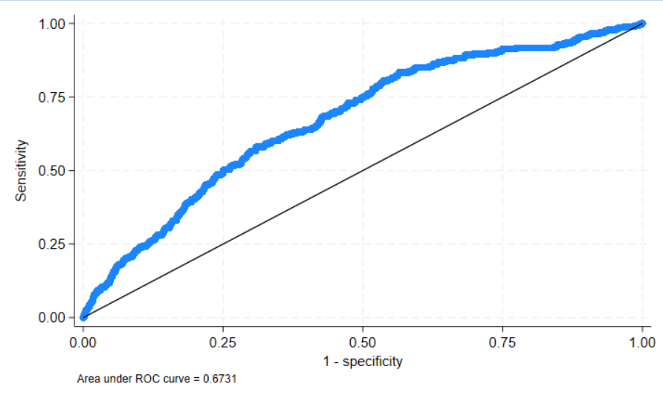

(2) Calibration plot comparing predicted and observed 10-year kidney cancer risk.

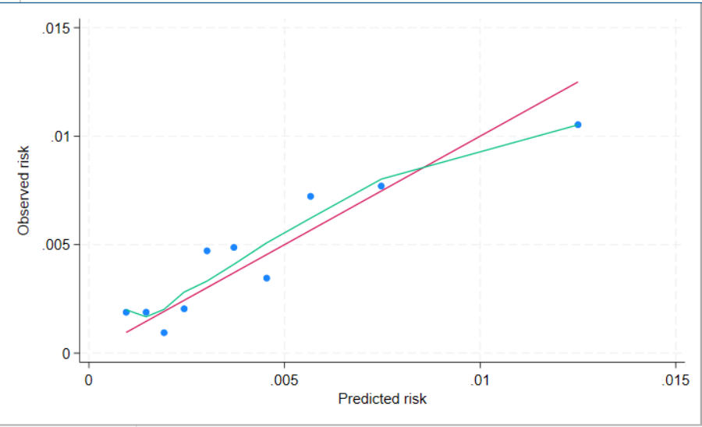

(3) Decision curve analysis (DCA) demonstrating net benefit across clinically relevant risk thresholds in (i) the entire validation cohort and (ii-iii) risk-stratified subgroups defined by predicted 10-year risk thresholds.

3A. Entire Test Population (N=63,634, Events=288, Prevalence=0.45%)

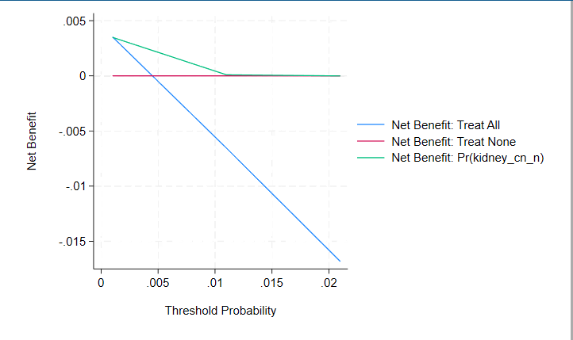

3B. High-Risk Subgroup with Predicted 10-year Risk ≥1.0% (N=4,689, Events=56, Prevalence=1.19%)

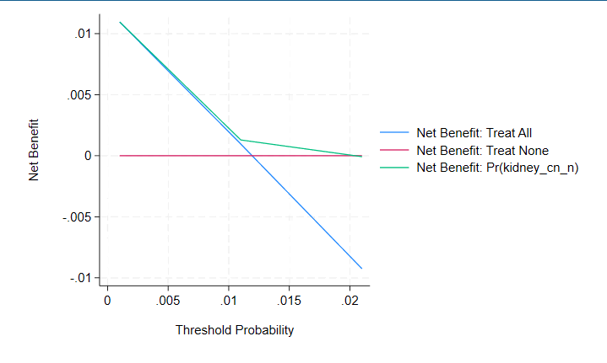

3C. High-Risk Subgroup with Predicted 10-year Risk ≥1.5% (N=1,227, Events=21, Prevalence=1.71%)

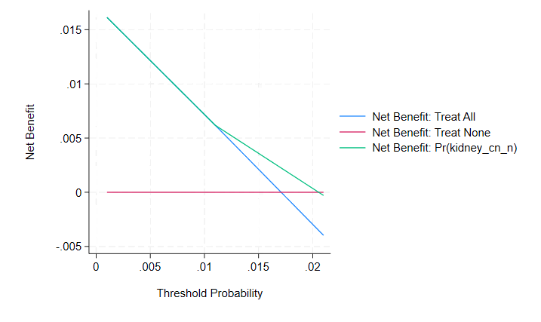

- Performance of kidney cancer risk prediction model in the validation cohort.
- Option 3; 6 variables: age, sex, BMI, hypertension, diabetes, European ancestry

(1) Discrimination assessed using receiver operating characteristic (ROC) analysis

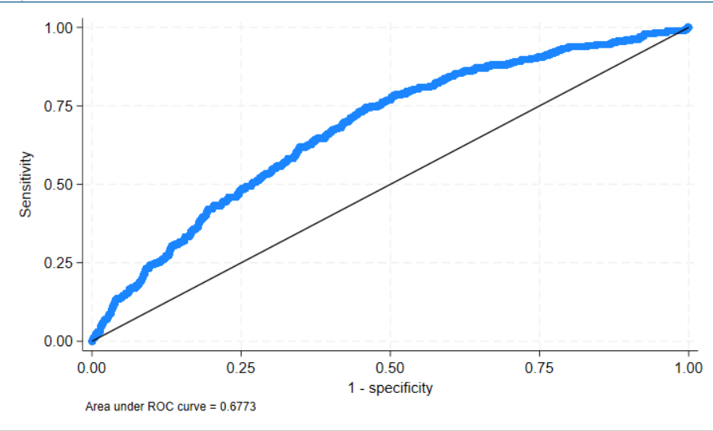

(2) Calibration plot comparing predicted and observed 10-year kidney cancer risk.

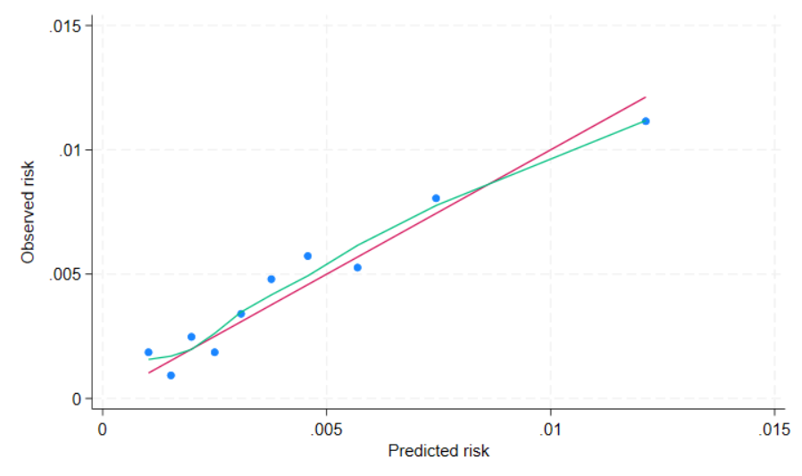

(3) Decision curve analysis (DCA) demonstrating net benefit across clinically relevant risk thresholds in (i) the entire validation cohort and (ii-iii) risk-stratified subgroups defined by predicted 10-year risk thresholds.

3A. Entire Test Population (N=64,579, Events=294, Prevalence=0.46%)

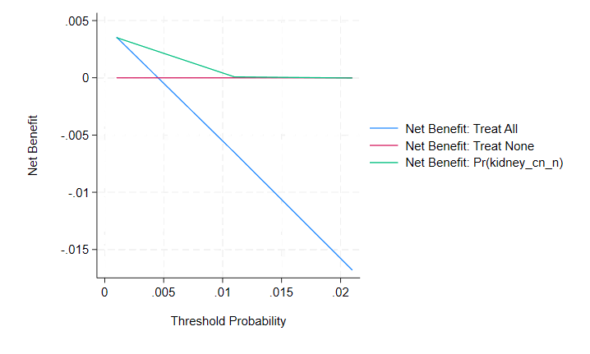

3B. High-Risk Subgroup with Predicted 10-year Risk ≥1.0% (N=4,588, Events=50, Prevalence=1.09%)

3C. High-Risk Subgroup with Predicted 10-year Risk ≥1.5% (N=959, Events=13, Prevalence=1.36%)

- Performance of kidney cancer risk prediction model in the validation cohort.
- Option 4; 8 variables: age, sex, BMI, hypertension, diabetes, VPA, alcohol, European ancestry

(1) Discrimination assessed using receiver operating characteristic (ROC) analysis

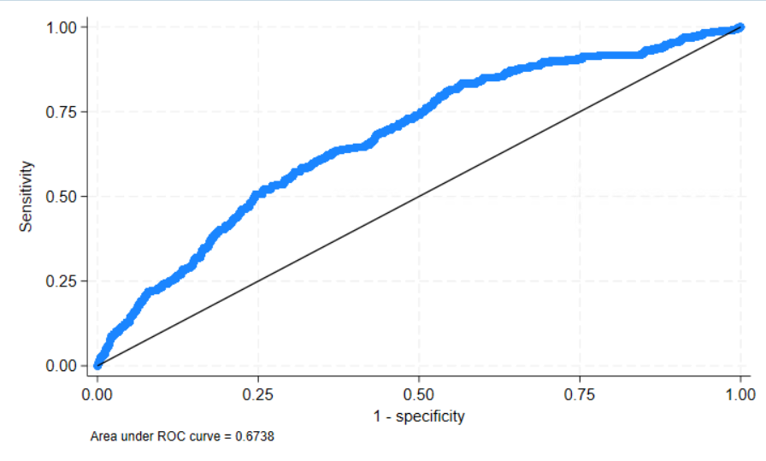

(2) Calibration plot comparing predicted and observed 10-year kidney cancer risk.

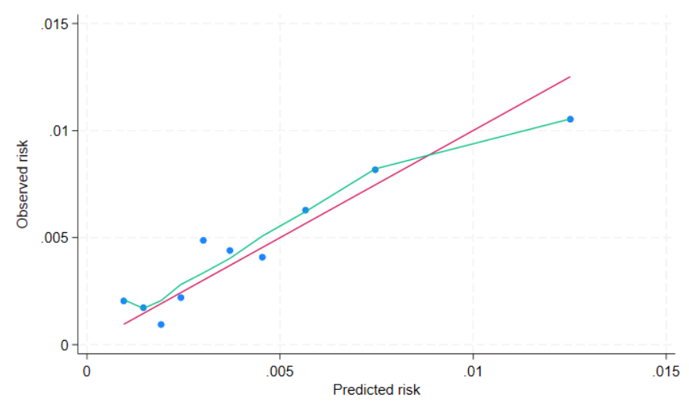

(3) Decision curve analysis (DCA) demonstrating net benefit across clinically relevant risk thresholds in (i) the entire validation cohort and (ii-iii) risk-stratified subgroups defined by predicted 10-year risk thresholds.

3A. Entire Test Population (N=63,634, Events=288, Prevalence=0.45%)

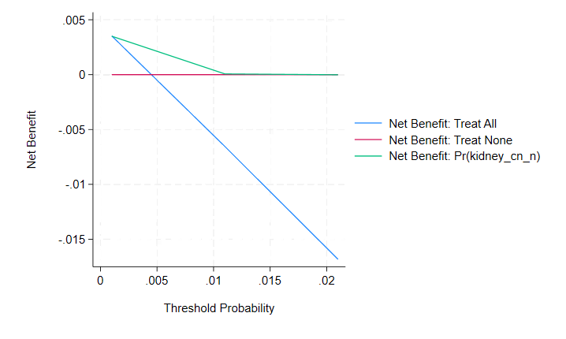

3B. High-Risk Subgroup with Predicted 10-year Risk ≥1.0% (N=4,680, Events=57, Prevalence=1.22%)

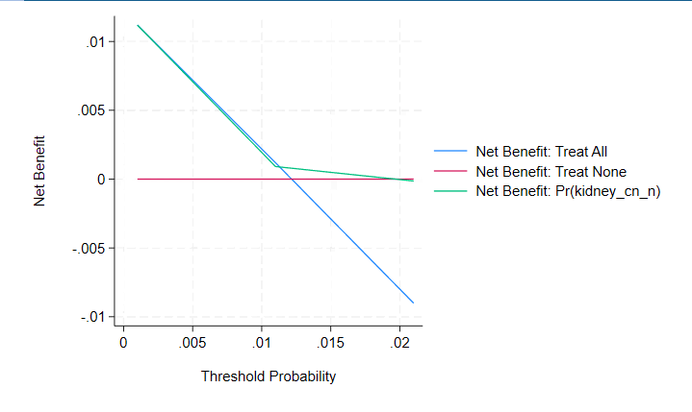

3C. High-Risk Subgroup with Predicted 10-year Risk ≥1.5% (N=1,239, Events=21, Prevalence=1.69%)

- Performance of kidney cancer risk prediction model in the validation cohort.
- Option 5; 8 variables: age, sex, BMI, hypertension, diabetes, VPA, alcohol, smoking (≥30 pack-years)
(1) Discrimination assessed using receiver operating characteristic (ROC) analysis

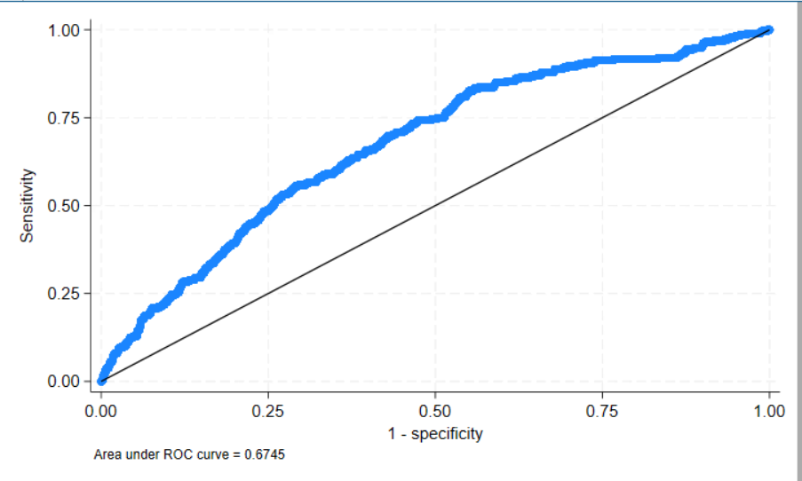

(2) Calibration plot comparing predicted and observed 10-year kidney cancer risk.

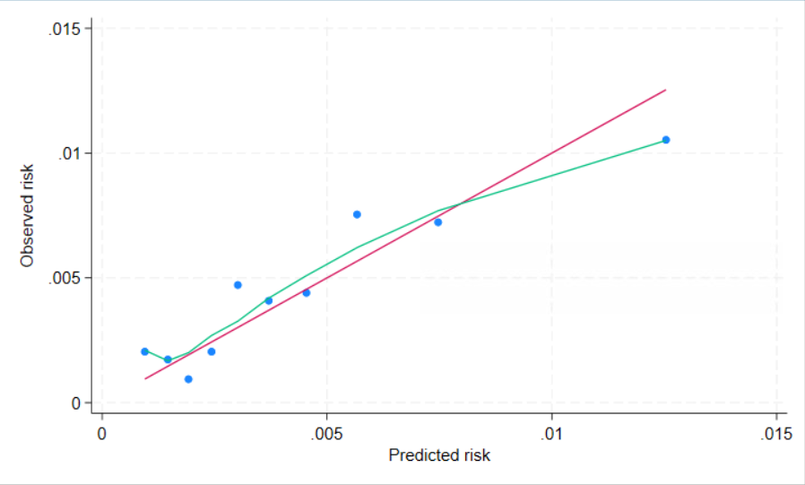

(3) Decision curve analysis (DCA) demonstrating net benefit across clinically relevant risk thresholds in (i) the entire validation cohort and (ii-iii) risk-stratified subgroups defined by predicted 10-year risk thresholds.

3A. Entire Test Population (N=64,579, Events=294, Prevalence=0.46%)

3B. High-Risk Subgroup with Predicted 10-year Risk ≥1.0% (N=4,697, Events=56, Prevalence=1.19%)

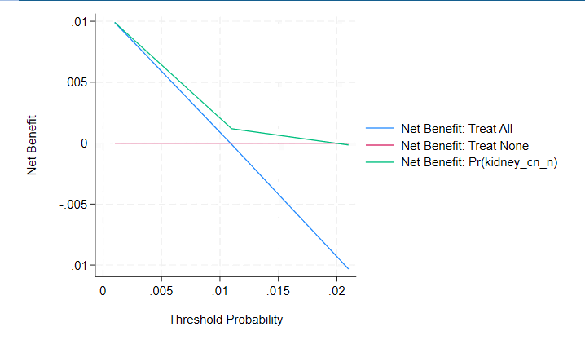

3C. High-Risk Subgroup with Predicted 10-year Risk ≥1.5% (N=959, Events=13, Prevalence=1.36%)

