Supplementary Information / Online Resources
Rougher flotation of copper flotation tailings from southern Peru: Fe upgrading, metallurgical balance and batch flotation kinetics
This file provides the detailed XRD/Rietveld phase list, particle-size distribution, representative SEM–EDS observations and replicate-level kinetic flotation data supporting the manuscript.

Online Resource 1. Semi-quantitative XRD/Rietveld phase composition of the feed tailings
The reported values are semi-quantitative relative estimates of the fitted crystalline assemblage. No internal standard was used; therefore, the amorphous fraction was not quantified. The estimates were used for phase grouping and mineralogical interpretation, not for elemental Fe mass-balance closure.
Table OR1 Semi-quantitative phase composition of the feed tailings obtained from XRD/Rietveld refinement
Phase identified in the Rietveld output | Mineral group used in the manuscript | Relative Rietveld estimate (%)
Quartz low | Silicates | 8.12
Pyrrhotite Fe₇S₈ | Fe-bearing sulfides | 2.00
Pyrrhotite 5C | Fe-bearing sulfides | 4.00
Pyrite | Fe-bearing sulfides | 16.40
Marcasite | Fe-bearing sulfides | 3.00
Fe₂O₃-type phase 1 | Fe-bearing oxides | 7.89
Fe₂O₃-type phase 2 | Fe-bearing oxides | 20.58
Fe₂O₃-type phase 3 | Fe-bearing oxides | 1.29
Fe₂O₃-type phase 4 | Fe-bearing oxides | 13.09
Dolomite | Carbonates/sulfates | 4.39
Cr-bearing oxide | Minor accessory phases | 0.89
Zincowoodwardite | Minor accessory phases | 1.59
Sphalerite | Minor accessory phases | 0.70
SiO₂ | Silicates | 6.02
Kaolinite | Silicates | 2.59
Gypsum | Carbonates/sulfates | 3.53
Siderite | Carbonates/sulfates | 3.48
Calcite | Carbonates/sulfates | 0.46
Table OR2 Grouped semi-quantitative phase estimates used in the manuscript
Mineral group | Phases included | Relative Rietveld estimate (%)
Fe-bearing sulfides | Pyrite, marcasite, pyrrhotite | 25.4
Fe-bearing oxides | Fe₂O₃-type phases | 42.9
Silicates | Quartz, SiO₂, kaolinite | 16.7
Carbonates/sulfates | Dolomite, calcite, siderite, gypsum | 11.9
Minor accessory phases | Sphalerite, zincowoodwardite, Cr-bearing oxide | 3.2
ª Values are semi-quantitative relative estimates of the fitted crystalline assemblage. No internal standard was used and the amorphous fraction was not quantified. Values may not sum exactly to 100% because of rounding.

Online Resource 2. Particle-size distribution of the feed tailings
The particle-size distribution was determined by dry sieving. Cumulative passing values were calculated from the retained mass in each size fraction, and D50 and D80 were obtained by interpolation.
Table OR3 Particle-size distribution data used to estimate D50 and D80
Particle size (µm) | Cumulative passing (%)
38 | 12.133
53 | 23.343
75 | 36.541
105 | 51.888
150 | 63.660
212 | 100.000
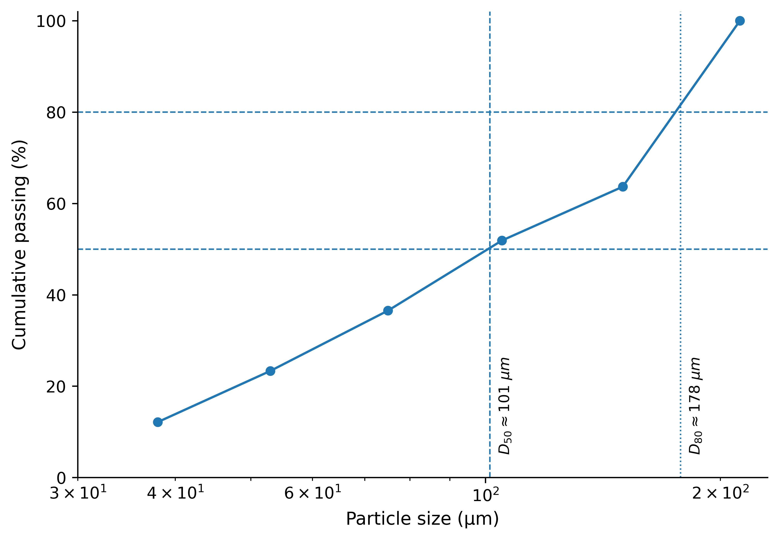
Fig. OR1 Particle-size distribution of the feed tailings expressed as cumulative passing as a function of particle size. The interpolated values were D50 ≈ 101 µm and D80 ≈ 178 µm

Online Resource 3. Representative SEM–EDS observations of the feed tailings
Representative SEM micrographs and a local SEM–EDS analysis are provided as complementary evidence of particle morphology and elemental associations. These results were not used for bulk chemical quantification or Fe mass-balance closure.
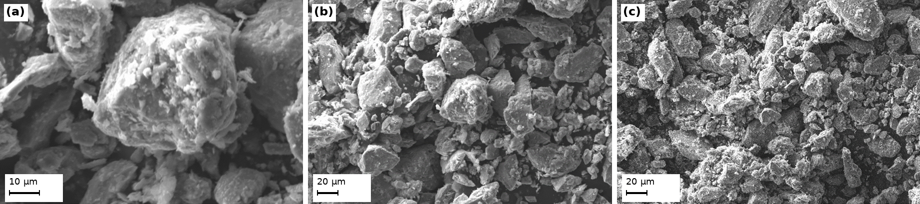
Fig. OR2 Representative SEM micrographs of the copper flotation tailings: (a) rough surface detail at high magnification; (b) particle-size heterogeneity and angular morphology; and (c) general particle morphology at lower magnification
Table OR4 Local SEM–EDS composition of a selected domain in the feed tailings
Element | Mass normalized (%) | Atomic (%)
C | 5.77 | 9.93
O | 43.06 | 55.64
Na | 1.22 | 1.09
Mg | 0.70 | 0.59
Al | 3.46 | 2.65
Si | 31.42 | 23.13
K | 0.83 | 0.44
Fe | 8.05 | 2.98
S | 5.50 | 3.55
Total | 100.00 | 100.00
ª The SEM–EDS values correspond to a local analysis of a selected domain and should not be interpreted as the bulk chemical composition of the feed tailings.

Online Resource 4. Replicate-level kinetic flotation data and model fitting
Three independent batch kinetic tests were conducted using fresh 500 g dry feed charges from the same homogenized composite. Nine sequential froth concentrates were collected from each replicate at 1 min intervals. Plant process water was added volumetrically during concentrate collection to maintain the pulp level.
Models used for fitting: classical first-order, R(t) = R∞[1 − exp(−kt)]; hyperbolic, R(t) = R∞kt/(1 + kt); and Klimpel, R(t) = R∞{1 − [1 − exp(−kt)]/(kt)}. Residual = experimental cumulative Fe recovery − fitted cumulative Fe recovery.
Table OR5 Incremental kinetic flotation data for the three independent replicates
Replicate | Interval (min) | Dry concentrate mass (g) | Make-up water added (mL) | Incremental Fe grade (wt.%)
Replicate 1 | 0-1 | 28.50 | 185 | 51.20
Replicate 1 | 1-2 | 24.80 | 162 | 44.10
Replicate 1 | 2-3 | 22.90 | 155 | 39.80
Replicate 1 | 3-4 | 19.50 | 142 | 38.00
Replicate 1 | 4-5 | 21.00 | 138 | 37.10
Replicate 1 | 5-6 | 20.10 | 132 | 34.00
Replicate 1 | 6-7 | 15.60 | 126 | 30.50
Replicate 1 | 7-8 | 13.50 | 120 | 28.80
Replicate 1 | 8-9 | 12.80 | 118 | 26.50
Replicate 2 | 0-1 | 30.10 | 178 | 49.50
Replicate 2 | 1-2 | 26.00 | 158 | 43.20
Replicate 2 | 2-3 | 24.10 | 148 | 41.10
Replicate 2 | 3-4 | 20.80 | 139 | 36.90
Replicate 2 | 4-5 | 19.90 | 135 | 36.40
Replicate 2 | 5-6 | 21.20 | 128 | 32.90
Replicate 2 | 6-7 | 16.50 | 124 | 32.10
Replicate 2 | 7-8 | 14.80 | 119 | 30.10
Replicate 2 | 8-9 | 13.40 | 114 | 27.90
Replicate 3 | 0-1 | 29.90 | 181 | 50.32
Replicate 3 | 1-2 | 25.10 | 160 | 44.19
Replicate 3 | 2-3 | 23.20 | 150 | 39.73
Replicate 3 | 3-4 | 20.30 | 141 | 37.96
Replicate 3 | 4-5 | 21.50 | 134 | 37.14
Replicate 3 | 5-6 | 20.50 | 130 | 34.17
Replicate 3 | 6-7 | 15.90 | 125 | 30.97
Replicate 3 | 7-8 | 13.70 | 121 | 29.18
Replicate 3 | 8-9 | 12.80 | 116 | 26.84
Table OR6 Final tailings and calculated feed grades for the kinetic replicates
Replicate | Final tailings mass (g) | Tailings Fe grade (wt.%) | Total product mass (g) | Calculated feed grade (wt.% Fe)
Replicate 1 | 321.30 | 30.92 | 500.00 | 33.612
Replicate 2 | 313.20 | 30.85 | 500.00 | 33.608
Replicate 3 | 317.10 | 30.79 | 500.00 | 33.609
ª The calculated feed grade was obtained by weighted recombination of the nine timed concentrates and final tailings for each replicate. Because product masses and grades were reported to limited decimal precision, the replicate values ranged from 33.608 to 33.612 wt.% Fe. Cumulative Fe recoveries were calculated using the common rounded head grade of 33.61 wt.% Fe (168.05 g Fe in 500 g feed), consistent with the metallurgical balance.

Table OR7 Cumulative metallurgical results for each kinetic replicate
Replicate | Time (min) | Cumulative concentrate mass (g) | Cumulative mass pull (%) | Cumulative make-up water (mL) | Cumulative Fe grade (wt.%) | Cumulative Fe recovery (%)
Replicate 1 | 1 | 28.50 | 5.70 | 185 | 51.20 | 8.68
Replicate 1 | 2 | 53.30 | 10.66 | 347 | 47.90 | 15.19
Replicate 1 | 3 | 76.20 | 15.24 | 502 | 45.46 | 20.61
Replicate 1 | 4 | 95.70 | 19.14 | 644 | 43.94 | 25.02
Replicate 1 | 5 | 116.70 | 23.34 | 782 | 42.71 | 29.66
Replicate 1 | 6 | 136.80 | 27.36 | 914 | 41.43 | 33.73
Replicate 1 | 7 | 152.40 | 30.48 | 1040 | 40.31 | 36.56
Replicate 1 | 8 | 165.90 | 33.18 | 1160 | 39.38 | 38.87
Replicate 1 | 9 | 178.70 | 35.74 | 1278 | 38.45 | 40.89
Replicate 2 | 1 | 30.10 | 6.02 | 178 | 49.50 | 8.87
Replicate 2 | 2 | 56.10 | 11.22 | 336 | 46.58 | 15.55
Replicate 2 | 3 | 80.20 | 16.04 | 484 | 44.93 | 21.44
Replicate 2 | 4 | 101.00 | 20.20 | 623 | 43.28 | 26.01
Replicate 2 | 5 | 120.90 | 24.18 | 758 | 42.15 | 30.32
Replicate 2 | 6 | 142.10 | 28.42 | 886 | 40.77 | 34.47
Replicate 2 | 7 | 158.60 | 31.72 | 1010 | 39.87 | 37.62
Replicate 2 | 8 | 173.40 | 34.68 | 1129 | 39.03 | 40.27
Replicate 2 | 9 | 186.80 | 37.36 | 1243 | 38.23 | 42.50
Replicate 3 | 1 | 29.90 | 5.98 | 181 | 50.32 | 8.95
Replicate 3 | 2 | 55.00 | 11.00 | 341 | 47.52 | 15.55
Replicate 3 | 3 | 78.20 | 15.64 | 491 | 45.21 | 21.04
Replicate 3 | 4 | 98.50 | 19.70 | 632 | 43.72 | 25.62
Replicate 3 | 5 | 120.00 | 24.00 | 766 | 42.54 | 30.38
Replicate 3 | 6 | 140.50 | 28.10 | 896 | 41.32 | 34.54
Replicate 3 | 7 | 156.40 | 31.28 | 1021 | 40.27 | 37.47
Replicate 3 | 8 | 170.10 | 34.02 | 1142 | 39.37 | 39.85
Replicate 3 | 9 | 182.90 | 36.58 | 1258 | 38.50 | 41.90
Table OR8 Mean cumulative kinetic results
Time (min) | Cumulative concentrate mass (g) | Cumulative mass pull (%) | Cumulative make-up water (mL) | Cumulative Fe grade (wt.%) | Cumulative Fe recovery (%)
1 | 29.50 ± 0.87 | 5.90 ± 0.17 | 181.3 ± 3.5 | 50.34 ± 0.85 | 8.83 ± 0.14
2 | 54.80 ± 1.41 | 10.96 ± 0.28 | 341.3 ± 5.5 | 47.33 ± 0.68 | 15.43 ± 0.21
3 | 78.20 ± 2.00 | 15.64 ± 0.40 | 492.3 ± 9.1 | 45.20 ± 0.27 | 21.03 ± 0.41
4 | 98.40 ± 2.65 | 19.68 ± 0.53 | 633.0 ± 10.5 | 43.65 ± 0.34 | 25.55 ± 0.50
5 | 119.20 ± 2.21 | 23.84 ± 0.44 | 768.7 ± 12.2 | 42.47 ± 0.29 | 30.12 ± 0.40
6 | 139.80 ± 2.72 | 27.96 ± 0.54 | 898.7 ± 14.2 | 41.17 ± 0.36 | 34.25 ± 0.45
7 | 155.80 ± 3.14 | 31.16 ± 0.63 | 1023.7 ± 15.2 | 40.15 ± 0.25 | 37.22 ± 0.58
8 | 169.80 ± 3.76 | 33.96 ± 0.75 | 1143.7 ± 15.6 | 39.26 ± 0.20 | 39.67 ± 0.72
9 | 182.80 ± 4.05 | 36.56 ± 0.81 | 1259.7 ± 17.6 | 38.39 ± 0.14 | 41.76 ± 0.81
ª Values are mean ± standard deviation for three independent kinetic tests.
Table OR9 Replicate-specific kinetic model parameters and goodness-of-fit statistics
Replicate | Model | R∞ (%) | k (min⁻¹) | R² | RMSE (percentage points) | AICc
Replicate 1 | Classical first-order | 52.84 | 0.1662 | 0.9989 | 0.345 | -13.18
Replicate 1 | Hyperbolic | 81.08 | 0.1152 | 0.9989 | 0.345 | -13.17
Replicate 1 | Klimpel | 65.40 | 0.2736 | 0.9990 | 0.338 | -13.55
Replicate 2 | Classical first-order | 55.21 | 0.1627 | 0.9993 | 0.288 | -16.41
Replicate 2 | Hyperbolic | 84.94 | 0.1123 | 0.9996 | 0.215 | -21.66
Replicate 2 | Klimpel | 68.37 | 0.2675 | 0.9995 | 0.253 | -18.71
Replicate 3 | Classical first-order | 54.27 | 0.1655 | 0.9988 | 0.371 | -11.84
Replicate 3 | Hyperbolic | 83.32 | 0.1146 | 0.9988 | 0.368 | -12.01
Replicate 3 | Klimpel | 67.17 | 0.2724 | 0.9989 | 0.364 | -12.21
ª R∞ is the fitted ultimate Fe recovery, k is the apparent rate parameter, RMSE is the root mean square error and AICc is the corrected Akaike information criterion. Parameters obtained from different model structures should not be interpreted as physically equivalent.
Table OR10a Experimental and fitted cumulative Fe recovery values and residuals for replicate 1
Time (min) | Experimental Fe recovery (%) | Classical first-order fitted (%) | Classical first-order residual (pp) | Hyperbolic fitted (%) | Hyperbolic residual (pp) | Klimpel fitted (%) | Klimpel residual (pp)
1 | 8.683 | 8.093 | 0.590 | 8.378 | 0.306 | 8.184 | 0.499
2 | 15.191 | 14.947 | 0.244 | 15.186 | 0.005 | 15.032 | 0.159
3 | 20.615 | 20.751 | -0.136 | 20.829 | -0.214 | 20.788 | -0.173
4 | 25.024 | 25.666 | -0.642 | 25.581 | -0.557 | 25.646 | -0.622
5 | 29.660 | 29.828 | -0.168 | 29.639 | 0.022 | 29.766 | -0.106
6 | 33.727 | 33.353 | 0.374 | 33.143 | 0.583 | 33.277 | 0.450
7 | 36.558 | 36.338 | 0.220 | 36.201 | 0.357 | 36.283 | 0.275
8 | 38.872 | 38.866 | 0.006 | 38.892 | -0.020 | 38.869 | 0.003
9 | 40.890 | 41.007 | -0.117 | 41.279 | -0.389 | 41.104 | -0.214
Table OR10b Experimental and fitted cumulative Fe recovery values and residuals for replicate 2
Time (min) | Experimental Fe recovery (%) | Classical first-order fitted (%) | Classical first-order residual (pp) | Hyperbolic fitted (%) | Hyperbolic residual (pp) | Klimpel fitted (%) | Klimpel residual (pp)
1 | 8.866 | 8.288 | 0.578 | 8.577 | 0.289 | 8.381 | 0.485
2 | 15.550 | 15.332 | 0.218 | 15.581 | -0.031 | 15.422 | 0.128
3 | 21.444 | 21.319 | 0.125 | 21.408 | 0.036 | 21.360 | 0.084
4 | 26.011 | 26.406 | -0.395 | 26.332 | -0.321 | 26.391 | -0.380
5 | 30.322 | 30.730 | -0.409 | 30.547 | -0.226 | 30.672 | -0.350
6 | 34.472 | 34.405 | 0.067 | 34.197 | 0.275 | 34.331 | 0.141
7 | 37.624 | 37.528 | 0.096 | 37.388 | 0.236 | 37.472 | 0.152
8 | 40.275 | 40.182 | 0.092 | 40.201 | 0.073 | 40.182 | 0.093
9 | 42.499 | 42.438 | 0.061 | 42.700 | -0.201 | 42.530 | -0.031
Table OR10c Experimental and fitted cumulative Fe recovery values and residuals for replicate 3
Time (min) | Experimental Fe recovery (%) | Classical first-order fitted (%) | Classical first-order residual (pp) | Hyperbolic fitted (%) | Hyperbolic residual (pp) | Klimpel fitted (%) | Klimpel residual (pp)
1 | 8.953 | 8.278 | 0.675 | 8.568 | 0.385 | 8.371 | 0.582
2 | 15.553 | 15.294 | 0.260 | 15.539 | 0.015 | 15.381 | 0.172
3 | 21.038 | 21.239 | -0.201 | 21.320 | -0.282 | 21.277 | -0.238
4 | 25.624 | 26.277 | -0.653 | 26.193 | -0.569 | 26.257 | -0.634
5 | 30.375 | 30.547 | -0.172 | 30.355 | 0.020 | 30.484 | -0.109
6 | 34.544 | 34.165 | 0.378 | 33.952 | 0.592 | 34.088 | 0.455
7 | 37.474 | 37.232 | 0.242 | 37.092 | 0.382 | 37.176 | 0.298
8 | 39.853 | 39.831 | 0.022 | 39.856 | -0.003 | 39.833 | 0.020
9 | 41.897 | 42.033 | -0.136 | 42.308 | -0.411 | 42.131 | -0.234

