Supplementary materials
These supplementary materials provide details on the methods to integrate different data sources into the BN model (S1). It also includes the complementary results of the Bayesian network (BN) analysis (S2) and the sensitivity test applied to the BN (S3).

1 Data sources for conditional probability tables 2
1.1 Variables based on quantitative data 2
1.1.1 Global warming level 2
1.1.2 Regional sea level rise 3
1.2 Variables based on semi-quantitative analysis 4
1.2.1 Assessment method 4
1.2.2 Island physical robustness 4
1.2.3 Risk to land 6
1.2.4 Risk to settlements and infrastructure 9
1.2.5 Risk to food supply 12
1.2.6 Risk to freshwater supply 13
1.2.7 Risk to economic activities 15
1.2.8 Risk to reefs 16
1.3 Variables based on narratives 18
1.3.1 Shared socioeconomic pathways 18
1.3.2 Local development pathways 18
1.3.3 Risk to imports 19
2 BN complementary results 22
3 Sensitivity test 23
3.1 How does the risk to habitability increase over time in different islands of Rangiroa under climate change and various socio-economic pathways? 23
3.2 Most compromised habitability pillars 24
3.3 Scenario storylines under which Rangiroa may become uninhabitable (if no additional adaptation) 24
4 References 25

Data sources for conditional probability tables

This section provides details about the data used to inform the Bayesian Network (BN). The BN structure involves different variables (nodes) that are related to each other through conditional probability tables (CPTs) that are derived from multiple data sources. We distinguish, in the following (Figure S1), the nodes whose CPTs are based on narratives (in yellow), on quantitative data (orange), on semi-quantitative analysis (green), and in a deterministic way (brown).
The following subsections explain for each analysis: the discretization of the variables, the conversion of the data into probabilities, and the final CPTs.
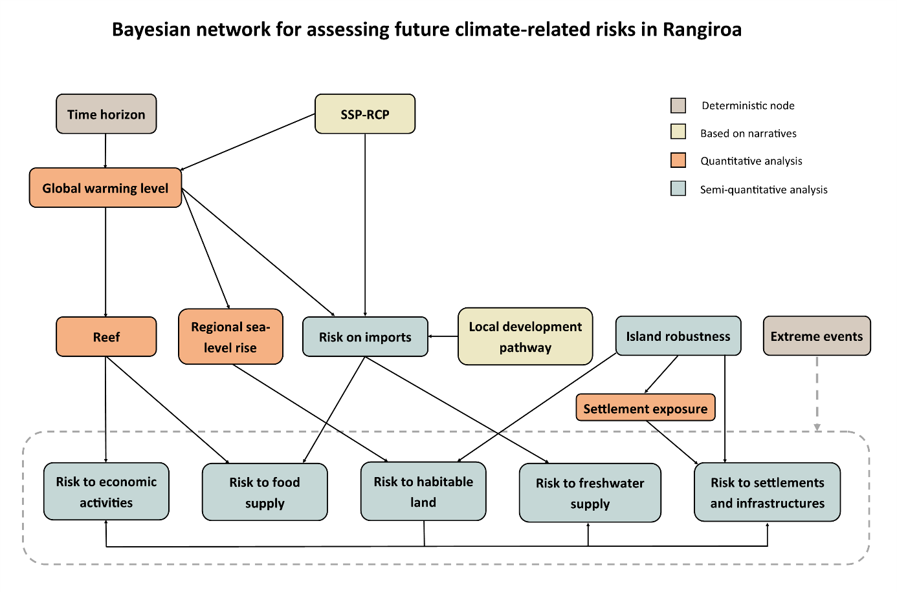
Figure S1: Bayesian network model developed in this study. The BN structure includes variables informed through quantitative and semi-quantitative analyses, narratives, and deterministic parameterization.

Variables based on quantitative data

Global warming level
To represent the global warming level, we use projections of global mean temperature increase obtained from the IPCC AR6 dataset, as provided by the IPCC Interactive Atlas. We considered projections for four Socio-economic pathways (SSP1-2.6, SSP2-4.5, SSP3-7.0, and SSP5-8.5) for the years 2050 and 2100. We defined five global warming intervals:1-1.5°C, 1.5-2°, 2-3°C, 3-4°C, and >4°C. This discretization was designed to reflect the most likely global warming outcomes associated with each SSP-RCP scenario and key global warming levels relevant to the Paris Agreement and the current commitments and policies of countries ¹. The IPCC provides percentile distributions for each projection, which were included in the conditional probability tables (Figure S2).
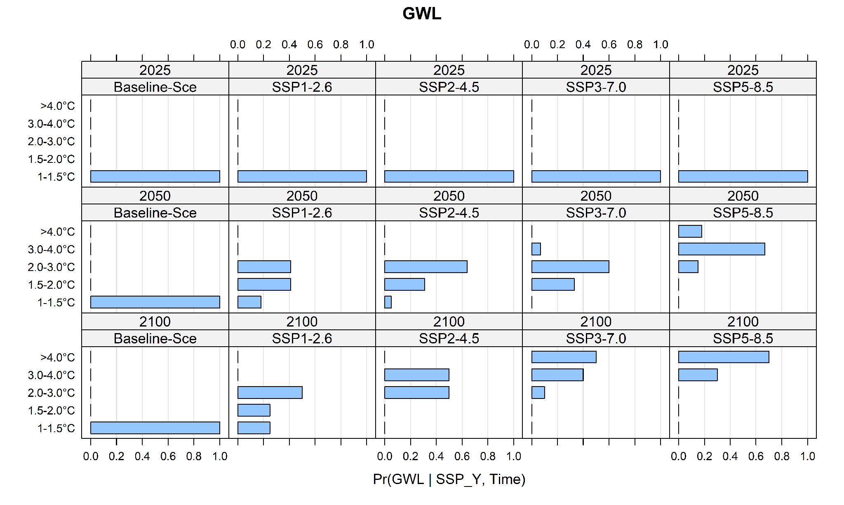
Figure S2: Conditional probability table for global warming level.

Regional sea level rise
Regional sea-level rise projections were obtained from the IPCC AR6 dataset, as provided by NASA for Papeete location. We considered projections for four Socio-economic pathways: SSP1-2.6, SSP2-4.5, SSP3-7.0, and SSP5-8.5 in 2050 and 2100 (Table S1). These projections are expressed relative to a 1995-2014 baseline. We discretize this variable into five intervals: <0.20 m, 0.20-0.50 m, 0.5-1.0 m, 1.0-1.5 m.
Table S1: Mean and 5th and 95th percentiles of the projected sea-level rise.
Time horizon | SSP1-2.6  Mean [Min-Max] | SSP2-4.5  Mean [Min-Max] | SSP3-7.0  Mean [Min-Max] | SSP5-8.5  Mean [Min-Max]
Total (2050) | 0.19 (0.13–0.26) | 0.20 (0.15–0.28) | 0.21 (0.16–0.29) | 0.23 (0.17–0.31)
Total (2100) | 0.45 (0.30–0.67) | 0.57 (0.41–0.82) | 0.68 (0.51–0.95) | 0.78 (0.59–1.08)

In Rangiroa, vertical ground motion has been estimated to be low (-0.11 ± 0.24 mm/yr according to ², and -0.08 mm/yr according to ^{3,4}. This is consistent with the geological context of Rangiroa, which suggests that the atoll experienced an uplifted phase in the past, followed by slow long-term subsidence ⁵. Therefore, vertical land motion is assumed to have a limited influence on relative sea level trends in this study. The IPCC provides percentile distributions for each projection, which were included in the conditional probability tables (Figure S3).
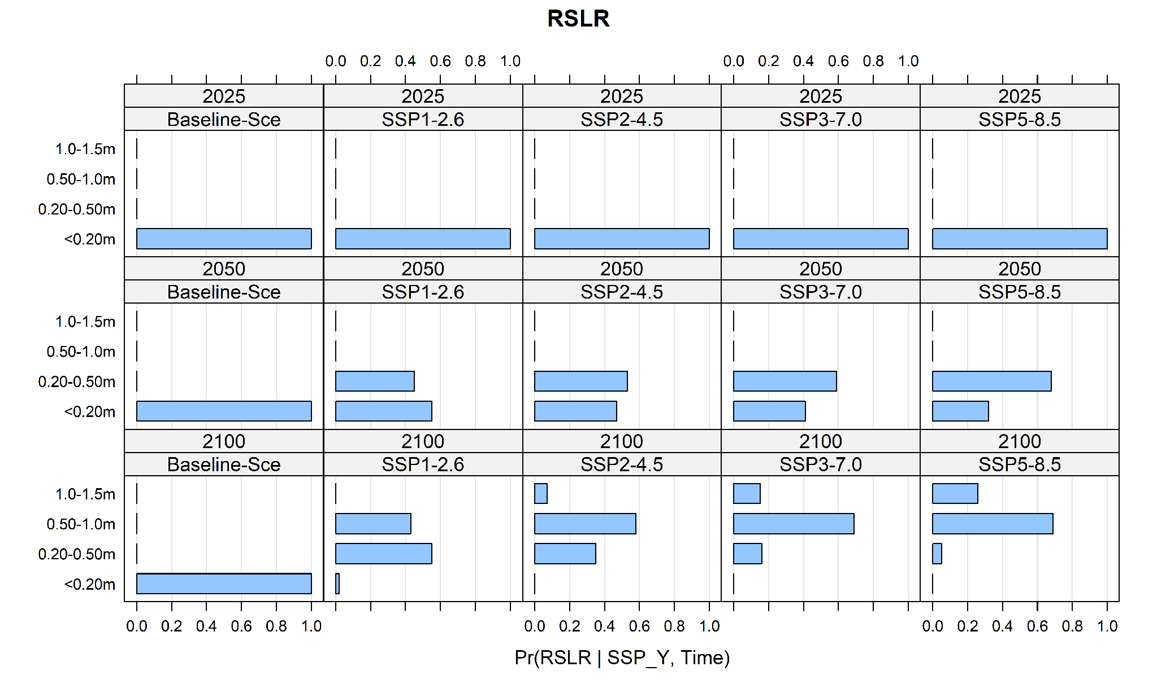
Figure S3: Conditional probability table for regional sea-level rise.

Variables based on semi-quantitative analysis
In the BN model, certain variables lack sufficient quantitative data to perform a full probabilistic analysis of their current or projected state. These variables include the island's physical robustness, risk to reefs, risk to land, risk to freshwater, risk to food supply, risk to settlements and infrastructure, and risk to economic activities. For these variables, we performed a semi-quantitative analysis based on the method described in section 1.2.1 to assess the current and future climate-related risks.

Assessment method
Our risk assessment is based on a synthesis of available knowledge, including datasets and literature. For each assessed risk, we associated a confidence level to represent the uncertainty. We defined a confidence scale tailored to this study, built on the IPCC framework, which considers evidence and agreement. To integrate these assessments into the BN model, confidence levels were converted into probability distributions using the methodology proposed in our previous work ⁶. Aware that associating a probability weight with a confidence level carries some subjectivity, we created an alternative set of probability distributions to assess the impact of our modelling assumptions (Table S2).

Confidence level into probability distributions

The BN model requires all input data to be expressed in probabilistic terms. To do this, we translated the confidence levels into probability distributions following the framework introduced in our previous work ⁶. In this approach, confidence levels are translated into probability distributions and then incorporated into the model as prior information. We associate the mode of the distribution with a probability weight that corresponds to the confidence level (Table S2). Accordingly, lower confidence levels in the assessment are represented by more dispersed distributions.
The selection of a distribution involves some subjectivity. To assess the impact of this choice on model outcomes, we developed an alternative set of distributions, providing a more conservative interpretation of the probability weights. This second set was used to perform a sensitivity analysis, the results of which are presented in Section 3. More details about the conversion of the confidence levels into probabilities are provided in ⁶.
Table S2: Probability weight associated with confidence levels. We tested two cases to assess the sensitivity of the model.
Confidence level | Probability weight -set 1 | Probability weight -set 2 (Section 3)
1. Very low | 0.30 | 0.40
2. Low | 0.40 | 0.60
3. Medium | 0.60 | 0.80
4. High | 0.80 | 0.90
5. Very high | 0.90 | 1

Island physical robustness
Atoll islands are dynamic structures that exhibit physical characteristics that influence their susceptibility to erosion and flooding. We grouped the study islands into four categories based on ⁷. These authors estimate an index of physical robustness that reflects how Rangiroa Atoll islands can resist and adapt to climate-ocean pressures. They define six key variables to characterize robustness:
- Island size: Larger islands are more likely to persist in the face of extreme events such as cyclones and changes in climate-ocean conditions.
- Elevation: The elevation of islands determines their susceptibility to temporary or permanent flooding. In addition, low-lying islands are more vulnerable to storm-wave erosion.
- Shape: Circular islands are less vulnerable to geomorphic change than irregular islands, as their configuration interferes less with sediment transport.
- Structure: The structure of an island refers to its geomorphological characteristics. Some landforms are more unstable, particularly sand and gravel spits, island tips, and elongated low-lying areas.
- Vegetation: Two major vegetation properties influence island stability: vegetation cover and vegetation type, based upon the assumption that the native vegetation is more effective at trapping and stabilising island sediments than introduced vegetation such as coconut trees.
- Human disturbance: human activities such as sediment extraction, land reclamation, and shoreline armouring modify island dynamics, affecting their natural capacity to adjust to climate-ocean changes horizontally and vertically.
⁷ evaluated each variable on a five-level scale and summed the scores to estimate an overall robustness index for each island. Due to the relatively small variability in the robustness index values (around 0.05 between islands in some cases), we retained four categories to maintain the geomorphological and anthropogenic nuances (see Table S3).
Table S3: Islands’ characteristics and associated physical robustness index ⁷.
Category | Island’s characteristics | Index estimated by Duvat et al. 2021 | Rangiroa Atoll Island
Very low robustness | Islands showing erosion-prone areas, low vegetation cover, heavily impacted by human activities, low elevation, and limited surface. | <0.45 | Island 2 (Avatoru), 5 (Aeroport), 3, and 7
Low robustness | Islands that are currently stable, but disturbed by human activities, have limited surface and vegetation cover and low elevation. | 0.45 – 0.49 | Island 4, 6, and 8 (Ohotu)
Moderate robustness | Moderate surface area and elevation, moderate vegetation cover, and affected by human activities. | 0.49-0.55 | Island 1,9 (Tiputa) and 10
High robustness | Islands that are currently stable, with a large surface, relatively high elevation, and limited or no disturbance from human activities. | >0.55 | Island 12 (Otepipi)

We associated the physical robustness index with a moderate confidence level, reflecting that the assessment is based on a limited number of studies, although this is based on robust measured data, including geomorphological surveys on twelve islands and an extensive literature review.
Conditional probability table
We populate the CPT for Island Robustness with the corresponding probability distributions (Figure S4).
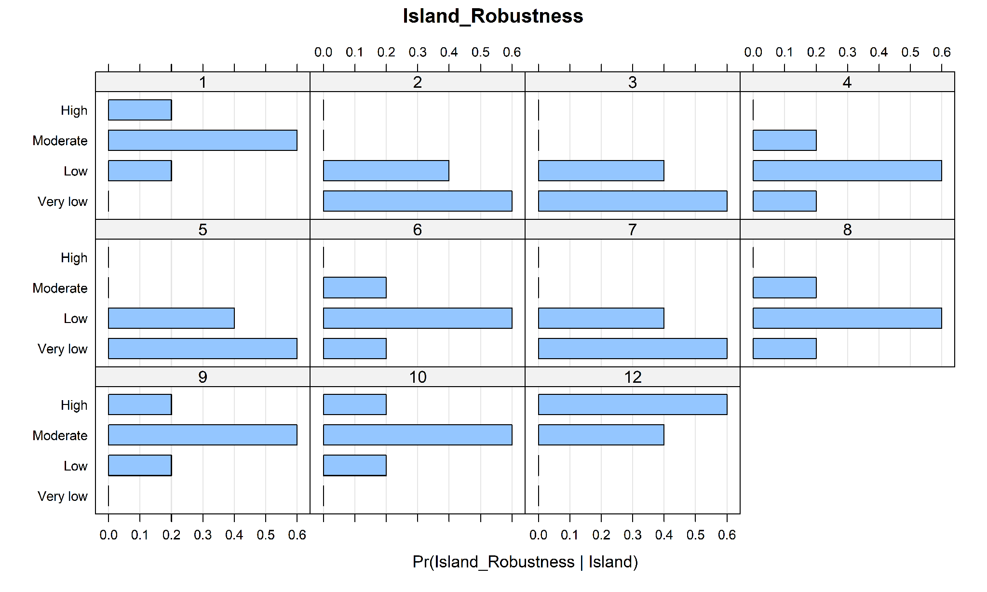
Figure S4: Conditional probability table for island robustness.

Risk to land
Current risk
Historical shoreline analyses suggest that islands of the Rangiroa atoll have remained globally stable over the past four decades ⁸, with no evidence of widespread chronic erosion. Regarding flooding, in Rangiroa is generally less exposed than some other atolls. This is mainly due to tectonic uplift, which has resulted in higher island elevations ⁹. However, spatial variability exists, with lagoon-side areas being low-lying and highly exposed to flooding (Avatoru Island) ⁷. Under present-day conditions and in the absence of extreme events, no island experiences regular flooding during high tides.
The overall stability suggests that the Rangiroa islands currently exhibit a certain degree of resilience to climatic conditions ⁸. However, several islands are significantly affected by human activities, including sediment extraction and hard coastal structures. Such disturbances alter natural shoreline dynamics by reducing sediment supply and limiting vertical adjustment processes, thereby decreasing islands' resilience ⁷. One example is the airport island, which has experienced a reduction in surface area of approximately 5.6%, attributed to significant environmental disruptions caused by the airport construction ¹⁰.
Based on these observations, we assessed the current risk to land as low across all islands, with medium evidence and high agreement, resulting in an overall high confidence level. The medium evidence reflects the limited number of studies, although these are based on robust data, long-term observations, and varied methods. The high level of agreement reflects the strong consistency across studies, which converge on the overall stability of islands and the limited flooding under present conditions.
Extreme events, including cyclones and intense distant-source swells generating extended flooding, are rare in this region. However, they can induce significant morphological changes ¹¹. For example, during cyclones Orama and Veena, several islands experienced flooding ¹² and erosion, while others showed accretion, highlighting the spatial variability of responses to such events ¹⁰. We assessed the impact of extreme events by considering the episodic flooding and erosion they caused. The spatial extent of cyclones and distant-source swells was estimated based on field observations ¹⁰ and impact chains maps derived from interviews with residents produced by ¹³. The information is available for cyclones Orama and Veena, as well as the 1996 distant-source swell event.
Under extreme event conditions, the risk to land was assessed as moderate to high, with low evidence and medium agreement, resulting in a low confidence level. The low confidence level is due to the limited number of documented events and available data, including only two major cyclones (Orama and Veena) and one distant-source swell event. Despite these limitations, the medium level of agreement reflects consistency between participatory mapping ¹⁴ and modelling results from the South Pacific Islands Applied Geoscience Commission - Secretariat of the Pacific Community (SOPAC-SPC) ¹², which identify similar inundation patterns and affected areas. The risk varies across islands, with higher risks observed in geomorphologically more vulnerable islands.
Future climate-related risk
Future risk to land is difficult to assess because, to our knowledge, there are no projections of future erosion, flooding, or extreme event impacts for the study islands. To overcome these data limitations, we assessed the risk to land by combining quantitative data with literature-based knowledge. Land loss was evaluated based on the proportion of the island surface projected to be exposed to marine inundation and erosion. We consider the island's physical characteristics, regional sea level rise, and extreme marine events (cyclones and distant-source swells). In our assessment, we considered that no major adaptation measures were implemented.
Flooding was estimated using a bathtub approach by intersecting each sea-level rise scenario with a high-resolution elevation model (Figure S6) produced by ¹² and referenced to hydrographic zero. The bathtub approach has known limitations, generally overestimating flooded areas by a factor of 2 or more during single extreme events ¹⁵. It is used here as a first-order assessment to identify areas exposed to marine flooding rather than those inundated through wave- and surge-induced processes. We added to all scenarios the baseline of 0.60 m, corresponding to the local reference for the high spring tide ⁷. We then calculated the percentage of the land area below the projected water levels. The percentages were translated into four risk levels (Table S4):
Table S4: Definition of land loss risk levels.
Risk level | Characterization
0 | A low proportion of the island (<10%) is permanently flooded or submerged during extreme events.
1 | A part of the island (10-30%) is permanently flooded or submerged during extreme events.
2 | A significant part of the island (30-50%) is permanently flooded or submerged during extreme events.
3 | Most of the island (>50%) is permanently flooded or submerged during extreme events.

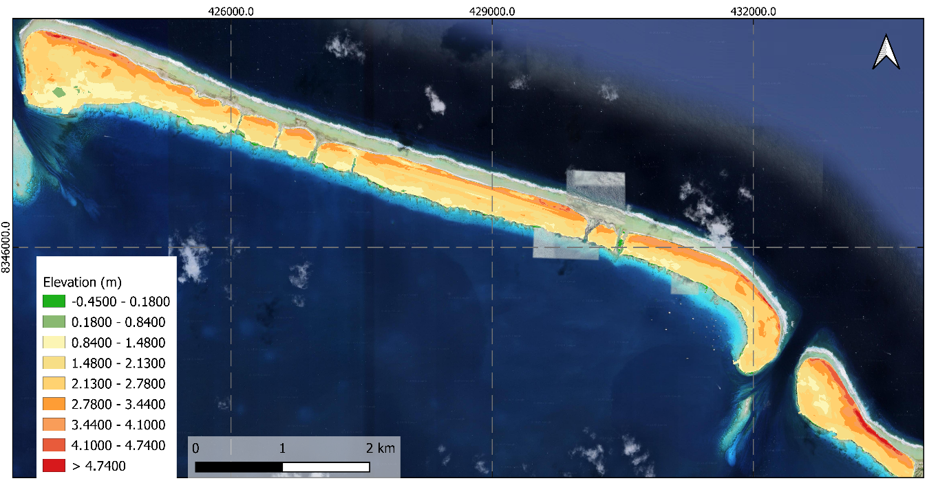
Figure S6: Elevation of inhabited islands in Rangiroa. Source: SOPAC-SPC.
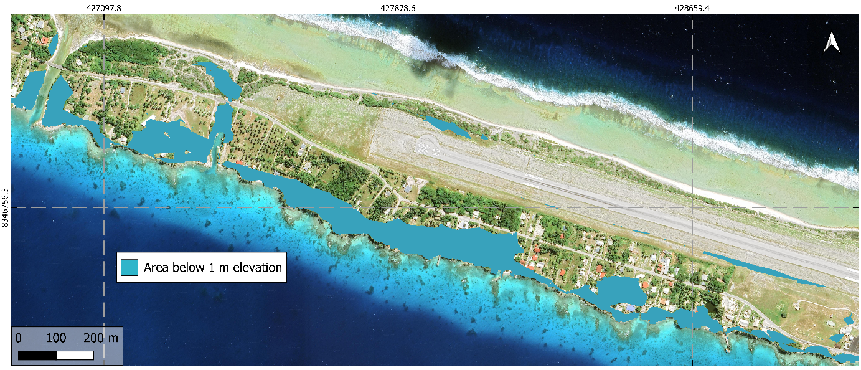
Figure S7: Area below 1 m elevation on Island 5 (Airport Island).
To account for erosion processes, we incorporated the island's physical robustness index following ⁷. As explained in section 1.2.2, physical robustness was interpreted as an indicator of island susceptibility to land destabilization. Erosion was accounted for by adjusting the probability of each risk level based on both island robustness and sea-level rise.
- Higher sea levels were assumed to increase the probability of erosion-induced land loss due to greater wave impact. As the sea-level rises, we associate higher uncertainty with future island morphological evolution.
- Higher robustness was assumed to reduce susceptibility to erosion.
As sea-level rises, probabilities shift towards higher risks. The shift is more pronounced for less resilient islands.
Under extreme-event conditions and considering sea-level rise, the only available simulations in the study area are from ¹⁶, who modelled cyclonic conditions similar to those of cyclone Orama under a +0.30 m sea-level rise scenario on Avatoru Island. They estimated an extreme lagoon-side water level of 2.6 m. To assess the impacts on the other islands, we intersected this extreme water level with island elevations (Figure S8).
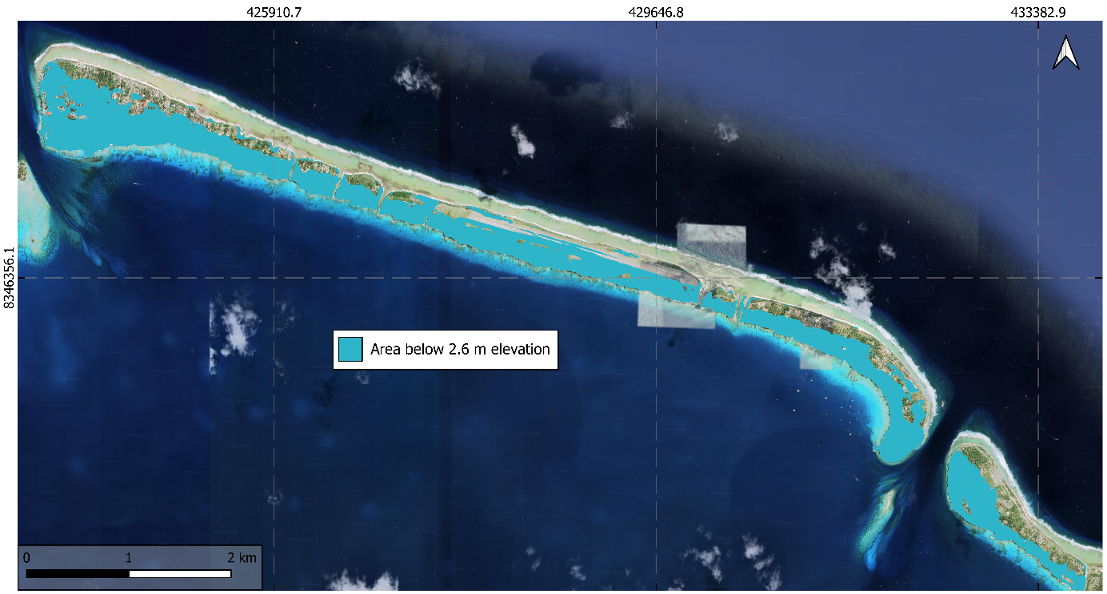
Figure S8: Area below 2.6 m corresponding to an extreme water level scenario using the bathtub approach.
Conditional probability tables
The probability distributions used to fill the CPT for Risk to land are shown in Figure S9.
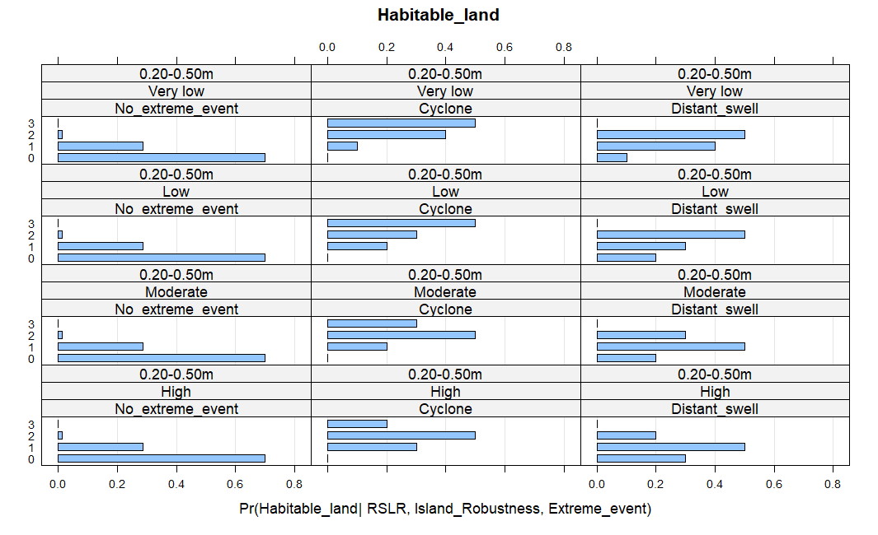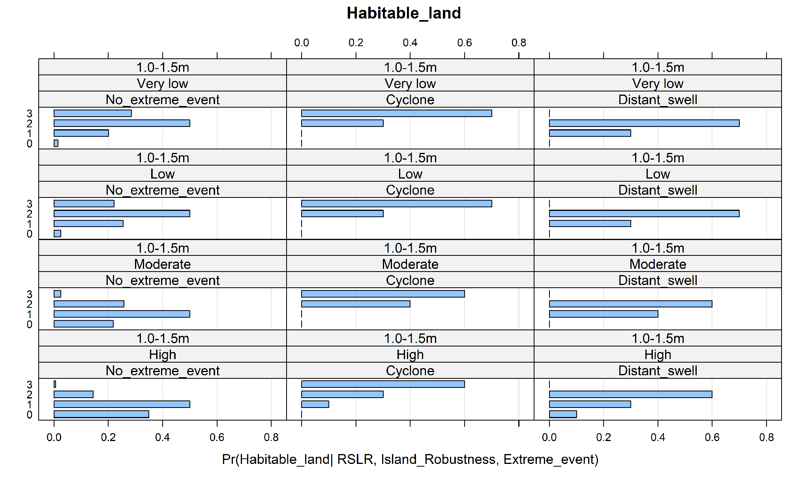
Figure S9: Conditional probability table of risk to land given a sea-level rise of 0.20-0.50 m and 1.0- 1.5 m.

Risk to settlements and infrastructure
Current risk
The risk to settlements and infrastructure is mainly driven by a combination of the exposure of residential buildings, climate-related hazards (slow-onset and extreme events), and ecosystem degradation ¹⁷. The level of exposure depends on several factors, including the location within the islands, the building elevation, and the construction material.
In Rangiroa, population growth has significantly increased the exposure of settlements (Figure S10). The number of residents increased by 138%, from 1169 inhabitants in 1983 to 2785 in 2022 ¹⁸. Consequently, the number of public and residential buildings has also increased from 200 to 1260 between 1981 and 2022. Most buildings are concentrated in Avatoru and Tiputa, which are the two main villages. Avatoru hosts most of the residential and public infrastructure, including a secondary school, the town hall, and technical services. It also hosts critical infrastructure such as the main port, a cyclone shelter, and the main route connecting inhabited islands.
Under present-day conditions, there is limited evidence of recurrent flooding affecting built areas. However, episodic extreme events can have a significant impact on settlements and infrastructure. ¹³ reconstructed chains of impacts and showed that cyclones Orama and Veena had caused extensive damage to public and residential buildings, as well as disruptions to transport and essential services. According to ¹⁴, in 2013, 588 residential buildings were located in flood-prone areas. Using updated GIS building data from 2020 (provided by the Cadastral and Topographic Section CAD-TOPO) and applying the same methodology, we estimated that this number increased to approximately 742 residential buildings, in addition to numerous public buildings, hotels, guesthouses, and restaurants in exposed areas.
Very few buildings are elevated, this is above ground level. According to ¹⁴, only around 550 houses in Avatoru and 170 in Tiputa were elevated less than 50 cm in 2013. Among these houses, 230 in Avatoru and 96 in Tiputa are in flood-prone areas that have been submerged at least once since 1980. No recent data is available for 2026. Coastal protection structures, including seawalls and dikes, are present in several lagoon areas, but they are mainly designed to control shoreline erosion and are generally insufficient to prevent marine flooding ¹⁴.
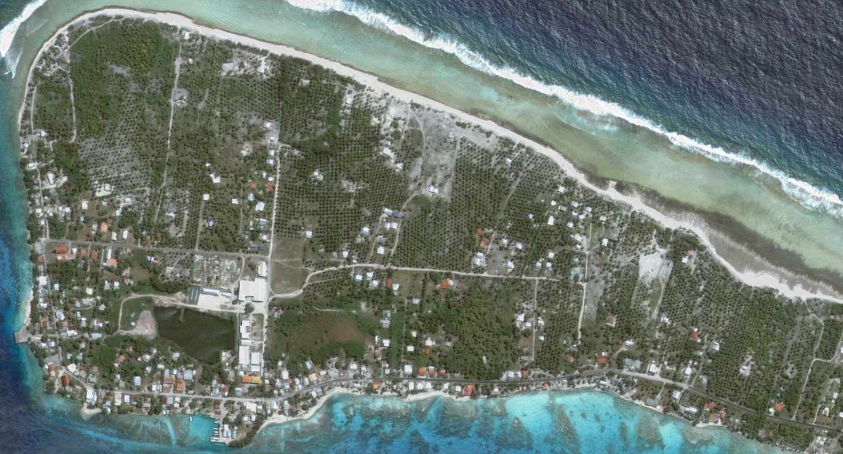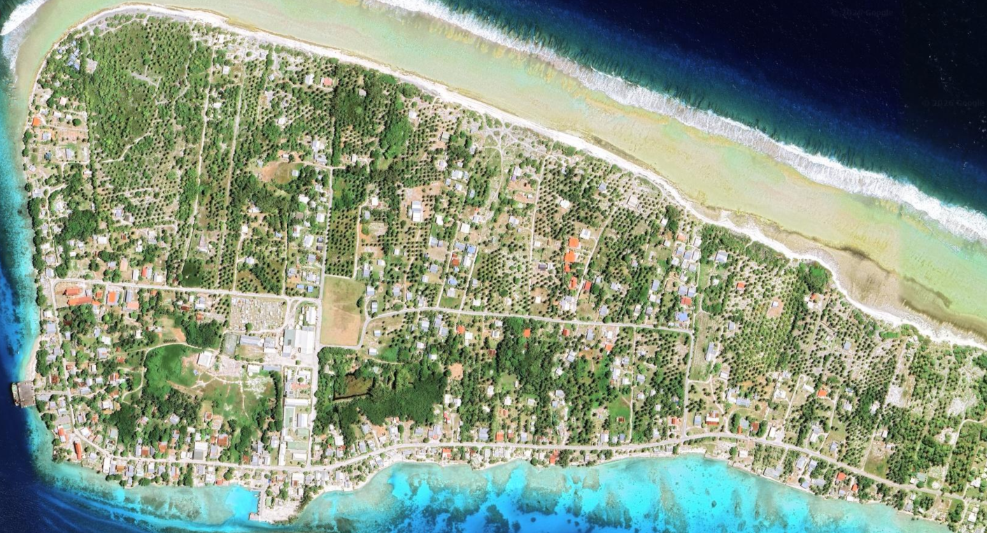
Figure S10: Evolution of housing and settlements in Avatoru Island from 2005 (left) to 2013 (right). Source: Google Earth.
Based on these observations, under present-day conditions, the risk to settlements is assessed as low (medium evidence, high agreement), with a high confidence level. Under extreme event conditions, the risk increases to moderate to high, with low evidence and medium agreement, reflecting the limited number of documented events; however, those documented are the most significant ones with consistent observations of their impacts. Risk levels vary between islands, as they have different exposure patterns and geomorphological characteristics.
Future risk
To assess the future risk to settlements and infrastructure, we considered three main drivers: risk to land, settlement exposure, and extreme events. Risk to land is directly linked to the susceptibility of islands to flooding and erosion. To our knowledge, no projections exist regarding future flooding and erosion damages or extreme-event impacts on settlements. There are also no projections of future settlement expansion. Therefore, our assessment assumes that current exposure remains constant in the future and that no major adaptations are implemented.
Settlement exposure varies between islands. Buildings are highly concentrated in Avatoru and Tiputa, while some other study islands remain uninhabited, such as islands 1 and 12. Critical infrastructure refers to facilities considered essential for the island's functioning ¹⁷, including hospitals, schools, cyclonic shelters, power plants, and administrative buildings. In this category, we also include harbours, main roads, and the airport, which are critical for transport connectivity.
To assess the potential future risk induced by permanent flooding, we estimated the percentage of buildings and critical infrastructure located in flooded areas for different sea-level rise scenarios, using the building GIS layer for 2020.
For flooding induced by extreme events (cyclones and distant-source swells), the risk was estimated based on water levels. Flood hazard levels were derived from ¹⁶. In their study, they modelled flooding under cyclone Orama conditions combined with +0.30 sea level rise. Water depth and flow velocity were used to classify flood hazard. In Avatoru Island, water levels ranging from 0.5 to 4 m and flow velocity between 0.5 m/s and 4 m/s correspond to high to very high hazard levels (Table S5). In the absence of building vulnerability functions for Rangiroa, this hazard classification was used as a proxy to represent potential impacts on buildings. We selected a threshold of 0.5 m water level to represent hazardous flooding, as it can already induce high hazard when combined with flow velocities >0.5 m/s (Table S6).
Table S5: Flood hazard classification used by ¹⁶ based on Stollsteiner (2009).
Flow velocity Flood depth | v < 0.5 m/s | v ≥ 0.5 m/s
h < 0.5 m | Low | Moderate
0.5 ≤ h < 1 m | Moderate | High
h ≥ 1 m | High | Very high

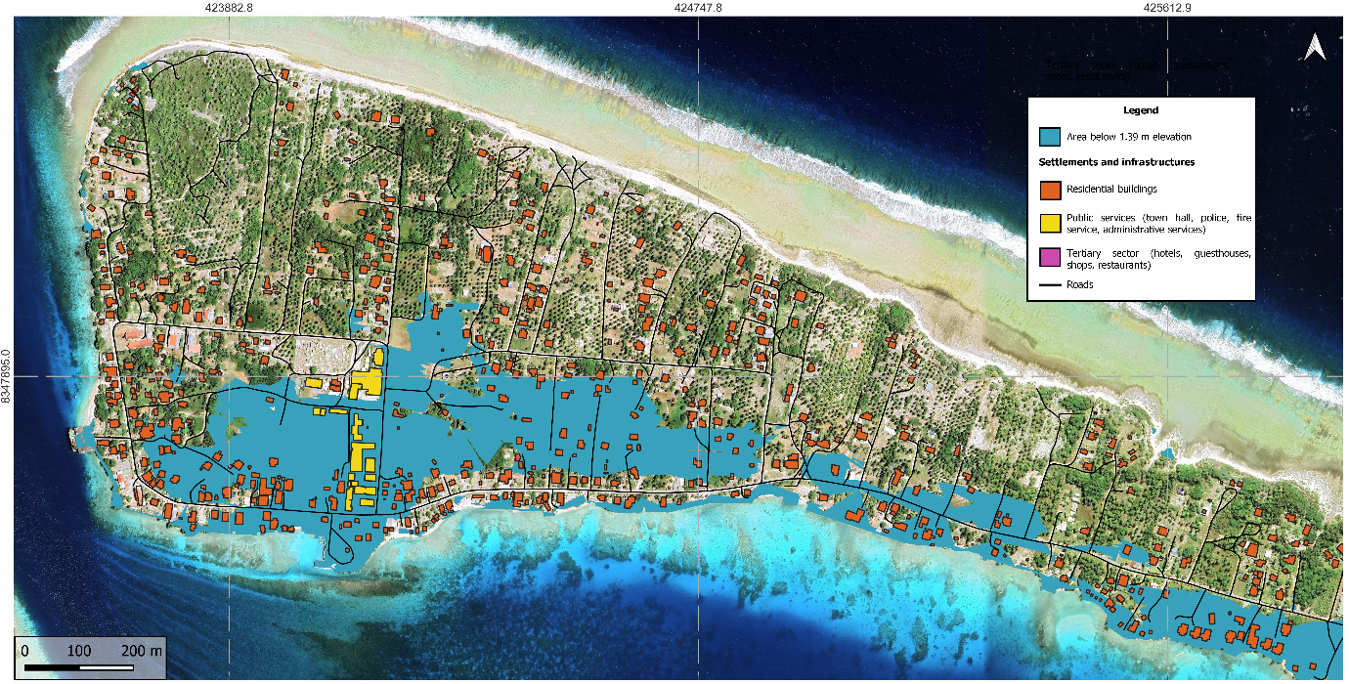
Figure S11: Residential buildings and public services located within areas below 1.39 m elevation – a permanent submersion scenario in 2100: 1 m (SSP5-8.5 upper-bound RSLR) + 0.39 m (mean sea level).
Risk levels were then defined on the proportion of settlements and infrastructure exposed to hazardous flooding:
Table S6: Risk level classification for settlements and infrastructure.
Risk level | Characterization
0 - low | Localized impacts: <5% of the housing and infrastructure are affected by permanent flooding or by hazardous flooding (≥0.5 m) during extreme events.
1 - moderate | Significant impacts: 5-10% of the housing and infrastructure are affected by permanent flooding or by hazardous flooding (≥0.5 m) during extreme events.
2 - high | Widespread impacts: 10-25% of the housing and infrastructure are affected by permanent flooding or hazardous flooding (≥0.5 m) during extreme events. A high-risk level is also assigned when at least one critical infrastructure is impacted.
3 – very high | Systemic impacts: >25% of the housing and infrastructure are affected by permanent flooding or hazardous flooding (≥0.5 m) during extreme events.

Conditional probability tables
Figure S12 shows the probability distributions used to fill the CPT for Risk to settlements and infrastructures in Island 5 (airport Island).

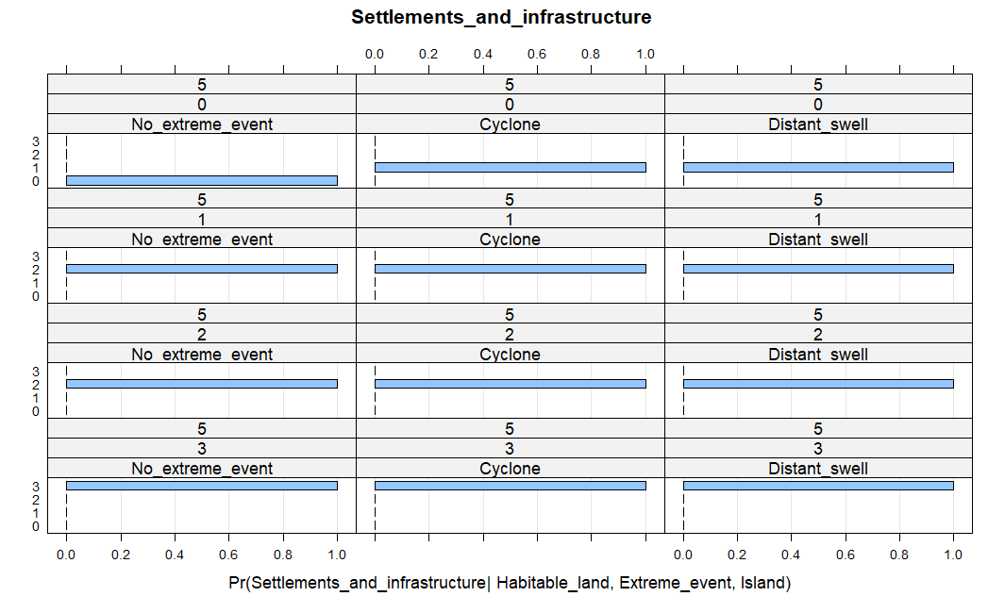
Figure S12: Conditional probability table for risk to settlements and infrastructures on the airport island.

Risk to food supply
Current risk
In Rangiroa, food supply primarily relies on imports, fishing, and subsistence practices. Lagoon-based fishing represents a significant part of local consumption. Basic food products such as bread, rice, and oil are imported. In contrast, agricultural activity plays a limited role ¹⁹ apart from coprah production. At present, the food system in Rangiroa can be considered relatively reliable, supported by regular imports from Tahiti ¹⁹ and local food production ²⁰. However, the high reliance on imports increases the vulnerability to potential supply disruptions ²¹.

Based on these observations, we assessed the current risk to food as low, with medium evidence and high agreement, resulting in an overall high confidence level. The medium level of evidence reflects the limited availability of data concerning locally produced food volumes, the proportion of imports versus local food production, or historical supply disruptions. However, existing sources provide a consistent description of the food system.

Future risk
To assess the future risk to food supply, we considered two main factors: reef ecosystems, given their contribution to lagoon-based fishing, and food imports. The impact of extreme events, such as cyclones or distant-source swell, is also included, as these can disrupt local fisheries, damage reef habitats, and interrupt supply chains.
In our assessment, the overall risk to food supply results from the combination of the risk to imports and the risk to the reefs. The rationale for this assessment is explained in the following table:
Table S7: Rationale of the future risk to food supply assessment.
Risk to imports | Risk to reefs | Risk to the food supply | Rationale of the assessment
0 | 0 | 0 | Low levels of risk associated with imports and reef conditions currently ensure food supply security.
0 | 1 | 0 | Imports remain stable, but there is a low risk of reef degradation that could affect local fisheries. At this stage, food supply remains secure.
0 | 2 | 1 | Moderate reef degradation reduces the availability of fish from lagoon-based fisheries. Although imports remain stable, the decline in local resources would lead to increased dependency on external food supplies.
0 | 3 | 1 | Severe reef degradation would compromise local fisheries. Even if imports remain stable, the reduction in local marine resources would affect food balance.
1 | 0 | 0 | Disruptions to imports generate a moderate risk to the supply of basic food products. However, as reef degradation progresses, the availability of fish is likely to decrease, threatening this balance and increasing dependence on imported goods. Consequently, reef degradation would lead to growing food insecurity.
1 | 1 | 1
1 | 2 | 1
1 | 3 | 2
2 | 0 | 1 | Highly disrupted imports compromise the supply of basic food products. Increasing reef degradation would reduce local fish resources. With both imports and local resources becoming unstable, food security is significantly compromised.
2 | 1 | 1
2 | 2 | 2
2 | 3 | 2
3 | 0 | 1 | Severe import disruptions would threaten food security due to Rangiora’s strong dependence on external supplies. Local fisheries alone would not be sufficient to meet the nutritional needs.
3 | 1 | 2
3 | 2 | 3
3 | 3 | 3

During a cyclone, food supply chains may be severely disrupted due to damage to key infrastructure, such as roads, ports, and the airport. Lagoon-based fisheries may also be significantly affected. Cyclones can destroy fish enclosures, equipment, and boats, and disrupt ecosystems. In this context, the risk to the food supply becomes considerably higher ¹³. In our analysis, cyclones are incorporated as an aggravating factor that compounds existing risks. When import capacity and/or reef conditions deteriorate, the resilience of the food system decreases, exposing the population to increased vulnerability.
During distant-source swell events, lagoon fisheries may be disrupted due to damage to sections of the reef. Food supply chains may also be affected, particularly if infrastructure such as roads, ports, or the airport becomes submerged or damaged by coral debris ¹³. In our analysis, austral swells are considered an aggravating factor that compounds pre-existing risks. When import capacity and/or reef conditions deteriorate, the resilience of the food system decreases, exposing the population to increased insecurity during austral swell events.
To assess the risk to food supply under extreme-event conditions, we calculated the average of the aggregated risk to imports and reef degradation. This average is then rounded up to the highest integer to reflect the intensifying effect of such events. Finally, the risk level is shifted by +1 in the case of cyclones to capture their multiple and more severe impacts.
We populated the conditional probability tables associated with the risk to food supply in a deterministic way. We assigned a probability of one to the assessed risk. This choice allows us to remain consistent with the risk rationale.

Risk to freshwater supply
Current risk
In Rangiroa, as in most atoll islands, freshwater is a limited resource. It is primarily supplied through three main sources: rainwater harvesting, groundwater extraction, and imported bottled water.
Rainwater constitutes the main source and is collected through rooftop catchment systems and household tanks. The average storage capacity is estimated at approximately 4 m³ per inhabitant. However, fewer than one quarter of the storage tanks meet the necessary quality standards. To address these limitations, the municipality installed in 2012 rainwater-based drinking water production systems in Avatoru and Tiputa, where access is granted via a prepaid card system.
The brackish water from the groundwater lens is widely used for domestic (non-drinking) purposes. According to piezometric measurements conducted by ²², the groundwater lens is situated between 0.50 m and 3.00 m below the ground surface, with the aquifer depth not exceeding 4 m. Wells located inland generally extract water with lower salinity levels. According to ²², despite the high water demand, wells rarely run dry, except during low tide. However, due to the narrowness of the islands, most of them are located less than 150 m from the lagoon, which increases their vulnerability to saline intrusion. Moreover, the groundwater lenses are highly vulnerable to human-caused pollution.
Imported bottled water represents the third potable water source. Its importation is regulated by the French Polynesian authorities, who classify bottled water as an essential good and grant it freight subsidies to ensure continued supply ²³. This supply relies on inter-island shipping and supply chains, which can be disrupted by extreme weather events or economic shocks.
Future risk
To assess the future risk to freshwater supply, we considered two drivers: risk to land and risk to imports. Land loss risk is linked to the risk of groundwater lens salinisation. We also include the impact of extreme events, as they can induce groundwater salinization, pollution of harvested rainwater, and destruction of catchment systems.
In our assessment, the overall risk to freshwater supply results from the combination of risk to land and risk to imports. The rationale for this assessment is explained in the following table:
Table S8: Rationale of the future risk to freshwater supply assessment.
Risk to land | Risk to imports | Risk to freshwater supply | Rationale of the assessment
0 | 0 | 0 | A low risk of groundwater lens salinisation and stable import conditions ensure water supply. However, when water imports are disrupted, the number of available water sources decreases, reducing water access.
0 | 1 | 0
0 | 2 | 1
0 | 3 | 1
1 | 0 | 0 | As the risk of land loss increases, so does the risk of groundwater salinisation. When this is combined with disrupted imports, the number of available sources decreases, increasing the pressure on the remaining ones.
1 | 1 | 1
1 | 2 | 1
1 | 3 | 2
2 | 0 | 1 | A high risk of groundwater salinization increases the risk of water shortages, especially during the dry season. When combining with disruptions on imports, the risk to the freshwater supply becomes high.
2 | 1 | 1
2 | 2 | 2
2 | 3 | 2
3 | 0 | 1 | When the lens becomes unusable due to salinization, the population depends on rainwater and imported water for daily needs. Disruptions in water imports increase the risk, as rainwater becomes the only available source. This combination results in extremely limited access to water.
3 | 1 | 2
3 | 2 | 2
3 | 3 | 3

During extreme climate events, there is a high risk of groundwater salinization. According to ¹³, during Veena and Orama cyclones in 1983, the saline lens remained unusable for 2 to 10 years, and the water in cisterns was contaminated (lasting several months to 1 year). Additionally, imports were disrupted due to damage to docks and ports (up to 6 months), leading to water shortages. The distant-source swell of July 1996 caused groundwater salinisation, with well water sometimes rendered unusable for 1-2 weeks, leading to water shortages in the village. To assess the risk to the freshwater supply under extreme-event conditions, we calculated the average of the aggregated risk to land and the risk to imports. This average is then rounded up to the next interval to reflect the intensifying effect of the extreme events. In the case of cyclones, an additional level (+1) is applied to capture their severe impact.
We populated the conditional probability tables associated with the risk to freshwater supply in a deterministic way. We associated a probability of one with the aggregated risk level. This choice allows us to remain consistent with the risk rationale.

Risk to economic activities
Current risk
Economic activities are primarily reliant on tourism, fisheries, and copra production. Tourism is the main activity. According to ²⁴, Rangiroa welcomed 32000 tourists in 2023. Lagoon fisheries support local consumption and small-scale commercial activities, while coastal fisheries export to Tahiti. Copra production is a state-subsidised activity that continues to support the local economy ²⁵. Despite a decline in copra and pearl farming in recent years, the overall economic activity remains stable, sustained by the growing tourism sector.
Future risk
To assess the risk to economic activities, we considered two factors: the risk to land and risk to reefs. The loss of land due to flooding or erosion impacts economic activities such as tourism and agriculture. Soil salinization and flooding have a direct effect on coconut trees and, consequently, on copra production. The condition of the reefs affects fisheries and tourism by reducing fish stocks and decreasing tourist-related activities (e.g., diving).
The overall risk to economic activities results from the combination of risk to land and risk to reefs. The rationale for this assessment is explained in the following table:
Table S9: Rationale of the future risk to economic activities assessment.
Risk to land | Risk to reefs | Risk to economic activities | Rationale of the assessment
0 | 0 | 0 | Low risk to land results in limited impacts on agriculture or tourism infrastructure. However, increasing reef degradation threatens fisheries and tourism-related activities.
0 | 1 | 1
0 | 2 | 1
0 | 3 | 2
1 | 0 | 1 | Moderate land loss can induce localized affected areas, resulting in moderate impacts on agriculture and tourism infrastructure. When combined with reef degradation, it could result in a decline of multiple economic activities.
1 | 1 | 1
1 | 2 | 2
1 | 3 | 2
2 | 0 | 1 | High risk to land can result in significant impacts on agriculture and tourism. When combined with reef degradation, it could result in a significant reduction of economic activities.
2 | 1 | 2
2 | 2 | 2
2 | 3 | 3
3 | 0 | 2 | High risk of land loss will induce significant impacts on agriculture and tourism. When combined with reef degradation, it could result in a severe decline in economic activities.
3 | 1 | 2
3 | 2 | 3
3 | 3 | 3

During extreme events such as cyclones and distant-source swells, these risks are exacerbated. Impact chains from cyclones and southern swells ²⁶ in Rangiroa illustrate the effects of these events, notably the salinization of the freshwater lens and soils due to marine inundation. During the distant-source swell of July 1996, the lens remained saline for 1 to 2 months. This event affected agriculture, damaging coconut trees on small motu, causing immediate losses (1 to 3 months) due to fallen and spoiled coconuts, and medium-term impacts (6 months to 3 years) such as reduced production and abandonment of coconut groves.
During Cyclones Veena and Orama in 1983, imports were disrupted due to damage to docks and ports (up to 6 months), leading to water shortages. Fruit trees and vegetable crops were destroyed, livestock was lost, tourist accommodations and infrastructure were damaged, over 90% of coconut groves were destroyed, copra production declined for 3 to 5 years, and lagoon, offshore, and outer slope fisheries collapsed (6 months to 5 years), including destruction of fish parks, equipment, and boats, as well as disruption to lagoon and reef ecosystems.
The risk to economic activities was calculated by averaging the aggregated risk for land and reefs. The average was rounded up in the case of distant-source swells to reflect their intensifying effect. In the case of cyclones, +1 was added to the assessed risk level to account for the major cascading impacts induced by these events.
We populated the conditional probability tables associated with the risk to economic activities in a deterministic way. We associated a probability of one with the aggregated risk level. This choice allows us to remain consistent with the risk rationale.

Risk to reefs
Current risk
In French Polynesia, the primary drivers of reef disturbance include crown-of-thorns starfish outbreaks, coral bleaching events, and cyclones ²⁷. In Rangiora, severe bleaching has been recorded in 1991, 1994, 1998, and 2016 ^{28–30}. Cyclones are also rare in the region, with the last major events (Orama and Veena) occurring in 1983.
Long-term monitoring from the outer reefs of Rangiroa Atoll indicates relative stability in coral cover over the past two decades ²⁷. Both the outer and lagoon reefs have demonstrated strong resilience, with documented recovery following past major disturbances. For example, lagoon reefs showed near complete recovery approximately 15 years after the severe 1998 bleaching event ²⁸. However, this resilience can be threatened by human pressures, particularly within the lagoon environments ²⁷.
Given the relative stability in coral cover and the infrequent large-scale disturbances, we assessed the current risk to reefs as low to moderate (with medium confidence and high agreement), considering that reefs have sufficient time to recover. The medium confidence reflects the availability of long-term monitoring data for the outer reef, but few observations for the lagoon reefs. The high level of agreement reflects consistency among available observations, the published literature, and the broader regional context, indicating that coral reefs in French Polynesia remain relatively stable.
Future risk
To assess the future risk to reefs, we used projections of Annual Severe Bleaching (ASB) from ³¹. In this study, ASB is defined as the occurrence of severe bleaching conditions every year, corresponding to a cumulative thermal indicator exceeding 8 Degree Heating Weeks (DHW) annually. This threshold represents thermal exposure strong enough to cause severe bleaching each year. The projections are based on sea surface temperature (SST) projections from CMIP6 models. This data is used to calculate DHWs and determine the year when a reef area will be exposed to ASB conditions. In Rangiroa, ASB occurrence is projected to be around 2048 (±5 years) under the SSP2-4.5 and 2041 (±5 years) under the SSP5-8.5.
To assess the risk to reefs under different global warming levels, we related the expected year for ASB to the projected global warming level from IPCC under each SSP-RCP scenario (Table S10).
Table S10: Annual Severe Bleaching year associated with a global warming level.
Rangiroa | SSP2-4.5 – Mean [Min-Max] | SSP5-8.5 - Mean [Min-Max]
ASB expected onset year | 2048 [2033-2077] | 2041 [2032-2061]
Associated global warming level | 1.9°C [1.5°C-2.5°C] | 2.0°C [1.5°C-3.0°C]

Based on these results, we defined the following assumptions:
Global warming level between 1.0-1.5°C (current state): At present warming levels, severe coral bleaching events remain rare in the Tuamotu, but they can occasionally occur as a result of extreme marine heatwaves (especially during El Niño). Historical observations indicate that bleaching events affecting Rangiroa have occurred at intervals of approximately 5 to 10 years. When such events remain infrequent, recovery is still possible for reefs. Evidence from Rangiroa suggests that both the outer reefs and lagoon reefs have demonstrated high resilience, with documented recovery following past severe bleaching events. For example, in the lagoon, approximately 15 years after a massive bleaching event in 1998, the reef reached full recovery in 2013. Given that extreme events remain rare and recovery is still possible, we assigned this category a low-to-moderate risk.
Global warming level between 1.5-2°C: According to ³¹, the lower bound of the projected onset of ASB falls within this temperature range. As global warming approaches 2°C, reefs are expected to experience an increase in the frequency of severe bleaching events. Before a site becomes ‘annually severe’, severe episodes may occur every 2–5 years ³¹, depending on local SST variability. Lower frequencies of bleaching events per decade (e.g., 2x or 4x per decade) are projected to occur earlier than ASB. This category represents a transition phase, where the resilience of reefs is increasingly compromised due to shorter recovery periods. To reflect this, a high to very high risk was assigned to this category.
Global warming level over 2°C: Climate projections indicate that annual severe bleaching conditions are likely to occur once global warming exceeds approximately 2°C. Under these conditions, coral reefs experience thermal stress every year, limiting full recovery between bleaching episodes. This will lead to cumulative coral reef mortality and degradation of ecosystem functioning. Considering this, we assigned a very high-risk level to the GWL categories above 2 °C, reflecting the high probability of persistent mortality.
These projections do not consider the potential adaptation of reefs. However, according to ³¹, the great majority of coral reefs (>80%) are projected to experience ASB this century, even if 2°C of adaptation is assumed. We associated a medium level of confidence with these assumptions. The medium confidence reflects the limited evidence, but high agreement on the degradation threshold for coral reefs over 2°C.
Figure S13 shows the conditional probability table for reefs.
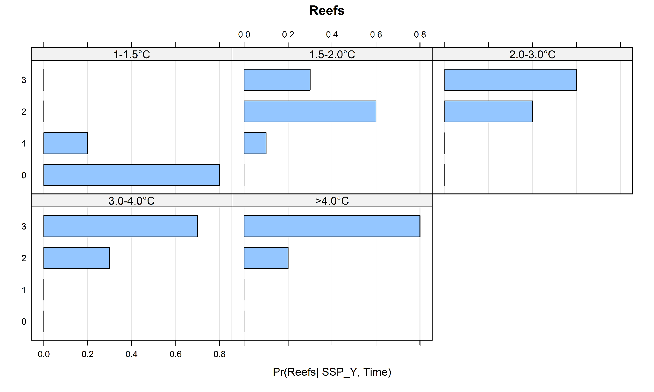
Figure S13: Conditional probability table for reefs.

Variables based on narratives
Importations in small islands such as Rangiroa are influenced by a combination of global and local factors. Global factors include food production, international cooperation, trade policies and barriers, price dynamics, globalisation, technological development, and climate-related impacts ^{32,33}, which determine the availability and accessibility of imported food. Local conditions include economic stability, dependence on imports, self-sufficiency, storage capacity (water, food, fuel), and local governance ^{34,35}. To assess the impact of climate change and socio-economic developments on food imports in Rangiroa, we incorporate the burning embers for food security developed by the IPCC ³⁶ to represent the global factors, and we combine these with narratives of local development pathways to represent local factors.

Shared socioeconomic pathways
The SSP-RCP scenario framework (Shared Socio-economic Pathways ³⁷, Representative Concentration Pathways ³⁸, and Shared Climate Policy Assumptions ³⁹ was developed as part of a research community effort supporting in particular IPCC assessment reports. This framework aims to produce scenarios based on combinations of socioeconomic conditions, climate projections, and shared climate policy assumptions. These scenarios have been used to assess the impact of climate change, mitigation, and adaptation measures ⁴⁰.
The Shared Socioeconomic Pathways describe how socioeconomic factors may change over the 21st century. The SSP pathways include five baseline narratives describing “how the future might unfold in terms of population growth, governance efficiency, inequality across and within countries, socio-economic developments, institutional factors, technological change, and environmental conditions” ⁴¹. In our study, we consider four SSP-RCP scenarios to assess their impact on the global warming level and the food/water import system (Table S11)
Table S11: Narratives associated with each SSP-RCP scenario considered in this study (based on ⁴⁰)
SSP-RCP | Narrative
SSP1-2.6  (low challenges to mitigation and adaptation) | Assumes an inclusive and sustainable development and strong international cooperation. Investments in low-carbon technologies improve resource efficiency and reduce consumption. Effective governance and stringent environmental policies limit environmental degradation and climate-related impacts.
SSP2-4.5  (medium challenges to mitigation and adaptation) | Assumes a continuation of current trends, with moderate progress in economic growth and technological development. International trade remains open but operates with structural imperfections. Global and national institutions function, but their effectiveness in addressing environmental challenges remains limited, leading to continued ecosystem degradation.
SSP3-7.0  (high challenges to mitigation and adaptation) | Assumes fragmented development, in which countries prioritize regional issues, leading to weak international cooperation and market connectivity. Economic and technological development is slow. Global environmental policies are poorly implemented, resulting in strong ecosystem degradation.
SSP5-8.5  (high challenges to mitigation, low challenges to adaptation) | Assumes rapid economic and technological development driven by intense fossil fuel use. Expansion of trade and globalization is supported by strong international cooperation. Environmental concerns are limited, while there is strong confidence in technological solutions to adapt to climate-related impacts.

Local development pathways
To integrate local factors influencing the food and water import system in Rangiroa, we developed two contrasting local development pathways based on historical data and literature.
The first pathway is a baseline scenario assuming historical trends will continue in the future. Food systems in Rangiroa, as in most of French Polynesia, are characterized by a high reliance on imports ²¹, reinforced by limited local agricultural production ¹⁹ According to the ²⁰, in 2021, the Tuamotu Archipelago was supplied by approximately 243 tons of local production (fruits and vegetables) and 9,760 tons of imported food. Historical data indicate relatively stable or increasing volumes of imported food ¹⁹ , along with rising food prices ⁴², reflecting strong exposure to global markets. In this pathway, limited investment in infrastructure and local supply chains constrains the development of local food production. As a result, import dependency persists or increases, reinforcing vulnerability to external shocks, including price increases and climate-related disruptions.

The second pathway assumes reduced import dependency through new adaptation policies. This pathway is based on current and planned strategies of the Government of French Polynesia and assumes a reduction in food and water imports through investments in local production systems, infrastructure, and resource management.
For example, the Sécurité Alimentaire et Transition Agroécologique des Atolls de Polynésie française (SAATAP) project, led by the Department of Agriculture, aims to enhance food security and reduce import dependency in the Tuamotu Archipelago. The main objectives are to promote agroecological production systems adapted to atoll environments and water-efficient production systems through rainwater harvesting and water management solutions. In this pathway, we also assumed that the reduction of import dependency is supported by broader policy frameworks, such as the Schéma Directeur de l’Agriculture (2021-2030), the Plan de transition alimentaire (2024-2034), and the Plan Climat de la Polynésie française 2030. These policies aim to develop resilient local systems through sustainable agriculture, strengthen short supply chains, and improve water resource management. Together, these initiatives contribute to reducing dependency on external food and water supplies.
Table S2: Narratives for the local development pathways.
Local development pathway | Data | Narrative
Business as usual development: Import dependency and low adaptation | Based on historical data | Dependence on imports continues, with limited efforts to strengthen food supply, access to drinking water, or sustainable resource management. Storage systems remain low.
Resilient development: Reduced import dependency and high adaptation | Based on current and planned projects | Dependence on imports is reduced through investments in agriculture, fisheries, and rainwater harvesting. Agroecological projects are implemented, including the establishment of sustainable production systems, promotion of short supply chains, training farmers in new cultivation techniques, and water management. In addition, food and water security are supported by policy frameworks.

Risk to imports
Current risk to imports
Rangiroa relies on a mixed food system combining imported products (processed foods, rice, flour, canned goods), lagoon and coastal fisheries, small family vegetable gardens, and some local products (coconuts, fruit). Agriculture does not play a significant role, apart from copra production.
Currently, the import system in Rangiroa can be considered relatively stable. It ensures relatively regular deliveries (~2 per month by maritime cargo, complemented by occasional air freight), is integrated within an inter-island logistics system, and has functional port and airport infrastructure. Maritime cargo vessels provide the main channel for the transport of food, construction materials, and other essential goods. However, Rangiroa heavily relies on imports due to consumption patterns and limited local food production, which makes it vulnerable to delays or logistical or meteorological disruptions.
Future risk to imports
To assess the risk to food imports in Rangiroa, we combined the assessed future risk for food security and the local development pathways.
In our study, we assessed the impact of four SSP-RCP scenarios (SSP1, SSP2, SSP3, and SSP5) using the IPCC Burning Embers for food security ³⁶. These diagrams, derived from a literature-based expert elicitation, represent how risks evolve with increasing global warming levels. Food security risk includes the availability and access to food ⁴³. The IPCC provides detailed assessments of food security risks for the SSP1 and SSP3, which represent contrasting socio-economic scenarios. The SSP1 scenario assumes a pathway of sustainable development, moderate trade, land use regulation, stringent environmental policies, and strong international cooperation ⁴⁰. Such conditions increase the resilience of food systems and reduce the climate change-related impacts ⁴³. In contrast, the SSP3 scenario describes a fragmented international cooperation, restricted markets, limited land regulation, and weak environmental policies ⁴⁰. These conditions contribute to rising food prices, ecosystem degradation, and higher climate-related impacts, increasing the risk to food security.
Based on these Burning Embers and the SSP narratives, we extended the analysis to the SSP2 and SSP5 scenarios. The SSP2 represents a continuation of current trends, with moderate progress in environmental policies and relatively stable international trade. Under this scenario, we assumed that risks to food availability and access are intermediate, higher than in SSP1 but lower than in SSP3. The SSP5 assumes rapid economic growth driven by fossil fuels, strong technological development, and expansion of global trade, combined with weak environmental policies ⁴⁰. These conditions are expected to increase food systems' potential through technological advancements. Accordingly, we assumed that in the near term, SSP5 follows a risk trajectory similar to that of SSP1, reflecting high adaptive capacity. However, in the long term, risk levels will depend on the ability of food systems to adapt to increasingly severe climate impacts.
We translated the Burning Embers into probabilities using the risk and uncertainty levels provided by the IPCC ⁴⁴. We then adjusted these probabilities when combined with the local development pathways. We assumed that a resilient pathway would decrease the risks, and the business as usual pathway would increase the risk to imports in Rangiroa. To represent this, we applied a shift in the probability distributions of +30% and -30% when combined with local business as usual and local resilient development, respectively (Figure S14). We performed a sensitivity test using shifts of 10% and 30%.
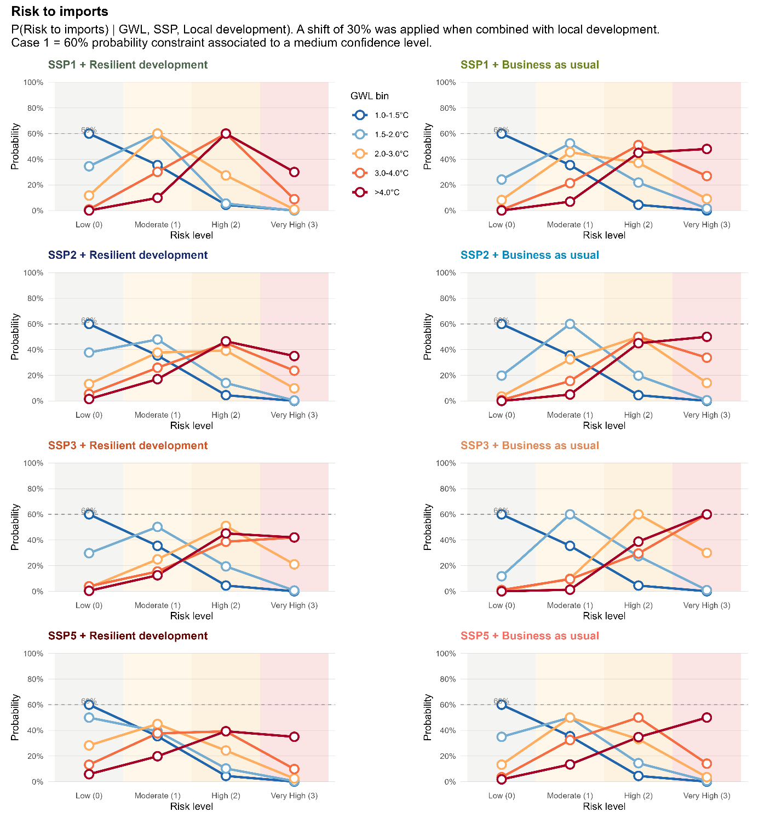
Figure S14: Probability distributions developed for each combination of SSP-RCP and local development. The risk level was assessed based on the Burning Embers for food security under the SSP1 and SSP3 scenarios (medium confidence). We extended the analysis to the SSP2 and SSP5 scenarios.
The CPT for risk to imports depends on the three variables: SSP-RCP, Global Warming Level, and Local development. We use the probability distributions in Figure S14 to populate the CPT (Figure S15).

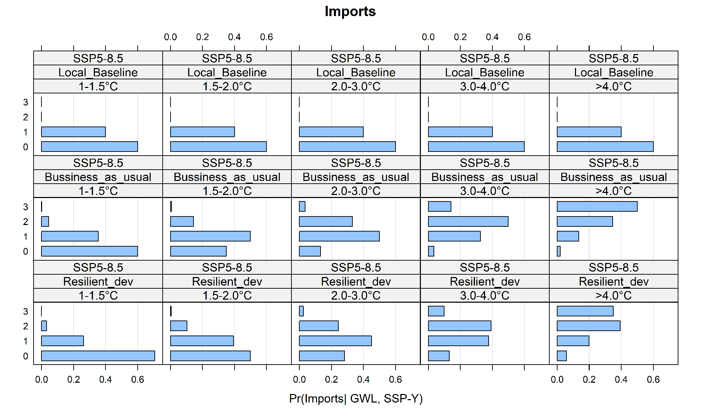
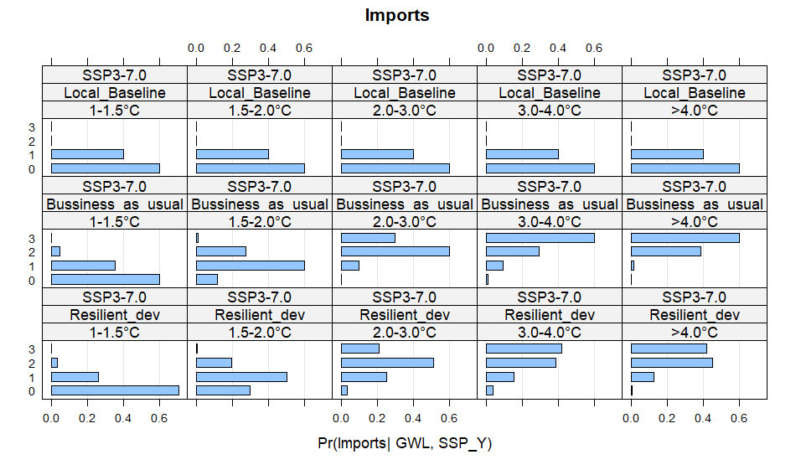
Figure S15: Conditional probability table for SSP3-7.0 and SSP5-8.5 for Risk to imports.

BN complementary results

The BN allows modelling the impact of risk to land on three related habitability pillars: settlements and infrastructure, freshwater supply, and economic activities. Figure S16 shows the results for Avatoru (Island 2) under different levels of regional sea-level rise (RSLR). For each RSLR level, we estimate the risk to land, which then propagates through the three related pillars. Results show that the probability of high or very high risk rises to 75% at RSLR = 1.0- 1.5 m, reflecting Avatoru's high susceptibility to flooding. This increase in risk to land propagates directly to settlements and infrastructure, due to the spatial concentration of critical infrastructure in low-lying areas (96% probability of high or very high risk). Freshwater supply and economic activities also increase with risk to land, but less sharply. At 1.0-1.5m, both pillars remain predominantly at high risk (51% and 73%, respectively), reflecting the influence of additional drivers, such as import disruption and reef degradation.
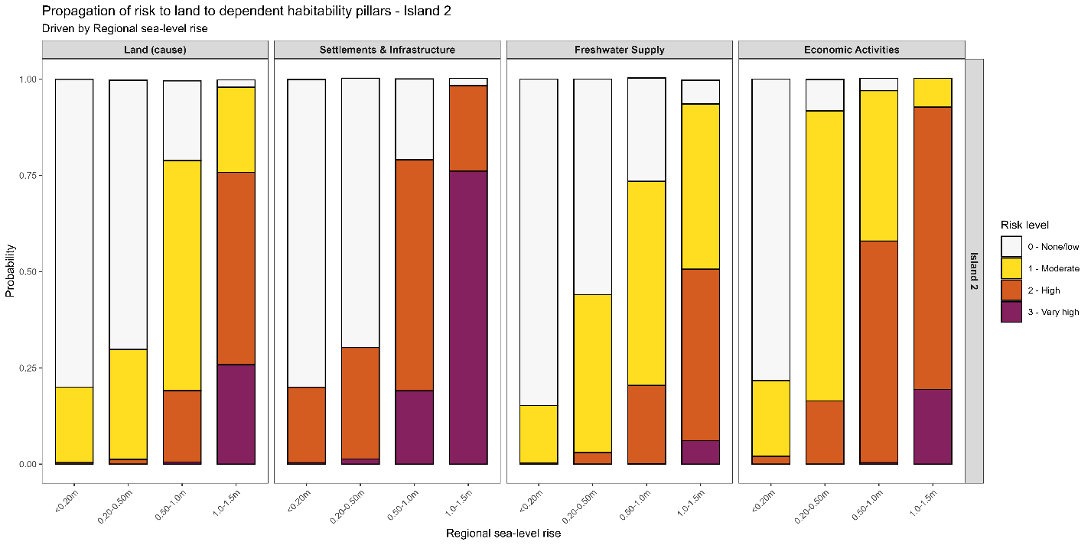
Figure S16: Propagation of risk to land on dependent habitability pillars in Avatoru (Island 2): settlements and infrastructures, freshwater supply, and economic activities. Each bar shows the stacked probability of each risk level, estimated across increasing levels of regional sea-level rise, which drives risk to land and then propagates through the other pillars.

Sensitivity test
We performed a sensitivity test using a second set of beta distributions for all the variables included in the semi-quantitative assessment. We associated a higher probability weight with the confidence level, as shown in Table S2. The results were consistent across both sets of distributions. Using the second set, we obtained a lower uncertainty index, but the most probable risk levels remain consistent.

How does climate risk to habitability change over time for different islands of Rangiroa Atoll under different climate and socio-economic scenarios?
Using the second set of beta distributions, the global uncertainty decreases due to the narrower spread of the probability distributions. However, the level of risk and the islands most at risk remain the same. For example, Avatoru and the airport island remain the most at risk (Figure S17).

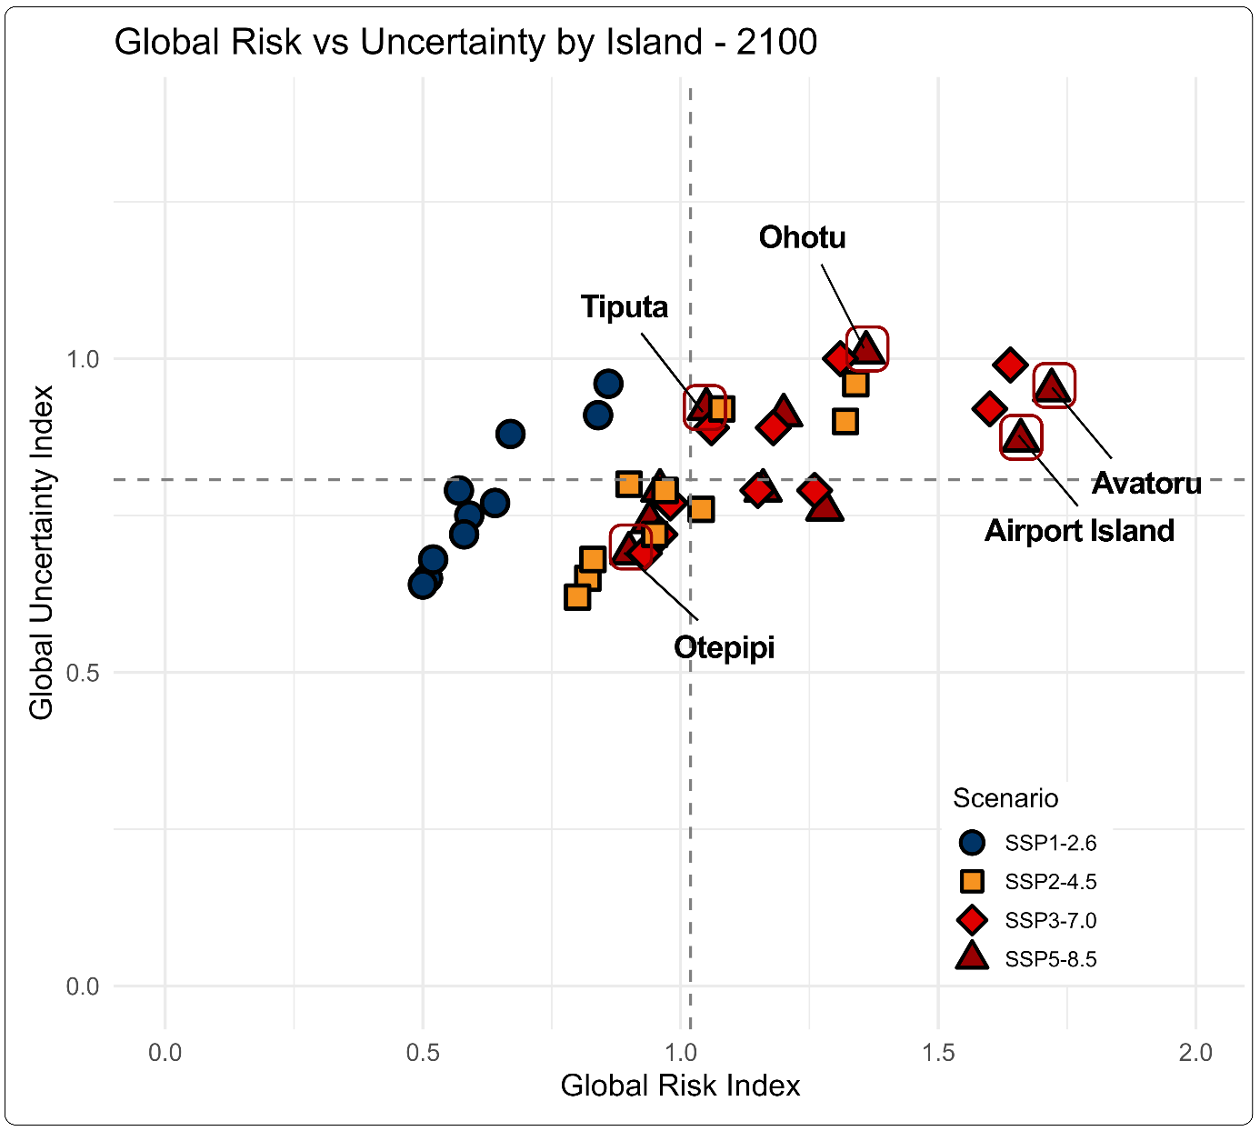
Figure S17: Global risk index vs global uncertainty index estimated using a second set of beta distributions.

Most threatened habitability pillars
The confidence level index increases due to the smaller spread in the probability distributions. However, the most expected risks remain the same (Figure S18). In 2050, the risk to all pillars has a 70-80% probability of remaining low (risk to land and settlements) to moderate (risk to economic activities and risk to freshwater) across the three islands, except for food supply, 80% probability of being high. In 2100, the risk to land has a probability of 55% and a 60% probability of being low in Tiputa and Otepipi, respectively. In Avatoru, the risk to land has a 55% probability of being moderate. Risk to settlements and infrastructure has a 55% probability of being low in Tiputa, and more than 95% probability of being low in Otepipi. In Avatoru, the risk to settlements has a 55% probability of being high and a 40% probability of being very high. The risk to food supply has a 55% probability of being high and a 45% probability of being very high.
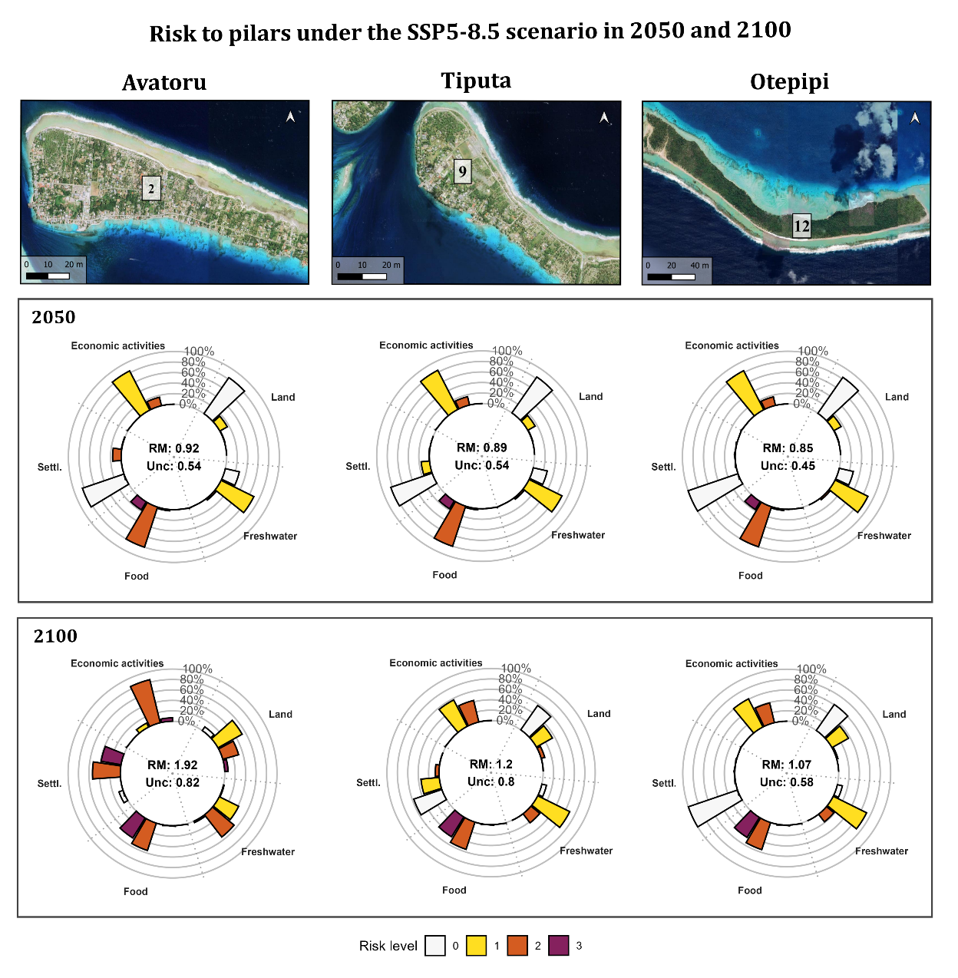
Figure S18: Risk to habitability pillars under the SSP5-8.5 in 2050 and 2100 using a second set of beta distributions.

Scenario storylines under which Rangiroa may become uninhabitable (without additional adaptation)
Using the second set of Beta distributions, the conditional probability slightly increases due to the narrower probability distributions used in the second set of Beta distributions. However, the best-estimated outcomes remain consistent. The main drivers are imports and reefs, the RSLR up to 0.50-1 m, and the GWL up to 3°C (Figure S19).

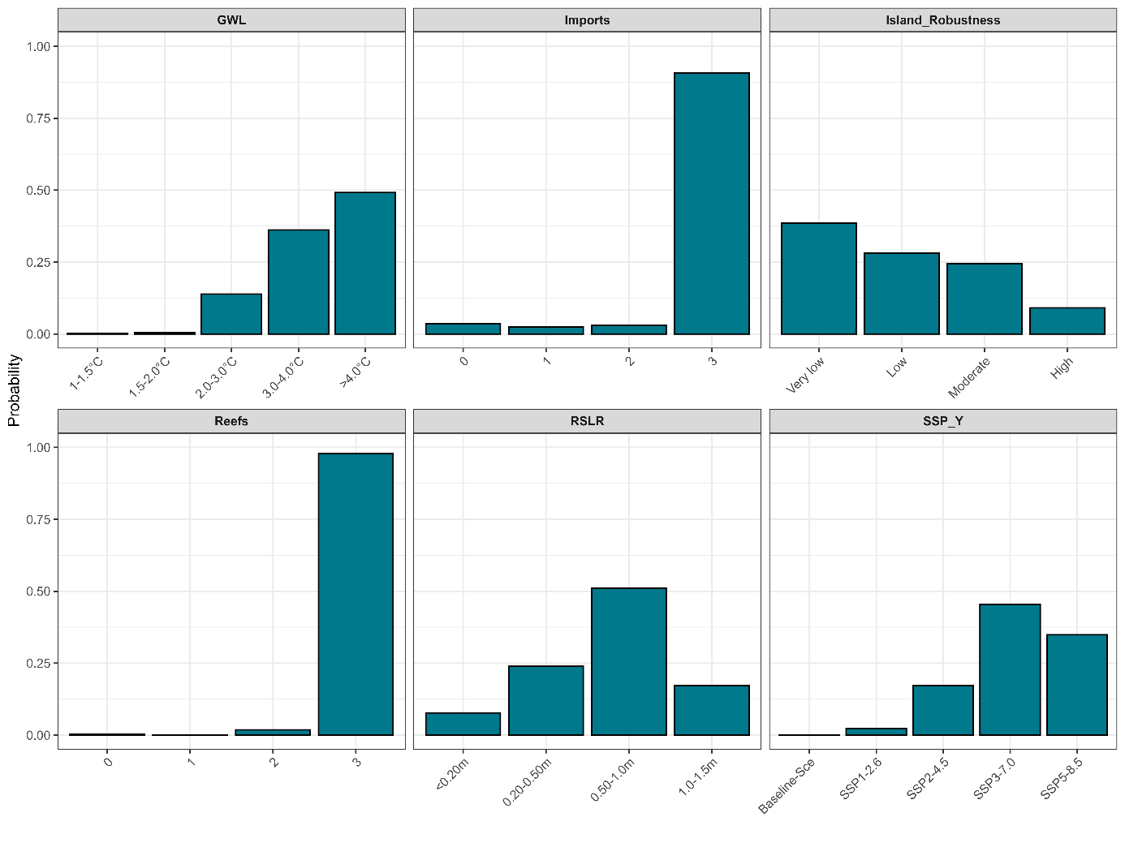
Figure S19: Drivers of severe risk to atoll habitability using a second set of beta distributions.

References
1. United Nations Environment Programme. Emissions Gap Report 2025: Off Target - Continued Collective Inaction Puts Global Temperature Goal at Risk. (United Nations Environment Programme, 2025). doi:10.59117/20.500.11822/48854.
2. Ducarme, B., Hopuare, M., Li, X., Maamaatuaiahutapu, K. & Barriot, J.-P. Trends in the relative sea level rises in French Polynesia for coastal submersion assessment from the comparative analysis of GLORYS and tide gauges / GNSS data. Regional Studies in Marine Science 104950 (2026) doi:10.1016/j.rsma.2026.104950.
3. Li, X., Barriot, J.-P., Ducarme, B., Hopuare, M. & Lou, Y. Monitoring absolute vertical land motions and absolute sea-level changes from GPS and tide gauges data over French Polynesia. Geodesy and Geodynamics 15, 13–26 (2024).
4. Martínez-Asensio, A. et al. Relative sea-level rise and the influence of vertical land motion at Tropical Pacific Islands. Global and Planetary Change 176, 132–143 (2019).
5. Montaggioni, L. F. et al. Reef-rim structure and building history, Rangiroa, an uplifted Atoll, French Polynesia: The role of morphotectonics and extreme marine hazard events. Marine Geology 445, 106748 (2022).
6. Badillo-Interiano, M., Rohmer, J., Le Cozannet, G. & Duvat, V. Assessing atoll island future habitability in the context of climate change using Bayesian networks. Natural Hazards and Earth System Sciences 25, 4527–4543 (2025).
7. Duvat, V. K. E. et al. Assessing atoll island physical robustness: Application to Rangiroa Atoll, French Polynesia. Geomorphology 390, 107871 (2021).
8. Duvat, V. K. E. A global assessment of atoll island planform changes over the past decades. WIREs Climate Change 10, e557 (2019).
9. Montaggioni, L. F. et al. Revisiting the geodynamical history of the so-called uplifted atolls, north-west Tuamotu, French Polynesia, central South Pacific. Earth-Science Reviews 244, 104532 (2023).
10. Duvat, V. & Salmon, C. Étude de l’évolution de la position du trait de côte des îles coralliennes des atolls de Rangiroa et de Tikehau, archipel des Tuamotu, Polynésie française. Rapport de résultats, Programme Réomers Résilience des territoires d’outre-mer aux risques météo-marins dans le contexte du changement global (2013-2016) (A Study of Changes in the Position of the Coastline of the Coral Islands in the Rangiroa and Tikehau Atolls, Tuamotu Archipelago, French Polynesia). (2015).
11. Canavesio, R., Cohen, O., Pons-Branchu, E. & Costa, S. Atoll islets reshaping processes induced by extreme cyclonic waves and calm weather. Evidence from two centuries of megablocks emergences and coral rubble displacements in Anaa, Rangiroa and Tikehau atolls (western Tuamotu archipelago - French Polynesia). Marine Geology 464, 107140 (2023).
12. Damlamian, H. & Kruger, J. 2D Coupled hydrodynamic spectral wave model of Rangiroa the 1983 Orama-Nisha tropical cyclone - SPC SOPAC Technical Report (PR166). Secretariat of the Pacific Community (2013).
13. Duvat, V. K. E., Magnan, A. K. & Canavesio, R. La reconstruction de chaînes d’impacts au service de l’évaluation de la résilience des territoires et de la réduction des risques météo-marins : le cas des atolls des Tuamotu, Polynésie française (Reconstructing Impact Chains to Assess Territorial Resilience and Reduce Weather- and Sea-Related Risks: The Case of the Tuamotu Atolls, French Polynesia). La Houille Blanche 13–21 (2018) doi:10.1051/lhb/2018016.
14. Magnan, A. K., Ranché, M., Duvat, V. K. E., Prenveille, A. & Rubia, F. L’exposition des populations des atolls de Rangiroa et de Tikehau (Polynésie française) au risque de submersion marine. vertigo 18–3, (2018).
15. Sanders, B. F., Wing, O. E. J. & Bates, P. D. Flooding is Not Like Filling a Bath. Earth’s Future 12, e2024EF005164 (2024).
16. Pedreros, R., Krien, Y. & Poisson, B. Programme ARAI 2. Caractérisation de la submersion marine liée aux houles cycloniques en Polynésie française. Rapport BRGM/RP- 58990-FR (ARAI 2 Program. Characterization of marine inundation caused by cyclonic swells in French Polynesia). BRGM 64 (2010).
17. Duvat, V. K. E. et al. Risks to future atoll habitability from climate-driven environmental changes. WIREs Climate Change 12, e700 (2021).
18. ISPF. Recensement de la population de la Polynésie française. (2022).
19. Direction de l’agriculture. L’image de l’agriculture Polynésienne (The Image of Polynesian Culture - Department of Agriculture of French Polynesia). https://www.service-public.pf/dag/wp-content/uploads/sites/28/2022/02/BSA-2020.pdf (2020).
20. Direction de l’agriculture. Bref Diagnostic de durabilité du système alimentaire des Tuamotu (A Brief Assessment of the Sustainability of the Tuamotu Food System). https://consultingdai.com/wp-content/uploads/2023/03/Bref-Diagnostic-du-syste%CC%80me-alimentaire-des-Tuamotu-2022.pdf (2022).
21. IEOM. Rapport annuel économique de la Polynésie française (Annual economic report of French Polynesia). https://www.ieom.fr/IMG/pdf/rapport_annuel_polynesie_2024_ieom_bd_-2.pdf (2024).
22. Corbier, P. & Pasquier, S. Programme d’actions pour l’exploitation et la gestion des eaux souterraines de la Polynésie française. Inventaire des données existantes sur les îles de Moorea, Maiao, Huahine, Raiatea, Taha’a, Ua Pou, Makatea et Rangiroa (Action Plan for the Use and Management of Groundwater in French Polynesia). 176 https://infoterre.brgm.fr/rapports/RP-67128-FR.pdf (2017).
23. Chambre territoriale des comptes. Rapport d’observations définitives Commune de Rangiroa. https://www.ccomptes.fr/sites/default/files/2023-10/PFR20190005_0.pdf (2019).
24. KPMG. Mission d’étude relative à la mise en place d’un schéma directeur de développement de l’offre d’hébergements touristiques marchands (terrestres et flottants) en Polynésie française. Livrable 1 – Diagnostic de l’hébergement touristique marchand. https://fm27.pf/wp-content/uploads/2025/03/Livrable-final-Phase-1.pdf (2024).
25. Duvat, V. K. E. et al. Internal relocation as a relevant and feasible adaptation strategy in Rangiroa Atoll, French Polynesia. Sci Rep 12, 14183 (2022).
26. Duvat, V. K. E., Magnan, A. K. & Canavesio, R. La reconstruction de chaînes d’impacts au service de l’évaluation de la résilience des territoires et de la réduction des risques météo-marins : le cas des atolls des Tuamotu, Polynésie française. La Houille Blanche 104, 13–21 (2018).
27. Vercelloni, J., Kayal, M., Chancerelle, Y. & Planes, S. Exposure, vulnerability, and resiliency of French Polynesian coral reefs to environmental disturbances. Sci Rep 9, 1027 (2019).
28. Roff, G. et al. Porites and the Phoenix effect: Unprecedented recovery after a mass coral bleaching event at Rangiroa Atoll, French Polynesia. Marine Biology 161, 1385–1393 (2014).
29. Mumby, P. et al. Unprecedented bleaching-induced mortality in Porites spp. at Rangiroa Atoll, French Polynesia. Marine Biology 139, 183–189 (2001).
30. Goeldner-Gianella, L., Grancher, D., Magnan, A. K., De Belizal, E. & Duvat, V. K. E. The perception of climate-related coastal risks and environmental changes on the Rangiroa and Tikehau atolls, French Polynesia: The role of sensitive and intellectual drivers. Ocean & Coastal Management 172, 14–29 (2019).
31. van Hooidonk, R. et al. Projections of future coral bleaching conditions using IPCC CMIP6 models: climate policy implications, management applications, and Regional Seas summaries - openasfa.title. United Nations Environment Programme https://www.fao.org/fishery/en/openasfa/aa4c20e4-d3ee-4efc-9499-d8a7ec44970e (2020).
32. World Trade Organization. World Trade Report 2022: Climate Change and International Trade. (WTO, 2023). doi:10.30875/9789287053961.
33. Factors Shaping the Future of World Trade. (2013).
34. Chadebech, L. Rapport de Diagnostic de Durabilité Du Système Alimentaire de Polynésie Française. Rapport 2 de l’étude de Renforcement de La Durabilité Des Systèmes Alimentaires Des PTOM Français Du Pacifique, Diagnostic de Polynésie Française (Report on the Sustainability Assessment of the Food System in French Polynesia). (2021).
35. IPCC. Climate Change 2022 – Impacts, Adaptation and Vulnerability: Working Group II Contribution to the Sixth Assessment Report of the Intergovernmental Panel on Climate Change. (Cambridge University Press, 2023). doi:10.1017/9781009325844.
36. Zommers, Z. et al. Burning embers: towards more transparent and robust climate-change risk assessments. Nat Rev Earth Environ 1, 516–529 (2020).
37. O’Neill, B. C. et al. A new scenario framework for climate change research: the concept of shared socioeconomic pathways. Climatic Change 122, 387–400 (2014).
38. Van Vuuren, D. P. et al. The representative concentration pathways: an overview. Climatic Change 109, 5–31 (2011).
39. Kriegler, E. et al. A new scenario framework for climate change research: the concept of shared climate policy assumptions. Climatic Change 122, 401–414 (2014).
40. Riahi, K. et al. The Shared Socioeconomic Pathways and their energy, land use, and greenhouse gas emissions implications: An overview. Global Environmental Change 42, 153–168 (2017).
41. van Vuuren, D. P. et al. A new scenario framework for Climate Change Research: scenario matrix architecture. Climatic Change 122, 373–386 (2014).
42. Vucher-Visin, J. L’évolution des prix de 2011 à septembre 2022. Institut de la statistique de la Polynésie française (Statistical Institute of French Polynesia) https://www.ispf.pf/content//uploads/1351_Prix_c77322b835.pdf (2022).
43. IPCC. Climate Change and Land: IPCC Special Report on Climate Change, Desertification, Land Degradation, Sustainable Land Management, Food Security, and Greenhouse Gas Fluxes in Terrestrial Ecosystems. (Cambridge University Press, 2022). doi:10.1017/9781009157988.
44. Mastrandrea, M. D. et al. Guidance Note for Lead Authors of the IPCC Fifth Assessment Report on Consistent Treatment of Uncertainties. Intergovernmental Panel on Climate Change (IPCC). http://www.ipcc.ch (2010).

