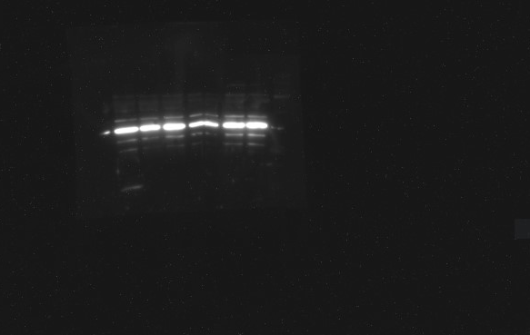

MDA-MB-231 HIF1a Normoxia

MDA-MB-231 HIF1a Hypoxia

MDA-MB-231 HIF2a and HSP90 Normoxia
MDA-MB-231 HIF2a and HSP90 Hypoxia

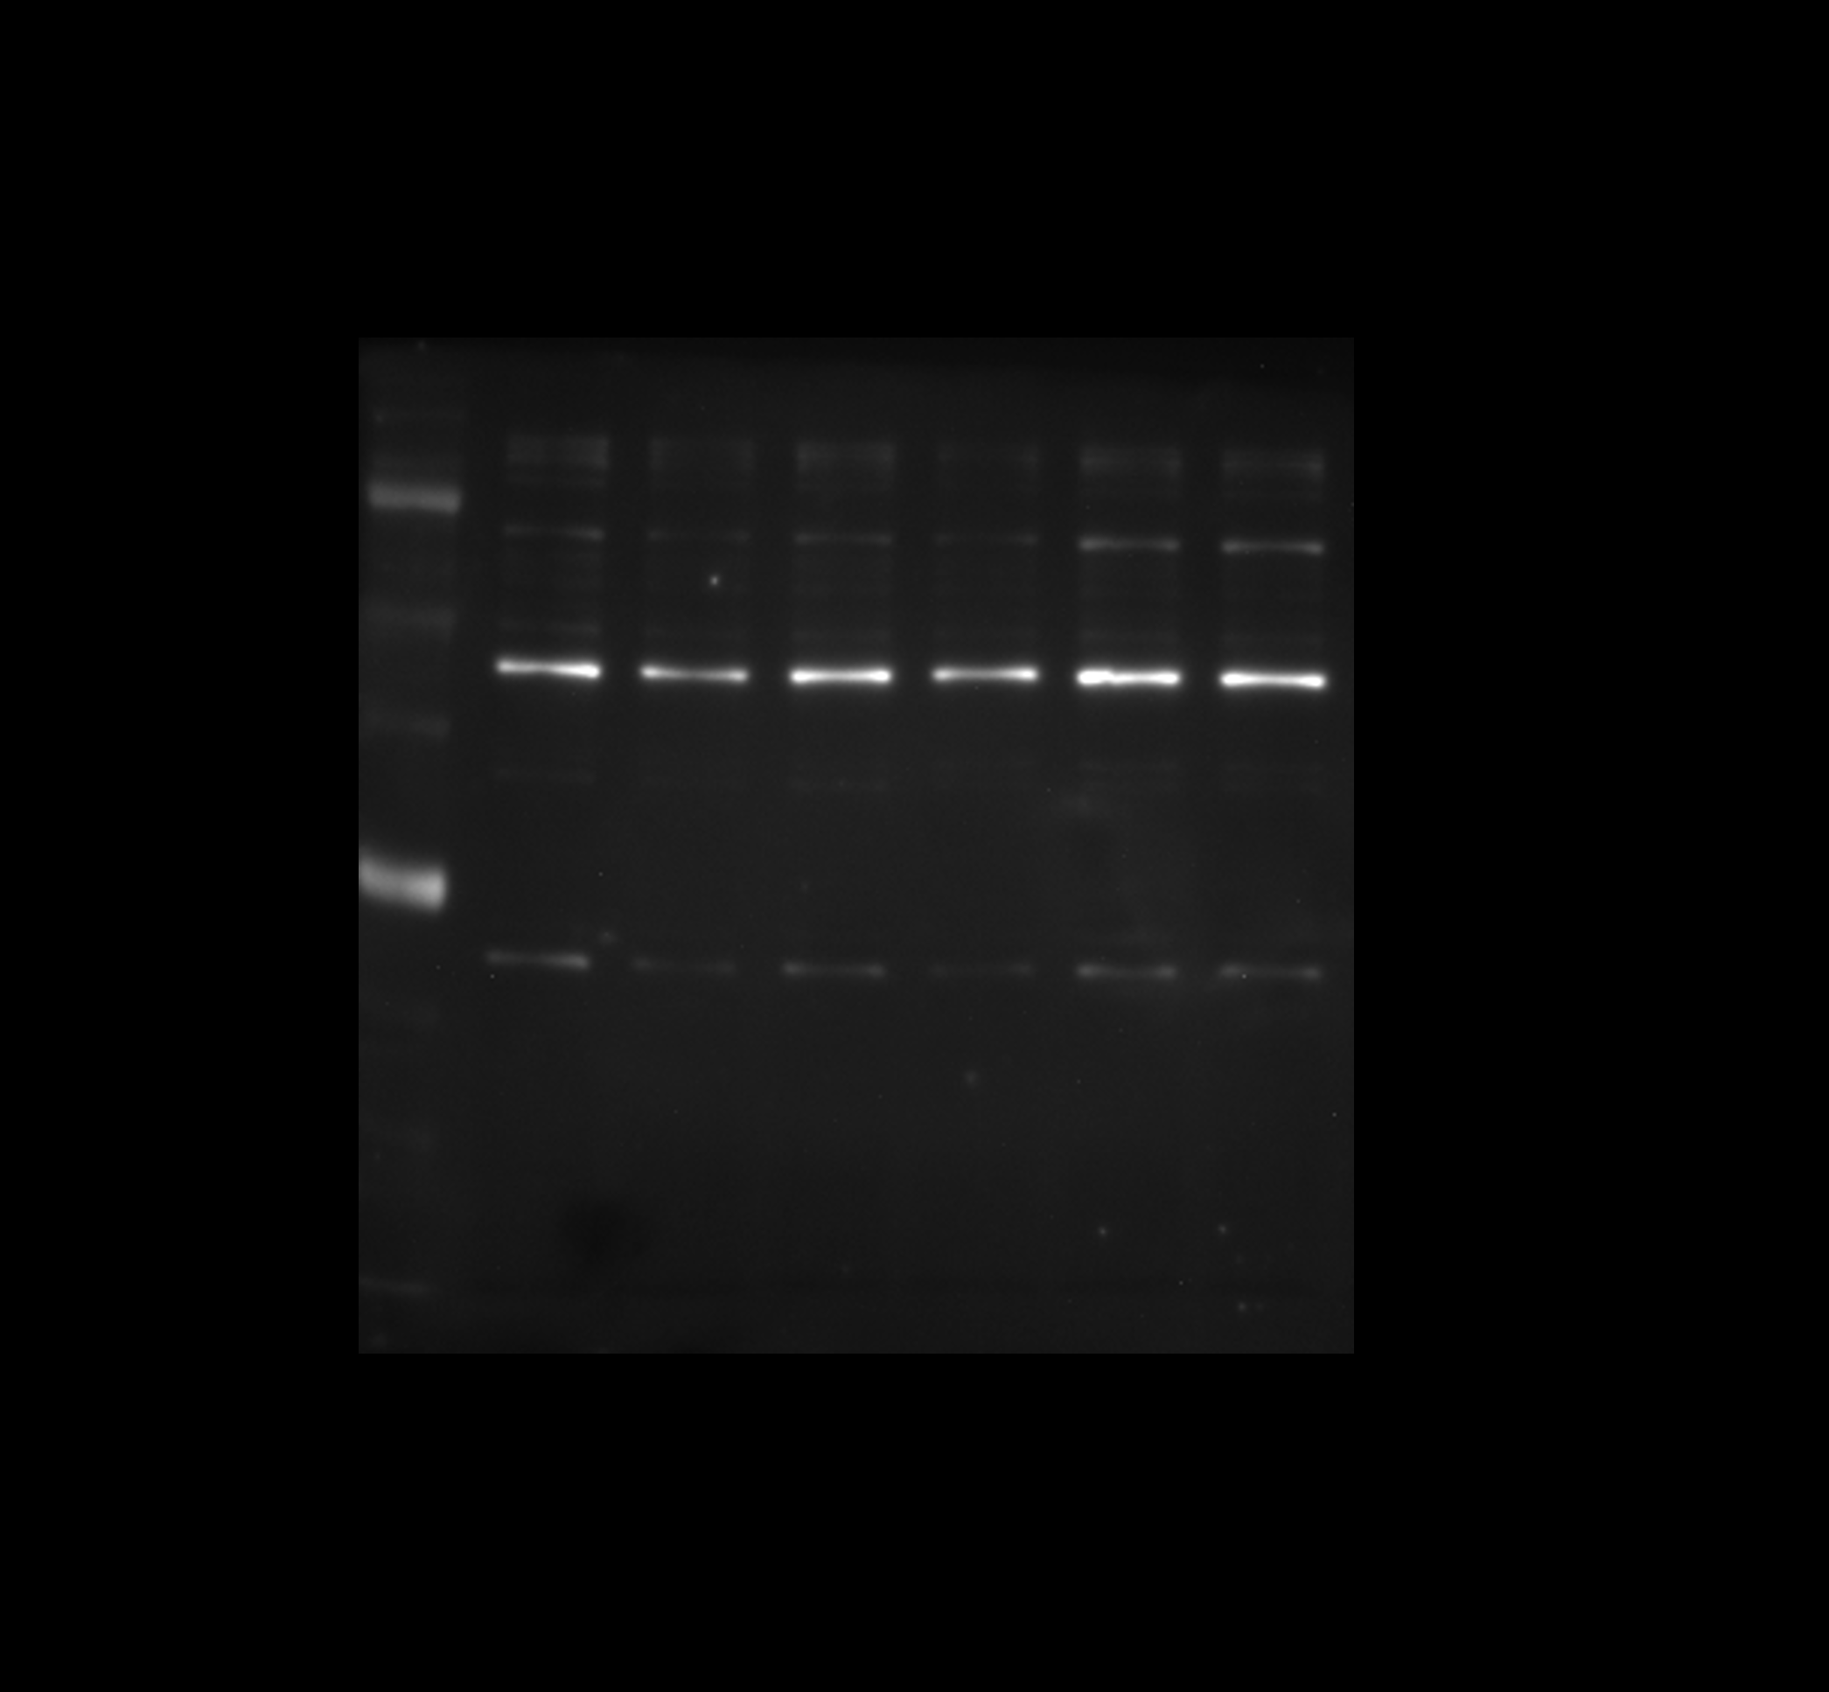
MDA-MB-231 TRAP1 Normoxia
MDA-MB-231 TRAP1 Hypoxia

MDA-MB-231 VEGF Normoxia
MDA-MB-231 VEGF Hypoxia

MCF-7 HIF1A Normoxia
MCF-7 HIF1A Hypoxia

MCF-7 HIF2A and HSP90 normoxia

MCF-7 HIF2A and HSP90 Hypoxia

MCF-7 TRAP1 Normoxia

MCF-7 TRAP1 Hypoxia

MCF-7 VEGF Normoxia
MCF-7 VEGF Hypoxia

