SUPPORTING INFORMATION

Carbon Calculus™: New metrics for sustainable decision making

Simon Brooks⁽¹⁾*, William Leighton⁽¹⁾, Christopher Kitchens^{(2)*}
⁽¹⁾Department of Sustainable Engineering, Villanova University, Villanova, PA
⁽²⁾Department of Chemical and Biological Engineering, Villanova University, Villanova, PA

Co-Corresponding Authors:
Simon Brooks; Department of Sustainable Engineering, Villanova University, 800 Lancaster Avenue, Villanova, PA 19085; simon.brooks@villanova.edu; phone: +1 (484)-919-8747
Christopher Kitchens; Department of Chemical and Biological Engineering, Villanova University, 800 Lancaster Avenue, Villanova, PA 19085; chris.kitchens@villanova.edu; phone: +1 (610)-519-5498
Table of Contents

Calculating Optimum i Values 3
References for Calculating Optimum i Values 7
Illustrative Example Carbon Calculus Assessment at a Project Level 8

Calculating Optimum i Values

Recall that Equation 1 provides the form of ${IRF}_{CO2}\left(t\right)$ and Equation 2 provides the form of ${TV}_{CO2}\left(t\right)$. Equation S1 is identical to Equation 6, representing the objective function to be minimized:
$E\left(R\right)=\int_{0}^{TH}{{\left(\left({IRF}_{CO2}\left(t\right)\right)-\left({TV}_{CO2}\left(t\right)\right)\right)}^{2}dt}$ (S1)
where: $E\left(R\right)$ = the total continuous squared error between Equation 1 and Equation 2.

Recall: $TH$ = time horizon (years).
$A=a_{0}+a_{1}+a_{2}+a_{3}$.

Expand the square:
$E\left(R\right)=\int_{0}^{TH}{\left({\left({IRF}_{CO2}\left(t\right)\right)}^{2}-2\left({IRF}_{CO2}\left(t\right)\right)\left({TV}_{CO2}\left(t\right)\right)+{\left({TV}_{CO2}\left(t\right)\right)}^{2}\right)dt}$
Split into three integrals, such that $E\left(R\right)=E{\left(R\right)}_{1}+E{\left(R\right)}_{2}+E{\left(R\right)}_{3}$:
${E\left(R\right)}_{1}=\int_{0}^{TH}{\left.{\left({IRF}_{CO2}\left(t\right)\right)}^{2}\right.dt}$
${E\left(R\right)}_{2}=-2\int_{0}^{TH}{\left.\left({IRF}_{CO2}\left(t\right)\right)\left({TV}_{CO2}\left(t\right)\right)\right.dt}$
${E\left(R\right)}_{3}=\int_{0}^{TH}{\left.{\left({TV}_{CO2}\left(t\right)\right)}^{2}\right.dt}$
Substitute in Equation 1 and Equation 2 parameters:
${E\left(R\right)}_{1}=\int_{0}^{TH}{\left.{\left(a_{0}+a_{1}e^{-r_{1}t}+a_{2}e^{-r_{2}t}+a_{3}e^{-r_{3}t}\right)}^{2}\right.dt}$
${E\left(R\right)}_{2}=-2\int_{0}^{TH}{\left.\left(a_{0}+a_{1}e^{-r_{1}t}+a_{2}e^{-r_{2}t}+a_{3}e^{-r_{3}t}\right)\left({Ae}^{-Rt}\right)\right.dt}$
${E\left(R\right)}_{3}=\int_{0}^{TH}{\left.{\left({Ae}^{-Rt}\right)}^{2}\right.dt}$
Expand and simplify:
${E\left(R\right)}_{1}=\int_{0}^{TH}{\left.\left(\begin{aligned}{a_{0}}^{2}+{a_{1}}^{2}e^{-{2r}_{1}t}+{a_{2}}^{2}e^{-{2r}_{2}t}+{a_{3}}^{2}e^{-2r_{3}t}+ \\ {2a}_{0}a_{1}e^{-r_{1}t}+{2a}_{0}a_{2}e^{-r_{2}t}+{2a}_{0}a_{3}e^{-r_{3}t}+ \\ {2a}_{1}a_{2}e^{-(r_{1}+r_{2})t}+{2a}_{1}a_{3}e^{-(r_{1}+r_{3})t}+{2a}_{2}a_{3}e^{-(r_{2}+r_{3})t}\end{aligned}\right)\right.dt}$
${E\left(R\right)}_{2}=-2\int_{0}^{TH}{\left.\left(\begin{aligned}a_{0}{Ae}^{-Rt}+a_{1}{Ae}^{-\left(r_{1}+R\right)t}+ \\ a_{2}{Ae}^{-(r_{2}+R)t}+a_{3}{Ae}^{-(r_{3}+R)t}\end{aligned}\right)\right.dt}$
${E\left(R\right)}_{3}=A^{2}\int_{0}^{TH}{\left.\left(e^{-2Rt}\right)\right.dt}$
Consider this known definite solution for exponential integrals, appropriate here as r > 0:
$\int_{0}^{TH}{\left.\left.e^{-rt}\right.\right.dt}=\frac{e^{-r(0)}-e^{-r(TH)}}{r}$ =$\frac{1-e^{-r\left(TH\right)}}{r}$ (r > 0)
Evaluate expressions:
${E\left(R\right)}_{1}=\left(\begin{aligned}{a_{0}}^{2}(TH)+{a_{1}}^{2}\frac{1-e^{-2r_{1}(TH)}}{2r_{1}}+{a_{2}}^{2}\frac{1-e^{-2r_{2}(TH)}}{2r_{2}}+{a_{3}}^{2}\frac{1-e^{-2r_{3}(TH)}}{2r_{3}}+ \\ {2a}_{0}a_{1}\frac{1-e^{-r_{1}(TH)}}{r_{1}}+{2a}_{0}a_{2}\frac{1-e^{-r_{2}(TH)}}{r_{2}}+{2a}_{0}a_{3}\frac{1-e^{-r_{3}(TH)}}{r_{3}}+ \\ {2a}_{1}a_{2}\frac{{1-e}^{-({r_{1}+r}_{2})(TH)}}{r_{1}+r_{2}}+{2a}_{1}a_{3}\frac{{1-e}^{-({r_{1}+r}_{3})(TH)}}{r_{1}+r_{3}}+{2a}_{2}a_{3}\frac{{1-e}^{-({r_{2}+r}_{3})(TH)}}{r_{2}+r_{3}}\end{aligned}\right)$
${E\left(R\right)}_{2}=-2\left.\left(\begin{aligned}a_{0}A\frac{1-e^{-R\left(TH\right)}}{R}+a_{1}A\frac{{1-e}^{-(r_{1}+R)(TH)}}{r_{1}+R}+ \\ a_{2}A\frac{{1-e}^{-(r_{2}+R)(TH)}}{r_{2}+R}+a_{3}A\frac{{1-e}^{-(r_{3}+R)(TH)}}{r_{3}+R}\end{aligned}\right)\right.$
${E\left(R\right)}_{3}=A^{2}\frac{1-e^{-2R\left(TH\right)}}{2R}$
Using the quotient rule for derivatives, differentiate with respect to R:
$\frac{d}{dR}\left({E\left(R\right)}_{1}\right)=0$ (${E\left(R\right)}_{1}$ is constant in R)
$\frac{d}{dR}\left({E\left(R\right)}_{2}\right)=-2\left(\begin{aligned}a_{0}A\frac{R\left(TH\right)e^{-R\left(TH\right)}-\left({1-e}^{-R\left(TH\right)}\right)}{R^{2}}+ \\ a_{1}A\frac{\left(r_{1}+R\right)\left(TH\right)e^{-\left(r_{1}+R\right)\left(TH\right)}-\left({1-e}^{-\left(r_{1}+R\right)\left(TH\right)}\right)}{{\left(r_{1}+R\right)}^{2}}+ \\ a_{2}A\frac{\left(r_{2}+R\right)\left(TH\right)e^{-\left(r_{2}+R\right)\left(TH\right)}-\left({1-e}^{-\left(r_{2}+R\right)\left(TH\right)}\right)}{{\left(r_{2}+R\right)}^{2}}+ \\ a_{3}A\frac{\left(r_{3}+R\right)\left(TH\right)e^{-\left(r_{3}+R\right)\left(TH\right)}-\left({1-e}^{-\left(r_{3}+R\right)\left(TH\right)}\right)}{{\left(r_{3}+R\right)}^{2}}\end{aligned}\right)$
$\frac{d}{dR}\left({E\left(R\right)}_{3}\right)=A^{2}\frac{2R\left(TH\right)e^{-2R\left(TH\right)}-\left({1-e}^{-2R\left(TH\right)}\right)}{2R^{2}}$
Combine terms back into one representation of E(R) differentiated with respect to R. Set minimizing condition $\frac{dE}{dR}=0$:
$\frac{dE}{dR}=A^{2}\frac{2R\left(TH\right)e^{-2R\left(TH\right)}-\left({1-e}^{-2R\left(TH\right)}\right)}{2R^{2}}-2\left(\begin{aligned}a_{0}A\frac{R\left(TH\right)e^{-R\left(TH\right)}-\left({1-e}^{-R\left(TH\right)}\right)}{R^{2}}+ \\ a_{1}A\frac{\left(r_{1}+R\right)\left(TH\right)e^{-\left(r_{1}+R\right)\left(TH\right)}-\left({1-e}^{-\left(r_{1}+R\right)\left(TH\right)}\right)}{{\left(r_{1}+R\right)}^{2}}+ \\ a_{2}A\frac{\left(r_{2}+R\right)\left(TH\right)e^{-\left(r_{2}+R\right)\left(TH\right)}-\left({1-e}^{-\left(r_{2}+R\right)\left(TH\right)}\right)}{{\left(r_{2}+R\right)}^{2}}+ \\ a_{3}A\frac{\left(r_{3}+R\right)\left(TH\right)e^{-\left(r_{3}+R\right)\left(TH\right)}-\left({1-e}^{-\left(r_{3}+R\right)\left(TH\right)}\right)}{{\left(r_{3}+R\right)}^{2}}\end{aligned}\right)=0$
Given this non-linear form, consider the secant method¹ for iteratively solving $F\left(R\right)=0$ provided here as Equation S2:
$R_{n+1}=R_{n}-F\left(R_{n}\right)\frac{R_{n}-R_{n-1}}{F\left(R_{n}\right)-F(R_{n-1})}$ (S2)
Substitute $F\left(R\right)=\frac{dE}{dR}$, set initial guesses and time horizon. Initial guesses of 1% and 2% are recommended. Each calculation corresponds to a time horizon of interest.
An example calculation is shown below for a time horizon of 100 years:
$R_{n+1}=R_{n}-{\left.\frac{ⅆE}{ⅆR}\right|}_{R_{n}}\frac{R_{n}-R_{n-1}}{\left({\left.\frac{ⅆE}{ⅆR}\right|}_{R_{n}}\right)-\left({\left.\frac{ⅆE}{ⅆR}\right|}_{R_{n-1}}\right)}$
$R_{n}=R_{1}=0.02$
$R_{n-1}=R_{0}=0.01$
$TH=100 years$
Using the Joos et al.² Multi-Model Mean parameters, iteratively solve following Equation S2 to yield $R_{n+1}$ values until convergence to six decimal places, using Equation S3 to check for convergence:
$\left|R_{n+1}-R_{n}\right|<{10}^{-6}$ (S3)
Resulting Optimum i values from the Multi-Model Mean parameter set were chosen as the basis for Carbon Calculus because the comprehensiveness of the Multi-Model Mean most strongly aligns with the purpose and utility of Carbon Calculus.
Multi-Model Mean parameters are provided below for convenience:
$\begin{matrix}a_{0}=0.2173 & a_{1}=0.2240 \\ a_{2}=0.2824 & a_{3}=0.2763\end{matrix}$
$\begin{matrix}r_{1}=\frac{1}{394} & r_{2}=\frac{1}{36.54} & r_{3}=\frac{1}{4.304}\end{matrix}$
When $\left|R_{n+1}-R_{n}\right|<{10}^{-6}$ the iteration calculations have converged, yielding the solution Optimum R = $R_{n+1}$. Optimum i values can then be calculated using the continuous to discrete transformation given by Equation 4³, copied here for convenience: $i=e^{R}-1$.
A time horizon of 100 years was used for calculations presented in the Results and Discussion of this manuscript to align with the widely reported 100-year GWPs used in GHG emission accounting calculations. Assuming a time horizon of 100 years yielded an optimum i dissipation rate of 1.339%. As 20-year GWPs are also widely published, the 20-year time horizon i value was also calculated, yielding an optimum i of 3.407%.
Optimum i values for all 17 IRFs explored by Joos et al.⁴ were calculated for 100-year and 20-year time horizons as part of this work. These 17 models are listed below for convenience. All model parameters can be found in Joos et al.⁴:
1. NCARCSM1.4 | 10. LOVECLIM
2. HadGEM2-ES | 11. MESMO
3. MPI-ESM | 12. UVic2.9
4. Bern3D-LPJ (reference) | 13. ACC2
5. Bern3D-LPJ (ensemble) | 14. Bern-SAR
6. Bern2.5D-LPJ | 15. MAGICC6 (ensemble)
7. CLIMBER2- LPJ | 16. TOTEM2
8. DCESS | 17. Multi-Model Mean
9. GENIE (ensemble)
The average 100-year and 20-year Optimum i values across the 17 models are 1.337% and 3.369%, respectively. With values nearly identical to the mean of the set, the comprehensiveness of the Multi-Model Mean was confirmed.

References for Calculating Optimum i Values

1. Weisstein, E. W. Secant Method. MathWorld--A Wolfram Resource https://mathworld.wolfram.com/SecantMethod.html.
2. Joos, F. et al. Carbon dioxide and climate impulse response functions for the computation of greenhouse gas metrics: A multi-model analysis. Atmos. Chem. Phys. 13, 2793–2825 (2013).
3. Vaidya, D. Effective Annual Rate. WallStreetMojo https://www.wallstreetmojo.com/effective-annual-rate/.
4. Joos, F., Roth, R., Fuglestvedt, J. & Peters, G. Carbon Dioxide and Climate Impulse Response Functions for the Computation of Greenhouse Gas Metrics: A Multi-Model Analysis Supplementary Information Part A: Protocol V1.1.

Illustrative Example Carbon Calculus Assessment at a Project Level

Table S1 provides simplified project life cycle inputs for three hypothetical projects. Equation 9 was used to generate Carbon Calculus assessment results considering a 100-year CO₂ dissipation time horizon and a scenario timeline K = 20 years. For this simplified example, assume a reference scenario with annual emissions that represent a form of business as usual (BAU) starting at 10,000 tons CO₂ and increasing 5% annually for 20 years, yielding an NPV_{CO2} of 184,444 tons CO₂.
Table S1. Carbon Calculus assessment inputs and results for three hypothetical projects. Please see the “Source Data Scenario Analysis” Microsoft Excel to further explore these results.
Metric | Project 1 - Smaller Project | Project 2 - Medium Project | Project 3 - Larger Project
Upfront CO₂ (tons) | 400 | 1,200 | 5,000
Annual Use Phase CO₂ Reductions from BAU (tons) | 300 | 600 | 2,000
NPV_{CO2} (tons) | 179,611 | 175,178 | 154,556
Net Reduction in NPV_{CO2} (D_{eff,CO2}, tons) | 4,833 | 9,267 | 29,889
% Reduction in NPV_{CO2}  (% D_{eff,CO2}) | 2.6% | 5.0% | 16.2%
Breakeven_{CO2} (years) | 1.36 | 2.04 | 2.56

Figure S1 visualizes these simple scenario net reductions in NPV_{CO2} values over time. Breakeven_{CO2} values from Table S1 align with the years since time 0 when each project crosses the reference scenario D_{eff,CO2} = 0 dotted line in Figure S1.
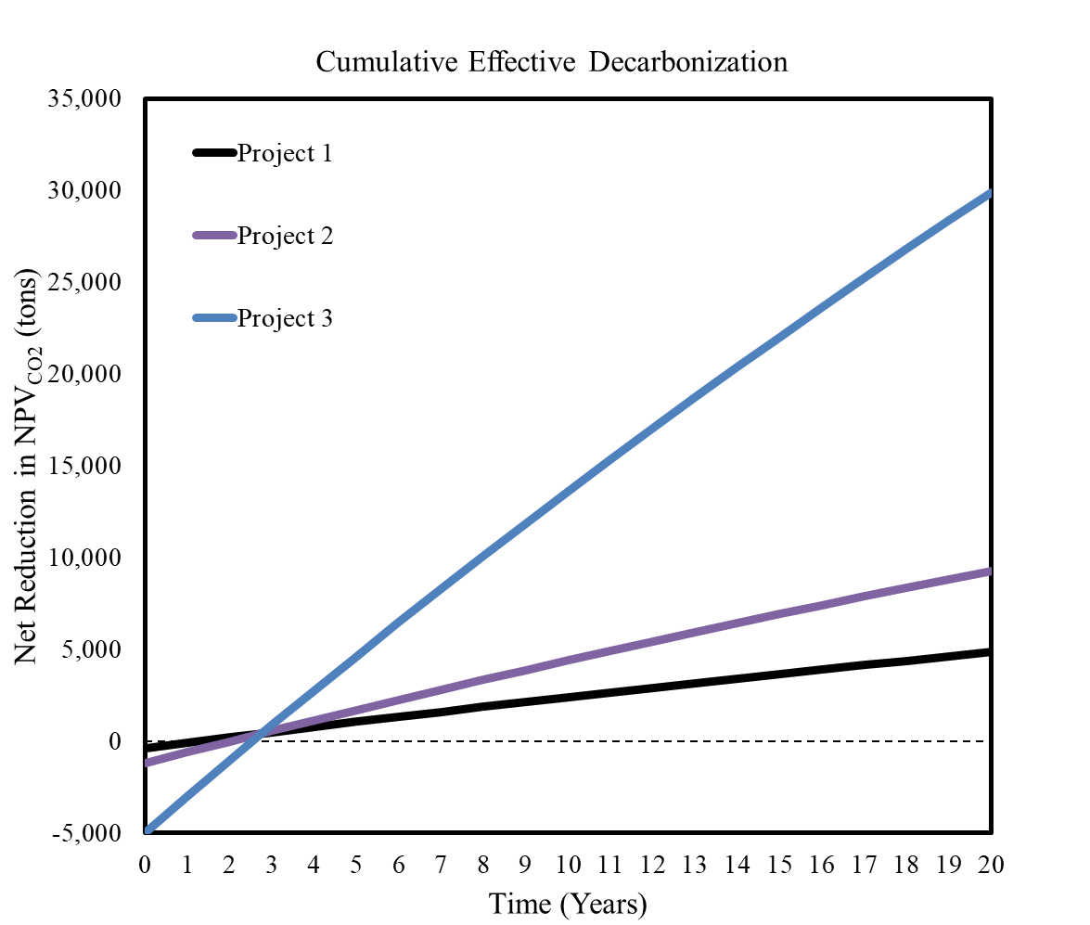
Figure S1. Carbon Calculus assessment cumulative D_{eff,CO2} results for three hypothetical projects.

Carbon Calculus™ is well-positioned to provide quantitative insights for decision-makers to consider alongside financial metrics when considering which projects, portfolios, mergers and acquisitions, and other decarbonization opportunities to invest in, when, and in what order. If the decision is constrained to only one project starting today, Project 3 provides the greatest effective decarbonization with a breakeven_{CO2} not significantly longer than Projects 1 or 2. Ideally, all three projects would be implemented starting in year 0 to maximize total CO₂ reduction. If this is not feasible with real-world constraints, nuanced scenarios can be evaluated.
For example, assume: Scenario A starts all three projects now; Scenario B starts Project 1 now, Project 2 delayed 5 years, and Project 3 delayed 10 years; Scenario C starts Project 3 now, and Project 1 and Project 2 both delayed 10 years.
Table S2 provides results for three hypothetical scenarios. Equations 9-11 were used to generate Carbon Calculus assessment results considering a 100-year CO₂ dissipation time horizon and a scenario timeline K = 20 years.
Table S2. Carbon Calculus assessment results for three hypothetical scenarios. Please see the “Source Data Scenario Analysis” Microsoft Excel to further explore these results.
Metric | Scenario A - All three projects now | Scenario B - Project 1 now, Project 2 delayed 5 years, Project 3 delayed 10 years | Scenario C - Project 3 now, Project 1 and Project 2 both delayed 10 years
NPV_{CO2} (tons) | 140,456 | 161,242 | 148,628
Net Reduction in NPV_{CO2}  (D_{eff,CO2}, tons) | 43,989 | 23,203 | 35,817
% Reduction in NPV_{CO2}  (% D_{eff,CO2}) | 23.8% | 12.6% | 19.4%
Breakeven_{CO2} (years) | 2.33 | 10.16 | 2.56

Figure S2 visualizes each scenario’s Net Reduction in NPV_{CO2} values over time. Breakeven_{CO2} values from Table 1 align with the years since time 0 when each scenario finally crosses the reference scenario D_{eff,CO2} = 0 dotted line in Figure S2.
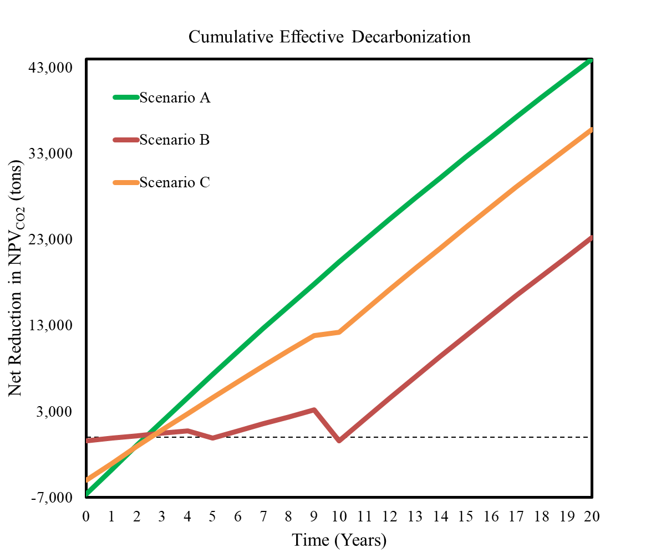
Figure 3. Carbon Calculus assessment cumulative D_{eff,CO2} results for three hypothetical scenarios.

Although all three scenarios end at the same annual CO₂ emissions value 20 years from now, their cumulative impacts are far from equal. If Scenario A is not feasible due to budget constraints, Scenario C is a much more effective decarbonization pathway alternative compared to Scenario B. In addition to being useful for project-level and scenario-level analysis to understand when and in what order to prioritize certain actions, a portfolio-level analysis is also feasible to explore when and in what order to prioritize the full picture of scope 1, 2, and 3 decarbonization. This is further explored in the Discussion section of this manuscript.

