HRS Study Population: Exclusion Flow
Rolling baseline design: 2004–2010 | Follow-up through 2020 | Health and Retirement Study (HRS)

Supplementary Table 1. Participant Selection and Exclusion Criteria (HRS)
Step | Criteria | Remaining (n) | Excluded (n) | Dementia lost
0 | Total unique participants in HRS longitudinal dataset | 45,234 | — | 5,953 total
1 | With observation in 2004–2010 baseline window | 45,234 | 0 | 0
2 | Age ≥ 50 years and non-missing | 38,117 | −7,117 | −234
3 | Dementia-free at baseline | 36,754 | −1,363 | −1,363
4 | Non-missing hearing impairment | 24,953 | −11,801 | −377
5 | Non-missing vision impairment | 24,937 | −16 | −4
6 | Non-missing frailty | 24,427 | −510 | −67
7 | ≥2 rounds of data + follow-up assessment | 22,756 | −1,671 | −31
 | Final analytic cohort | 22,756 |  | 3,877 incidents
Note: The final analytic cohort included 22,756 participants drawn from HRS waves 7–15 (2004–2020). For each participant, baseline was defined as the earliest wave within the 2004–2010 recruitment window meeting the following criteria: age ≥50 years, absence of dementia, and non-missing data for hearing impairment, vision impairment, and frailty status. Participants were followed through 2020, yielding 187,030 person-wave observations, with 9,803 deaths (43.1%) ascertained via HRS death tracking.

Supplementary Table 2. Baseline Year Distribution (HRS)
Baseline Year | Participants (n)
2004 | 16,025
2006 | 978
2008 | 463
2010 | 5,290
Total | 22,756
Note: Baseline year reflects the earliest wave within 2004–2010 at which each participant met all eligibility criteria. The 2004 cohort (n = 16,025; 70.4%) dominates the sample, consistent with the rolling-recruitment design in which most participants enter at the first available wave. The 2010 cohort (n = 5,290; 23.2%) primarily represents new HRS refresher-cohort entrants, who contribute fewer incident dementia cases due to shorter follow-up (10 years vs. up to 16 years for 2004 entrants).

ELSA Study Population: Exclusion Flow
Rolling baseline design: 2002–2008 | Follow-up through 2018/19 | English Longitudinal Study of Ageing (ELSA)

Supplementary Table 3. Participant Selection and Exclusion Criteria (ELSA)
Step | Criteria | Remaining (n) | Excluded (n) | Dementia lost
0 | Total participants in ELSA longitudinal dataset | 19,807 | — | 941 total
1 | With observation in 2002–2008 baseline window | 16,623 | −3,184 | −22
2 | Age ≥ 50 years | 16,056 | −567 | −6
3 | Dementia-free at baseline | 15,916 | −140 | −140
4 | Non-missing hearing loss at baseline | 15,906 | −10 | −1
5 | Non-missing vision loss at baseline | 15,905 | −1 | 0
6 | Non-missing frailty at baseline | 15,603 | −302 | −27
7 | ≥2 waves of data + complete follow-up sensory impairments, frailty, and dementia assessment | 12,921 | −2,682 | −57
 | Final analytic cohort | 12,921 | 6,886 total | 688 incidents
Note: Participants were drawn from ELSA waves 1–9 (2002–2018/19). Baseline was defined as the first wave within the 2002–2008 window at which the participant was aged ≥50, free of dementia, and had non-missing data on self-rated hearing, self-rated vision, and the 49-item Frailty Index (≥40 items valid). Participants were further required to have at least one follow-up wave with non-missing hearing, vision, frailty, and dementia measurements. Dementia was treated as an absorbing state, carried forward across waves. The final analytic cohort comprised 12,921 participants contributing 76,068 person-wave observations. Of the 941 ever-dementia cases in ELSA, 688 (73.1%) were retained as incident events occurring after baseline.

Supplementary Table 4. Baseline Year Distribution (ELSA)
Baseline Year | Participants (n)
2002 | 9,226
2004 | 260
2006 | 1,196
2008 | 2,239
Total | 12,921

Supplementary Table 5. Self-reported items used to ascertain hearing and vision impairment in HRS and ELSA
Construct | HRS | ELSA
Hearing impairment | Self-reported hearing from the Functional Limitations and Helpers (FAT) module: "Is your hearing excellent, very good, good, fair or poor?" (with hearing aid if normally worn). Variable codes JC103 (2004), KC103 (2006), LC103 (2008), MC103 (2010), NC103 (2012), OC103 (2014), PC103 (2016). Response scale 1 = excellent, 2 = very good, 3 = good, 4 = fair, 5 = poor. Coded 1 (impaired) if response was fair or poor (4–5); 0 (not impaired) if excellent, very good or good (1–3); otherwise missing. | Self-reported hearing from the ELSA core interview Health module: "Is your hearing, with a hearing aid if you normally wear one, excellent, very good, good, fair or poor?" Variable "hehear" (Wave 1, Wave 3 onwards) or "Hehear"/"HeHear" (Wave 2 and selected later waves). Response scale 1 = excellent, 2 = very good, 3 = good, 4 = fair, 5 = poor. Coded 1 (impaired) if response was fair or poor (4–5); 0 (not impaired) if excellent, very good or good (1–3); otherwise missing.
Vision impairment | Self-reported overall eyesight from the FAT module: "Is your eyesight excellent, very good, good, fair or poor, or are you legally blind?" (with corrective lenses if normally worn). Variable codes JC095 (2004), KC095 (2006), LC095 (2008), MC095 (2010), NC095 (2012), OC095 (2014), PC095 (2016). Response scale 1 = excellent, 2 = very good, 3 = good, 4 = fair, 5 = poor, 6 = legally blind. Coded 1 (impaired) if response was fair, poor or legally blind (4–6); 0 (not impaired) if excellent, very good or good (1–3); otherwise missing. | Self-reported overall eyesight from the ELSA core interview Health module: "Is your eyesight, using glasses or corrective lenses if you normally wear them, excellent, very good, good, fair or poor; or are you registered blind?" Variable "heeye" (Wave 1, Wave 3 onwards) or "Heeye"/"HeEye" (Wave 2 and selected later waves). Response scale 1 = excellent, 2 = very good, 3 = good, 4 = fair, 5 = poor, 6 = registered/legally blind. Coded 1 (impaired) if response was fair, poor or registered blind (4–6); 0 (not impaired) if excellent, very good or good (1–3); otherwise missing.
Notes. HRS, Health and Retirement Study; ELSA, English Longitudinal Study of Ageing; FAT, Functional Limitations and Helpers (HRS interviewer-administered module). Both items are answered with reference to the participant's usual aided state (i.e., hearing with a hearing aid if normally worn; vision with corrective lenses if normally worn). Non-substantive responses (don't know, refused, not ascertained, skip-pattern non-applicable except where noted) were set to missing. Variable casing (hehear vs Hehear vs HeHear; heeye vs Heeye vs HeEye) varied between ELSA waves owing to historical differences in dataset preparation; harmonised lower-case names were used in analysis after wave-level renaming.

Supplementary Table 6. Composition of frailty indices in HRS and ELSA
Domain | HRS (n = 37) | ELSA (n = 49)
Activities of daily living (ADL) | Dressing; bathing; eating; getting in/out of bed; using the toilet; walking across a room | Dressing; walking across a room; bathing or showering; eating; getting in/out of bed; using the toilet
Instrumental ADL / domestic tasks | Using the telephone; managing money; preparing a hot meal; shopping for groceries; taking medications | Using a map; preparing a hot meal; shopping for groceries; making telephone calls; taking medications; doing work around the house or garden; managing money
Mobility and physical function | Walking one block; walking several blocks; climbing one flight of stairs; lifting ~5 kg / 10 lb; getting up from a chair; stooping, kneeling, or crouching; picking up a small coin; reaching/extending arms above shoulder | Walking 100 yards; sitting for 2 h; getting up from a chair; climbing several flights of stairs; climbing one flight of stairs; stooping, kneeling, or crouching; reaching/extending arms above shoulder; pulling or pushing large objects; lifting ~10 lb; picking up a small coin
Diagnosed chronic conditions | High blood pressure; diabetes; cancer; arthritis; lung disease; heart disease; stroke | High blood pressure; angina; myocardial infarction; congestive heart failure; abnormal heart rhythm; diabetes or high blood glucose; stroke; lung disease; asthma; arthritis; osteoporosis; cancer; psychiatric condition
Depressive and affective symptoms (CES-D) | Restless sleep; depressed mood; everything an effort; felt lonely; felt sad; could not get going; did not enjoy life (reverse-coded) | Depressed mood; everything an effort; restless sleep; not happy (reverse-coded); felt lonely; did not enjoy life (reverse-coded); felt sad; could not get going
General and other health | Self-rated health; underweight (BMI < 18.5); pain; urinary incontinence | Self-rated general health; fallen since last interview; hip fracture; joint replacement; pain while walking
Notes. ADL, activities of daily living; BMI, body mass index; CES-D, Center for Epidemiologic Studies Depression scale; ELSA, English Longitudinal Study of Ageing; HRS, Health, and Retirement Study. Deficits were coded 1 (present) or 0 (absent); self-rated health was graded on a five-level scale (0, 0.25, 0.50, 0.75, 1). The frailty index was computed as the sum of deficits divided by the number of non-missing items, calculated only for participants with ≥ 80% of items non-missing (≥ 30 items for HRS; ≥ 40 items for ELSA). Participants were classified as frail (FI ≥ 0.25) or non-frail (FI < 0.25).

Supplementary Table 7. Definition and harmonisation of covariates in HRS and ELSA
Covariate | Type | HRS | ELSA
Age | Time-invariant | End-of-wave age at baseline, drawn from the RAND HRS Longitudinal File; continuous, in years. When missing, derived as wave year minus year of birth. | Participant-reported age at baseline, drawn from the ELSA core interview; continuous, in years.
Sex | Time-invariant | Self-reported sex from the RAND HRS Longitudinal File. Coded as 1 = male, 2 = female. | Self-reported sex from the ELSA core interview. Coded as 1 = male, 2 = female.
Race / ethnicity | Time-invariant | Derived jointly from self-reported race (non-Hispanic White; non-Hispanic Black; other) and Hispanic ethnicity. Dichotomised as 0 = non-Hispanic White; 1 = Hispanic or non-White (non-Hispanic Black or other race). | Self-reported ethnicity from the ELSA core interview, supplemented by the Health Survey for England ethnicity item in Wave 1 to recover coverage for participants not asked in ELSA. Dichotomised as 0 = White; 1 = non-White.
Education | Time-invariant | RAND-harmonised educational attainment (RAEDUC), recoded into three tiers: 0 = lower (less than high school); 1 = intermediate (GED or high-school graduate); 2 = higher (some college or college and above). | Highest educational or vocational qualification (core interview), recoded into three tiers: 0 = lower (no qualification); 1 = intermediate (O-level, CSE or foreign/other qualification); 2 = higher (A-level, higher-education below degree, or degree and above).
Marital status | Time-invariant | RAND-harmonised marital status at baseline. Dichotomised as 1 = married, partnered or with spouse absent; 0 = separated, divorced, widowed, or never married. | Marital status at baseline (core interview). Dichotomised as 1 = married (first marriage or remarried); 0 = single, separated, divorced, or widowed.
Employment status | Time-varying | RAND-harmonised labour-force status at each wave. Dichotomised as 1 = currently working (employed or self-employed) or retired; 0 = not in the labour force (unemployed, permanently sick or disabled, or looking after the home). | Current main activity at each wave (core interview). Dichotomised as 1 = currently working (employed or self-employed); 0 = not in the labour force (retired, unemployed, permanently sick or disabled, looking after the home, or semi-retired).
Smoking status | Time-varying | RAND-harmonised current smoking at each wave. Coded as 1 = current smoker; 0 = non-smoker. | Current smoking at each wave (core interview). Coded as 1 = current smoker; 0 = non-smoker.
Alcohol consumption | Time-varying | RAND-harmonised number of drinking days per week at each wave. Dichotomised as 1 = any drinking days (> 0); 0 = no drinking days. | Frequency of alcohol consumption at each wave (core interview). Dichotomised as 1 = drinks at least once or twice per week (daily, twice daily or more, or once to twice weekly); 0 = drinks less than once per week (monthly, special occasions only, or not at all). For later waves, the 7-day drinking indicator was used with the same dichotomy.
Notes. HRS, Health and Retirement Study; ELSA, English Longitudinal Study of Ageing; RAND, RAND Center for the Study of Aging Harmonised HRS Longitudinal File. "Time-invariant" covariates were fixed at each participant's baseline wave; "time-varying" covariates were updated at each subsequent biennial wave and entered regression models as lagged values (i.e. the value at the start of each interval). Non-substantive responses (don't know, refused, not applicable) were set to missing in both cohorts. For ELSA Wave 1, the race/ethnicity item (fqethnr) was supplemented with the Health Survey for England ethnicity item (aethnicr) to recover coverage for participants who had not been asked the ethnicity question during the ELSA interview.

Supplementary Table 8. State construction—HRS (8-state model)
State | Label | Definition
1 | Healthy | No sensory impairment and no frailty
2 | Sensory impairment only | Sensory impairment without concurrent frailty
3 | Frailty only | Frailty without concurrent sensory impairment
4 | Sensory impairment-first, both | Sensory impairment recorded at an earlier wave than frailty
5 | Frailty-first, both | Frailty recorded at an earlier wave than sensory impairment
6 | Simultaneous, both | Sensory impairment and frailty first recorded at the same wave
7 | Dementia | Incident dementia (absorbing)
8 | Death | All-cause death (absorbing)
Notes. States define each participant’s status at every biennial HRS wave in the multi-state Markov models (Supplementary Tables 12–13). Sensory impairment denotes the wave-specific hearing or vision impairment used in the corresponding model, and frailty denotes a frailty index ≥ 0.25 (Supplementary Table 6). For the co-occurrence states (4–6), ordering is determined by the wave at which each condition was first recorded: state 4 (sensory-first) when sensory impairment preceded frailty, state 5 (frailty-first) when frailty preceded sensory impairment, and state 6 (simultaneous) when both were first recorded at the same wave. Dementia (state 7) and death (state 8) are absorbing and cannot be left once entered, except that death remains reachable from dementia as a terminal step.

Supplementary Table 9. Allowed transitions in HRS (8-state model) (✓ = permitted; blank = fixed at zero)
From \ To | 1 | 2 | 3 | 4 | 5 | 6 | 7 | 8
1 Healthy | — | ✓ | ✓ |  |  | ✓ | ✓ | ✓
2 Sensory only |  | — |  | ✓ |  |  | ✓ | ✓
3 Frailty only |  |  | — |  | ✓ |  | ✓ | ✓
4 Sensory-first, both |  |  |  | — |  |  | ✓ | ✓
5 Frailty-first, both |  |  |  |  | — |  | ✓ | ✓
6 Simultaneous, both |  |  |  |  |  | — | ✓ | ✓
7 Dementia |  |  |  |  |  |  | — | —
8 Death |  |  |  |  |  |  |  | —
Note. ✓ marks a one-step transition permitted in the eight-state HRS model; blank cells were constrained to an intensity of zero and were not estimated. The permitted structure encodes the conceptual disease pathway: from Healthy a participant may acquire a single condition (state 2 or 3) or both conditions simultaneously (state 6), and may move directly to dementia (7) or death (8); from a single-condition state the only onward clinical progression is to the corresponding ordered co-occurrence state (2→4, 3→5) or to dementia or death. Reversals to a less-impaired state, and direct jumps from Healthy to an ordered co-occurrence state (4 or 5) without first passing through the intervening single-condition state, were fixed at zero.

Supplementary Table 10. State construction—ELSA (7-state model)
State | Label | Definition
1 | Healthy | No sensory impairment and no frailty
2 | Sensory impairment only | Sensory impairment without concurrent frailty
3 | Frailty only | Frailty without concurrent sensory impairment
4 | Sensory impairment-first, both | Sensory impairment recorded at an earlier wave than frailty
5 | Frailty-first, both | Frailty recorded at an earlier wave than sensory impairment
6 | Simultaneous, both | Sensory impairment and frailty first recorded at the same wave
7 | Dementia | Incident dementia (absorbing)

Supplementary Table 11. Allowed transitions in ELSA (7-state model) (✓ = permitted; blank = fixed at zero)
From \ To | 1 | 2 | 3 | 4 | 5 | 6 | 7
1 Healthy | — | ✓ | ✓ |  |  | ✓ | ✓
2 Sensory only |  | — |  | ✓ |  |  | ✓
3 Frailty only |  |  | — |  | ✓ |  | ✓
4 Sensory-first, both |  |  |  | — |  |  | ✓
5 Frailty-first, both |  |  |  |  | — |  | ✓
6 Simultaneous, both |  |  |  |  |  | — | ✓
7 Dementia |  |  |  |  |  |  | —

Supplementary Tables — HRS Multi-state Markov Models
Transition intensities, 95% confidence intervals and observed counts for the eight-state continuous-time Markov models fitted to the HRS cohort (hearing and vision models, fitted separately). Mortality (Death) is included as an additional absorbing state in addition to Dementia.

Supplementary Table 12. Hearing × Frailty multi-state model (HRS) — transition intensities and observed counts
# | Transition | Intensity λ, per year (95% CI) | Observed n
1 | Healthy → Hearing impairment only | 0.0215 (0.0207 – 0.0223) | 2,548
2 | Healthy → Frailty only | 0.0333 (0.0322 – 0.0343) | 3,871
3 | Healthy → Both, simultaneous onset | 0.00434 (0.00397 – 0.00474) | 493
4 | Healthy → Dementia | 0.00731 (0.00681 – 0.00785) | 1,024
5 | Healthy → Death | 0.0102 (0.00963 – 0.0108) | 1,377
6 | Hearing impairment only → Both (hearing first) | 0.0554 (0.0530 – 0.0580) | 1,923
7 | Hearing impairment only → Dementia | 0.0127 (0.0115 – 0.0140) | 487
8 | Hearing impairment only → Death | 0.0177 (0.0163 – 0.0193) | 710
9 | Frailty only → Both (frailty first) | 0.0401 (0.0384 – 0.0419) | 2,036
10 | Frailty only → Dementia | 0.0203 (0.0190 – 0.0216) | 1,084
11 | Frailty only → Death | 0.0395 (0.0378 – 0.0412) | 2,135
12 | Both (hearing first) → Dementia | 0.0269 (0.0239 – 0.0303) | 272
13 | Both (hearing first) → Death | 0.0718 (0.0670 – 0.0770) | 784
14 | Both (frailty first) → Dementia | 0.0312 (0.0280 – 0.0347) | 340
15 | Both (frailty first) → Death | 0.0681 (0.0636 – 0.0730) | 803
16 | Both, simultaneous → Dementia | 0.0377 (0.0349 – 0.0407) | 652
17 | Both, simultaneous → Death | 0.0523 (0.0491 – 0.0558) | 916
Total dementia events |  |  | 3,877
Total death events |  |  | 6,725
States: 1 = Healthy (no hearing impairment, no frailty); 2 = Hearing impairment only; 3 = Frailty only; 4 = Both, hearing impairment preceding frailty; 5 = Both, frailty preceding hearing impairment; 6 = Both, simultaneous onset; 7 = Dementia (clinical absorbing state; transition to death permitted); 8 = Death (absorbing).
Note. Intensities (λ) are instantaneous transition rates per person-year from a continuous-time, time-homogeneous Markov model fitted to the biennial HRS observations under interval censoring. They are crude rates (not adjusted for covariates) estimated by maximum likelihood, with 95% confidence intervals obtained on the log-intensity scale. Observed n is the number of directly observed consecutive-wave transitions of each type; because states are recorded only at biennial waves, the underlying transition may have occurred at any point within an interval. Death is modelled as a competing absorbing state, so every non-absorbing clinical state carries a non-zero intensity toward death. Deaths captured as directly-observed interval transitions in the Markov model (deaths following dementia, or after the last analysable wave, wouldn't enter that total).

Supplementary Table 13. Vision × Frailty multi-state model (HRS) — transition intensities and observed counts
# | Transition | Intensity λ, per year (95% CI) | Observed n
1 | Healthy → Vision impairment only | 0.0264 (0.0255 – 0.0274) | 3,068
2 | Healthy → Frailty only | 0.0309 (0.0299 – 0.0319) | 3,515
3 | Healthy → Both, simultaneous onset | 0.00575 (0.00532 – 0.00621) | 641
4 | Healthy → Dementia | 0.00709 (0.00659 – 0.00763) | 983
5 | Healthy → Death | 0.0107 (0.0101 – 0.0113) | 1,404
6 | Vision impairment only → Both (vision first) | 0.0570 (0.0546 – 0.0595) | 2,131
7 | Vision impairment only → Dementia | 0.0130 (0.0119 – 0.0143) | 528
8 | Vision impairment only → Death | 0.0160 (0.0147 – 0.0174) | 683
9 | Frailty only → Both (frailty first) | 0.0619 (0.0595 – 0.0644) | 2,474
10 | Frailty only → Dementia | 0.0199 (0.0185 – 0.0214) | 838
11 | Frailty only → Death | 0.0400 (0.0381 – 0.0421) | 1,708
12 | Both (vision first) → Dementia | 0.0247 (0.0220 – 0.0278) | 282
13 | Both (vision first) → Death | 0.0622 (0.0580 – 0.0668) | 764
14 | Both (frailty first) → Dementia | 0.0265 (0.0240 – 0.0293) | 373
15 | Both (frailty first) → Death | 0.0637 (0.0598 – 0.0679) | 966
16 | Both, simultaneous → Dementia | 0.0358 (0.0335 – 0.0383) | 855
17 | Both, simultaneous → Death | 0.0497 (0.0469 – 0.0526) | 1,200
Total dementia events |  |  | 3,877
Total death events |  |  | 6,725
States: 1 = Healthy (no vision impairment, no frailty); 2 = Vision impairment only; 3 = Frailty only; 4 = Both, vision impairment preceding frailty; 5 = Both, frailty preceding vision impairment; 6 = Both, simultaneous onset; 7 = Dementia (clinical absorbing state; transition to death permitted); 8 = Death (absorbing).

Note.
Transitions not represented in the conceptual model — including reversals from any “both” state back to a single-condition state, and direct jumps from the healthy state to a “both” pathway-specific state without passing through the corresponding intermediate single-condition state — were fixed at zero. Death (state 8) was reachable from every non-absorbing clinical state. Dementia (state 7) was treated as an absorbing state for clinical progression, with transitions from dementia to death permitted as a terminal step. All transitions were treated as interval censored, and initial values were generated internally from the observed state-transition frequencies. Models were fitted separately for hearing impairment and vision impairment. Deaths captured as directly-observed interval transitions in the Markov model (deaths following dementia, or after the last analysable wave, wouldn't enter that total).

Supplementary Tables — ELSA Multi-state Markov Models
Transition intensities, 95% confidence intervals and observed counts for the seven-state continuous-time Markov models fitted to the ELSA cohort separately for hearing × frailty and vision × frailty.
Supplementary Table 14. Hearing × Frailty multi-state model (ELSA) — transition intensities and observed counts
 | Transition | Intensity λ, per year (95% CI) | Observed n
1 | Healthy → Hearing loss only | 0.0300 (0.0288 – 0.0313) | 2,214
2 | Healthy → Frailty only | 0.0139 (0.0130 – 0.0147) | 1,019
3 | Healthy → Both, simultaneous onset | 0.00263 (0.00228 – 0.00303) | 192
4 | Healthy → Dementia | 0.00209 (0.00176 – 0.00249) | 187
5 | Hearing loss only → Both (hearing first) | 0.0238 (0.0221 – 0.0256) | 692
6 | Hearing loss only → Dementia | 0.00614 (0.00523 – 0.00720) | 181
7 | Frailty only → Both (frailty first) | 0.0506 (0.0469 – 0.0546) | 666
8 | Frailty only → Dementia | 0.00939 (0.00774 – 0.0114) | 127
9 | Both (hearing first) → Dementia | 0.0207 (0.0159 – 0.0269) | 55
10 | Both (frailty first) → Dementia | 0.0166 (0.0126 – 0.0219) | 50
11 | Both, simultaneous → Dementia | 0.0153 (0.0124 – 0.0189) | 88
Total dementia events |  |  | 688
States: 1 = Healthy (no sensory impairment, no frailty); 2 = Hearing loss only; 3 = Frailty only; 4 = Both, hearing loss preceding frailty; 5 = Both, frailty preceding hearing loss; 6 = Both, simultaneous onset; 7 = Dementia (absorbing).
Supplementary Table 15. Vision × Frailty multi-state model (ELSA) — transition intensities and observed counts
# | Transition | Intensity λ, per year (95% CI) | Observed n
1 | Healthy → Vision loss only | 0.0233 (0.0223 – 0.0243) | 1,933
2 | Healthy → Frailty only | 0.0127 (0.0120 – 0.0135) | 1,057
3 | Healthy → Both, simultaneous onset | 0.00274 (0.00241 – 0.00312) | 225
4 | Healthy → Dementia | 0.00243 (0.00210 – 0.00282) | 233
5 | Vision loss only → Both (vision first) | 0.0312 (0.0288 – 0.0338) | 621
6 | Vision loss only → Dementia | 0.00687 (0.00571 – 0.00826) | 135
7 | Frailty only → Both (frailty first) | 0.0720 (0.0674 – 0.0769) | 894
8 | Frailty only → Dementia | 0.00689 (0.00536 – 0.00887) | 101
9 | Both (vision first) → Dementia | 0.0171 (0.0125 – 0.0234) | 39
10 | Both (frailty first) → Dementia | 0.0211 (0.0170 – 0.0261) | 84
11 | Both, simultaneous → Dementia | 0.0174 (0.0143 – 0.0213) | 96
Total dementia events |  |  | 688
States: 1 = Healthy (no sensory impairment, no frailty); 2 = Vision loss only; 3 = Frailty only; 4 = Both, vision loss preceding frailty; 5 = Both, frailty preceding vision loss; 6 = Both, simultaneous onset; 7 = Dementia (absorbing).
Note.
Transitions not represented in the conceptual model — including reversals from any “both” state back to a single-condition state, and direct jumps from the healthy state to a sequenced “both” state (4 or 5) bypassing the corresponding single-condition intermediate — were fixed at zero and are not shown. Intensities were estimated by maximum likelihood under a continuous-time, time-homogeneous Markov assumption with interval-censored observations at biennial waves; 95% confidence intervals are derived from the asymptotic standard errors on the log-intensity scale. Observed n is the number of consecutive-wave transitions of each type. Mean sojourn time is the reciprocal of the total leaving rate from each state. Mean sojourn times for the “both” states (4–6) are likely overstated because mortality is not modelled as a competing transition in ELSA (linked mortality data available only through Wave 6, 2012). The 688 incident dementia events are partitioned across the six prior-state pathways and match the cohort total reported in the main analysis.

Supplementary Table 16. Rate ratios for transitions to dementia (HRS): co-occurrence vs single impairment
Contrast (numerator vs reference) | Hearing model RR (95% CI) | Vision model RR (95% CI)
Co-occurrence, sensory first vs sensory only | 2.12 (1.80 – 2.51) | 1.89 (1.61 – 2.22)
Co-occurrence, frailty first vs frailty only | 1.54 (1.35 – 1.75) | 1.33 (1.17 – 1.52)
Simultaneous co-occurrence vs sensory only | 2.98 (2.63 – 3.38) | 2.74 (2.44 – 3.08)
Simultaneous co-occurrence vs frailty only | 1.86 (1.68 – 2.06) | 1.80 (1.63 – 1.99)
Note. Rate ratios compare the rate of progression to dementia from a co-occurrence (“both”) state with that from the corresponding single-condition state, and are obtained directly from the HRS multi-state Markov intensities (Supplementary Tables 12 and 13) as the ratio of the relevant transition intensities — for example, co-occurrence (sensory-first) vs sensory only = λ[both, sensory-first → dementia] ÷ λ[sensory only → dementia]. A ratio above 1 indicates faster progression to dementia once both conditions are present than with the single condition alone. The hearing and vision columns are taken from the separately fitted hearing and vision models; 95% confidence intervals were derived on the log-intensity scale. Because both intensities in each contrast come from the same fitted model, these comparisons are unadjusted for covariates.

Supplementary Table 17. Rate ratios for transitions to dementia (ELSA): co-occurrence vs single impairment
Contrast (numerator vs reference) | Hearing model RR (95% CI) | Vision model RR (95% CI)
Co-occurrence, sensory first vs sensory only | 3.37 (2.43 – 4.68) | 2.50 (1.70 – 3.67)
Co-occurrence, frailty first vs frailty only | 1.77 (1.23 – 2.54) | 3.05 (2.12 – 4.40)
Simultaneous co-occurrence vs sensory only | 2.49 (1.92 – 3.24) | 2.53 (1.93 – 3.33)
Simultaneous co-occurrence vs frailty only | 1.63 (1.23 – 2.17) | 2.53 (1.83 – 3.48)

Supplementary Table 18. The association of sensory impairments and dementia
 | HRS |  |  | ELSA
 | HR (95% CI) | P-Value | PAF, % (95% CI) | HR (95% CI) | P-Value |  | PAF, % (95% CI)
Model 1 (null/unadjusted model)
Hearing impairment | 1.88 (1.75-2.01) | P < 0.001 | 15.2% (13.3, 17.2) | 1.93 (1.63-2.28) | P < 0.001 |  | 16.0% (11.4%, 20.9%)
Vision impairment | 2.15 (2.01-2.31) | P < 0.001 | 20.4% (18.3, 22.4) | 3.13 (2.63-3.71) | P < 0.001 |  | 21.2% (17.1%, 25.5%)
Frailty | 2.70 (2.53-2.88) | P < 0.001 | 33.0% (30.7, 35.3) | 4.02 (3.40-4.76) | P < 0.001 |  | 27.7% (23.3%, 32.2%)
Model 2 (adjusted chronological age)
Hearing impairment | 1.34 (1.25-1.44) | P < 0.001 | 6.5% (4.7, 8.3) | 1.24 (1.04-1.47) | P = 0.015 |  | 4.6% (0.8%, 8.8%)
Vision impairment | 1.88 (1.75-2.01) | P < 0.001 | 16.2% (14.2, 18.3) | 1.87 (1.56-2.25) | P < 0.001 |  | 9.9% (6.6%, 13.7%)
Frailty | 2.02 (1.89-2.17) | P < 0.001 | 22.9% (20.4, 25.4) | 2.41 (2.01-2.90) | P < 0.001 |  | 15.2% (11.3%, 19.4%)
Model 3 (adjusted sociodemographic + lifestyle characteristics)
Hearing impairment | 1.17 (1.09-1.26) | P < 0.001 | 3.4% (1.8, 5.1) | 1.20 (1.01-1.43) | P = 0.036 |  | 4.0% (0.2%, 8.0%)
Vision impairment | 1.32 (1.23-1.42) | P < 0.001 | 6.7% (4.9, 8.5) | 1.80 (1.50-2.16) | P < 0.001 |  | 9.2% (6.0%, 12.8%)
Frailty | 1.50 (1.40-1.61) | P < 0.001 | 12.7% (10.4, 15.1) | 2.29 (1.91-2.76) | P < 0.001 |  | 14.1% (10.4%, 18.3%)
Model 4 (adjusted all covariables + frailty/sensory impairments)
Hearing impairment | 1.10 (1.02-1.18) | P = 0.016 | 1.9% (0.3, 3.6) | 1.08 (0.91-1.28) | P = 0.406 |  | 1.5% (-2.1%, 5.4%)
Vision impairment | 1.21 (1.13-1.30) | P < 0.001 | 4.5% (2.8, 6.3) | 1.56 (1.30-1.88) | P < 0.001 |  | 6.6% (3.6%, 10.0%)
Frailty | 1.43 (1.33-1.54) | P < 0.001 | 11.1% (8.7, 13.4) | 2.10 (1.74-2.53) | P < 0.001 |  | 12.2% (8.5%, 16.2%)
CI = confidence interval; ELSA = English Longitudinal Study of Ageing; HR = hazard ratio; HRS = Health and Retirement Study; PAF = population attributable fraction.
Note. Estimates are hazard ratios for incident dementia from Cox proportional-hazards models; the models are nested, each adding the terms below to the preceding one. Model 1 is unadjusted. Model 2 adds baseline chronological age. Model 3 adds the sociodemographic and lifestyle covariates of Supplementary Table 7 (sex, race/ethnicity, education, marital status, employment, smoking and alcohol consumption), with time-varying covariates entered as lagged values. Model 4 is the fully (mutually) adjusted model: the hearing and vision rows are additionally adjusted for frailty status, and the frailty row is additionally adjusted for hearing and vision impairment, so no exposure is adjusted for itself. PAF is the population attributable fraction — the proportion of dementia in the cohort attributable to the exposure given its adjusted hazard ratio and prevalence. The HRS columns are described here; the ELSA columns replicate the identical model sequence.

Supplementary Table 19. Hazard ratios and population attributable fractions for context-specific sensory impairment (Model 5, fully adjusted)
 | HRS (n = 22,756) |  |  | ELSA (n = 12,921)
Exposure pathway | N | HR (95% CI); P-value | PAF, % (95% CI) | N | HR (95% CI) | PAF, % (95% CI); P-value
Hearing impairment
No hearing impairment | 12,765 | 1.00 (Reference) | — | 7,277 | 1.00 (Reference) | —
Hearing impairment before frailty onset | 5,132 | 0.88 (0.78–0.99); P = 0.031 | −1.1 (−2.1 to −0.1) | 4,130 | 0.91 (0.73–1.13); P = 0.399 | −1.3 (−3.9 to 1.7)
Hearing impairment with or subsequent to frailty onset | 4,859 | 1.31 (1.21–1.43); P < 0.001 | 3.4 (2.3 to 4.6) | 1,514 | 1.70 (1.37–2.10); P < 0.001 | 4.2 (2.3 to 6.5)
Total hearing-context PAF | — | — | 2.3 (0.7 to 4.0) | — | — | 2.9 (−0.6 to 6.9)
Vision impairment
No vision impairment | 10,817 | 1.00 (Reference) | — | 8,041 | 1.00 (Reference) | —
Vision impairment before frailty onset | 5,824 | 1.03 (0.91–1.15); P = 0.649 | 0.2 (−0.7 to 1.3) | 3,118 | 1.22 (0.95–1.57); P = 0.118 | 1.5 (−0.4 to 3.8)
Vision impairment with or subsequent to frailty onset | 6,115 | 1.44 (1.33–1.55); P < 0.001 | 5.5 (4.3 to 6.9) | 1,762 | 2.28 (1.84–2.82); P < 0.001 | 6.4 (4.3 to 8.8)
Total vision-context PAF | — | — | 5.8 (4.0 to 7.6) | — | — | 7.9 (4.9 to 11.3)
CI = confidence interval; ELSA = English Longitudinal Study of Ageing; HR = hazard ratio; HRS = Health and Retirement Study; PAF = population attributable fraction.
Note. Model 5 replaces frailty status as a covariate with the timing of sensory impairment relative to frailty onset, retaining the same covariate set as Model 4 (Supplementary Tables 7 and 18). Each participant’s sensory-impairment person-time is divided into two mutually exclusive windows: impairment “before frailty onset” (accrued while the participant was not frail, including the entire follow-up of participants who never became frail) and impairment “with or subsequent to frailty onset” (accrued from the first wave at which the participant met the frailty threshold). “No impairment” is the reference. N is the number of participants contributing to each category; the categories are mutually exclusive and sum to the analytic sample. The total context PAF combines the attributable fractions of the two windows. The HRS columns are annotated here; the ELSA columns replicate the same specification.

Supplementary Table 20. The association of sensory impairments and dementia (Fine–Gray)
Model | HR (95% CI) | P-value | PAF, % (95% CI)
Model 1 unadjusted
Hearing impairment | 1.77 (1.65–1.90) | P < 0.001 | 14.4% (12.3–16.4)
Vision impairment | 2.00 (1.87–2.14) | P < 0.001 | 19.1% (17.2–21.3)
Frailty | 2.38 (2.22–2.54) | P < 0.001 | 31.0% (28.6–33.7)
Model 2 + chronological age
Hearing impairment | 1.32 (1.22–1.42) | P < 0.001 | 6.4% (4.7–8.3)
Vision impairment | 1.75 (1.63–1.88) | P < 0.001 | 15.1% (12.9–17.2)
Frailty | 1.81 (1.69–1.95) | P < 0.001 | 21.0% (18.4–23.7)
Model 3 + demographics & lifestyle
Hearing impairment | 1.18 (1.09–1.27) | P < 0.001 | 3.7% (1.8–5.5)
Vision impairment | 1.26 (1.17–1.36) | P < 0.001 | 5.8% (3.9–7.7)
Frailty | 1.34 (1.25–1.44) | P < 0.001 | 10.1% (7.6–12.7)
Model 4 hybrid
Hearing impairment | 1.12 (1.04–1.21) | P < 0.001 | 2.6% (0.8–4.4)
Vision impairment | 1.19 (1.10–1.28) | P < 0.001 | 4.2% (2.4–6.3)
Frailty | 1.28 (1.19–1.38) | P < 0.001 | 8.4% (5.7–11.1)
Note. Sensitivity analysis fitted in HRS only. Hazard ratios are subdistribution hazard ratios from Fine–Gray competing-risk regression, which treats death without dementia as a competing event, so the associations and PAFs refer to the cumulative incidence of dementia in the presence of competing mortality rather than the cause-specific hazard. The model sequence matches Supplementary Table 18: Model 1 is unadjusted; Model 2 adds chronological age; Model 3 adds the sociodemographic and lifestyle covariates of Supplementary Table 7; and Model 4 (labelled “hybrid”) is the fully mutually adjusted model in which each sensory exposure is additionally adjusted for frailty and frailty is additionally adjusted for both sensory impairments. “Hybrid” here denotes this mutual adjustment and is equivalent to Model 4 elsewhere in this supplement.

Supplementary Table 21. Hazard ratios and population attributable fractions for context-specific sensory impairment (Model 5, fully adjusted) (Fine–Gray)
Exposure category | SHR (95% CI) | P-value | PAF, % (95% CI)
Hearing impairment before frailty onset | 0.96 (0.85–1.08) | P = 0.476 | −0.4% (−1.4 to 0.6)
Hearing impairment with or subsequent to frailty onset | 1.27 (1.16–1.39) | P < 0.001 | 3.5% (2.1 to 5.1)
Vision impairment before frailty onset | 1.03 (0.92–1.16) | P = 0.613 | 0.2% (−0.8 to 1.2)
Vision impairment with or subsequent to frailty onset | 1.33 (1.23–1.45) | P < 0.001 | 5.0% (3.5 to 6.6)
Note. HRS-only sensitivity analysis corresponding to Supplementary Table 19 but estimated with the Fine–Gray competing-risk approach. SHR is the subdistribution hazard ratio, which quantifies the effect of the exposure on the cumulative incidence of dementia while accounting for the competing risk of death. Exposure is defined by the timing of sensory impairment relative to frailty onset (before vs with or subsequent to frailty onset), as in Model 5, with “no impairment” as the reference and the same covariate set as the fully adjusted model. A PAF below zero denotes a negative attributable fraction, indicating that the exposure window is associated with a lower cumulative incidence of dementia relative to the reference.

Supplementary Table 22. The association of sensory impairments and dementia (lagged 2 waves)
 | HRS |  |  | ELSA
 | HR (95% CI) | P-Value | PAF, % (95% CI) | HR (95% CI) | P-Value |  | PAF, % (95% CI)
Model 1 (null/unadjusted model)
Hearing impairment | 1.76 (1.61-1.93) | P < 0.001 | 13.3% (11.0, 15.8) | 1.84 (1.52-2.21) | P < 0.001 |  | 14.6% (9.6, 20.0)
Vision impairment | 1.97 (1.80-2.15) | P < 0.001 | 17.5% (14.9, 20.0) | 3.04 (2.51-3.69) | P < 0.001 |  | 20.5% (15.9, 25.2)
Frailty | 2.44 (2.25-2.66) | P < 0.001 | 29.2% (26.3, 32.2) | 3.98 (3.29-4.81) | P < 0.001 |  | 27.2% (22.3, 32.3)
Model 2 (adjusted chronological age)
Hearing impairment | 1.25 (1.14-1.37) | P < 0.001 | 4.8% (2.6, 7.0) | 1.20 (0.99-1.45) | P = 0.068 |  | 3.9% (-0.3 to 8.5)
Vision impairment | 1.71 (1.56-1.87) | P < 0.001 | 13.4% (10.9, 16.0) | 1.86 (1.52-2.28) | P < 0.001 |  | 9.8% (6.1, 14.0)
Frailty | 1.79 (1.64-1.96) | P < 0.001 | 18.5% (15.5, 21.6) | 2.45 (2.00-3.01) | P < 0.001 |  | 15.4% (11.1, 20.2)
Model 3 (adjusted sociodemographic + lifestyle characteristics)
Hearing impairment | 1.11 (1.01-1.22) | P = 0.031 | 2.2% (0.2, 4.3) | 1.17 (0.97-1.42) | P = 0.109 |  | 3.4% (-0.8 to 7.9)
Vision impairment | 1.25 (1.14-1.37) | P < 0.001 | 5.2% (3.0, 7.5) | 1.78 (1.45-2.18) | P < 0.001 |  | 8.9% (5.4, 13.0)
Frailty | 1.38 (1.26-1.51) | P < 0.001 | 9.8% (7.0, 12.8) | 2.31 (1.88-2.85) | P < 0.001 |  | 14.2% (10.0, 19.0)
Model 4 (adjusted all covariables + frailty/sensory impairments)
Hearing impairment | 1.05 (0.95-1.16) | P = 0.311 | 1.0% (-1.0 to 3.0) | 1.05 (0.86-1.27) | P = 0.632 |  | 1.0% (-3.0 to 5.3)
Vision impairment | 1.17 (1.07-1.29) | P = 0.001 | 3.6% (1.4, 5.9) | 1.54 (1.26-1.90) | P < 0.001 |  | 6.4% (3.1, 10.2)
Frailty | 1.33 (1.22-1.46) | P < 0.001 | 8.7% (5.8, 11.6) | 2.13 (1.72-2.63) | P < 0.001 |  | 12.4% (8.3, 16.9)
Note. Exposure-lagged sensitivity analysis: hearing impairment, vision impairment and frailty are each lagged by two biennial waves (approximately four years), so that exposure status is measured well before dementia ascertainment to reduce reverse causation and the influence of prodromal change. Apart from the lag, the Model 1–4 sequence and covariate adjustment are identical to Supplementary Table 18. The HRS columns are annotated here; the ELSA columns replicate the same approach.

Supplementary Table 23. Hazard ratios and population attributable fractions for context-specific sensory impairment (Model 5, fully adjusted) (lagged 2 waves)
 | HRS (n = 22,756) |  |  | ELSA (n = 12,921)
Exposure pathway | N | HR (95% CI); P-value | PAF, % (95% CI) | N | HR (95% CI) | PAF, % (95% CI); P-value
Hearing impairment
No hearing impairment | 12,866 | 1.00 (Reference) | — | 7,277 | 1.00 (Reference) | —
Hearing impairment before frailty onset | 4,721 | 0.83 (0.71–0.97); P = 0.023 | -1.6% (-2.8 to -0.2) | 4,130 | 0.89 (0.70–1.13); P = 0.340 | -1.6% (-4.4 to 1.8)
Hearing impairment with or after frailty onset | 5,169 | 1.22 (1.10–1.35); P < 0.001 | 2.4% (1.1, 3.8) | 1,514 | 1.65 (1.30–2.10); P < 0.001 | 3.9% (1.8, 6.4)
Total hearing-context PAF | — | — | 0.8 (-1.2 to 2.9) | — | — | 2.3% (-1.5 to 6.8)
Vision impairment
No vision impairment | 10,817 | 1.00 (Reference) | — | 8,041 | 1.00 (Reference) | —
Vision impairment before frailty onset | 5,824 | 0.94 (0.79–1.10); P = 0.420 | -0.5% (-1.8, 0.8) | 3,118 | 1.18 (0.89–1.57); P = 0.259 | 1.2% (-0.8 to 3.8)
Vision impairment with or after frailty onset | 6,115 | 1.35 (1.22–1.49); P < 0.001 | 4.4% (2.8, 6.1) | 1,762 | 2.20 (1.73–2.80); P < 0.001 | 6.0% (3.7, 8.6)
Total vision-context PAF | — | — | 3.8% (1.7, 6.1) | — | — | 7.2% (3.9, 11.0)
Note. Two-wave exposure-lagged version of the context-specific analysis in Supplementary Table 19. Sensory impairment is lagged by two biennial waves and then partitioned into the windows before, and with or subsequent to, frailty onset, using the same covariate set as the fully adjusted Model 5. N denotes participants in each mutually exclusive category, and the total context PAF combines the two windows. The HRS columns are annotated here; the ELSA columns replicate the same specification.

Supplementary Table 24. Association between sensory impairments and incident dementia (Models 1–4), using a frailty index with (I)ADL items removed
 | HRS |  |  | ELSA
 | HR (95% CI) | P-Value | PAF, % (95% CI) | HR (95% CI) | P-Value |  | PAF, % (95% CI)
Model 1 (null/unadjusted model)
Hearing impairment | 1.82 (1.69-1.96) | P < 0.001 | 14.3% (12.3, 16.3) | 1.92 (1.62-2.28) | P < 0.001 |  | 15.9% (11.3, 20.8)
Vision impairment | 2.12 (1.98-2.28) | P < 0.001 | 19.9% (17.8, 22.0) | 3.07 (2.58-3.65) | P < 0.001 |  | 20.7% (16.6, 25.0)
Frailty | 2.27 (2.12-2.43) | P < 0.001 | 34.8% (31.9, 37.7) | 3.09 (2.62-3.64) | P < 0.001 |  | 28.6% (23.7, 33.6)
Model 2 (adjusted chronological age)
Hearing impairment | 1.32 (1.22-1.42) | P < 0.001 | 6.0% (4.2, 7.9) | 1.24 (1.04-1.47) | P = 0.016 |  | 4.6% (0.8, 8.9)
Vision impairment | 1.85 (1.73-1.99) | P < 0.001 | 15.9% (13.8, 18.0) | 1.84 (1.53-2.22) | P < 0.001 |  | 9.6% (6.3, 13.4)
Frailty | 1.69 (1.57-1.81) | P < 0.001 | 22.4% (19.2, 25.5) | 1.94 (1.63-2.32) | P < 0.001 |  | 15.3% (10.7, 20.3)
Model 3 (adjusted sociodemographic + lifestyle characteristics)
Hearing impairment | 1.16 (1.08-1.25) | P < 0.001 | 3.2% (1.5, 4.9) | 1.20 (1.01-1.43) | P = 0.036 |  | 4.0% (0.2, 8.1)
Vision impairment | 1.31 (1.22-1.41) | P < 0.001 | 6.4% (4.6, 8.3) | 1.77 (1.48-2.13) | P < 0.001 |  | 8.9% (5.7, 12.4)
Frailty | 1.26 (1.17-1.35) | P < 0.001 | 9.7% (6.6, 12.9) | 1.84 (1.54-2.19) | P < 0.001 |  | 13.9% (9.5, 18.8)
Model 4 (adjusted all covariables + frailty/sensory impairments)
Hearing impairment | 1.12 (1.04-1.21) | P = 0.003 | 2.5% (0.8, 4.2) | 1.10 (0.93-1.31) | P = 0.262 |  | 2.1% (-1.6, 6.0)
Vision impairment | 1.26 (1.17-1.36) | P = 0.001 | 5.5% (3.7, 7.4) | 1.59 (1.33-1.92) | P < 0.001 |  | 7.0% (4.0, 10.4)
Frailty | 1.19 (1.11-1.29) | P < 0.001 | 7.5% (4.3, 10.8) | 1.68 (1.41-2.01) | P < 0.001 |  | 11.6% (7.3, 16.2)
Note. Sensitivity analysis recomputing the frailty index after removing the activities-of-daily-living (ADL) items, to test whether the findings depend on overlap between the frailty measure and functional disability. Frailty (a reduced-index score ≥ 0.25) and the Model 1–4 sequence are otherwise defined as in Supplementary Tables 6 and 18. The HRS columns are annotated here; the ELSA columns replicate the same approach.

Supplementary Table 25. Hazard ratios and population attributable fractions for context-specific sensory impairment (Model 5, fully adjusted), using a frailty index with (I)ADL items removed
 | HRS |  | ELSA
Exposure pathway | HR (95% CI); P-value | PAF, % (95% CI) | HR (95% CI) | PAF, % (95% CI)
Hearing impairment
No hearing impairment | 1.00 (Reference) | — | 1.00 (Reference) | —
Hearing impairment before frailty onset | 1.06 (0.93-1.20) P = 0.397 | 0.4% (-0.5%, 1.3%) | 0.93 (0.73-1.18) P = 0.540 | -0.8% (-3.2%, 2.0%)
Hearing impairment with or subsequent to frailty onset | 1.18 (1.09-1.28) P < 0.001 | 2.4% (1.2%, 3.7%) | 1.50 (1.23-1.82) P < 0.001 | 4.1% (1.9%, 6.7%)
Total hearing-context PAF | — | 2.8% (1.2%, 4.5%) | — | 3.3% (-0.3%, 7.3%)
Vision impairment
No vision impairment | 1.00 (Reference) | — | 1.00 (Reference) | —
Vision impairment before frailty onset | 1.24 (1.09-1.41) P = 0.001 | 1.4% (0.5%, 2.3%) | 1.28 (0.97-1.69) P = 0.081 | 1.5% (-0.2%, 3.6%)
Vision impairment with or subsequent to frailty onset | 1.30 (1.21-1.41) P < 0.001 | 4.6% (3.2%, 6.0%) | 2.03 (1.66-2.49) P < 0.001 | 6.6% (4.4%, 9.3%)
Total vision-context PAF | — | 6.0% (4.2%, 7.8%) | — | 8.1% (5.1%, 11.6%)

Supplementary Figures
Supplementary Fig. 1 Cumulative incidence of incident dementia by baseline hearing-impairment status in HRS.
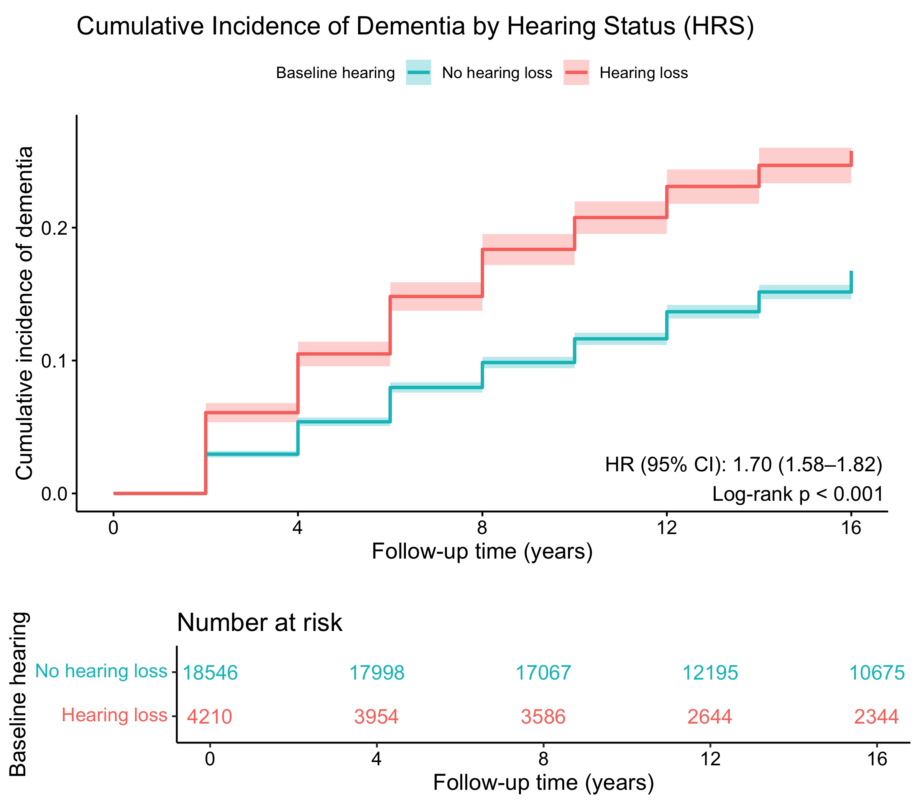
Note. Kaplan–Meier cumulative-incidence curves for incident all-cause dementia in the Health and Retirement Study (HRS; n = 22,756; 3,877 incident dementia events), comparing participants with baseline hearing impairment (n = 4,210) and without (n = 18,546). The x axis shows follow-up time from baseline (years) and the y axis the cumulative incidence of dementia, estimated as the complement of the Kaplan–Meier survivor function, with deaths and loss to follow-up treated as censored. Hearing impairment was defined at baseline as self-rated hearing (with hearing aid if usually worn) of "fair" or "poor" versus "excellent", "very good" or "good". Groups were compared with a two-sided log-rank test (P < 0.001). HRS, Health and Retirement Study.
Supplementary Fig. 2 Cumulative incidence of incident dementia by baseline vision-impairment status in HRS.
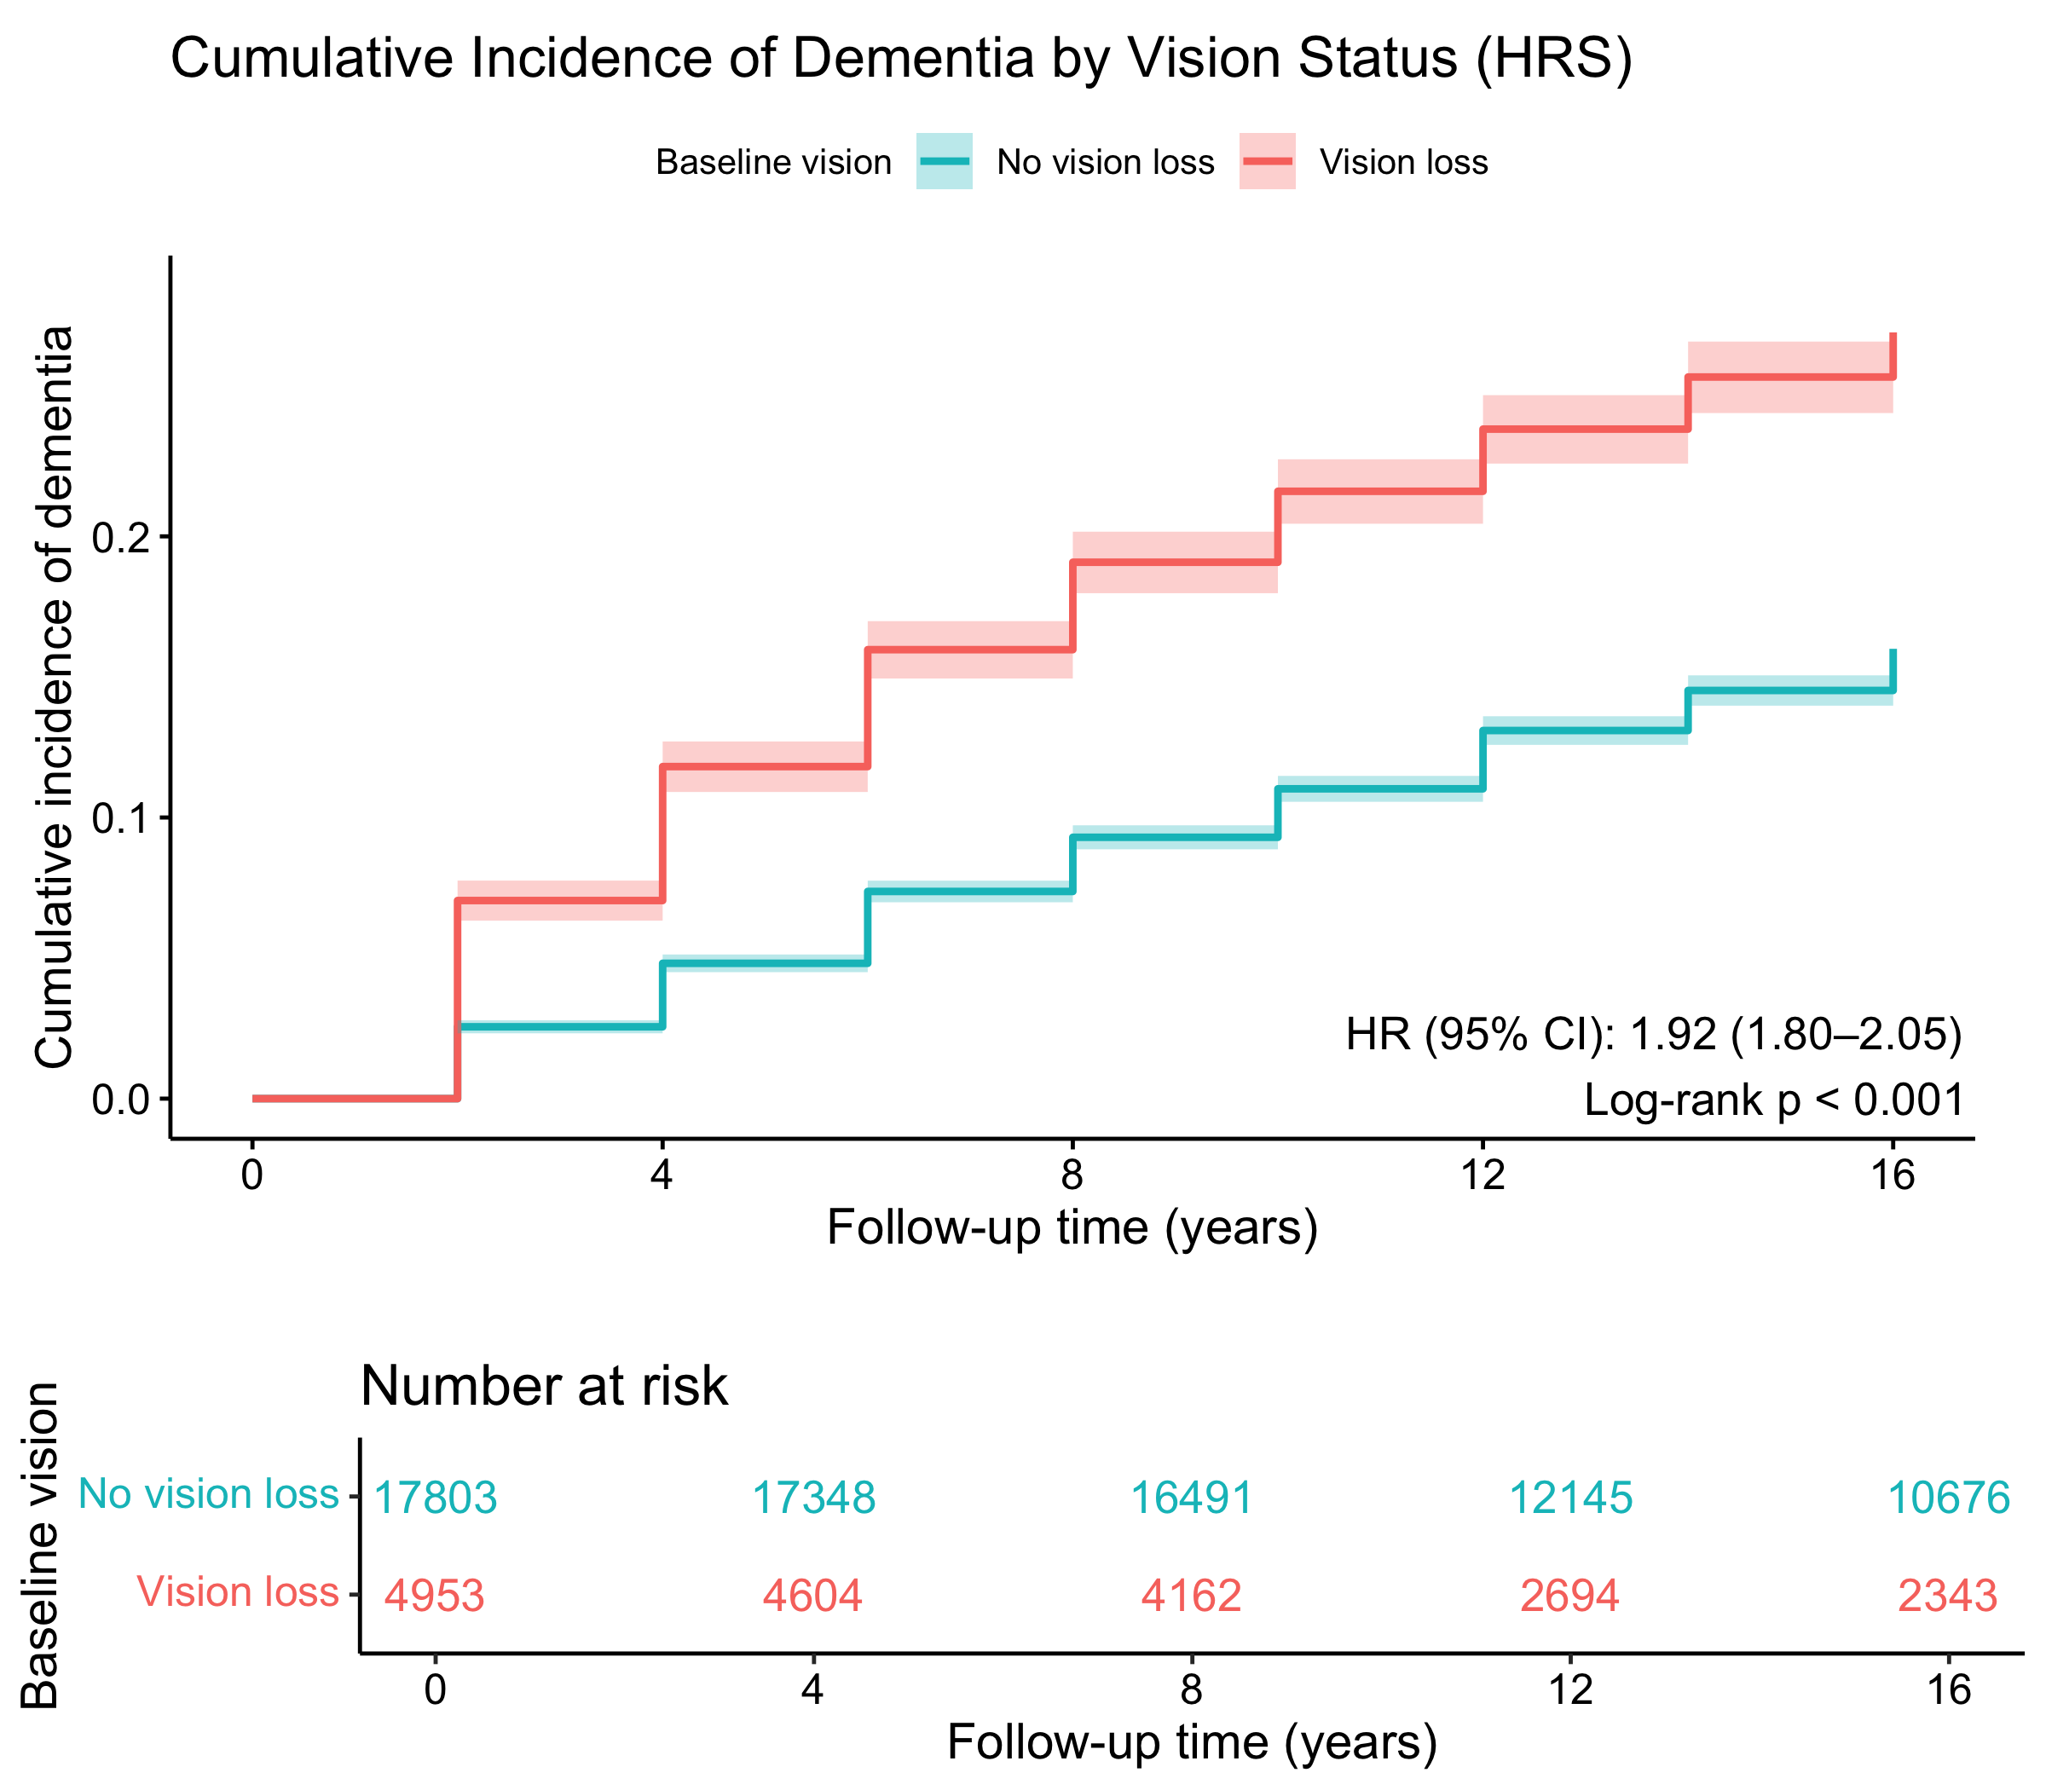
Note. Kaplan–Meier cumulative-incidence curves for incident all-cause dementia in HRS (n = 22,756; 3,877 events), comparing participants with baseline vision impairment (n = 4,953) and without (n = 17,803). Axes and estimation are as in Supplementary Fig. 1. Vision impairment was defined at baseline as self-rated eyesight (with corrective lenses if usually worn) of "fair", "poor" or "legally blind" versus "excellent", "very good" or "good". Groups were compared with a two-sided log-rank test (P < 0.001). HRS, Health and Retirement Study.
Supplementary Fig. 3 Cumulative incidence of incident dementia by baseline frailty status in HRS.
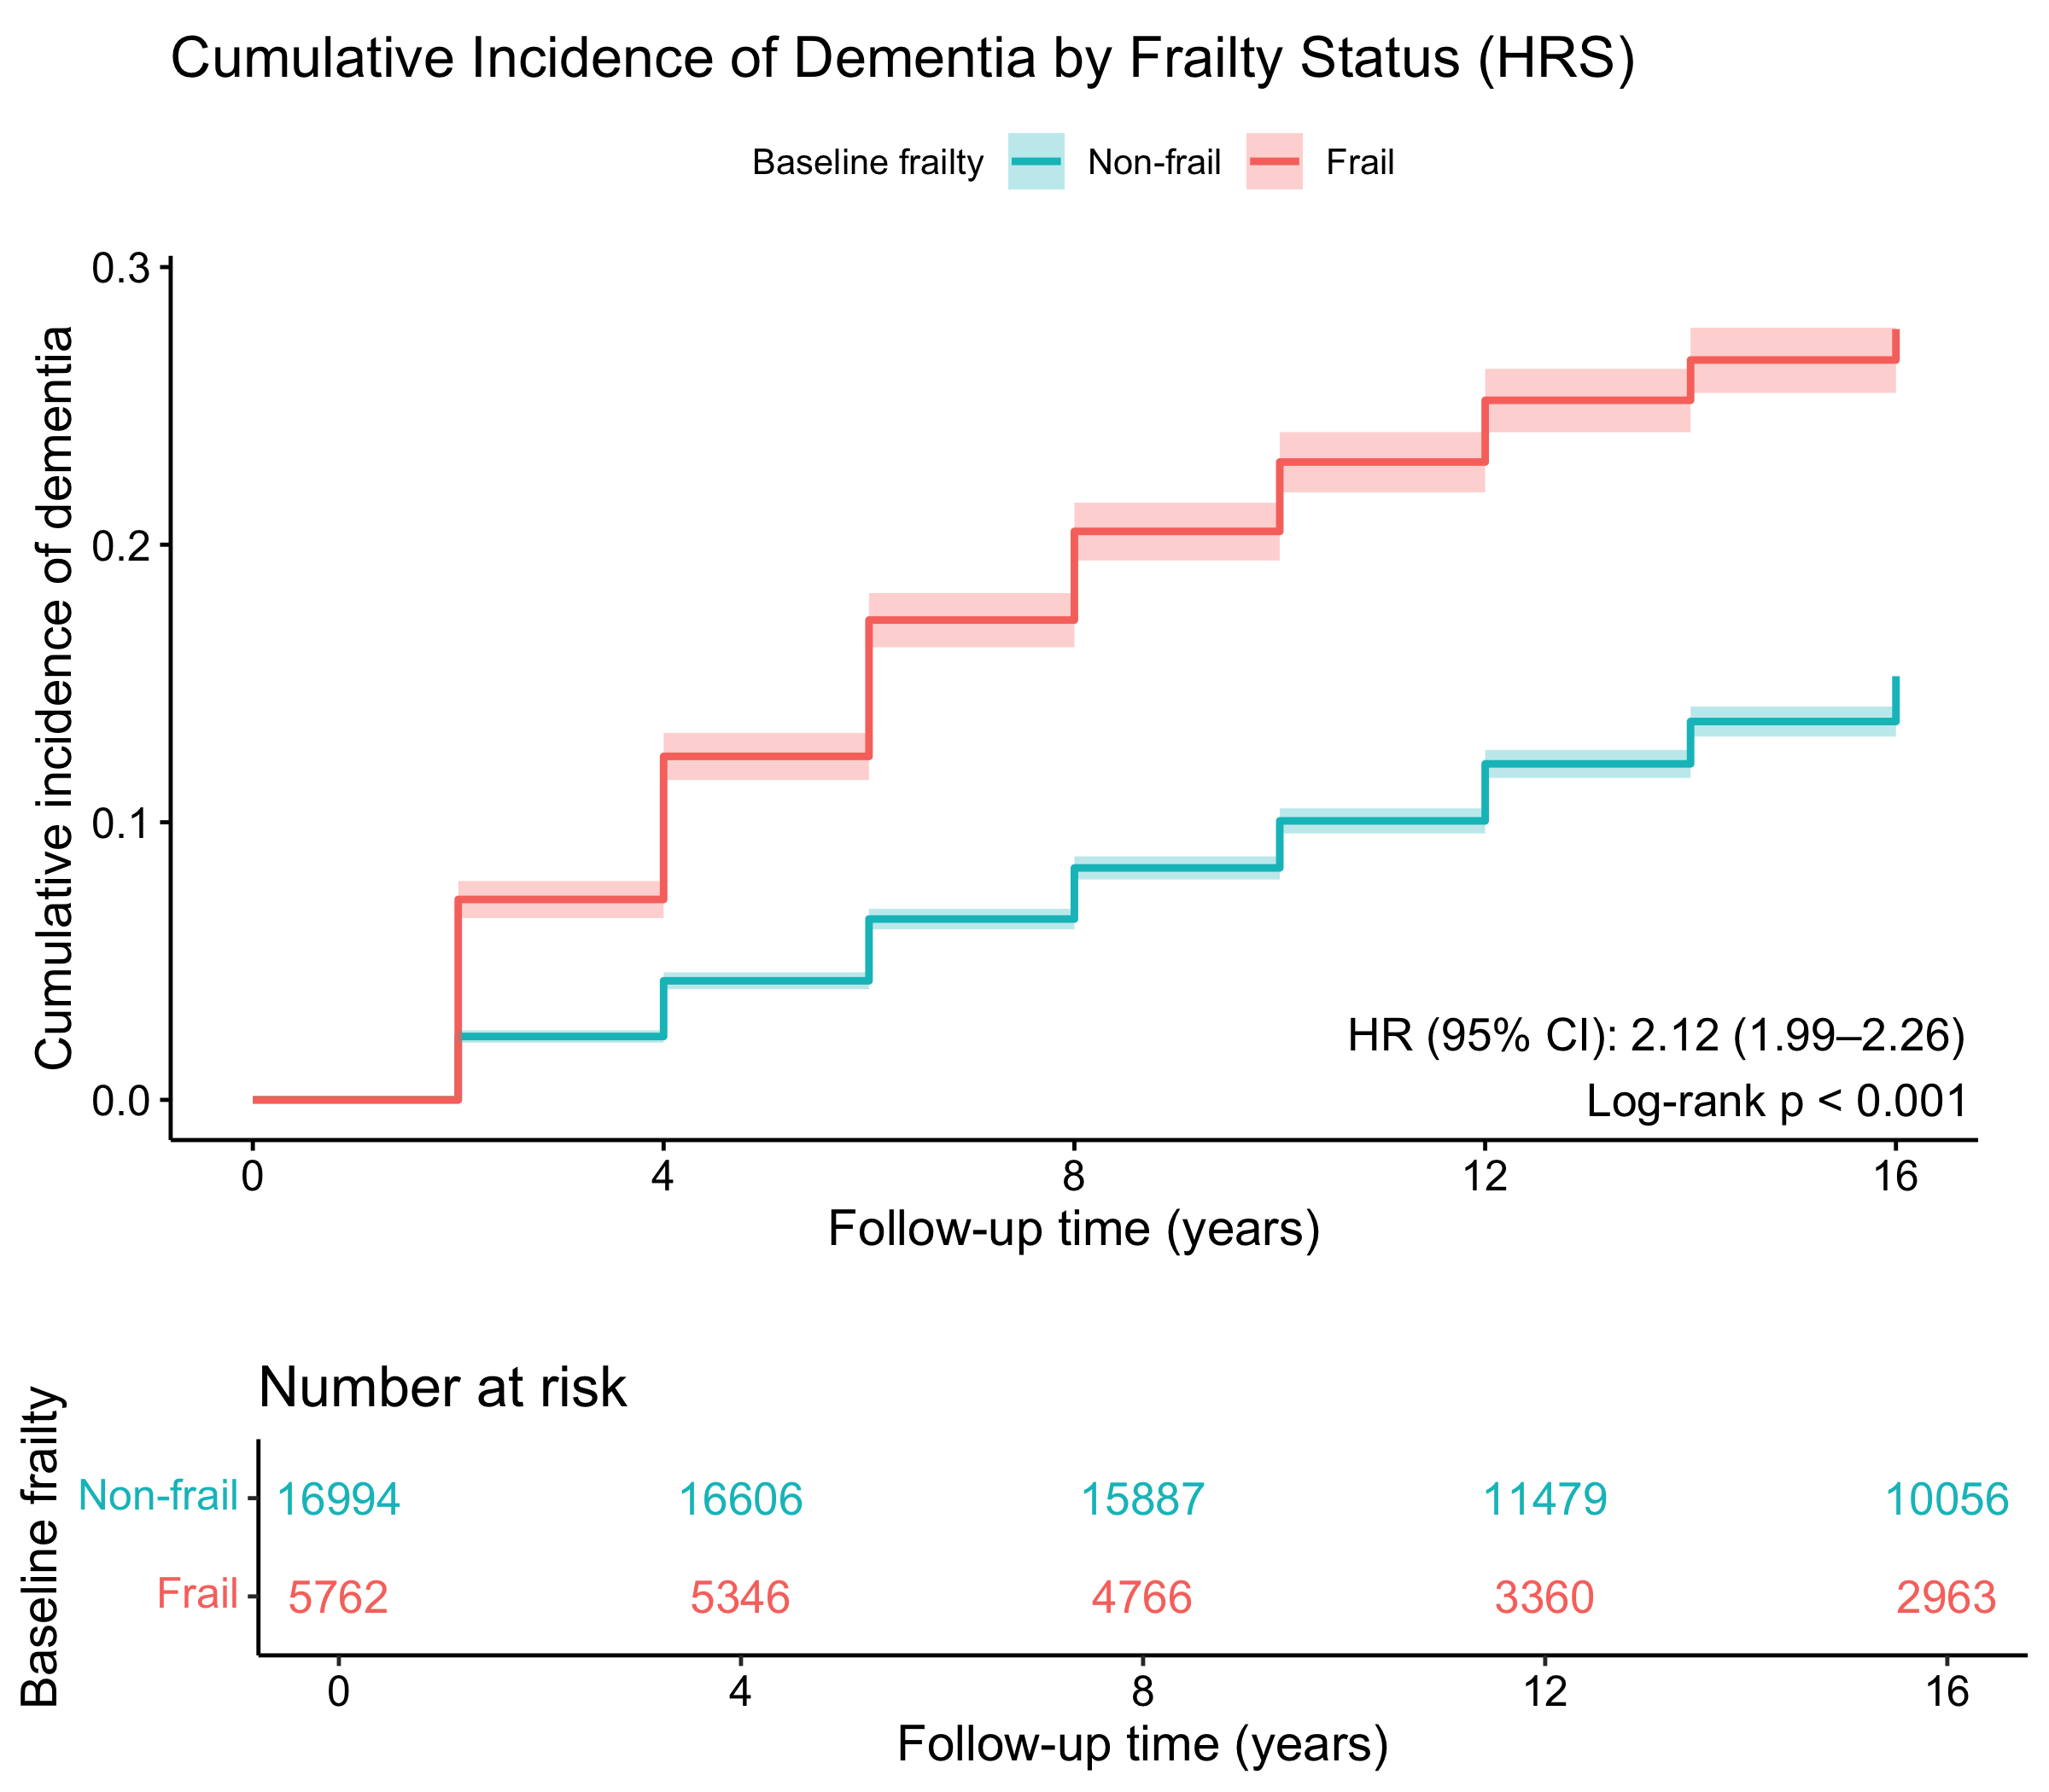
Note. Kaplan–Meier cumulative-incidence curves for incident all-cause dementia in HRS (n = 22,756; 3,877 events), comparing frail (frailty index ≥ 0.25; n = 5,762) and non-frail (frailty index < 0.25; n = 16,994) participants at baseline. Axes and estimation are as in Supplementary Fig. 1. The frailty index was a deficit-accumulation index (37 items) from which hearing-, vision- and cognition-related deficits were excluded; a score ≥ 0.25 defined frailty. Groups were compared with a two-sided log-rank test (P < 0.001). HRS, Health and Retirement Study.
Supplementary Fig. 4 Cumulative incidence of incident dementia by baseline hearing-impairment status in ELSA.
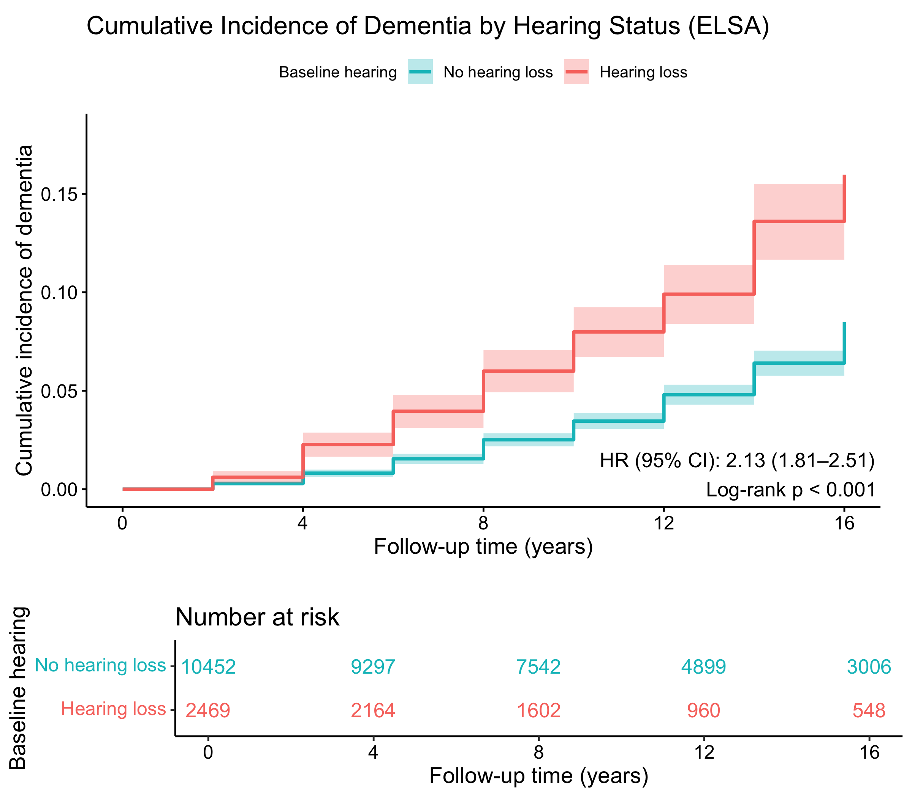
Note. Kaplan–Meier cumulative-incidence curves for incident all-cause dementia in the English Longitudinal Study of Ageing (ELSA; n = 12,921; 688 incident dementia events), comparing participants with baseline hearing impairment (n = 2,469) and without (n = 10,452). Axes and estimation are as in Supplementary Fig. 1; the hearing-impairment definition is identical. Groups were compared with a two-sided log-rank test (P < 0.001). ELSA, English Longitudinal Study of Ageing.
Supplementary Fig. 5 Cumulative incidence of incident dementia by baseline vision-impairment status in ELSA.
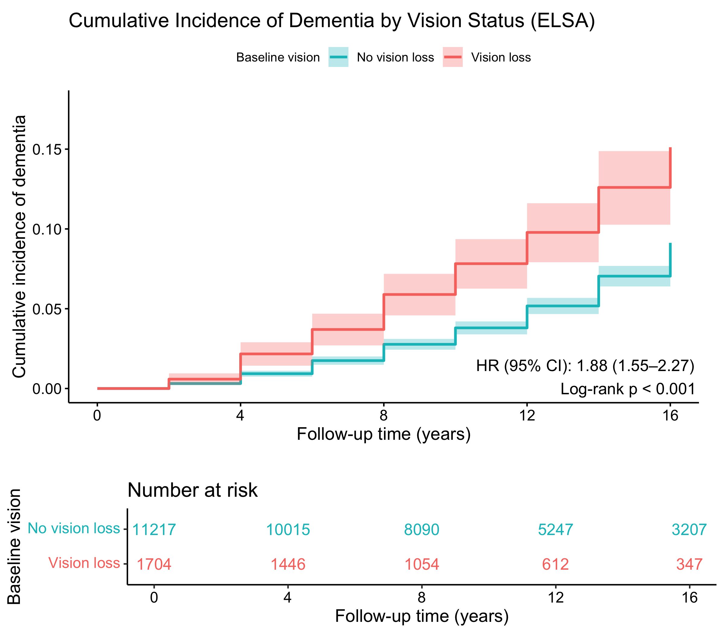
Note. Kaplan–Meier cumulative-incidence curves for incident all-cause dementia in ELSA (n = 12,921; 688 events), comparing participants with baseline vision impairment (n = 1,704) and without (n = 11,217). Axes and estimation are as in Supplementary Fig. 1. Vision impairment was defined at baseline as self-rated eyesight (with corrective lenses if usually worn) of "fair", "poor" or registered/legally blind versus "excellent", "very good" or "good". Groups were compared with a two-sided log-rank test (P < 0.001). ELSA, English Longitudinal Study of Ageing.
Supplementary Fig. 6 Cumulative incidence of incident dementia by baseline frailty status in ELSA.
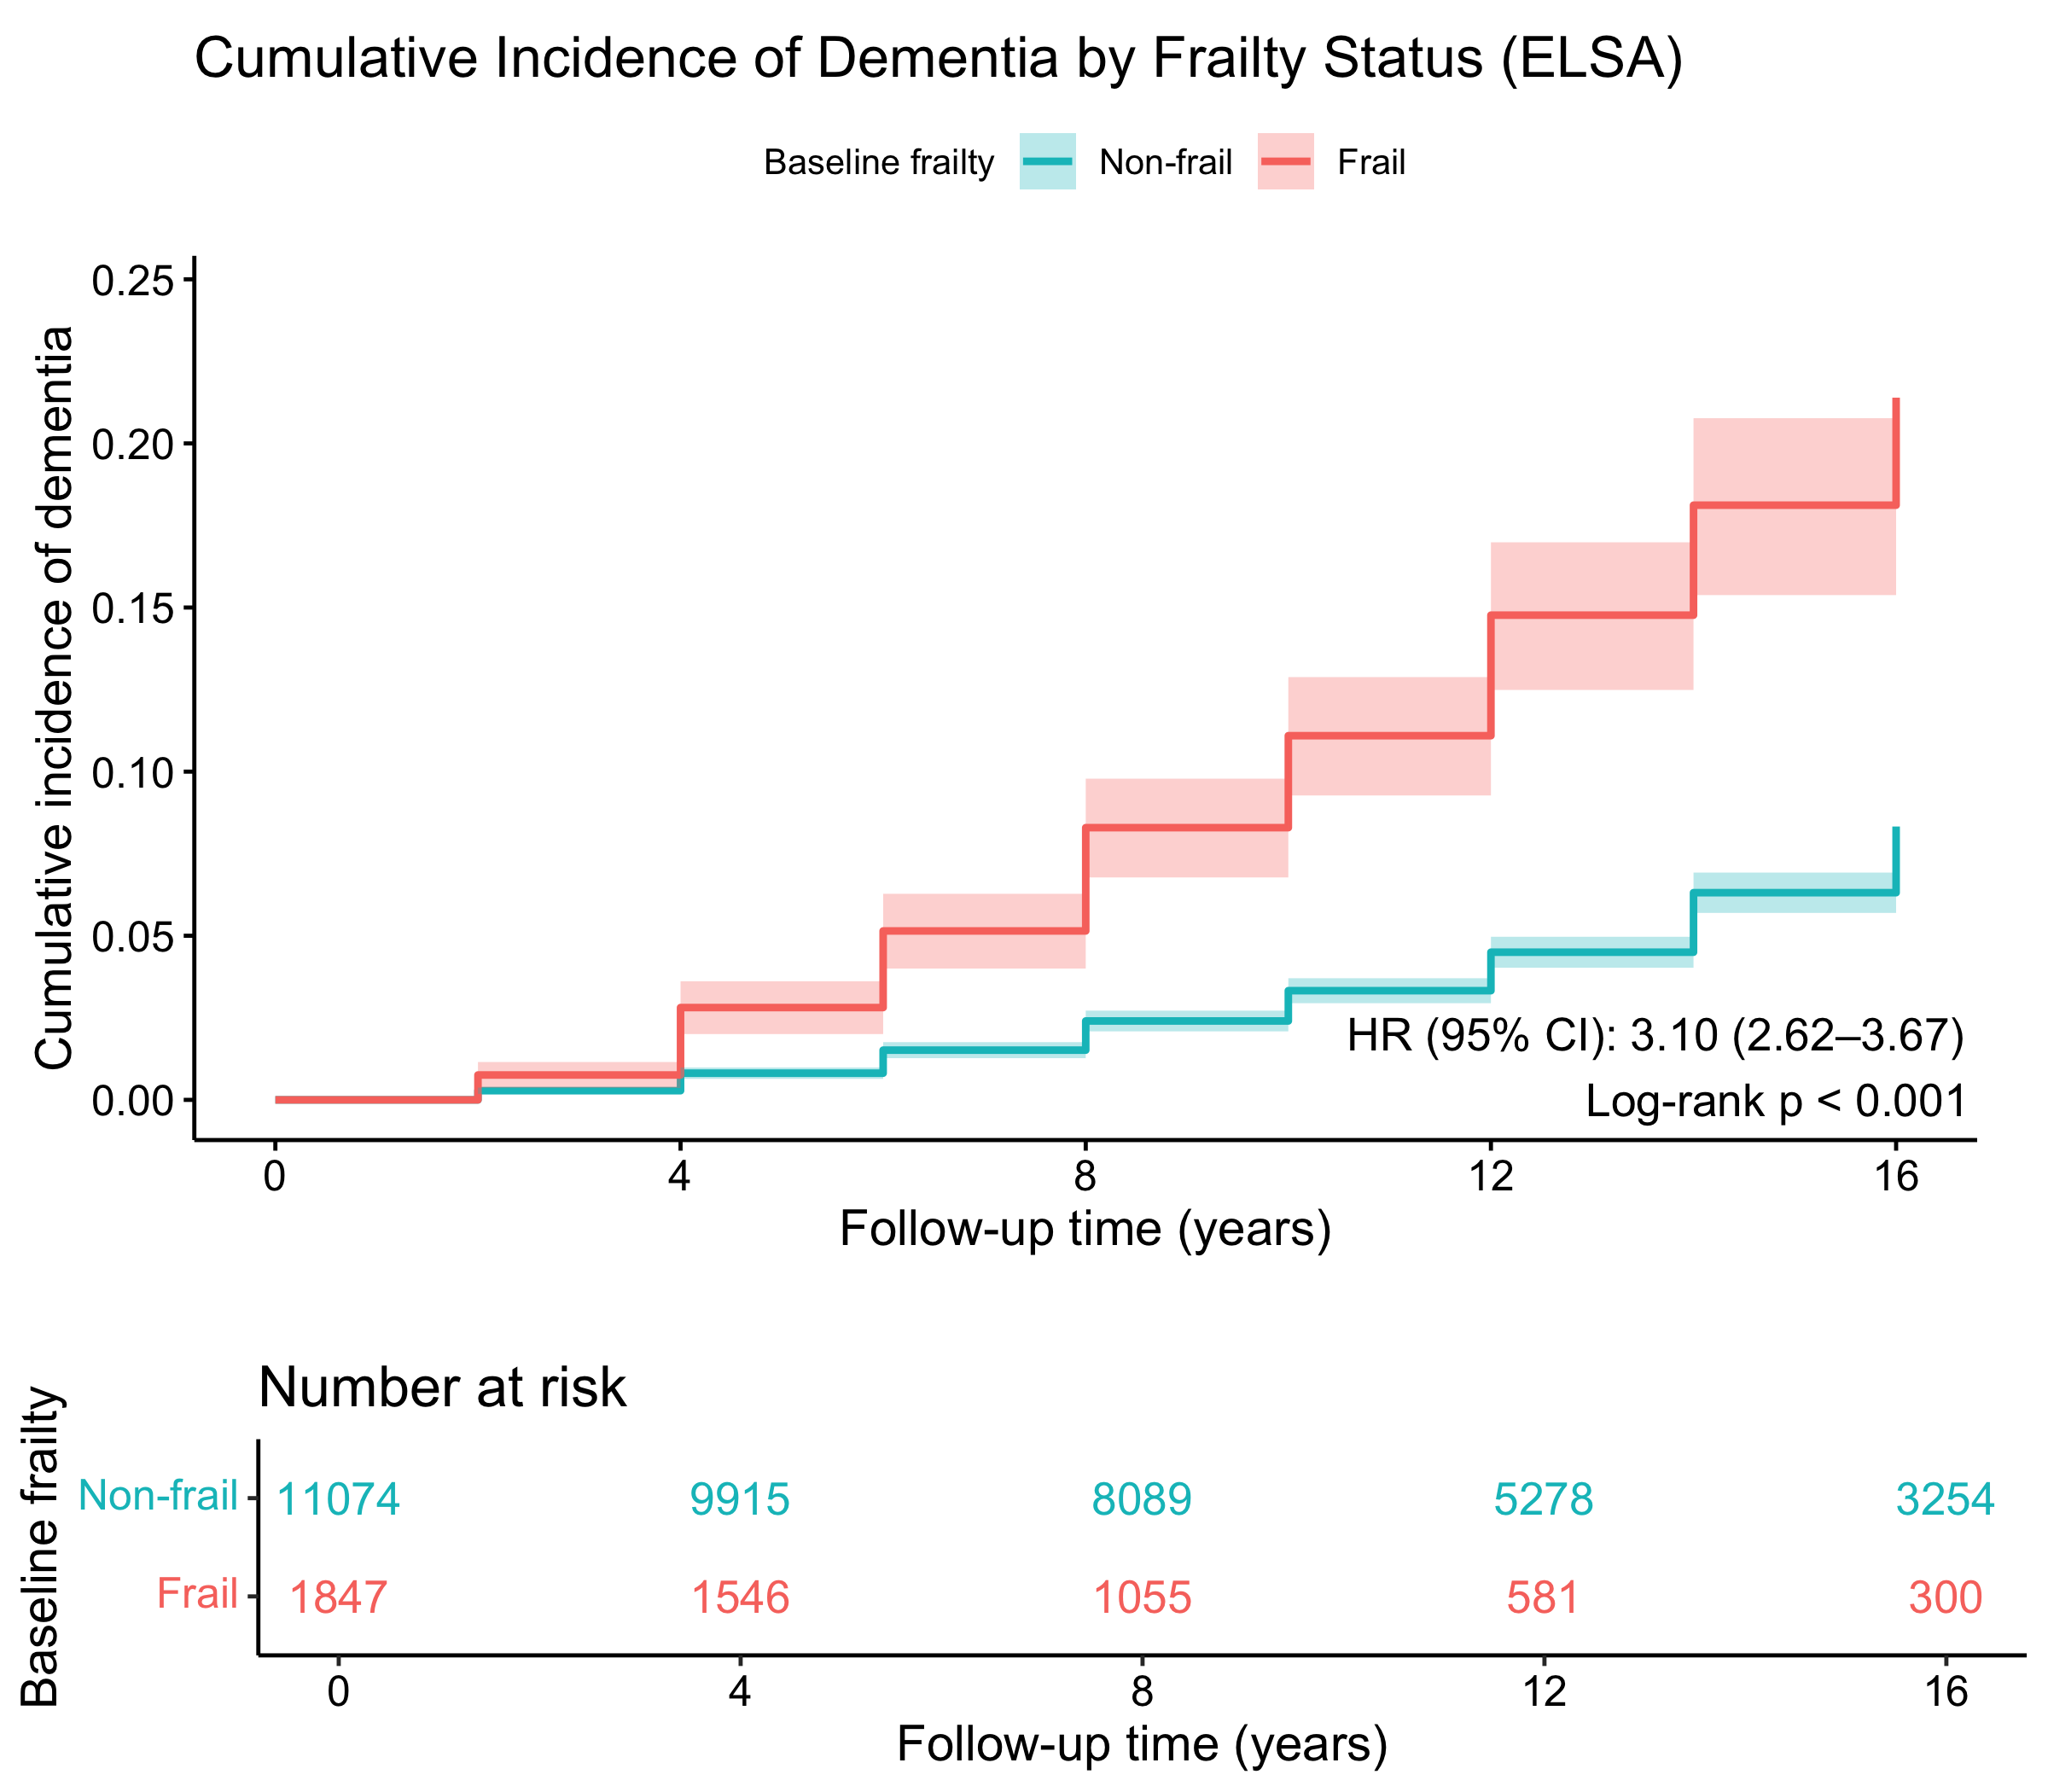
Note. Kaplan–Meier cumulative-incidence curves for incident all-cause dementia in ELSA (n = 12,921; 688 events), comparing frail (frailty index ≥ 0.25; n = 1,847) and non-frail (frailty index < 0.25; n = 11,074) participants at baseline. Axes and estimation are as in Supplementary Fig. 1. The frailty index was a deficit-accumulation index (49 items) excluding hearing-, vision- and cognition-related deficits; a score ≥ 0.25 defined frailty. Groups were compared with a two-sided log-rank test (P < 0.001). ELSA, English Longitudinal Study of Ageing.

Supplementary Fig. 7 Subgroup analyses by age and sex for hearing impairment, vision impairment and frailty as predictors of incident dementia in HRS and ELSA
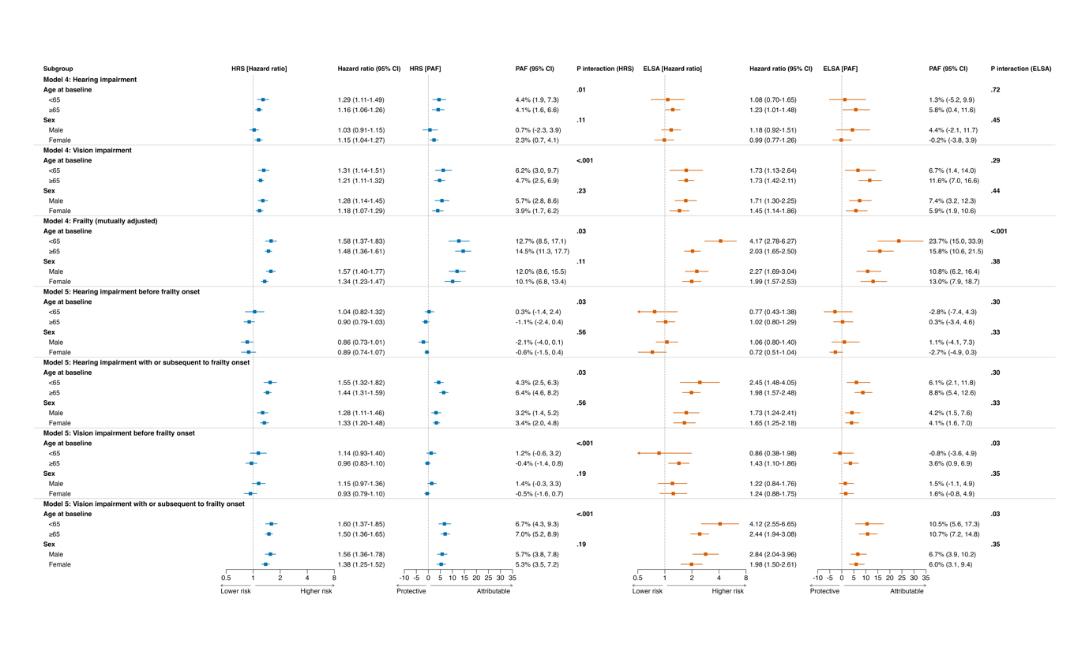
Note: Forest plot of hazard ratios (HR) for incident dementia with 95% confidence intervals (CI), stratified by baseline age (< 65 vs ≥ 65 years) and sex (male vs female). Rows are organised by exposure–model combination. Model 4 gives the fully adjusted main effect estimate for each exposure: hearing impairment and vision impairment are each adjusted for baseline age, sex, race/ethnicity, education, marital status, employment, smoking, alcohol consumption and frailty status; the frailty row is from a mutually adjusted model that additionally includes hearing and vision impairment. Model 5 gives the corresponding frailty-stratified estimates, splitting person-time into the windows before or without subsequent frailty onset (accrued while not frail) and concurrently with or subsequent to frailty onset (accrued from the first wave at which a participant was classified as frail), and is fitted with the same covariate set as Model 4 except for frailty status, which defines the strata. Within each row, P-interaction tests whether the exposure × subgroup product term is non-zero in a model containing both subgroup levels jointly; values are shown to two decimal places, with P < 0.001 reported as such. HRS, Health and Retirement Study, is shown in blue (left) and ELSA, English Longitudinal Study of Ageing, in orange (right); squares denote point estimates with horizontal lines for 95% CIs, and the dashed vertical line denotes HR = 1. The x axis is on a log scale and arrows indicate truncated CIs that extend beyond the plotting range. HR, hazard ratio; CI, confidence interval.

Supplementary Fig. 8 Hazard ratios and population attributable fractions for incident dementia under a Fine–Gray competing-risk model (HRS)
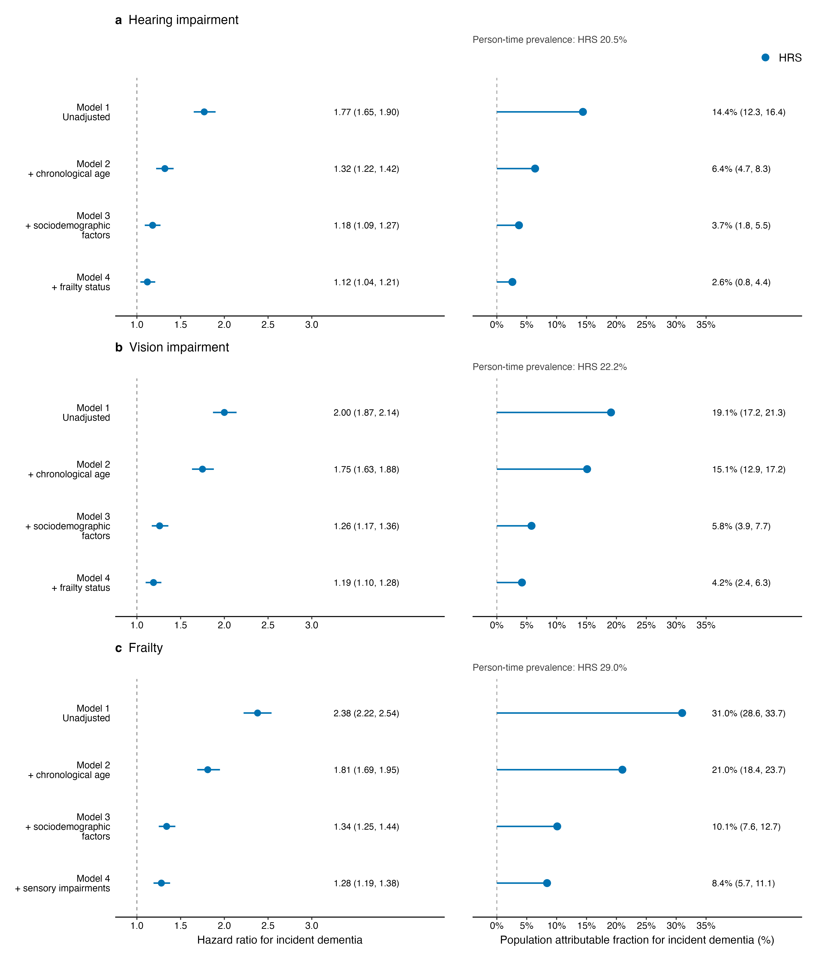

Note. HRS-only figure visualising the estimates in Supplementary Table 20. Hazard ratios are subdistribution hazard ratios from Fine–Gray competing-risk regression, in which death without dementia is treated as a competing event, so the hazard ratios and accompanying population attributable fractions refer to the cumulative incidence of dementia. Points are point estimates and horizontal lines are 95% confidence intervals; the dashed reference line denotes a hazard ratio of 1. Models 1–4 are the nested sequence defined for Supplementary Table 20, with Model 4 (“hybrid”) being the fully mutually adjusted model.

Supplementary Fig. 9 Context-specific Fine–Gray hazard ratios and population attributable fractions for sensory impairment in relation to frailty onset (HRS, Model 5, fully adjusted)
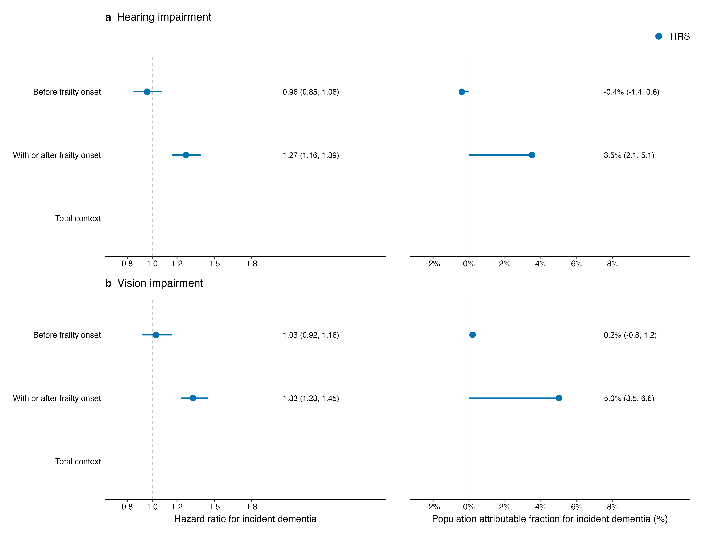

Note. HRS-only figure corresponding to Supplementary Table 21. Estimates are subdistribution hazard ratios (and population attributable fractions) from the fully adjusted Fine–Gray competing-risk model (Model 5), in which sensory impairment is classified by its timing relative to frailty onset (before vs with or subsequent to frailty onset) against a “no impairment” reference, accounting for the competing risk of death. Points are point estimates with 95% confidence intervals; the dashed line marks a hazard ratio of 1.

Supplementary Fig. 10 Two-wave exposure-lagged sensitivity analysis: hazard ratios and population attributable fractions for incident dementia in HRS and ELSA.
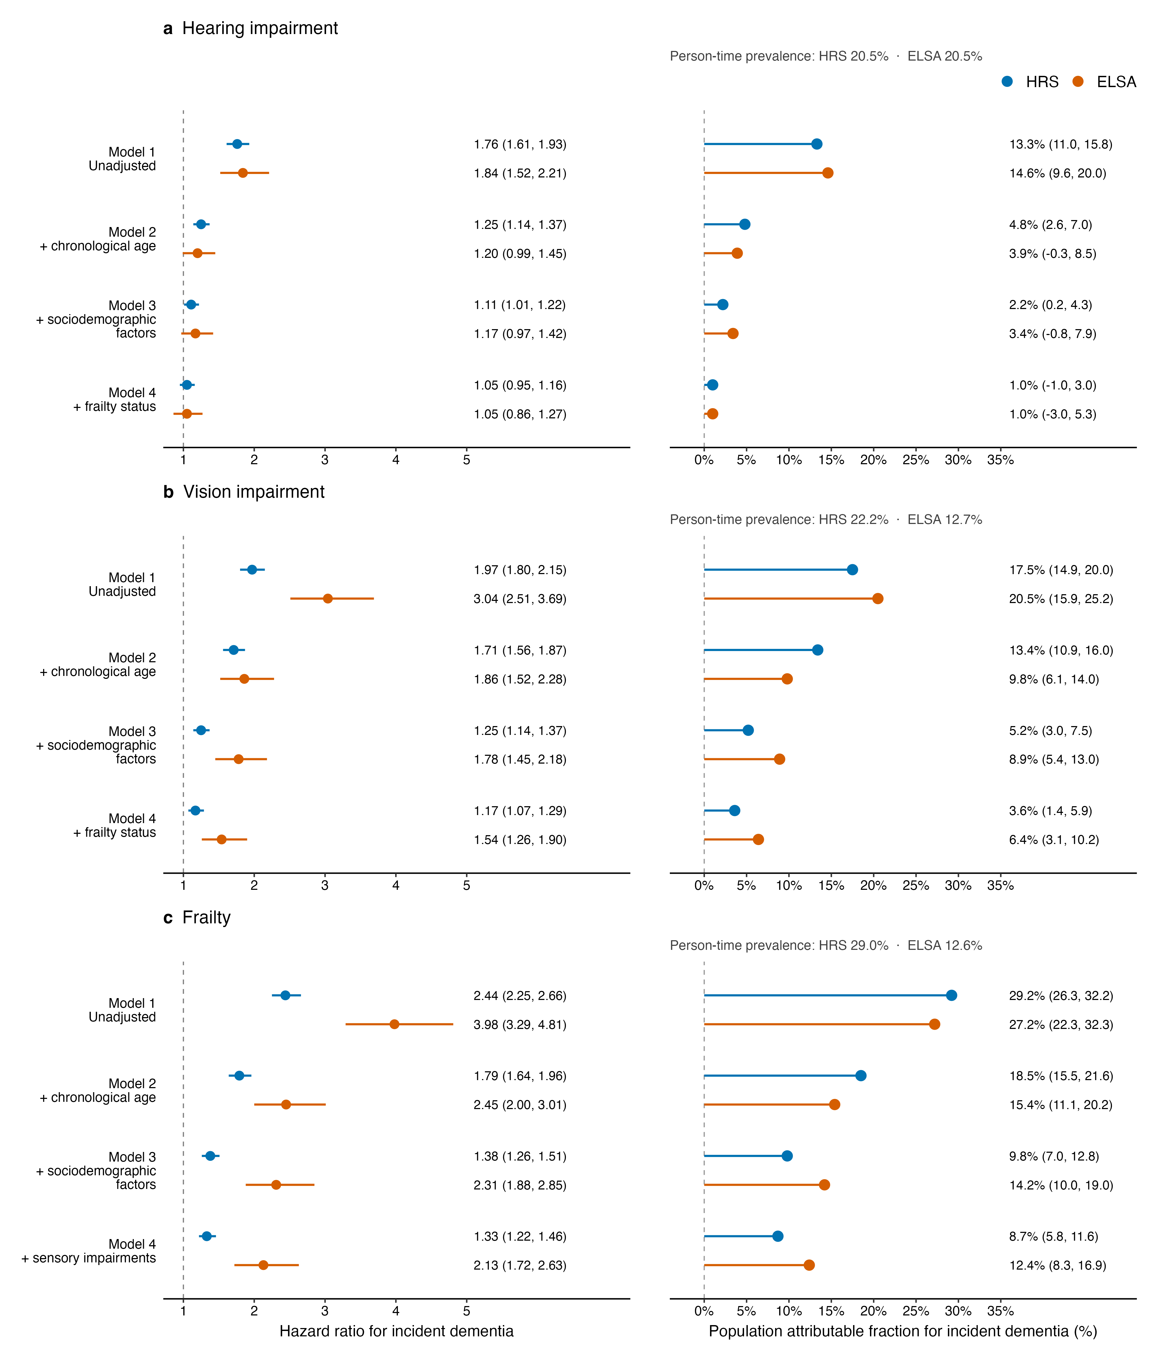

Note. Figure for the two-wave exposure-lagged sensitivity analysis in Supplementary Table 22. Each exposure (hearing impairment, vision impairment, frailty) is lagged by two biennial waves so that it is measured before dementia ascertainment, reducing reverse causation; otherwise the nested Model 1–4 sequence and covariate adjustment follow Supplementary Table 18. Points are point estimates with 95% confidence intervals; the dashed line marks a hazard ratio of 1. The HRS results are described here; the ELSA panel replicates the same approach.

Supplementary Fig. 11 Two-wave exposure-lagged sensitivity analysis: context-specific hazard ratios and population attributable fractions for sensory impairment in relation to frailty onset (HRS and ELSA, Model 5, fully adjusted).
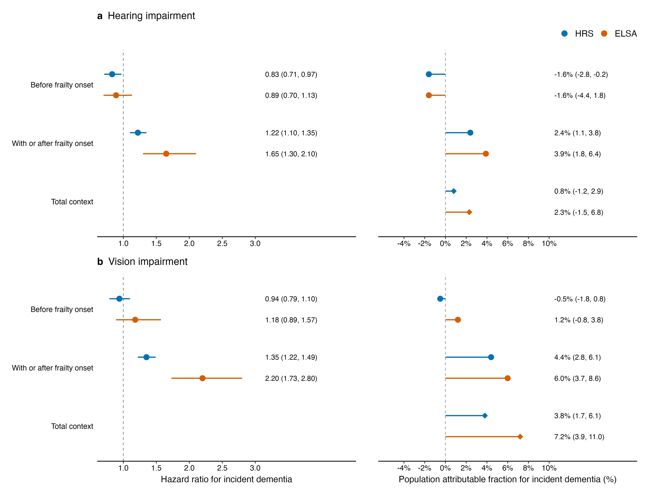

Note. Figure for the two-wave exposure-lagged, context-specific analysis in Supplementary Table 23. Sensory impairment is lagged by two biennial waves and classified by its timing relative to frailty onset (before vs with or subsequent to frailty onset) against a “no impairment” reference, with the fully adjusted Model 5 covariate set. Points are point estimates with 95% confidence intervals; the dashed line marks a hazard ratio of 1. The HRS results are described here; the ELSA panel replicates the same specification.

Supplementary Fig. 12 Sensitivity analysis with a frailty index excluding (I)ADL items: hazard ratios and population attributable fractions for incident dementia in HRS and ELSA.
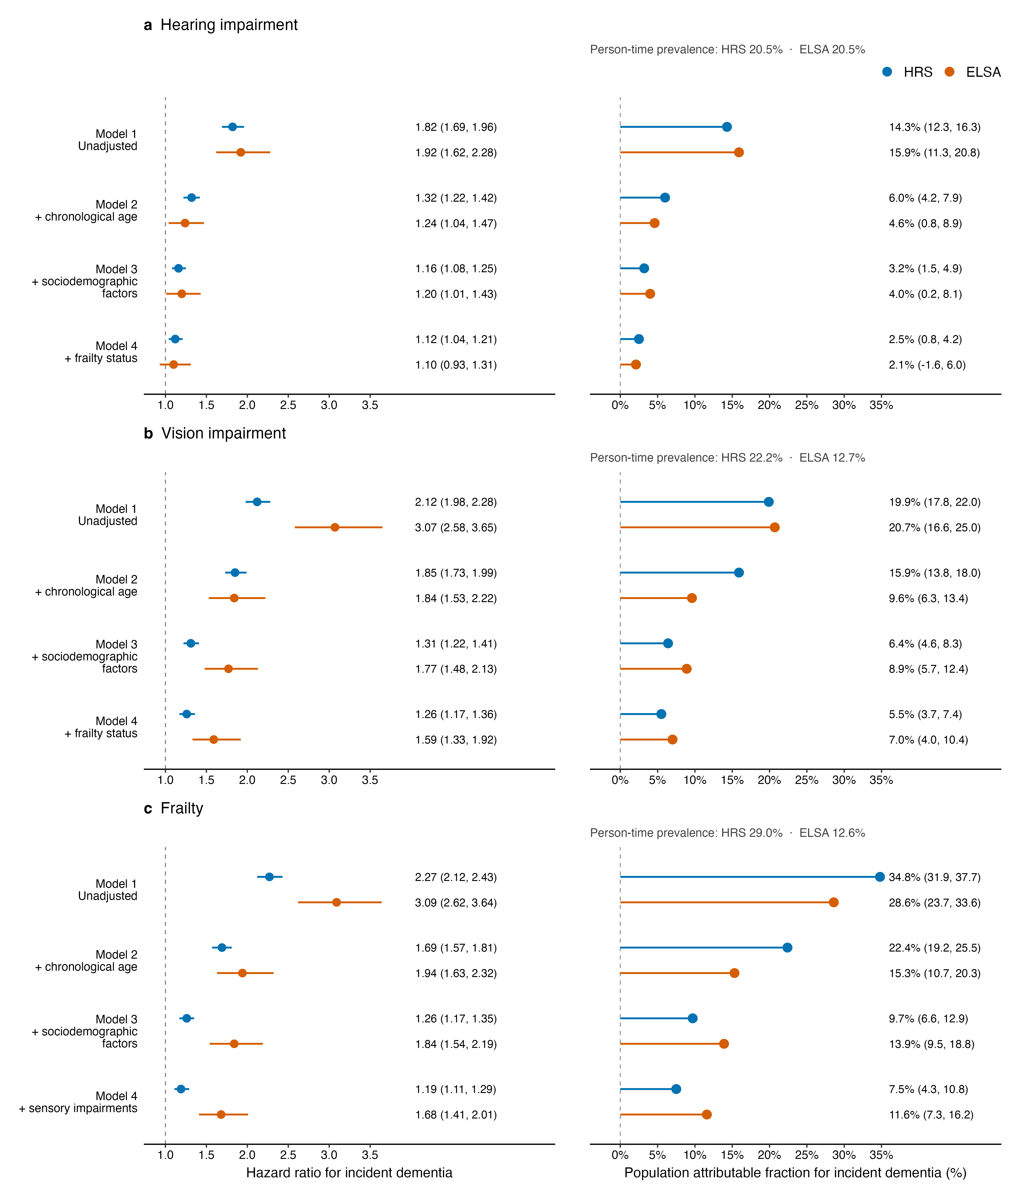

Note. Figure for the sensitivity analysis in Supplementary Table 24, in which the frailty index is recomputed after excluding the (instrumental) activities-of-daily-living [(I)ADL] items to remove overlap between the frailty measure and functional disability. The nested Model 1–4 sequence and covariate adjustment otherwise match Supplementary Table 18. Points are point estimates with 95% confidence intervals; the dashed line marks a hazard ratio of 1. The HRS results are described here; the ELSA panel replicates the same approach.

Supplementary Fig. 13 Sensitivity analysis with a frailty index excluding (I)ADL items: context-specific hazard ratios and population attributable fractions for sensory impairment in relation to frailty onset (HRS and ELSA, Model 5, fully adjusted).
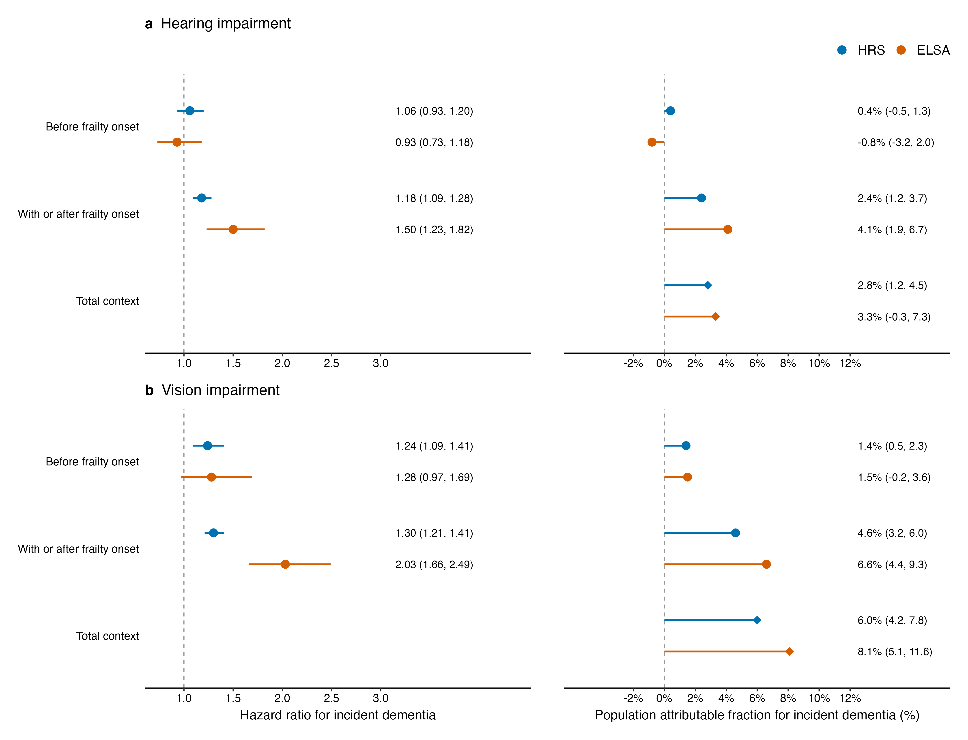

Note. Figure for the context-specific sensitivity analysis in Supplementary Table 25, using a frailty index that excludes the (instrumental) activities-of-daily-living [(I)ADL] items. Frailty onset, which defines the before, and with or subsequent to, frailty-onset exposure windows, is taken from this reduced index; the fully adjusted Model 5 covariate set is otherwise retained, with “no impairment” as the reference. Points are point estimates with 95% confidence intervals; the dashed line marks a hazard ratio of 1. The HRS results are described here; the ELSA panel replicates the same specification.

