Supplementary Table 1: Trends in Age-Adjusted Mortality Rates and Deaths from Heart Failure among United States Adults Aged 25 and Older stratified by Overall and Sex, 1999–2025.
Year | Overall |  | Women |  | Men
Year | Deaths | AAMR (95% CI) | Deaths | AAMR (95% CI) | Deaths | AAMR (95% CI)
1999 | 293811 | 167.41 (166.80 to 168.02) | 170335 | 150.72 (150.00 to 151.44) | 123476 | 192.13 (191.03 to 193.23)
2000 | 294131 | 165.24 (164.65 to 165.84) | 170760 | 149.17 (148.46 to 149.88) | 123371 | 189.30 (188.22 to 190.38)
2001 | 291672 | 161.19 (160.61 to 161.78) | 169313 | 145.98 (145.28 to 146.67) | 122359 | 183.36 (182.31 to 184.41)
2002 | 290308 | 158.24 (157.67 to 158.82) | 167109 | 142.68 (141.99 to 143.37) | 123199 | 181.29 (180.26 to 182.32)
2003 | 293223 | 157.15 (156.58 to 157.72) | 168179 | 141.68 (141.00 to 142.36) | 125044 | 179.66 (178.65 to 180.67)
2004 | 288315 | 152.28 (151.72 to 152.84) | 164200 | 137.02 (136.36 to 137.69) | 124115 | 174.70 (173.71 to 175.69)
2005 | 296202 | 153.12 (152.57 to 153.68) | 168727 | 138.14 (137.48 to 138.80) | 127475 | 175.00 (174.02 to 175.97)
2006 | 286695 | 144.87 (144.34 to 145.40) | 161728 | 129.85 (129.21 to 130.48) | 124967 | 166.53 (165.59 to 167.46)
2007 | 281389 | 139.05 (138.53 to 139.56) | 158148 | 124.55 (123.93 to 125.17) | 123241 | 159.83 (158.93 to 160.73)
2008 | 285633 | 138.12 (137.61 to 138.62) | 159491 | 123.29 (122.68 to 123.90) | 126142 | 159.16 (158.27 to 160.05)
2009 | 278893 | 132.08 (131.59 to 132.57) | 153454 | 116.72 (116.13 to 117.31) | 125439 | 154.07 (153.21 to 154.93)
2010 | 283577 | 131.92 (131.43 to 132.41) | 154984 | 115.95 (115.36 to 116.53) | 128593 | 154.80 (153.94 to 155.66)
2011 | 288636 | 130.24 (129.76 to 130.72) | 157260 | 114.62 (114.04 to 115.20) | 131376 | 152.21 (151.38 to 153.04)
2012 | 290171 | 127.74 (127.27 to 128.21) | 156431 | 111.81 (111.24 to 112.37) | 133740 | 150.06 (149.25 to 150.88)
2013 | 304625 | 130.88 (130.41 to 131.35) | 162563 | 114.10 (113.53 to 114.66) | 142062 | 154.21 (153.39 to 155.02)
2014 | 313713 | 131.78 (131.32 to 132.25) | 165617 | 114.32 (113.76 to 114.88) | 148096 | 155.87 (155.07 to 156.68)
2015 | 335847 | 138.02 (137.54 to 138.49) | 177139 | 120.10 (119.53 to 120.67) | 158708 | 162.28 (161.47 to 163.08)
2016 | 342879 | 138.09 (137.62 to 138.55) | 178205 | 119.00 (118.43 to 119.56) | 164674 | 163.96 (163.16 to 164.76)
2017 | 361407 | 142.36 (141.89 to 142.82) | 186697 | 122.53 (121.97 to 123.10) | 174710 | 169.03 (168.22 to 169.83)
2018 | 378335 | 145.77 (145.30 to 146.24) | 193739 | 124.90 (124.33 to 125.46) | 184596 | 173.42 (172.62 to 174.22)
2019 | 392322 | 148.25 (147.78 to 148.72) | 199284 | 126.79 (126.23 to 127.36) | 193038 | 176.49 (175.70 to 177.29)
2020 | 436218 | 162.20 (161.71 to 162.68) | 218294 | 137.47 (136.88 to 138.05) | 217924 | 194.31 (193.48 to 195.13)
2021 | 442859 | 174.15 (173.63 to 174.67) | 219956 | 148.55 (147.93 to 149.18) | 222903 | 207.19 (206.31 to 208.07)
2022 | 453626 | 168.47 (167.98 to 168.97) | 227350 | 143.12 (142.52 to 143.71) | 226276 | 202.38 (201.54 to 203.23)
2023 | 448840 | 167.42 (166.92 to 167.91) | 223136 | 143.19 (142.60 to 143.80) | 225704 | 198.50 (197.66 to 199.34)
2024 | 457930 | 164.95 (164.47 to 165.43) | 226861 | 141.24 (140.66 to 141.83) | 231069 | 194.93 (194.12 to 195.74)
2025 | 478288 | 172.13 (171.64 to 172.62) | 236170 | 147.09 (146.49 to 147.69) | 242118 | 203.92 (203.09 to 204.74)
Total/Average | 9189545 | 149.75 (149.23 to 150.26) | 4895130 | 131.28 (130.67 to 131.89) | 4294415 | 175.13 (174.24 to 176.02)
Supplementary Table 2: Heart Failure–related Forecast Age-Adjusted Mortality Rates, Stratified by Overall, Sex, Race, Age, Census region, and Urbanization in Adults in the United States, 2026 to 2050.
Stratification | Year | Forecast Value (95% CI)
Overall | 2026 | 173.72 (164.25 to 183.19)
Overall | 2027 | 176.08 (162.69 to 189.47)
Overall | 2028 | 178.41 (162.01 to 194.81)
Overall | 2029 | 180.72 (161.78 to 199.66)
Overall | 2030 | 183.00 (161.83 to 204.18)
Overall | 2031 | 185.27 (162.08 to 208.47)
Overall | 2032 | 187.53 (162.47 to 212.58)
Overall | 2033 | 189.77 (162.99 to 216.56)
Overall | 2034 | 192.01 (163.6 to 220.42)
Overall | 2035 | 194.24 (164.29 to 224.18)
Overall | 2036 | 196.46 (165.05 to 227.87)
Overall | 2037 | 198.67 (165.87 to 231.48)
Overall | 2038 | 200.88 (166.74 to 235.03)
Overall | 2039 | 203.09 (167.66 to 238.52)
Overall | 2040 | 205.29 (168.62 to 241.97)
Overall | 2041 | 207.49 (169.61 to 245.37)
Overall | 2042 | 209.69 (170.65 to 248.74)
Overall | 2043 | 211.89 (171.71 to 252.07)
Overall | 2044 | 214.08 (172.81 to 255.36)
Overall | 2045 | 216.28 (173.93 to 258.63)
Overall | 2046 | 218.47 (175.07 to 261.87)
Overall | 2047 | 220.66 (176.25 to 265.08)
Overall | 2048 | 222.85 (177.44 to 268.27)
Overall | 2049 | 225.04 (178.65 to 271.44)
Overall | 2050 | 227.23 (179.89 to 274.58)
Sex
Women | 2026 | 147.41 (138.8 to 156.02)
Women | 2027 | 149.11 (136.94 to 161.29)
Women | 2028 | 150.75 (135.84 to 165.66)
Women | 2029 | 152.33 (135.11 to 169.54)
Women | 2030 | 153.87 (134.62 to 173.11)
Women | 2031 | 155.37 (134.28 to 176.45)
Women | 2032 | 156.84 (134.06 to 179.61)
Women | 2033 | 158.29 (133.94 to 182.63)
Women | 2034 | 159.71 (133.89 to 185.54)
Women | 2035 | 161.12 (133.9 to 188.34)
Women | 2036 | 162.51 (133.96 to 191.06)
Women | 2037 | 163.9 (134.08 to 193.72)
Women | 2038 | 165.27 (134.23 to 196.31)
Women | 2039 | 166.63 (134.42 to 198.84)
Women | 2040 | 167.99 (134.65 to 201.33)
Women | 2041 | 169.34 (134.91 to 203.78)
Women | 2042 | 170.69 (135.2 to 206.18)
Women | 2043 | 172.03 (135.51 to 208.55)
Women | 2044 | 173.37 (135.85 to 210.89)
Women | 2045 | 174.71 (136.21 to 213.21)
Women | 2046 | 176.04 (136.6 to 215.49)
Women | 2047 | 177.38 (137 to 217.75)
Women | 2048 | 178.71 (137.43 to 219.99)
Women | 2049 | 180.04 (137.87 to 222.21)
Women | 2050 | 181.37 (138.33 to 224.41)
Men | 2026 | 207.57 (196.51 to 218.64)
Men | 2027 | 210.89 (195.24 to 226.54)
Men | 2028 | 214.21 (195.04 to 233.38)
Men | 2029 | 217.53 (195.39 to 239.67)
Men | 2030 | 220.86 (196.1 to 245.61)
Men | 2031 | 224.18 (197.07 to 251.3)
Men | 2032 | 227.51 (198.23 to 256.8)
Men | 2033 | 230.84 (199.54 to 262.15)
Men | 2034 | 234.18 (200.97 to 267.38)
Men | 2035 | 237.51 (202.51 to 272.51)
Men | 2036 | 240.85 (204.14 to 277.56)
Men | 2037 | 244.18 (205.84 to 282.53)
Men | 2038 | 247.52 (207.61 to 287.43)
Men | 2039 | 250.86 (209.44 to 292.27)
Men | 2040 | 254.19 (211.32 to 297.06)
Men | 2041 | 257.53 (213.26 to 301.81)
Men | 2042 | 260.87 (215.23 to 306.51)
Men | 2043 | 264.21 (217.25 to 311.17)
Men | 2044 | 267.55 (219.3 to 315.8)
Men | 2045 | 270.89 (221.39 to 320.39)
Men | 2046 | 274.23 (223.5 to 324.95)
Men | 2047 | 277.57 (225.65 to 329.48)
Men | 2048 | 280.91 (227.82 to 333.99)
Men | 2049 | 284.24 (230.02 to 338.47)
Men | 2050 | 287.58 (232.24 to 342.93)
Race
NH American Indian or Alaska Native | 2026 | 137.81 (113.98 to 161.63)
NH American Indian or Alaska Native | 2027 | 133.97 (100.28 to 167.67)
NH American Indian or Alaska Native | 2028 | 130.91 (89.65 to 172.18)
NH American Indian or Alaska Native | 2029 | 128.47 (80.82 to 176.13)
NH American Indian or Alaska Native | 2030 | 126.53 (73.25 to 179.8)
NH American Indian or Alaska Native | 2031 | 124.97 (66.61 to 183.34)
NH American Indian or Alaska Native | 2032 | 123.74 (60.7 to 186.78)
NH American Indian or Alaska Native | 2033 | 122.75 (55.36 to 190.15)
NH American Indian or Alaska Native | 2034 | 121.97 (50.49 to 193.46)
NH American Indian or Alaska Native | 2035 | 121.36 (46.01 to 196.7)
NH American Indian or Alaska Native | 2036 | 120.87 (41.84 to 199.89)
NH American Indian or Alaska Native | 2037 | 120.48 (37.95 to 203.02)
NH American Indian or Alaska Native | 2038 | 120.18 (34.27 to 206.09)
NH American Indian or Alaska Native | 2039 | 119.95 (30.8 to 209.1)
NH American Indian or Alaska Native | 2040 | 119.76 (27.48 to 212.04)
NH American Indian or Alaska Native | 2041 | 119.62 (24.32 to 214.93)
NH American Indian or Alaska Native | 2042 | 119.52 (21.28 to 217.76)
NH American Indian or Alaska Native | 2043 | 119.44 (18.35 to 220.53)
NH American Indian or Alaska Native | 2044 | 119.38 (15.52 to 223.24)
NH American Indian or Alaska Native | 2045 | 119.34 (12.79 to 225.9)
NH American Indian or Alaska Native | 2046 | 119.32 (10.13 to 228.51)
NH American Indian or Alaska Native | 2047 | 119.3 (7.55 to 231.06)
NH American Indian or Alaska Native | 2048 | 119.3 (5.03 to 233.57)
NH American Indian or Alaska Native | 2049 | 119.3 (2.57 to 236.03)
NH American Indian or Alaska Native | 2050 | 119.31 (0.17 to 238.44)
NH Asian or Pacific Islander | 2026 | 69.05 (61.48 to 76.63)
NH Asian or Pacific Islander | 2027 | 68.25 (57.53 to 78.96)
NH Asian or Pacific Islander | 2028 | 67.53 (54.41 to 80.65)
NH Asian or Pacific Islander | 2029 | 66.88 (51.73 to 82.03)
NH Asian or Pacific Islander | 2030 | 66.28 (49.34 to 83.22)
NH Asian or Pacific Islander | 2031 | 65.72 (47.17 to 84.28)
NH Asian or Pacific Islander | 2032 | 65.2 (45.16 to 85.25)
NH Asian or Pacific Islander | 2033 | 64.71 (43.28 to 86.14)
NH Asian or Pacific Islander | 2034 | 64.24 (41.51 to 86.97)
NH Asian or Pacific Islander | 2035 | 63.79 (39.83 to 87.75)
NH Asian or Pacific Islander | 2036 | 63.35 (38.22 to 88.48)
NH Asian or Pacific Islander | 2037 | 62.92 (36.68 to 89.17)
NH Asian or Pacific Islander | 2038 | 62.5 (35.19 to 89.82)
NH Asian or Pacific Islander | 2039 | 62.09 (33.74 to 90.44)
NH Asian or Pacific Islander | 2040 | 61.68 (32.34 to 91.03)
NH Asian or Pacific Islander | 2041 | 61.28 (30.98 to 91.59)
NH Asian or Pacific Islander | 2042 | 60.89 (29.65 to 92.12)
NH Asian or Pacific Islander | 2043 | 60.49 (28.35 to 92.63)
NH Asian or Pacific Islander | 2044 | 60.1 (27.08 to 93.12)
NH Asian or Pacific Islander | 2045 | 59.71 (25.83 to 93.59)
NH Asian or Pacific Islander | 2046 | 59.32 (24.6 to 94.04)
NH Asian or Pacific Islander | 2047 | 58.93 (23.4 to 94.47)
NH Asian or Pacific Islander | 2048 | 58.55 (22.21 to 94.88)
NH Asian or Pacific Islander | 2049 | 58.16 (21.05 to 95.28)
NH Asian or Pacific Islander | 2050 | 57.78 (19.89 to 95.66)
NH Black or African American | 2026 | 208.26 (193.65 to 222.88)
NH Black or African American | 2027 | 212.9 (192.23 to 233.57)
NH Black or African American | 2028 | 217.62 (192.3 to 242.94)
NH Black or African American | 2029 | 222.41 (193.17 to 251.64)
NH Black or African American | 2030 | 227.24 (194.56 to 259.93)
NH Black or African American | 2031 | 232.13 (196.32 to 267.93)
NH Black or African American | 2032 | 237.04 (198.36 to 275.72)
NH Black or African American | 2033 | 241.98 (200.64 to 283.33)
NH Black or African American | 2034 | 246.94 (203.09 to 290.8)
NH Black or African American | 2035 | 251.92 (205.7 to 298.15)
NH Black or African American | 2036 | 256.92 (208.44 to 305.4)
NH Black or African American | 2037 | 261.92 (211.29 to 312.56)
NH Black or African American | 2038 | 266.94 (214.23 to 319.64)
NH Black or African American | 2039 | 271.96 (217.26 to 326.65)
NH Black or African American | 2040 | 276.99 (220.37 to 333.6)
NH Black or African American | 2041 | 282.02 (223.55 to 340.49)
NH Black or African American | 2042 | 287.05 (226.78 to 347.32)
NH Black or African American | 2043 | 292.09 (230.07 to 354.11)
NH Black or African American | 2044 | 297.13 (233.41 to 360.85)
NH Black or African American | 2045 | 302.17 (236.8 to 367.55)
NH Black or African American | 2046 | 307.22 (240.23 to 374.2)
NH Black or African American | 2047 | 312.26 (243.7 to 380.82)
NH Black or African American | 2048 | 317.31 (247.2 to 387.41)
NH Black or African American | 2049 | 322.35 (250.74 to 393.96)
NH Black or African American | 2050 | 327.4 (254.31 to 400.49)
NH White | 2026 | 183.66 (173.92 to 193.4)
NH White | 2027 | 186.19 (172.41 to 199.96)
NH White | 2028 | 188.65 (171.78 to 205.52)
NH White | 2029 | 191.06 (171.58 to 210.54)
NH White | 2030 | 193.41 (171.63 to 215.19)
NH White | 2031 | 195.73 (171.87 to 219.58)
NH White | 2032 | 198 (172.24 to 223.77)
NH White | 2033 | 200.25 (172.71 to 227.8)
NH White | 2034 | 202.48 (173.26 to 231.69)
NH White | 2035 | 204.68 (173.88 to 235.48)
NH White | 2036 | 206.86 (174.56 to 239.16)
NH White | 2037 | 209.03 (175.29 to 242.77)
NH White | 2038 | 211.19 (176.07 to 246.3)
NH White | 2039 | 213.33 (176.89 to 249.77)
NH White | 2040 | 215.47 (177.75 to 253.19)
NH White | 2041 | 217.6 (178.64 to 256.55)
NH White | 2042 | 219.72 (179.56 to 259.87)
NH White | 2043 | 221.83 (180.51 to 263.15)
NH White | 2044 | 223.95 (181.49 to 266.4)
NH White | 2045 | 226.05 (182.5 to 269.61)
NH White | 2046 | 228.16 (183.52 to 272.79)
NH White | 2047 | 230.26 (184.58 to 275.94)
NH White | 2048 | 232.36 (185.65 to 279.06)
NH White | 2049 | 234.45 (186.74 to 282.17)
NH White | 2050 | 236.55 (187.85 to 285.24)
Hispanic or Latino | 2026 | 113.64 (103.9 to 123.39)
Hispanic or Latino | 2027 | 115.43 (101.64 to 129.21)
Hispanic or Latino | 2028 | 117.24 (100.35 to 134.12)
Hispanic or Latino | 2029 | 119.07 (99.57 to 138.56)
Hispanic or Latino | 2030 | 120.92 (99.12 to 142.71)
Hispanic or Latino | 2031 | 122.78 (98.9 to 146.66)
Hispanic or Latino | 2032 | 124.65 (98.86 to 150.45)
Hispanic or Latino | 2033 | 126.54 (98.96 to 154.11)
Hispanic or Latino | 2034 | 128.43 (99.18 to 157.67)
Hispanic or Latino | 2035 | 130.32 (99.5 to 161.15)
Hispanic or Latino | 2036 | 132.22 (99.89 to 164.56)
Hispanic or Latino | 2037 | 134.13 (100.36 to 167.9)
Hispanic or Latino | 2038 | 136.04 (100.89 to 171.18)
Hispanic or Latino | 2039 | 137.95 (101.47 to 174.42)
Hispanic or Latino | 2040 | 139.86 (102.1 to 177.61)
Hispanic or Latino | 2041 | 141.77 (102.78 to 180.76)
Hispanic or Latino | 2042 | 143.69 (103.49 to 183.88)
Hispanic or Latino | 2043 | 145.6 (104.24 to 186.96)
Hispanic or Latino | 2044 | 147.52 (105.02 to 190.01)
Hispanic or Latino | 2045 | 149.43 (105.84 to 193.03)
Hispanic or Latino | 2046 | 151.35 (106.68 to 196.02)
Hispanic or Latino | 2047 | 153.27 (107.54 to 198.99)
Hispanic or Latino | 2048 | 155.19 (108.43 to 201.94)
Hispanic or Latino | 2049 | 157.1 (109.35 to 204.86)
Hispanic or Latino | 2050 | 159.02 (110.28 to 207.77)
Age group
25-44 Years | 2026 | 5.27 (4.32 to 6.22)
25-44 Years | 2027 | 4.96 (3.61 to 6.3)
25-44 Years | 2028 | 4.69 (3.05 to 6.34)
25-44 Years | 2029 | 4.47 (2.58 to 6.37)
25-44 Years | 2030 | 4.29 (2.16 to 6.41)
25-44 Years | 2031 | 4.13 (1.8 to 6.45)
25-44 Years | 2032 | 3.99 (1.48 to 6.5)
25-44 Years | 2033 | 3.87 (1.19 to 6.56)
25-44 Years | 2034 | 3.77 (0.92 to 6.61)
25-44 Years | 2035 | 3.67 (0.67 to 6.67)
25-44 Years | 2036 | 3.59 (0.44 to 6.74)
25-44 Years | 2037 | 3.51 (0.22 to 6.8)
25-44 Years | 2038 | 3.44 (0.02 to 6.86)
25-44 Years | 2039 | 3.37 (0 to 6.93)
25-44 Years | 2040 | 3.31 (0 to 6.99)
25-44 Years | 2041 | 3.25 (0 to 7.05)
25-44 Years | 2042 | 3.2 (0 to 7.11)
25-44 Years | 2043 | 3.14 (0 to 7.17)
25-44 Years | 2044 | 3.09 (0 to 7.23)
25-44 Years | 2045 | 3.04 (0 to 7.28)
25-44 Years | 2046 | 2.99 (0 to 7.34)
25-44 Years | 2047 | 2.94 (0 to 7.39)
25-44 Years | 2048 | 2.89 (0 to 7.44)
25-44 Years | 2049 | 2.84 (0 to 7.49)
25-44 Years | 2050 | 2.79 (0 to 7.54)
45-64 Years | 2026 | 48.53 (44.11 to 52.94)
45-64 Years | 2027 | 49.29 (43.05 to 55.53)
45-64 Years | 2028 | 50.02 (42.38 to 57.67)
45-64 Years | 2029 | 50.73 (41.91 to 59.56)
45-64 Years | 2030 | 51.42 (41.56 to 61.29)
45-64 Years | 2031 | 52.1 (41.29 to 62.9)
45-64 Years | 2032 | 52.76 (41.08 to 64.43)
45-64 Years | 2033 | 53.4 (40.92 to 65.88)
45-64 Years | 2034 | 54.04 (40.81 to 67.28)
45-64 Years | 2035 | 54.67 (40.72 to 68.62)
45-64 Years | 2036 | 55.29 (40.66 to 69.92)
45-64 Years | 2037 | 55.91 (40.63 to 71.19)
45-64 Years | 2038 | 56.52 (40.61 to 72.43)
45-64 Years | 2039 | 57.13 (40.62 to 73.64)
45-64 Years | 2040 | 57.73 (40.65 to 74.82)
45-64 Years | 2041 | 58.33 (40.69 to 75.98)
45-64 Years | 2042 | 58.93 (40.74 to 77.12)
45-64 Years | 2043 | 59.53 (40.81 to 78.25)
45-64 Years | 2044 | 60.13 (40.9 to 79.36)
45-64 Years | 2045 | 60.72 (40.99 to 80.45)
45-64 Years | 2046 | 61.32 (41.1 to 81.53)
45-64 Years | 2047 | 61.91 (41.22 to 82.6)
45-64 Years | 2048 | 62.5 (41.34 to 83.66)
45-64 Years | 2049 | 63.09 (41.48 to 84.71)
45-64 Years | 2050 | 63.68 (41.63 to 85.74)
65-85+ Years | 2026 | 788.53 (746.44 to 830.63)
65-85+ Years | 2027 | 798.94 (739.41 to 858.47)
65-85+ Years | 2028 | 809.07 (736.17 to 881.98)
65-85+ Years | 2029 | 818.99 (734.8 to 903.17)
65-85+ Years | 2030 | 828.71 (734.59 to 922.83)
65-85+ Years | 2031 | 838.28 (735.18 to 941.39)
65-85+ Years | 2032 | 847.72 (736.36 to 959.09)
65-85+ Years | 2033 | 857.06 (738 to 976.11)
65-85+ Years | 2034 | 866.3 (740.02 to 992.58)
65-85+ Years | 2035 | 875.47 (742.36 to 1008.58)
65-85+ Years | 2036 | 884.58 (744.97 to 1024.18)
65-85+ Years | 2037 | 893.63 (747.82 to 1039.45)
65-85+ Years | 2038 | 902.65 (750.88 to 1054.41)
65-85+ Years | 2039 | 911.62 (754.13 to 1069.12)
65-85+ Years | 2040 | 920.57 (757.55 to 1083.6)
65-85+ Years | 2041 | 929.5 (761.12 to 1097.87)
65-85+ Years | 2042 | 938.4 (764.85 to 1111.95)
65-85+ Years | 2043 | 947.28 (768.7 to 1125.87)
65-85+ Years | 2044 | 956.15 (772.68 to 1139.63)
65-85+ Years | 2045 | 965.01 (776.77 to 1153.26)
65-85+ Years | 2046 | 973.86 (780.97 to 1166.76)
65-85+ Years | 2047 | 982.71 (785.27 to 1180.14)
65-85+ Years | 2048 | 991.54 (789.67 to 1193.41)
65-85+ Years | 2049 | 1000.37 (794.16 to 1206.58)
65-85+ Years | 2050 | 1009.19 (798.73 to 1219.66)
Census region
Northeast | 2026 | 138.46 (130.61 to 146.31)
Northeast | 2027 | 139.08 (127.98 to 150.18)
Northeast | 2028 | 139.66 (126.06 to 153.26)
Northeast | 2029 | 140.21 (124.51 to 155.91)
Northeast | 2030 | 140.72 (123.17 to 158.28)
Northeast | 2031 | 141.22 (121.99 to 160.45)
Northeast | 2032 | 141.7 (120.93 to 162.47)
Northeast | 2033 | 142.16 (119.95 to 164.36)
Northeast | 2034 | 142.61 (119.06 to 166.16)
Northeast | 2035 | 143.04 (118.22 to 167.87)
Northeast | 2036 | 143.47 (117.44 to 169.51)
Northeast | 2037 | 143.89 (116.7 to 171.09)
Northeast | 2038 | 144.31 (116 to 172.61)
Northeast | 2039 | 144.71 (115.34 to 174.09)
Northeast | 2040 | 145.12 (114.72 to 175.52)
Northeast | 2041 | 145.52 (114.12 to 176.92)
Northeast | 2042 | 145.92 (113.55 to 178.28)
Northeast | 2043 | 146.31 (113.01 to 179.62)
Northeast | 2044 | 146.71 (112.49 to 180.92)
Northeast | 2045 | 147.1 (111.99 to 182.2)
Northeast | 2046 | 147.49 (111.51 to 183.46)
Northeast | 2047 | 147.88 (111.06 to 184.7)
Northeast | 2048 | 148.26 (110.62 to 185.91)
Northeast | 2049 | 148.65 (110.19 to 187.11)
Northeast | 2050 | 149.04 (109.79 to 188.29)
Midwest | 2026 | 198.31 (186.94 to 209.67)
Midwest | 2027 | 201.67 (185.6 to 217.75)
Midwest | 2028 | 204.88 (185.19 to 224.57)
Midwest | 2029 | 207.94 (185.2 to 230.68)
Midwest | 2030 | 210.88 (185.46 to 236.3)
Midwest | 2031 | 213.72 (185.87 to 241.57)
Midwest | 2032 | 216.47 (186.39 to 246.55)
Midwest | 2033 | 219.14 (186.99 to 251.3)
Midwest | 2034 | 221.75 (187.65 to 255.86)
Midwest | 2035 | 224.31 (188.36 to 260.26)
Midwest | 2036 | 226.82 (189.11 to 264.52)
Midwest | 2037 | 229.28 (189.9 to 268.67)
Midwest | 2038 | 231.72 (190.73 to 272.71)
Midwest | 2039 | 234.12 (191.58 to 276.66)
Midwest | 2040 | 236.5 (192.47 to 280.53)
Midwest | 2041 | 238.86 (193.38 to 284.33)
Midwest | 2042 | 241.19 (194.32 to 288.07)
Midwest | 2043 | 243.52 (195.28 to 291.75)
Midwest | 2044 | 245.82 (196.27 to 295.38)
Midwest | 2045 | 248.12 (197.28 to 298.96)
Midwest | 2046 | 250.41 (198.31 to 302.51)
Midwest | 2047 | 252.69 (199.37 to 306.01)
Midwest | 2048 | 254.96 (200.44 to 309.48)
Midwest | 2049 | 257.23 (201.53 to 312.92)
Midwest | 2050 | 259.49 (202.65 to 316.33)
South | 2026 | 187.39 (176.38 to 198.41)
South | 2027 | 190.96 (175.39 to 206.54)
South | 2028 | 194.54 (175.46 to 213.61)
South | 2029 | 198.12 (176.1 to 220.14)
South | 2030 | 201.71 (177.08 to 226.33)
South | 2031 | 205.3 (178.33 to 232.27)
South | 2032 | 208.9 (179.76 to 238.03)
South | 2033 | 212.5 (181.35 to 243.64)
South | 2034 | 216.1 (183.06 to 249.13)
South | 2035 | 219.7 (184.88 to 254.52)
South | 2036 | 223.31 (186.78 to 259.83)
South | 2037 | 226.91 (188.77 to 265.06)
South | 2038 | 230.52 (190.82 to 270.22)
South | 2039 | 234.13 (192.92 to 275.33)
South | 2040 | 237.74 (195.09 to 280.39)
South | 2041 | 241.35 (197.3 to 285.4)
South | 2042 | 244.96 (199.55 to 290.36)
South | 2043 | 248.57 (201.85 to 295.29)
South | 2044 | 252.18 (204.18 to 300.18)
South | 2045 | 255.79 (206.55 to 305.04)
South | 2046 | 259.4 (208.94 to 309.87)
South | 2047 | 263.02 (211.37 to 314.67)
South | 2048 | 266.63 (213.82 to 319.44)
South | 2049 | 270.24 (216.29 to 324.19)
South | 2050 | 273.85 (218.79 to 328.91)
West | 2026 | 157.05 (146.21 to 167.89)
West | 2027 | 159.29 (143.96 to 174.62)
West | 2028 | 161.47 (142.7 to 180.24)
West | 2029 | 163.6 (141.92 to 185.28)
West | 2030 | 165.68 (141.45 to 189.92)
West | 2031 | 167.74 (141.19 to 194.29)
West | 2032 | 169.77 (141.09 to 198.44)
West | 2033 | 171.77 (141.11 to 202.43)
West | 2034 | 173.76 (141.24 to 206.28)
West | 2035 | 175.74 (141.46 to 210.01)
West | 2036 | 177.7 (141.75 to 213.65)
West | 2037 | 179.66 (142.11 to 217.21)
West | 2038 | 181.61 (142.52 to 220.69)
West | 2039 | 183.55 (142.99 to 224.11)
West | 2040 | 185.49 (143.51 to 227.47)
West | 2041 | 187.43 (144.07 to 230.78)
West | 2042 | 189.36 (144.67 to 234.05)
West | 2043 | 191.29 (145.3 to 237.28)
West | 2044 | 193.22 (145.97 to 240.47)
West | 2045 | 195.15 (146.67 to 243.62)
West | 2046 | 197.07 (147.4 to 246.75)
West | 2047 | 199 (148.16 to 249.84)
West | 2048 | 200.92 (148.94 to 252.91)
West | 2049 | 202.85 (149.74 to 255.95)
West | 2050 | 204.77 (150.57 to 258.97)
Urbanization
Metropolitan | 2021 | 166.66 (159.59 to 173.74)
Metropolitan | 2022 | 161.04 (151.78 to 170.30)
Metropolitan | 2023 | 159.93 (149.13 to 170.74)
Metropolitan | 2024 | 157.52 (145.71 to 169.33)
Metropolitan | 2025 | 164.27 (151.02 to 177.52)
Metropolitan | 2026 | 166.05 (151.91 to 180.19)
Metropolitan | 2027 | 168.56 (153.60 to 183.52)
Metropolitan | 2028 | 171.03 (155.35 to 186.71)
Metropolitan | 2029 | 173.45 (157.14 to 189.77)
Metropolitan | 2030 | 175.85 (158.96 to 192.73)
Metropolitan | 2031 | 178.21 (160.81 to 195.61)
Metropolitan | 2032 | 180.55 (162.68 to 198.42)
Metropolitan | 2033 | 182.87 (164.57 to 201.17)
Metropolitan | 2034 | 185.17 (166.48 to 203.86)
Metropolitan | 2035 | 187.46 (168.41 to 206.52)
Metropolitan | 2036 | 189.74 (170.35 to 209.13)
Metropolitan | 2037 | 192.01 (172.30 to 211.72)
Metropolitan | 2038 | 194.27 (174.26 to 214.28)
Metropolitan | 2039 | 196.52 (176.24 to 216.81)
Metropolitan | 2040 | 198.77 (178.22 to 219.32)
Metropolitan | 2041 | 201.01 (180.21 to 221.81)
Metropolitan | 2042 | 203.25 (182.21 to 224.29)
Metropolitan | 2043 | 205.48 (184.22 to 226.75)
Metropolitan | 2044 | 207.72 (186.23 to 229.20)
Metropolitan | 2045 | 209.95 (188.25 to 231.64)
Metropolitan | 2046 | 212.17 (190.27 to 234.07)
Metropolitan | 2047 | 214.40 (192.31 to 236.49)
Metropolitan | 2048 | 216.62 (194.34 to 238.90)
Metropolitan | 2049 | 218.85 (196.38 to 241.31)
Metropolitan | 2050 | 221.07 (198.43 to 243.71)
Non-metropolitan | 2021 | 220.26 (211.12 to 229.41)
Non-metropolitan | 2022 | 213.48 (201.52 to 225.44)
Non-metropolitan | 2023 | 212.61 (198.66 to 226.57)
Non-metropolitan | 2024 | 209.96 (194.71 to 225.21)
Non-metropolitan | 2025 | 219.48 (202.37 to 236.60)
Non-metropolitan | 2026 | 222.37 (204.11 to 240.64)
Non-metropolitan | 2027 | 226.23 (206.90 to 245.55)
Non-metropolitan | 2028 | 230.00 (209.75 to 250.26)
Non-metropolitan | 2029 | 233.71 (212.63 to 254.79)
Non-metropolitan | 2030 | 237.37 (215.55 to 259.18)
Non-metropolitan | 2031 | 240.97 (218.49 to 263.45)
Non-metropolitan | 2032 | 244.53 (221.45 to 267.62)
Non-metropolitan | 2033 | 248.06 (224.43 to 271.70)
Non-metropolitan | 2034 | 251.57 (227.42 to 275.71)
Non-metropolitan | 2035 | 255.04 (230.43 to 279.65)
Non-metropolitan | 2036 | 258.49 (233.44 to 283.54)
Non-metropolitan | 2037 | 261.93 (236.47 to 287.39)
Non-metropolitan | 2038 | 265.35 (239.50 to 291.19)
Non-metropolitan | 2039 | 268.75 (242.55 to 294.96)
Non-metropolitan | 2040 | 272.15 (245.60 to 298.69)
Non-metropolitan | 2041 | 275.53 (248.66 to 302.40)
Non-metropolitan | 2042 | 278.91 (251.73 to 306.08)
Non-metropolitan | 2043 | 282.27 (254.80 to 309.75)
Non-metropolitan | 2044 | 285.63 (257.88 to 313.39)
Non-metropolitan | 2045 | 288.99 (260.96 to 317.02)
Non-metropolitan | 2046 | 292.34 (264.05 to 320.63)
Non-metropolitan | 2047 | 295.69 (267.15 to 324.23)
Non-metropolitan | 2048 | 299.03 (270.25 to 327.81)
Non-metropolitan | 2049 | 302.37 (273.36 to 331.39)
Non-metropolitan | 2050 | 305.71 (276.47 to 334.96)
Supplementary Table 3: Trends in Age-Adjusted Mortality Rates and Deaths from Heart Failure among United States Adults Aged 25 and Older stratified by Age group, 1999–2025.
Year | 25-44 Years |  | 45-64 Years |  | 65-85+ Years
Year | Deaths | AAMR (95% CI) | Deaths | AAMR (95% CI) | Deaths | AAMR (95% CI)
1999 | 2570 | 3.04 (2.92 to 3.15) | 20061 | 33.19 (32.73 to 33.65) | 271180 | 791.08 (788.1 to 794.06)
2000 | 2479 | 2.94 (2.82 to 3.05) | 20300 | 32.81 (32.36 to 33.27) | 271352 | 780.89 (777.95 to 783.82)
2001 | 2521 | 2.98 (2.87 to 3.1) | 20536 | 32.01 (31.57 to 32.45) | 268615 | 761.47 (758.59 to 764.35)
2002 | 2649 | 3.18 (3.06 to 3.3) | 21082 | 31.27 (30.85 to 31.69) | 266577 | 747.20 (744.36 to 750.03)
2003 | 2674 | 3.29 (3.17 to 3.42) | 21967 | 31.35 (30.94 to 31.77) | 268582 | 741.20 (738.4 to 744.0)
2004 | 2629 | 3.24 (3.11 to 3.36) | 22313 | 30.69 (30.29 to 31.09) | 263373 | 717.59 (714.85 to 720.33)
2005 | 2589 | 3.19 (3.07 to 3.31) | 23030 | 30.53 (30.14 to 30.93) | 270583 | 722.29 (719.57 to 725.02)
2006 | 2554 | 3.13 (3.01 to 3.25) | 23245 | 29.79 (29.4 to 30.17) | 260896 | 681.50 (678.89 to 684.12)
2007 | 2492 | 3.08 (2.96 to 3.2) | 22953 | 28.51 (28.14 to 28.88) | 255944 | 654.06 (651.53 to 656.6)
2008 | 2468 | 3.08 (2.96 to 3.2) | 23414 | 28.34 (27.97 to 28.7) | 259751 | 649.62 (647.12 to 652.13)
2009 | 2472 | 3.14 (3.01 to 3.26) | 23643 | 27.93 (27.57 to 28.29) | 252778 | 619.32 (616.9 to 621.74)
2010 | 2290 | 2.93 (2.81 to 3.05) | 23933 | 27.54 (27.19 to 27.89) | 257354 | 619.67 (617.27 to 622.07)
2011 | 2353 | 3.03 (2.9 to 3.15) | 24452 | 27.39 (27.04 to 27.74) | 261831 | 611.10 (608.75 to 613.45)
2012 | 2359 | 3.04 (2.91 to 3.16) | 25079 | 27.86 (27.52 to 28.21) | 262733 | 597.48 (595.18 to 599.78)
2013 | 2552 | 3.25 (3.12 to 3.37) | 26768 | 29.41 (29.05 to 29.77) | 275305 | 610.32 (608.02 to 612.61)
2014 | 2648 | 3.35 (3.23 to 3.48) | 28039 | 30.43 (30.06 to 30.79) | 283026 | 612.91 (610.63 to 615.18)
2015 | 2799 | 3.51 (3.38 to 3.64) | 30146 | 32.37 (32 to 32.74) | 302902 | 641.01 (638.71 to 643.31)
2016 | 2917 | 3.66 (3.53 to 3.8) | 31729 | 33.74 (33.36 to 34.12) | 308233 | 638.60 (636.32 to 640.87)
2017 | 3110 | 3.86 (3.73 to 4) | 33214 | 35.00 (34.62 to 35.39) | 325083 | 657.75 (655.47 to 660.03)
2018 | 3459 | 4.24 (4.1 to 4.39) | 35540 | 37.55 (37.15 to 37.95) | 339336 | 669.86 (667.59 to 672.13)
2019 | 3545 | 4.34 (4.2 to 4.49) | 37030 | 39.07 (38.66 to 39.48) | 351747 | 679.63 (677.37 to 681.89)
2020 | 4683 | 5.7 (5.54 to 5.86) | 44530 | 47.40 (46.95 to 47.85) | 387005 | 733.16 (730.84 to 735.49)
2021 | 5227 | 6.39 (6.22 to 6.57) | 47429 | 50.88 (50.41 to 51.35) | 390203 | 786.56 (784.08 to 789.05)
2022 | 5127 | 6.23 (6.06 to 6.4) | 45346 | 49.20 (48.74 to 49.67) | 403153 | 760.85 (758.49 to 763.21)
2023 | 4761 | 5.73 (5.56 to 5.89) | 43324 | 47.28 (46.83 to 47.74) | 400755 | 760.00 (757.64 to 762.37)
2024 | 4714 | 5.56 (5.4 to 5.72) | 42462 | 46.39 (45.94 to 46.84) | 410754 | 749.35 (747.05 to 751.66)
2025 | 4594 | 5.41 (5.25 to 5.57) | 43466 | 47.52 (47.06 to 47.98) | 430228 | 784.44 (782.09 to 786.79)
Total/Average | 85235 | 3.87 (3.74 to 4.01) | 805031 | 35.02 (34.61 to 35.42) | 8299279 | 695.52 (693.03 to 698.00)
Supplementary Table 4: Trends in Age-Adjusted Mortality Rates and Deaths from Heart Failure among United States Adults Aged 25 and Older stratified by Race, 1999–2025.
Year | Hispanic or Latino |  | NH American Indian or Alaska Native |  | NH Asian or Pacific Islander |  | NH Black or African American |  | NH White
Year | Deaths | AAMR (95% CI) | Deaths | AAMR (95% CI) | Deaths | AAMR (95% CI) | Deaths | AAMR (95% CI) | Deaths | AAMR (95% CI)
1999 | 8724 | 116.35 (113.83 to 118.88) | 928 | 147.54 (137.62 to 157.46) | 2925 | 86.81 (83.54 to 90.08) | 25709 | 179.94 (177.72 to 182.16) | 255525 | 169.85 (169.19 to 170.51)
2000 | 8995 | 114.01 (111.58 to 116.45) | 934 | 136.94 (127.83 to 146.06) | 2860 | 79.31 (76.3 to 82.32) | 25599 | 177.12 (174.92 to 179.31) | 255743 | 168.15 (167.49 to 168.8)
2001 | 9528 | 113.42 (111.07 to 115.78) | 893 | 128.04 (119.27 to 136.81) | 2951 | 74.21 (71.44 to 76.97) | 25364 | 172.84 (170.68 to 174.99) | 252936 | 164.16 (163.52 to 164.8)
2002 | 9488 | 107.74 (105.49 to 109.98) | 1021 | 142.2 (133.07 to 151.34) | 3144 | 74.46 (71.78 to 77.15) | 25505 | 171.25 (169.11 to 173.38) | 251150 | 161.23 (160.6 to 161.87)
2003 | 10229 | 109.82 (107.62 to 112.03) | 1102 | 150.56 (141.22 to 159.89) | 3298 | 73.41 (70.83 to 75.99) | 25699 | 169.46 (167.36 to 171.57) | 252895 | 160.05 (159.43 to 160.67)
2004 | 10010 | 102.13 (100.06 to 104.2) | 1075 | 142.66 (133.68 to 151.63) | 3398 | 71.91 (69.43 to 74.39) | 25578 | 165.22 (163.16 to 167.28) | 248254 | 155.46 (154.85 to 156.07)
2005 | 10880 | 105.19 (103.15 to 107.23) | 1148 | 144.17 (135.36 to 152.98) | 3707 | 72.6 (70.21 to 75) | 26773 | 168.33 (166.27 to 170.38) | 253694 | 156.06 (155.45 to 156.67)
2006 | 11043 | 101.19 (99.24 to 103.14) | 1134 | 136.29 (127.9 to 144.68) | 3852 | 71.22 (68.92 to 73.51) | 25645 | 157.17 (155.2 to 159.13) | 245021 | 147.9 (147.31 to 148.49)
2007 | 11242 | 97.34 (95.48 to 99.19) | 1110 | 130.37 (122.28 to 138.47) | 3865 | 67.1 (64.94 to 69.26) | 25823 | 154.34 (152.42 to 156.26) | 239349 | 141.81 (141.24 to 142.38)
2008 | 11434 | 93.82 (92.05 to 95.59) | 1203 | 138.17 (129.95 to 146.39) | 4014 | 65.35 (63.29 to 67.41) | 25825 | 149.8 (147.93 to 151.66) | 243157 | 141.56 (141 to 142.13)
2009 | 11484 | 88.25 (86.58 to 89.91) | 1243 | 136.98 (128.97 to 145) | 4218 | 64.7 (62.72 to 66.69) | 25842 | 145.14 (143.33 to 146.95) | 236106 | 135.31 (134.77 to 135.86)
2010 | 11868 | 88.44 (86.8 to 90.07) | 1268 | 136.32 (128.43 to 144.22) | 4280 | 62.96 (61.05 to 64.88) | 26286 | 144.39 (142.61 to 146.18) | 239875 | 135.53 (134.98 to 136.08)
2011 | 12549 | 86.09 (84.55 to 87.63) | 1358 | 135.28 (127.72 to 142.83) | 4474 | 60.38 (58.59 to 62.18) | 26470 | 140.64 (138.9 to 142.37) | 243785 | 134.47 (133.93 to 135.01)
2012 | 13236 | 85.36 (83.87 to 86.85) | 1344 | 127.17 (120.05 to 134.28) | 4749 | 59.41 (57.69 to 61.12) | 27692 | 140.88 (139.18 to 142.58) | 243150 | 131.78 (131.25 to 132.3)
2013 | 14155 | 85.89 (84.45 to 87.34) | 1474 | 131.49 (124.48 to 138.51) | 5369 | 61.83 (60.15 to 63.5) | 29506 | 144.71 (143.02 to 146.4) | 254121 | 135.35 (134.81 to 135.88)
2014 | 14944 | 84.32 (82.94 to 85.71) | 1564 | 132.21 (125.39 to 139.03) | 5474 | 58.38 (56.82 to 59.95) | 30790 | 146.02 (144.35 to 147.69) | 260941 | 137.02 (136.49 to 137.55)
2015 | 16918 | 89.71 (88.33 to 91.09) | 1724 | 135.79 (129.12 to 142.46) | 6228 | 61.64 (60.1 to 63.19) | 33350 | 152.69 (151.01 to 154.37) | 277627 | 143.76 (143.22 to 144.3)
2016 | 17928 | 90.37 (89.01 to 91.72) | 1777 | 133.11 (126.68 to 139.53) | 6519 | 61.35 (59.85 to 62.86) | 34770 | 154.05 (152.39 to 155.71) | 281885 | 143.92 (143.38 to 144.46)
2017 | 19535 | 92.62 (91.3 to 93.95) | 1923 | 138.77 (132.36 to 145.17) | 7191 | 63.11 (61.63 to 64.58) | 37292 | 159.44 (157.78 to 161.1) | 295466 | 148.74 (148.2 to 149.29)
2018 | 20828 | 94.25 (92.94 to 95.56) | 2084 | 137.61 (131.5 to 143.71) | 7954 | 66.35 (64.88 to 67.82) | 39302 | 163.04 (161.38 to 164.69) | 308167 | 152.61 (152.06 to 153.15)
2019 | 22019 | 95.71 (94.42 to 97) | 2110 | 135.77 (129.8 to 141.73) | 8181 | 64.53 (63.12 to 65.94) | 41562 | 167.3 (165.66 to 168.95) | 318450 | 155.54 (155 to 156.09)
2020 | 26979 | 110.98 (109.63 to 112.33) | 2675 | 162.41 (156.09 to 168.73) | 9736 | 72.58 (71.13 to 74.04) | 50710 | 197.2 (195.45 to 198.96) | 346118 | 167.87 (167.3 to 168.43)
2021 | 27532 | 114.85 (113.46 to 116.25) | 2660 | 174.07 (167.32 to 181.05) | 9722 | 74.99 (73.5 to 76.51) | 50262 | 200.9 (199.1 to 202.72) | 352683 | 182.75 (182.14 to 183.36)
2022 | 27449 | 109.49 (108.17 to 110.83) | 2546 | 158.05 (151.85 to 164.46) | 10450 | 74.26 (72.83 to 75.7) | 50430 | 195.72 (193.97 to 197.48) | 362751 | 177.05 (176.47 to 177.63)
2023 | 27753 | 107.9 (106.6 to 109.21) | 2421 | 144.52 (138.72 to 150.53) | 10350 | 71.1 (69.73 to 72.49) | 50041 | 191.36 (189.64 to 193.09) | 358275 | 177.2 (176.62 to 177.79)
2024 | 28388 | 102.78 (101.56 to 104.01) | 2483 | 140.69 (135.12 to 146.44) | 10798 | 68.72 (67.42 to 70.03) | 51926 | 190.61 (188.94 to 192.3) | 364335 | 175.63 (175.06 to 176.21)
2025 | 30518 | 110.78 (109.51 to 112.06) | 2595 | 145.98 (140.32 to 151.82) | 11483 | 73.28 (71.94 to 74.64) | 54749 | 201.36 (199.64 to 203.09) | 378943 | 182.44 (181.85 to 183.03)
Total/Average | 445656 | 99.96 (98.28 to 101.63) | 43797 | 140.86 (133.41 to 148.34) | 161190 | 68.74 (66.81 to 70.67) | 918500 | 166.70 (164.86 to 168.55) | 7620402 | 154.93 (154.36 to 155.51)
Supplementary Table 5: Trends in Age-Adjusted Mortality Rates and Deaths from Heart Failure among United States Adults Aged 25 and Older stratified by Census region, 1999–2025.
Year | Northeast |  | Midwest |  | South |  | West
Year | Deaths | AAMR (95% CI) | Deaths | AAMR (95% CI) | Deaths | AAMR (95% CI) | Deaths | AAMR (95% CI)
1999 | 58069 | 153.51 (152.26 to 154.76) | 77466 | 181.12 (179.84 to 182.40) | 104230 | 171.16 (170.12 to 172.20) | 54046 | 158.29 (156.96 to 159.63)
2000 | 58553 | 152.59 (151.35 to 153.83) | 76730 | 177.76 (176.50 to 179.02) | 105295 | 170.50 (169.47 to 171.53) | 53553 | 153.70 (152.40 to 155.01)
2001 | 57523 | 147.80 (146.59 to 149.01) | 75615 | 172.92 (171.69 to 174.15) | 104350 | 166.55 (165.54 to 167.56) | 54184 | 151.26 (149.99 to 152.54)
2002 | 56037 | 142.18 (141.01 to 143.36) | 75518 | 170.82 (169.60 to 172.04) | 103542 | 163.15 (162.16 to 164.15) | 55211 | 150.90 (149.64 to 152.16)
2003 | 55949 | 139.78 (138.62 to 140.94) | 75493 | 168.34 (167.13 to 169.54) | 105102 | 162.93 (161.95 to 163.92) | 56679 | 151.06 (149.81 to 152.30)
2004 | 56184 | 139.10 (137.95 to 140.25) | 73968 | 163.14 (161.96 to 164.31) | 102373 | 155.98 (155.03 to 156.94) | 55790 | 145.61 (144.40 to 146.82)
2005 | 56652 | 137.91 (136.77 to 139.05) | 75593 | 164.15 (162.98 to 165.32) | 106104 | 157.85 (156.90 to 158.80) | 57853 | 146.52 (145.33 to 147.72)
2006 | 54229 | 129.74 (128.64 to 130.84) | 72476 | 154.50 (153.37 to 155.63) | 102424 | 148.59 (147.68 to 149.50) | 57566 | 141.61 (140.45 to 142.77)
2007 | 52682 | 123.84 (122.78 to 124.90) | 70405 | 147.19 (146.10 to 148.28) | 101560 | 143.82 (142.93 to 144.70) | 56742 | 135.62 (134.50 to 136.74)
2008 | 53547 | 123.80 (122.75 to 124.86) | 72115 | 148.51 (147.42 to 149.60) | 102207 | 141.19 (140.33 to 142.06) | 57764 | 134.11 (133.02 to 135.21)
2009 | 51562 | 117.58 (116.56 to 118.61) | 69534 | 141.15 (140.10 to 142.21) | 101086 | 136.24 (135.39 to 137.08) | 56711 | 127.72 (126.66 to 128.77)
2010 | 52727 | 118.50 (117.48 to 119.52) | 70409 | 140.91 (139.86 to 141.95) | 103127 | 136.27 (135.43 to 137.11) | 57314 | 126.38 (125.33 to 127.42)
2011 | 53730 | 118.33 (117.32 to 119.34) | 72474 | 141.80 (140.76 to 142.84) | 102637 | 130.83 (130.03 to 131.64) | 59795 | 126.53 (125.51 to 127.56)
2012 | 53349 | 115.50 (114.50 to 116.49) | 71703 | 137.91 (136.89 to 138.94) | 106028 | 131.19 (130.39 to 131.98) | 59091 | 121.25 (120.27 to 122.24)
2013 | 55991 | 119.08 (118.07 to 120.08) | 75514 | 142.63 (141.60 to 143.66) | 111473 | 133.80 (133.01 to 134.59) | 61647 | 123.07 (122.09 to 124.05)
2014 | 56709 | 119.34 (118.35 to 120.34) | 77894 | 145.00 (143.97 to 146.03) | 116241 | 135.67 (134.88 to 136.46) | 62869 | 121.56 (120.60 to 122.52)
2015 | 59445 | 123.57 (122.56 to 124.58) | 83060 | 152.68 (151.63 to 153.73) | 124565 | 141.28 (140.49 to 142.07) | 68777 | 129.04 (128.07 to 130.02)
2016 | 59357 | 122.14 (121.14 to 123.14) | 83191 | 151.13 (150.09 to 152.17) | 128497 | 141.83 (141.05 to 142.61) | 71834 | 131.43 (130.46 to 132.40)
2017 | 61867 | 123.94 (122.95 to 124.93) | 88262 | 157.43 (156.38 to 158.48) | 136201 | 146.75 (145.96 to 147.53) | 75077 | 134.68 (133.70 to 135.65)
2018 | 64423 | 127.73 (126.73 to 128.73) | 91922 | 161.40 (160.35 to 162.46) | 144519 | 151.23 (150.45 to 152.02) | 77471 | 135.23 (134.27 to 136.19)
2019 | 65124 | 127.65 (126.66 to 128.65) | 94715 | 164.20 (163.15 to 165.26) | 151305 | 154.41 (153.63 to 155.19) | 81178 | 138.48 (137.52 to 139.44)
2020 | 70891 | 138.39 (137.36 to 139.43) | 106241 | 183.08 (181.97 to 184.19) | 169176 | 168.49 (167.68 to 169.30) | 89910 | 149.95 (148.96 to 150.94)
2021 | 69023 | 140.99 (139.93 to 142.05) | 105184 | 192.81 (191.64 to 194.00) | 176510 | 185.22 (184.35 to 186.10) | 92142 | 164.58 (163.51 to 165.66)
2022 | 70986 | 138.03 (137.01 to 139.06) | 108393 | 188.36 (187.23 to 189.49) | 179996 | 178.18 (177.35 to 179.01) | 94251 | 157.58 (156.57 to 158.60)
2023 | 69907 | 137.74 (136.72 to 138.77) | 107161 | 188.70 (187.56 to 189.84) | 178778 | 176.45 (175.63 to 177.28) | 92994 | 155.78 (154.78 to 156.80)
2024 | 70355 | 134.28 (133.28 to 135.28) | 109813 | 187.49 (186.38 to 188.61) | 184432 | 175.49 (174.68 to 176.30) | 93330 | 150.54 (149.57 to 151.52)
2025 | 73138 | 139.55 (138.53 to 140.57) | 116135 | 198.08 (196.94 to 199.23) | 193206 | 183.65 (182.82 to 184.48) | 95809 | 154.35 (153.36 to 155.33)
Total/Average | 1618009 | 131.58 (130.51 to 132.64) | 2276984 | 163.82 (162.71 to 164.94) | 3444964 | 155.14 (154.27 to 156.00) | 1849588 | 141.36 (140.29 to 142.44)
Supplementary Table 6: Trends in Age-Adjusted Mortality Rates and Deaths from Heart Failure among United States Adults Aged 25 and Older stratified by Urbanization, 1999–2020.
Year | Metropolitan |  | Non-metropolitan
Year | Deaths | AAMR (95% CI) | Deaths | AAMR (95% CI)
1999 | 225146 | 159.22 (158.56-159.88) | 68665 | 201.68 (200.17-203.19)
2000 | 225361 | 156.95 (156.3-157.6) | 68770 | 200.02 (198.53-201.52)
2001 | 224281 | 153.34 (152.7-153.97) | 67391 | 194.73 (193.26-196.2)
2002 | 223635 | 150.46 (149.84-151.09) | 66673 | 191.66 (190.2-193.11)
2003 | 225639 | 148.92 (148.31-149.54) | 67584 | 192.64 (191.19-194.1)
2004 | 222465 | 144.49 (143.89-145.09) | 65850 | 186.35 (184.92-187.77)
2005 | 228947 | 145.22 (144.63-145.82) | 67255 | 187.92 (186.5-189.35)
2006 | 221863 | 137.39 (136.82-137.97) | 64832 | 178.27 (176.89-179.64)
2007 | 217979 | 131.73 (131.17-132.28) | 63410 | 171.92 (170.57-173.26)
2008 | 221215 | 130.59 (130.05-131.14) | 64418 | 172.55 (171.22-173.89)
2009 | 216755 | 124.98 (124.45-125.51) | 62138 | 164.67 (163.37-165.97)
2010 | 220670 | 124.89 (124.36-125.41) | 62907 | 164.38 (163.09-165.67)
2011 | 225648 | 123.58 (123.06-124.09) | 62988 | 161.49 (160.22-162.76)
2012 | 227166 | 121.12 (120.62-121.63) | 63005 | 159.04 (157.79-160.29)
2013 | 239608 | 124.49 (123.98-124.99) | 65017 | 161.65 (160.4-162.91)
2014 | 247124 | 125.29 (124.79-125.78) | 66589 | 163.44 (162.19-164.69)
2015 | 265137 | 131.27 (130.76-131.77) | 70710 | 171.12 (169.85-172.4)
2016 | 271427 | 131.44 (130.94-131.94) | 71452 | 171.11 (169.84-172.37)
2017 | 286527 | 135.59 (135.09-136.09) | 74880 | 176.29 (175.01-177.57)
2018 | 300675 | 139.01 (138.51-139.51) | 77660 | 179.77 (178.49-181.05)
2019 | 311333 | 141.02 (140.52-141.52) | 80989 | 184.92 (183.63-186.2)
2020 | 347061 | 154.45 (153.93-154.97) | 89157 | 202.04 (200.69-203.39)
Total/Average | 5395662 | 137.97 (137.42-138.53) | 1512340 | 178.98 (177.64-180.33)
Supplementary Table 7: Trends in Age-Adjusted Mortality Rates and Deaths from Heart Failure among United States Adults Aged 25 and Older stratified by State, 1999–2025.
State | 1999-2020 |  | 2021-2025 |  | 1999-2025
State | Deaths | AAMR (95% CI) | Deaths | AAMR (95% CI) | Deaths
Alabama | 135954 | (185.36 to 187.35) | 39632 | 192.53 (190.62 to 194.47) | 175586
Alaska | 7106 | (126.04 to 132.3) | 3129 | 156.92 (151.24 to 162.76) | 10235
Arizona | 101411 | (102.57 to 103.84) | 40590 | 125.45 (124.22 to 126.69) | 142001
Arkansas | 89817 | (189.43 to 191.93) | 29333 | 236.4 (233.67 to 239.15) | 119150
California | 701876 | (135.75 to 136.39) | 212974 | 144.41 (143.79 to 145.03) | 914850
Colorado | 91272 | (142.6 to 144.48) | 35944 | 180.32 (178.44 to 182.21) | 127216
Connecticut | 82408 | (124.53 to 126.26) | 21156 | 128.49 (126.76 to 130.25) | 103564
Delaware | 18480 | (126.5 to 130.21) | 7608 | 165.34 (161.58 to 169.18) | 26088
District of Columbia | 9446 | (107.18 to 111.62) | 2943 | 134.74 (129.89 to 139.74) | 12389
Florida | 376646 | (97.23 to 97.85) | 152206 | 129.41 (128.75 to 130.07) | 528852
Georgia | 176375 | (151.99 to 153.43) | 67057 | 179.43 (178.05 to 180.81) | 243432
Hawaii | 21271 | (87.23 to 89.63) | 6109 | 90.03 (87.71 to 92.41) | 27380
Idaho | 35532 | (159.19 to 162.55) | 14250 | 200.98 (197.66 to 204.36) | 49782
Illinois | 283200 | (143.12 to 144.18) | 83540 | 161.91 (160.81 to 163.02) | 366740
Indiana | 176090 | (176.63 to 178.3) | 56719 | 212.95 (211.18 to 214.72) | 232809
Iowa | 85655 | (144.28 to 146.25) | 28084 | 196.51 (194.2 to 198.86) | 113739
Kansas | 77103 | (158.94 to 161.22) | 21643 | 180.81 (178.39 to 183.26) | 98746
Kentucky | 123590 | (189.57 to 191.7) | 41764 | 234.77 (232.49 to 237.06) | 165354
Louisiana | 107805 | (166.36 to 168.37) | 35240 | 201.59 (199.46 to 203.74) | 143045
Maine | 36082 | (143.16 to 146.16) | 10961 | 157.09 (154.12 to 160.11) | 47043
Maryland | 95250 | (112.6 to 114.04) | 37649 | 152.64 (151.09 to 154.2) | 132899
Massachusetts | 150666 | (128.63 to 129.95) | 44294 | 147.12 (145.74 to 148.5) | 194960
Michigan | 258216 | (159.3 to 160.54) | 81022 | 192.26 (190.92 to 193.6) | 339238
Minnesota | 127558 | (145.33 to 146.95) | 47418 | 198.41 (196.62 to 200.22) | 174976
Mississippi | 105225 | (242.89 to 245.86) | 31335 | 272.73 (269.68 to 275.82) | 136560
Missouri | 154061 | (154.85 to 156.41) | 49599 | 191.40 (189.7 to 193.11) | 203660
Montana | 26167 | (150.58 to 154.29) | 8092 | 166.32 (162.67 to 170.04) | 34259
Nebraska | 52605 | (164.87 to 167.73) | 17607 | 223.52 (220.21 to 226.88) | 70212
Nevada | 36489 | (108.9 to 111.2) | 17168 | 146.8 (144.58 to 149.06) | 53657
New Hampshire | 30479 | (141.28 to 144.5) | 10911 | 171.3 (168.07 to 174.59) | 41390
New Jersey | 179319 | (121.63 to 122.77) | 47957 | 122.4 (121.3 to 123.51) | 227276
New Mexico | 37066 | (122.35 to 124.88) | 11782 | 131.51 (129.11 to 133.95) | 48848
New York | 378059 | (116.04 to 116.79) | 95784 | 109.05 (108.35 to 109.75) | 473843
North Carolina | 205038 | (148.08 to 149.37) | 79853 | 190.4 (189.06 to 191.74) | 284891
North Dakota | 21133 | (158.63 to 163.04) | 6203 | 188.37 (183.64 to 193.21) | 27336
Ohio | 325661 | (167.65 to 168.81) | 93916 | 189 (187.78 to 190.23) | 419577
Oklahoma | 122763 | (212.08 to 214.47) | 41740 | 278.44 (275.75 to 281.16) | 164503
Oregon | 110195 | (171.14 to 173.18) | 41540 | 233.75 (231.48 to 236.03) | 151735
Pennsylvania | 361453 | (146.99 to 147.95) | 108695 | 178.76 (177.69 to 179.83) | 470148
Rhode Island | 30393 | (148.34 to 151.76) | 8376 | 167.04 (163.46 to 170.7) | 38769
South Carolina | 113653 | (163.83 to 165.76) | 47084 | 214.38 (212.41 to 216.36) | 160737
South Dakota | 23754 | (154.08 to 158.1) | 7619 | 200.97 (196.42 to 205.62) | 31373
Tennessee | 157805 | (166.26 to 167.92) | 54968 | 202.1 (200.39 to 203.82) | 212773
Texas | 478831 | (160.61 to 161.53) | 167123 | 180.09 (179.22 to 180.97) | 645954
Utah | 46183 | (162.57 to 165.57) | 17973 | 206.2 (203.16 to 209.27) | 64156
Vermont | 15741 | (143.38 to 147.96) | 5275 | 173.06 (168.37 to 177.87) | 21016
Virginia | 150509 | (134.25 to 135.62) | 60872 | 180.34 (178.9 to 181.79) | 211381
Washington | 154410 | (155.7 to 157.27) | 54796 | 189.29 (187.69 to 190.89) | 209206
West Virginia | 64855 | (193.73 to 196.75) | 16515 | 196.55 (193.52 to 199.62) | 81370
Wisconsin | 145262 | (149.04 to 150.59) | 53316 | 212.32 (210.51 to 214.15) | 198578
Wyoming | 12084 | (148.91 to 154.34) | 4179 | 178.12 (172.69 to 183.71) | 16263
Supplementary Table 8: Percentage distribution of place of death in the United States (1999–2025), with Heart Failure related mortality highlighted.
Place of Death | Deaths | % Total
Medical Facility to Inpatient | 3,038,119 | 33.06%
Medical Facility to Outpatient or ER | 436,734 | 4.75%
Medical Facility to Dead on Arrival | 30,533 | 0.33%
Medical Facility to Status unknown | 5,144 | 0.06%
Decedent's home | 2,486,203 | 27.06%
Hospice facility | 435,775 | 4.74%
Nursing home/long term care | 2,361,871 | 25.70%
Other | 377,939 | 4.11%
Place of death unknown | 17,227 | 0.19%
Total | 9189545 | 100%

Supplementary Table 9. 2050 projected rate by stratum and pandemic-handling arm
Stratum | Manuscript 2050 | Arm A (adj.) | Arm A 95% PI | Naive | Counterfactual (B) | MAPE A/naive
Overall
Overall | 227.2 | 222.4 | 28-417 | 220.5 | 215.6 | 3.5/6.5%
Sex
Women | 181.4 | 186.7 | 15-359 | 186.1 | 166.7 | 3.1/6.1%
Men | 287.6 | 247.3 | 10-485 | 263.1 | 268.1 | 4.4/5.5%
Age group (age-specific rates)
25-44 Years | 2.8 | 4.6 | 0-16 | 4.5 | 10.7 | 7.4/7.7%
45-64 Years | 63.7 | 73.3 | 0-152 | 57.6 | 97.5 | 4.3/6.9%
65-85+ Years | 1009.2 | 1017.5 | 174-1861 | 998.0 | 914.5 | 3.2/5.9%
Race and ethnicity
Hispanic or Latino | 159.0 | 123.2 | 0-271 | 135.9 | 129.5 | 5.9/8.5%
AI/AN | 119.3 | 150.8 | 107-194 | 152.3 | 135.8 | 6.3/8.7%
Asian or Pacific Islander | 57.8 | 74.7 | 0-189 | 84.2 | 84.6 | 5.7/6.5%
Black or African American | 327.4 | 280.8 | 39-523 | 261.7 | 259.6 | 4.3/6.1%
White | 236.6 | 239.2 | 34-444 | 237.7 | 234.7 | 2.9/6.1%
Census region
Northeast | 149.0 | 161.1 | 31-291 | 139.9 | 162.8 | 2.7/3.4%
Midwest | 259.5 | 272.8 | 40-505 | 240.9 | 246.7 | 3.8/5.5%
South | 273.9 | 250.9 | 31-470 | 246.0 | 272.1 | 3.7/7.1%
West | 204.8 | 176.0 | 35-317 | 172.5 | 182.0 | 3.7/7.6%
Urbanization (observed 1999-2020; unreconciled)
Metropolitan | 221.1 (reconciled) | 151.5 | 0-381 | 357.7 | 205.2 | 0.9/2.1%
Non-metropolitan | 305.7 (reconciled) | 229.7 | 0-582 | 499.0 | 266.1 | 1.5/2.7%
Rates per 100,000. Manuscript column = the value currently in the paper (urbanization reconciled). Arm A is the recommended primary. MAPE = mean rolling-origin back-test error, Arm A / naive. Age-group values are age-specific rates.
Supplementary Figure S1. Subgroup sensitivity forecasts (panels a–q)
Each panel: observed series (points), Arm A COVID-adjusted (solid), Arm B counterfactual (dashed), naive (dotted); shaded 95% prediction intervals; pandemic years shaded.
Overall
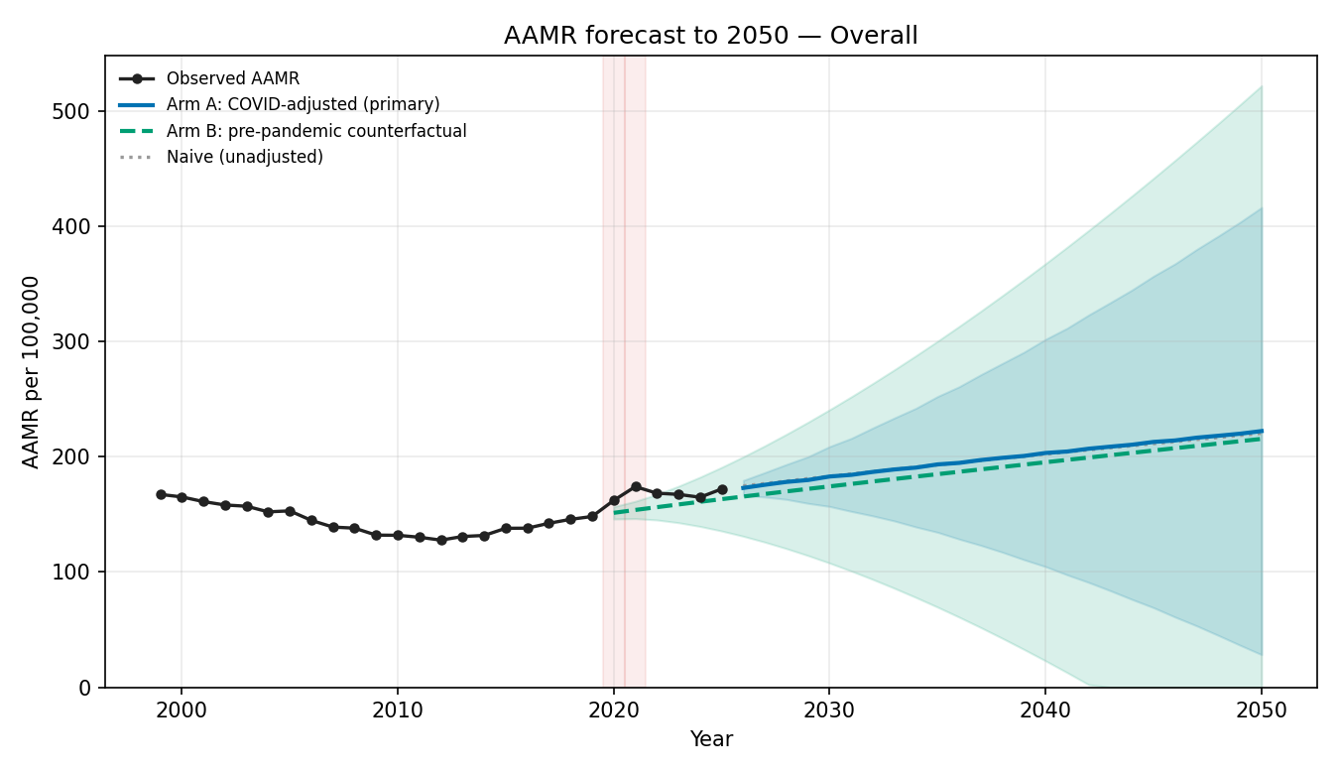
Overall: Arm A 222.4 | Naive 220.4 | Counterfactual 215.6 (per 100,000, 2050)
Sex
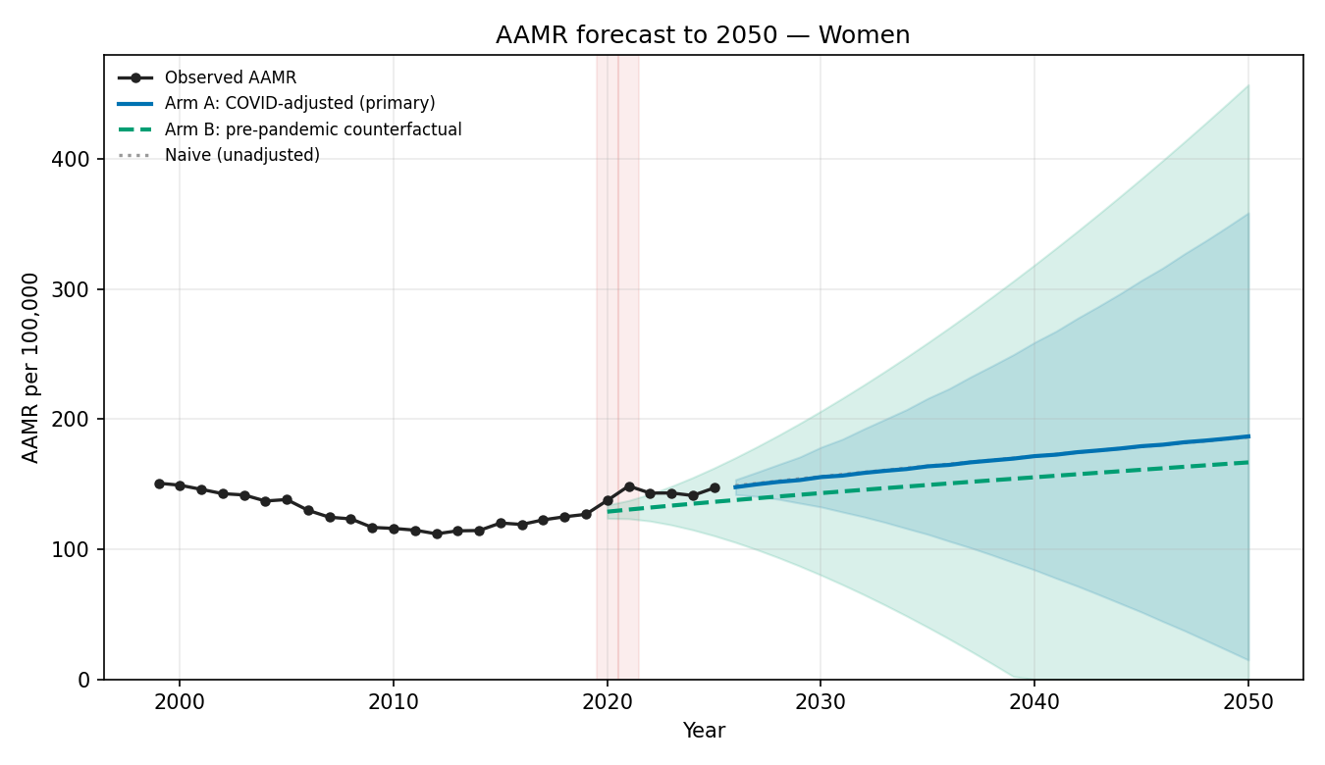
Women: Arm A 186.6 | Naive 186.1 | Counterfactual 166.7 (per 100,000, 2050)
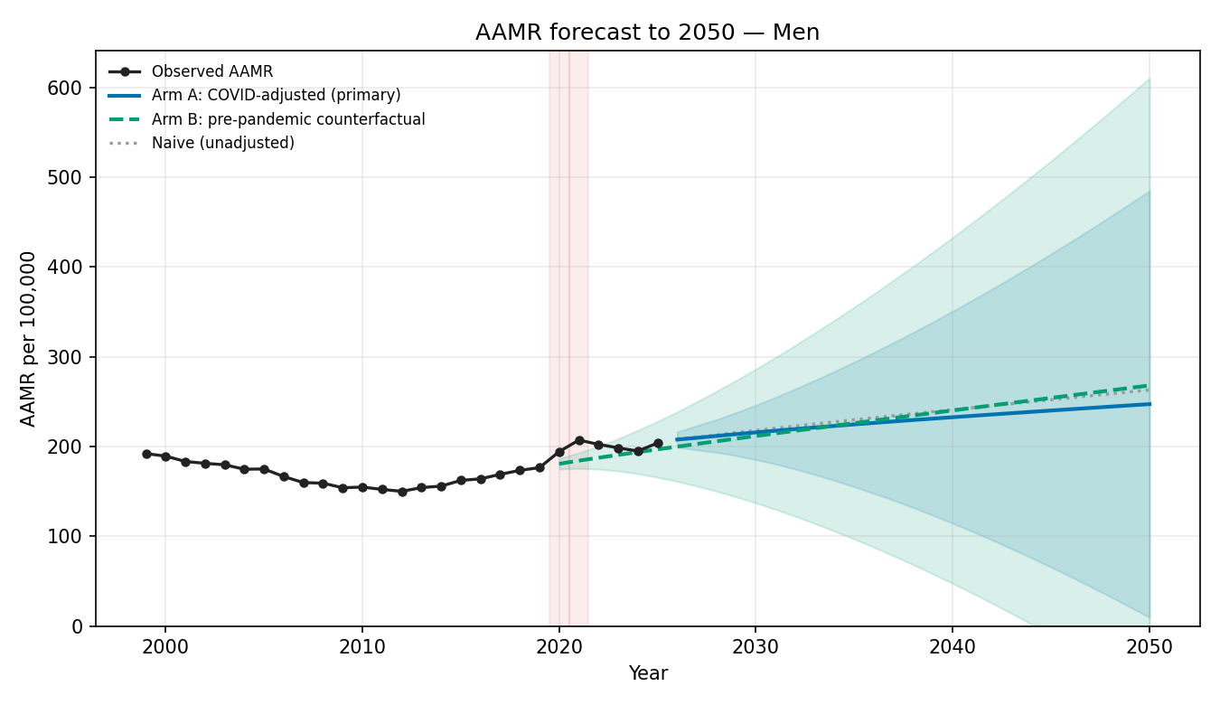
Men: Arm A 247.2 | Naive 263.1 | Counterfactual 268.0 (per 100,000, 2050)
Age group (age-specific rates)
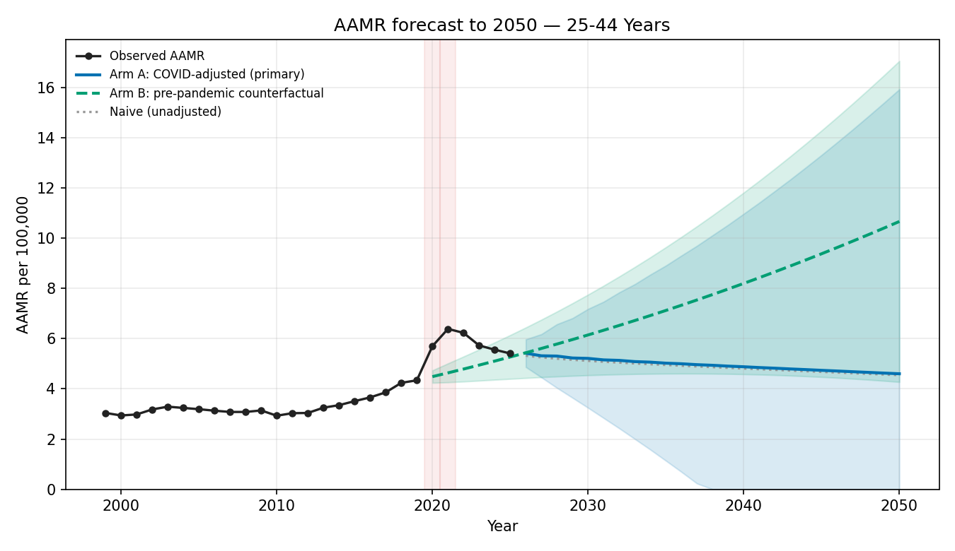
25-44 Years: Arm A 4.601 | Naive 4.546 | Counterfactual 10.66 (per 100,000, 2050)
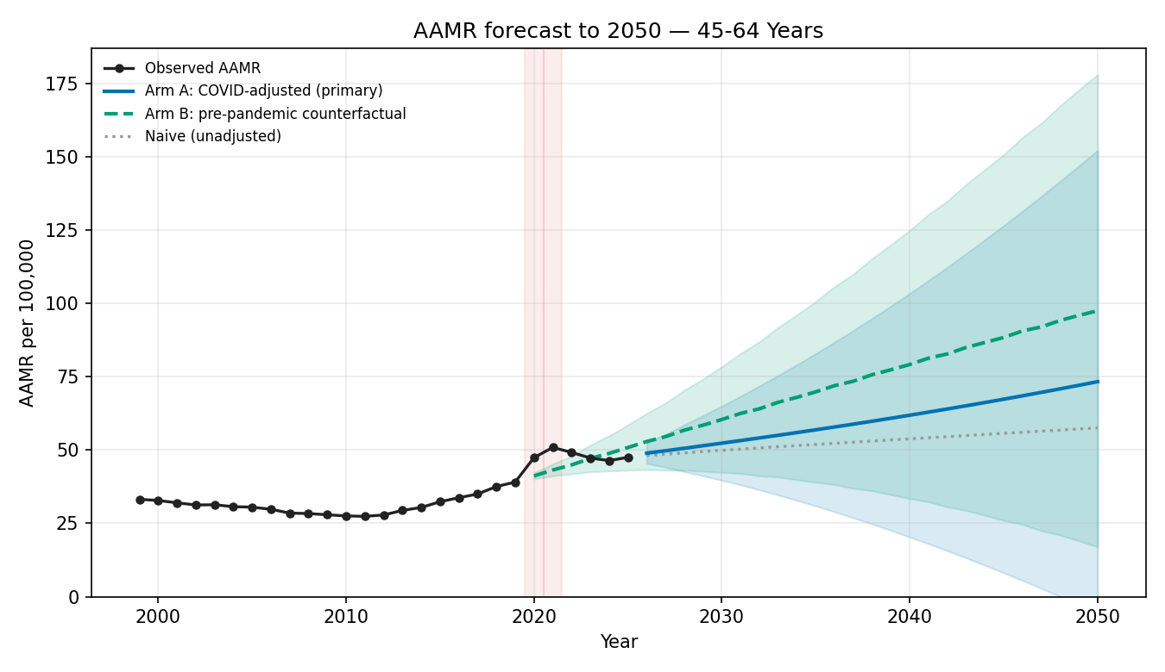
45-64 Years: Arm A 73.30 | Naive 57.55 | Counterfactual 97.49 (per 100,000, 2050)
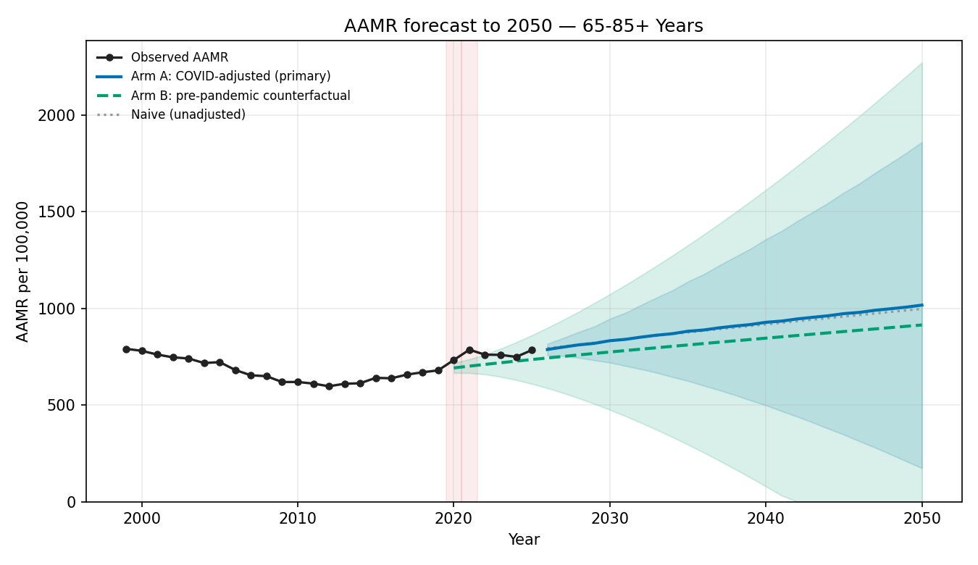
65-85+ Years: Arm A 1017. | Naive 998.0 | Counterfactual 914.4 (per 100,000, 2050)
Race and ethnicity
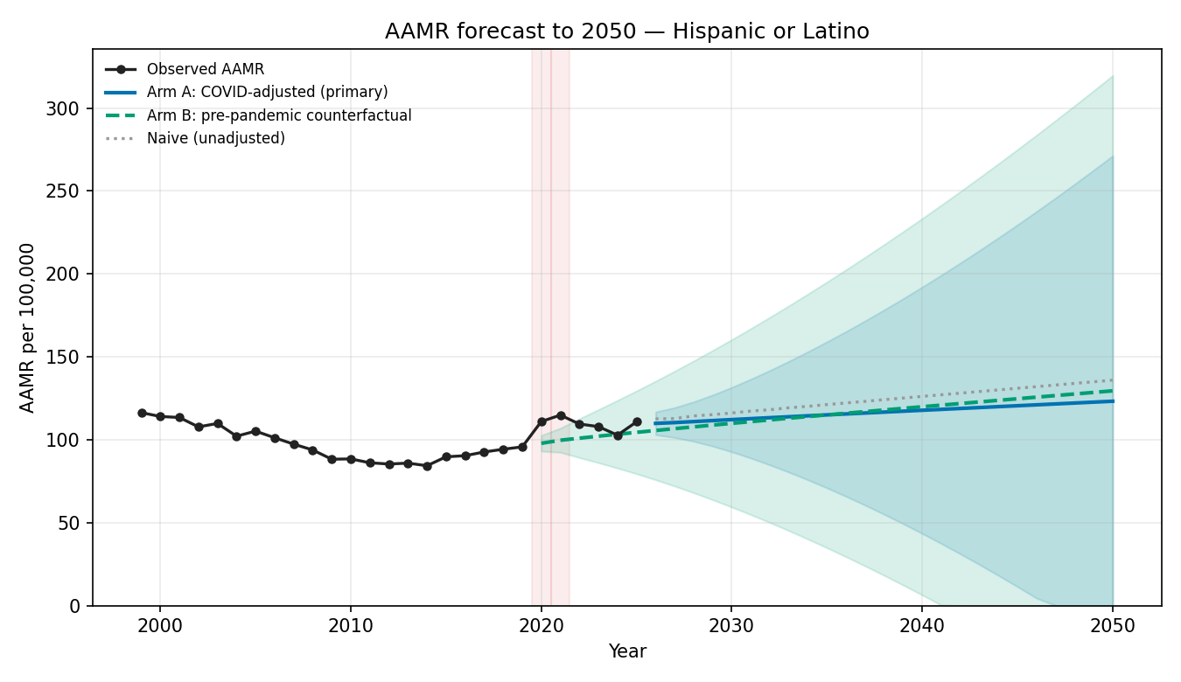
Hispanic or Latino: Arm A 123.2 | Naive 135.9 | Counterfactual 129.4 (per 100,000, 2050)
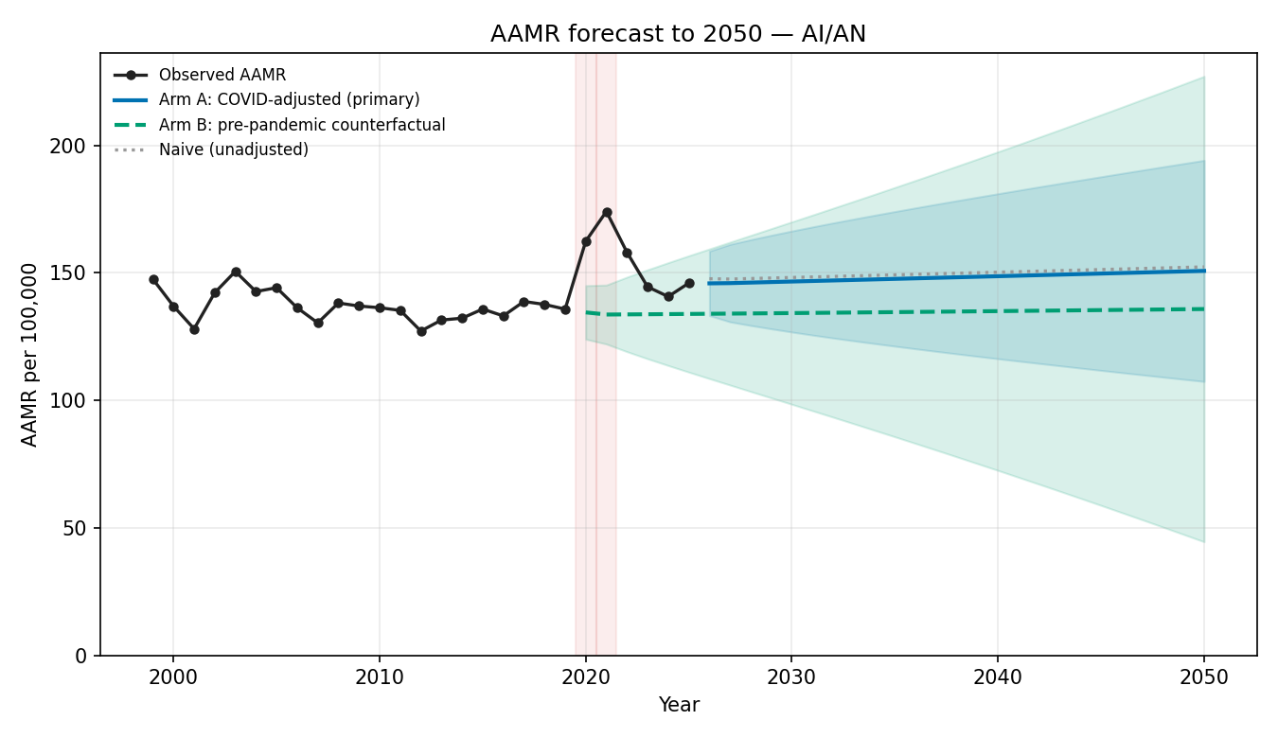
AI/AN: Arm A 150.7 | Naive 152.3 | Counterfactual 135.8 (per 100,000, 2050)
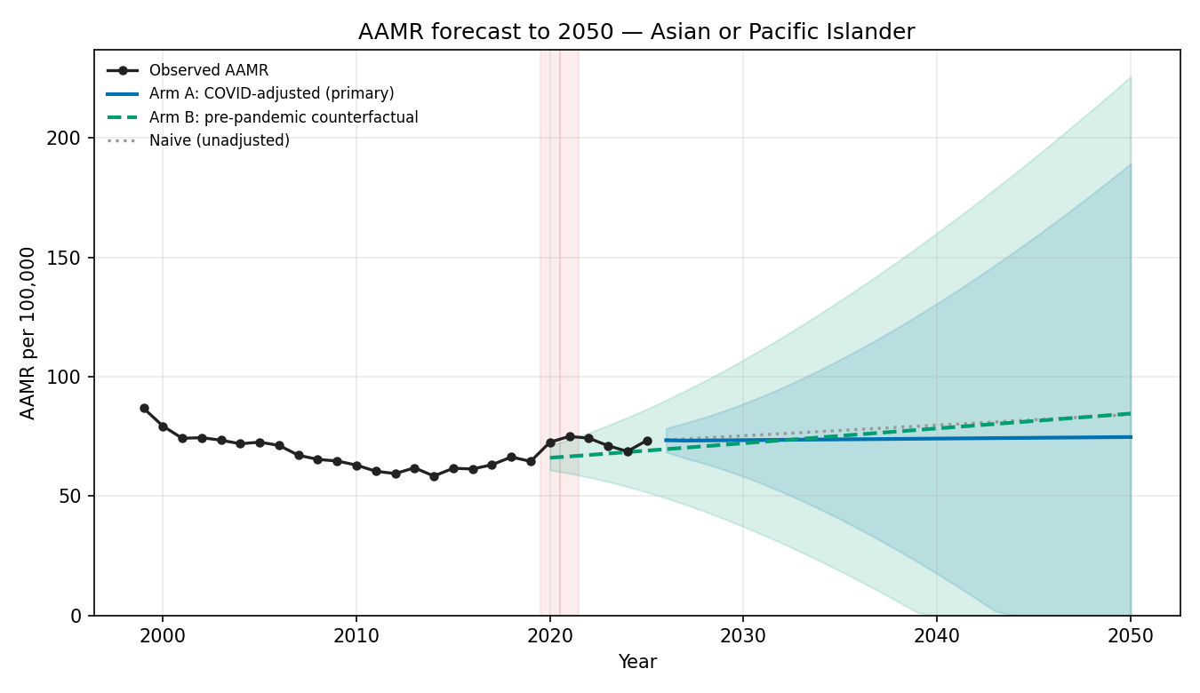
Asian or Pacific Islander: Arm A 74.73 | Naive 84.16 | Counterfactual 84.56 (per 100,000, 2050)
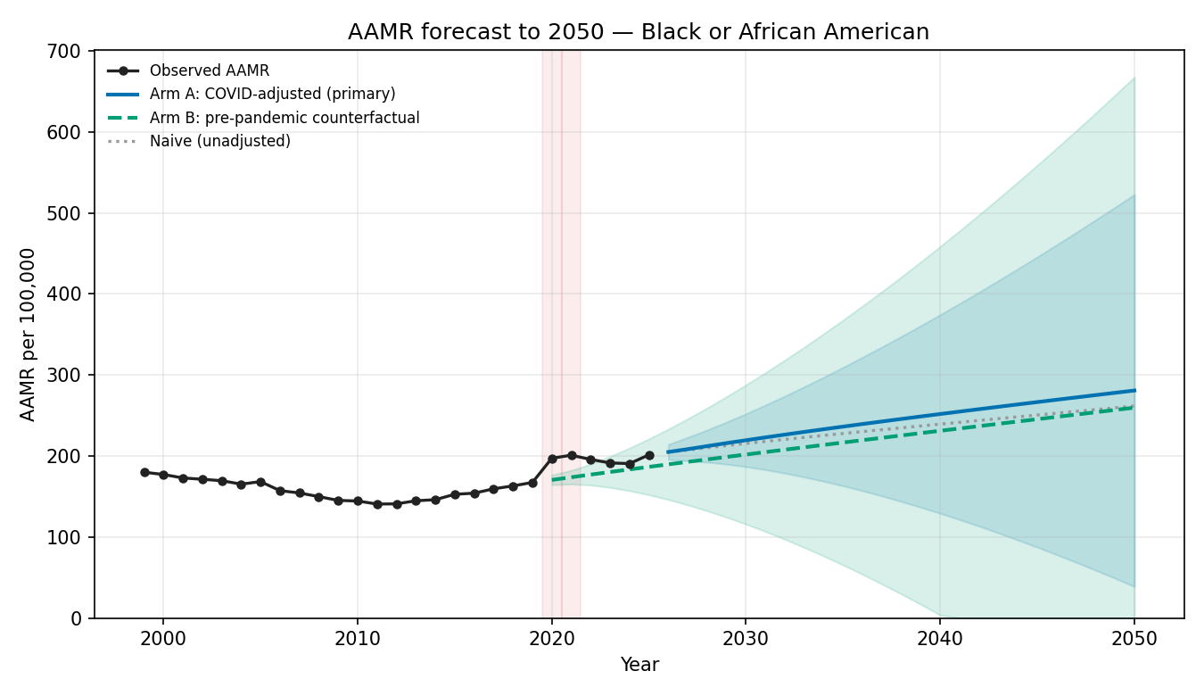
Black or African American: Arm A 280.7 | Naive 261.7 | Counterfactual 259.6 (per 100,000, 2050)
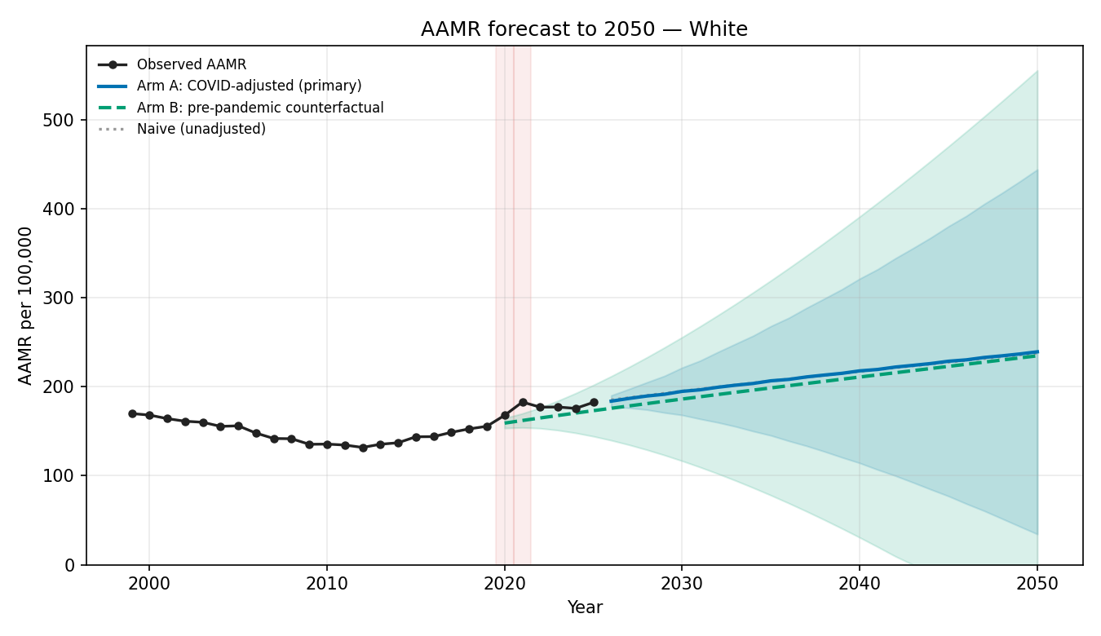
White: Arm A 239.2 | Naive 237.6 | Counterfactual 234.7 (per 100,000, 2050)
Census region
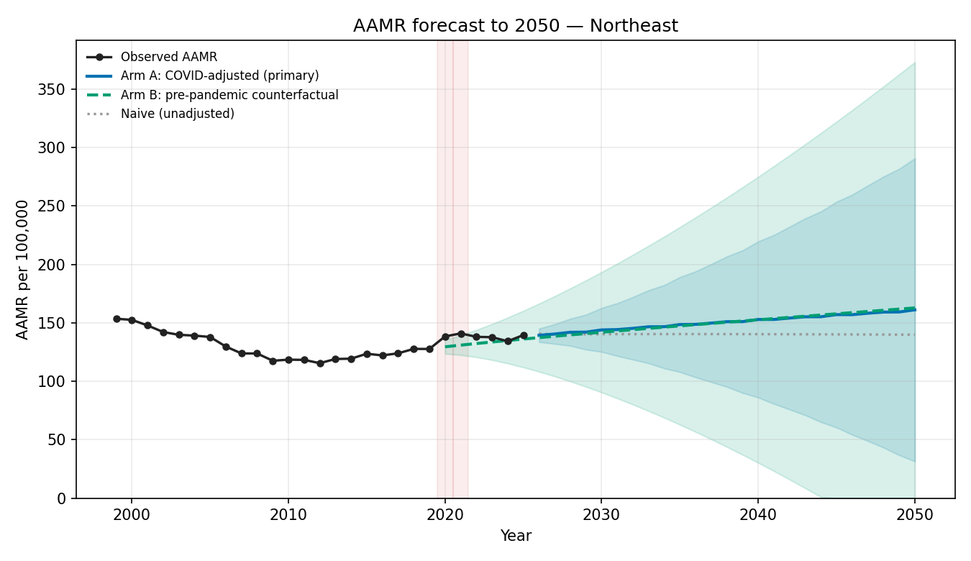
Northeast: Arm A 161.1 | Naive 139.8 | Counterfactual 162.7 (per 100,000, 2050)
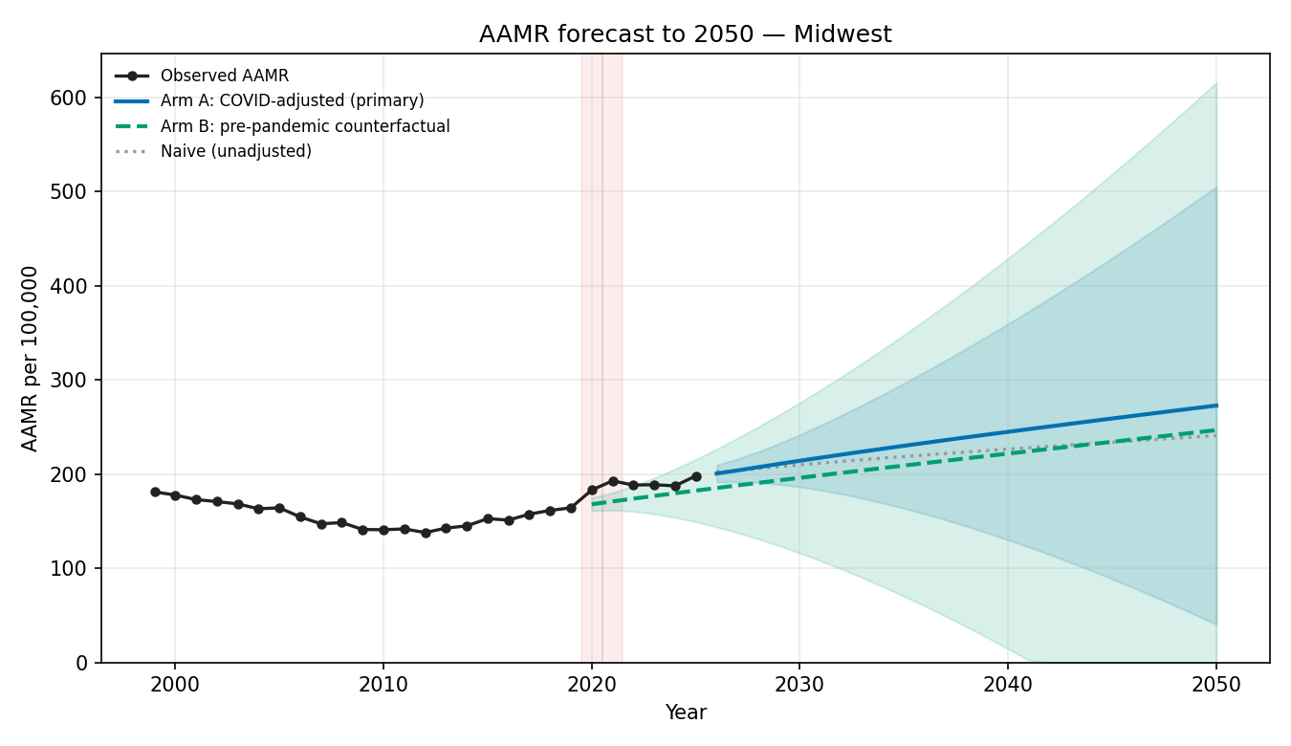
Midwest: Arm A 272.8 | Naive 240.8 | Counterfactual 246.6 (per 100,000, 2050)
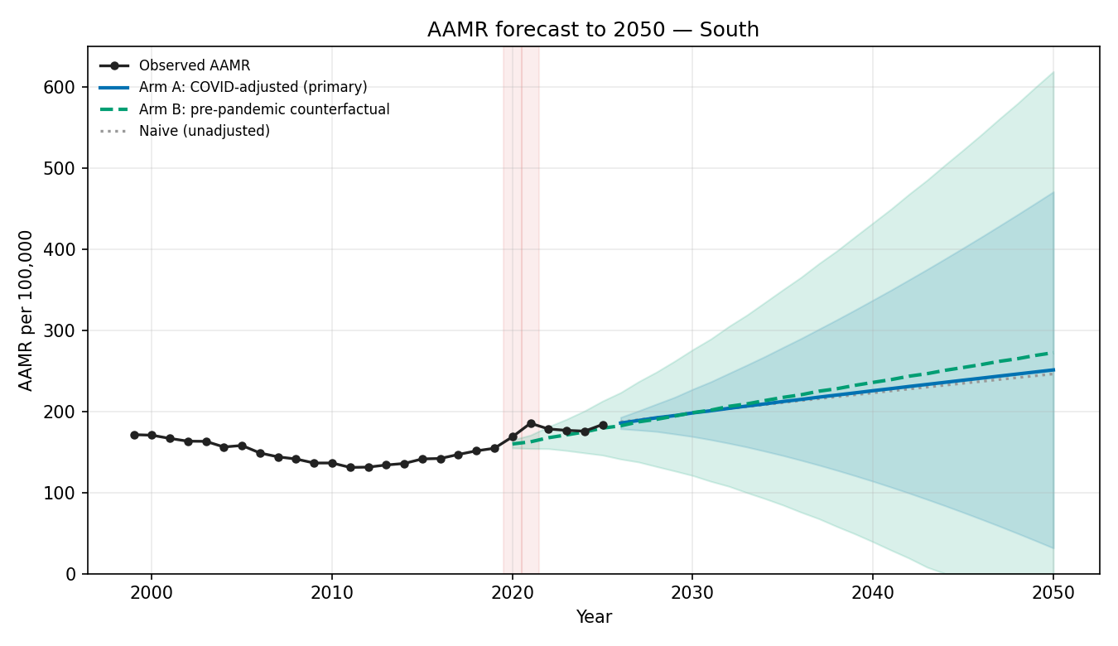
South: Arm A 250.9 | Naive 245.9 | Counterfactual 272.1 (per 100,000, 2050)
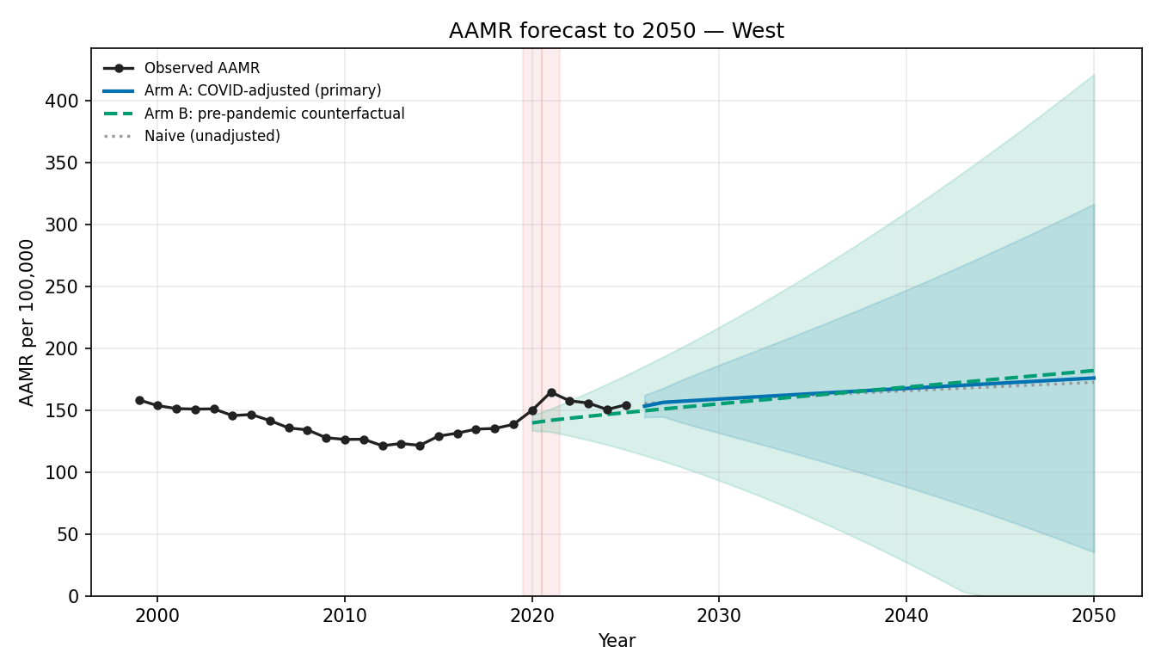
West: Arm A 175.9 | Naive 172.4 | Counterfactual 181.9 (per 100,000, 2050)
Urbanization (observed 1999-2020; unreconciled)
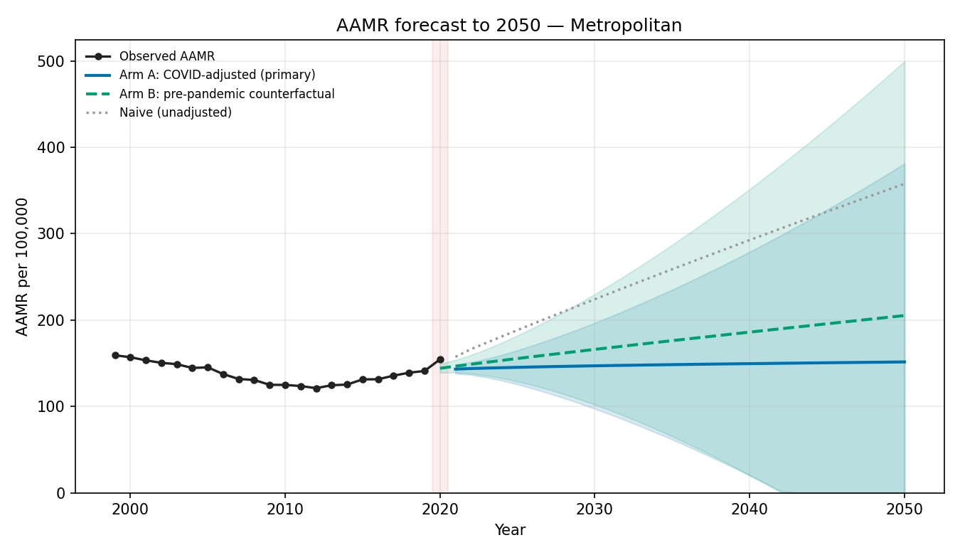
Metropolitan: Arm A 151.4 | Naive 357.6 | Counterfactual 205.1 (per 100,000, 2050)
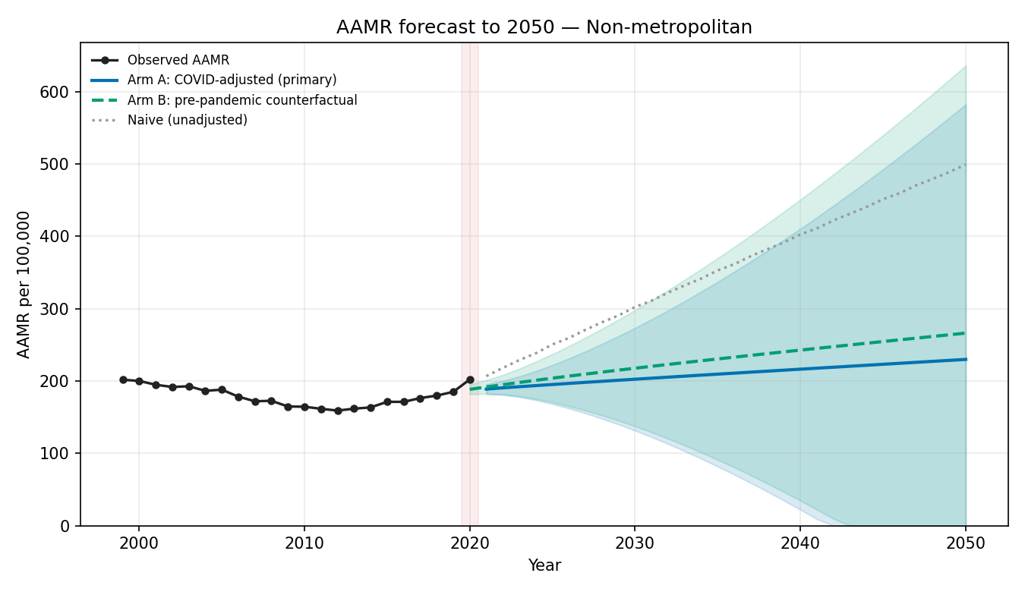
Non-metropolitan: Arm A 229.7 | Naive 499.0 | Counterfactual 266.1 (per 100,000, 2050)
As a sensitivity analysis, we repeated the forecast for every demographic and geographic stratum under three strategies for the 2020-2021 pandemic years: a COVID-adjusted model (imputing the pandemic years), a pre-pandemic counterfactual fitted to 1999-2019 data only, and an unadjusted (naive) model. Across strata, the direction and relative ordering of the 2050 projections were preserved, and the pre-pandemic counterfactual - which incorporates no pandemic-era data - reproduced a comparable long-term rise, indicating that the projected increases reflect the pre-2020 secular trend rather than extrapolation of the transient pandemic surge. The COVID-adjusted model achieved lower out-of-sample back-test error than the unadjusted model in all 17 strata. The unadjusted model produced implausibly steep urbanization projections (metropolitan and non-metropolitan rates exceeding the national estimate), which the COVID-adjusted model and the reconciliation procedure both corrected. Projections for adults aged 25-44 years were sensitive to pandemic handling (a continued decline under the adjusted model versus a rise under the counterfactual) and should be interpreted with corresponding caution. Prediction intervals widened substantially over the horizon for all strata, and long-range subgroup estimates should be read as broad indications of direction rather than precise values.

