Reproducible psychosocial–emotional profiles reveal population-level heterogeneity in young adults
-Supplementary Materials

Supplementary Appendices
- Appendix I. Determination of the optimal number of psychosocial–emotional profiles.
- Appendix II. Cross-dataset reproducibility and validation analyses.

Supplementary Figures
- Supplementary Figure S1. Determination of the optimal number of psychosocial–emotional profiles (K selection).
- Supplementary Figure S2. Cross-dataset reproducibility analyses in the Xiangya validation cohort.

Supplementary Tables
- Supplementary Table S1. Statistical Profiles of Shaoyang Profiles: Item Scores, Averages, Variances, and Confidence Intervals
- Supplementary Table S2. Statistical Tests Among Shaoyang Profiles: Overall Group Comparisons and Pairwise Analyses
- Supplementary Table S3. Statistical Profiles of hierarchical clustering results in Xiangya Cohort
- Supplementary Table S4. Statistical Tests Among Xiangya Profiles: Overall Group Comparisons and Pairwise Analyses
- Supplementary Table S5. Edge Stability Results in the Xiangya Validation Cohort
- Supplementary Table S6. Global Network Metrics of the Xiangya Validation Cohort

Appendix I. Determination of the optimal number of psychosocial–emotional profiles
Agglomerative hierarchical clustering was applied to identify latent psychosocial-emotional profiles without requiring prior assumptions about the number of clusters, yielding deterministic solutions. First, visual inspection of profile patterns (Supplementary Figure S1.A-D) was used to exclude clearly under- or over-segmented solutions. The K=2 solution showed insufficient differentiation across psychosocial–emotional dimensions, whereas the K=5 solution introduced redundant subdivisions of highly similar profiles. At this stage, both K=3 and K=4 retained coherent and interpretable profile structures. Second, overall between-profile differentiation was evaluated (Supplementary Figure S1.E). Although increasing the number of clusters improved separation up to K=5, this gain was accompanied by fragmentation without clear interpretive benefit. In contrast, the K=4 solution achieved a balance between enhanced differentiation and structural coherence. Finally, item-level differences within each dimension were formally examined. Tukey post hoc tests indicated that the K=4 solution yielded consistently strong item-level discrimination across psychosocial-emotional dimensions (Supplementary Figure S1.F). Taken together, the convergence of interpretability and statistical separation supports K = 4 as the optimal clustering solution.
Appendix II. Cross-dataset reproducibility and validation analyses
The robustness of these profiles was further verified in the independent Xiangya validity cohort. Unsupervised hierarchical clustering successfully reproduced the four-profile structure (Supplementary Figure S2.A), while profile-specific psychosocial-emotional networks exhibited stable structural patterns with narrow confidence intervals (Supplementary Figure S2.B). Detailed statistical characterizations of item scores, pairwise group comparisons, edge stability, and global network metrics for Shaoyang cohort are provided in Supplementary Tables 1-3, while Xiangya validity cohorts are provided in Supplementary Tables 3-6. SHAP analysis further confirmed that classification was driven by distinct psychosocial-emotional associations rather than socio-demographics (Supplementary Figure S2.C). Specifically, the HEE–LEB profile showed prominent contributions from perceived helplessness–related items, particularly perceived uncontrollability (PSS9) and overwhelming difficulties (PSS10). The LEE–HSD profile was characterized by joint contributions from stress and depressive items, including anhedonia-related symptoms (PHQ4, PHQ1). In contrast, the AEE–HEB profile was mainly driven by anxiety-related somatic tension and restlessness (GAD4, GAD5).
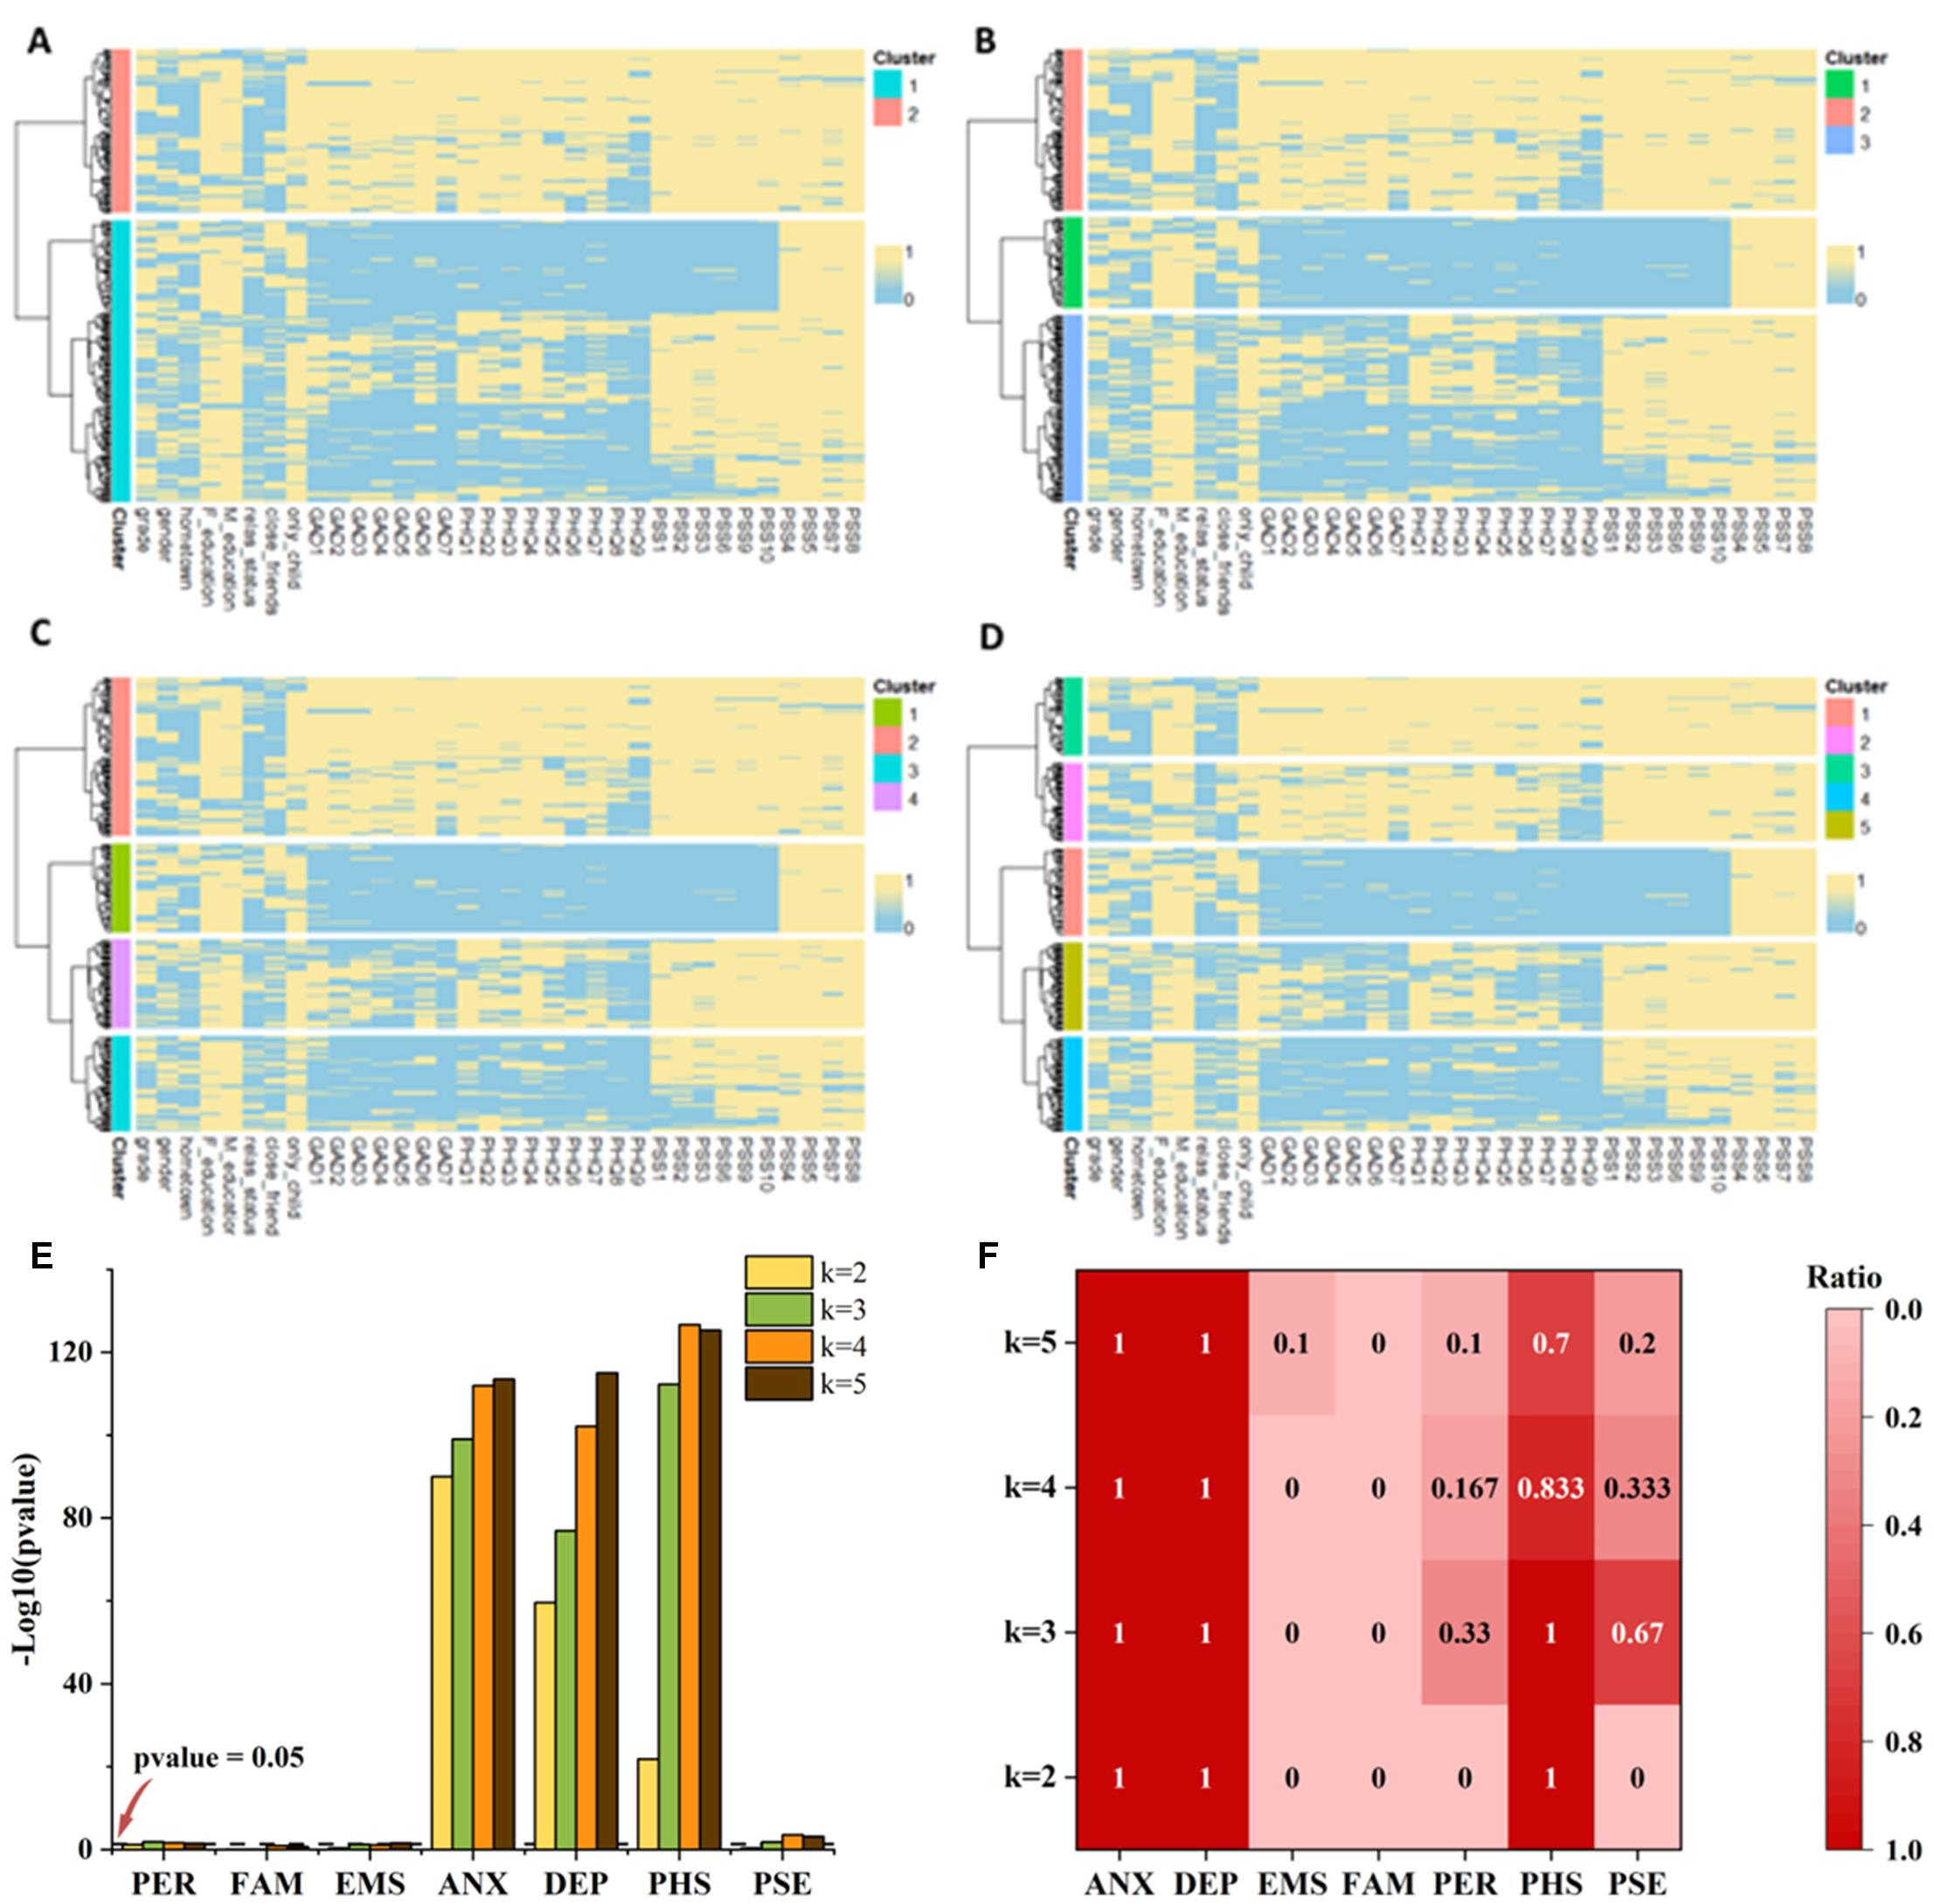
Supplementary Figure 1. Determination of the optimal number of psychosocial–emotional profiles. (A–D) Heatmaps illustrating psychosocial–emotional item patterns in the Shaoyang cohort under hierarchical clustering solutions with K = 2, 3, 4, and 5 clusters, respectively. Rows represent individuals and columns represent psychosocial–emotional items. Cluster assignments are indicated by color bars on the left. (E) Overall between-profile differentiation across psychosocial–emotional dimensions under different K solutions, quantified using one-way ANOVA. Bars represent −log10 (p-values) for each dimension. The dashed horizontal line denotes the significance threshold (p = 0.05). Increased resolution improved separation for emotional dimensions up to K = 5. (F) Proportion of item-level pairwise contrasts showing statistically significant differences across profiles, assessed using Tukey post hoc tests for each K solution. Darker colors indicate higher proportions of significant contrasts.

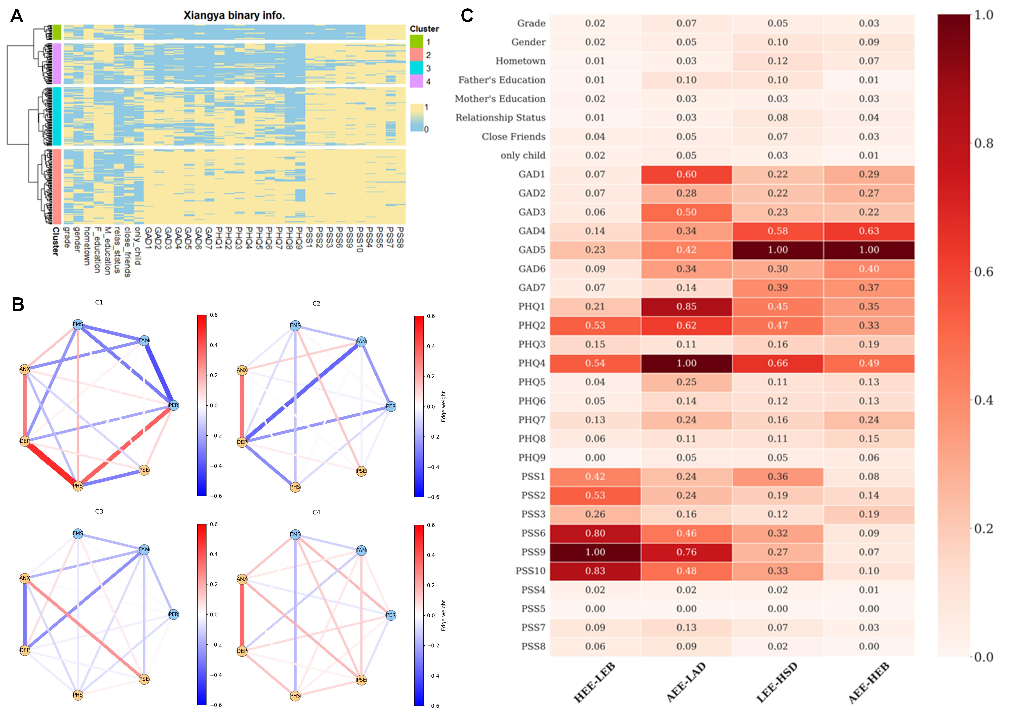

Supplementary Figure S2. Cross-dataset reproducibility analyses in the Xiangya validation cohort. (A) Hierarchical clustering heatmap of psychosocial-emotional factors in the Xiangya cohort, illustrating the successful re-identification of the four psychosocial-emotional profiles using the same unsupervised procedure applied in the discovery cohort. (B) Profile-specific psychosocial-emotional networks reconstructed in the Xiangya cohort. Networks exhibit stable association patterns between environmental and emotional dimensions, with edge-weight estimates showing narrow confidence intervals under nonparametric bootstrapping, indicating robust network structure. (C) Mean SHAP feature contributions derived from the Random Forest classifier during cross-dataset profile transfer. Feature importance patterns indicate that profile classification is primarily driven by psychosocial–emotional item associations rather than sociodemographic variables, with distinct contribution signatures observed across profiles.

Supplementary Table 1. Statistical Profiles of Shaoyang Profiles: Item Scores, Averages, Variances, and Confidence Intervals
Variable |  | Profile 1(n = 67) |  | Profile 2(n=72) |  | Profile 3(n=67) |  | Profile 4(n=120)
Dimension | Specific Score | Mean±SD | 95%CI | Mean±SD | 95%CI | Mean±SD | 95%CI | Mean±SD | 95%CI
PER |  | 0.57±0.34 | 0.49-0.66 | 0.49±0.29 | 0.42-0.55 | 0.43±0.31 | 0.36-0.51 | 0.43±0.35 | 0.37-0.49
 | Grade | 0.67±0.47 | 0.56-0.79 | 0.57±0.5 | 0.45-0.69 | 0.45±0.5 | 0.33-0.57 | 0.57±0.5 | 0.48-0.66
 | Gender | 0.48±0.5 | 0.35-0.6 | 0.4±0.49 | 0.29-0.52 | 0.42±0.5 | 0.3-0.54 | 0.29±0.46 | 0.21-0.37
FAM |  | 0.69±0.2 | 0.64-0.74 | 0.71±0.18 | 0.67-0.76 | 0.64±0.18 | 0.59-0.68 | 0.68±0.2 | 0.65-0.72
 | Hometown | 0.39±0.49 | 0.27-0.51 | 0.35±0.48 | 0.23-0.46 | 0.3±0.46 | 0.19-0.41 | 0.37±0.48 | 0.28-0.45
 | Father's Education | 0.85±0.36 | 0.76-0.94 | 0.88±0.33 | 0.8-0.95 | 0.72±0.45 | 0.61-0.83 | 0.84±0.37 | 0.78-0.91
 | Mather's Education | 0.84±0.37 | 0.74-0.93 | 0.92±0.28 | 0.85-0.98 | 0.9±0.31 | 0.82-0.97 | 0.84±0.37 | 0.78-0.91
EMS |  | 0.53±0.25 | 0.47-0.59 | 0.47±0.24 | 0.42-0.53 | 0.43±0.23 | 0.38-0.49 | 0.46±0.22 | 0.42-0.5
 | Relationship Status | 0.34±0.48 | 0.23-0.46 | 0.28±0.45 | 0.17-0.38 | 0.21±0.41 | 0.11-0.31 | 0.21±0.41 | 0.13-0.28
 | Close friends | 0.49±0.5 | 0.37-0.62 | 0.31±0.46 | 0.2-0.41 | 0.28±0.45 | 0.17-0.39 | 0.33±0.47 | 0.25-0.42
 | Only Child | 0.76±0.43 | 0.66-0.87 | 0.83±0.38 | 0.75-0.92 | 0.81±0.4 | 0.71-0.9 | 0.82±0.38 | 0.76-0.89
ANX |  | 0.04±0.1 | 0.02-0.06 | 0.13±0.2 | 0.08-0.18 | 0.4±0.26 | 0.33-0.46 | 0.9±0.15 | 0.88-0.93
 | GAD1 | 0.09±0.29 | 0.02-0.16 | 0.18±0.39 | 0.09-0.27 | 0.67±0.47 | 0.56-0.79 | 0.96±0.2 | 0.92-0.99
 | GAD2 | 0.03±0.17 | -0.01-0.07 | 0.1±0.3 | 0.03-0.17 | 0.37±0.49 | 0.25-0.49 | 0.86±0.35 | 0.8-0.92
 | GAD3 | 0.07±0.26 | 0.01-0.14 | 0.12±0.33 | 0.05-0.2 | 0.55±0.5 | 0.43-0.67 | 0.92±0.26 | 0.88-0.97
 | GAD4 | 0.03±0.17 | -0.01-0.07 | 0.15±0.36 | 0.07-0.24 | 0.34±0.48 | 0.23-0.46 | 0.93±0.25 | 0.89-0.98
 | GAD5 | 0±0 | 0-0 | 0.08±0.28 | 0.02-0.15 | 0.16±0.37 | 0.07-0.26 | 0.9±0.3 | 0.85-0.95
 | GAD6 | 0.04±0.21 | -0.01-0.1 | 0.21±0.41 | 0.11-0.3 | 0.51±0.5 | 0.38-0.63 | 0.98±0.16 | 0.95-1
 | GAD7 | 0.01±0.12 | -0.01-0.04 | 0.07±0.26 | 0.01-0.13 | 0.16±0.37 | 0.07-0.26 | 0.78±0.42 | 0.7-0.85
DEP |  | 0.02±0.06 | 0.01-0.04 | 0.17±0.21 | 0.12-0.22 | 0.54±0.23 | 0.49-0.6 | 0.83±0.18 | 0.8-0.86
 | PHQ1 | 0.04±0.21 | -0.01-0.1 | 0.22±0.42 | 0.12-0.32 | 0.82±0.39 | 0.73-0.92 | 0.97±0.18 | 0.93-1
 | PHQ2 | 0±0 | 0-0 | 0.21±0.41 | 0.11-0.3 | 0.72±0.45 | 0.61-0.83 | 0.95±0.22 | 0.91-0.99
 | PHQ3 | 0.04±0.21 | -0.01-0.1 | 0.29±0.46 | 0.18-0.4 | 0.55±0.5 | 0.43-0.67 | 0.91±0.29 | 0.86-0.96
 | PHQ4 | 0.01±0.12 | -0.01-0.04 | 0.22±0.42 | 0.12-0.32 | 0.88±0.33 | 0.8-0.96 | 0.98±0.13 | 0.96-1.01
 | PHQ5 | 0.07±0.26 | 0.01-0.14 | 0.21±0.41 | 0.11-0.3 | 0.58±0.5 | 0.46-0.7 | 0.87±0.34 | 0.8-0.93
 | PHQ6 | 0.01±0.12 | -0.01-0.04 | 0.11±0.32 | 0.04-0.19 | 0.39±0.49 | 0.27-0.51 | 0.76±0.43 | 0.68-0.84
 | PHQ7 | 0.03±0.17 | -0.01-0.07 | 0.18±0.39 | 0.09-0.27 | 0.58±0.5 | 0.46-0.7 | 0.91±0.29 | 0.86-0.96
 | PHQ8 | 0±0 | 0-0 | 0.06±0.23 | 0-0.11 | 0.27±0.45 | 0.16-0.38 | 0.68±0.47 | 0.6-0.77
 | PHQ9 | 0±0 | 0-0 | 0.01±0.12 | -0.01-0.04 | 0.1±0.31 | 0.03-0.18 | 0.46±0.5 | 0.37-0.55
PHS |  | 0.01±0.05 | 0-0.02 | 0.69±0.32 | 0.62-0.77 | 0.95±0.1 | 0.92-0.97 | 0.98±0.07 | 0.97-1
 | PSS1 | 0±0 | 0-0 | 0.57±0.5 | 0.45-0.69 | 0.97±0.17 | 0.93-1.01 | 0.98±0.13 | 0.96-1.01
 | PSS2 | 0±0 | 0-0 | 0.62±0.49 | 0.51-0.74 | 0.93±0.26 | 0.86-0.99 | 1±0 | 1-1
 | PSS3 | 0.01±0.12 | -0.01-0.04 | 0.51±0.5 | 0.4-0.63 | 0.84±0.37 | 0.74-0.93 | 0.98±0.13 | 0.96-1.01
 | PSS6 | 0.03±0.17 | -0.01-0.07 | 0.85±0.36 | 0.76-0.93 | 1±0 | 1-1 | 0.98±0.13 | 0.96-1.01
 | PSS9 | 0±0 | 0-0 | 0.83±0.38 | 0.75-0.92 | 0.97±0.17 | 0.93-1.01 | 0.97±0.18 | 0.93-1
 | PSS10 | 0.01±0.12 | -0.01-0.04 | 0.78±0.42 | 0.68-0.88 | 0.99±0.12 | 0.96-1.01 | 0.98±0.16 | 0.95-1
PSE |  | 0.99±0.04 | 0.98-1 | 0.89±0.22 | 0.84-0.94 | 0.97±0.08 | 0.96-0.99 | 0.94±0.17 | 0.91-0.97
 | PSS4 | 0.99±0.12 | 0.96-1.01 | 0.9±0.3 | 0.83-0.97 | 0.99±0.12 | 0.96-1.01 | 0.93±0.25 | 0.89-0.98
 | PSS5 | 1±0 | 1-1 | 0.99±0.12 | 0.96-1.01 | 0.97±0.17 | 0.93-1.01 | 0.97±0.18 | 0.93-1
 | PSS7 | 0.99±0.12 | 0.96-1.01 | 0.76±0.43 | 0.66-0.86 | 0.94±0.24 | 0.88-1 | 0.88±0.33 | 0.81-0.94
 | PSS8 | 1±0 | 1-1 | 0.9±0.3 | 0.83-0.97 | 1±0 | 1-1 | 0.97±0.18 | 0.93-1

Supplementary Table 2. Statistical Tests Among Shaoyang Profiles: Overall Group Comparisons and Pairwise Analyses
Variable | ANOVA | Value | HEE-LEB vs AEE-LAD | HEE-LEB vs LEE-HSD | HEE-LEB vs AEE-HEB | AEE-LAD vs LEE-HSD | AEE-LAD vs AEE-HEB | LEE-HSD vs AEE-HEB
PER | 2.28E-02 | p-value | 3.87E-01 | 6.18E-02 | 2.04E-02 | 7.75E-01 | 6.50E-01 | 1.00E+00
PER | 2.28E-02 | lwr of CI | -2.32E-01 | -2.88E-01 | -2.75E-01 | -1.97E-01 | -1.83E-01 | -1.33E-01
PER | 2.28E-02 | upr of CI | 5.54E-02 | 4.70E-03 | -1.62E-02 | 9.06E-02 | 6.94E-02 | 1.26E-01
FAM | 1.25E-01 | p-value | 9.12E-01 | 3.50E-01 | 9.92E-01 | 9.10E-02 | 7.28E-01 | 3.85E-01
FAM | 1.25E-01 | lwr of CI | -6.26E-02 | -1.40E-01 | -8.37E-02 | -1.60E-01 | -1.03E-01 | -2.89E-02
FAM | 1.25E-01 | upr of CI | 1.05E-01 | 3.08E-02 | 6.73E-02 | 7.85E-03 | 4.41E-02 | 1.22E-01
EMS | 7.82E-02 | p-value | 4.33E-01 | 6.92E-02 | 1.41E-01 | 7.56E-01 | 9.64E-01 | 9.21E-01
EMS | 7.82E-02 | lwr of CI | -1.63E-01 | -2.04E-01 | -1.69E-01 | -1.42E-01 | -1.07E-01 | -6.97E-02
EMS | 7.82E-02 | upr of CI | 4.27E-02 | 5.18E-03 | 1.56E-02 | 6.35E-02 | 7.37E-02 | 1.15E-01
ANX | 1.09E-112 | p-value | 1.98E-02 | 8.91E-13 | 8.77E-13 | 9.18E-13 | 8.77E-13 | 8.77E-13
ANX | 1.09E-112 | lwr of CI | 1.03E-02 | 2.75E-01 | 7.91E-01 | 1.86E-01 | 7.02E-01 | 4.35E-01
ANX | 1.09E-112 | upr of CI | 1.71E-01 | 4.38E-01 | 9.35E-01 | 3.46E-01 | 8.43E-01 | 5.79E-01
DEP | 7.47E-103 | p-value | 2.86E-05 | 8.77E-13 | 8.77E-13 | 8.78E-13 | 8.77E-13 | 9.13E-13
DEP | 7.47E-103 | lwr of CI | 6.37E-02 | 4.38E-01 | 7.35E-01 | 2.96E-01 | 5.93E-01 | 2.16E-01
DEP | 7.47E-103 | upr of CI | 2.23E-01 | 6.00E-01 | 8.78E-01 | 4.55E-01 | 7.33E-01 | 3.59E-01
PHS | 1.98E-127 | p-value | 8.77E-13 | 8.77E-13 | 8.77E-13 | 9.14E-13 | 8.81E-13 | 5.24E-01
PHS | 1.98E-127 | lwr of CI | 6.12E-01 | 8.64E-01 | 9.07E-01 | 1.81E-01 | 2.24E-01 | -3.06E-02
PHS | 1.98E-127 | upr of CI | 7.57E-01 | 1.01E+00 | 1.04E+00 | 3.25E-01 | 3.51E-01 | 9.90E-02
PSE | 2.66E-04 | p-value | 3.69E-04 | 8.90E-01 | 6.41E-02 | 5.46E-03 | 1.65E-01 | 3.39E-01
PSE | 2.66E-04 | lwr of CI | -1.70E-01 | -8.59E-02 | -1.16E-01 | 1.89E-02 | -1.15E-02 | -9.78E-02
PSE | 2.66E-04 | upr of CI | -3.76E-02 | 4.86E-02 | 2.23E-03 | 1.51E-01 | 1.05E-01 | 2.09E-02

Supplementary Table 3. Statistical Profiles of hierarchical clustering results in Xiangya Cohort
Variable |  | Profile1(n = 24) |  | Profile2(n=65) |  | Profile3(n=93) |  | Profile4(n=120)
Dimension | Specific Score | Mean±SD | 95%CI | Mean±SD | 95%CI | Mean±SD | 95%CI | Mean±SD | 95%CI
PER |  | 0.46±0.33 | 0.32-0.6 | 0.43±0.33 | 0.35-0.51 | 0.4±0.35 | 0.33-0.47 | 0.42±0.31 | 0.37-0.48
 | Grade | 0.54±0.51 | 0.33-0.76 | 0.52±0.5 | 0.4-0.65 | 0.49±0.5 | 0.39-0.6 | 0.52±0.5 | 0.43-0.62
 | Gender | 0.38±0.49 | 0.17-0.58 | 0.34±0.48 | 0.22-0.46 | 0.31±0.47 | 0.22-0.41 | 0.32±0.47 | 0.24-0.41
FAM |  | 0.62±0.25 | 0.52-0.73 | 0.6±0.25 | 0.54-0.66 | 0.67±0.27 | 0.61-0.72 | 0.61±0.26 | 0.56-0.66
 | Hometown | 0.75±0.44 | 0.56-0.94 | 0.68±0.47 | 0.56-0.79 | 0.66±0.48 | 0.56-0.75 | 0.71±0.46 | 0.63-0.79
 | Father’s  Education | 0.58±0.5 | 0.37-0.8 | 0.48±0.5 | 0.35-0.6 | 0.68±0.47 | 0.58-0.77 | 0.52±0.5 | 0.43-0.61
 | Mother’s  Education | 0.54±0.51 | 0.33-0.76 | 0.65±0.48 | 0.53-0.77 | 0.67±0.47 | 0.57-0.76 | 0.61±0.49 | 0.52-0.7
EMS |  | 0.51±0.29 | 0.39-0.64 | 0.43±0.28 | 0.36-0.5 | 0.26±0.23 | 0.21-0.31 | 0.35±0.25 | 0.31-0.4
 | Relationship Status | 0.21±0.41 | 0.03-0.38 | 0.22±0.41 | 0.11-0.32 | 0.11±0.31 | 0.04-0.17 | 0.18±0.39 | 0.11-0.25
 | Close Friends | 0.58±0.5 | 0.37-0.8 | 0.48±0.5 | 0.35-0.6 | 0.28±0.45 | 0.19-0.37 | 0.32±0.47 | 0.23-0.4
 | Only child | 0.75±0.44 | 0.56-0.94 | 0.6±0.49 | 0.48-0.72 | 0.4±0.49 | 0.3-0.5 | 0.56±0.5 | 0.47-0.65
ANX |  | 0.05±0.11 | 0.01-0.1 | 0.13±0.14 | 0.1-0.17 | 0.61±0.26 | 0.55-0.66 | 0.93±0.12 | 0.91-0.95
 | GAD1 | 0.08±0.28 | -0.04-0.2 | 0.37±0.49 | 0.25-0.49 | 0.85±0.36 | 0.78-0.92 | 0.99±0.09 | 0.98-1.01
 | GAD2 | 0±0 | 0-0 | 0.03±0.17 | -0.01-0.07 | 0.7±0.46 | 0.6-0.79 | 0.95±0.22 | 0.91-0.99
 | GAD3 | 0.08±0.28 | -0.04-0.2 | 0.26±0.44 | 0.15-0.37 | 0.8±0.41 | 0.71-0.88 | 0.98±0.16 | 0.95-1
 | GAD4 | 0.08±0.28 | -0.04-0.2 | 0.15±0.36 | 0.06-0.24 | 0.63±0.48 | 0.53-0.73 | 0.98±0.13 | 0.96-1.01
 | GAD5 | 0±0 | 0-0 | 0.02±0.12 | -0.02-0.05 | 0.31±0.47 | 0.22-0.41 | 0.83±0.37 | 0.77-0.9
 | GAD6 | 0.12±0.34 | -0.02-0.27 | 0.09±0.29 | 0.02-0.16 | 0.63±0.48 | 0.53-0.73 | 0.98±0.13 | 0.96-1.01
 | GAD7 | 0±0 | 0-0 | 0±0 | 0-0 | 0.32±0.47 | 0.23-0.42 | 0.82±0.39 | 0.75-0.89
DEP |  | 0.06±0.12 | 0.01-0.11 | 0.2±0.18 | 0.16-0.25 | 0.55±0.2 | 0.51-0.59 | 0.88±0.15 | 0.85-0.9
 | PHQ1 | 0±0 | 0-0 | 0.32±0.47 | 0.21-0.44 | 0.78±0.41 | 0.7-0.87 | 0.98±0.13 | 0.96-1.01
 | PHQ2 | 0.08±0.28 | -0.04-0.2 | 0.14±0.35 | 0.05-0.22 | 0.74±0.44 | 0.65-0.83 | 0.96±0.2 | 0.92-0.99
 | PHQ3 | 0.17±0.38 | 0.01-0.33 | 0.26±0.44 | 0.15-0.37 | 0.68±0.47 | 0.58-0.77 | 0.88±0.33 | 0.81-0.94
 | PHQ4 | 0.21±0.41 | 0.03-0.38 | 0.38±0.49 | 0.26-0.51 | 0.88±0.32 | 0.81-0.95 | 1±0 | 1-1
 | PHQ5 | 0.08±0.28 | -0.04-0.2 | 0.34±0.48 | 0.22-0.46 | 0.59±0.49 | 0.49-0.69 | 0.9±0.3 | 0.85-0.95
 | PHQ6 | 0±0 | 0-0 | 0.11±0.31 | 0.03-0.19 | 0.49±0.5 | 0.39-0.6 | 0.87±0.34 | 0.8-0.93
 | PHQ7 | 0±0 | 0-0 | 0.23±0.42 | 0.13-0.34 | 0.55±0.5 | 0.45-0.65 | 0.95±0.22 | 0.91-0.99
 | PHQ8 | 0±0 | 0-0 | 0.03±0.17 | -0.01-0.07 | 0.13±0.34 | 0.06-0.2 | 0.82±0.38 | 0.76-0.89
 | PHQ9 | 0±0 | 0-0 | 0.02±0.12 | -0.02-0.05 | 0.13±0.34 | 0.06-0.2 | 0.53±0.5 | 0.44-0.62
PHS |  | 0.05±0.1 | 0-0.09 | 0.81±0.24 | 0.75-0.87 | 0.91±0.17 | 0.88-0.95 | 0.99±0.05 | 0.98-1
 | PSS1 | 0.04±0.2 | -0.04-0.13 | 0.8±0.4 | 0.7-0.9 | 0.89±0.31 | 0.83-0.96 | 0.98±0.13 | 0.96-1.01
 | PSS2 | 0.04±0.2 | -0.04-0.13 | 0.78±0.41 | 0.68-0.89 | 0.92±0.27 | 0.87-0.98 | 0.99±0.09 | 0.98-1.01
 | PSS3 | 0.08±0.28 | -0.04-0.2 | 0.69±0.47 | 0.58-0.81 | 0.86±0.35 | 0.79-0.93 | 0.98±0.13 | 0.96-1.01
 | PSS6 | 0±0 | 0-0 | 0.89±0.31 | 0.81-0.97 | 0.97±0.18 | 0.93-1 | 0.99±0.09 | 0.98-1.01
 | PSS9 | 0.08±0.28 | -0.04-0.2 | 0.8±0.4 | 0.7-0.9 | 0.91±0.28 | 0.86-0.97 | 1±0 | 1-1
 | PSS10 | 0.04±0.2 | -0.04-0.13 | 0.91±0.29 | 0.84-0.98 | 0.92±0.27 | 0.87-0.98 | 0.99±0.09 | 0.98-1.01
PSE |  | 0.99±0.05 | 0.97-1.01 | 0.79±0.28 | 0.72-0.86 | 0.88±0.15 | 0.85-0.92 | 0.95±0.15 | 0.92-0.98
 | PSS4 | 1±0 | 1-1 | 0.83±0.38 | 0.74-0.92 | 0.9±0.3 | 0.84-0.96 | 0.95±0.22 | 0.91-0.99
 | PSS5 | 1±0 | 1-1 | 0.86±0.35 | 0.78-0.95 | 1±0 | 1-1 | 0.97±0.18 | 0.93-1
 | PSS7 | 0.96±0.2 | 0.87-1.04 | 0.6±0.49 | 0.48-0.72 | 0.65±0.48 | 0.55-0.74 | 0.92±0.26 | 0.88-0.97
 | PSS8 | 1±0 | 1-1 | 0.88±0.33 | 0.79-0.96 | 0.99±0.1 | 0.97-1.01 | 0.97±0.18 | 0.93-1

Supplementary Table 4. Statistical Tests Among Xiangya Profiles: Overall Group Comparisons and Pairwise Analyses
Variable | Between groups | Value | 1-2 | 1-3 | 1-4 | 2-3 | 2-4 | 3-4
PER | 8.83E-01 | p-value | 9.85E-01 | 8.82E-01 | 9.68E-01 | 9.54E-01 | 9.99E-01 | 9.63E-01
PER | 8.83E-01 | lwr of CI | -2.29E-01 | -2.48E-01 | -2.22E-01 | -1.64E-01 | -1.36E-01 | -9.49E-02
PER | 8.83E-01 | upr of CI | 1.74E-01 | 1.38E-01 | 1.56E-01 | 1.09E-01 | 1.24E-01 | 1.38E-01
FAM | 3.53E-01 | p-value | 9.78E-01 | 8.99E-01 | 9.95E-01 | 3.94E-01 | 9.93E-01 | 4.17E-01
FAM | 3.53E-01 | lwr of CI | -1.86E-01 | -1.13E-01 | -1.65E-01 | -4.26E-02 | -9.30E-02 | -1.49E-01
FAM | 3.53E-01 | upr of CI | 1.36E-01 | 1.96E-01 | 1.37E-01 | 1.76E-01 | 1.15E-01 | 3.79E-02
EMS | 7.59E-06 | p-value | 5.21E-01 | 1.20E-04 | 2.54E-02 | 2.97E-04 | 1.94E-01 | 4.89E-02
EMS | 7.59E-06 | lwr of CI | -2.40E-01 | -4.03E-01 | -3.08E-01 | -2.75E-01 | -1.79E-01 | 2.96E-04
EMS | 7.59E-06 | upr of CI | 7.39E-02 | -1.02E-01 | -1.41E-02 | -6.28E-02 | 2.33E-02 | 1.82E-01
ANX | 1.71E-100 | p-value | 2.48E-01 | 8.12E-13 | 8.12E-13 | 8.12E-13 | 8.12E-13 | 8.12E-13
ANX | 1.71E-100 | lwr of CI | -3.04E-02 | 4.49E-01 | 7.78E-01 | 4.01E-01 | 7.31E-01 | 2.64E-01
ANX | 1.71E-100 | upr of CI | 1.87E-01 | 6.57E-01 | 9.82E-01 | 5.48E-01 | 8.72E-01 | 3.89E-01
DEP | 2.61E-89 | p-value | 3.05E-03 | 8.12E-13 | 8.12E-13 | 8.12E-13 | 8.12E-13 | 8.12E-13
DEP | 2.61E-89 | lwr of CI | 3.73E-02 | 3.91E-01 | 7.18E-01 | 2.78E-01 | 6.05E-01 | 2.62E-01
DEP | 2.61E-89 | upr of CI | 2.49E-01 | 5.94E-01 | 9.16E-01 | 4.21E-01 | 7.42E-01 | 3.85E-01
PHS | 2.55E-82 | p-value | 8.12E-13 | 8.12E-13 | 8.12E-13 | 3.52E-04 | 5.51E-12 | 2.17E-03
PHS | 2.55E-82 | lwr of CI | 6.69E-01 | 7.74E-01 | 8.53E-01 | 3.69E-02 | 1.16E-01 | 2.14E-02
PHS | 2.55E-82 | upr of CI | 8.59E-01 | 9.56E-01 | 1.03E+00 | 1.65E-01 | 2.39E-01 | 1.31E-01
PSE | 9.36E-08 | p-value | 6.96E-05 | 6.54E-02 | 8.02E-01 | 1.23E-02 | 2.95E-07 | 4.28E-02
PSE | 9.36E-08 | lwr of CI | -3.12E-01 | -2.15E-01 | -1.45E-01 | 1.47E-02 | 8.60E-02 | 1.52E-03
PSE | 9.36E-08 | upr of CI | -8.29E-02 | 4.46E-03 | 6.96E-02 | 1.70E-01 | 2.34E-01 | 1.34E-01
Lwr: lower; upr: upper

Supplementary Table 5. Edge Stability Results in the Xiangya Validation Cohort
Edge | Profile 1 |  |  |  | Profile 2 |  |  |  | Profile 3 |  |  |  | Profile 4
Edge | lwr of CI | upr of CI | Mean | Full sample | lwr of CI | upr of CI | Mean | Full sample | lwr of CI | upr of CI | Mean | Full sample | lwr of CI | upr of CI | Mean | Full sample
PER-FAM | -0.596 | -0.247 | -0.429 | -0.428 | -0.341 | -0.151 | -0.242 | -0.245 | -0.239 | -0.079 | -0.157 | -0.153 | 0.001 | 0.099 | 0.05 | 0.05
PER-EMS | -0.441 | -0.12 | -0.32 | -0.319 | -0.085 | 0.103 | 0.014 | 0.015 | -0.089 | 0.057 | -0.017 | -0.014 | 0.116 | 0.226 | 0.17 | 0.168
PER-ANX | -0.096 | 0.211 | 0.07 | 0.062 | -0.223 | 0.059 | -0.034 | -0.03 | -0.087 | 0.071 | -0.011 | -0.012 | -0.12 | 0.015 | -0.053 | -0.052
PER-DEP | -0.348 | -0.016 | -0.204 | -0.218 | -0.348 | -0.164 | -0.252 | -0.256 | -0.123 | 0.037 | -0.038 | -0.037 | 0.038 | 0.14 | 0.088 | 0.089
PER-PHS | 0.239 | 0.492 | 0.394 | 0.391 | -0.18 | -0.002 | -0.092 | -0.092 | -0.157 | -0.001 | -0.085 | -0.082 | -0.074 | 0.097 | 0.033 | 0.035
PER-PSE | 0.023 | 0.286 | 0.109 | 0.101 | -0.125 | 0.088 | -0.035 | -0.037 | -0.082 | 0.11 | 0.015 | 0.017 | -0.131 | 0.019 | -0.073 | -0.075
FAM-EMS | -0.422 | -0.178 | -0.315 | -0.316 | -0.244 | -0.079 | -0.157 | -0.157 | -0.248 | -0.1 | -0.174 | -0.175 | -0.169 | -0.059 | -0.113 | -0.112
FAM-ANX | -0.394 | -0.063 | -0.261 | -0.267 | 0.005 | 0.195 | 0.109 | 0.11 | -0.252 | -0.092 | -0.181 | -0.181 | 0.005 | 0.103 | 0.056 | 0.055
FAM-DEP | -0.139 | 0.186 | 0.022 | 0.031 | -0.47 | -0.284 | -0.373 | -0.374 | -0.329 | -0.214 | -0.272 | -0.273 | -0.181 | -0.06 | -0.117 | -0.116
FAM-PHS | -0.067 | 0.21 | 0.022 | 0.009 | -0.075 | 0.125 | 0.012 | 0.011 | -0.156 | 0.008 | -0.081 | -0.083 | 0.006 | 0.111 | 0.056 | 0.056
FAM-PSE | -0.101 | 0.196 | 0.006 | -0.007 | -0.125 | 0.086 | -0.03 | -0.029 | -0.198 | -0.04 | -0.123 | -0.122 | 0.073 | 0.156 | 0.118 | 0.119
EMS-ANX | -0.232 | 0.32 | 0.132 | 0.136 | -0.16 | 0.022 | -0.056 | -0.054 | -0.122 | 0.059 | -0.031 | -0.03 | 0.085 | 0.184 | 0.135 | 0.138
EMS-DEP | -0.349 | -0.076 | -0.236 | -0.262 | -0.179 | 0.001 | -0.087 | -0.088 | 0 | 0.161 | 0.077 | 0.076 | -0.045 | 0.069 | 0.011 | 0.008
EMS-PHS | 0.059 | 0.274 | 0.177 | 0.177 | -0.24 | -0.044 | -0.148 | -0.149 | -0.15 | 0.049 | -0.055 | -0.054 | -0.245 | -0.012 | -0.17 | -0.173
EMS-PSE | -0.125 | 0.336 | 0.001 | -0.002 | 0.064 | 0.204 | 0.136 | 0.136 | -0.029 | 0.16 | 0.049 | 0.05 | 0.078 | 0.167 | 0.125 | 0.126
ANX-DEP | 0.174 | 0.467 | 0.319 | 0.331 | 0.271 | 0.409 | 0.34 | 0.341 | -0.391 | -0.248 | -0.33 | -0.332 | 0.318 | 0.419 | 0.366 | 0.366
ANX-PHS | -0.273 | 0 | -0.16 | -0.162 | -0.083 | 0.078 | -0.006 | -0.004 | -0.166 | 0 | -0.09 | -0.092 | -0.07 | 0.057 | -0.007 | -0.002
ANX-PSE | -0.459 | 0.064 | -0.118 | -0.101 | -0.073 | 0.114 | 0.013 | 0.014 | 0.187 | 0.352 | 0.268 | 0.265 | 0.1 | 0.239 | 0.169 | 0.169
DEP-PHS | 0.026 | 0.743 | 0.506 | 0.528 | -0.364 | -0.183 | -0.28 | -0.282 | -0.098 | 0.009 | -0.043 | -0.044 | 0.037 | 0.198 | 0.151 | 0.149
DEP-PSE | -0.163 | 0.361 | 0.08 | 0.064 | -0.068 | 0.134 | 0.041 | 0.041 | -0.106 | 0.058 | -0.033 | -0.032 | -0.002 | 0.086 | 0.032 | 0.031
PHS-PSE | -0.58 | -0.212 | -0.329 | -0.313 | -0.168 | 0.079 | -0.001 | -0.003 | -0.096 | 0.104 | 0.029 | 0.028 | 0.013 | 0.146 | 0.097 | 0.097

Supplementary Table 6. Global Network Metrics of the Xiangya Validation Cohort
Metric (Mean±SD) | Profile 1 | Profile 2 | Profile 3 | Profile 4
Average Degree | 5.886±0.165 | 5.929±0.145 | 5.91±0.152 | 5.852±0.176
Average Strength | -0.153±0.075 | -0.322±0.072 | -0.366±0.07 | 0.321±0.032
Network Diameter | 1.352±0.478 | 1.217±0.412 | 1.281±0.449 | 1.455±0.498
Global Clustering | 0.979±0.031 | 0.987±0.027 | 0.983±0.028 | 0.972±0.034
Global Efficiency | 0.149±0.027 | 0.055±0.012 | 0.035±0.011 | 0.111±0.007

