Extended Data figures:

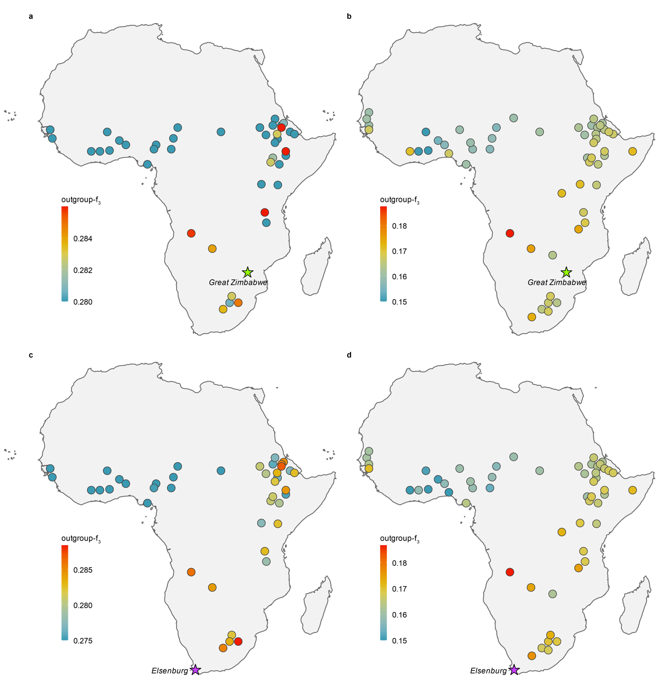
Extended Data Figure. 1 | Geographic distribution of shared drift between the two ancient genomes and present-day African cattle populations, by ancestry component. Each filled circle is one present-day population, placed at its sampling locality and coloured by its outgroup-f₃ with the ancient genome, on a per-panel scale in which warmer colours denote more shared drift; the star marks the locality of the ancient genome itself. a, b, Shared drift of the Great Zimbabwe genome across the taurine (a) and indicine (b) components. c, d, Shared drift of the Elsenburg genome across the taurine (c) and indicine (d) components. In the taurine component, both ancient genomes share most drift with southern and eastern African populations nearest their own localities, whereas indicine sharing is comparatively uniform across the continent, consistent with the more recent spread of indicine ancestry.

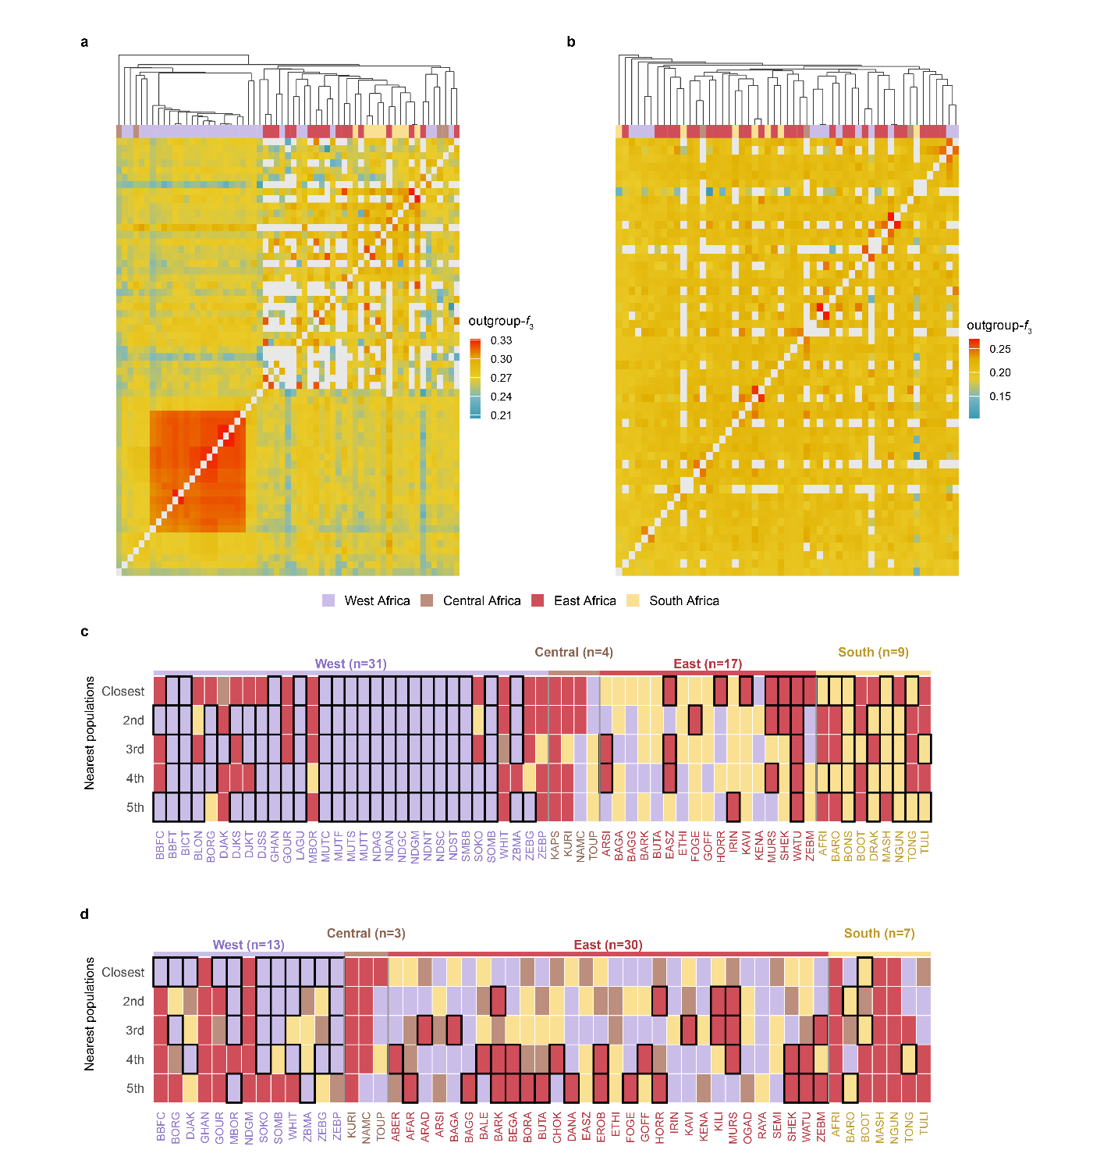
Extended Data Figure. 2 | Ancestry-specific shared drift and nearest-neighbour structure of the African taurine and Asian indicine components. a, b, Pairwise outgroup-f₃ among all populations of the taurine (a; 61 populations) and indicine (b; 53 populations) components. c, d, For every population of the taurine (c) and indicine (d) components, the five populations with which it shares the most drift ranked from closest (‘Closest’) to fifth. Columns are grouped by the geographic region of the focal population (headers), each cell is coloured by the region of the neighbouring population, and a black outline marks neighbours drawn from the same region as the focal population. The taurine component is strongly geographically structured: populations resolve into clear regional blocks (a) and their closest relatives lie predominantly within their own region (c). This structure is markedly weaker in the indicine component, whose populations share drift more uniformly (b) and whose nearest neighbours frequently cross regional boundaries (d), consistent with a more recent and homogenising spread of indicine ancestry across the continent. Population codes are defined in Supplementary Table 1.

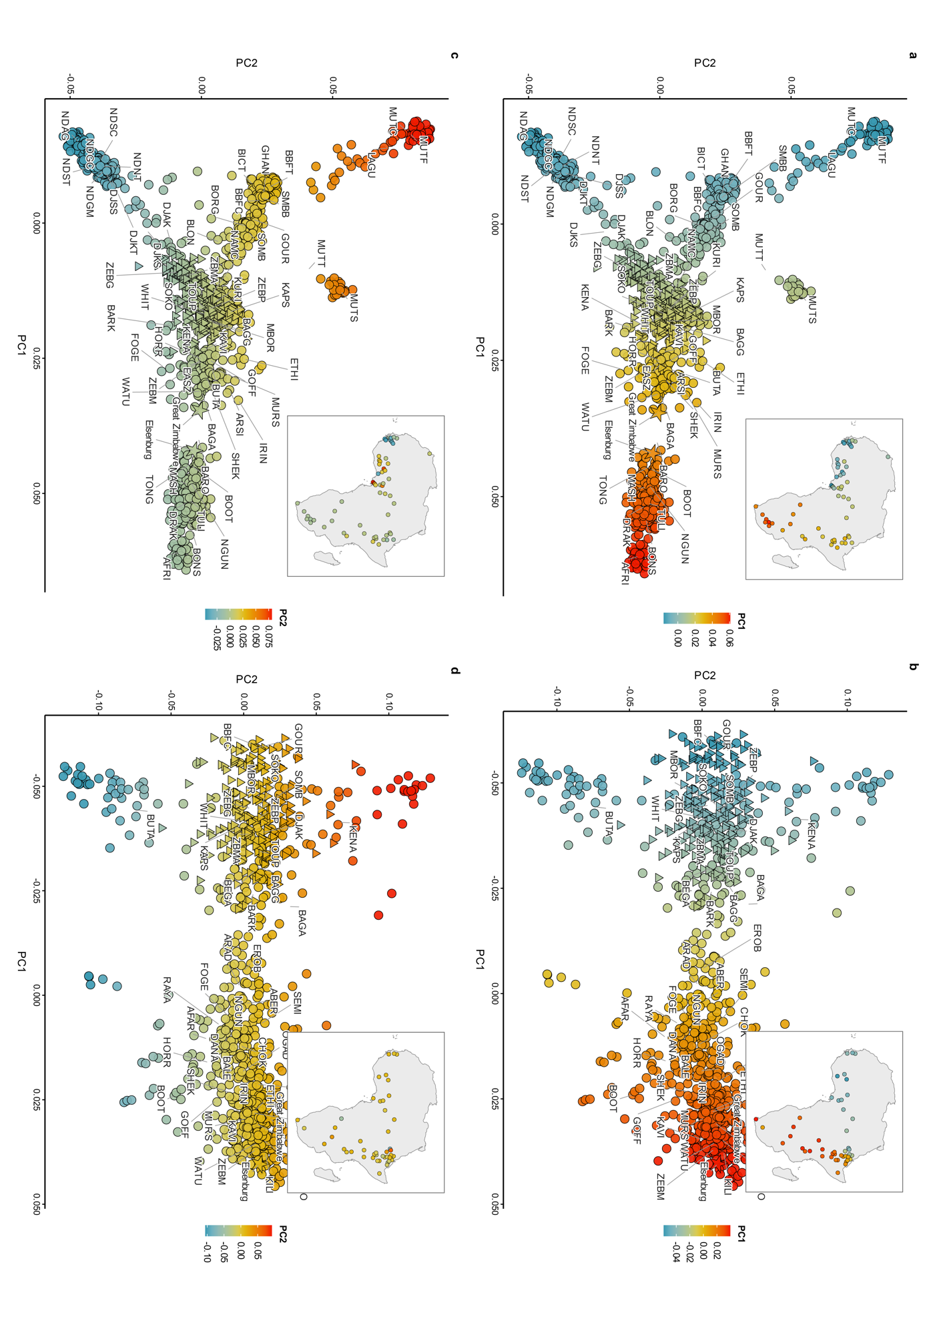
Extended Data Figure. 3 | Principal component structure of the African taurine and Asian indicine ancestry components. Each point is one animal, and each population is labelled at its centroid; Fulani-associated populations are drawn as triangle symbols and the two ancient genomes, Great Zimbabwe and Elsenburg, as stars. a, b, PC1 versus PC2 for the AFT (a; n = 1,360 individuals, 63 populations) and ASI (b; n = 842 individuals, 48 populations) components, with individuals coloured by PC1. c, d, the same two ordinations coloured by PC2. In every panel, the inset shows the sampling localities of the constituent populations across Africa, each coloured by the population-mean value of the plotted component (PC1 in a, b; PC2 in c, d) on the identical scale. PC1 describes a broadly west-to-southeast continental cline in both ancestry components, more sharply resolved in the taurine substrate (a) than in the indicine component (b). PC2 of the taurine component (c) separates the two ancestral West African taurine lineages — N'Dama/Djakkoré longhorns from West African Shorthorns, including Baoulé, Muturu and Lagune — structure that is essentially absent from the indicine component (d). Population codes are defined in Supplementary Table 1.

