Supplementary Material for A Genomic History of African Cattle

Supplementary Materials and Methods
Archaeological specimens and site description
We extracted DNA from archaeological cattle remains recovered from four sites: two in Senegal, Mboumba (800–1050 CE) and Casamance (early 20th century); one at Great Zimbabwe (1000–1600 CE) on the southern Zimbabwe Plateau; and one at Elsenburg in the southwestern Cape of South Africa (ca. 1700 CE). Sufficient DNA for genome sequencing was successfully recovered only from the Great Zimbabwe and Elsenburg specimens.

Elsenburg (Stellenbosch, Western Cape, South Africa). Elsenburg is an historical farm complex located in the Eerste River valley near Stellenbosch, approximately 50 km east of Cape Town. The area was incorporated into the expanding agricultural hinterland of the Dutch East India Company (Vereenigde Oostindische Compagnie, VOC) following Governor Simon van der Stel's identification of the Eerste River valley as suitable arable land in 1679, making Stellenbosch the first region outside the immediate vicinity of Table Mountain to be permanently colonised by VOC settlers. The tooth analysed in this study was excavated in 1993 from Square D3, level DBYC. These deposits are dated (on the basis of historical information and archaeological context) to approximately 1740-1761 ¹, at which time cattle were obtained from local Khoekhoe pastoralists. Only from about 1780 did the VOC begin to import European cattle to improve local stock ². This genome therefore represents pre-colonial Khoekhoe herds. Square: D3; Stratigraphic level: D.B.Y.C.; Dates: 1740-1761.

Great Zimbabwe (Masvingo Province, Zimbabwe). Great Zimbabwe is the eponymous and largest of the dry-stone-walled (dzimbahwe) sites of the southern African Iron Age, situated on the watershed between the Zambezi and Limpopo rivers in south-eastern Zimbabwe. The site served as the capital of a powerful Shona-ancestral polity that, at its peak between approximately the 12th and 15th centuries CE, accommodated an estimated population of up to 20,000 and exerted political and economic influence over a large area, integrating local agro-pastoral production heavily focused on cattle with long-distance intracontinental and Indian Ocean trade in gold, ivory, and copper through Swahili coastal entrepôts.

Archaeological specimen DNA extraction and library preparation
A petrous bone from Great Zimbabwe and a tooth root from Elsenburg were sectioned into fragments using a hand drill, pulverised using a mechanical press, and finely ground using a Retsch MM400 swing mill. Samples were subjected to a pre-lysis bleaching step ^{3,4}, specifically a 15-min incubation in 1 ml bleach (0.25% NaOCl), followed by two washes (vortexed and centrifuged at 3,000 rpm for 2 min) in 900 µl HPLC-grade water, and one final wash in 700 µl of 0.5 M EDTA (pH 8.0). The powder was digested using 975 µl of extraction buffer (0.45 M EDTA, 0.05% Tween-20) and 25 µl of Proteinase K (0.25 mg/ml; Thermo Scientific™); incubated at 37°C for 48 hr, with a final 2-hr incubation at 56°C.

DNA extraction was performed semi-automatically using a Hamilton Microlab StarLet IV liquid handler (Hamilton, Germany) following a modified ⁵ protocol. Specifically, 150 µl of lysate was combined with 1560 µl of binding buffer (5 M GuHCl, 40% 2-propanol, 0.12 M sodium acetate, 0.05% Tween 20; ⁶) and 10 µl of washed silica-coated magnetic beads (G-Biosciences). After a 15-min binding step, the beads were pelleted on a magnet, the supernatant discarded, and the beads washed three times with PE buffer (Qiagen) and air-dried for 3 min. DNA was then eluted twice by incubating 30 µl of TET buffer (1 mM EDTA, 10 mM Tris-HCl, 0.05% Tween-20) at RT for 5 min, with eluates combined for a total extract volume of ~50 µl. Two negative controls were included in each extraction round.

Double-stranded Illumina sequencing libraries were prepared from 32 µl of each DNA extract using a modified ⁷ protocol. Blunt-end repair was performed by adding T4 DNA Ligase buffer, dNTPs, T4 PNK, and T4 DNA polymerase, followed by incubation at 20°C for 30 min and 65°C for 30 min. Products were purified using silica-coated beads and washing buffer PB (Qiagen) with minor volume adjustments to the ⁸ protocol. After washing with PE buffer and air-drying, DNA was eluted with 21 µl of TET buffer. Illumina P5 and P7 sequencing adapters were ligated by incubating 20 µl of the purified blunt-end product with T4 DNA ligase buffer, PEG-4000, T4 DNA ligase, and adapters at 20°C for 30 min and 65°C for 10 min. Clean-up was performed on a Hamilton Microlab StarLet IV using Sera-Mag SpeedBeads™ (Cytivia) and 80% ethanol washes, followed by elution with 21 µl of TET buffer. The libraries were finalised with a fill-in reaction using Isothermal amplification buffer, dNTPs, and BST 2.0 Polymerase, incubated at 65°C and 80°C for 20 min each.

Unique dual indices (UDIs) were added to 10 µl (out of 30 µl) of the library reaction for multiplex sequencing using AmpliTaq Gold™ DNA polymerase. The amplification protocol included an initial denaturation at 95°C for 10 min, followed by 15 cycles of 95°C for 30 s, 60°C for 30 s, and 72°C for 1 min, and a final extension at 72°C for 7 min. Three library amplifications were obtained and subsequently pooled at equimolar concentrations for shotgun whole-genome sequencing (PE, 150 bp) on NovaSeq X Plus lane(s) (25B flow cell) at Macrogen, Amsterdam.

Previously published animal data
Also included in this analysis are previously published WGS data from 3,384 cattle and 5 bison (Bison bison) Sample accession codes are detailed in Supplementary Table 1.

Modern animal genomes
DNA samples were obtained from 889 cattle sampled across Africa. Data for these animals were previously published in surveys of microsatellite and mitochondrial diversity in African cattle ^{9–12}. Additionally, 220 cattle were sampled in 2022 by collecting ear tissue via RFID tagging. Ethical approval was granted by the University of Pretoria (UP) (NAS264/2021). DNA was extracted from ear tissue using QIAGEN DNeasy Blood & Tissue kits at the University of Pretoria. A further 16 cattle were included from a previously published experimental infection study ^{13–16}. These comprised trypanotolerant N'Dama and trypanosusceptible Boran animals reared at the International Livestock Research Institute (ILRI) ranch at Kapiti Plains Estate, Kenya. Finally, raw sequence reads (FASTQ) were provided for an additional 243 cattle by Olivier Hanotte and Abdulfatai Tijjani, and for a further 12 cattle by Tad Sonstegard of Acceligen (Supplementary Table 2).

Modern Library Preparation sequencing
Sequencing libraries were prepared using a downscaled version of the bead-based tagmentation kit from Illumina (DNA-prep, Illumina, San Diego, USA) following the manufacturer’s protocol, with several adjustments. A 3 μl volume containing 200 to 500 ng of genomic DNA was mixed with 2 μl of tagmentation mastermix (DNA-prep kit, Illumina), incubated at 55°C for 15 min, then at 37 °C for a further 15 min after addition of Tagmentation stop buffer (DNA-prep kit, Illumina). Tagmented DNA bound to magnetic beads was then purified according to the kit protocol. The beads were then added to a PCR mix containing unique double index (UDI) primers (xGen™ UDI, Integrated DNA Technologies) and amplified for 7‒9 cycles. Products were purified with SPRI beads (DNA-prep kit, Illumina). Concentration was measured with 50 μl of Qubit HS reagent on a plate reader (Fluostar Omega, BMG Labtech, Ortenberg, Germany), and equal amounts of the library were pooled for sequencing. Libraries were then sequenced on a NovaSeqX platform (Illumina) at an average 0.1‒13× coverage (Supplementary Table 2).

Data Processing
Modern Genomes: Sequence data were processed using the Genome Analysis Toolkit (GATK) v.4.1.9.0 best practices ¹⁷. Sequence reads were mapped to the bovine reference genome (ARS-UCD1.2) ¹⁸ using the default parameters for bwa mem ¹⁹. Picard v.2.24.1 was used to sort the bam files and create index files (Available online at: http://broadinstitute.github.io/picard/). Potential PCR duplicates were identified using the MarkDuplicates function in GATK. The BaseRecalibrator and ApplyBQSR functions of GATK were also used to perform base quality score recalibration. These analyses were based on known variants provided by the 1000 Bulls Genomes Project (ARS1.2PlusY_BQSR_v3.vcf.gz; www.1000bullgenomes.com).

Ancient Genomes: The two ancient samples were mapped to the bovine reference genome (ARS-UCD1.2) ¹⁸ using the EAGER pipeline ²⁰. We preprocessed the samples by removing adapter sequences with AdapterRemoval 2.0 ²¹. We then assessed the adapter-trimmed reads with FastQC ²². Next, the reads were aligned to the cattle genome using bwa aln and sampe ²³. Reads with a quality score below 25 (-q25) were discarded with Samtools v.1.21 ²⁴, and SAM files were converted to bam format. PCR duplicates were identified and removed using DeDup ²⁵. Post-mortem DNA damage patterns and mismatch rates were estimated with DamageProfiler ²⁶. The quality of the bam files was evaluated using Qualimap v.2 ²⁷, and overall statistics were compiled with MultiQC ²⁸ (Supplementary Table 2).

Pseudohaploid calling dataset
We used ANGSD v.0.938 ²⁹ for pseudohaploidization of the bam files by employing these parameters: a set of 11 million high-quality SNPs from our reference panel was provided with the -sites option. We performed random base calling with (-doHaploCall 1), retained reads with a minimum mapping quality of 25 (-minMapQ 25), and set a base quality threshold of 30 (-minQ 30). Additional parameters included requiring at least one minor allele across samples (-minMinor 1), removing triallelic sites (-rmTriallelic 1e-4), and specifying major/minor alleles (-doMajorMinor 2). Reads with excessive mismatches were downscaled (-C 50), a base quality adjustment was applied (-baq 1), and bad reads were removed (-removebads 1). We also excluded transitions (-rmTrans 1) to mitigate the effects of postmortem DNA deamination, which disproportionately affects transitions compared to transversions, thereby reducing the number of poor-quality SNPs. The resulting haplo files were converted to Plink tped format via the ANGSD haploToPlink tool, then further converted to ped files using Plink v.1.9 ³⁰.

Phasing and imputation:
Using a reference panel previously constructed and benchmarked by ³¹. We used GLIMPSE v.1.1.1 ³² for imputation, first splitting the extracted site positions of the reference panel using the GLIMPSE chunk tool with default settings of --window-size 2000000 and --buffer-size 200000 to improve computational efficiency. We then used the BAM files, the site positions of the reference panel, a genetic map, and imputation chunks with their buffers, as described above, as input for the imputation step using the GLIMPSE_phase tool. Following this, we merged the imputed chunks for each animal sample using the GLIMPSE_ligate tool and phased the ligated imputed vcf file with GLIMPSE_sample. The phased and imputed dataset included 11,726,797 SNPs.

Principal component analysis, and ADMIXTURE
We performed principal component analysis (PCA) using EMU v1.6.0 ³³. This analysis generated eigenvalues and eigenvectors for 4,888 individuals, representing both contemporary and ancient cattle. To ensure the integrity of the analysis, we restricted the dataset to Bos taurus and Bos indicus, excluding outgroup species. The SNP dataset underwent linkage disequilibrium pruning via PLINK ³⁰, utilizing the “--indep-pairwise 50 10 0.1” filter, which resulted in a final set of 119,253 SNPs for the analysis. Using this pruned dataset, we employed ADMIXTURE v1.3 ³⁴ to estimate population structure, testing ancestral population numbers (K) ranging from 2 to 8 (Supplementary Figure 1)

F- and D-tatistics
F-statistics were estimated from a random subsample of 500,000 SNPs drawn from the full panel of 11,726,797 SNPs to reduce computational cost using ADMIXTOOLS v. 8.0.2 ³⁵. Standard errors were obtained using a weighted block jackknife over 5-cM blocks, with genetic-map positions assigned via linear interpolation of the recombination map ³⁶. We calculated D-statistics of form: D(EUT, X; IND, OUT) using four bison as the outgroup, to assess for gene flow from IND, representing indicine gene flow into X, representing a target African population since its split from Eurasian taurine (EUT). For all African population exhibiting significant D-statistics (i.e., |Z|>3), we quantified admixture proportions using the f₄-ratio (α), which compares two f₄ statistics of the form: f₄(EUT, OUT; IND, X)/f₄(EUT, OUT; IND, AFT) In our analysis, X represents the target African population, while bison serves as the outgroup (OUT). The resulting α value specifically quantifies the proportion of African taurine ancestry in the target population X, using Guinean N’Dama (AFT) as the reference population for pure African taurine ancestry, based on previous microsatellite and SNP array analysis of the same animals ^{9,37})

Estimation of the date of admixture
The timing of admixture events between African taurine and indicine ancestry was estimated using ALDER v1.03 ³⁸ and DATES ³⁹, with both analyses employing default parameters and a minimum genetic distance threshold of 0.5 cM. These analyses were performed on our dataset comprising 11,726,797 SNPs, using a linearly interpolated recombination map ³⁶. To represent the ancestral source populations (African taurine and indicine), we first identified appropriate reference populations through D-statistics – see the local ancestry inference section below. Specifically, we selected African taurine individuals showing no evidence of indicine gene flow, and indicine individuals displaying no evidence of Eurasian taurine admixture ⁴⁰, to serve as the reference populations for both ALDER and DATES analyses. DATES and ALDER estimates were highly correlated (r² = 0.94, n = 62) but not identical: ALDER yielded systematically older ages (OLS slope = 0.76; mean offset ≈ 14 generations), with the gap increasing for older events.

Local ancestry inference
Local ancestry inference was carried out using Gnomix ⁴¹ for all cattle used in this study. Individuals serving as representative sources for the three cattle lineages: European taurine (EUT), African taurine (AFT), and indicine (ASI). Candidate references were first identified from PCA and then finalised under two competing schemes: one retaining individuals on the basis of their ADMIXTURE membership proportions, the other based on D-statistics testing for residual gene flow. We selected between the resulting panels using the cross-validation confusion matrices returned by Gnomix, which measure how accurately simulated haplotypes of each lineage are recovered (Supplementary Figure 10). The D-statistics-based panel discriminated all three lineages essentially without error (per-class accuracy ≈ 1), whereas the ADMIXTURE-based panel misassigned roughly 30% of both indicine and African taurine haplotypes to European taurine. We therefore used the D-statistic-based references (Supplementary Table 16) for all downstream local ancestry inference.

Ancestry Masking
High confidence ancestry tracts were derived from the Gnomix per-window posterior probabilities (.fb output). For each individual, a genomic region was assigned to African taurine (AFT), indicine (ASI), or European taurine (EUT) ancestry when both haplotypes carried the same inferred ancestry across contiguous windows with a posterior probability exceeding 0.99; these windows were merged into a single interval, producing per-individual BED files of high-confidence ancestry regions. For each sample/ancestry combination, we generated a VCF containing genotype information at regions where both haplotypes were assigned to that ancestry with a posterior probability exceeding 0.99. Genotypes at all other positions were recorded as missing (.|.). To validate this approach, we ran a PCA on the three reference populations (EUT, AFT, and ASI) and projected the masked admixed genomes onto this reference space using the lsqproject option in smartpca ³⁵. We also computed D- and f₄-ratio statistics to test whether the masked genomes retained any evidence of admixture.

Ancestry Specific PCA and outgroup-f₃
Ancestry-specific PCA (asPCA) was additionally performed using EMU-EM-PCA, a method designed to handle high missingness in genetic datasets ³³. We constructed PCAs on two eigenvectors for the African taurine and indicine ancestries, respectively. PCAs were constructed from African taurine- and indicine-ancestry-specific datasets with less than 98% missingness.

Outgroup-f₃ statistics of the form f₃(Outgroup; Pop1, Pop2) measure the shared genetic drift between Pop1 and Pop2 since their divergence from a common ancestor with the outgroup (reference). Outgroup-f₃ was computed using ADMIXTOOLS ³⁵. Higher f₃ values indicate greater shared drift and thus a closer genetic relationship. We computed f₃ statistics using Bison bison (American bison) as the outgroup, which is sufficiently diverged from both taurine and indicine cattle to serve as a valid outgroup for both ancestry-specific analyses. By computing f₃ on the ancestry-masked datasets, we obtain ancestry-specific measures of shared drift. For example, f₃(Bison; Population1_ASI, Population2_ASI) measures the shared drift in the indicine component of Pop1 and Pop2, independent of their taurine ancestry.
Ancestry-specific isolation by distance and environment
To test for isolation by distance (IBD) and isolation by environment (IBE) within each ancestry component, we performed Mantel tests using the mantel functions in vegan ⁴². Genetic distances were derived from ancestry-specific pairwise outgroup-f₃ statistics. Because outgroup-f₃ measures similarity, we converted it to a distance by rescaling each matrix to a 0–1 range and subtracting from 1, so that the most genetically similar populations have the smallest distance. Geographic distance matrices were computed as pairwise Haversine distances (km) from population-level coordinates. Environmental distance matrices were computed as pairwise Euclidean distances on scaled bioclimatic variables ⁴³to limit collinearity, we retained four representative variables (bio1, annual mean temperature; bio4, temperature seasonality; bio12, annual precipitation; and bio15, precipitation seasonality), selected from the full BioClim set such that no retained pair exceeded |r| = 0.7. Pearson correlations were used throughout, with significance assessed across 9,999 permutations. All Mantel analyses were run with and without Fulani-associated populations to assess their impact on IBD and IBE estimates.
Ancestry-specific analysis of molecular variance (AMOVA)
To quantify the degree of regional genetic structuring within each ancestry component, we applied AMOVA (implemented as PERMANOVA via adonis2 in the R package vegan ⁴²) to ancestry-specific Weir-Cockerham pair-wise F_{ST} matrices computed from the masked datasets. Populations were assigned to four predefined geographic regions: West Africa, East Africa, Central Africa, and South Africa. PERMANOVA partitions the total sum of squared genetic distances into between-region and within-region components, with significance assessed across 9,999 permutations of group labels. The key output, R², represents the proportion of total genetic variance explained by regional grouping. We additionally performed betadisper tests (permutational tests of multivariate dispersion homogeneity) to assess whether within-group variance was comparable across regions, as PERMANOVA is sensitive to heterogeneous dispersion. Ancestry-specific F_{ST}, asPCA, and outgroup-f₃ statistics independently identified Fulani-associated populations as carrying East African taurine ancestry despite their current West African geographic location. To account for this, we ran three analytical treatments: all populations assigned to their geographic region (Analysis A), Fulani-associated populations excluded (Analysis B), and Fulani-associated populations assigned to a fifth group (Analysis C). Each treatment was applied to both independent population sets, maximising sample size per ancestry, and a shared population set comprising populations present in both ancestry-specific datasets, controlling for differences in population composition. The R² values were compared between ancestries across all treatments to assess whether taurine ancestry exhibits stronger regional partitioning than indicine ancestry.
Ancestry-specific redundancy analysis (RDA)
To assess the multivariate relationship between ancestry-specific genetic variation and environment while controlling for geography, we performed partial redundancy analysis (pRDA) using the rda function in vegan ⁴². For each ancestry-specific masked dataset, population-level allele frequencies were computed from the masked VCF using PLINK (--freq --within), then pivoted to a populations × SNPs matrix. Four bioclimatic variables, mean annual temperature (bio1), temperature seasonality (bio4), annual precipitation (bio12), and precipitation seasonality (bio15), were selected as environmental predictors after examining pairwise correlations across all 19 BioClim variables ⁴³ and elevation; variable pairs with |r| > 0.7 were identified and representatives were retained to minimise multicollinearity while capturing the major axes of thermal and moisture variation. Environmental variables were centred and scaled prior to analysis. The full RDA model tested the overall significance of the environment-genetics relationship by permutation (999 permutations), with per-term ANOVA assessing the contribution of each variable sequentially. Variance partitioning (varpart in vegan) decomposed total genetic variance into four fractions: pure environment, pure geography (population-level longitude and latitude), the shared component of environment and geography, and residual variance. A partial RDA conditioning on geographic coordinates was then tested by permutation to determine whether the environment explains genetic variance beyond what geography alone captures. RDA triplots were produced for each dataset, with populations plotted in constrained ordination space and coloured by their taurine ancestry proportion (f₄-ratio), and bioclimatic predictors displayed as biplot arrows indicating the direction and relative strength of each variable’s association with the constrained axes. All analyses were run on four datasets: African taurine (AFT), indicine (ASI), and the corresponding subsets excluding Fulani-associated populations (AFT_noFulani, ASI_noFulani).
Selection Analyses
We scanned for excess IBD sharing using the isweep (v1.0) framework ⁴⁴ on the phased/imputed VCF (1,947 samples). Briefly, we used the “scan-selection” workflow to identify regions of excessive IBD by applying the following parameters: “scan_cutoff: 2.0 cM”, “step_size: 0.05”, “confidence_level: 0.05”, and “num_sims: 500”. We then used a “model-selection” workflow to compute the selection coefficient and identify outliers. Positions with IBD rates exceeding the genome-wide median plus four times the standard deviation were considered to have excess IBD rates. Approximate P-values under the null model that IBD rates are normally distributed were computed at the position of maximum IBD rate within each significant region.

To determine the ancestral origins of haplotypes under selection, we cross-referenced the isweep selection regions with local ancestry inferences from Gnomix ⁴¹. Gnomix was run as previously described, using a reference panel that includes European taurine (EUT), African taurine (AFT), and indicine (ASI) ancestries. This process produced most-likely ancestry assignments (MSP files) and per-window posterior probabilities (FB files) across the cattle genome.
For each of the 22 iSweep regions of interest (ROIs), we identified the set of haplotypes exhibiting excess IBD sharing (outliers) from the isweep output. Each outlier haplotype was mapped to its corresponding Gnomix column (isweep haplotype suffix _1/_2 to Gnomix suffix .0/.1). For each ROI, multiple MSP windows may overlap the region boundaries; we therefore assigned each outlier haplotype the majority ancestry call across all overlapping windows; that is, the most frequently assigned ancestry (EUT, AFT, or ASI) across the MSP windows spanning the ROI.
To exclude ambiguous ancestry assignments, we applied the following method: for each outlier haplotype, we extracted the maximum ancestry posterior probability at each MSP window that overlapped the ROI from the corresponding FB file. The mean of these maximum posteriors across the overlapping windows was computed; haplotypes for which this mean fell below a threshold of 0.90 were classified as low-confidence and excluded from ancestry tallies. Ancestry fractions were computed from confident assignments only, by dividing the count of each ancestry by the total number of confidently assigned haplotypes (n_AFT + n_ASI + n_EUT), excluding low-confidence haplotypes.
Supplementary Notes

Classification of African Cattle into Distinct Groups
In case of publicly available data, the sample-level group assignments were inherited from the source publications from which individual samples were drawn. These assignments may not represent a single coherent framework that combines population-name conventions. To produce grouping for downstream analyses, we re-evaluated group assignments using three criteria in combination: (i) genome-wide ancestry proportions from an ADMIXTURE analysis at K = 3, (ii) published population assignment, and (iii) geographic and historical context of each population. Throughout, we refer to the major African cattle groupings by the following abbreviations: African Taurine (AFT), African Sanga (AFS), African Zenga (AFZ), and African Indicine (AFI), together with North African Taurine (NAT), the African Indicine Composite comprising the East African Shorthorn Zebu (AIC), and the South African Composite (SAC).

Fulani vs Non-Fulani
The main text classifies cattle populations into two categories: Fulani and non-Fulani. This distinction is based on genetic data patterns and reflects the unique pastoral traditions of the Fulani people in West and Central Africa. The Fulani are transhumant pastoralists, and their cattle have been shaped by centuries of management practices and environmental pressures. To refine the classification, population labels were cross-referenced with an encyclopedia ⁴⁵ to ensure ethnographic accuracy. Populations associated with the Fulani were identified based on their historical connections to Fulani pastoralists, while non-Fulani populations were linked to other ethnic groups or systems. It is important to note that the distinction between Fulani and non-Fulani is an oversimplification of complex historical, cultural, and ethnic diversity. The Fulani are not a homogeneous group, and “non-Fulani” is essentially a residual category that groups together populations with significant diversity. Thus, this dichotomy should be understood as a useful analytical approximation rather than a definitive classification of distinct, non-overlapping populations.

Generation Intervals
We convert admixture dates from generations to calendar years using a generation interval (L) of 7 years. Because L enters as a simple multiplier, it directly scales calendar estimates – for an event dated at 100 generations, the difference between L = 5 and L = 7 is 200 years. We adopt L = 7 as a central estimate within the pedigree-derived range 6.0–7.6 years: N’Dama at 7.6⁴⁶, Boran at 6.75⁴⁷, Kenana at 6.72⁴⁸, and South African Sanga populations at 6.0–6.4⁴⁹. Because these intervals were recorded under managed conditions—research stations and commercial studs with controlled mating, veterinary care, supplementary feeding, and systematic bull replacement—that likely shorten generation times relative to historical pastoral herds. The L = 7 value is a conservative choice with respect to event age, and calendar dates should be treated as minimum ages.
Temporal stability of taurine ancestry within populations
To assess whether the pooling of samples from the same population collected at different time points (1990, 1992, 2000, and samples collected recently [> 2015]) should be treated as a single population, we tested for differences in individual taurine ancestry proportion (f₄-ratio; described below) between sampling periods within each population for which we had samples from different sampling periods. This pooling was observed in all analyses except those estimating the time of admixture, owing to a large 30-year time differential (approximately four generations in cattle) among some samples.

For each population represented in more than one sampling period, f₄-ratio values were compared between periods using a two-sided Wilcoxon rank-sum test. Populations with fewer than two individuals in any period were excluded from testing but retained in summary statistics. The P-values within each analysis were adjusted using the Benjamini-Hochberg (BH) procedure ⁵⁰. A significant directional shift of meaningful magnitude was taken as evidence against pooling; a non-significant result, or a statistically significant shift of negligible magnitude, was taken as support for treating the temporal samples as a single population. Where subgroup sample sizes were unbalanced or small in one direction, results were interpreted cautiously, as the test’s sensitivity and the stability of subgroup summary statistics are both reduced in this regime.

The majority of temporally split populations (ARAD, KENA, KURI, NDGM, NGUN, RAYA, SHEK, and ZBMA) showed no significant difference in f₄-ratio between sampling periods after BH correction, and are treated as single populations in downstream analyses. BUTA showed a statistically significant but negligible shift (delta f₄-ratio = 0.007, P_{adj} = 0.05), with both time points at the lower end of the taurine distribution (f₄-ratio = 0.3); we consider pooling appropriate here. The NDGC and NDAG pair was likewise significant but of trivial magnitude (delta f₄-ratio = 0.004, P_{adj} = 1.4 × 10⁻³), with both groups at the taurine extreme (f₄-ratio = 0.99), and was pooled. NDSC and NDST showed no significant difference (P_{adj} = 0.18) and are pooled. The recent ZBMA samples showed a notable increase in variance (SD 0.027 to 0.151) despite a stable mean, which may reflect heterogeneity in the contemporary population but does not, on its own, motivate splitting.

Differences were observed for MASH (delta f₄-ratio = 0.053, P_{adj} = 1.5 × 10⁻³) and TULI (delta f₄-ratio = 0.083, P_{adj} = 1.1 × 10⁻³), where recent samples carry less taurine ancestry than earlier samples. However, we feel the differences were not sufficiently substantial to warrant treating each as a separate population, given the complex three-way admixture of African taurine, Eurasian taurine, and indicine ancestry that these populations share. Larger differences were observed between BBFC and BBFT (delta f₄-ratio = 0.105, P_{adj} = 2.0 × 10⁻³) and between DJAK and two other populations, DJKT (delta f₄-ratio = 0.365, P_{adj} = 2.1 × 10⁻⁷) and DJKS (delta f₄-ratio = 0.124, P_{adj} = 0.048). These populations with larger differences were considered separate groups, excluding analyses to estimate the time of admixture.

Supplementary Results

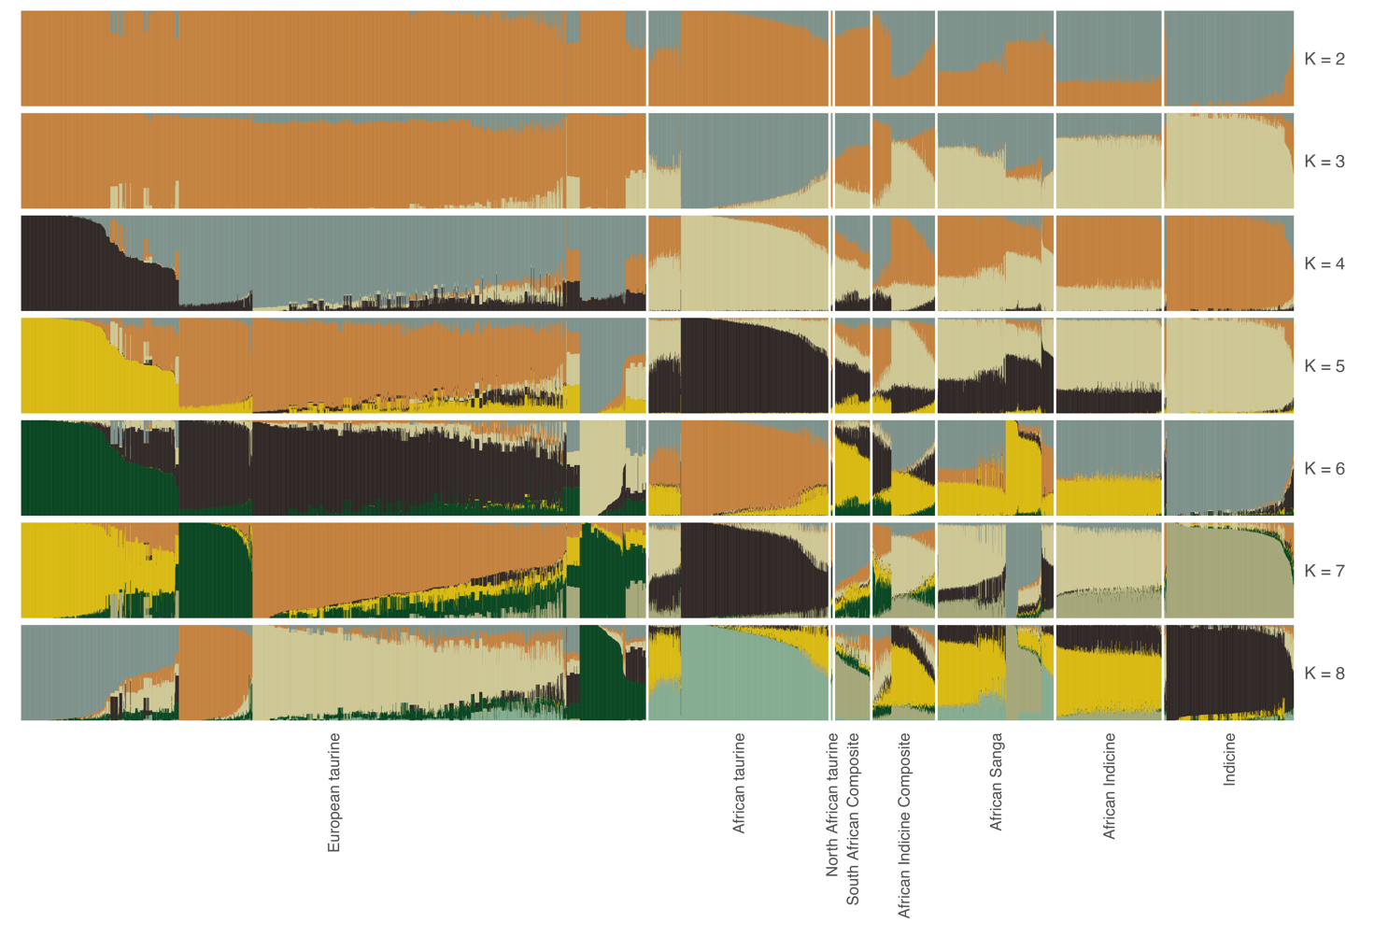
Supplementary Figure 1 | ADMIXTURE-based ancestry clustering across K = 2–8. Unsupervised ancestry proportions for all individuals estimated for K = 2 to K = 8 (top to bottom). Each vertical bar is one individual and each colour an inferred ancestry component; individuals are ordered and grouped by population, with the eight broad ancestry groups (African taurine, South African Composite, African Sanga, indicine, European taurine, North African taurine, African Indicine Composite and African indicine) indicated above.

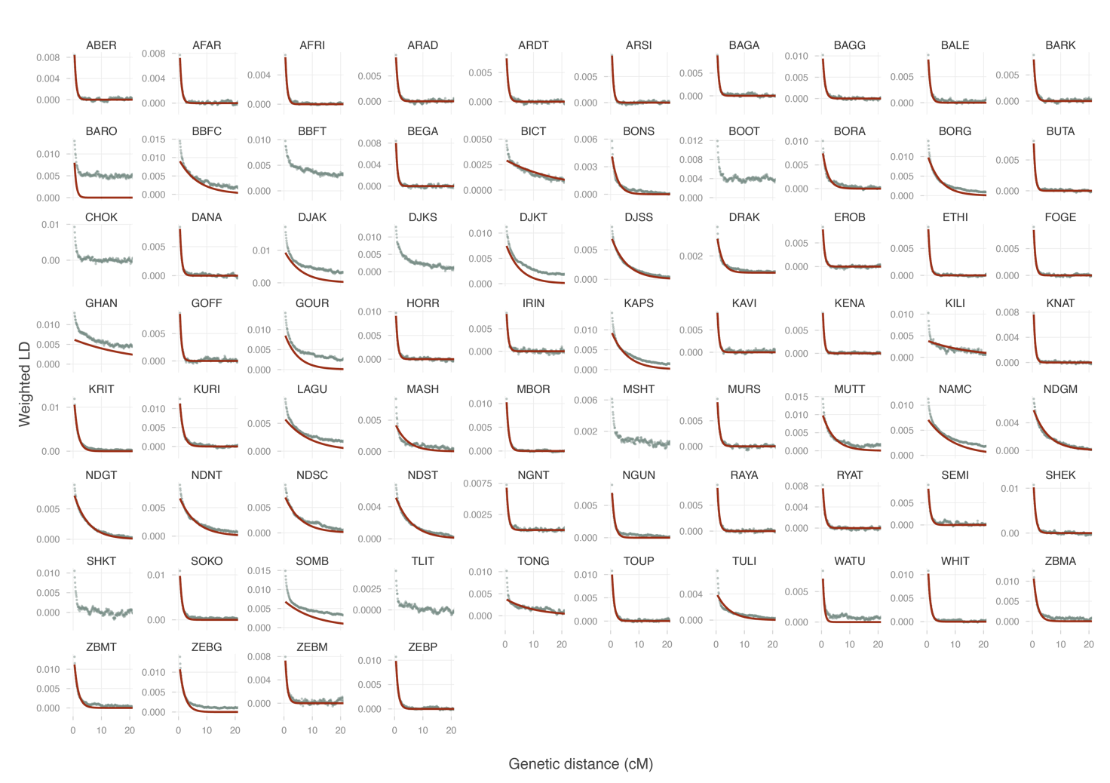
Supplementary Figure 2 | Ancestry-covariance decay for admixture dating (ALDER) on modern popualtions. Weighted ancestry covariance as a function of inter-marker genetic distance (cM) for each population, with the fitted single-exponential curve whose decay constant yields the admixture time in generations. One panel per population; corresponding estimates are given in Supplementary Table 5.

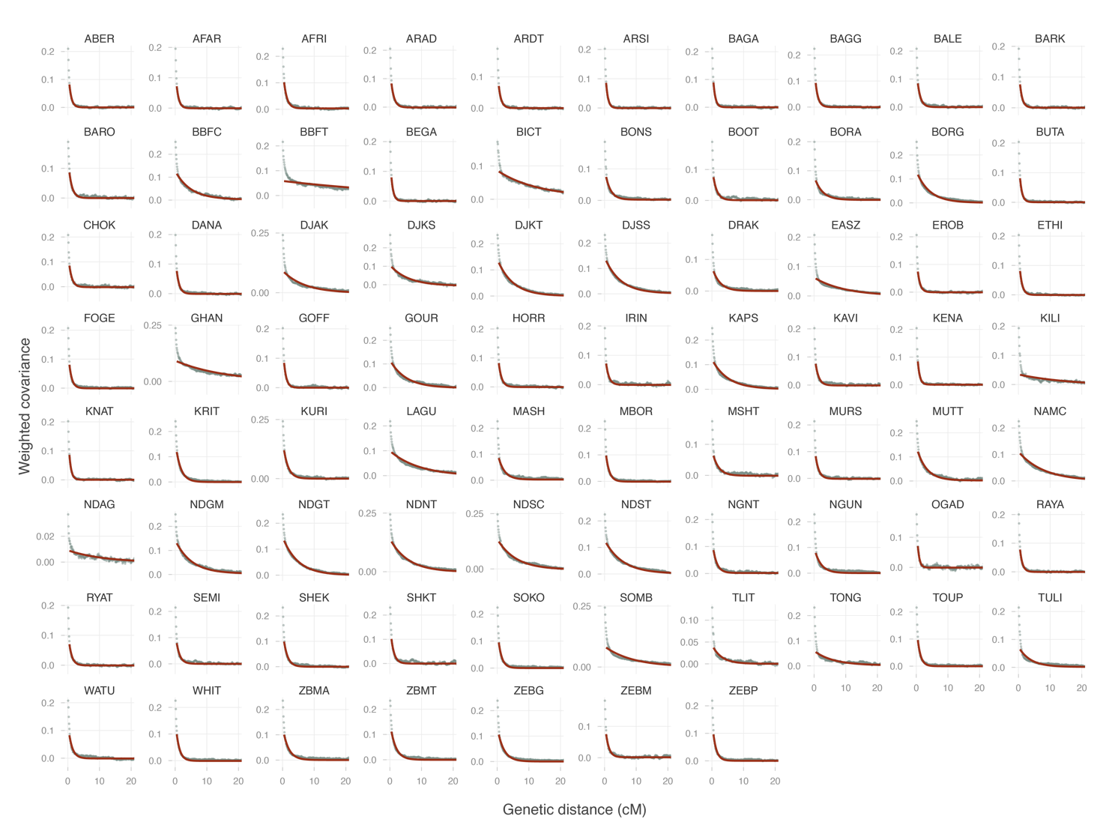
Supplementary Figure 3 | Ancestry-covariance decay for admixture dating (DATES) on modern populations. Weighted ancestry covariance as a function of inter-marker genetic distance (cM) for each population, with the fitted single-exponential curve whose decay constant yields the admixture time in generations. One panel per population; corresponding estimates are given in Supplementary Table 6.

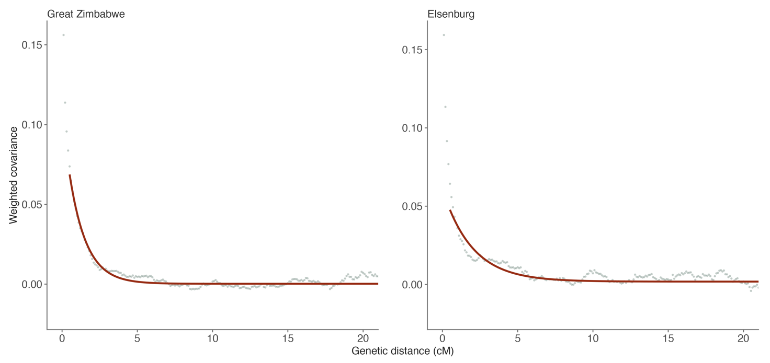
Supplementary Figure 4 | Ancestry-covariance decay for admixture dating (DATES) on ancient samples. Weighted ancestry covariance as a function of inter-marker genetic distance (cM) for the two ancient samples, with the fitted single-exponential curve whose decay constant yields the admixture time in generations. Corresponding estimates are given in Supplementary Table 9.
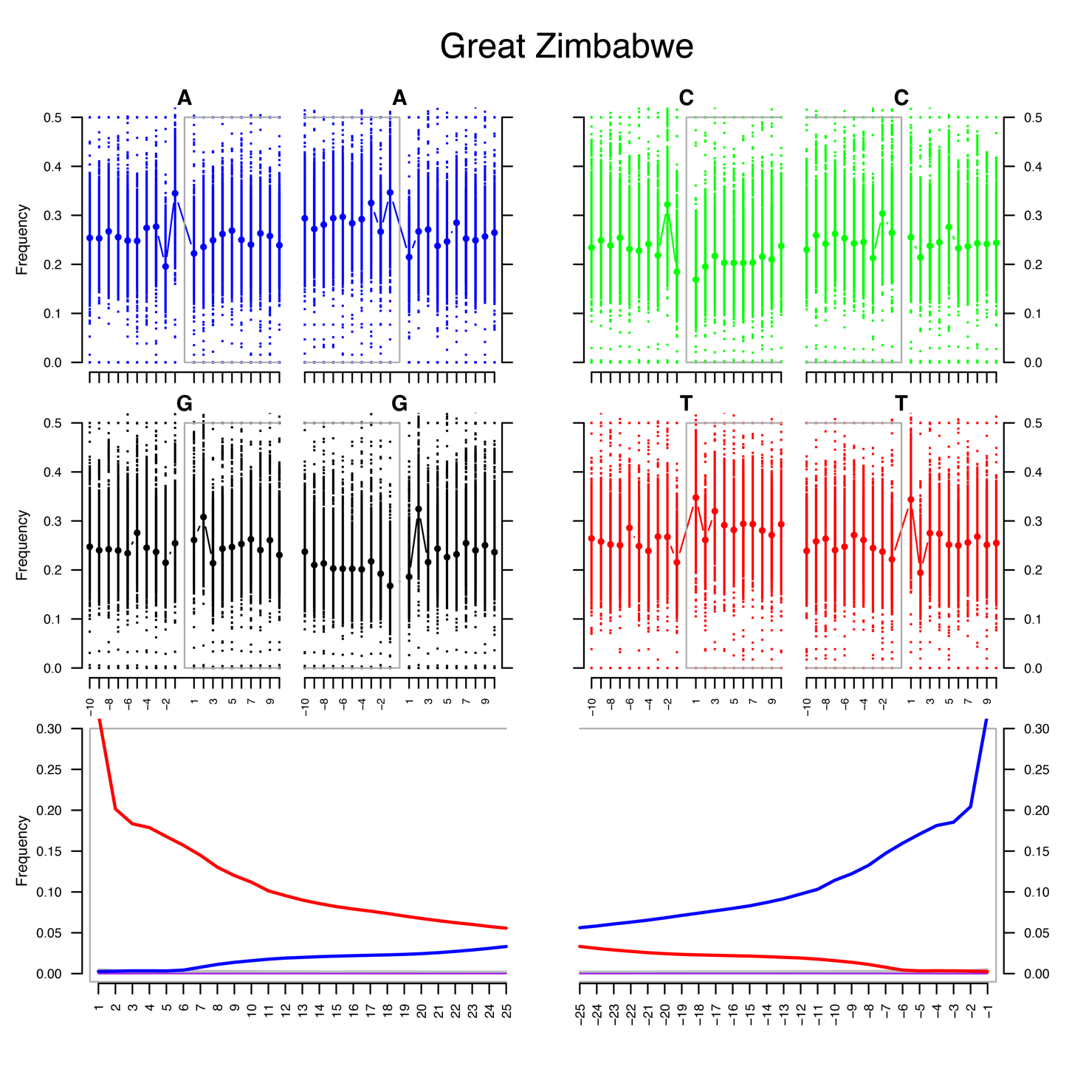
Supplementary Figure 5 | Post-mortem misincorporation patterns, Great Zimbabwe. Base-composition and substitution plots for the Great Zimbabwe genome. Upper panels show reference base frequencies flanking the read termini (grey box = aligned read region), including the purine enrichment immediately 5′ of fragment starts; lower panels show substitution frequencies along the read, with elevated C→T at the 5′ end (red, left) and G→A at the 3′ end (blue, right).

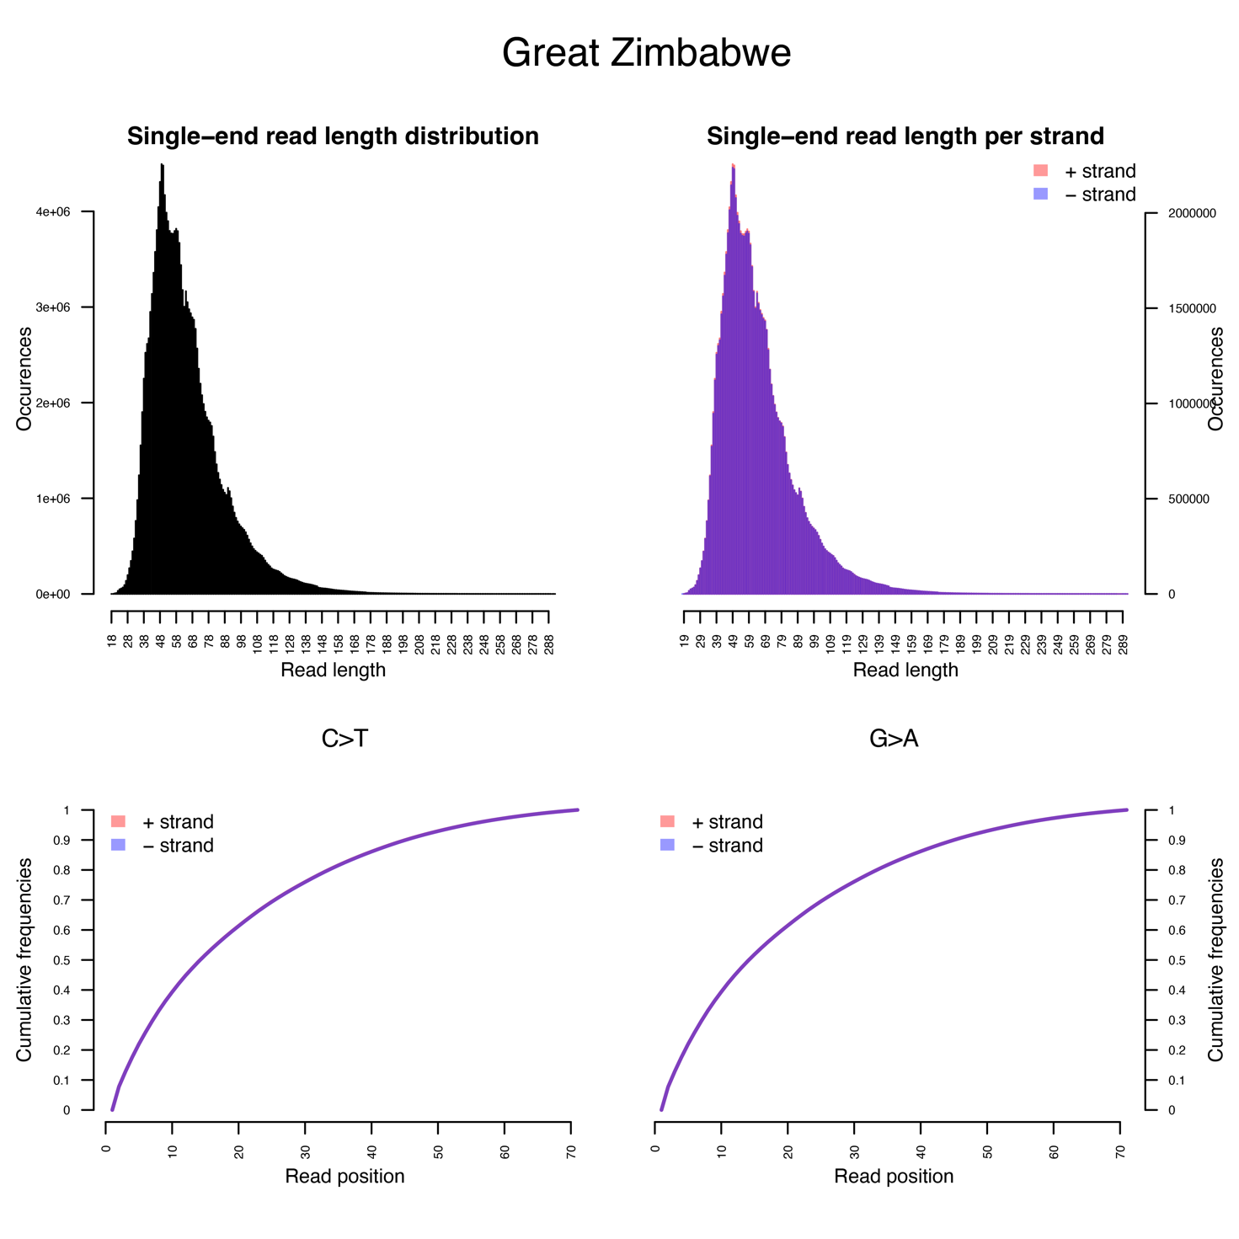
Supplementary Figure 6 | Read-length distributions and cumulative damage, Great Zimbabwe. Single-end read-length distributions for the Great Zimbabwe genome, overall (top left) and split by strand (top right), showing the short fragments characteristic of ancient DNA; lower panels give the cumulative frequency of C→T and G→A substitutions as a function of read position for each strand.

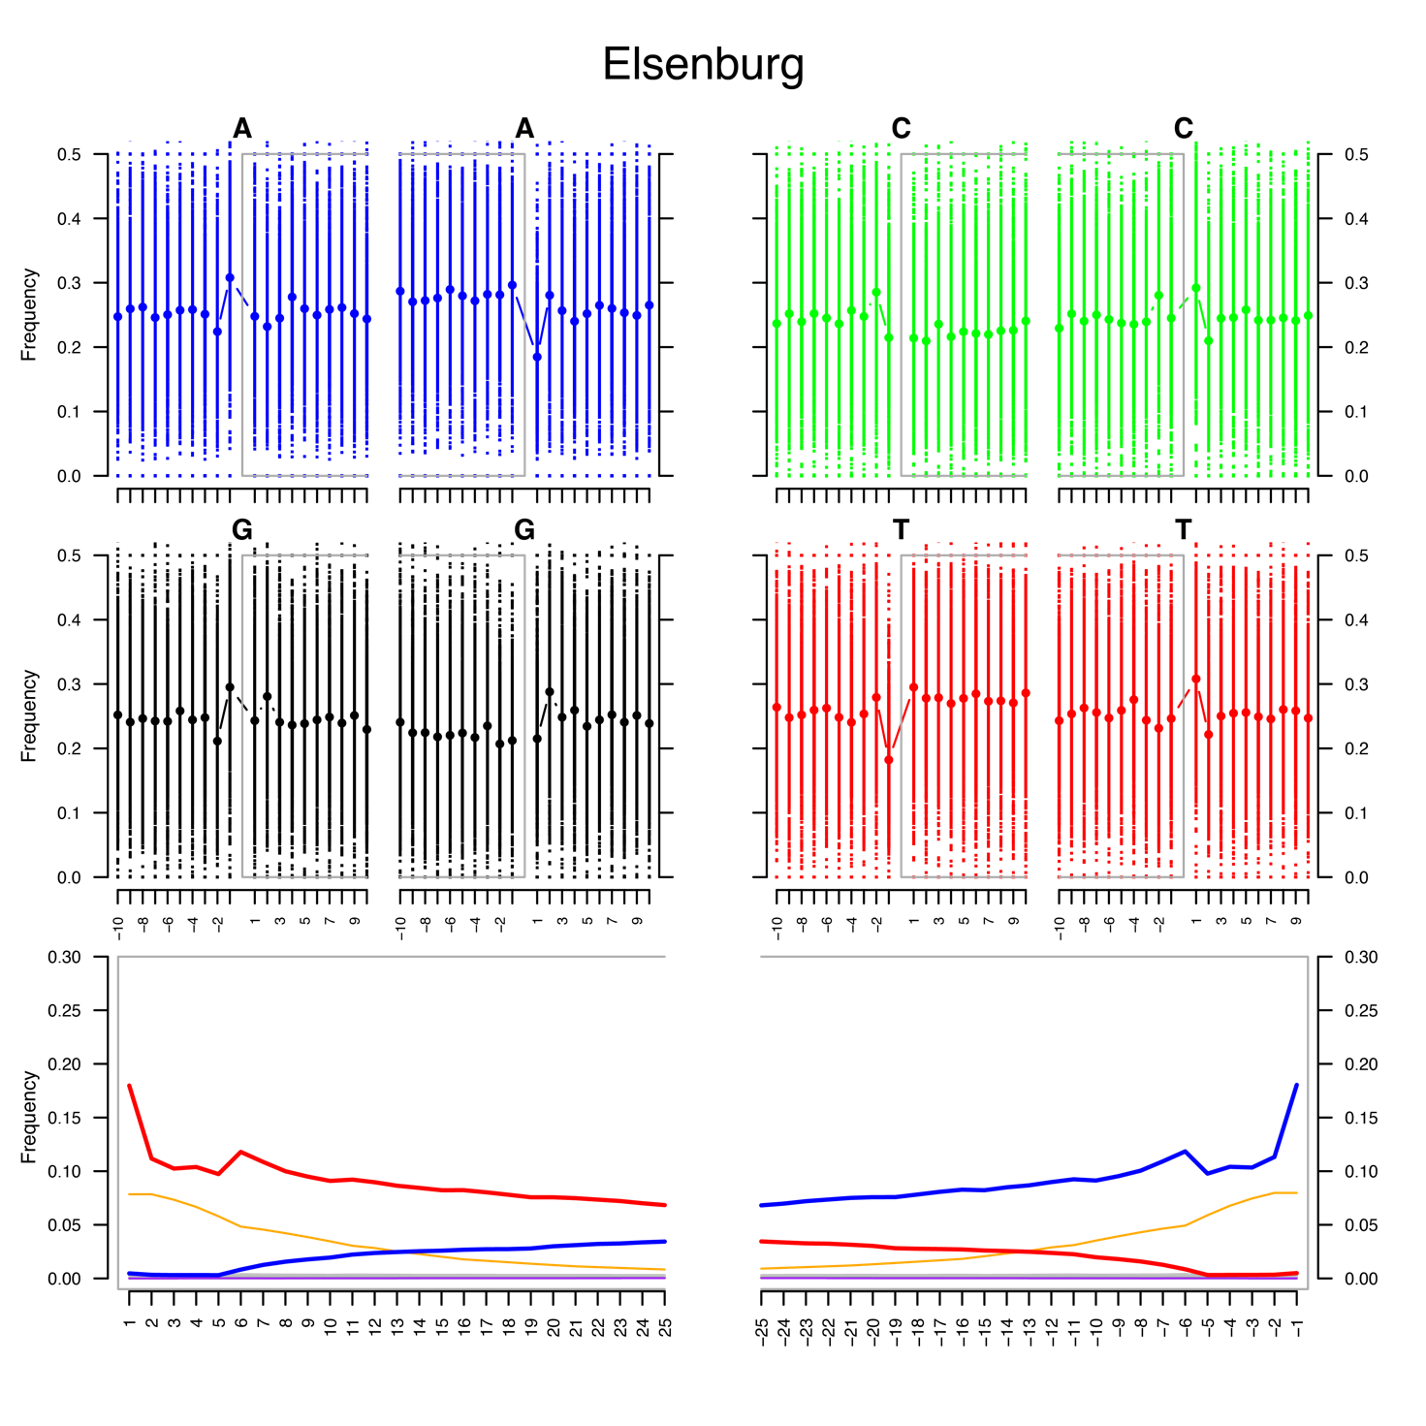
Supplementary Figure 7 | Post-mortem misincorporation patterns, Elsenburg. Base-composition and substitution plots for the Great Zimbabwe genome. Upper panels show reference base frequencies flanking the read termini (grey box = aligned read region), including the purine enrichment immediately 5′ of fragment starts; lower panels show substitution frequencies along the read, with elevated C→T at the 5′ end (red, left) and G→A at the 3′ end (blue, right).
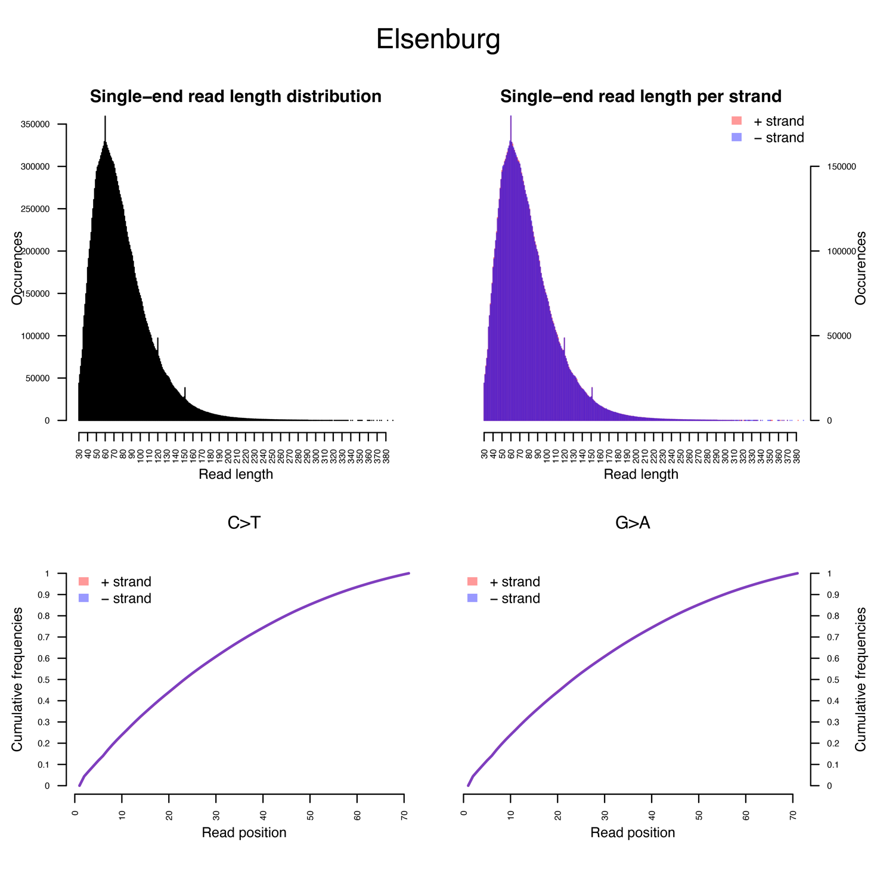
Supplementary Figure 8 | Read-length distributions and cumulative damage, Elsenburg. Single-end read-length distributions for the Great Zimbabwe genome, overall (top left) and split by strand (top right), showing the short fragments characteristic of ancient DNA; lower panels give the cumulative frequency of C→T and G→A substitutions as a function of read position for each strand.

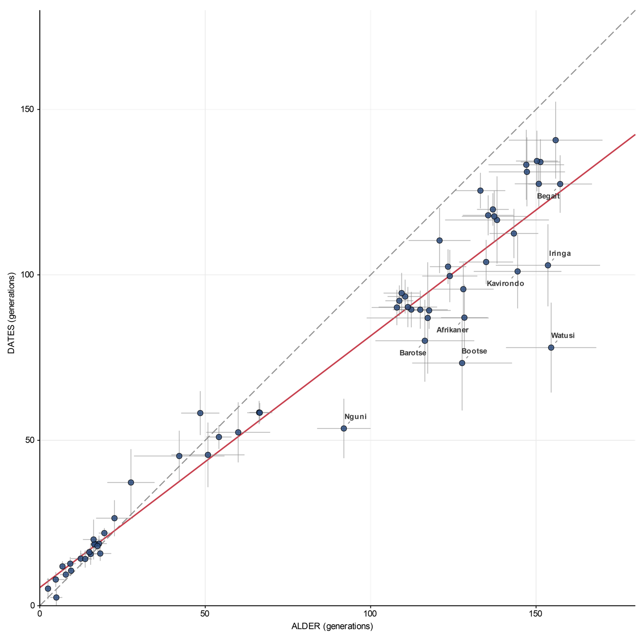
Supplementary Figure 9 | Concordance of ALDER and DATES admixture-time estimates. Per-population admixture times (generations) estimated by ALDER (x-axis) and DATES (y-axis), with horizontal and vertical bars giving the standard error of each estimate. The dashed line is the 1:1 expectation and the red line the fitted regression; selected populations discussed in the text are labelled.

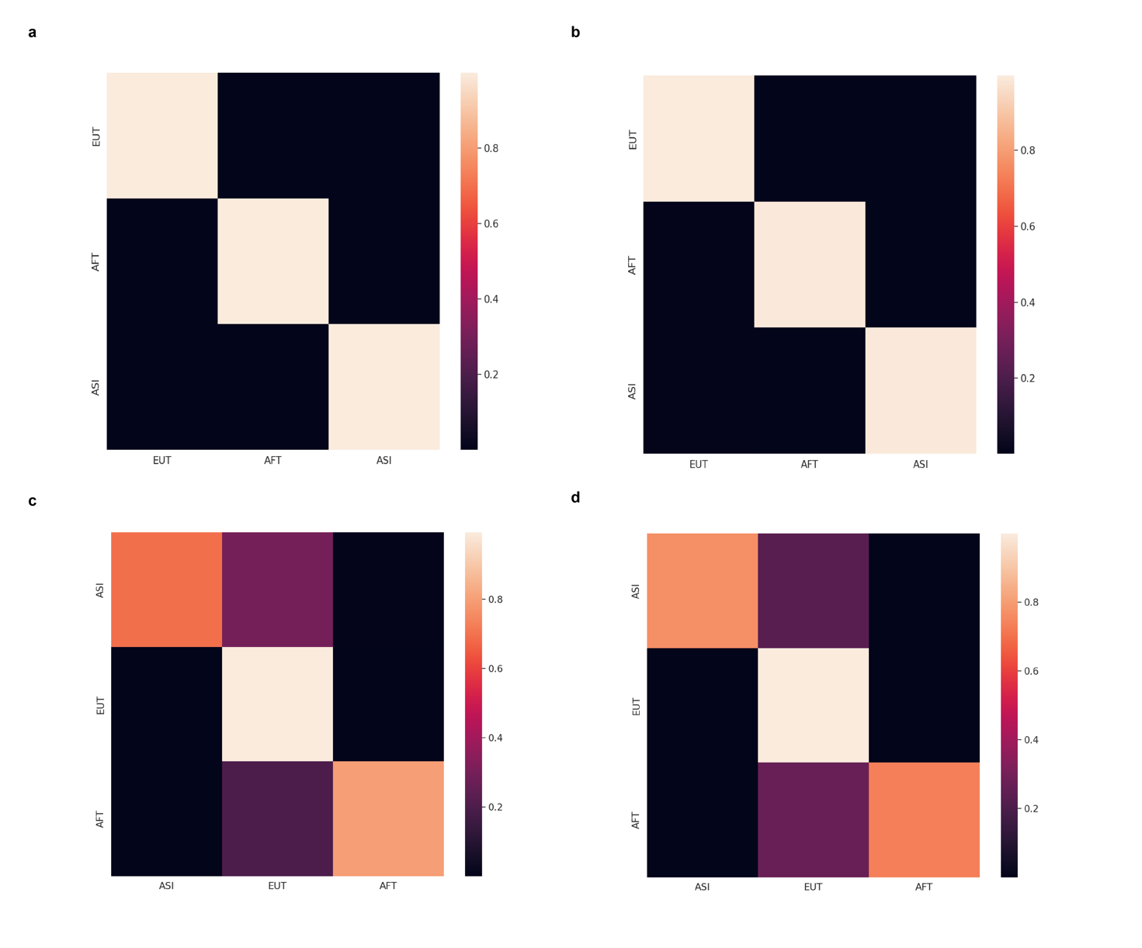
Supplementary Figure 10 | Gnomix cross-validation confusion matrices for candidate local-ancestry reference panels. Recovery of simulated European taurine (EUT), African taurine (AFT) and indicine (ASI) haplotypes under two competing reference schemes — the D-statistic-based panel (a, b) and the ADMIXTURE-based panel (c, d). Rows give the true simulated lineage and columns the inferred lineage, with shading the proportion of haplotypes assigned; the D-statistic panel recovers all three lineages essentially without error (per-class accuracy ≈ 1), whereas the ADMIXTURE panel misassigns ~30% of indicine and African taurine haplotypes to European taurine, motivating the choice of the D-statistic-based references (Supplementary Table 16) for downstream inference.

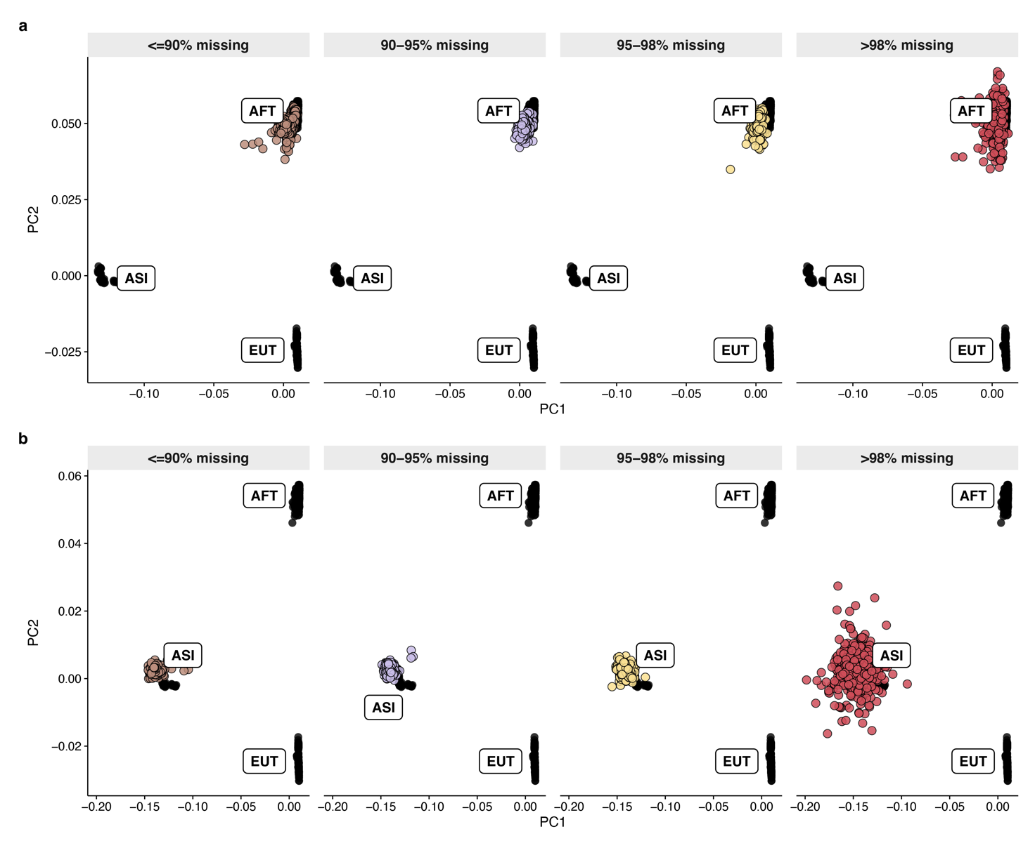
Supplementary Figure 11 | PCA projection of ancestry-masked genomes. Reference individuals from the three lineages (black; AFT, ASI, EUT) define the PCA space, onto which ancestry-masked admixed genomes are projected (lsqproject, smartpca), coloured and faceted by per-genome missingness. African-taurine-masked genomes (a) project onto the AFT reference cluster and indicine-masked genomes (b) onto ASI across missingness bins; projections remain stable up to 98% missingness and disperse only in the >98% bin.

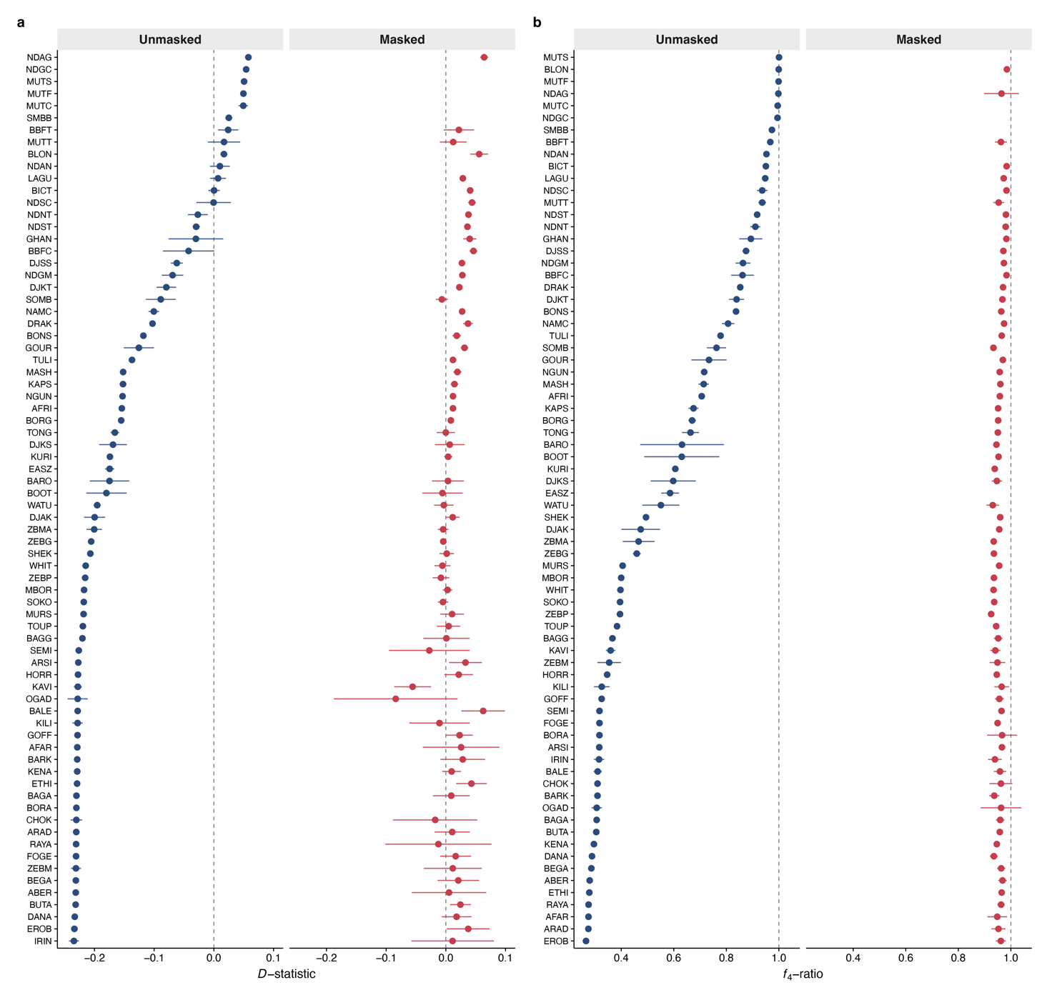
Supplementary Figure 12 | Ancestry masking removes residual admixture signal. Per-population D-statistics (a) and f4-ratio ancestry estimates (b) before (Unmasked) and after (Masked) restriction to high-confidence African taurine ancestry tracts. Points are per-population estimates with error bars; the dashed line marks the no-admixture expectation (D = 0 in a, f4-ratio = 1 in b).

Supplementary Table 1: All samples
Sample panel. All 4,893 individuals in the study (4,891 modern, 2 ancient), with accession, population, ancestry-group assignment, species and temporal status.

Supplementary Table 2: Unpublished
Newly sequenced genomes. The 1,381 individuals sequenced for this study, with metadata (population, country, sampling period, source) and per-sample Qualimap/MultiQC quality metrics including coverage, read and base counts, insert size, mapping quality and alignment rate.

Supplementary Table 3: D-statistics on modern samples
D-statistics, modern African cattle. Per-individual D-statistics for D(Hereford, X, Cholistani, Bison bison), testing indicine introgression in each modern African target X. Negative D indicates indicine ancestry; |Z| > 3 is treated as significant.

Supplementary Table 4: f₄-ratio for modern samples
f4-ratio ancestry proportions, modern African cattle. Per-individual African taurine (α) and indicine (1 − α) ancestry proportions with standard errors and Z-scores, carrying the matching D-statistic from Supplementary Table 3.

Supplementary Table 5: Taurine-indicine admixture dating on modern samples using ALDER
Admixture dating, modern populations (ALDER). Weighted-LD-decay admixture times in generations for 68 modern populations, with standard error, Z-score and P value.

Supplementary Table 6: Taurine-indicine admixture dating on modern samples using DATES
Admixture dating, modern populations (DATES). Ancestry-covariance admixture times in generations for 77 modern populations, with standard error and Z-score.

Supplementary Table 7: D-statistics on ancient samples
D-statistics, ancient African cattle. D-statistics for the Great Zimbabwe and Elsenburg genomes, as in Supplementary Table 3.

Supplementary Table 8: f₄-ratio for ancient samples
f4-ratio ancestry proportions, ancient African cattle. African taurine (α) and indicine (1 − α) proportions for the Great Zimbabwe and Elsenburg genomes, with standard error and Z-score.

Supplementary Table 9: Taurine-indicine admixture dating on ancient samples using DATES
Admixture dating, ancient African cattle (DATES). DATES admixture times in generations, with standard error and Z-score, for the Great Zimbabwe and Elsenburg genomes.

Supplementary Table 10: Outgroup-f₃ on modern African populations
Outgroup-f3. Pairwise f3(Pop1, Pop2; Bison bison) shared drift between African cattle populations.

Supplementary Table 11: Outgroup-f₃ between ancient and modern African populations
Outgroup-f3. Pairwise f3(Pop1, Pop2; Bison bison) shared drift between the two ancient samples, Great Zimbabwe and Elsenburg and modern African cattle populations.
Supplementary Table 12: African taurine ancestry-specific outgroup-f₃ on modern samples
African-taurine-specific outgroup-f3. Pairwise f3(Pop1, Pop2; Bison bison) shared drift within the African taurine ancestry component; comparisons based on fewer than 10,000 SNPs are flagged.

Supplementary Table 13: Indicine ancestry-specific outgroup-f₃ on modern samples
Indicine-specific outgroup-f3. As Supplementary Table 11, for the indicine ancestry component.

Supplementary Table 14: African taurine ancestry-specific outgroup-f₃ on ancient samples
African-taurine-specific outgroup-f3. Pairwise f3(Pop1, Pop2; Bison bison) shared drift within the African taurine ancestry component; comparisons based on fewer than 10,000 SNPs are flagged.

Supplementary Table 15: Indicine ancestry-specific outgroup-f₃ on ancient samples
Indicine-specific outgroup-f3. As Supplementary Table 11, for the indicine ancestry component.

Supplementary Table 16: Local ancestry inference reference individuals
Local ancestry inference reference panel. The 804 reference individuals used for local ancestry inference, each assigned to indicine, African taurine or European taurine ancestry.

Supplementary References
1. Hart, T. C. & Halkett, D. Archaeological Investigation of the Elsenburg Herehuis. (1993).
2. van Rijneveld, W. S., Thom, H. B., Murray, I. M. & Franken, J. L. M. Willem Stephanus van Ryneveld Se Aanmerkingen over de Verbetering van Het Vee Aan de Kaap de Goede Hoop, 1804. 5 p. l., 229 p. front., ports., facsims. 22 cm. (Die Van Riebeeck-vereniging, Kaapstad, 1942).
3. Boessenkool, S. et al. Combining bleach and mild predigestion improves ancient DNA recovery from bones. Mol. Ecol. Resour. 17, 742–751 (2017).
4. Kemp, B. M. & Smith, D. G. Use of bleach to eliminate contaminating DNA from the surface of bones and teeth. Forensic Sci. Int. 154, 53–61 (2005).
5. Rohland, N., Glocke, I., Aximu-Petri, A. & Meyer, M. Extraction of highly degraded DNA from ancient bones, teeth and sediments for high-throughput sequencing. Nat. Protoc. 13, 2447–2461 (2018).
6. Dabney, J. et al. Complete mitochondrial genome sequence of a Middle Pleistocene cave bear reconstructed from ultrashort DNA fragments. Proc. Natl. Acad. Sci. U. S. A. 110, 15758–15763 (2013).
7. Meyer, M. & Kircher, M. Illumina sequencing library preparation for highly multiplexed target capture and sequencing. Cold Spring Harb. Protoc. 2010, db.prot5448 (2010).
8. Prendergast, M. E. et al. Ancient DNA reveals a multistep spread of the first herders into sub-Saharan Africa. Science 365, eaaw6275 (2019).
9. MacHugh, D. E., Shriver, M. D., Loftus, R. T., Cunningham, P. & Bradley, D. G. Microsatellite DNA variation and the evolution, domestication and phylogeography of taurine and zebu cattle (Bos taurus and Bos indicus). Genetics 146, 1071–1086 (1997).
10. Freeman, A. R. et al. Admixture and diversity in West African cattle populations: GENETIC SURVEY OF WEST AFRICAN CATTLE. Mol. Ecol. 13, 3477–3487 (2004).
11. Hanotte, O. et al. African pastoralism: Genetic imprints of origins and migrations. Science 296, 336–339 (2002).
12. Troy, C. S. et al. Genetic evidence for Near-Eastern origins of European cattle. Nature 410, 1088–1091 (2001).
13. Meade, K. G. et al. Divergent antimicrobial peptide (AMP) and acute phase protein (APP) responses to Trypanosoma congolense infection in trypanotolerant and trypanosusceptible cattle. Mol. Immunol. 47, 196–204 (2009).
14. O’Gorman, G. M. et al. Transcriptional profiling of cattle infected with Trypanosoma congolense highlights gene expression signatures underlying trypanotolerance and trypanosusceptibility. BMC Genomics 10, 207 (2009).
15. O’Gorman, G. M. et al. Cytokine mRNA profiling of peripheral blood mononuclear cells from trypanotolerant and trypanosusceptible cattle infected with Trypanosoma congolense. Physiol. Genomics 28, 53–61 (2006).
16. McHugo, G. P. et al. Functional genomics of trypanotolerant and trypanosusceptible cattle infected with Trypanosoma congolense across multiple time points and tissues. PLoS Negl. Trop. Dis. 19, e0012882 (2025).
17. Van der Auwera, G. A. & O’Connor, B. D. Genomics in the Cloud : Using Docker, GATK, and WDL in Terra. (O’Reilly Media, Sebastopol, CA, 2020).
18. Rosen, B. D. et al. De novo assembly of the cattle reference genome with single-molecule sequencing. Gigascience 9, (2020).
19. Li, H. Aligning sequence reads, clone sequences and assembly contigs with BWA-MEM. arXiv [q-bio.GN] (2013) doi:10.48550/arXiv.1303.3997.
20. Fellows Yates, J. A. et al. Reproducible, portable, and efficient ancient genome reconstruction with nf-core/eager. PeerJ 9, e10947 (2021).
21. Schubert, M., Lindgreen, S. & Orlando, L. AdapterRemoval v2: rapid adapter trimming, identification, and read merging. BMC Res. Notes 9, 88 (2016).
22. Andrews, S. FastQC: A Quality Control tool for High Throughput Sequence Data. https://www.bioinformatics.babraham.ac.uk/projects/fastqc/ (2010).
23. Li, H. & Durbin, R. Fast and accurate short read alignment with Burrows-Wheeler transform. Bioinformatics 25, 1754–1760 (2009).
24. Danecek, P. et al. Twelve years of SAMtools and BCFtools. Gigascience 10, (2021).
25. Peltzer, A. et al. EAGER: efficient ancient genome reconstruction. Genome Biol. 17, 60 (2016).
26. Neukamm, J., Peltzer, A. & Nieselt, K. DamageProfiler: fast damage pattern calculation for ancient DNA. Bioinformatics 37, 3652–3653 (2021).
27. Okonechnikov, K., Conesa, A. & García-Alcalde, F. Qualimap 2: advanced multi-sample quality control for high-throughput sequencing data. Bioinformatics 32, 292–294 (2016).
28. Ewels, P., Magnusson, M., Lundin, S. & Käller, M. MultiQC: summarize analysis results for multiple tools and samples in a single report. Bioinformatics 32, 3047–3048 (2016).
29. Korneliussen, T. S., Albrechtsen, A. & Nielsen, R. ANGSD: Analysis of next generation sequencing data. BMC Bioinformatics 15, 356 (2014).
30. Chang, C. C. et al. Second-generation PLINK: rising to the challenge of larger and richer datasets. Gigascience 4, 7 (2015).
31. Ng’ang'a, S. I. et al. Accurate imputation of African cattle genomes using a diverse reference panel. BMC Genomics 1–9 (2026).
32. Rubinacci, S., Ribeiro, D. M., Hofmeister, R. J. & Delaneau, O. Efficient phasing and imputation of low-coverage sequencing data using large reference panels. Nat. Genet. 53, 120–126 (2021).
33. Meisner, J., Liu, S., Huang, M. & Albrechtsen, A. Large-scale inference of population structure in presence of missingness using PCA. Bioinformatics 37, 1868–1875 (2021).
34. Alexander, D. H., Novembre, J. & Lange, K. Fast model-based estimation of ancestry in unrelated individuals. Genome Res. 19, 1655–1664 (2009).
35. Patterson, N. et al. Ancient admixture in human history. Genetics 192, 1065–1093 (2012).
36. Qanbari, S. & Wittenburg, D. Male recombination map of the autosomal genome in German Holstein. Genet. Sel. Evol. 52, 73 (2020).
37. Ward, J. A. et al. Genome-wide local ancestry and evidence for mitonuclear coadaptation in African hybrid cattle populations. iScience 25, (2022).
38. Loh, P.-R. et al. Inferring admixture histories of human populations using linkage disequilibrium. Genetics 193, 1233–1254 (2013).
39. Chintalapati, M., Patterson, N. & Moorjani, P. The spatiotemporal patterns of major human admixture events during the European Holocene. Elife 11, (2022).
40. Chen, N. et al. Global genetic diversity, introgression, and evolutionary adaptation of indicine cattle revealed by whole genome sequencing. Nat. Commun. 14, 7803 (2023).
41. Hilmarsson, H. et al. High resolution ancestry deconvolution for next generation genomic data. bioRxiv 2021.09.19.460980 (2021) doi:10.1101/2021.09.19.460980.
42. Oksanen, J. et al. Vegan: Community Ecology Package. (2022).
43. Fick, S. E. & Hijmans, R. J. WorldClim 2: new 1‐km spatial resolution climate surfaces for global land areas: NEW CLIMATE SURFACES FOR GLOBAL LAND AREAS. Int. J. Climatol. 37, 4302–4315 (2017).
44. Temple, S. D. & Browning, S. R. Multiple-testing corrections in selection scans using identity-by-descent segments. Am. J. Hum. Genet. 112, 2751–2771 (2025).
45. Felius, M. Cattle Breeds of the World. (Brill, Leiden, Netherlands, 2024). doi:10.1163/9789004708143.
46. Carew, S., Sandford, J., Wissocq, Y. J., Durkin, J. & Trail, J. N’dama cattle productivity at Teko Livestock Station, Sierra Leone, and initial results from cross-breeding with Sahiwal. LCA Bulletin No. 23, (1986).
47. Haile-Mariam, M. & Philipson, J. Estimates of genetic and environmental trends of growth traits in Boran cattle. J. Anim. Breed. Genet. 113, 43–55 (1996).
48. Alim, K. A. Reproductive rates and milk yield of Kenana cattle in Sudan. J. Agric. Sci. 55, 183–188 (1960).
49. Abin, S., Theron, H. E. & van Marle-Koster, E. Population structure and genetic trends for indigenous African beef cattle breeds in South Africa. S. Afr. J. Anim. Sci. 46, 152–156 (2016).
50. Benjamini, Y. & Hochberg, Y. Controlling the false discovery rate: A practical and powerful approach to multiple testing. J. R. Stat. Soc. Series B Stat. Methodol. 57, 289–300 (1995).

