Table S1: FFQ food items constituting the 18 food groups of the PDI, hPDI, and uPDI.
Plant food groups
Healthy plant-based foods
Whole grains | Whole grain bread, whole grain buns, cereal, oats, muesli
Fruits | Apples, pears, oranges, kiwis, pineapple, bananas, fresh figs, physalis, pomegranate, cherries, plums, mirabelles, apricots, grapes, peaches, nectarines, berries, melons, stewed fruits, canned fruits, fresh fruit salad
Vegetables | Tomatoes (fresh or cooked), tomato sauce (from fresh or canned tomatoes), bell peppers (fresh or cooked), green salads, lettuce, cucumber, pickles, sauerkraut, spinach, carrots (raw or cooked), white/green/red cabbage, brussels sprouts, broccoli, cauliflower, kohlrabi (raw or cooked), asparagus, eggplant, zucchini, mixed vegetables, mushrooms, avocado, olives, vegetable juice, onions, garlic
Nuts | Nuts (fresh, roasted, salted; including peanuts, almonds, pistachios, trail mix)
Legumes | Legumes (e.g., beans, peas, lentils, chickpeas)
Vegetable oils | Olive oil, rapeseed oil, other vegetable oils
Coffee and tea | Coffee, espresso, decaffeinated coffee, green or black tea
Less healthy plant-based foods
Fruit juices | Orange juice, apple juice, multivitamin fruit juice, other fruit juices
Sugar-sweetened beverages | Lemonade, Cola
Refined grains | Wheat bread, baguette, toast, flatbread, lye pastries, croissant, “Splitterbrötchen”, rice, pasta, barley, other grains, salty biscuits, salty snacks (e.g., crackers, chips, pretzels, salty sticks)
Potatoes | Potatoes, mashed potatoes, potato dumplings, other potato preparations (e.g., fried or roast potatoes, French potatoes, hash browns, potato salad)
Sweets/desserts | Chocolates, candy with chocolate (e.g. candy bars, pralines, dried fruit with chocolate cover), candy without chocolate (e.g., gummy bears, hard candy, licorice), desserts (e.g. ice cream, mousse au chocolat, pudding, tiramisu, fruit quark, red fruit jelly), fruit cake, yeast pastry, yeast cake (e.g., cinnamon roll, bee sting cake), cheese cake, cream cake, sponge cake (e.g., marble cake, Bundt cake, muffin), cookies, biscuits (e.g., butter biscuits, sandwich biscuit), jam, honey, sugar syrup, nougat spread, chocolate spread
Animal food groups
Animal fats | Butter, other animal fat, deep frying fats
Dairy | Milk, cocoa drink, milkshake, milk-based beverage, fruit yogurt and yogurt with other flavors, buttermilk, natural yogurt, thick milk, kefir, cream, crème fraîche, quark, herb quark, cream cheese, cottage cheese, soft cheese (e.g., Camembert, mozzarella, feta), sour milk cheese (e.g., Harzer cheese), semi-hard cheese, hard cheese (e.g., Gouda, Parmesan, Emmental)
Eggs | Eggs and egg products
Fish/seafood | Fish, fresh, canned (e.g., herring, tuna, salmon, pollock, trout), fish preparation (e.g., fish sticks, gourmet fillet), seafood (e.g., shrimp, squid, mussels)
Meat (poultry and red meat) | Beef, veal, pork, mutton, lamb, horse, goat, chicken, hen, turkey, duck, goose, rabbit, game, processed meat, offals
Miscellaneous animal-based foods | Stew with meat content (e.g., vegetable, lentil, or bean stew with meat), cream soups (e.g., made from pumpkin, asparagus, broccoli), mayonnaise, remoulade, dishes with meat content (e.g., casseroles, lasagna, pizza, döner, filled puff pastry pockets)

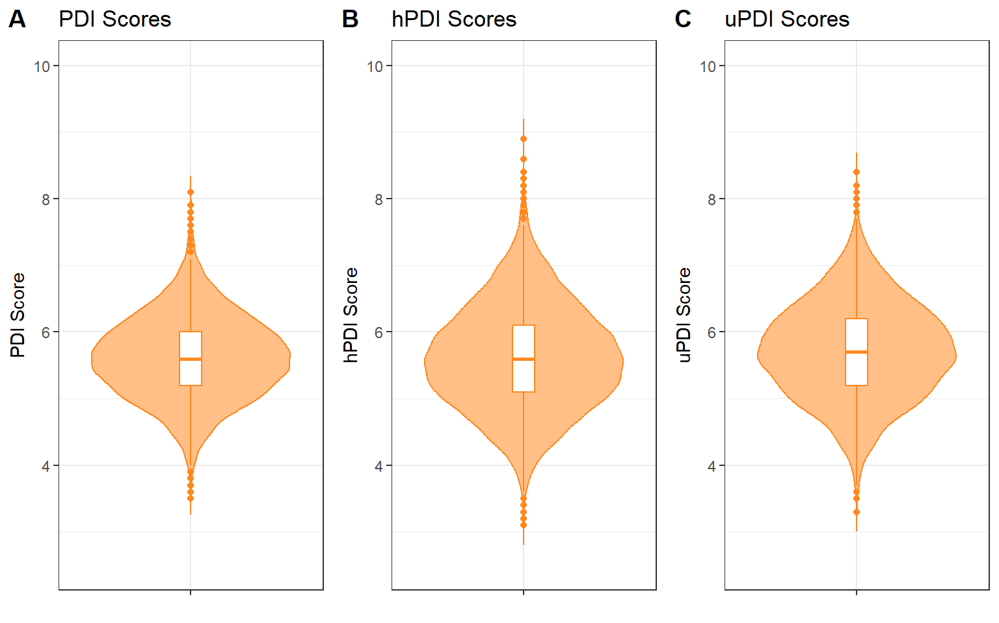
Figure S1: Distribution of PDI, hPDI, and uPDI.

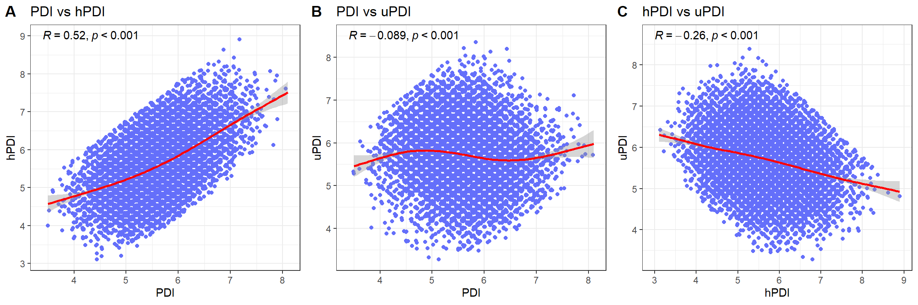
Figure S2: Correlations between PDI scores.

Table S2: Baseline characteristics of the participants, stratified by PDI, hPDI, uPDI quintiles, respectively.
Characteristics | Overall | PDI Score – Quintiles |  |  |  |  | p-value² | hPDI Score – Quintiles |  |  |  |  | p-value² | uPDI Score - Quintiles |  |  |  |  | p-value²
 | N = 9,144¹ | [3.5,5.1] | [5.2,5.5] | [5.6,5.8] | [5.9,6.2] | [6.3,8.1] |  | [3.2,4.9] | [5.0,5.4] | [5.5,5.8] | [5.9,6.3] | [6.4,8.9] |  | [3.3,5.1] | [5.2,5.5] | [5.6,5.9] | [6.0,6.3] | [6.4,8.2]
 |  | N = 2019 (22%)¹ | N = 2109 (23%)¹ | N = 1715 (19%)¹ | N = 1833 (20%)¹ | N = 1468 (16%)¹ |  | N = 1846 (20%)¹ | N = 2039 (22%)¹ | N = 1770 (19%)¹ | N = 1766 (19%)¹ | N = 1723 (19%)¹ |  | N = 2095 (23%)¹ | N = 1730 (19%)¹ | N = 1935 (21%)¹ | N = 1660 (18%)¹ | N = 1724 (19%)¹
Sociodemographics
Sex |  |  |  |  |  |  | <0.001 |  |  |  |  |  | <0.001 |  |  |  |  |  | <0.001
Male | 4,625 (51%) | 1,373 (68%) | 1,173 (56%) | 850 (50%) | 757 (41%) | 472 (32%) |  | 1,412 (76%) | 1,235 (61%) | 863 (49%) | 684 (39%) | 431 (25%) |  | 995 (47%) | 853 (49%) | 954 (49%) | 898 (54%) | 925 (54%)
Female | 4,519 (49%) | 646 (32%) | 936  (44%) | 865 (50%) | 1,076 (59%) | 996 (68%) |  | 434 (24%) | 804 (39%) | 907 (51%) | 1,082 (61%) | 1,292 (75%) |  | 1,100 (53%) | 877 (51%) | 981 (51%) | 762 (46%) | 799 (46%)
Age (years) | 60.0 (53.0,  67.0) | 61.0 (54.0,  69.0) | 60.0 (54.0,  68.0) | 60.0 (53.0,  68.0) | 60.0 (53.0,  67.0) | 58.0 (52.0,  65.0) | <0.001 | 59.0 (52.0,  67.0) | 60.0 (53.0,  67.0) | 60.0 (53.0,  68.0) | 60.0 (53.0,  68.0) | 60.0 (54.0,  67.0) | 0.001 | 60.0 (53.0,  67.0) | 60.0 (53.0,  68.0) | 60.0 (53.0,  67.0) | 59.0 (53.0,  67.0) | 60.0 (53.0,  68.0) | 0.728
Education |  |  |  |  |  |  | <0.001 |  |  |  |  |  | 0.020 |  |  |  |  |  | <0.001
Low | 168 (2.0%) | 51 (2.8%) | 44 (2.3%) | 22 (1.4%) | 28 (1.7%) | 23 (1.7%) |  | 41 (2.4%) | 38 (2.0%) | 35 (2.2%) | 32 (2.0%) | 22 (1.4%) |  | 24 (1.2%) | 33 (2.1%) | 33 (1.9%) | 32 (2.1%) | 46 (3.0%)
Medium | 3,917 (47%) | 932 (51%) | 916  (48%) | 770 (49%) | 758 (45%) | 541 (40%) |  | 804 (48%) | 915 (49%) | 771 (48%) | 750 (46%) | 677 (44%) |  | 796 (41%) | 677 (43%) | 818 (46%) | 743 (49%) | 883 (57%)
High | 4,249 (51%) | 836 (46%) | 946  (50%) | 785 (50%) | 885 (53%) | 797 (59%) |  | 832 (50%) | 912 (49%) | 817 (50%) | 832 (52%) | 856 (55%) |  | 1,108 (57%) | 859 (55%) | 921 (52%) | 743 (49%) | 618 (40%)
(Missing) | 810 | 200 | 203 | 138 | 162 | 107 |  | 169 | 174 | 147 | 152 | 168 |  | 167 | 161 | 163 | 142 | 177
Cardiovask. risk factors
Hypertension | 5,485 (62%) | 1,392 (71%) | 1,365 (67%) | 1,002 (60%) | 1,001 (57%) | 725 (51%) | <0.001 | 1,225 (69%) | 1,288 (66%) | 1,060 (61%) | 995 (58%) | 917 (55%) | <0.001 | 1,212 (60%) | 1,021 (61%) | 1,134 (60%) | 1,019 (64%) | 1,099 (65%) | 0.001
(Missing) | 300 | 62 | 58 | 58 | 71 | 51 |  | 63 | 73 | 45 | 64 | 55 |  | 65 | 63 | 59 | 68 | 45
BMI (kg/m²) | 25.9 (23.4,  28.9) | 27.0 (24.4,  30.2) | 26.3 (23.7,  29.2) | 25.8 (23.4,  28.7) | 25.5 (23.0,  28.6) | 24.6 (22.2,  27.2) | <0.001 | 26.5 (24.3,  29.7) | 26.4 (23.9,  29.4) | 25.9 (23.5,  28.9) | 25.7 (23.2,  28.6) | 24.6 (22.2,  27.8) | <0.001 | 26.0 (23.5,  29.2) | 25.8 (23.4,  29.0) | 25.6 (23.1,  28.5) | 25.9 (23.5,  28.8) | 26.1 (23.5,  29.1) | 0.038
(Missing) | 563 | 112 | 127 | 113 | 110 | 101 |  | 106 | 127 | 107 | 115 | 108 |  | 131 | 107 | 124 | 98 | 103
Hyperlipoproteinemia | 1,877 (22%) | 538 (28%) | 465 (23%) | 332 (21%) | 324 (19%) | 218 (16%) | <0.001 | 435 (25%) | 467 (24%) | 388 (23%) | 324 (19%) | 263 (16%) | <0.001 | 397 (20%) | 357 (22%) | 389 (21%) | 340 (22%) | 394 (24%) | 0.042
(Missing) | 497 | 118 | 122 | 96 | 94 | 67 |  | 123 | 112 | 77 | 98 | 87 |  | 105 | 100 | 97 | 99 | 96
Diabetes | 664 (7.8%) | 234 (13%) | 192 (9.7%) | 92  (5.8%) | 93  (5.4%) | 53  (3.8%) | <0.001 | 149 (8.7%) | 173 (9.1%) | 131 (7.8%) | 124 (7.5%) | 87  (5.4%) | <0.001 | 164 (8.4%) | 116 (7.2%) | 135 (7.4%) | 109 (7.1%) | 140 (8.6%) | 0.301
(Missing) | 597 | 148 | 125 | 122 | 114 | 88 |  | 131 | 130 | 101 | 118 | 117 |  | 138 | 113 | 122 | 119 | 105
Smoking |  |  |  |  |  |  | <0.001 |  |  |  |  |  | <0.001 |  |  |  |  |  | <0.001
Current | 1,708 (19%) | 489 (24%) | 409  (19%) | 290 (17%) | 311 (17%) | 209 (14%) |  | 425 (23%) | 418 (21%) | 352 (20%) | 282 (16%) | 231 (13%) |  | 303 (15%) | 305 (18%) | 347 (18%) | 342 (21%) | 411 (24%)
Former | 3,814 (42%) | 871 (43%) | 865  (41%) | 710 (42%) | 749 (41%) | 619 (42%) |  | 721 (39%) | 843 (42%) | 753 (43%) | 757 (43%) | 740 (43%) |  | 953 (46%) | 740 (43%) | 804 (42%) | 673 (41%) | 644 (38%)
Never | 3,581 (39%) | 644 (32%) | 826  (39%) | 707 (41%) | 769 (42%) | 635 (43%) |  | 693 (38%) | 770 (38%) | 655 (37%) | 718 (41%) | 745 (43%) |  | 830 (40%) | 677 (39%) | 774 (40%) | 640 (39%) | 660 (38%)
(Missing) | 41 | 15 | 9 | 8 | 4 | 5 |  | 7 | 8 | 10 | 9 | 7 |  | 9 | 8 | 10 | 5 | 9
Biomarkers
Triglycerides (mg/dL) | 97.0 (72.0,  137.0) | 106.0 (77.0,  156.0) | 100.0 (73.0,  138.0) | 98.0 (72.0,  135.0) | 93.0 (70.0,  128.0) | 90.0 (67.0,  123.0) | <0.001 | 108.5 (79.0,  153.0) | 101.0 (74.0,  143.0) | 98.0 (73.0,  138.0) | 92.0 (69.0,  128.0) | 88.0 (66.0,  121.0) | <0.001 | 94.0 (70.0,  132.0) | 95.0 (70.0,  131.0) | 98.0 (71.0,  136.0) | 99.0 (73.0,  140.0) | 104.0 (76.0,  148.0) | <0.001
(Missing) | 204 | 50 | 48 | 45 | 30 | 31 |  | 50 | 33 | 37 | 43 | 41 |  | 42 | 33 | 47 | 33 | 49
HDL-Cholesterol (mg/dL) | 61.0 (49.0,  74.0) | 57.0 (46.0,  70.0) | 60.0 (49.0,  73.0) | 61.0 (49.0,  74.0) | 63.0 (51.0,  77.0) | 64.0 (52.0,  77.0) | <0.001 | 55.0 (45.0,  67.0) | 58.0 (48.0,  71.0) | 61.0 (49.0,  74.5) | 64.0 (51.0,  77.0) | 67.0 (55.0,  80.0) | <0.001 | 63.0 (51.0,  76.0) | 61.0 (50.0,  75.0) | 61.0 (49.0,  75.0) | 60.0 (50.0,  73.0) | 58.0 (48.0,  71.0) | <0.001
(Missing) | 207 | 50 | 48 | 46 | 31 | 32 |  | 50 | 35 | 38 | 43 | 41 |  | 43 | 33 | 48 | 33 | 50
LDL-Cholesterol (mg/dL) | 122.0 (99.0,  147.0) | 123.0 (100.0,  147.0) | 122.0 (99.0,  146.0) | 123.0 (100.0,  147.0) | 123.0 (100.0,  147.0) | 120.0 (99.0,  144.0) | 0.583 | 123.0 (101.0,  146.0) | 122.0 (99.0,  146.0) | 124.0 (99.5,  150.0) | 121.5 (99.0,  145.0) | 121.0 (99.0,  144.5) | 0.073 | 121.0 (100.0,  145.0) | 125.0 (102.0,  149.0) | 122.0 (99.0,  147.0) | 123.0 (99.0,  147.5) | 120.0 (98.0,  145.0) | 0.011
(Missing) | 290 | 81 | 70 | 58 | 44 | 37 |  | 78 | 57 | 50 | 54 | 51 |  | 57 | 47 | 68 | 48 | 70
Non-HDL-Cholesterol (mg/dL) | 144.0 (119.0,172.0) | 148.0 (122.0,  174.0) | 144.0 (120.0,  172.0) | 145.0 (120.0,  172.0) | 144.0 (118.0,  170.0) | 140.0 (116.0,  167.5) | <0.001 | 147.0 (124.0,  174.0) | 146.0 (119.0,  171.0) | 146.0 (119.0,  176.0) | 142.0 (117.0,  168.0) | 140.0 (116.0,  168.0) | <0.001 | 143.0 (118.5,170.0) | 146.0 (121.0,  173.0) | 144.0 (118.0,  171.0) | 145.0 (119.0,  172.0) | 144.5 (119.0,  171.0) | 0.165
(Missing) | 207 | 50 | 48 | 46 | 31 | 32 |  | 50 | 35 | 38 | 43 | 41 |  | 43 | 33 | 48 | 33 | 50
eGFR (ml/min/  1.73m²) | 86.8 (76.5,  95.1) | 86.0 (75.1,  94.7) | 86.9 (76.6,  95.1) | 86.2 (75.8,  94.7) | 87.0 (77.1,  94.7) | 88.2 (78.2,  96.7) | <0.001 | 86.6 (76.6,  95.1) | 86.8 (76.8,  95.2) | 86.5 (76.1,  94.5) | 85.9 (75.4,  94.6) | 88.2 (77.7,  95.9) | 0.001 | 87.8 (77.8,  95.4) | 86.8 (76.1,  94.9) | 87.4 (77.0,  95.3) | 86.4 (75.8,  95.1) | 85.1 (75.3,  94.3) | <0.001
(Missing) | 225 | 59 | 50 | 49 | 31 | 36 |  | 53 | 38 | 38 | 49 | 47 |  | 46 | 35 | 51 | 37 | 56
Dietary Scores
PDI Score | 5.6 (5.2,  6.0) |  |  |  |  |  |  | 5.2 (4.9,5.6) | 5.5 (5.1,5.9) | 5.6 (5.2,6.0) | 5.8 (5.4,6.2) | 6.1 (5.7,6.5) | <0.001 | 5.7 (5.3,6.1) | 5.7 (5.2,6.1) | 5.6 (5.2,6.1) | 5.6 (5.2,6.0) | 5.5 (5.2,5.9) | <0.001
hPDI Score | 5.6 (5.1,  6.2) | 5.1 (4.7,5.6) | 5.4 (4.9,5.9) | 5.7 (5.1,6.1) | 5.8 (5.3,6.4) | 6.3 (5.8,6.8) | <0.001 |  |  |  |  |  |  | 5.9 (5.4,6.4) | 5.7 (5.1,6.2) | 5.6 (5.0,6.2) | 5.5 (4.9,6.0) | 5.3 (4.9,5.8) | <0.001
uPDI Score | 5.7 (5.2,  6.2) | 5.8 (5.3,6.3) | 5.8 (5.2,6.3) | 5.7 (5.2,6.2) | 5.6 (5.1,6.1) | 5.6 (5.2,6.0) | <0.001 | 5.9 (5.5,6.4) | 5.8 (5.3,6.3) | 5.7 (5.2,6.2) | 5.6 (5.1,6.1) | 5.4 (4.9,5.9) | <0.001
¹ Median (IQR) for continuous; n (%) for categorical
² Pearson’s Chi-squared test; Kruskal-Wallis rank sum test
BMI: Body Mass Index, hPDI: healthful plant-based diet index, eGFR: estimated glomerular filtration rate, HDL: high-density-lipoprotein, hsCRP: high-sensitivity C-reactive protein, LDL: low-density-lipoprotein, PDI: plant-based diet index, uPDI: unhealthful plant-based diet index.

