Supporting materials

Movie file
Figure S1 Anting behaviour of juvenile individual of Japanese gray thrush Turdus cardis. It often holds a posture of spread and stretched wings as stereotyped forms of anting and performs often wiping ants onto the plumage.

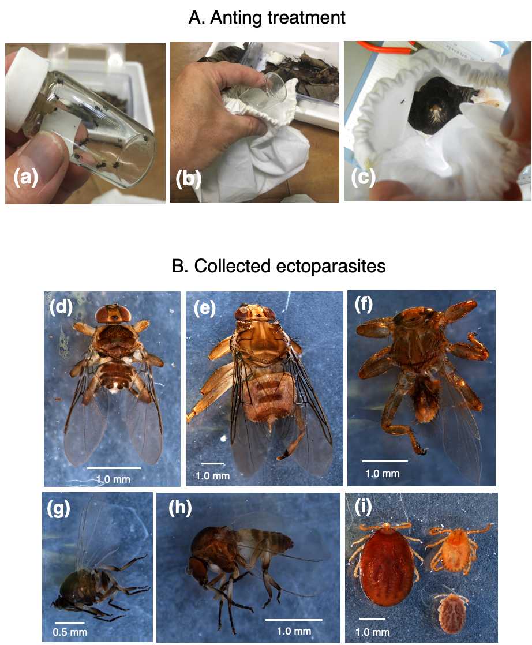

Figure S2
A. (a) Ant workers used in the experiments. (b) Adding of ants into cloth bag which in T. cardis was put. (c) T. cardis and ants into the bag.
B. Dipteran insects and mites collected in anting treatment experiments. Louse flies: (d) Ornithoica momiyamai, (e) Ornithomya chloropus extensa and (f) Lipoptena fortisetosa. Black flies: (g) and (h) Simulium spp.. Blood-sucking mites: (i) Ixodidae species.

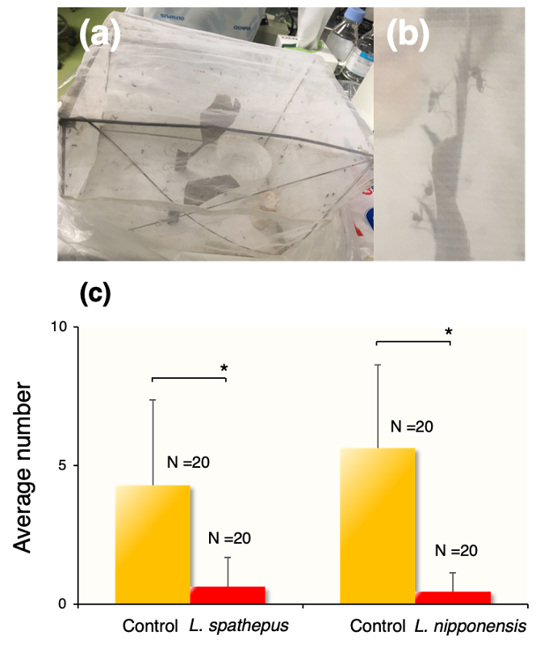

Figure S3 Experiments of repellent effects in anting on mosquitoes. (a) The mesh cages in which mosquitoes and feather pieces were placed for experiments. (b) The mosquitoes Aedes albopictus and A. flavopictus remaining on the feather pieces in the cage. (c) Average number of mosquitoes remaining for more than 5 seconds on feather pieces of anting treatments (red bar) and no treatment (yellow bar) were shown. Ant name means species using the experimental treatment respectively. The error bar shows the standard deviation value. The difference of average number was tested using GLM anova, *: p < 0.0001.

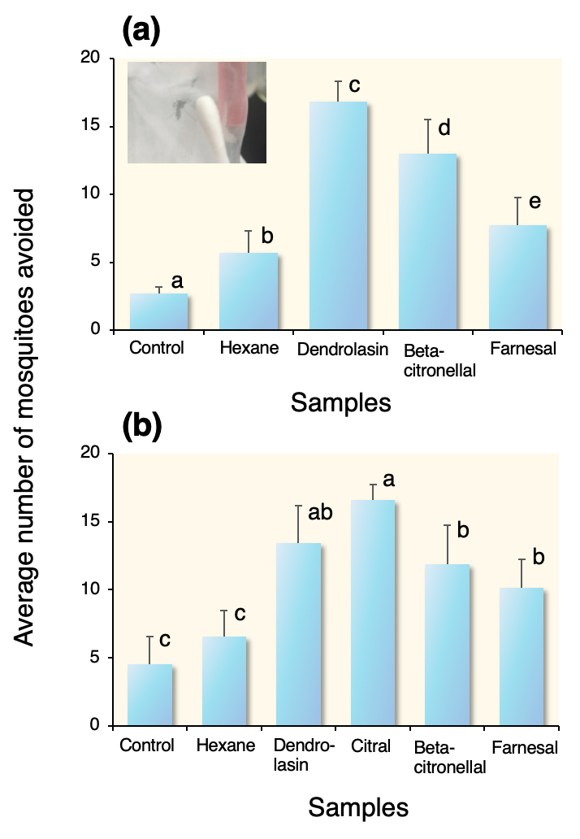

Figure S4 Approach of cotton swab including some chemical substances to mosquitoes. Average number of mosquitoes avoided the component of chemical substances emitted by (a) L. spathepus and (b) L. nipponensis. Alphabets on bars means the significance of statistical difference (p < 0.05, GLM anova, Tukey-Kramer honestly significant difference test).

Table S1 The chemical structures of nine peaks identified by GC-MS analyses. Alphabets mean the peaks shown in Fig. 1.

Peak | Chemical structures
a | beta-citronellal
b | Dendrolasin
c | Farnesal
d | Unknown 1
e | Citronellal (3,7-dimethyl-6-octenal)
f | Citral (3,7-dimethyl-2Z,6-octadecadienal)
g | Citral (3,7-dimethyl-2E,6-octadienal)
h | 3,7-dimethyl-octanol
i | Unknown 2

Table S2 Dipteran insects collected in the anting treatment experiments.

Family | Species | Collected number
Hippoboscidae | Ornithoica momiyamai | 39
 | Ornithomya chloropus extensa | 5
 | Lipoptena fortisetosa | 1
Simuliidae | Simulium spp. | 8

Table S3 Experiments of insecticidal effects of ant’s chemical substances on ectoparasites. As ectoparasites, louse flies, blood-sucking mites, feather mites and lice were collected from T. cardis and other Turdus species and used for the experiments. For anting treatments, workers of L. spathepus and L. nipponensis were used. P value shows the significance of difference among control and the experimental treatments of two ant species (GLM).

Experimental groups | Treatments | Number |  | Rate (%) | p
Experimental groups | Treatments | Trial | Dead | Rate (%) | p
Louse flies
Ornithoica momiyamai | Control | 8 | 0 | 0 | -
 | L. spathepus | 8 | 4 | 50.0 | 0.008
 | L. nipponensis | 8 | 5 | 62.5 | 0.002
Blood-sucking mites
Ixodidae spp. | Control | 24 | 0 | 0
 | L. spathepus | 24 | 1 | 4.0 | 0.23
 | L. nipponensis | 13 | 0 | 0 | -
Feather mites
Analgidae spp. | Control | 23 | 1 | 4.1 | 0.2
 | L. nipponensis | 28 | 0 | 0 | -
Lice
Amblycera spp. | Control | 24 | 0 | 0 | -
 | L. spathepus | 26 | 0 | 0 | -
 | L. nipponensis | 34 | 0 | 0 | -

