Supplementary Information

Ingestion of Poly-Ethylene Terephthalate Nanofragments Derived from Plastic Bottles Triggers Long-term Gut Inflammation and Microbiome Dysbiosis in Mice

Aswin Kuttykattil^{1,2,3}, Hannes R. Van Goethem⁴, Raquel Egea⁴, Arnau Rocabert⁴, Adriana Rodríguez-Garraus^{5,6}, Sonja Holme^{1,2,3}, Aliro Villacorta^{4,7}, Alba Garcia Rodriguez⁴, Julia Catalán^{5,8}, Ricard Marcos⁴, Alba Hernandez⁴, Thomas Loret^{1,2,3,9}, Cyrill Bussy^{1,2,3}

1. Division of Immunology, Immunity to Infection and Respiratory Medicine, School of Biological Sciences, Faculty of Biology, Medicine and Health, The University of Manchester, United Kingdom
2. Lydia Becker Institute, Faculty of Biology, Medicine and Health, The University of Manchester, United Kingdom
3. Manchester Environmental Research Institute, The University of Manchester, United Kingdom
4. Group of Mutagenesis, Department of Genetics and Microbiology, Faculty of Biosciences, Universitat Autònoma de Barcelona, Cerdanyola del Vallès, Spain
5. Finnish Institute of Occupational Health, Helsinki, Finland
6. Department of Pharmaceutical Sciences, School of Pharmacy and Nutrition, Universidad de Navarra, 31008 Pamplona, Spain
7. Facultad de Recursos Naturales Renovables, Universidad Arturo Prat, Iquique, Chile
8. Department of Anatomy, Embryology and Genetics, University of Zaragoza, Zaragoza, Spain
9. Experimental Toxicology and Modelling Unit, French National Institute for Industrial Environment and Risks (Ineris), Verneuil‑en‑Halatte, France

Key words: microplastics; nanomaterials; emerging contaminant; environmental health; gastrointestinal tract;

Correspondence should be addressed to: cyrill.bussy@manchester.ac.uk

Supplementary Material and Methods

S1.1. Detailed procedure for comet assay
To preserve DNA integrity during tissue processing, all equipment (crusher, piston, tubes) and tissue samples were maintained on dry ice throughout the procedure. Each tissue sample was placed in a stainless-steel crusher with the piston positioned above. A single controlled strike with a hammer was applied to generate a tissue disc. The disc was immediately transferred to a 5 mL tube containing 1 mL of cold Hank’s complete solution (Thermo Scientific, Rockford, USA ) , supplemented with 20 mM EDTA, pH 7.5, adjusted with 3 M NaOH and 10% dimethyl sulfoxide. The crusher was wiped with a sterile tissue and returned to dry ice between samples to minimise contamination and preserve low temperature. Tissue suspensions were disaggregated by pipetting up-and-down, and tubes were placed on ice until further processing.
For embedding in agarose, 30 µL of the disaggregated tissue suspension was mixed with 120 µL of 1% low-melting-point agarose (i.e., 0.8% final concentration; Merck, Darmstadt, Germany). Aliquots of 40 µL were dispensed onto pre-cleaned glass slides and overlaid with 24 × 24 mm coverslips. Slides were placed on a cold metal tray for 10 min to allow gel solidification. After gelation, coverslips were removed, and slides were immersed in pre-cooled (4°C) lysis solution (2.5 M NaCl, 100 mM EDTA, 10 mM Trizma base, adjusted to pH 10.0, supplemented with 10% DMSO and 1% Triton X-100) overnight at 4 °C.
Following lysis, the slides were placed into a pre-cooled (4°C) horizontal gel electrophoresis chamber containing freshly prepared alkaline electrophoresis buffer (pH > 13) to undergo alkaline unwinding for 30 min at room temperature, followed by electrophoresis at 0.67 V/cm for 20 min. After electrophoresis, the slides were neutralised by immersion in 4°C cold 1× PBS for 10 min, followed by rinsing in 4°C cold distilled water for an additional 10 min. Slides were air-dried at room temperature.
To visualise DNA migration, 25 µL of 1× Ethidium Bromide was applied to each gel, and 20 × 50 mm coverslips were placed on top. Comet images were captured using a fluorescence microscope (Axioplan 2, Zeiss, Jena, Germany) equipped with image analysis software (Komet 7.1, Andor an Oxford Instruments company ,UK).

S1.2. Genomic DNA extraction of caecum samples
To extract the different micro-organisms present in the Mus musculus gut microbiota, the ZymoBiomics kit (Zymo Research Corporation, Orange, CA, USA) was used. The workflow involved homogenising the samples and then transferring them in a bead-beating tube containing ultrahigh-density Bashing Beads (Zymo Research Corporation, Orange, CA, USA) for rapid and thorough homogenization. Post-lysis, inhibitors were removed using Inhibitor Removal Technology® (IRT) (Zymo Research Corporation, Orange, CA, USA) and the total genomic DNA was captured on a silica membrane using a spin column. DNA was then washed and eluted. The isolated genomic DNA was quantified using a Qubit 4 Fluorometer (Thermo Fisher Scientific). The amount of sample used was 1 µl which allowed for the precise quantification of approximately 0.1 to 120 ng of DNA sample. Lastly, the DNA is stored at -20 °C for further use.

S1.3. 16S rRNA gene amplification
To identify taxonomic units, the amplification of the V1-V9 region (9 hypervariable regions) of the 16S rRNA gene was done using tailed primers. PCR amplification was performed in a 25 µL reaction containing 12.5 µL LongAmp® Hot Start Taq 2X Master Mix (New England Biolabs), 0.4 µM of each primer, 15 ng of template DNA, and nuclease-free water. Reactions were run on a BIOER XP thermal cycler with the following cycling conditions: initial denaturation at 95 °C for 3 min; 5 cycles of 95 °C for 15 s, 55 °C for 15 s, and 65 °C for 90 s; followed by 30 cycles of 95 °C for 15 s, 62 °C for 15 s, and 65 °C for 90 s; with a final extension at 65 °C for 2 min.

S1.4. Library Preparation and Oxford Nanopore Sequencing Workflow
To prepare amplicons for sequencing, 16S rRNA gene PCR products were purified using the AMPure XP beads system (Beckman Coulter, Inc.) at a bead-to-sample volume ratio of 1:1, following the manufacturer's instructions. Purified DNA was quantified using a Qubit 4 Fluorometer (Thermo Fisher Scientific) with 1 µL sample input, suitable for detection in the range of 0.1–120 ng.
Barcoding was done by EXP-PBC096 barcoding kit (Oxford Nanopore Technologies). Each barcoding reaction included the PCR product, LongAmp® Taq 2X Master Mix (New England Biolabs) and a unique barcode. Thermocycling conditions include: initial denaturation at 95°C (3 min), followed by 15 cycles of 95°C (15 s), 62°C (15 s), and 65°C (90 s), and then a final extension at 65°C (2 min). Barcoded samples were purified again using AMPure XP beads (1:1 ratio) and eluted in 20 µL of Milli-Q water. Samples were pooled in equimolar ratios to a total of 3000 ng in a final volume of 147 µL in a microtube. If the pooled volume exceeded 147 µL, a secondary purification step was performed. The pooled DNA library was quantified using a Qubit 4 Fluorometer and then stored at –20 °C overnight.
End-repair (5′ phosphorylation and 3′ tailing) was carried out using 49 µL of the pooled DNA, 1 µL of DNA control, 7 µL of NEBNext Ultra II End Prep Reaction Buffer, and 3 µL of NEBNext Ultra II End Prep Enzyme Mix (New England Biolabs). The reaction was incubated at 20 °C for 5 min and then at 65 °C for 5 min in a thermal cycler. Following this, a purification step using AMPure XP beads (1:1) was performed, and DNA was eluted in 61 µL of Milli-Q water. Quantification was done with Qubit.
Adapter ligation was done by the SQK-LSK114 ligation sequencing kit (Oxford Nanopore Technologies). A total of 60 µL of repaired DNA was mixed with 25 µL Ligation Buffer, 10 µL NEBNext Quick T4 DNA Ligase (New England Biolabs), and 5 µL Adapter Mix H. A final purification with AMPure XP beads was performed as per the ONT protocol. The library was eluted and quantified with Qubit prior to sequencing.
Approx. 45 fmol of the final library were diluted in 12 µL of Milli-Q water and used to prime the MinION flow cell. Flow cell priming and washing were performed using the EXP-FLP002 and EXP-WSH004 kits (Oxford Nanopore Technologies) following the manufacturer’s instructions. Before loading, active pore count was verified, and previously used flow cells were cleaned with DNase I and stored using the appropriate buffers.

Supplementary Tables and Figures

Supplementary tables
Tables S1: Primer Sequence of genes in rt-qPCR
Gene | Forward (5′ → 3′) | Reverse (5′ → 3′)
IL-10 | GGTTGCCAAGCCTTATCGGA | ACCTGCTCCACTGCCTTGCT
IL-1β | GGACAGAATATCAACCAACAAGTGATA | GTGTGCCGTCTTTCATTACACAG
IL-6 | ATGGATGCTACCAAACTGGA | CCTCTTGGTTGAAGATATGA
IL-9 | AATGCCACCTCTCAGCCTTC | AGAATGCCCACATCCCTTGG
il-33 | CTCACTGCAGGAAAGTACA | TATTTTGCAAGGCGGGACCA
NOS-2 | CTTGGTGAAGGGACTGAGCTG | TCCAAATCCAACGTTCTCCGT
casp-1 | ACTGCTATGGACAAGGCACC | GCAAGACGTGTACGAGTGGT
saa-3 | BACTATGATECTACCEGGAG | GCTCCATGTCCCGTGAACTT
Tgf-β | AACTATTGCTTCAGCTCCACAGAG | GTTGGCATGGTAGCCCTTG
Ho-1 | CATAGCCCGGAGCCTGAATC | CTCAGCATTCTCGCTTGGA
Sod1 | ACAAAGACTGGAAATGCTG | AGACTCAGACCACACAGGG
Sod2 | AGGCTGTGAATGGAGTTCA | TAAGCACTCCTCAAGCAGG
Nrf-2 | AACAGAACGCCCTAAAGCA | TGGGATTCACCATAGGAGC
Casp2 | GACTGCCTACTCGCTCAGAC | ACATCTCCTTGCATCGGTGG
Casp3 | GAGCTTGGAACGGTACGCT | CCGTACCAGAGCGAGATGA
Hsp90 | TGCTAAGTCTGGCACGAAGG | CACCACT TCCTTGACCCTCC
Cyp1b1 | ACATCCCCAAGAATACGGTC | TAGACAGGTTCCTCACCGATG
Cdk1 | TCCGGAACTGCGGTGTG | CCGTAAGTACCTTCTCCAATTTTC
Cdk2 | CATTCCTCTTCCCCTCATCA | ACGTGAGAATGGCAGAAAG
Ki67 | CTGGTCACCATCAAGCGGAG | CATACTCCTCCAAACAGGCAG
Kdm5a | GTGGGAAGACTCGGACCAA | TGGCTGATGACACACGGAAG
Bcl-2 | CTCGTCGCTACCGTCGTGA | CAGATGCCGGTTCAGGTAC
Col1a1 | CGATGGATTCCCGTTCGAGT | GCTGTAGGTGAAGCGACTGT
Mmp12 | CCTGCTTACCCCAAGCTGAT | ATGTTTTGGTGACACGACGG
Mmp2 | AACGGTCGGGAATACAGCA | AAACAAGGCTTCATGGGGGC
Spp1 | CTGGCAGCTCAGAGGAGÃA | ACAGGGATGACATCGAGGG
Ligase 4 | GCAGGGAGGTTCTTGGTCCTA | GCAGCGTGCGGATACAACTA
Ogg1 | ACTGCATCTGCTTAATGGC | CGAAGGTCAGCACTGAACA
Tnf-α | GGAAATAGCTCCCAGAAAAGCAAG | TAGCAAATCGGCTGACGGTGTG
IL-4 | GAGACTCTITCGGGCTTTTC | TGATGCTCTTTAGGCTTTCCA
Claudin-1 | TGGGGCTGATCGCAATCTTT | CACTAATGTCGCCAGACCTGA
Zo-1 | GCCGCTAAGAGCACAGCAA | TCCCCACTCTGAAAATGAGGA
Gapdh | AATGTGTCCGTCGTGGATCT | CCCAGCTCTCCCCATACATA
Gsh | CAAAGCAGGCCATAGACAGGG | AAAAGCGTGAATGGGGCATAC

Table S2: Tailed primers for 16S rRNA gene sequencing

Tailed Primers | Sequence
Forward Primer  (27F) | 5’TTTCTGTTGGTGCTGATATTGC- [AGAGTTTGATCMTGGCTCAG] 3’
Reverse Primer  (1492R) | 5’ ACTTGCCTGTCGCTCTATCTTC-[CGGTTACCTTGTTACGACTT] 3’

Table S3: Key Characteristics of produced PET nanoplastics (reproduced from Villacorta et al., 2022)
Parameter | Vehicle | Value
Hydrodynamic diameter (DLS) | Water/0.5% SDS | 161.01 ± 3.94 nm (PDI 0.22) in Water  129.01 ± 0.94 nm (PDI 0.21) in 0.5 % SDS
Weighted geometric diameter  (AF4‑MALS, Dgeo) | — | 145 ± 7 nm
Surface charge  (Zeta potential) | Water / 0.5% SDS | -29.90 ± 0.44 mv (water)  -35.40 ± 0.68 (0.5% SDS)

Supplementary Figures

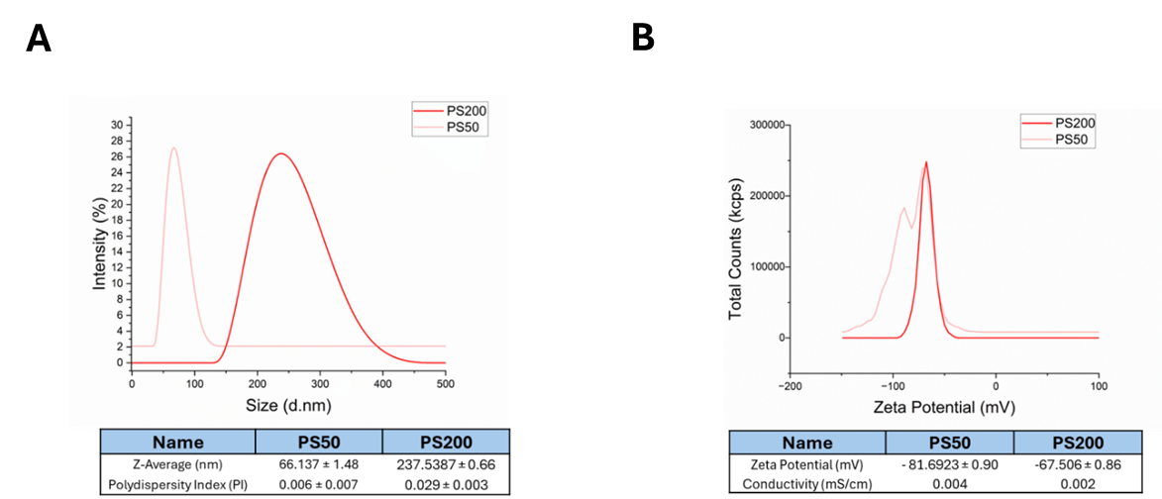

Figure S1. Size and Zeta potential of PS nanoplastics. (a) Size distribution (z average) in nm and polydispersity index of PS nanobeads, 50 or 200 nm. (b) Charge distribution of PS nanobeads, presented as zeta potential in mV and conductivity in mS/cm, measured in milliQ water. Data are shown as mean ± SD (n=3).

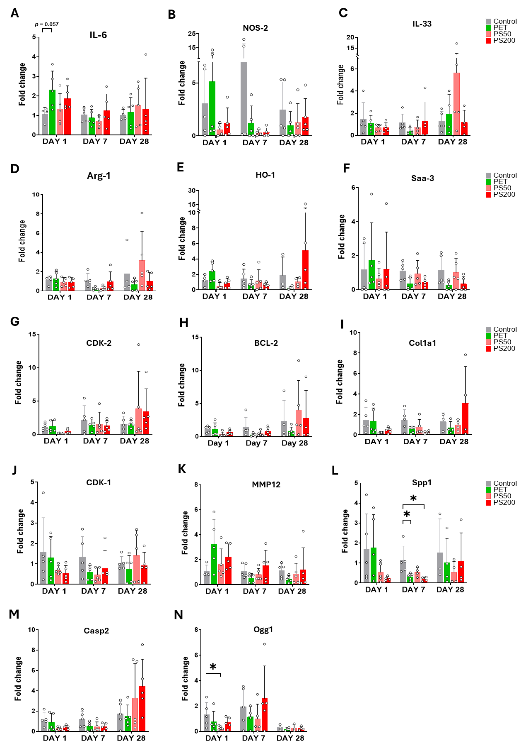
Figure S2. Expression of genes related to inflammation, cell cycle regulation, proliferation, and antioxidant response in the jejunum. Mean fold change expression is shown for inflammatory and oxidative stress markers Il-6 (a), Nos2 (b), Il-33 (c), Arg1 (d), Ho-1 (e), and Saa3 (f). Cell cycle and survival regulators Cdk2 (g), Bcl-2 (h), and Cdk1 (i) revealed downregulation by PET by day 28. Extracellular matrix and tissue repair genes Col1a1 (j), Mmp12 (k), and Spp1 (l) were dynamically altered, with Spp1 significantly suppressed by PET and PS200 at day 7, consistent with histological evidence of villus shortening. Apoptosis-related gene (m) Casp2 and DNA repair genes (n) Ogg1 (p <0.05) were downregulated with PS50 on day 1, suggesting tissue damage. Overall, NPs exposure disrupted jejunal inflammatory balance, redox defences, cell cycle control, and tissue regeneration pathways (*p < 0.05, n=4-5).

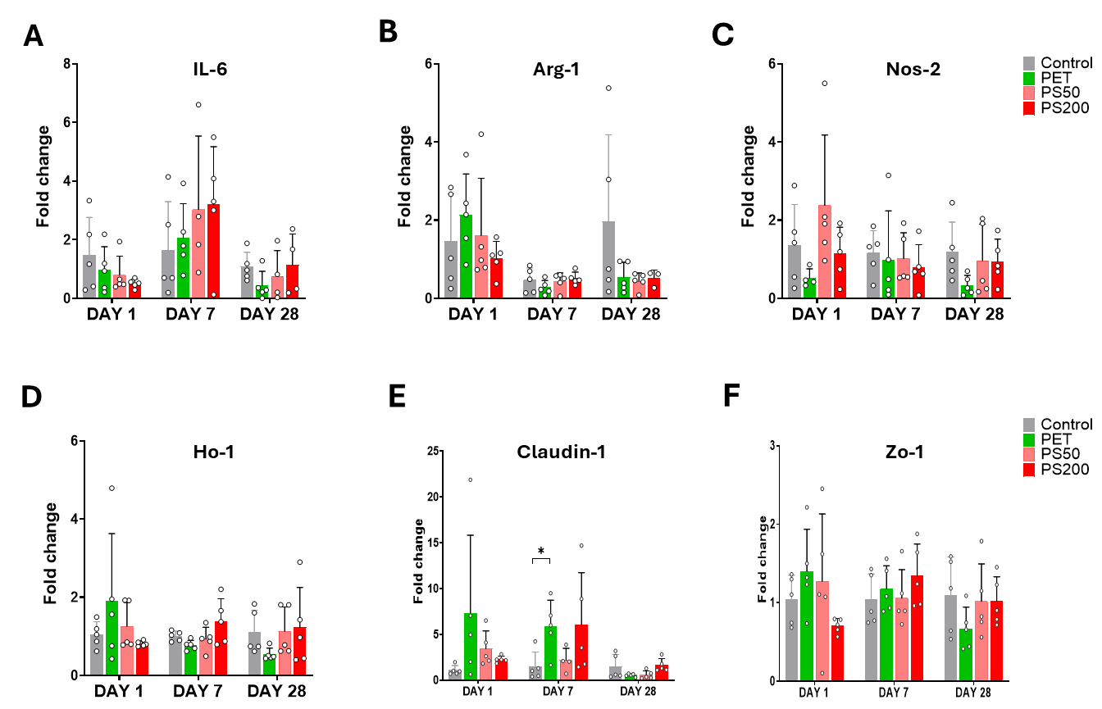

Figure S3. Expression of genes related to Inflammation, barrier proliferation, and antioxidant response in the colon. Mean fold change expression is shown for inflammatory and oxidative stress markers Il-6 (a), Arg-1 (b), Il-33 (c), Nos-2 (d), Ho-1 (e), and Saa3 (f). Barrier-related genes expressed mean fold change for Claudin-1 (e) and Zo-1 (f) showed variable expression, with PET exposure significantly increasing Claudin-1 (*, p < 0.05) at day 7 but reducing Claudin-1 and Zo-1 at 28 days, albeit not significantly.

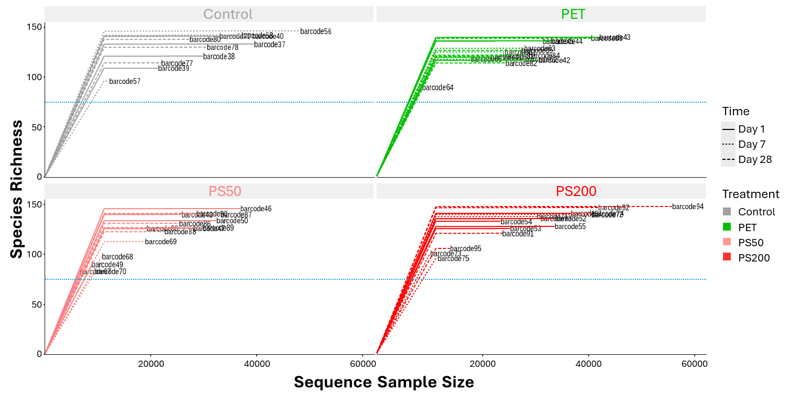
Figure S4. Rarefaction curve for the different treatments. The cut-off at 50% species richness (75) is presented as a blue bar. All samples met the criteria necessary to perform a reliable analysis of microbial diversity, since none of the samples falls below the 50% cut-off.

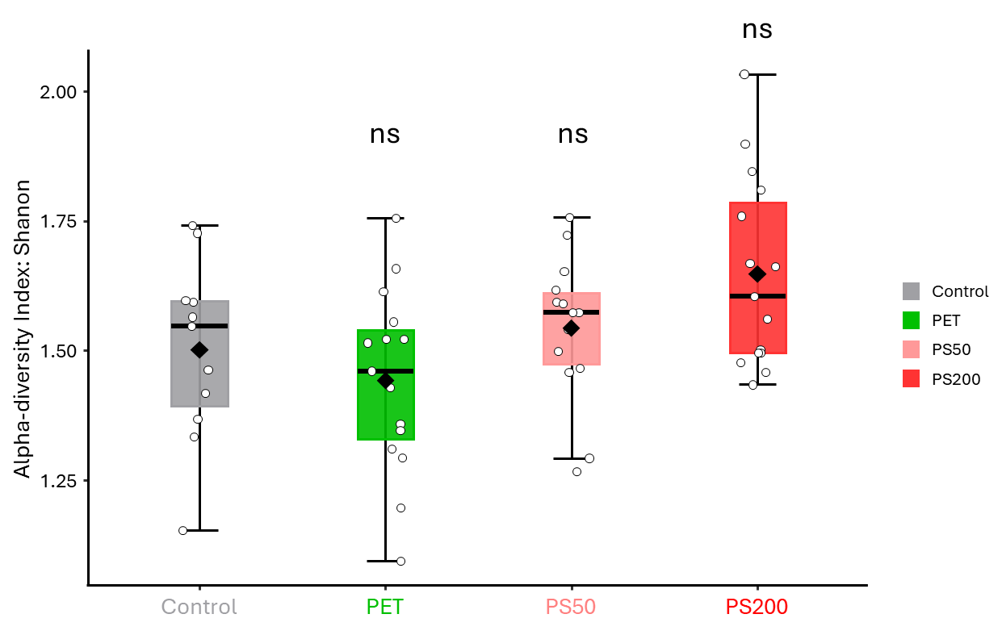
Figure S5. Genera alpha diversity. Shannon was used as the diversity index, and ANOVA as the statistical method. ns: non-significant compared to control (p>0.05) (with p-value Control-PET: 0.47298, p-value Control-PS200: 0.54188, p-value Control-PS50: 0.15048).

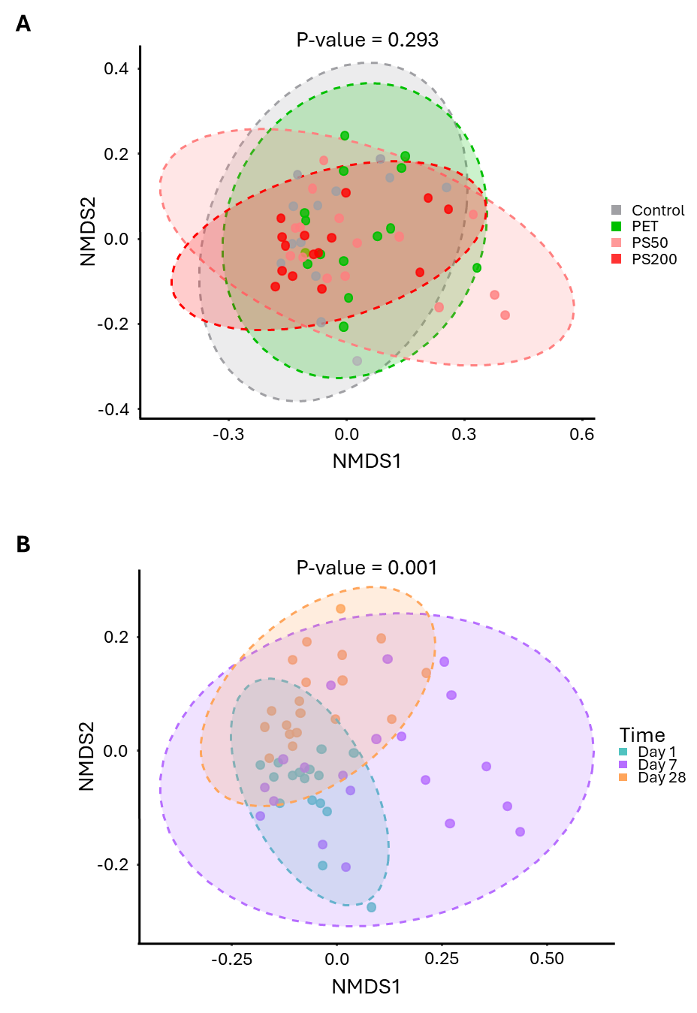
Figure S6. Genera beta diversity. There were no statistically significant differences between the four treatment groups when all time points were pooled (a). However, significant differences were found between day 1 and day 28 (p = 0.0015), and day 7 and day 28 (p = 0.0015) when treatments were pooled (b).

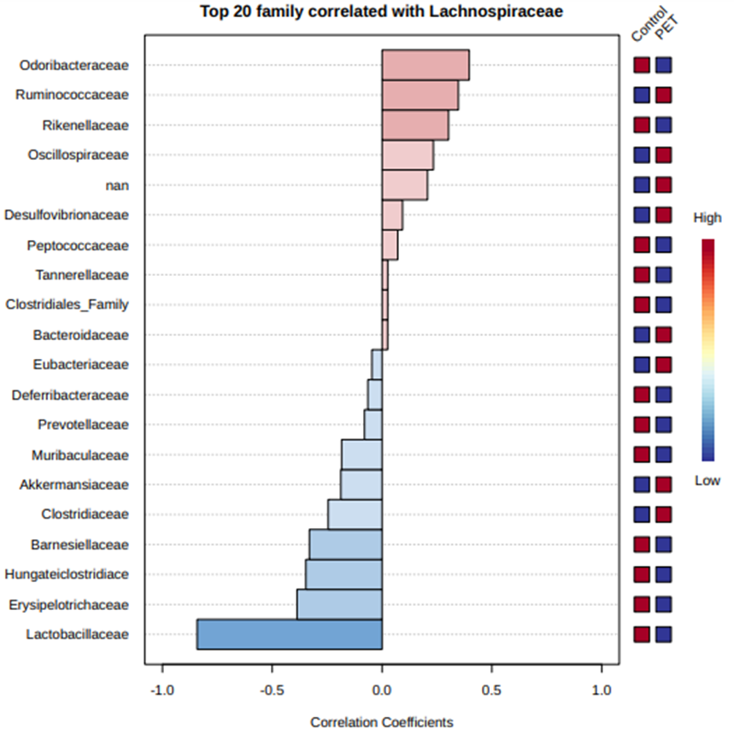
Figure S7. Pattern search plot for the 20 most correlated families with Lachnospiraceae. Positive correlations are indicated in red, negative correlations in blue. Significant correlations have Control-PET abundance markings next to them. “nan” signifies all reads without taxa designation.
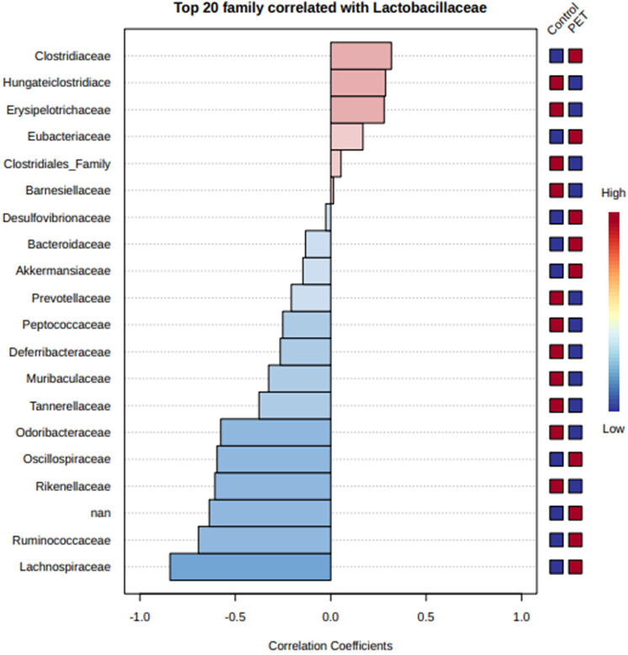
Figure S8. Pattern search plot for the 20 most correlated families with Lactobacillaceae. Positive correlations are indicated in red, negative correlations in blue. Significant correlations have Control-PET abundance markings next to them. “nan” signifies all reads without taxa designation.

Figure S9. TUNEL assay validation. Quantification of TUNEL-positive nuclei (%) in liver sections after DNase I treatment (200 U/mL) showed a significant increase compared with the negative control (p < 0.01, Mann–Whitney test), confirming assay specificity and sensitivity for detecting DNA strand breaks.

