Frequency of utilization of conventional food groups and dietary diversity of the study population:
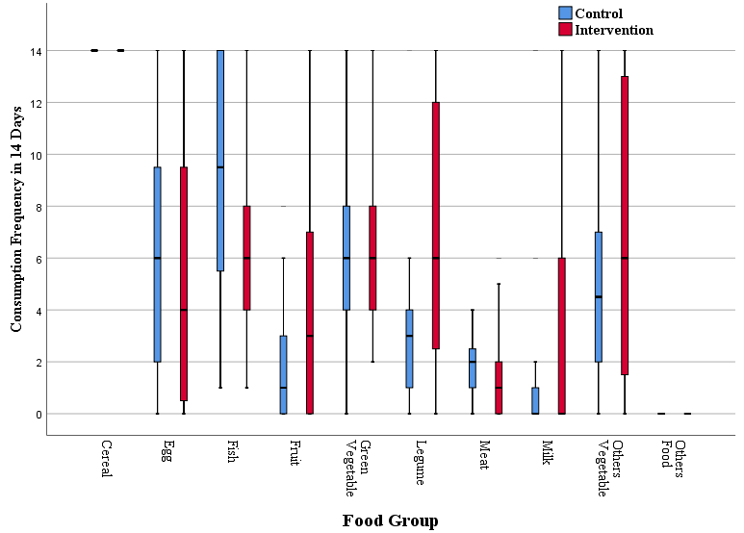
Figure S1. Control vs. intervention consumption frequency of various food groups per 14 days.
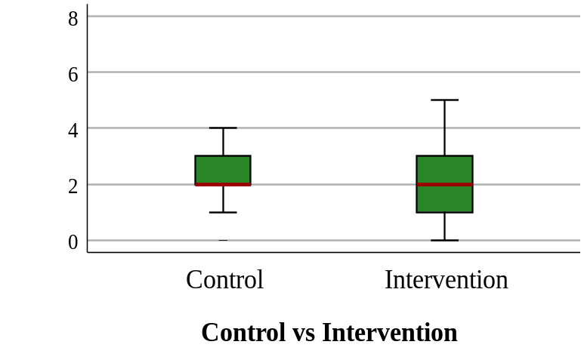
Figure S2. Individual Dietary Diversity Score (IDDS) of children in the control versus the intervention group.

Table S2. Usual macro and micro nutrition intake by the control and intervention groups from the 24H recall method.
Nutrient Type | Indicators | Control |  | Intervention
Nutrient Type | Indicators | Mean (SD) | % Contribution to Daily RDA | Mean (SD) | % Contribution to Daily RDA
Macronutrient | Energy (Kcal) (1) | 207.5 (145.4) | 25.2 - 16.9 | 310.8 (439.3) | 37.7 – 25.3
Macronutrient | Protein (g) (1) | 9.8 (7.7) | 75.6 | 13.9 (22.3) | 106.7
Macronutrient | Fat (g) (2) | 5.5 (5.3) | 21.9 | 10.0 (21.5) | 40.1
Macronutrient | CHO (g) (1) | 28.8 (24.7) | 30.4 – 22.2 | 40.4 (47.5) | 42.6 – 31.1
Macronutrient | Fiber (g) (3) | 1.8 (2.5) | 9.4 | 1.6 (1.6) | 8.6
Vitamins | Vitamin A (µg) (1) | 65.5 (83.2) | 2.3 – 2.1 | 184.9 (300.8) | 6.6 – 5.8
Vitamins | Retinol (µg) (4) | 59.2 (83.6) | 11.8 | 118.7 (228.5) | 23.7
Vitamins | B-carotene (µg) (5) | 42.2 (127.7) | 0.7 – 1.2 | 81.3 (141.6) | 1.4 – 2.3
Vitamins | Vitamin D (µg) (1) | 1.0 (1.3) | 10.3 | 1.6 (3.2) | 16.1
Vitamins | Vitamin E (mg) (1) | 0.1 (0.1) | 3 – 2 | 0.9 (1.6) | 23.3 – 15.5
Vitamins | Thiamin (mg) (1) | 0.3 (0.2) | 86.7 – 52 | 0.3 (0.5) | 113.3 – 68
Vitamins | Riboflavin (mg) (1) | 0.2 (0.3) | 34 – 21.3 | 0.7 (1.6) | 146 – 91.3
Vitamins | Niacin (mg) (1) | 0.9 (0.6) | 17.0 – 10.2 | 4.5 (6.3) | 84.1 – 50.4
Vitamins | Vit B6 (mg) (1) | 0 (0) | 7.5 – 4.3 | 0.2 (0.3) | 45 – 25.7
Vitamins | Folate (µg) (2) | 6.5 (4.1) | 25.9 – 16.2 | 37.7 (43.5) | 150.7 – 94.2
Vitamins | Vitamin C (mg) (1) | 0.7 (2.0) | 3.6 | 2.4 (8.2) | 11.8
Minerals | Calcium (mg) | 104.6 (160.7) | 17.4 – 26.2 | 53.8 (137.5) | 9.0 – 13.5
Minerals | Iron (mg) | 0.6 (0.7) | 6.5 – 11 | 0.7 (1.6) | 8.5 – 14.4
Minerals | Magnesium (mg) | 29.9 (25.3) | 49.8 – 37. 4 | 8.4 (12.5) | 14 – 10.5
Minerals | Phosphorus (mg) | 160.8 (141.2) | 53.6 | 60.1 (103.5) | 20.0
Minerals | Potassium (mg) | 183.9 (210.0) | 26.3 – 23 | 59.2 (148.2) | 8.5 – 7.4
Minerals | Sodium (mg) | 180.7 (145.5) | 90.4 – 80.3 | 32.2 (50.8) | 16.1 – 14.3
Minerals | Zinc (mg) | 2.2 (1.7) | 39.1 - 39.8 | 0.6 (0.6) | 9.8 – 10
Minerals | Copper (mg) | 0.3 (0.2) | 41.7 – 44.6 | 0.1 (0.1) | 8.3 – 8.9

Table S3. Summary of biomarker metrics-based status among control and intervention groups from pre-intervention to post-intervention.
Biomarker Metrics |  | Control Group, n (%) |  |  | Intervention Group, n (%)
 |  | Deficient | Normal | Over Range | Deficient | Normal | Over Range
Retinol Status | Pre-intervention | 2 (22.2) | 7 (77.8) | 0 (0) | 0 (0) | 7 (100) | 0 (0)
Retinol Status | Post-intervention | 1 (11.1) | 8 (88.9) | 0 (0) | 0 (0) | 7 (100) | 0 (0)
Vitamin B12 Status | Pre-intervention | 0 (0) | 8 (100) | 0 (0) | 0 (0) | 7 (100) | 0 (0)
Vitamin B12 Status | Post-intervention | 0 (0) | 8 (100) | 0 (0) | 0 (0) | 7 (100) | 0 (0)
Ferritin Status | Pre-intervention | 0 (0) | 8 (100) | 0 (0) | 0 (0) | 7 (100) | 0 (0)
Ferritin Status | Post-intervention | 2 (25) | 6 (75) | 0 (0) | 0 (0) | 7 (100) | 0 (0)
Iron Status | Pre-intervention | 1 (12.5) | 7 (87.5) | 0 (0) | 0 (0) | 7 (100) | 0 (0)
Iron Status | Post-intervention | 4 (50) | 4 (50) | 0 (0) | 1 (14.3) | 6 (85.7) | 0 (0)

Table S4. Summary of anthropometric metrics-based status among control and intervention groups from pre-intervention to post-intervention.
Anthropometric Metrics |  | Control Group, n (%) |  | Intervention Group, n (%)
 |  | Pre-intervention | Post-intervention | Pre-intervention | Post-intervention
Weight | Above Normal | 0 (0) | 3 (15.8) | 0 (0) | 0 (0)
Weight | Normal | 15 (78.9) | 14 (73.7) | 10 (47.6) | 18 (85.7)
Weight | Below Normal | 4 (21.1) | 2 (10.5) | 11 (52.4) | 3 (14.3)
Length | Above Normal | 1 (5.3) | 1 (5.3) | 0 (0) | 0 (0)
Length | Normal | 15 (78.9) | 15 (78.9) | 15 (71.4) | 18 (85.7)
Length | Below Normal | 3 (15.8) | 3 (15.8) | 6 (28.6) | 3 (14.3)
MUAC | Moderate Malnutrition | 1 (5.3) | 1 (5.3) | 1 (4.8) | 0 (0)
MUAC | Normal | 18 (94.7) | 18 (94.7) | 20 (95.2) | 21 (100)
Head circumference | Above Normal | 2 (10.5) | 3 (15.8) | 0 (0) | 0 (0)
Head circumference | Normal | 11 (57.9) | 13 (68.4) | 11 (52.4) | 15 (71.4)
Head circumference | Below Normal | 6 (31.6) | 3 (15.8) | 10 (47.6) | 6 (28.6)
WAZ | Normal | 16 (84.2) | 19 (100) | 18 (85.7) | 20 (95.2)
WAZ | Underweight | 3 (15.8) | 0 (0) | 3 (14.3) | 1 (4.8)
WAZ | Severely Underweight | 0 (0) | 0 (0) | 0 (0) | 0 (0)
LAZ | Normal | 16 (84.2) | 13 (68.4) | 17 (80.9) | 9 (42.9)
LAZ | Stunted | 2 (10.5) | 4 (21.1) | 3 (14.3) | 9 (42.9)
LAZ | Severely Stunted | 1 (5.3) | 2 (10.5) | 1 (4.8) | 3 (14.3)
WLZ | Normal | 16 (84.2) | 19 (100) | 20 (95.2) | 21 (100)
WLZ | Wasted | 3 (15.8) | 0 (0) | 1 (4.8) | 0 (0)
WLZ | Severely Wasted | 0 (0) | 0 (0) | 0 (0) | 0 (0)

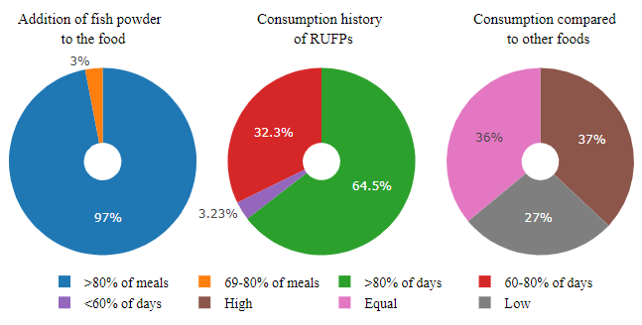
Figure S3. Summary of consumption of fish powder-based RUFPs by intervention group.
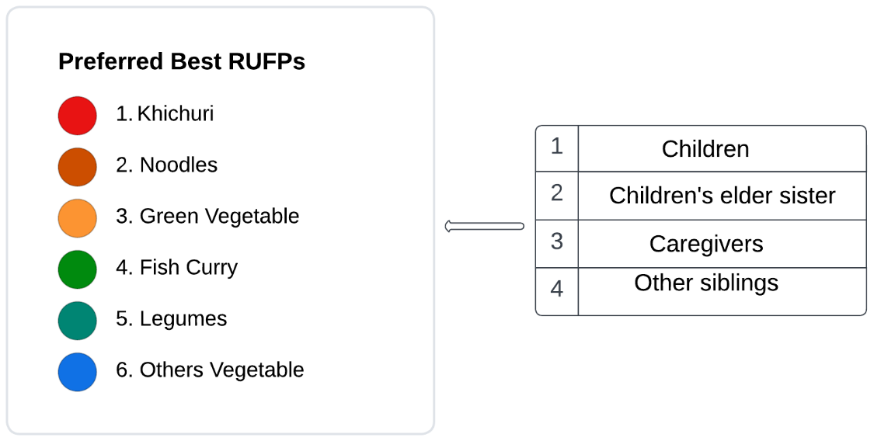
Figure S4. Preferences for fish powder-based items among household members.
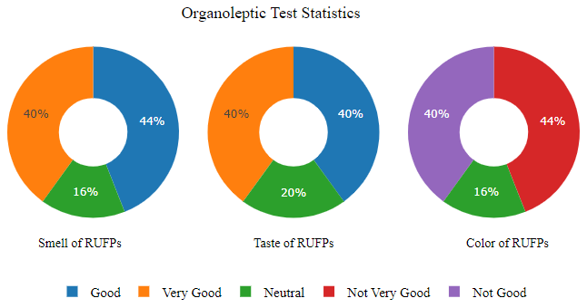
Figure S5. Organoleptic test statistics of fish powder-based RUFPs by the caregivers.
Table S5. Caregiver’s perception and expectation of fish powder marketing (n = 25).
Marketing Markers | Strongly Agree (%) | Agree (%) | Neutral (%) | Disagree (%) | Strongly Disagree (%)
They like to buy fish powder from the market | 84 | - | 8 | 8 | -
Will inspire others to purchase the product | 84 | 8 | 4 | 4 | -
Preferred location to collect the powder | Peddle (28) | Grocery (20) | Market (40) |  | Online shop (12)
Preferred type of package | Glass jar (12) - |  | Polythene bag (64) |  | Paper package (24)
Preferred season/time to purchase the powder | Around the year (80) |  | The rainy season (12) |  | Winter season (8)
The type of market preferred to purchase powder | Large (84) | Medium (16) | Small | Cottage | Women entrepreneurship
Preferred weight to purchase the powder | 50g (12) | 100g (48) | 150g (12) | 200g (4) | 250g (24)
Preferred price to buy 250g of the products (USD) | ≤ 0.75 (32) | 1 (20) | 1.5-1.75 (28) | 2 (16) | > 2 (4)

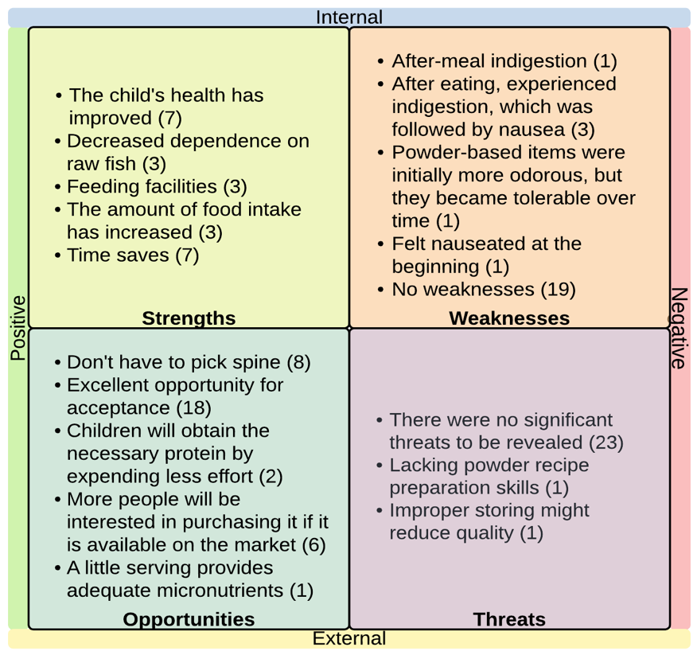
Figure S6. SWOT summary of the fish powder-based ready-to-use food products (RUFPs).
References
1. Garrow JSea. ED. London, Churchill, Livingstone 1999.
2. Recommended Daily Allowance for Infants and Toddlers [Internet]. TarlaDalal. October 26, 2018 [cited September 1, 2022]. Available from: https://www.tarladalal.com/article-recommended-daily-allowance-for-infants-and-toddlers-202.
3. How Much Fiber Do Children Need? [Internet]. Cleveland Clinic 2020 [cited September 1, 2022]. Available from: https://health.clevelandclinic.org/figuring-dietary-fiber-child-need/.
4. Trumbo P, Yates AA, Schlicker S, Poos M. Dietary reference intakes. Journal of the American Dietetic Association. 2001;101(3):294-.
5. Dietary Reference Intakes: Thiamin R N, Vitamin B6, Folate, Vitamin B12, Pantothenic Acid, Biotin,, Choline. Institute of Medicine. Food and Nutrition Board. National Academy Press Washington, DC; 1998.

