Patient and health care provider evaluation of an electronic Patient-Reported Outcome Measure (SYMPRO-Lung) to monitor symptoms of lung cancer patients: recommendations for implementation in clinical practice
Supportive care in cancer
Nicole E. Billingy, MSc^{1,2*}, Vashti, N.M.F. Tromp*, MSc. ³, Corina J.G. van den Hurk, PhD⁴, Lonneke van de Poll-Franse, PhD, ^{4,5,6}, Jacqueline G. Hugtenburg, PhD³, Harm Jan Bogaard, MD, PhD⁷, José Belderbos, MD, PhD⁸, Neil K. Aaronson, PhD ⁵, Bregje D. Onwuteaka-Philipsen, PhD⁹, Iris Walraven, PhD ², Annemarie Becker-Commissaris, MD, PhD ⁸, on behalf of the SYMPRO-Lung Consortium

Corresponding author: Dr. A. Becker-Commissaris a.becker@amsterdamumc.nl

Appendix 1 (online resource 1)

Table of contents

eFigure 1.: Stepped Wedge Cluster Randomized Design of the SYMPRO-Lung trial p2
eFigure 2.: Set of predefined conditions that prompted the SYMPRO-Lung webpage to create an alert p3
Additional information on the qualitative methodology p4
eFigure 3.: Flow chart of the SYMPRO-Lung Trial p5
eTable 1.: Baseline characteristics of the SYMPRO-Lung cohort p6
Evaluation survey for the health care practitioners p7
Evaluation survey for the patients p8
Topic list health care practitioner interviews p10
Topic list patient interviews p12
eTable 2.: Patients’ usefulness ratings of the core features of the SYMPRO-Lung application stratified by intervention group p13

eFigure 1

eFigure 2. Set of predefined conditions that prompted the SYMPRO-Lung webpage to create an alert
Symptoms | Conditions for an alert
PRO-CTCAE symptoms
Decreased appetite | - If the symptom reaches grade 3  - And the symptom has not reached a grade 3 in the last 2 weeks  - However, if the symptom stays a stable grade 3 for 4 consecutive weeks, the fourth week will provide the next alert  - If the symptom worsens by ≥ 2 grades  - In 2 weeks  - However, if the checklist has not been filled-in for 4 consecutive weeks, the grade will be compared to the last measurement
Cough
Shortness of breath
Fatigue
Constipation
Nausea
Diarrhea
Sad or unhappy feelings
General pain
Other symptoms
Fever | 3. If ‘yes’ is scored (independent of earlier reports about fever)
Hemoptysis | 4. If ‘a little’ or ‘a lot’ is scored (independent of earlier reports about hemoptysis)
Weight | 5. Loss of weight ≥ 3 kg in 1 or 2 weeks  - If the questionnaire was not filled-in for 4 consecutive weeks a loss of weight of ≥ 3 kg since the last measurement will also summon an alert  - If the patient has scored ‘I did not weigh myself’ it is seen as rule 5a (as if the questionnaire was not filled-in)
Abbreviations: PRO-CTCAE, Patient Reported Outcomes-Common Terminology Criteria for Adverse Events.

Additional information on the qualitative methodology

NB and VT conducted all interviews. Both researchers were female (MSc) PhD students working on the SYMPRO-Lung trial. They had received training in qualitative research methods during their bachelor’s and master’s programs, and VT had prior experience applying these methods. NEB had additionally completed post-master qualitative training and had three years of experience conducting semi-structured interviews.
The researchers may have met some health care practitioners (HCPs) prior to the study initiation visit to discuss site-specific logistics. No prior relationship with patients was established before the study began. All participants were aware that the researchers were members of the study team and understood the purpose of the interviews.
HCPs were invited to participate by email, whereas patients were contacted by telephone. Some HCPs conducted their online interviews from their offices, occasionally with colleagues present in the room. For several patient interviews, a partner was present in the same room during the conversation. Interviews lasted between 30 minutes and one hour. Field notes were taken during all interviews. Transcripts were not returned to participants, and participants were not asked to provide feedback on the findings.

eFigure 3.: Flowchart of the SYMPRO-Lung Trial
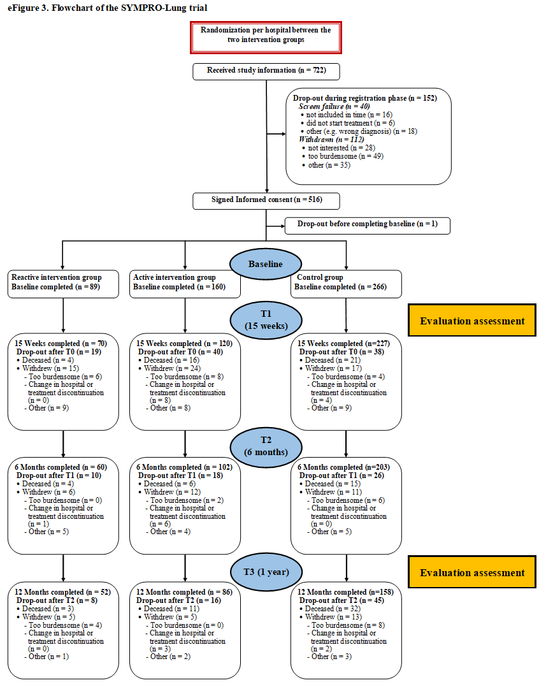

eTable 1.: Baseline characteristics of the SYMPRO-Lung cohort
Patient Characteristics | Control group | Active Intervention | Reactive intervention
Total | 266 | 160 | 89
Age mean (years) | 66.0 (9.2) | 64.6 (10.5) | 65.3 (8.0)
Sex (% male) | 139 (52.3%) | 84 (52.5%) | 43 (48.3%)
Education
Primary education | 121 (45.5%) | 77 (48.1%) | 32 (36.0%)
High school & vocational education | 83 (31.2%) | 40 (25.0%) | 22 (24.7%)
College/university | 60 (22.6%) | 41 (25.6%) | 35 (39.3%)
Missing | 2 (0.8%) | 2 (1.3%) | -
Living status
Alone | 59 (22.2.%) | 33 (20.6%) | 21 (23.6%)
Together (with another adult) | 206 (77.4%) | 127 (79.4%) | 66 (74.2%)
Missing | 1 (0.4%) | - | 2 (2.2%)
Work (% employed) | 66 (24.8%) | 50 (31.3%) | 28 (31.5%)
ECOG Performance Status
0 | 104 (39.1%) | 60 (37.5%) | 46 (51.7%)
1 | 143 (53.8) | 81 (50.6%) | 39 (43.8%)
2 | 19 (7.1%) | 19 (11.9%) | 4 (4.5%)
Other comorbidities (% Yes) | 122 (45.9%) | 76 (47,5%) | 33 (37.1%)
Histology
Non-adenocarcinoma/non-squamous | 30 (11.3%) | 12 (7.5%) | 4 (4.5%)
Adenocarcinoma, M− | 120 (45.1%) | 84 (52.5%) | 53 (59.6%)
Adenocarcinoma, M+ | 14 (5.3%) | 24 (15.0%) | 2 (2.2%)
Squamous cell carcinoma | 51 (19.2%) | 19 (11.9%) | 15 (16.9%)
SCLC | 19 (7.1%) | 17 (10.6%) | 9 (10.1%)
No histology confirmed | 32 (12.0%) | 4 (2.5%) | 6 (6.7%)
Stage distribution
I | 52 (19.5%) | 13 (8.1%) | 10 (11.1%)
II | 16 (6.0%) | 8 (5.0%) | 9 (10.1%)
III | 80 (30.1%) | 39 (24.4%) | 31 (34.8%)
IV | 118 (44.4%) | 100 (62.5%) | 39 (43.8%)
Previous treatment for lung cancer (% Yes) | 90 (33.8% | 61 (38.1%) | 41 (46.1%)
Treatment plan
Immunotherapy | 45 (16.9%) | 22 (13.8%) | 7 (7.9%)
Immunotherapy combined | 44 (16.5%) | 29 (18.1%) | 14 (15.7%)
Radiotherapy (combined) | 62 (23.3%) | 12 (7.5%) | 16 (18.0%)
Chemotherapy (combined) | 92 (34.6%) | 64 (40.0%) | 41 (46.1%)
Targeted therapy | 9 (3.4%) | 24 (15.0%) | 4 (4.5%)
Surgery | 14 (5.3%) | 9 (5.6%) | 7 (7.9%)
Age is presented as mean (SD), other data are presented as n (%). Abbreviations: M-, no targetable driver mutation or unknown status; M+, targetable driver mutation; ECOG, Eastern Cooperative Oncology Group. Immunotherapy combined: immunotherapy (combined with chemotherapy or chemo radiation and/or surgery and/or targeted therapy. Radiotherapy combined: radiotherapy (combined with surgery). Chemotherapy combined: chemotherapy or chemo radiation (combined with radiotherapy, and/or targeted therapy and/or surgery).

Evaluation survey for the health care practitioners

The following statements regard your opinion of the weekly symptom checklist. Please indicate to what extent you agree with each statement?

 | Strongly disagree | Disagree | Neutral | Agree | Strongly agree
- The weekly symptom checklist adds value to the delivery of high-quality care | □ | □ | □ | □ | □
- The alerts when a patient’s score is elevated are useful | □ | □ | □ | □ | □
- I have regularly used the (PDF’s* containing) feedback reports | □ | □ | □ | □ | □
- I would like to continue using the weekly symptom checklist in the future | □ | □ | □ | □ | □
*PDF Portable Document Format

- Compared to standard care, the weekly symptom checklist cost me:
□ Less work
□ The same amount of work
□ More work

- How would you rate the weekly symptom checklist on a scale of 0 to 10? (0 = very poor, 10 = very good)?

0 1 2 3 4 5 6 7 8 9 10

Evaluation survey for the patients

We'd like to know how you've experienced the care you received since your current lung cancer treatment. There are no right or wrong answers. We'd like to hear your opinion.

How would you rate your healthcare providers during your lung cancer treatment in terms of:

 | Poor | Fair | Good | Very good | Excellent
- The care they provided you | □ | □ | □ | □ | □
- The consultations/appointments with your healthcare provider | □ | □ | □ | □ | □
- Discussing your symptoms | □ | □ | □ | □ | □

The following statements are about the weekly symptom checklist. Please indicate to what extent you agree with each statement?

 | Strongly disagree | Disagree | Neutral | Agree | Strongly agree
- The weekly symptom checklist was easy to use | □ | □ | □ | □ | □
- By completing the weekly symptom checklist I gained more control over the treatment of my symptoms | □ | □ | □ | □ | □
- Completing the weekly symptom checklist was a good addition to my treatment | □ | □ | □ | □ | □
- My health care practitioners paid attention to the symptoms that I reported | □ | □ | □ | □ | □
- The weekly reminder to fill in the weekly symptom checklist were useful | □ | □ | □ | □ | □
- Completing the weekly symptom checklist gave me insight into the severity of my symptoms | □ | □ | □ | □ | □

- I find the symptom checklist useful (0 = not at all useful, 10 = very useful).

0 1 2 3 4 5 6 7 8 9 10
Absolutely not useful very useful

- I find the longitudinal report useful (0 = not at all useful, 10 = very useful).

0 1 2 3 4 5 6 7 8 9 10
Absolutely not useful very useful

- I find the alerts (the message to discuss your symptoms with a healthcare provider) useful (0 = not at all useful, 10 = very useful).

0 1 2 3 4 5 6 7 8 9 10
Absolutely not useful very useful

- Would you recommend the use of the app/website to others in the same situation?
□ No
□ Yes

Topic list health care practitioner interviews

Introduction/background information
- Experience as a health care practitioner
- Prior experience with PROMs
- Initial impression of SYMPRO before trial initiation
- Possible goals of perceived benefits
- Trial initiation visit
- Patient recruitment

Website
- First impression
- Overall experience
Check the next subjects for the following elements of the application: (use (frequency and consistency), ease of use(or user-friendliness), perceived benefits (or motivations and reasons for (non-)use)/disadvantages (or challenges)
- Weekly symptom checklist (symptoms/notes from patients)
- Reports (interface, data interpretation and understanding)
- Alerts (preferences for active vs. reactive monitoring approach)
- Qol questionnaire (interface, data interpretation and understanding)
- Recommendations for improvement

Support and supporting tools
- Experience with support (study team, colleagues, management)
- Experience with supporting tools (informational website, user manual and pocket card)
- Recommendations for improvement

Impact on patient interactions
Discuss experiences and perceived value (barriers and facilitators)
- Contact with the patient (after an alert)
- Use during routine consultations
- Patient's initiative to discuss weekly symptom checklist
- Patient feedback
- Time and effort required
- Recommendations for improvement

COVID-19
- Interaction with patients during COVID-19
- Possible influence of SYMPRO during covid-19 and vice versa

Overall satisfaction
- Perceived benefits using the SYMPRO-app
- Possible changes in symptom monitoring
- Contributions/disadvantages of SYMPRO in patient care
- Barriers and facilitators for department-wide implementation
- Final verdict

Closing statements
- Final comments, insights or additional thoughts

Topic list patient interviews

Introduction/general information
- Prior experience with internet
- Initial impression of SYMPRO at patient recruitment
- Possible goals of perceived benefits

Website
- First impression
- Overall experience
Check the next subjects for the following elements of the application: (use (frequency and consistency), ease of use(or user-friendliness), perceived benefits (or motivations and reasons for (non-)use)/disadvantages (or challenges)
- Weekly symptom checklist (symptoms/notes from patients)
- Reports (interface, data interpretation and understanding)
- Alerts (preferences for active vs. reactive monitoring approach)
- Recommendations for improvement

Support and supporting tools
- Experience with support (study team, relatives/informal caregivers)
- Experience with supporting tools (informational website)
- Recommendations for improvement

Impact on interactions with the health care practitioners
Discuss experiences and perceived value (barriers and facilitators)
- Contact with health care practitioner(s) (after an alert)
- Use during routine consultations
- HCPs initiative to discuss weekly symptom checklist
- Recommendations for improvement

COVID-19
- Interaction with HCPs during COVID-19
- Possible influence of SYMPRO during COVID-19 and vice versa

Overall satisfaction
- Perceived benefits/achieved goals using the SYMPRO-app
- Possible changes in symptom monitoring
- Final verdict

Closing statements
- Final comments, insights or additional thoughts

eTable 2. Patients’ usefulness ratings of the core features of the SYMPRO-Lung application stratified by intervention group

On a scale of 0 (absolutely not useful) to 10 (extremely useful), the majority of patients rated the weekly symptom checklist (active T1: M 8, SD1.61; T3: M 7.74 SD 1.74; reactive T1: M 7.39 SD1.90; T3: M7.56 SD1.65), the longitudinal reports (active T1: M 7.9, SD1.63; T3: M 7.72 SD1.72; reactive T1: M 7.38 SD1.94 T3 M 7.67 SD 1.53), and the alerts (active T1: M 8.11, SD1.74; T3: M 7.86 SD 1.94; reactive T1: M 7.2 SD 2.24 T3: M 7.67 SD 1.77) as useful with slightly higher ratings, although not clinically meaningful, in the active versus the reactive intervention group
eTable 2.: Patients’ usefulness ratings of the core features of the SYMPRO-Lung application stratified by intervention group
 |  | Mean (SD)
 |  | Active group | Reactive group | p-value
Usefulness of the core features of the application | Time points
Weekly symptom checklist | T1  T3 | 8.00 (1.61)  7.74 (1.74) | 7.39 (1.90) 7.56 (1.65) | .023  .535
Longitudinal reports | T1  T3 | 7.90 (1.63)  7.72 (1.72) | 7.38 (1.94) 7.67 (1.53) | .049  .869
Alerts | T1  T3 | 8.11 (1.74) 7.86 (1.94) | 7.20 (2.24) 7.67 (1.77) | .003  .570
On a scale of 0 (absolutely not useful) to 10 (extremely useful)
Abbreviation: SD, standard deviation

