Supplementary data
Supplementary table 1. Clinical information of control and TSC cases. Bold and underlined: used for IF validation
ID | PA  Diagnosis | Sex | Onset epilepsy age (y) | Age at operation  (m/y) | Cause of death | Brain area | Mutation
1 | Control | M | - | 12 | Myocarditis | Frontal cortex | -
2 | Control | F | - | 16 | Intramedullary spinal cord tumor | Frontal cortex | -
3 * | Control | F | - | 5 | Pneumonia | Frontal cortex | -
4 * | TSC | M | 0 | 2 | - | Frontal cortex | TSC2 (c.3098dupA, p.Tyr1033Ter) germline
5 * | TSC | M | 0 | 5 | - | Frontal cortex | TSC2 (c.5024C>T; p.Pro1675Leu) germline
6 | TSC | F | 0 | 8 | - | Frontal cortex | TSC2 (c.2183dup;p.Cys728fs) germline
7 | TSC | F | 0 | 0 | - | Temporal cortex | TSC2 (c.1831C>T; c.1831C>T) germline
8 | TSC | F | 0 | 17 | - | Parietal cortex | TSC2 (c.4730del ; p.Gly1577fs)
9 | FCD2a | M | 5 | 11 | - | Frontal cortex | MTOR (c.7255G>A, p.E2419K) somatic
10 | FCD2a | F | 2 | 9 | - | Frontal cortex | MTOR (c.6644C>T, p.Ser2215Phe) somatic
11 | FCD2b | M | 1 | 14 | - | Frontal cortex | MTOR (c.5930C>A, p.Thr1977Lys) somatic
12 | FCD2b | M | 3 | 5 | - | Frontal cortex | MTOR (c.6644C>A, p.Ser2215Tyr) somatic
13 | FCD2b | M | 1 | 15 | - | Frontal cortex | MTOR (c.7280T>A, p.Leu2427Gln) somatic
14 | FCD2a | F | 0 | 1 | - | Frontal cortex | DEPDC5 (c.4152_4153delGA, p.Thr1385fs) somatic
15 | FCD2a | F | 0 | 10 | - | Frontal cortex | DEPDC5 (c.4155dupC, p.Ala1386fs) somatic; c.1324+1G>A (germline)
16 | FCD2a | M | 0 | 0 | - | Frontal cortex | DEPDC5 (c.4051_4057 dupGTGAACA; p.Asn1353fs) somatic; c.715C>T (germline; p.Arg239)

Supplementary table 2. Cell type markers used in annotation of cell type clusters.
Cell type | Marker genes
Glutamatergic neurons | SLC17A7, SATB2, SLC17A6, GRIN1
GABAergic neurons | GAD1, GAD2
Astrocytes | ALDH1L1, AQP4, SLC1A2, S100B
Microglia | PTPRC, ITGAM, P2RY12, TMEM119
Oligodendrocytes | OLIG1, CLDN11, MOG, MBP
OPCs | PDGFRA, CSPG4
Endothelial cells | CLDN5, PECAM1
Perictyes | PDGFRB

Supplementary figure 1. Quality control metrics across donors and microglial clusters. (a–b) Boxplots showing quality control metrics per donor sample. (a) Number of genes detected per cell across individual donor samples. (b) Number of unique molecular identifiers (UMIs) detected per cell across donor samples. Each box represents the interquartile range (IQR), the horizontal line indicates the median, whiskers extend to 1.5× IQR, and points represent individual cells outside this range. The number of cells per donor is indicated in parentheses. (c–d) Boxplots showing quality control metrics stratified by microglial cluster identity (clusters 0–9). (c) Number of genes detected per cell per cluster. (d) Number of UMIs detected per cell per cluster. Boxes and whiskers are displayed as in panels (a–b). The number of cells per cluster is indicated in parentheses.

Supplementary figure 2. Validation of myeloid lineage identity across clusters. (A) Violin plots showing expression of genes previously reported to be enriched in peripheral monocytes compared to microglia. Expression is displayed across clusters 0–14. Each violin represents the distribution of normalized expression values per cluster, with width reflecting the density of cells at a given expression level. Maximum counts per gene are indicated on the right. (B) Violin plots depicting expression of canonical microglia-enriched genes across clusters 0–14. Robust and widespread expression of microglial markers is observed in the majority of clusters, confirming bona fide microglial identity.
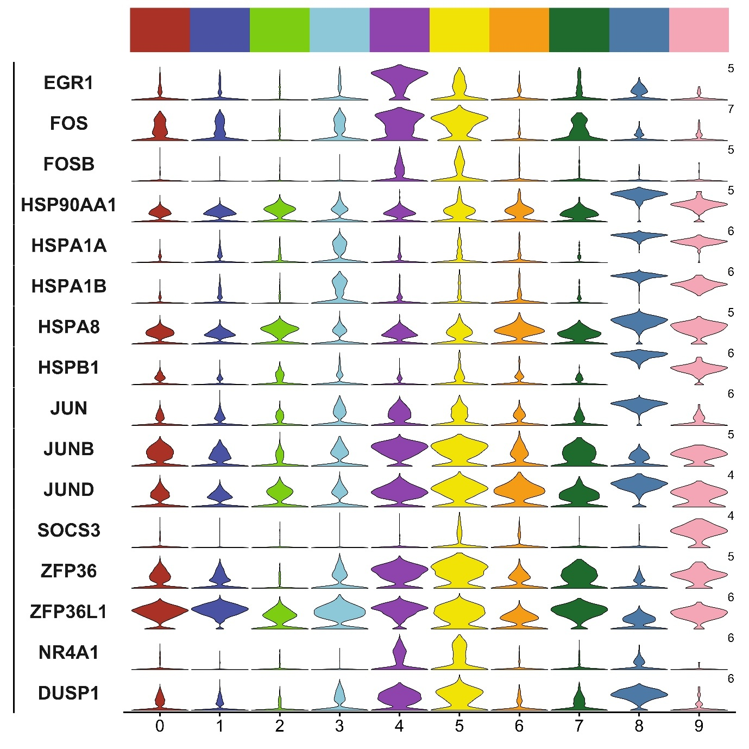
Supplementary figure 3. Stress- and immediate early gene expression across microglial clusters. Stacked violin plots showing normalized expression of immediate early genes and stress-response genes across microglial clusters 0–9. Each row represents one gene and each column corresponds to a cluster. Violin width reflects the distribution density of expression values within each cluster. Numbers on the right indicate maximum scaled expression per gene.

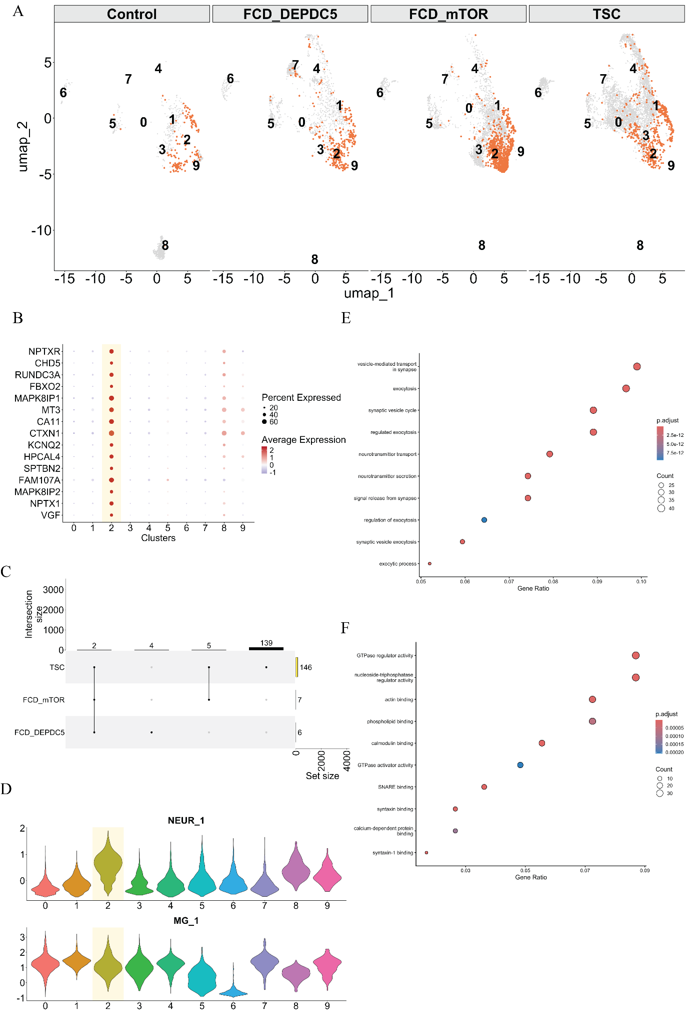

Supplementary figure 4. Stress- and immediate early gene expression across microglial clusters. (A) UMAP projections of microglial clusters (0–9) shown separately for Control, FCD_DEPDC5, FCD_mTOR, and TSC samples. Cells belonging to cluster 2 (highlighted in orange) are overlaid on the full embedding (gray), illustrating its relative distribution across conditions. (B) Dot plot showing expression of neuron-associated transcripts enriched in cluster 2. Dot size indicates the percentage of cells expressing each gene and color represents scaled average expression. (C) UpSet plot summarizing overlap of differentially expressed genes (DEGs) for cluster 2 across TSC, FCD_mTOR, and FCD_DEPDC5 compared to control. Bars represent intersection sizes and set sizes per condition. (D) Violin plots displaying module scores for a neuron-associated gene signature (NEUR_1) and a microglial signature (MG_1) across clusters. (E) Gene Ontology (biological process) enrichment analysis of cluster 2 DEGs. Dot size reflects gene count and color indicates adjusted p-value. (F) Gene Ontology (molecular function) enrichment analysis for cluster 2. Dot size represents gene count and color denotes adjusted p-value.

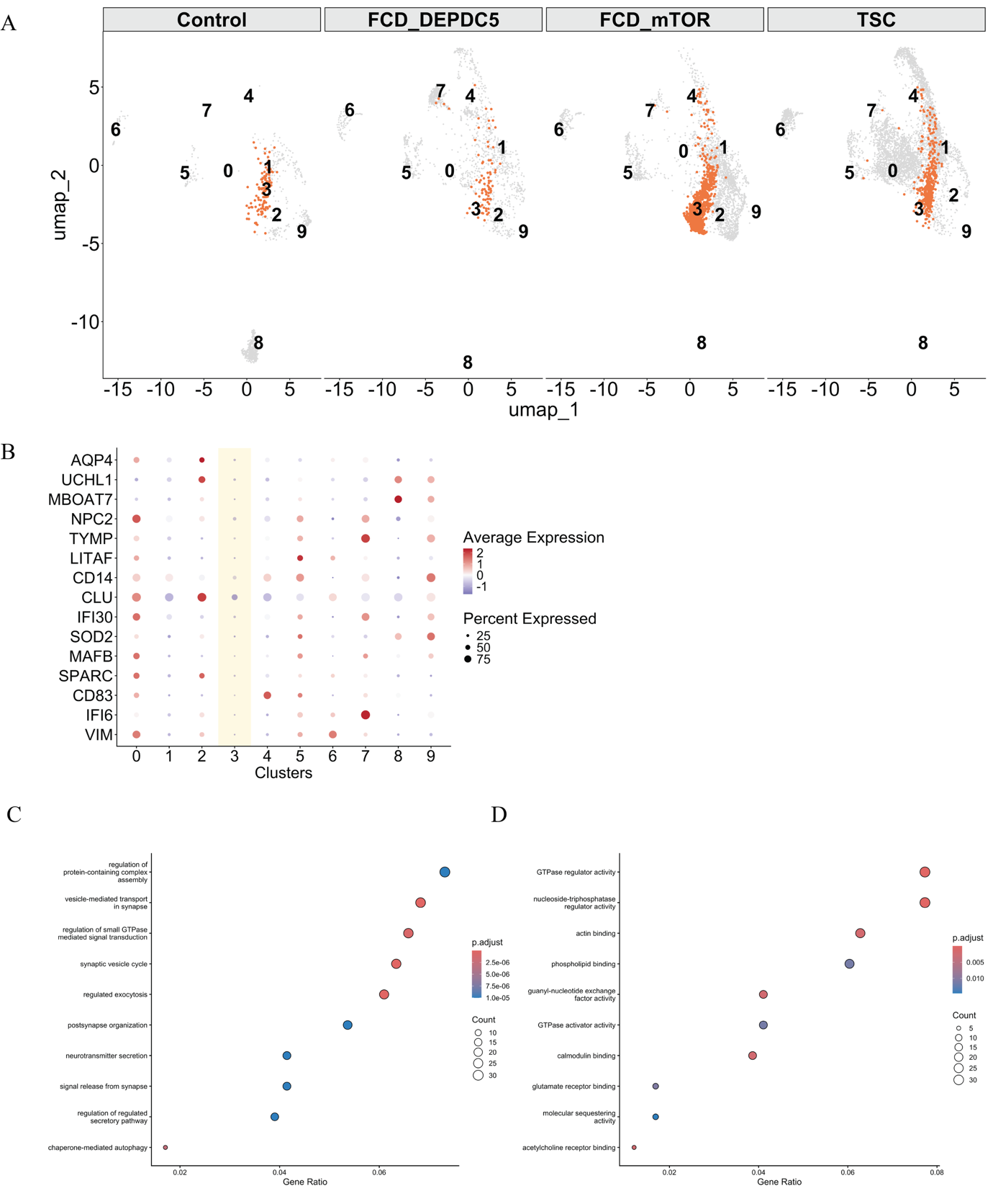
Supplementary Figure 5. Characterization of hypo-responsive microglial state. Supplementary figure 5. Hypo-responsive microglial cluster characterized by transcriptional attenuation and reduced functional enrichment. (A) UMAP projections of microglial clusters (0–9) displayed separately for Control, FCD_DEPDC5, FCD_mTOR, and TSC samples. Cells belonging to cluster 3 (highlighted in orange) are overlaid on the full embedding (gray), illustrating their relative distribution across conditions. (B) Dot plot showing expression of selected genes associated with stress regulation, immune modulation, and structural programs across clusters. Dot size represents the percentage of cells expressing each gene, and color indicates scaled average expression. (C) Gene Ontology (biological process) enrichment analysis of cluster 3 differentially expressed genes. Dot size reflects gene count and color indicates adjusted p-value. (D) Gene Ontology (molecular function) enrichment analysis. Dot size denotes gene count and color represents adjusted p-value.
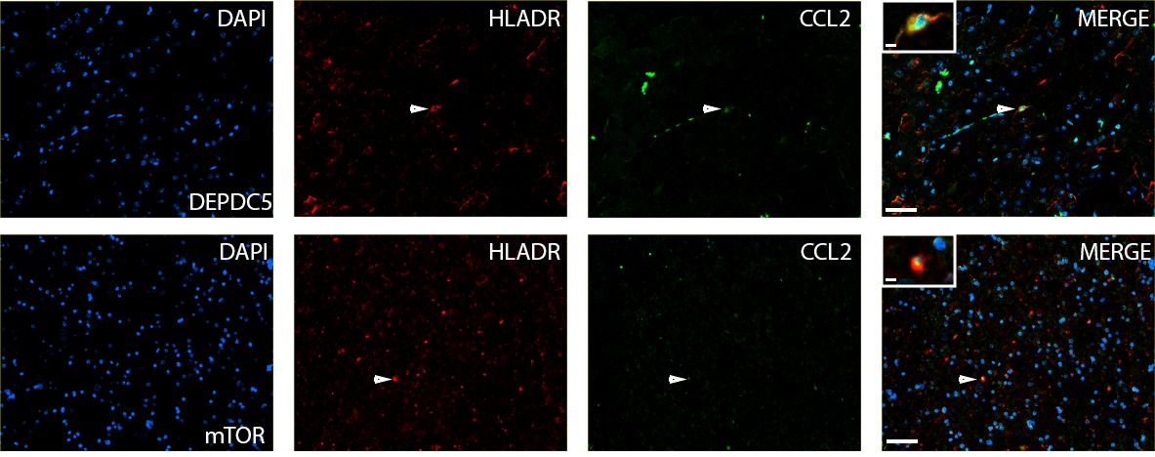
Supplementary Figure 6. Immunofluorescent validation of pro-inflammatory microglial cluster 0 in human tissue of FCD_DEPDC5 (n = 3) and FCD_mTOR (n = 4). Arrows indicate HLADR⁺ CCL2⁺ cells. The scalebar of the lowest magnification represents 50µm, while the scalebar of the highest magnification represents 5µM.

Supplementary Figure 7. Immunofluorescent validation of the lipid-associated DAM-like cluster 0 in human tissue of FCD_DEPDC5 (n = 3) and FCD_mTOR (n = 4). Arrows indicate HLADR⁺ GPNMB⁺ cells. The scalebar of the lowest magnification represents 50µm, while the scalebar of the highest magnification represents 5µM.

Supplementary Figure 8. Immunofluorescent validation of interferon responsive cluster 7 in human tissue of FCD_DEPDC5 (n = 3) and FCD_mTOR (n = 4). Arrows indicate HLADR⁺ ISG15⁺ cells. The scalebar of the lowest magnification represents 50µm, while the scalebar of the highest magnification represents 5µM.

