Pre-test ­ Coronary Angiographic Training Study

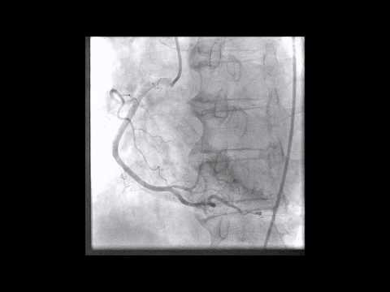

  - What Artery and What View? * Mark only one oval.
Left coronary RAO Caudal Left coronary AP Caudal Left coronary LAO Caudal Left coronary LAO Cranial Left coronary AP Cranial Left coronary RAO Cranial Right coronary LAO Cranial Right coronary AP Cranial Right coronary RAO

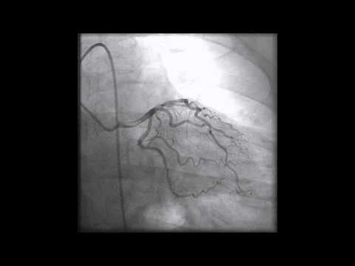

  - What Artery and What View? * Mark only one oval.
Left coronary RAO Caudal Left coronary AP Caudal Left coronary LAO Caudal Left coronary LAO Cranial Left coronary AP Cranial Left coronary RAO Cranial Right coronary LAO Cranial Right coronary AP Cranial Right coronary RAO

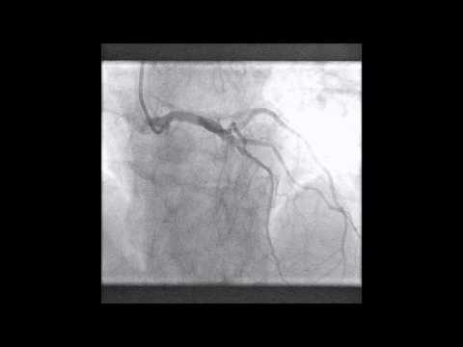

  - What Artery and What View? * Mark only one oval.
Left coronary RAO Caudal Left coronary AP Caudal Left coronary LAO Caudal Left coronary LAO Cranial Left coronary AP Cranial Left coronary RAO Cranial Right coronary LAO Cranial Right coronary AP Cranial Right coronary RAO

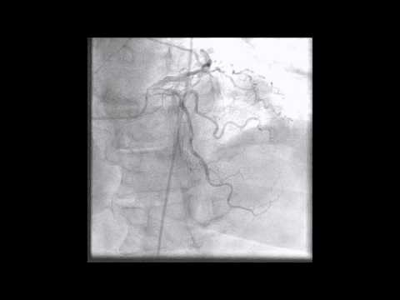

  - What Artery and What View? * Mark only one oval.
Left coronary RAO Caudal Left coronary AP Caudal Left coronary LAO Caudal Left coronary LAO Cranial Left coronary AP Cranial

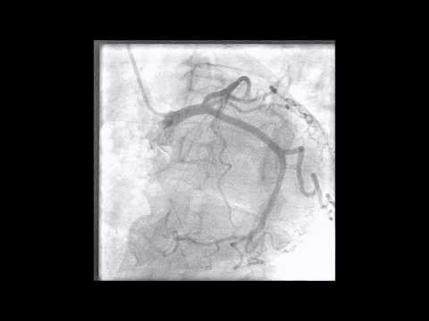

  - What Artery and What View? * Mark only one oval.
Left coronary RAO Caudal Left coronary AP Caudal Left coronary LAO Caudal Left coronary LAO Cranial Left coronary AP Cranial Left coronary RAO Cranial Right coronary LAO Cranial Right coronary AP Cranial Right coronary RAO

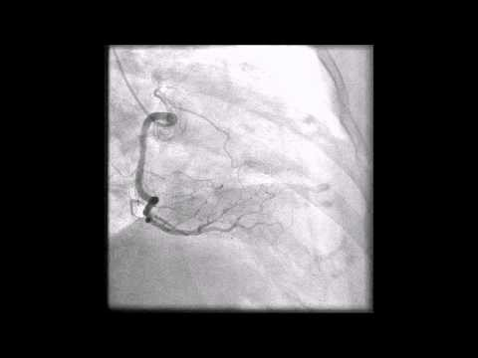

  - What Artery and What View? * Mark only one oval.
Left coronary RAO Caudal Left coronary AP Caudal Left coronary LAO Caudal Left coronary LAO Cranial Left coronary AP Cranial Left coronary RAO Cranial Right coronary LAO Cranial Right coronary AP Cranial Right coronary RAO

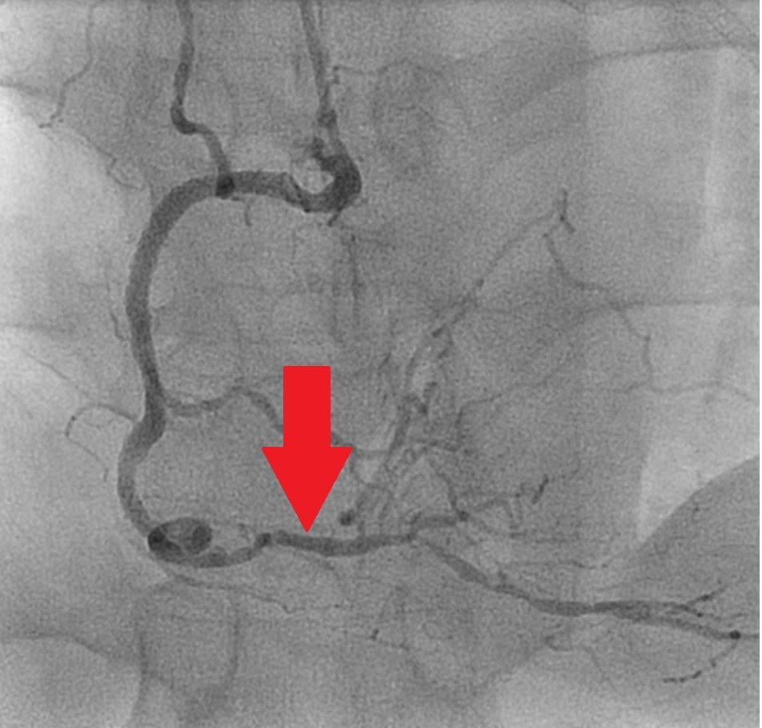

  - What Artery? * Mark only one oval.
Left Anterior Descending Artery Left Circumflex Artery
Right Coronary Artery

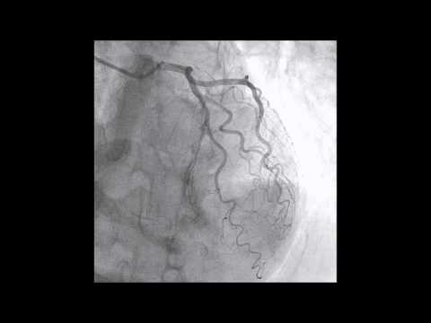

  - What Artery and What View? * Mark only one oval.
Left coronary RAO Caudal Left coronary AP Caudal Left coronary LAO Caudal Left coronary LAO Cranial Left coronary AP Cranial

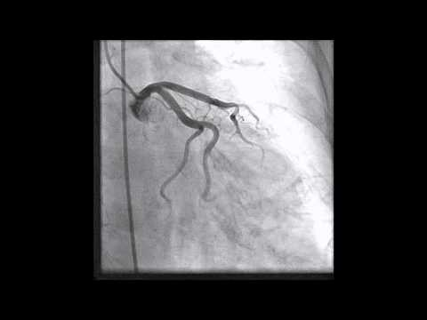

  - What Artery and What View? * Mark only one oval.
Left coronary RAO Caudal Left coronary AP Caudal Left coronary LAO Caudal Left coronary LAO Cranial Left coronary AP Cranial

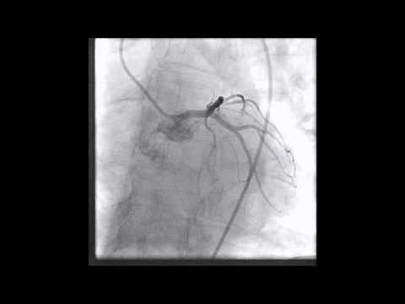

  - What Artery and What View? * Mark only one oval.
Left coronary RAO Caudal Left coronary AP Caudal Left coronary LAO Caudal Left coronary LAO Cranial Left coronary AP Cranial

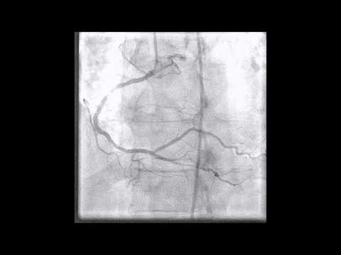

  - What Artery and What View? * Mark only one oval.
Left coronary RAO Caudal Left coronary AP Caudal Left coronary LAO Caudal Left coronary LAO Cranial Left coronary AP Cranial

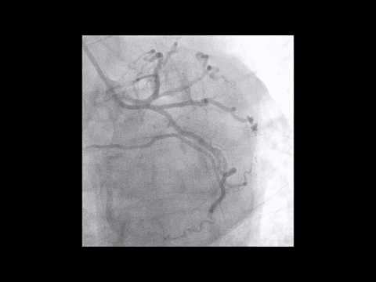

  - What Artery and What View? * Mark only one oval.
Left coronary RAO Caudal Left coronary AP Caudal Left coronary LAO Caudal Left coronary LAO Cranial Left coronary AP Cranial

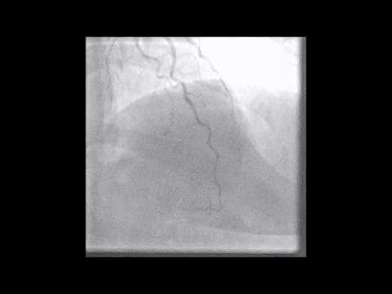

  - What Artery and What View? * Mark only one oval.
Left coronary RAO Caudal Left coronary AP Caudal Left coronary LAO Caudal Left coronary LAO Cranial Left coronary AP Cranial

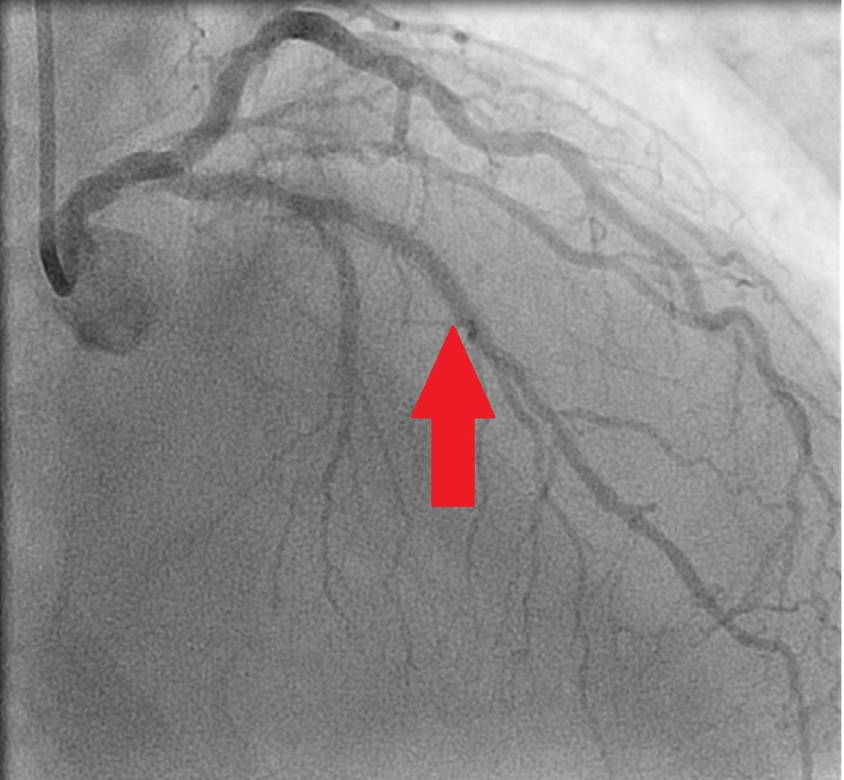

  - What Artery? * Mark only one oval.
Left Anterior Descending Artery Left Circumflex Artery
Right Coronary Artery

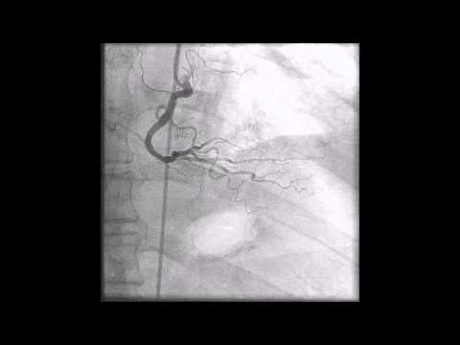

  - What Artery and What View? * Mark only one oval.
Left coronary RAO Caudal Left coronary AP Caudal Left coronary LAO Caudal Left coronary LAO Cranial Left coronary AP Cranial

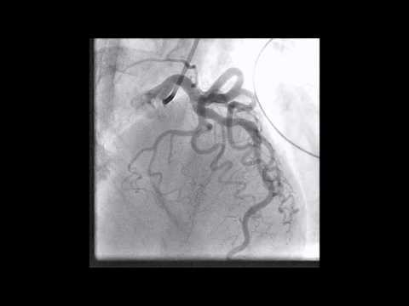

  - What Artery and What View? * Mark only one oval.
Left coronary RAO Caudal Left coronary AP Caudal Left coronary LAO Caudal Left coronary LAO Cranial Left coronary AP Cranial

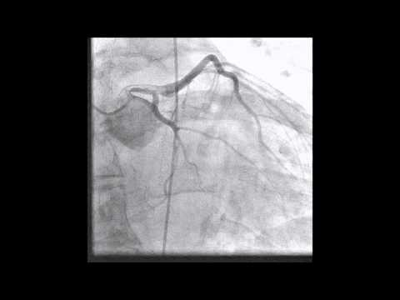

  - What Artery and What View? * Mark only one oval.
Left coronary RAO Caudal Left coronary AP Caudal Left coronary LAO Caudal Left coronary LAO Cranial Left coronary AP Cranial

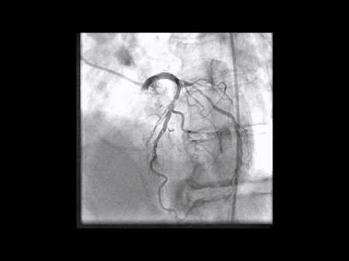

  - What Artery and What View? * Mark only one oval.
Left coronary RAO Caudal Left coronary AP Caudal Left coronary LAO Caudal Left coronary LAO Cranial Left coronary AP Cranial

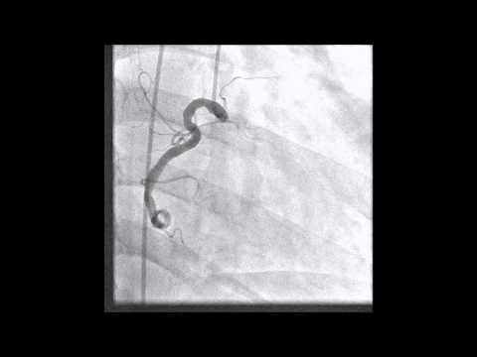

  - What Artery and What View? * Mark only one oval.
Left coronary RAO Caudal Left coronary AP Caudal Left coronary LAO Caudal Left coronary LAO Cranial Left coronary AP Cranial

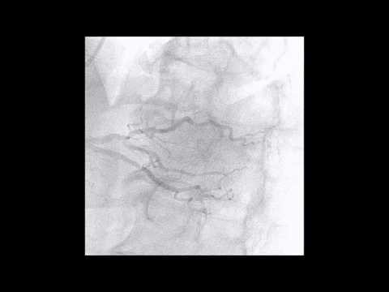

  - What Artery and What View? * Mark only one oval.
Left coronary RAO Caudal Left coronary AP Caudal Left coronary LAO Caudal Left coronary LAO Cranial Left coronary AP Cranial

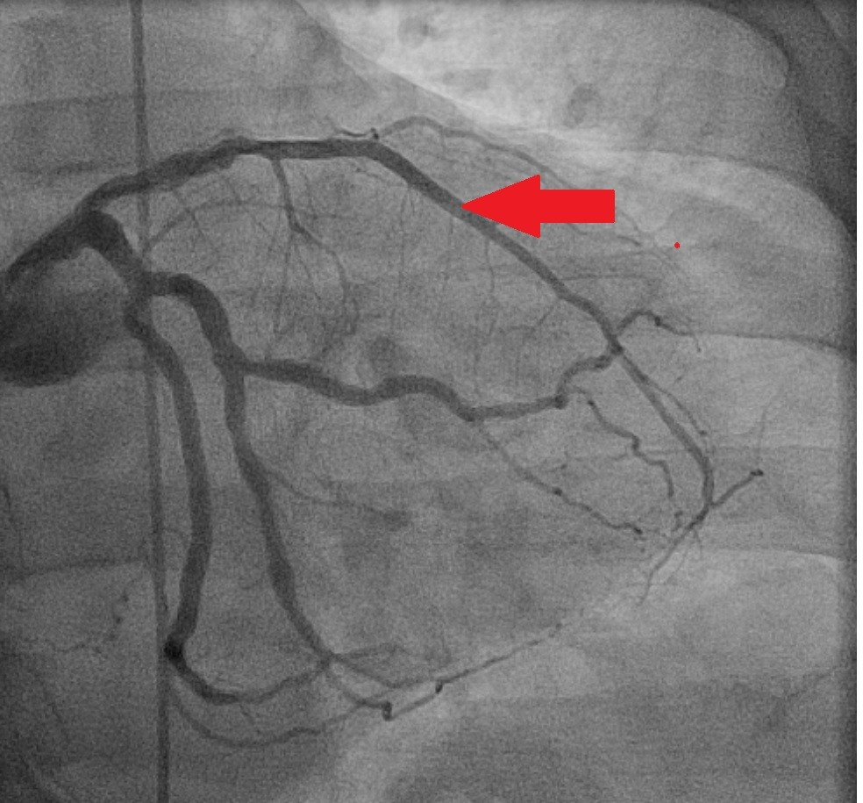

  - What Artery? * Mark only one oval.
Left Anterior Descending Artery Left Circumflex Artery
Right Coronary Artery

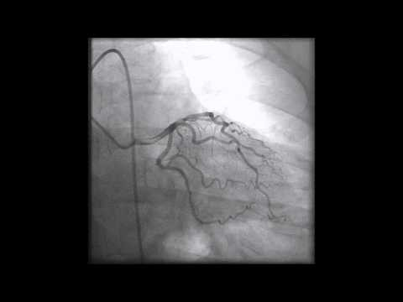

  - What Artery and What View? * Mark only one oval.
Left coronary RAO Caudal Left coronary AP Caudal Left coronary LAO Caudal Left coronary LAO Cranial Left coronary AP Cranial

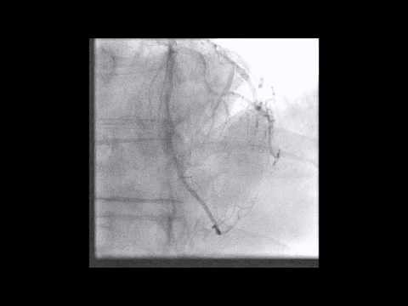

  - What Artery and What View? * Mark only one oval.
Left coronary RAO Caudal Left coronary AP Caudal Left coronary LAO Caudal Left coronary LAO Cranial Left coronary AP Cranial

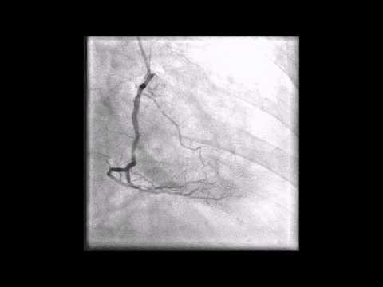

  - What Artery and What View? * Mark only one oval.
Left coronary RAO Caudal Left coronary AP Caudal Left coronary LAO Caudal Left coronary LAO Cranial Left coronary AP Cranial

  - What Artery and What View? * Mark only one oval.
Left coronary RAO Caudal Left coronary AP Caudal Left coronary LAO Caudal Left coronary LAO Cranial Left coronary AP Cranial

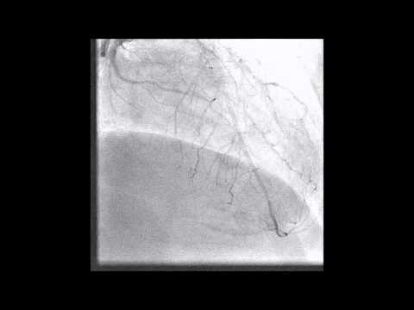

  - What Artery and What View? * Mark only one oval.
Left coronary RAO Caudal Left coronary AP Caudal Left coronary LAO Caudal Left coronary LAO Cranial Left coronary AP Cranial

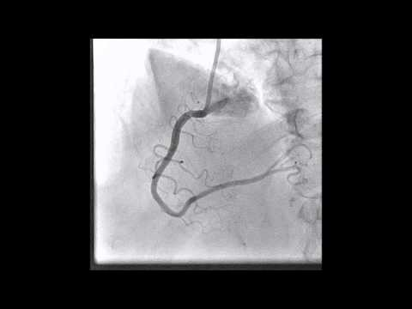

  - What Artery and What View? * Mark only one oval.
Left coronary RAO Caudal Left coronary AP Caudal Left coronary LAO Caudal Left coronary LAO Cranial Left coronary AP Cranial

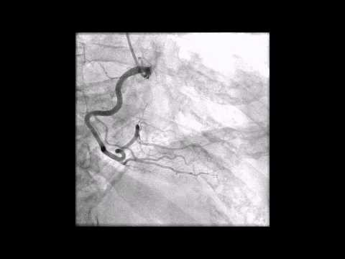

  - What Artery and What View? * Mark only one oval.
Left coronary RAO Caudal Left coronary AP Caudal Left coronary LAO Caudal Left coronary LAO Cranial Left coronary AP Cranial

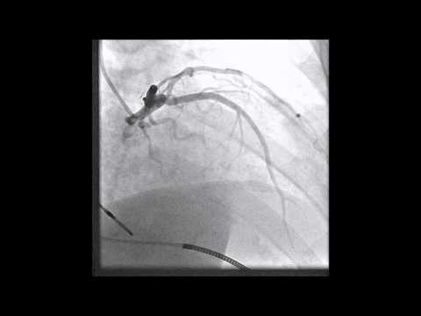

  - What Artery and What View? * Mark only one oval.
Left coronary RAO Caudal Left coronary AP Caudal Left coronary LAO Caudal Left coronary LAO Cranial Left coronary AP Cranial

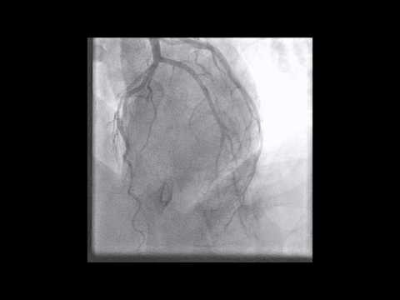

  - What Artery and What View? * Mark only one oval.
Left coronary RAO Caudal Left coronary AP Caudal Left coronary LAO Caudal Left coronary LAO Cranial Left coronary AP Cranial Left coronary RAO Cranial Right coronary LAO Cranial Right coronary AP Cranial Right coronary RAO

End of Pretest.

