Extended Data

RNA folding below the nanopore impairs direct RNA sequencing fidelity and modification calling

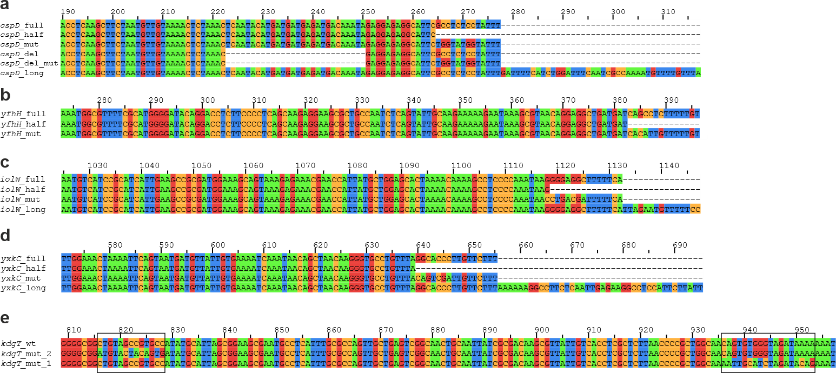

Extended Data Fig. 1 | Design of DNA templates used for in vitro transcription
a–d, Alignment of 3′ terminal regions of DNA templates used to generate full-length (“full”), truncated (“half”), mutated (“mut”), extended (“long”) variants and transcripts with deletions (“del”, “del_mut”). e, Alignment of mutated intragenic regions (black boxes) used to disrupt internal RNA secondary structures in kdgT. Truncations, point mutations and sequence extensions introduced by primer design are indicated relative to the full-length construct.
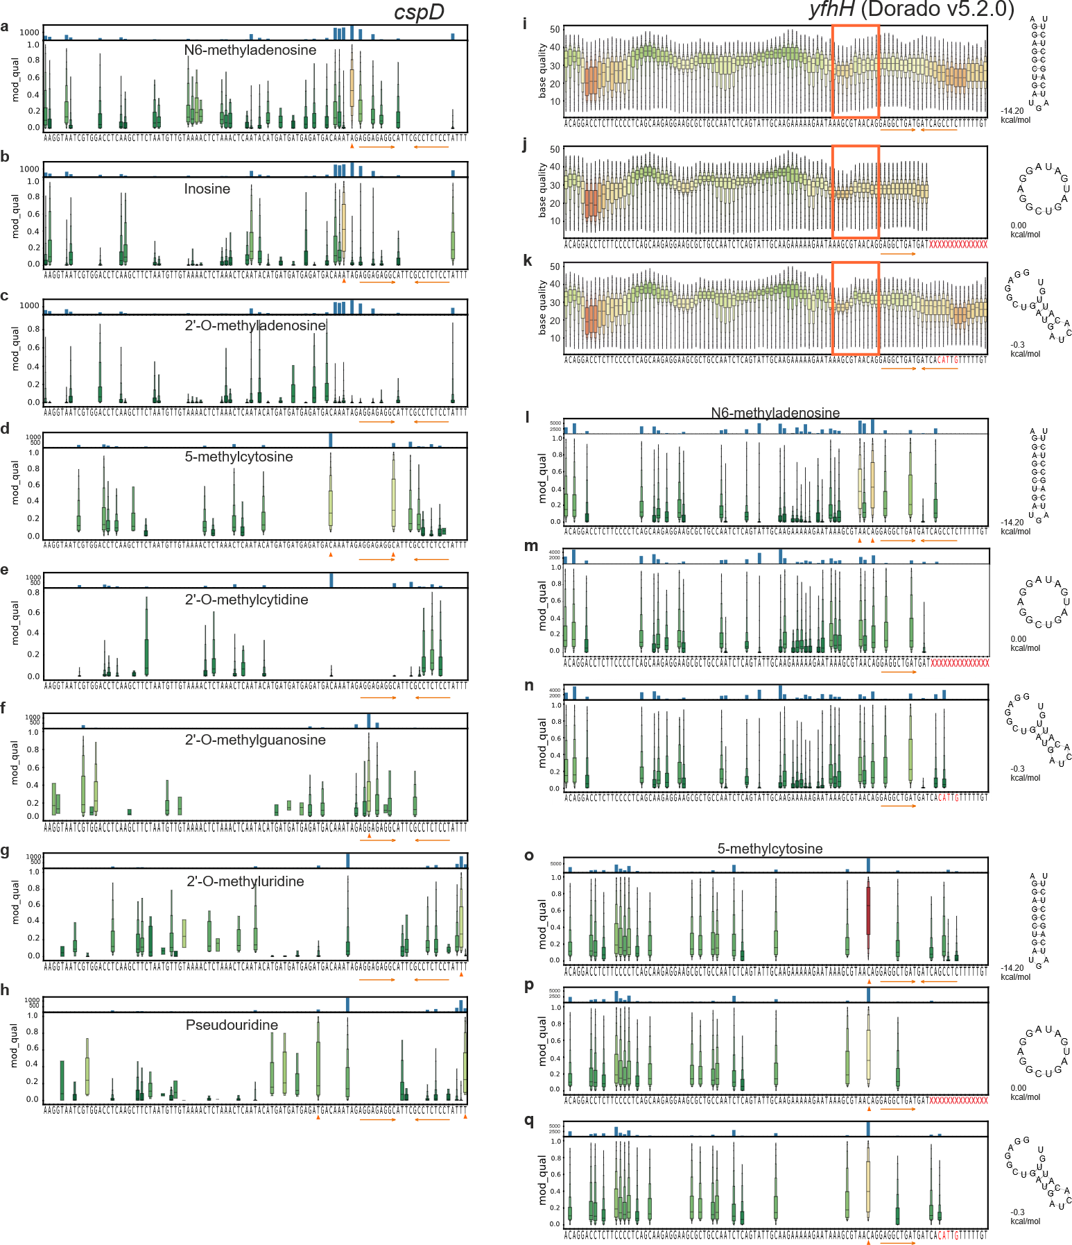

Extended Data Fig. 2 | Detailed modification profiles of cspD full and yfhH transcript variants, and per-base quality scores (QS) of yfhH transcript variants
a–h, l–q, Per-read modification probabilities (mod_qual) across nucleotide positions in cspD and yfhH transcripts, obtained with modkit from Dorado v5.2.0 basecalls (default settings). Upper panels show the number of reads with non-zero modification probability at each position (maximum depth 10,000); lower panels show mod_qual distributions as boxen plots, with the center line indicating the median. Modification classes detected by the RNA004 SUP model are: a, l-n, m⁶A; b, inosine; c, 2′-O-mA; d, o-q, m⁵C; e, 2′-O-mC; f, 2′-O-mG; g, 2′-O-mU; h, pseudouridine.
i–k, Distribution of QS reported by the Dorado v5.2.0 model for nucleotides in the 3′ terminal region of the yfhH transcripts (cspD QS is reported in the main text Fig. 3). The distribution of QS at each base is represented by boxen plot where the center line denotes the median. Each position is colored by the median QS (red, lowest; green, highest).
Orange arrows indicate the terminator hairpin, red highlights denote mutated or deleted nucleotides, and orange triangles mark positions with a high fraction of high-confidence modification calls (HCM). Predicted secondary structures and minimum free energies (ΔG, kcal mol⁻¹) are shown next to the corresponding panels. i, l, o, yfhH full; j, m, p, yfhH half; k, n, q, yfhH mut.

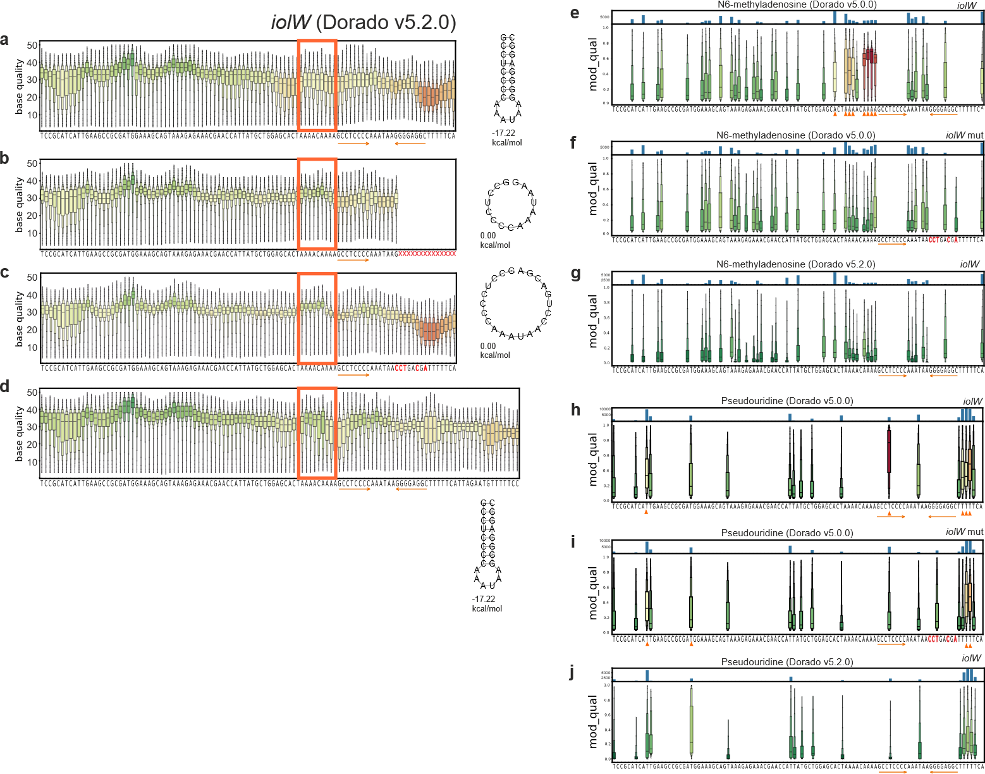

Extended Data Fig. 3 | Per-base quality scores (QS) of iolW transcript variants and comparison of m6A and pseudouridine calling by Dorado v5.0.0 and v5.2.0 in iolW transcripts
a-d, Distribution of QS reported by the Dorado v5.2.0 model for nucleotides in the 3′ terminal region of the iolW transcripts. The distribution of QS at each base is represented by boxen plot where the center line denotes the median. Each position is colored by the median QS (red, lowest; green, highest). Orange arrows indicate the terminator hairpin, red highlights denote mutated or deleted nucleotides, and orange triangles mark positions with a high fraction of high-confidence modification calls (HCM). Predicted secondary structures and minimum free energies (ΔG, kcal mol⁻¹) are shown next to the corresponding panels. QS profiles by Dorado v5.0.0 were similar and are not shown.
e-j, Distribution of per-read modification probabilities (mod_qual) across nucleotide positions at the 3′ end of iolW transcripts (wild type and mutant), derived using modkit from Dorado basecalls. Panels e-g show m6A probabilities and panels h-j show pseudouridine (Ψ) probabilities. Panels e,f,h,i correspond to Dorado v5.0.0, whereas panels g and j correspond to Dorado v5.2.0. Display conventions are as in Extended Data Fig. 2. a, e, h iolW full; b, f, i, iolW half; c, g, j, iolW mut, d, iolW long.

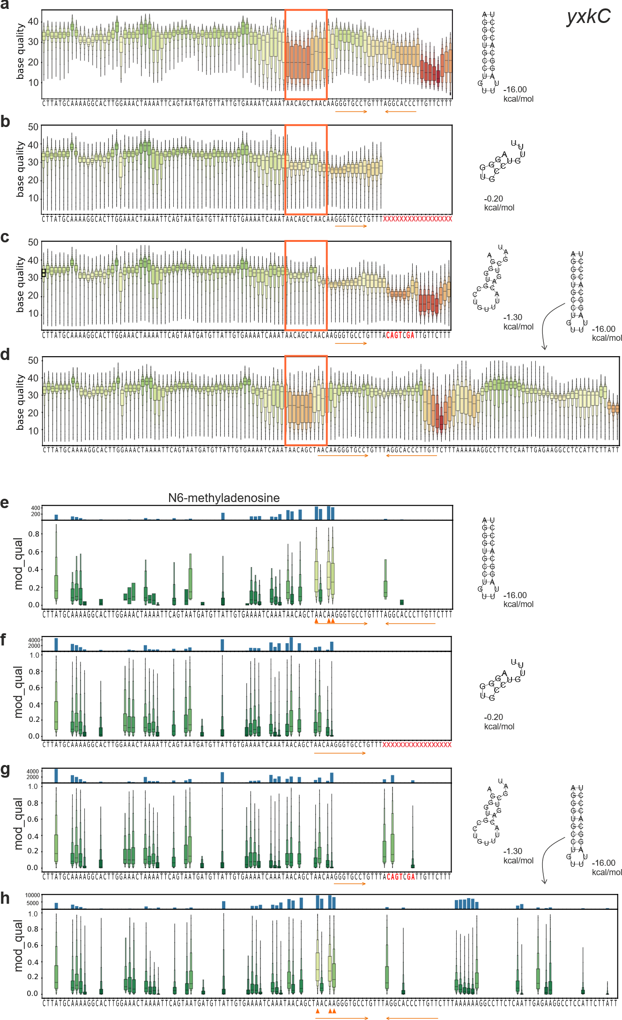

Extended Data Fig. 4 | Detailed per-base quality scores (QS) and modification profiles of yxkC transcript variants
a–d, Distribution of per-base quality scores (QS) reported by Dorado v5.2.0 for nucleotides in the 3′ terminal region of the yxkC transcripts. Each position is colored according to the median QS (red, lowest; green, highest), and QS distributions at individual nucleotides are shown as boxen plots with the center line denoting the median. The predicted secondary structure of the terminator region and its minimum free energy (ΔG, kcal mol⁻¹) are shown next to the corresponding panels. The terminator is indicated by orange arrows, and positions that are mutated or deleted in the construct are highlighted in red.
e-h, Distribution of per-read m⁶A modification probabilities (mod_qual) across nucleotide positions at the 3′ end of yxkC transcripts derived using modkit from Dorado v5.2.0 basecalls. Display conventions are as in Extended Data Fig. 2. a,e yxkC full; b,f, yxkC half; c,g, yxkC mut; d,h, yxkC long.

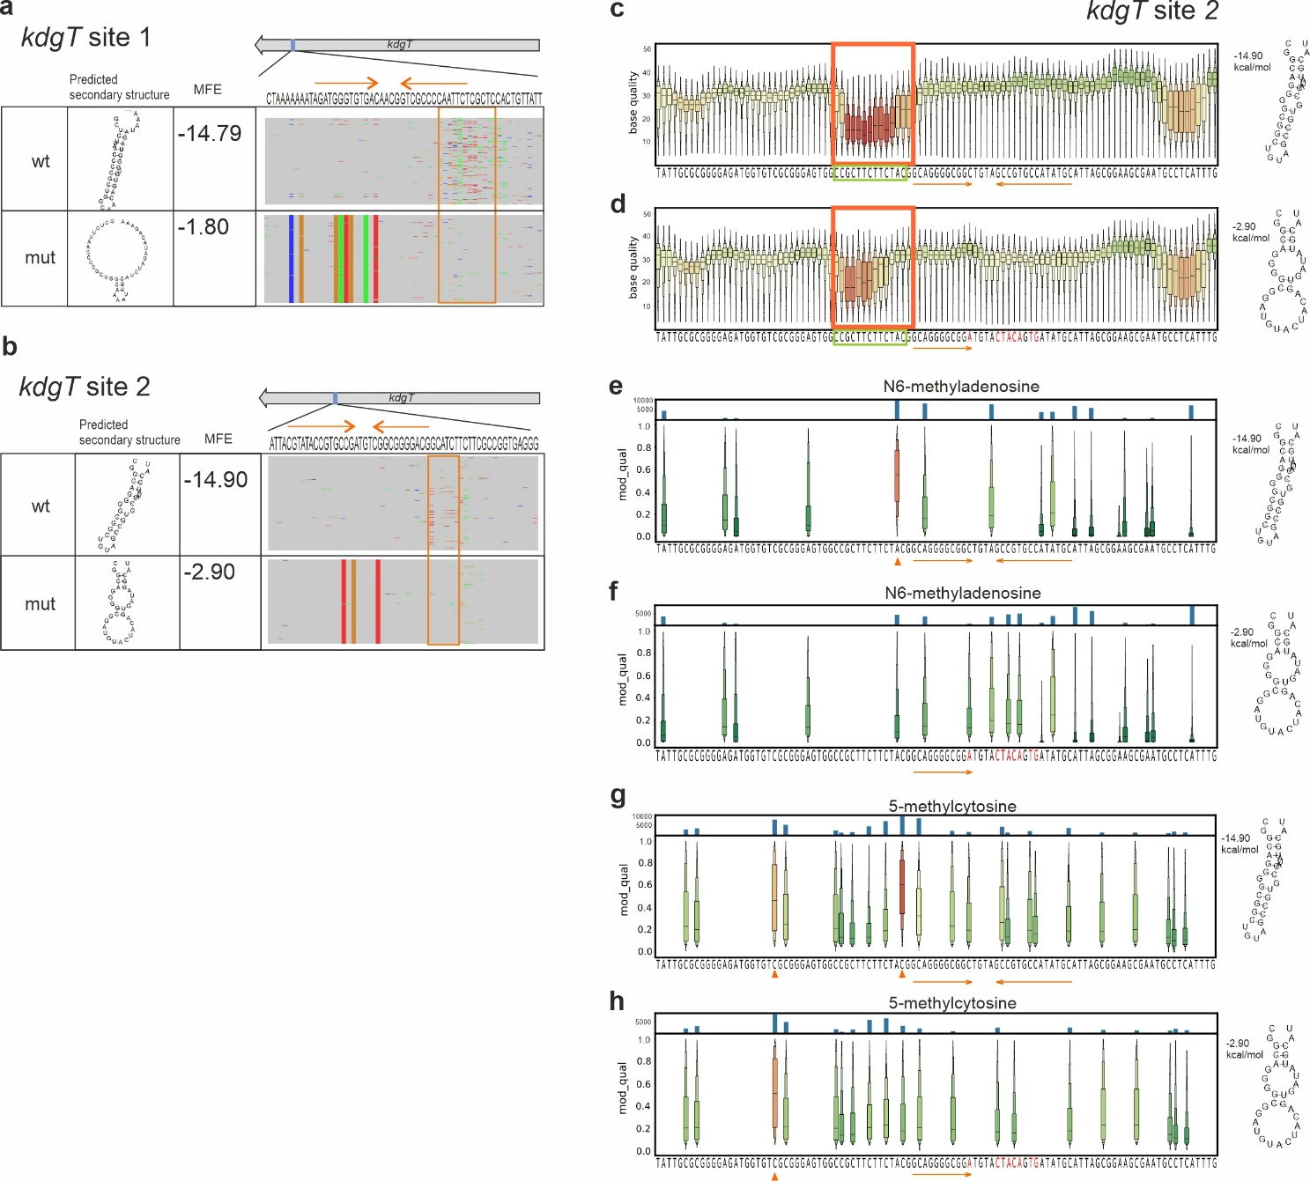

Extended Data Fig. 5 | Internal RNA secondary structures reduce sequencing fidelity and induce false-positive modification calls
a,b, Schematic representation and IGV views of two regions within kdgT showing elevated sequencing error frequency in direct RNA sequencing data. Regions with high error rates are highlighted by orange boxes, and predicted downstream RNA secondary structures together with their minimum free energies are shown. Mismatched bases are color-coded in the IGV views (showing also the mutated positions in ”mut” transcript variants). c,d, Distribution of per-base quality scores (QS) for kdgT site 2 wild-type and mutant constructs across the high-error region adjacent to a strong internal hairpin. Sequence encoding UC-rich RNA region is highlighted in green box. e–h, Distribution of per-read modification probabilities (mod_qual), showing m⁶A for wild-type (e) and mutant (f) constructs and m⁵C for wild-type (g) and mutant (h) constructs. Display conventions are as in Extended Data Fig. 2.

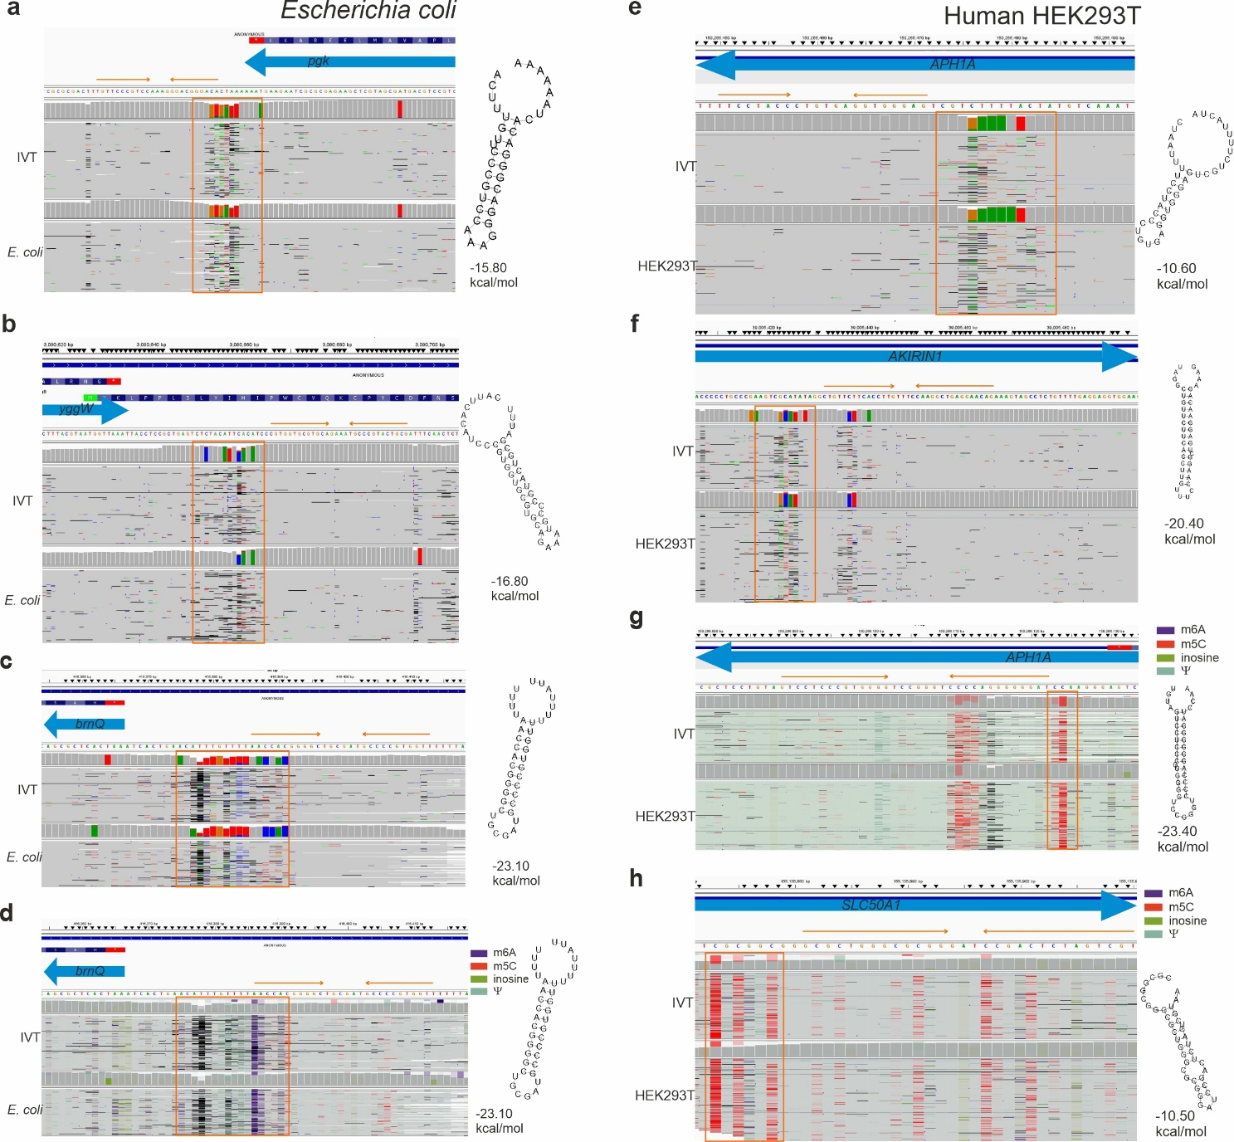

Extended Data Fig. 6 | Structure-linked sequencing artefacts in Escherichia coli and human direct RNA sequencing data
Representative examples from Escherichia coli (a–d) and from the human HEK293T dataset (e–h). Cellular RNA (bottom panels) and the corresponding in vitro-transcribed control RNA (top panels) were sequenced by ONT direct RNA sequencing, basecalled with Dorado v5.2.0, and visualized in IGV. Reads are colored by sequencing errors (a,b,c,e,f) or predicted modifications (d,g,h; m⁶A, blue; m⁵C, red; inosine, green; pseudouridine, cyan). Predicted downstream RNA hairpins are indicated by orange arrows, and regions with elevated sequencing errors or false-positive modification signals are highlighted by orange boxes. The predicted secondary structures of the upstream region and its minimum free energy (ΔG, kcal mol⁻¹) are shown next to the corresponding panels.

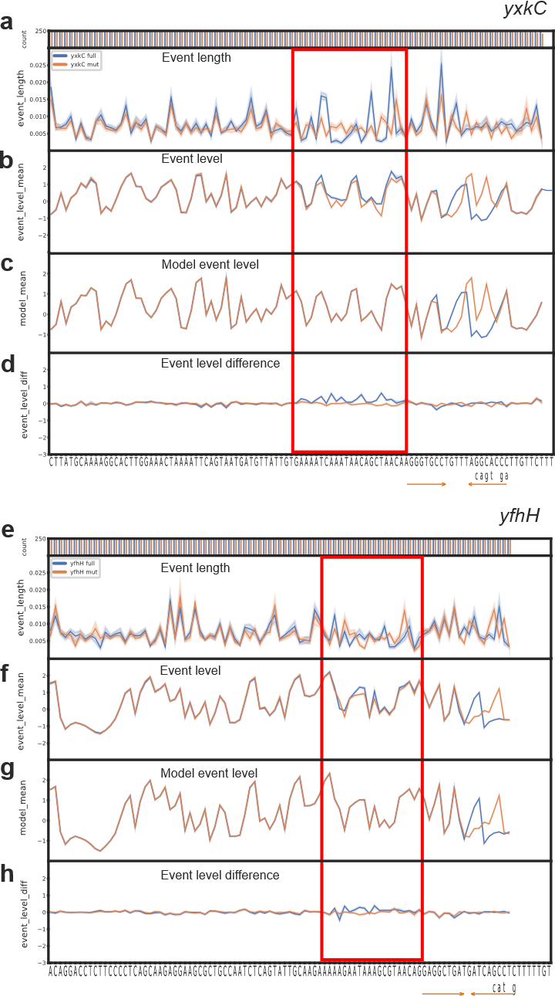

Extended Data Fig. 7 | Signal-level analyses of yxkC and yfhH transcripts with and without downstream secondary structure
Panels show position-wise event statistics obtained by signal/event alignment with Uncalled4 for yxkC (a—d) and yfhH constructs (e-h) [full (hairpin present; blue) and mut (hairpin base pairing disrupted; orange)] constructs. a,e, Median of event length (dwell time) per position. b,f, Median of observed event level (ionic current) per position. c,g, Median of Uncalled4-reported model event level (model-predicted current) for the aligned sequence context. d,h, Event level difference (observed minus model-predicted current means) per position. The terminator hairpin location is indicated beneath the plots (orange arrows), and the window showing the strongest structure-associated deviations immediately upstream of the hairpin is highlighted (red box). In all panels, a random subset of 250 reads was analyzed. Shaded bands indicate 95% confidence intervals; for d,h, intervals correspond to a two-sided Z confidence interval for the difference of means (α = 0.05).
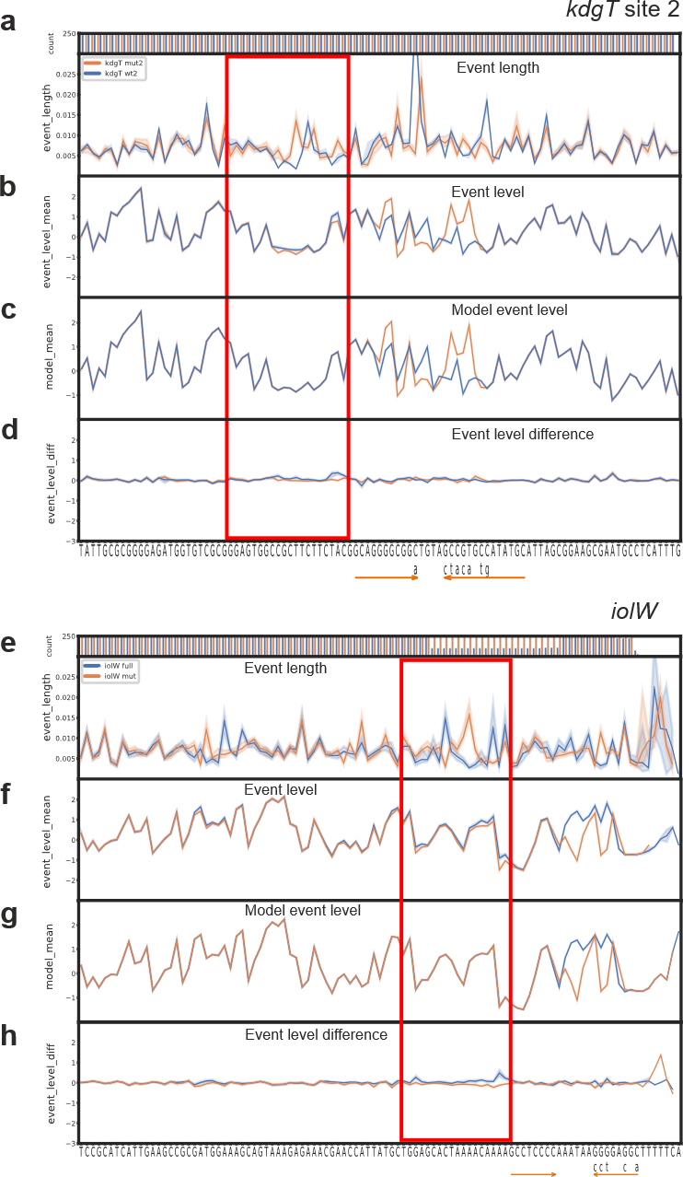

Extended Data Fig. 8 | Signal-level analyses of kdgT site 2 and iolW transcripts with and without downstream secondary structure
Panels show position-wise event statistics obtained by signal/event alignment with Uncalled4 for kdgT site 2 (a—d) and iolW constructs (e-h) [full/wt (hairpin present; blue) and mut (hairpin base pairing disrupted; orange)] constructs. a,e, Median of event length (dwell time) per position. b,f, Median of observed event level (ionic current) per position. c,g, Median of Uncalled4-reported model event level (model-predicted current) for the aligned sequence context. d,h, Event level difference (observed minus model-predicted current means) per position. The terminator hairpin location is indicated beneath the plots (orange arrows), and the window showing the strongest structure-associated deviations immediately upstream of the hairpin is highlighted (red box). In all panels, a random subset of 250 reads was analyzed. Shaded bands indicate 95% confidence intervals; for d,h, intervals correspond to a two-sided Z confidence interval for the difference of means (α = 0.05).

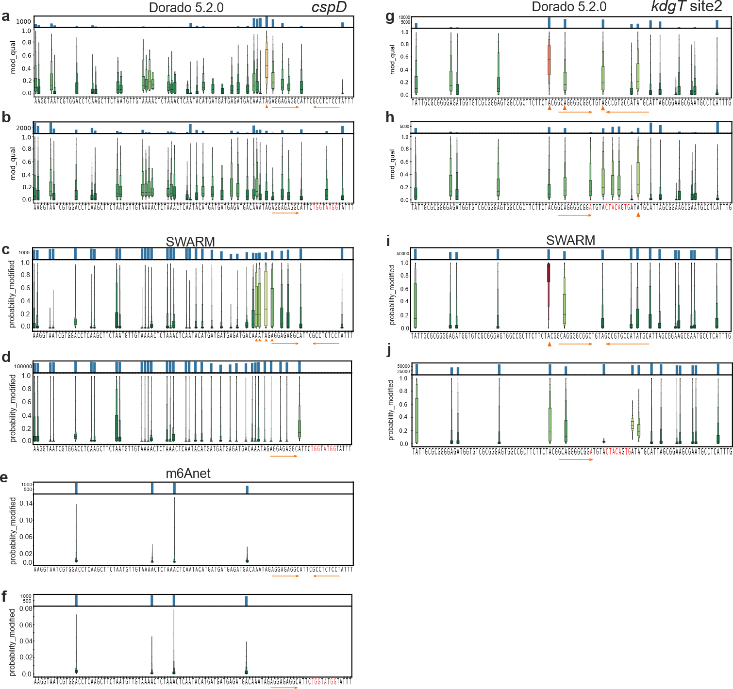
Extended Data Fig. 9 | Comparison of false-positive m⁶A calling by Dorado v5.2.0, m6Anet and SWARM
Panels show the distribution or position-wise profiles of predicted m⁶A probabilities for cspD (a-f) and kdgT site 2 (g-j) transcript variants with intact (wt- a,c,e,g,i) or disrupted downstream secondary structures (mut- b,d,f,h,j). Upper panels show the number of reads with non-zero modification probability at each position; lower panels show per-read modification probabilities across nucleotide positions reported by Dorado v5.2.0 (mod_qual; a-b, g-h), SWARM (probability_modified; c-d, i-j), m6Anet (probability_modified; e-f) as boxen plots, with the center line indicating the median.

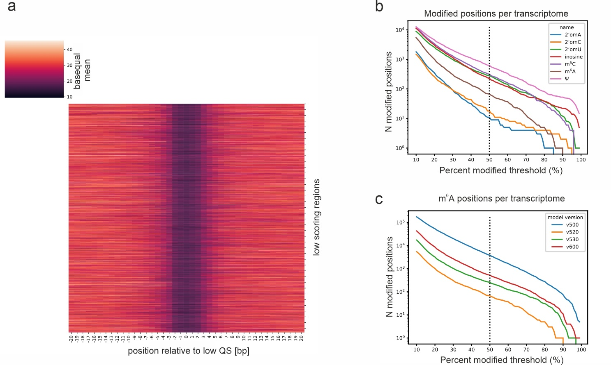

Extended Data Fig. 10 | Transcriptome-wide organization of low-QS regions and false-positive modification calls in the IVT transcriptome
a, Heatmap of per-base quality scores (QS) centered on low-QS regions identified transcriptome-wide in the IVT Bacillus subtilis transcriptome; regions are ordered by genomic position. b, Transcriptome-wide distribution of false-positive modification calls across modification types (color-coded) and modification-fraction thresholds. The number of transcriptomic positions is plotted against the minimum fraction of reads required to be called as modified at a position (percent modified threshold). c, Model dependence of m⁶A calls: as in b, but restricted to m⁶A and showing different Dorado model versions (v5.0.0, v5.2.0, v5.3.0 and v6.0.0). For panels b-c, minimal coverage of 20 was required for each position.

