Table 1 Baseline patient characteristics
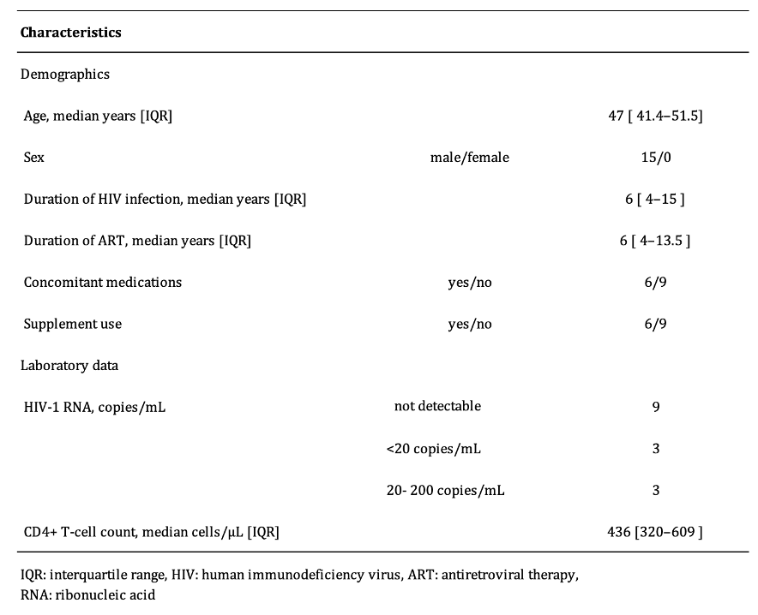

Table 2. Free-text comments regarding bottle packaging
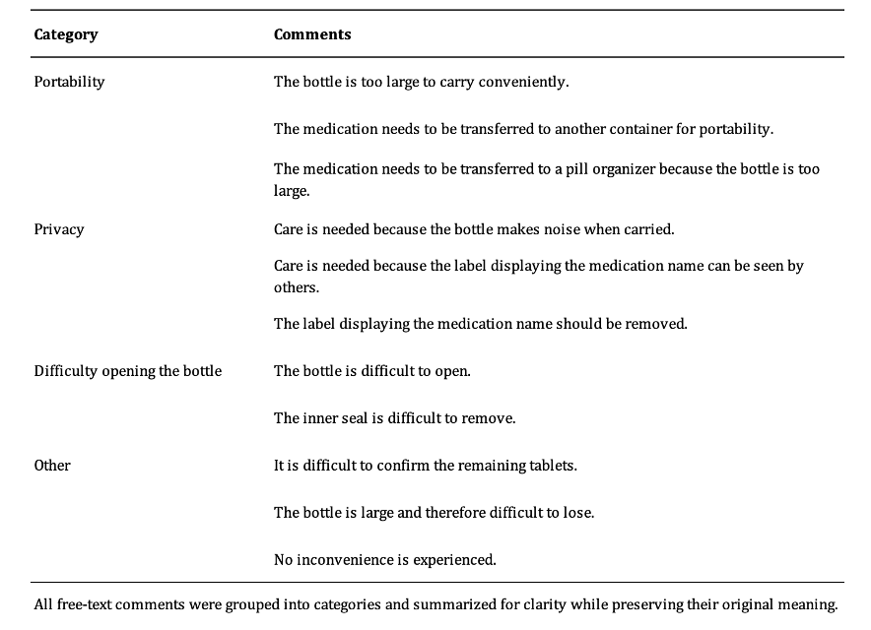

Table3 Participant perceptions of bottle and PTP packaging
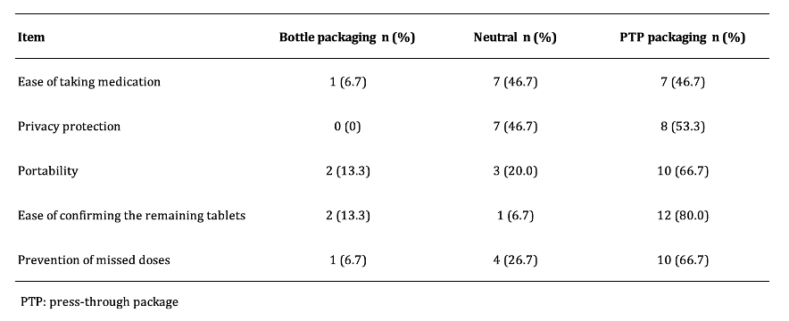

Table 4. Free-text comments regarding PTP packaging
