Appendix 1: Interview outline

"Hello, and thank you for agreeing to talk to me about my thesis on domestic violence.
The aim of this research project is to gather as accurate a picture as possible of your personal feelings about what you've experienced.
There's no right or wrong answer, no nonsense or "silly things", anything you think can be said without taboo, and above all, without fear of judgment.
I'm going to record our interview using this Dictaphone, and may take a few notes on this sheet, but don't worry, this is simply to enable me to transcribe as accurately as possible. Sometimes, if you digress too much, I may interrupt your story to refocus on the history of your relationship with the person who abused you. Please don't think this is because I'm not interested in your story, but to make it easier for me to transcribe and analyze it afterwards. All data collected will then be completely anonymized for further research. If you wish, you can have access to the written transcript of the interview by e-mail, and confirm the validity of your comments.
Before we begin, do you have any questions?"

Icebreaker question:

What do you think of the latest news on the subject of domestic violence?

Interview:

1/ Tell me the story of your relationship with the person who abused you, from the very beginning of your relationship.

Possible follow-ups :
On certain points that seem key in the person's story (without interrupting)
- In your story, you told me about the time ....
- What exactly happened? Try to give me a detailed account.
- What did you feel at that moment? Why or why not?

2/ When did you start to question the balance of your relationship? Why?

Possible follow-ups :
- How did it feel?
- What was different in this situation compared to before in your relationship?
- What made you "tick" for the first time?
- What did you find "not normal" or inappropriate about this situation?

3/ What do you think triggered the realization that what you were experiencing was not acceptable/normal?

Possible follow-ups :
- Is this a specific situation? Why or why not?
- Involving an outsider? Who is involved? Who?
- A new feeling?

4/ What, in your opinion, triggered a decision about this relationship? Why or why not?

Possible follow-ups :
- Is this a specific situation? Why or why not?
- Involving an outsider? Who is involved? Who?
- A new feeling?

5/ When and how did you finally break the silence/start taking action? Why or why not?

Possible follow-ups :
- What triggered you to take action or talk about it?
- How did you feel then?

→ Incidental question?

Final question:

What do you think could have helped you become aware of your situation sooner?

Possible follow-ups :
- Anyone in particular?
- An unacceptable situation from the outset?
- What questions? What words? What interventions? By whom?
- Why?

Appendix 2: the 7 questions (Gilles de la Londe et al., 2020)

- What is my initial question?
- How did I come to ask this question?
- If I were asked this question myself, what would my answer be?
- Why am I convinced that this question is relevant?
- What answers do I expect from the participants?
- What answers do I not expect from the participants?
- What is my ultimate research question?

Reference

Gilles de la Londe, J., Cadwallader, J.-S., Lustman, M., & Lebeau, J.-P. (2020). Questioner la question. Affiner la problématisation en recherche qualitative avec « les 7 questions ». Exercer, (165), 324‑328.

Appendix 3 : Approval by the Ethics Committee for Human Research at the Faculty of Medicine, Tours, n°2020072

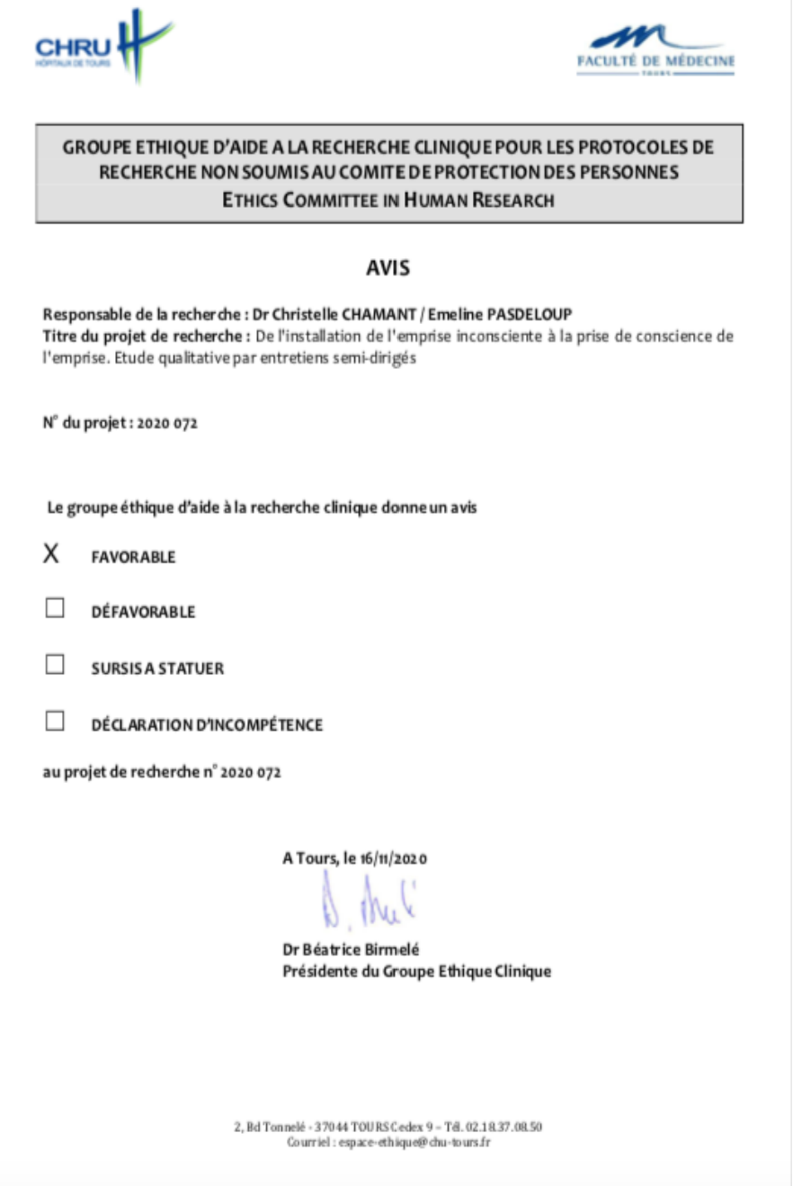

Appendix 4 : Information note and consent

CONSENT TO PARTICIPATE IN RESEARCH
From Entrapment to Recognition: Women’s Experience of Emprise in Intimate Partner Violence – A Qualitative Study

I, the undersigned ........................................ agree to participate in the research work of Dr. Emeline Pasdeloup.

I have been informed of the terms and conditions of my participation and the use of the data, including for publication.

I may revoke my consent at any time with regard to my participation or the use of the data collected during the interview.

AT …............., date : …..................

Signature

Appendix 5 : COREQ (COnsolidated criteria for REporting Qualitative research) Checklist

