Formation charging reveals hidden manufacturing defects in lithium-ion batteries

Table S1. 71 electric-vehicle fire incidents attributed to manufacturing defects from 2019 to 2025.
Time and location | Vehicle model | Incident description | Defect type | Estimated loss or recall scale
2019–2021, United States | Chevrolet Bolt EV | 13 publicly reported fire incidents | Anode tab tearing and separator folding | Approximately US$ 2 billion
2019–2021, Korea and Europe | Hyundai Kona Electric | At least 13 fire incidents | Anode tab folding | Approximately US$ 0.9 billion
2020, Europe | Ford Kuga PHEV | 7 publicly reported fire incidents | Particle contamination | More than 20,000 vehicles recalled
2022–2024, North America | Chrysler Pacifica PHEV | At least 19 fire incidents | Anode tab tearing and tab folding | More than 43,000 vehicles recalled
2024–2025, United States | Jeep Wrangler 4xe and Grand Cherokee 4xe | At least 19 fire incidents | Separator damage | More than 375,000 vehicles recalled

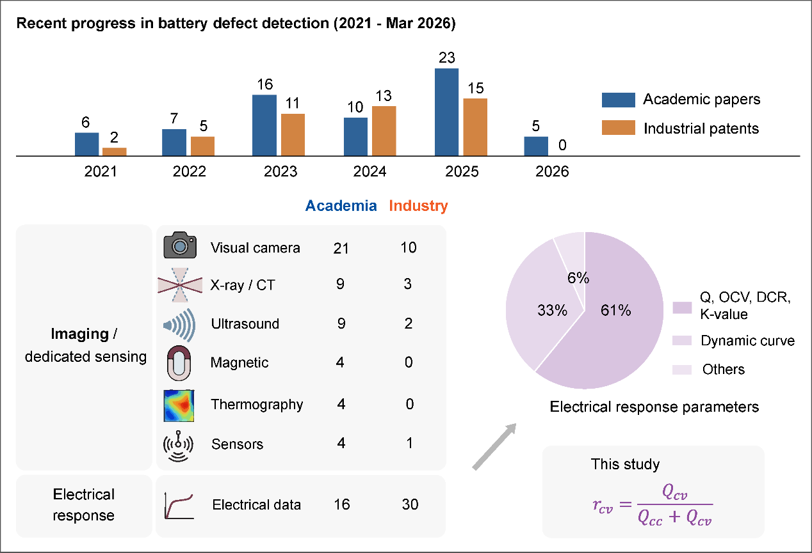
Figure S1. Recent progress in battery defect detection. We searched the Web of Science and the China Patent Network using the keywords “battery sorting” and “defect detection” from 2021 to March 2026, and identified 113 papers and patents. In recent years, attention to this issue has been steadily growing in both academia and industry. Overall, existing methods for detecting manufacturing defects can be broadly classified into two categories: one relies on multi‑dimensional inspection equipment, and the other relies on electrical response features during battery charge–discharge processes.

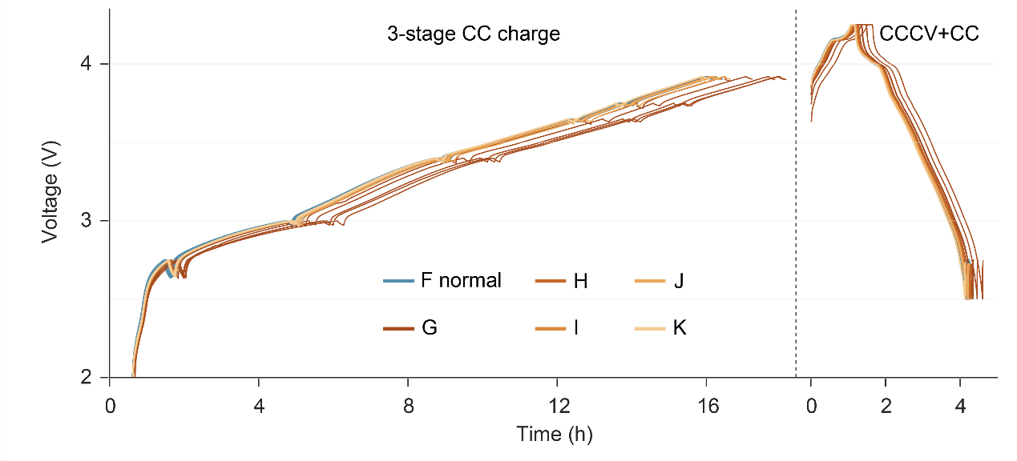
Figure S2. The voltage-time curves of 55 cells during three-stage CC charge and CCCV charge + CC discharge stages. Although the curves of batteries with Class G metallic foreign matter defects exhibit a certain deviation from those of normal batteries, the differences for batteries with other types of defects are not pronounced. Overall, the charge–discharge curves of defective cells were similar to those of normal cells, without any significant differences or abnormal phenomena such as sudden voltage drops.

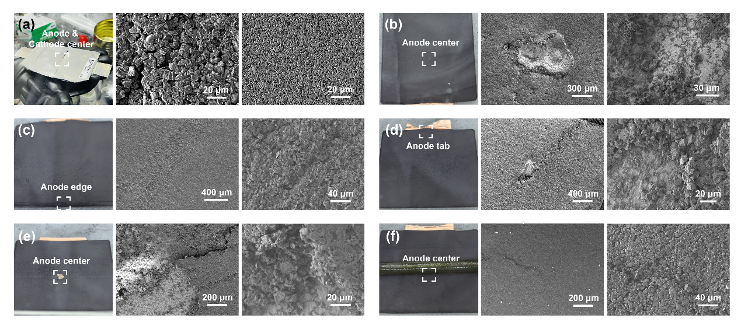
Figure S3. SEM characterization after cell disassembly. (a) Central anode and cathode regions of a normal cell. (b) Central anode region of a metallic-foreign-matter cell. (c) Edge anode region of an edge active-material-loss cell. (d) Tab-side anode region of a tab-tearing cell. (e) Central anode region of an electrode-cracking cell. (f) Central anode region of a separator-pore-closure cell. These observations indicate that the common $r_{CV}$ shift does not arise from a single defect morphology.

The central regions of the normal anode and cathode showed relatively uniform particle distributions and continuous electrode morphology (Fig. S3a). Metallic foreign matter, such as copper particles on the cathode, can dissolve at high potential, migrate as metal ions, deposit on the anode and increase the risk of internal short circuits. Consistent with this pathway, the anode center of the metallic-foreign-matter cell showed local roughening and deposition-like features (Fig. S3b). Edge active-material loss disrupts local electrode continuity, creates fresh reactive interfaces and increases the risk of edge lithium plating. Correspondingly, morphological non-uniformity and fractured interfaces were observed near the detached edge (Fig. S3c). Tab tearing alters the boundary condition of the anode solid-phase potential and can induce non-uniform current distribution and reaction-state heterogeneity. Linear damage and heterogeneous morphology appeared near the tab side (Fig. S3d). Anode cracking interrupts local active regions and creates abnormal lithiation pathways, as evidenced by a clear material-discontinuity region in the anode center (Fig. S3e). Separator pore closure impedes local ion transport, thereby increasing polarization and lithium-plating risk. Although the overall morphological change was less pronounced in this group, local non-uniform features were still observed (Fig. S3f).

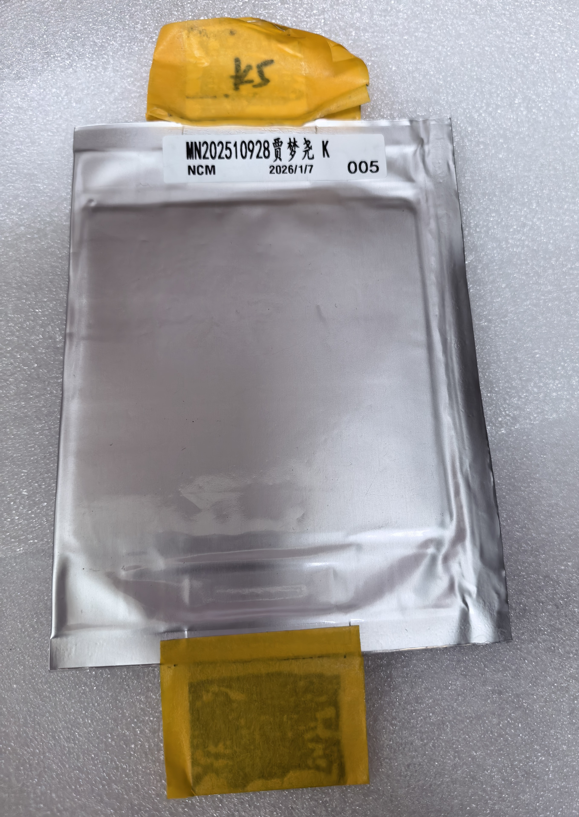
Figure S4. One of the fabricated pouch cells. For the metallic foreign matter defect, a copper particle with a diameter of 300 $μm$ was implanted in the cathode. For the edge active material loss defect, half of the active-material thickness was removed from a region covering approximately one tenth of the anode edge. For the tab tearing defect, half of the width of the middle three anode tabs was cut off in the transverse direction. For the electrode cracking defect, an approximately 5 mm × 5 mm region was removed from the center of the anode. For the separator pore closure defect, PET tape was applied near the anode side to transversely block approximately one tenth of the separator length. Apart from these target defects, all other manufacturing conditions were kept unchanged.

