Additional File

Metagenomics methods for the quantitative detection of pathogens causing ventilator-associated pneumonia

Content

Additional method information 1
Accuracy of SPC detection 1
Detailed workflow for sequence data analysis and interpretation 2
Normalization of sequence read counts 2
SOI and SPC detection 2
Calculation of absolute concentration of detected SOI 4
Calculation of minimal detectable concentration of SOI 5
Determination of metagenomics threshold 5
Additional figures 6
Additional Tables 11
Additional references 13

Additional method information

Accuracy of SPC detection
We assessed the accuracy of taxonomic classification of sequence reads derived from SPC and their potential confusion with SOI(s) by Kraken V0.10.5b [1], a tool used in our bioinformatics pipeline (see Additional figure 1). The measured precision is above 99.95 % with a sensitivity of 98.7 %. These figures show that the sequence reads of the SPC can be efficiently distinguished from those of SOIs, bacterial flora and patient DNA.

Detailed workflow for sequence data analysis and interpretation
The complete workflow for quantitative detection of SOI by mNGS is presented in Figure 1 in the main text. Additional figure 2 provides more details on data interpretation applied to each sample after the demultiplexing step and taxonomic classification of sequences. All SOIs were analyzed separately as independent detection assays.

Normalization of sequence read counts
Given that the total number of reads and the proportion of human reads vary between sequencing runs, a normalization step is needed for comparing results from different samples. We normalized the numbers of sequence reads classified to a bacterial species of interest (R_{SOI}) or to the SPC (R_{SPC}) with the total number of reads associated to all bacterial species including B. subtilis (R_{bacteria}). The normalized values (RN_{SOI} and RN_{SPC}) were expressed in reads per million of bacterial reads (RPMB):
${RN}_{SOI}=\frac{R_{SOI}}{R_{bacteria}}×1,000,000$ and ${RN}_{SPC}=\frac{R_{SPC}}{R_{bacteria}}×1,000,000$

SOI and SPC detection
Correct taxonomic classification of SOIs and SPC sequences is key to mNGS-based diagnostic, to prevent false positive or false negative detections. Taxonomic classification errors can arise for several reasons such as sequencing errors, inaccuracy of classification algorithm or low quality of genomic sequences within the reference database [2]. Moreover, the presence of contaminating DNA in the reagents may also induce false detection of species [3, 4].
We defined detection thresholds (DT), to differentiate background from ‘true’ taxonomic assignments of sequence reads to SPC or SOI. DT_{SPC} and DT_{SOI} represent the minimal count of classified sequence reads normalized per million of bacterial reads required to report SPC or SOI as detected.

Definition of DT_{SPC}
To evaluate the possibility for distinguishing the natural presence of B. subtilis in BAL sample from spiked SPC and to define DT_{SPC}, we compared the quantity of sequence reads classified as B. subtilis on 7 non-spiked and on 45 SPC-spiked BAL samples. The median normalized quantity of sequences classified as B. subtilis in non-spiked samples was 5 RPMB and 12,000 RPMB in SPC-spiked samples (Additional figure 3). This result reveals the low level of misclassification of sequences to B. subtilis and/or the presence of B. subtilis in BAL samples or in reagents, as a contaminant, in amounts substantially lower than the one which is spiked as SPC. We calculated, with the 3 sigma method (mean plus 3 standard deviations), a detection threshold (DT_{SPC}) at 475 RPMB. In 40 of 45 spiked samples (88.9 %) from the “training set”, normalized quantities of sequence reads classified as B. subtilis were above DT_{SPC}. The remaining 5 samples, in which sequence reads assigned as B. subtilis were below DT_{SPC}, contained at least one SOI represented by more than 500,000 RPMB (see T17, T26, T35, T39 and T43 in Additional table 1). Most of these SOIs were also detected at high concentrations (≥ 1.0E+5 CFU/mL) by microbial cultures. The quantity of reads associated to all SOI in these samples were above 887,000 RPMB, leaving little room for detection of other species, including B. subtilis (SPC).

Definition of DT_{SOI}
For each of the SOIs, we measured the background of the taxonomic classification using the samples from the “training set” that were negative in microbial culture for the assessed species. When large amounts of sequences in a tested sample were classified as an SOI that was not identified by culture, k-mer based sequence read classification (Kraken) was controlled using BLAST-based 16S/MetaPhlAn2 markers search. Confirmation of k-mer based classification by marker search may point to the mNGS detection of dead or non-growing SOIs, resulting from antibiotic treatments, or to substantial reagent contamination [3]. Therefore, the results of these samples were removed for the estimation of the background level of sequence classification (see values in italic in column “RN_{SOI}” in Additional table 1). Although background sequence classifications varied between SOIs, in most cases they were below 10,000 RPMB. (see Additional figure 4).
Background taxonomic classification to E. coli measured up to 7,797 RPMB may reflect reagent contaminations that is documented to cause false detections by both PCR and sequencing methods [5]. In three (T16, T21 and T29) of 42 samples that remained culture-negative for E. coli, k-mer based taxonomic classification of sequence reads to E. coli was confirmed by MetaPhlAn2 and 16S markers search; the corresponding sequencing data were removed from the analysis of background taxonomic assignments to E. coli. For Enterobacter cloacae, the level of background sequence association was much stronger as it frequently exceeded 100,000 RPMB. After 16S/MetaPhlAn2 marker confirmation, the results of 2 out of 45 samples that were culture-negative to E. cloacae were removed from background taxonomic assessment. Therefore, a bulk of assignments to E. cloacae could be due to the presence of poor quality or wrongly annotated genomic sequences in the database used by Kraken for taxonomic classification.
As the observed level of background taxonomic classification varied between species (see Additional figure 4), we calculated DT for each SOI (DT_{SOI}). The calculated DT_{E. cloacae} was above 1,000,000 RPMB, making impossible the mNGS analysis for this species.
An SOI was reported as detected in the sample when normalized quantity of its reads (RN_{SOI}) were equal or above the corresponding detection threshold (DT_{SOI}) (see Additional figure 2&).

Calculation of absolute concentration of detected SOI
In mNGS assays, relative quantity of sequence reads associated to a species is proportional to the relative DNA quantity of this species in the DNA extract [6]. As SPC is added at a defined concentration (C_{SPC} = 1.7E+4 CFU/mL) within each sample, when both SOI and SPC are detected (Additional figure 2), SPC can be used as a calibrator to calculate the absolute concentration of detected SOI (C_{SOI}) using the following formula:
$$C_{SOI}=\frac{R_{SOI}}{R_{SPC}}×\frac{L_{SPC}}{L_{SOI}}×C_{SPC}×{Eff}_{SOI}$$
R_{SOI} and R_{SPC} correspond to the quantity of sequence reads associated to SOI and SPC, respectively. L_{SOI} and L_{SPC} correspond to the genome size of SOI and SPC, respectively. As SOI and SPC may have different DNA extraction yields, library preparation and sequencing efficiencies, an Eff_{SOI} factor should be used to compensate differences in the mNGS process efficiency. The Eff_{SOI} factor value can be determined empirically, for example, by comparing the bacterial concentration quantified by mNGS to the quantity of bacteria added in a pool of BAL samples. In our study we did not have enough material to determine Eff_{SOI} for each SOI. Therefore, we used a default value of Eff_{SOI} = 1. Since B. subtilis used as SPC has a genome size of 4.13 Mbp and was spiked into samples at 1.7E+04 GEq/mL, C_{SOI} can be calculated using a simplified formula:
$$C_{SOI}=\frac{R_{SOI}×7.02E+04}{R_{SPC}×L_{SOI}}$$

Calculation of minimal detectable concentration of SOI
When an SOI is not detected (Additional figure 2), the assessment of its minimal detectable concentration (Cmin_{SOI}) is important. Cmin_{SOI} is the concentration of SOI required to generate at least the number of reads sufficient for its detection defined by DT_{SOI}. It is calculated with the following formula:
$${Cmin}_{SOI}= \frac{{DT}_{SOI} }{{RN}_{SPC}} × \frac{L_{SPC}}{L_{SOI}} × C_{SPC}×{Eff}_{SOI}$$
which, in our study, can be simplified to:
$${Cmin}_{SOI}=\frac{{DT}_{SOI}×7.02E+04}{{RN}_{SPC}×L_{SOI}}$$

Determination of metagenomics threshold
A metagenomics threshold (MT) was defined as the concentration of genomes above which infection by the pathogen can be suspected. When an SOI is detected and quantified (Additional figure 2), its absolute concentration is compared to MT to determine whether to report a colonization or a suspected infection by the SOI.
To differentiate the populations of SOI(s) detected by culture at or above the clinical threshold from SOI(s) detected below this threshold, we calculated the MT. The training set consisted of 45 (mini-)BAL samples in which we assessed 19 SOIs (855 detections in total). We observed 20 SOI detections above the clinical threshold, 6 SOI detections below the clinical threshold and 829 negative detections (Additional table 1). As the determination of an MT for each species would require to test substantially more samples than we had at our disposal, we defined a unique MT for all the species composing our study panel. Genomic DNA concentrations of detected SOI were assessed by the receiver operating characteristics method [7] to differentiate between their detections above or below the clinical threshold by microbial culture (see Additional figure 5). The MT calculated with Youden’s Index [8] was 5.3E+3 GEq/mL (sensitivity: 95 %; specificity: 96. 1%).

Additional figures

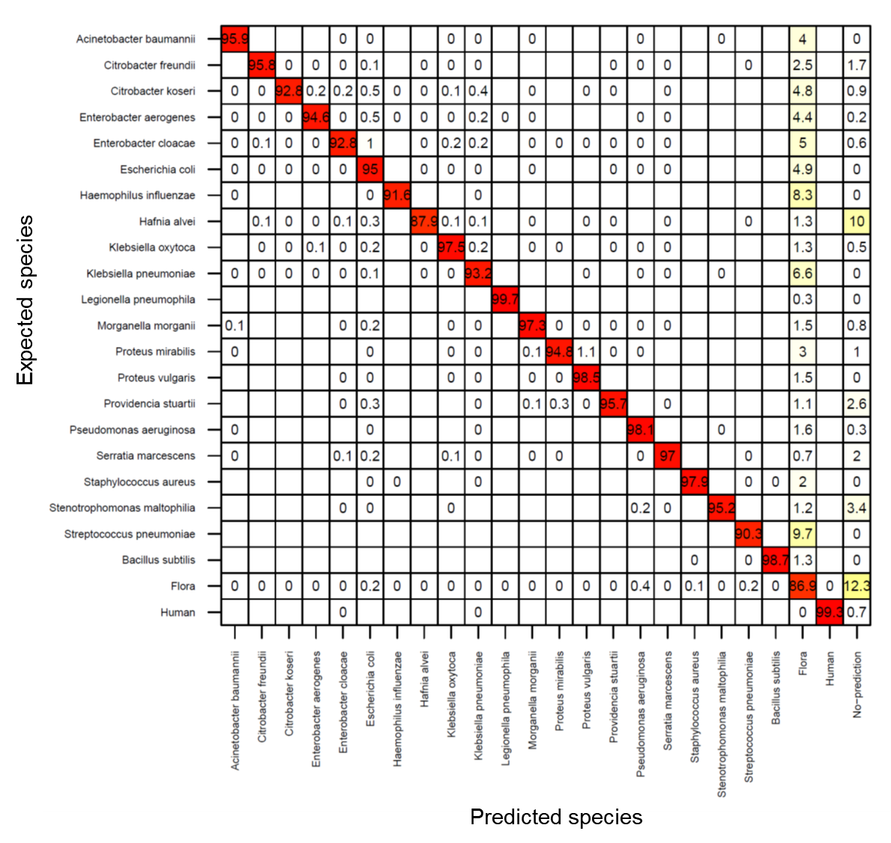
Additional figure 1: Accuracy of Kraken taxonomic binning of simulated sequence reads. Illumina 300bp paired-end reads were simulated using an in-house simulator. For each species, reads were simulated using a genome not included in the reference database. The rows correspond to the expected species (species from which the tested sequences originate) and columns to the predicted species (the taxonomic classification obtained with KRAKEN). “No-prediction” means that the read pair were not classified. The values in the boxes correspond to the sensitivity of the taxonomic classification (i.e. the percentage of reads classified to a given species) with color intensity, from red (100 %) to white (0 %). The precision of taxonomic classification of a given species is calculated as 100 % minus the sum of sensitivities obtained for other species.

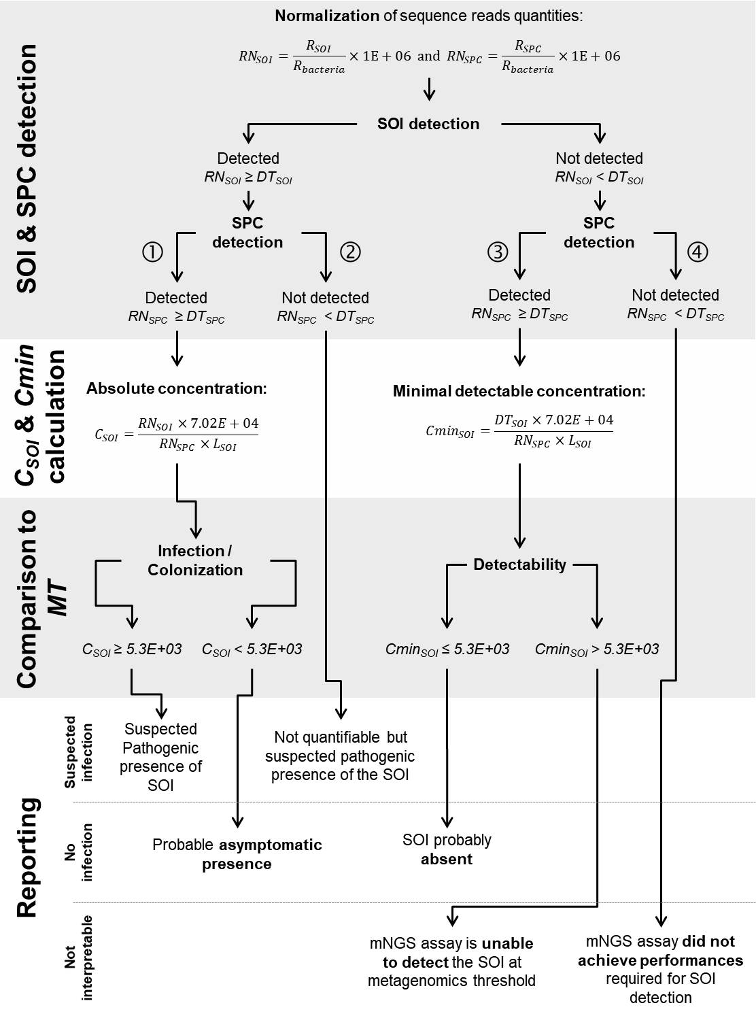
Additional figure 2 : Detailed workflow for data interpretation and reporting. This workflow is applied after demultiplexing and taxonomic classification of sequence reads at the species level. RN_{SOI} and RN_{SPC} are normalized quantities of reads classified to SOI and SPC, respectively (in RPMB). DT_{SOI} and DT_{SPC} are threshold of detection of normalized quantity of reads associated to SOI and SPC, respectively (in RPMB). L_{SOI} is the genome size of SOI (in Mbp). C_{SOI} is the calculated absolute concentration of SOI in a sample (in GEq/mL). Cmin_{SOI} is the minimal detectable concentration of SOI in a sample (in GEq/mL) for a given mNGS run.

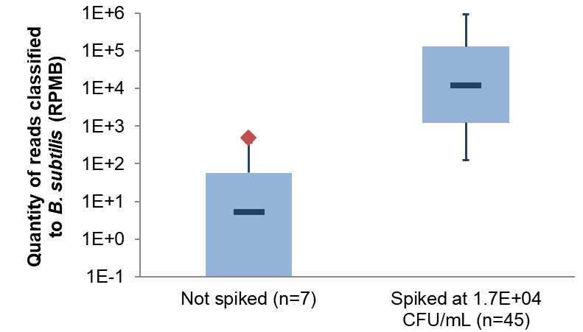
Additional figure 3: Quantity of sequence reads classified as B. subtilis in spiked and non-spiked BAL samples. Center lines show the medians; box limits indicate the 25th and 75th percentiles; whiskers extend to minimum and maximum values. The red diamond correspond to the calculated DT_{SPC} (475 RPMB).

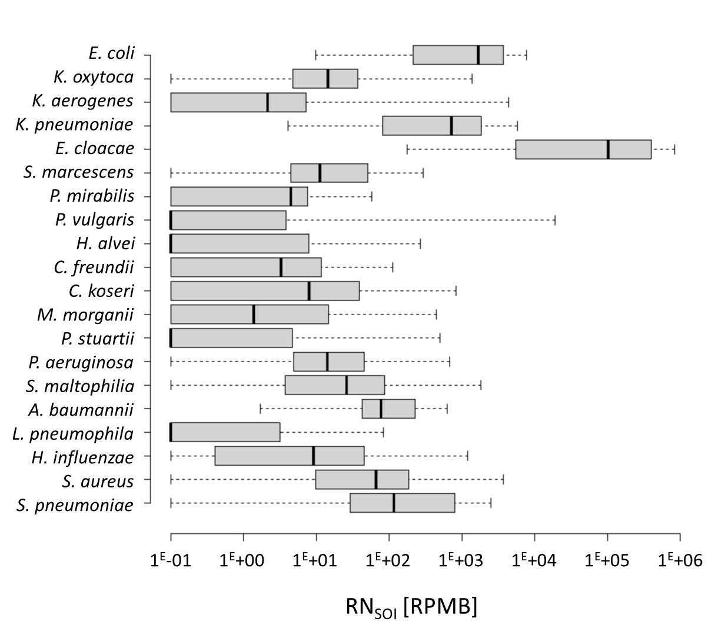
Additional figure 4: Distribution of normalized quantity of reads (RN_{SOI}) associated to SOI in samples culture negative for tested SOI. Center lines show the medians; box limits indicate the 25th and 75th percentiles as determined by R software; whiskers extend to minimum and maximum values. RPMB, reads per million of bacterial reads.

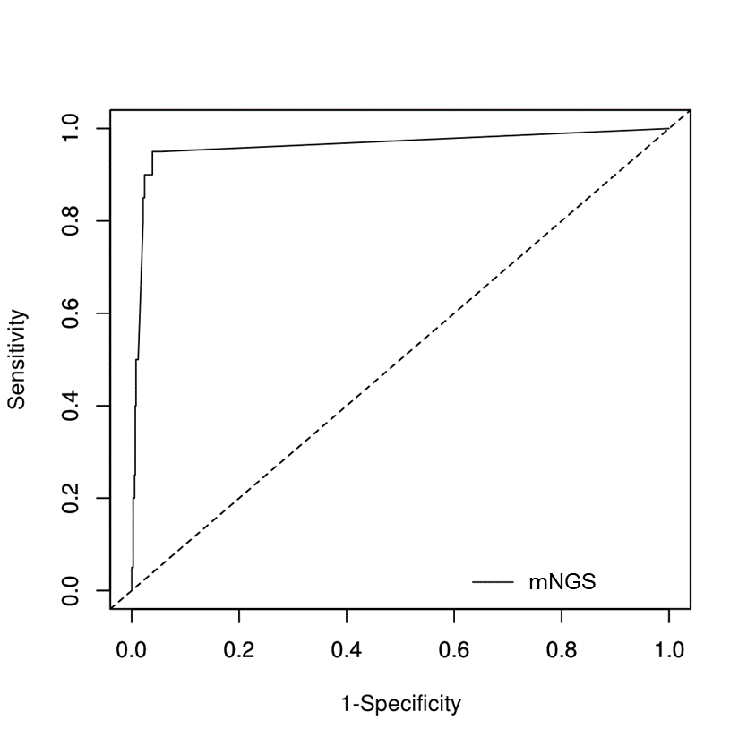
Additional figure 5: Receiver operating characteristics curve for determination of MT to differentiate concentration [GEq/mL] of SOI when present above/below clinical threshold in culture tests.

Additional Tables

ID | Sample  type | Bacterial species | Quantification (log10) ª |  | RNsoi [RPMB] ^{b} | 16S MetaPhlAn2 markers | RNspc [RPMB] ^{c}
ID | Sample  type | Bacterial species | Microbial culture | mNGS | RNsoi [RPMB] ^{b} | 16S MetaPhlAn2 markers | RNspc [RPMB] ^{c}
T01 | mini-BAL | S. aureus | 6 | 7,4 | 989770 | + | 884
T02 | mini-BAL |  |  |  |  |  | 2442
T03 | mini-BAL | S. aureus | 3 | 6,2 | 73040 | + | 1234
T03 | mini-BAL | S. pneumoniae | 3 | 4,9 | 2917 |  | 1234
T04 | mini-BAL | C. freundii | 2 | 4,3 | 721 |  | 521
T04 | mini-BAL | K. oxytoca |  | 7,3 | 958560 | + | 521
T05 | mini-BAL |  |  |  |  |  | 331961
T06 | mini-BAL |  |  |  |  |  | 612358
T07 | mini-BAL | S. aureus |  | 4,0 | 57744 | + | 135763
T08 | mini-BAL |  |  |  |  |  | 354289
T09 | mini-BAL |  |  |  |  |  | 776411
T10 | mini-BAL | S. pneumoniae |  | 3,9 | 17120 | + | 78257
T11 | mini-BAL |  |  |  |  |  | 31116
T12 | mini-BAL |  |  |  |  |  | 1321
T13 | mini-BAL |  |  |  |  |  | 902605
T14 | mini-BAL |  |  |  |  |  | 922099
T15 | mini-BAL |  |  |  |  |  | 924367
T16 | BAL | C. freundii |  | 6,1 | 239169 | + | 2391
T16 | BAL | E. coli |  |  | 5212 | + | 2391
T16 | BAL | K. pneumoniae | 3 | 6,6 | 731024 | + | 2391
T17 | BAL | K. pneumoniae |  | 7,5 | 988952 | + | 422
T17 | BAL | S. aureus | 2 | 5,1 | 2394 | + | 422
T18 | BAL | E. coli | >5 | 7,0 | 629675 | + | 775
T18 | BAL | S. aureus | >5 | 6,3 | 71078 | + | 775
T19 | BAL | S. aureus | 5 | 6,3 | 863430 | + | 11046
T20 | BAL | S. pneumoniae |  | 4,7 | 87286 | + | 51792
T21 | BAL | C. freundii | 2 | 7,2 | 772664 | + | 637
T21 | BAL | E. coli |  |  | 14038 | + | 637
T21 | BAL | K. pneumoniae |  | 6,5 | 176247 | + | 637
T22 | mini-BAL |  |  |  |  |  | 12226
T23 | BAL |  |  |  |  |  | 141765
T24 | mini-BAL |  |  |  |  |  | 5307
T25 | mini-BAL | H. influenzae |  | 6,3 | 115715 | + | 2052
T26 | BAL | E. coli | >5 | 7,7 | 870427 | + | 211
T26 | BAL | P. mirabilis | >5 | 3,9 | 88 |  | 211
T26 | BAL | S. aureus | >5 | 5,6 | 3274 | + | 211
T27 | BAL | H. influenzae | >5 | 5,9 | 718264 | + | 36503
T28 | BAL | H. influenzae | >5 | 7,1 | 818867 | + | 2679
T28 | BAL | P. vulgaris | 4 | 4,0 | 1593 |  | 2679
T28 | BAL | S. aureus | 5 | 5,0 | 10836 | + | 2679
T29 | BAL | E. coli |  | 5,4 | 23817 | + | 1209
T29 | BAL | P. aeruginosa | >5 | 6,9 | 876624 | + | 1209
T30 | BAL |  |  |  |  |  | 128034
T31 | BAL | H. influenzae |  | 3,8 | 1055 | + | 5696
T31 | BAL | S. aureus | 5 | 6,0 | 217608 | + | 5696
T32 | mini-BAL | S. pneumoniae |  | 4,2 | 39789 | + | 74542
T33 | BAL | S. pneumoniae |  | 3,2 | 12522 | + | 247773
T34 | BAL |  |  |  |  |  | 89686
T35 | mini-BAL | E. coli | 2 | 6,6 | 35394 |  | 124
T35 | mini-BAL | S. maltophilia | 5 | 7,9 | 663154 | + | 124
T36 | mini-BAL |  |  |  |  |  | 575708
T37 | BAL |  |  |  |  |  | 15739
T38 | mini-BAL |  |  |  |  |  | 569
T39 | BAL | K. pneumoniae | >5 | 7,6 | 949758 | + | 308
T40 | BAL |  |  |  |  |  | 84757
T41 | mini-BAL |  |  |  |  |  | 11089
T42 | BAL |  |  |  |  |  | 3781
T43 | BAL | H. influenzae |  | 5,7 | 4609 | + | 322
T43 | BAL | P. mirabilis | >5 | 7,7 | 959346 | + | 322
T43 | BAL | S. aureus | 2 | 2,4 | 4 |  | 322
T44 | BAL | S. aureus | 4 | 6,1 | 689401 | + | 11952
T45 | BAL | S. aureus | 4 | 3,7 | 5875 | + | 26606

Additional table 1: Results of microbial culture, mNGS and qPCR detections on training set of samples. (a) Quantification results are provided in log10 of concentration, in CFU/mL for microbial culture and in GEq/mL for mNGS and qPCR. Values above clinical threshold for microbial culture (3 for mini-BAL and 4 for BAL) or above MT (3,72) for mNGS are shown in bold. (b) Values in italic were removed from the calculation of DT_{SOI} because the negative culture result for a given SOI was associated with a substantial number of sequence reads assigned to this SOI, which was confirmed by the 16S/MetaPhlAn2 markers search. (c) Values above DT_{SPC} (475 RPMB) are in bold. (+) is the detection of 16S/MetaPhlAn2 markers specific to the corresponding SOI.

Additional references

1. Wood DE, Salzberg SL. Kraken: ultrafast metagenomic sequence classification using exact alignments. Genome Biol. 2014;15:R46. doi: https://doi.org/10.1186/gb-2014-15-3-r46.
2. Ye SH, Siddle KJ, Park DJ, Sabeti PC. Benchmarking Metagenomics Tools for Taxonomic Classification. Cell. 2019;178:779-94. doi: https://doi.org/10.1016/j.cell.2019.07.010.
3. Glassing A, Dowd SE, Galandiuk S, Davis B, Chiodini RJ. Inherent bacterial DNA contamination of extraction and sequencing reagents may affect interpretation of microbiota in low bacterial biomass samples. Gut Pathog. 2016;8. doi: https://doi.org/10.1186/s13099-016-0103-7.
4. Salter SJ, Cox MJ, Turek EM, Calus ST, Cookson WO, Moffatt MF, et al. Reagent and laboratory contamination can critically impact sequence-based microbiome analyses. BMC Biol. 2014;12. doi: https://doi.org/10.1186/s12915-014-0087-z.
5. Silkie SS, Tolcher MP, Nelson KL. Reagent decontamination to eliminate false-positives in Escherichia coli qPCR. J Microbiol Methods. 2008;72:275-82. doi: https://dx.doi.org/10.1016/j.mimet.2007.12.011.
6. O'Sullivan DM, Laver T, Temisak S, Redshaw N, Harris KA, Foy CA, et al. Assessing the accuracy of quantitative molecular microbial profiling. Int J Mol Sci. 2014;15:21476-91. doi: https://doi.org/10.3390/ijms151121476.
7. Goksuluk D, Korkmaz S, Zararsiz G, Karaağaoğlu A. easyROC: An Interactive Web-tool for ROC Curve Analysis Using R Language Environment. The R Journal. 2016;8:213-30. doi: http://dx.doi.org/10.32614/RJ-2016-042.
8. Youden WJ. Index for rating diagnostic tests. Cancer. 1950;3:32-5. doi: https://dx.doi.org/10.1002/1097-0142(1950)3:1<32::aid-cncr2820030106>3.0.co;2-3.

