Supplementary file1

Title: Inverted repeat sequences involved in high-frequency T-DNA truncation in “Princettia” (Euphorbia pulcherrima × Euphorbia cornastra)

Author names: Koya Ito, Reiko Kogishi, Sayaka Shindo, Rina Shimo, Yukiko Shimbo, Maki Ohtsubo, Keisuke Matsui, Kenichi Suzuki, Koichi Tomomatsu, Norihiro Ohtsubo*

Corresponding author: N. Ohtsubo
Email: nohtsubo@kpu.ac.jp
ORCID-ID: 0000-0002-2487-025X
Graduate School of Life and Environmental Sciences, Kyoto Prefectural University, Shimogamo Hangi-cho 1-5, Sakyo-ku, Kyoto 606-8522, Japan

Description of supplementary file1
Supplementary Fig. S1 Images of “Princettia” (Euphorbia pulcherrima × Euphorbia cornastra) varieties
Supplementary Fig. S2 Schematic representation of the IR sequence in #28[EIN3] and #74[EIN3]
Supplementary Fig. S3 Schematic representation of sequence analysis for #1[EIN3]
Supplementary Fig. S4 Alternative model of T-DNA truncation, suggesting IR sequence-mediated
Supplementary Fig. S5 T-DNA truncation analysis in Torenia fournieri transformed with pBCKH-35S::AtPAP1-SRDX
Supplementary Table S1 List of primers used in this study
Supplementary Table S2 Genomic PCR amplification results for T-DNA regions in each EIN3-SRDX line
Supplementary Table S3 Genomic PCR amplification results for T-DNA regions in each PAP1-SRDX line
Supplementary Table S4 List of lines used for sequence analysis

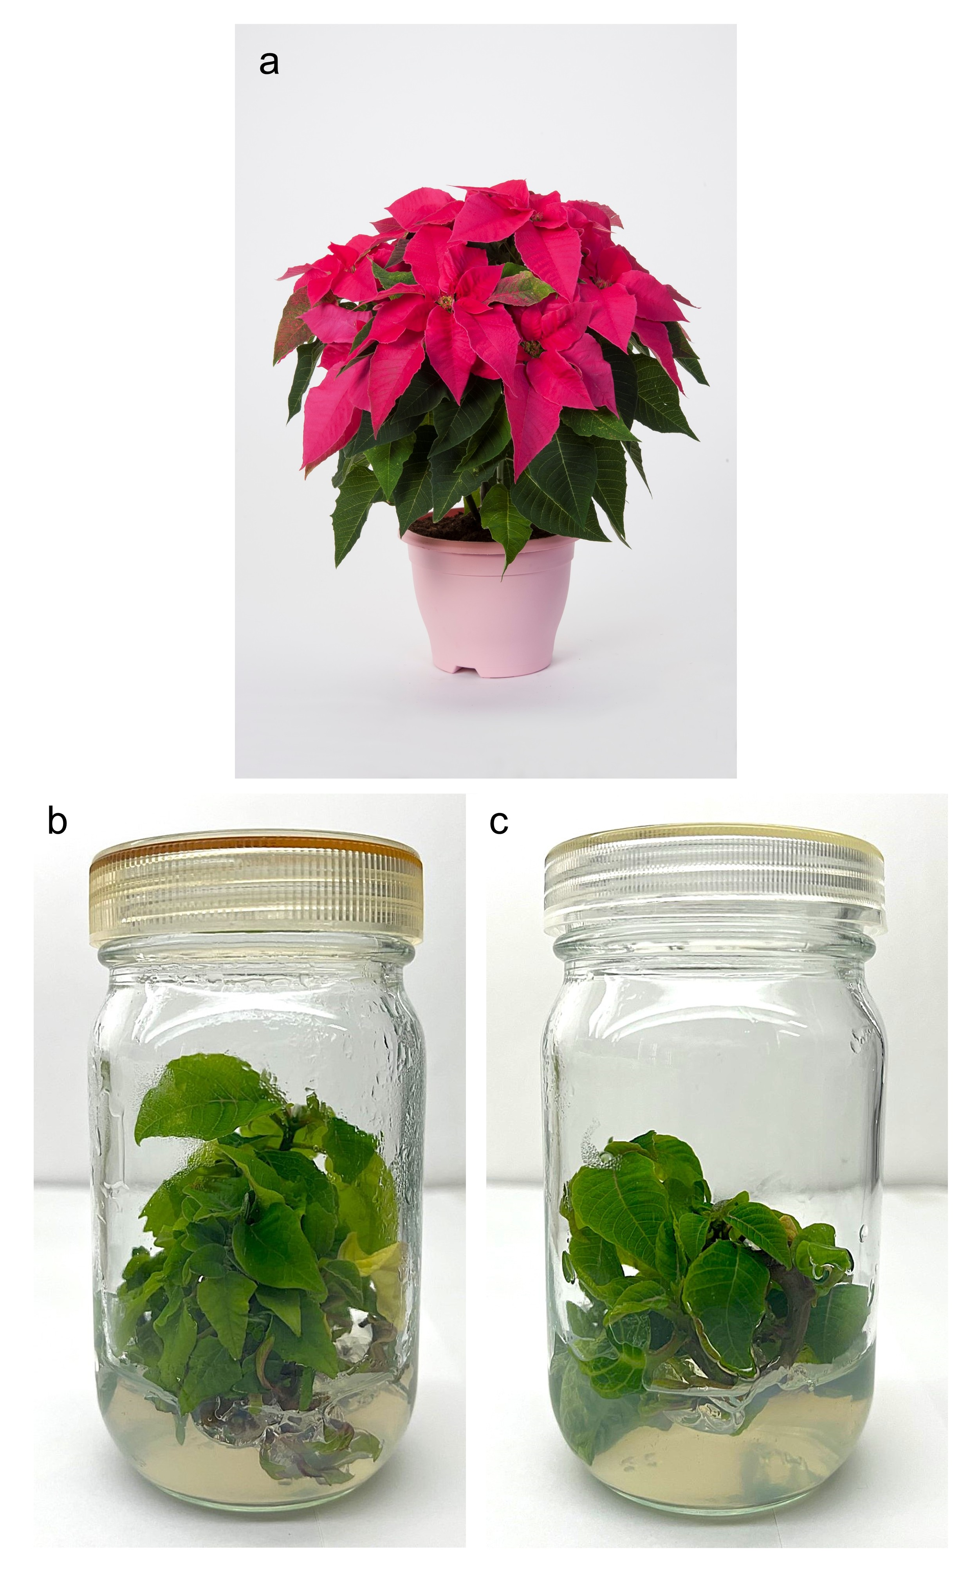
Supplementary Fig. S1 Images of “Princettia” (Euphorbia pulcherrima × Euphorbia cornastra) varieties. (a) “Princettia Queen Pink”. Image provided by Suntory Flowers Ltd. (b) Photograph of experimental line #7801. (c) Photograph of experimental line #7155

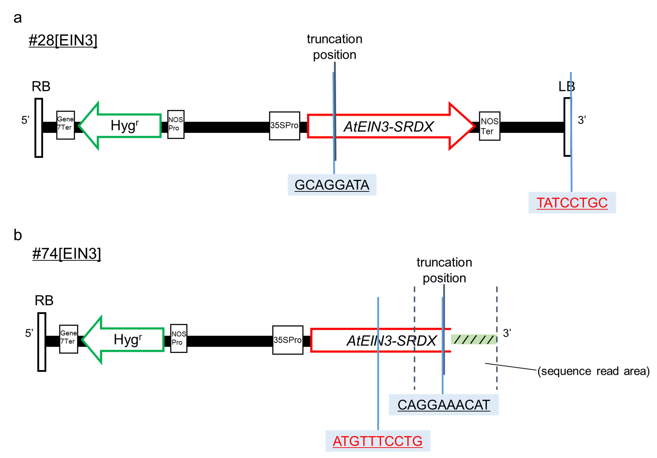
Supplementary Fig. S2 Schematic representation of the IR sequence in #28[EIN3] and #74[EIN3]. (a) An 8-bp IR sequence, GCAGGATA, was found immediately 5' of the truncation site in #28[EIN3]. A homologous IR sequence was present on the LB region that originally extended 3' of the truncation. (b) A 10-bp IR sequence, CAGGAAACAT, was found immediately 5' of the truncation site in #74[EIN3]. A homologous IR sequence was present within AtEIN3-SRDX

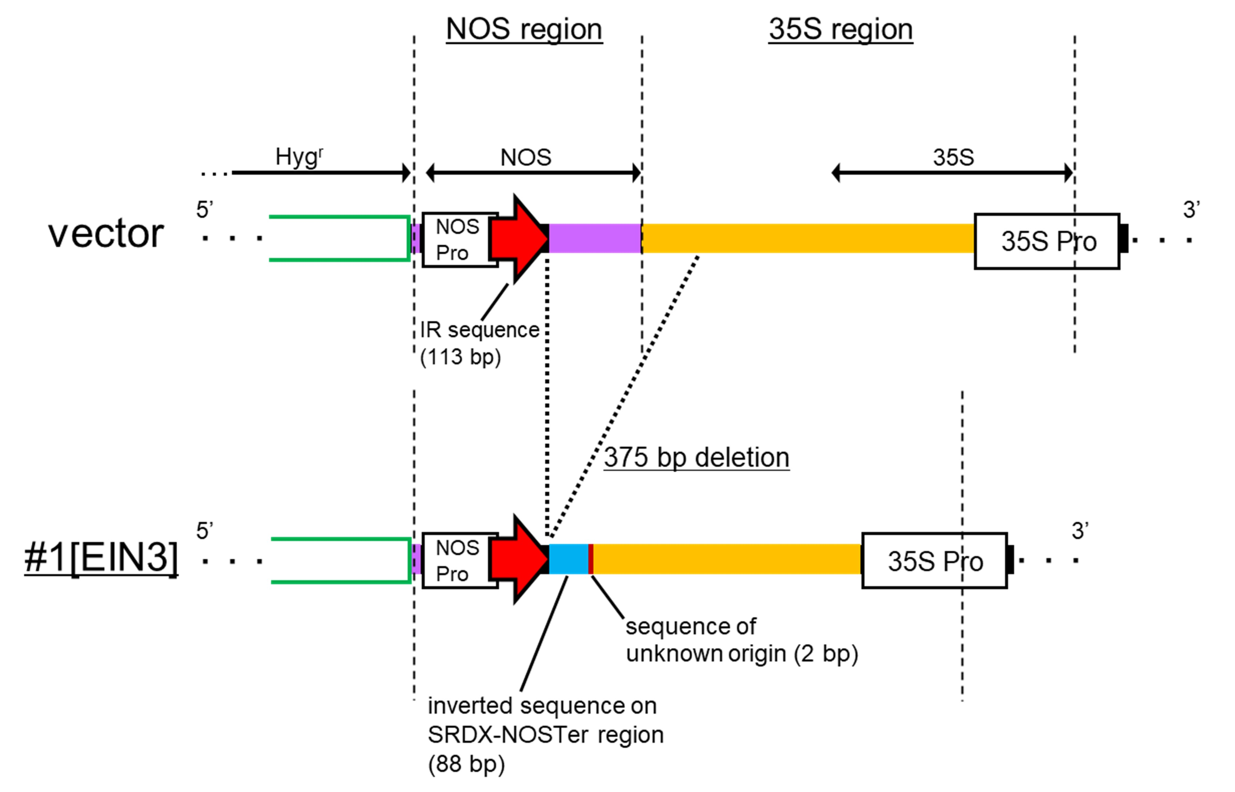
Supplementary Fig. S3 Schematic representation of sequence analysis in #1[EIN3], revealing a deletion around the NOS region between Hyg^{r} and 35S. Genomic PCR amplified regions are indicated by double-headed arrows. This line showed a 375 bp deletion immediately 3' of the 113-bp IR sequence within the NOS region. Additionally, an 88-bp inverted sequence from the SRDX-NOSTer region, containing a 2 bp insertion, was found immediately following the IR sequence

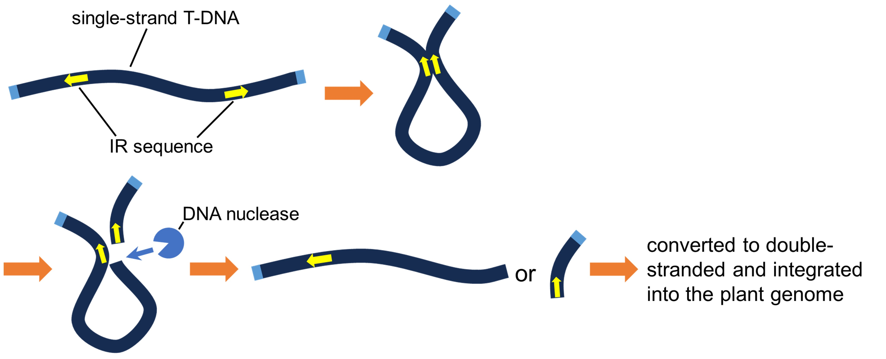
Supplementary Fig. S4 Alternative model of T-DNA truncation, suggesting IR sequence-mediated. This model proposes that truncation is induced inside at the loop junction. Lines #28[EIN3] and #29[PAP1] may represent examples of this truncation pattern

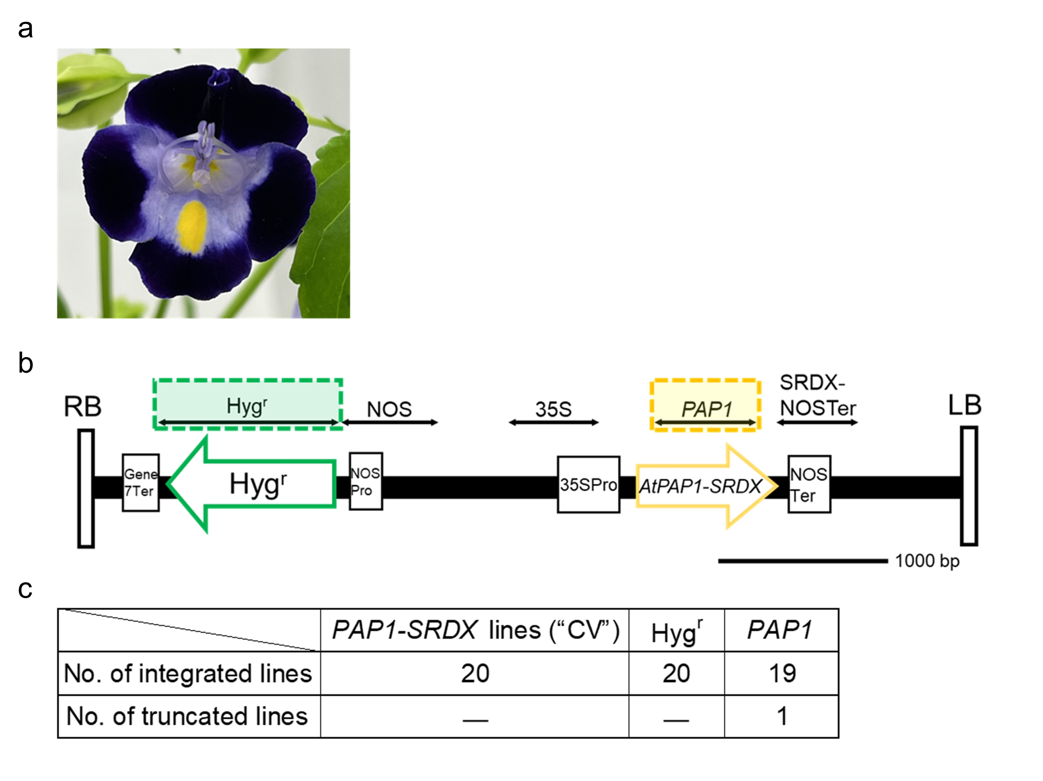
Supplementary Fig. S5 T-DNA truncation analysis in the Torenia fournieri experimental line “CV” transformed with pBCKH-35S::AtPAP1-SRDX. (a) Photograph of the Torenia fournieri experimental line “CV”. (b) Schematic representation of the T-DNA region of pBCKH-35S::AtPAP1-SRDX. Colored dashed boxes indicate the two regions examined for transgene integration: Hyg^{r} near the RB and PAP1 near the LB. Transformation was performed using Agrobacterium tumefaciens strain EHA105, as in the transformation of “Princettia”. (c) Summary of T-DNA integration results in 20 PAP1-SRDX transgenic lines of “CV”

Supplementary Table S1 List of primers used in this study
vector | Forward primer | Sequence (5'→3') | Reverse primer | Sequence (5'→3') | Product length (bp) | Application
common | Hyg^{r_}F | ATGAAAAAGCCTGAACTCACCG | Hyg^{r}_R | CTATTCCTTTGCCCTCGGACG | 1026 | Genomic PCR (Confirmation of Hyg^{r} integration)
common | NOS_F | ATGAATGTCAGCTACTGGGCTATC | NOS_R | GTCGAGATCTGGATTGAGAGTG | 523 | Genomic PCR (Confirmation of NOS integration)
common | 35S_F | GGACGATTCAAGGCTTGCTTC | 35S_R | CCACTTGCTTTGAAGACGTGG | 510 | Genomic PCR (Confirmation of 35S integration)
common | SRDX-NOSTer_F | GATCTAGAACTCCGTTTGGGTTTCG | SRDX-NOSTer_R | TGCTGCAAGGCGATTAAGTTGG | 443 | Genomic PCR (Confirmation of SRDX-NOSTer integration)
common | NOS_InF | GCGTATATGCTCCGCATTGGTCTTG | NOS_InR | CATATCCACGCCCTCCTACATCGAAG | ― | Inverse PCR (Analysis of the truncation in the NOS region)
common | NOS_NeF | CGTCCGAGGGCAAAGGAATAGAGTAG | NOS_NeR | CCCTCCTACATCGAAGCTGAAAGC | ― | Nested PCR (Analysis of the truncation in the NOS region)
pBCKH-35S::  AtEIN3-SRDX | EIN3-a_F | CAGGACCTTGATCTTTAGGCAAACC | EIN3-a_R | ATGGATTTCTTCTCTTCTGGATCAC | 670 | Genomic PCR (Confirmation of EIN3-a integration)
pBCKH-35S::  AtEIN3-SRDX | EIN3-b_F | AGATCCGTAAGCTCGTGAGG | EIN3-b_R | TGGGCTACTGAGTTCACTGG | 592 | Genomic PCR (Confirmation of EIN3-b integration)
pBCKH-35S::  AtEIN3-SRDX | EIN3-c_F | GCTTCTGCTGCATTCCATCC | EIN3-c_R | TCAGAGCTCATGTCCATGTACG | 427 | Genomic PCR (Confirmation of EIN3-c integration)
pBCKH-35S::  AtEIN3-SRDX |  |  | EIN3_InR1 | GATGATGTTTAATGAGATGGGAATGTGTGG | ― | Inverse PCR (Analysis of the truncation in the EIN3-a, EIN3-c, and SRDX-NOSTer region)
pBCKH-35S::  AtEIN3-SRDX | EIN3_InF | ATCCGAGGAGGTTTCCGGATATTACC | EIN3_InR3 | TTCACCTGCGAGAATCTTGGGTGTG | ―
pBCKH-35S::  AtEIN3-SRDX |  |  | SRDX-NOSTer_InR | AGTTCGACACTGCAGATCACAACAAC | ―
pBCKH-35S::  AtEIN3-SRDX |  |  | EIN3_NeR1 | GAAACATGGATTTCTTCTCTTCTGGATC | ― | Nested PCR (Analysis of the truncation in the EIN3-a, EIN3-c, and SRDX-NOSTer region)
pBCKH-35S::  AtEIN3-SRDX | EIN3_NeF | TGTGTCGTGCTCCACCATGTTGAC | EIN3_NeR3 | TCCACATCGAGACAGTCGCTTACC | ―
pBCKH-35S::  AtEIN3-SRDX |  |  | SRDX-NOSTer_NeR | ACAGGTTCCAGCTTGTGTTTGATTCC | ―
pBCKH-35S::  AtPAP1-SRDX | PAP1_F | ACCGGTGCAGGAAAAGTTGT | PAP1_R | TGTTGTCGTCGCTTCAGGAA | 542 | Genomic PCR (Confirmation of PAP1 integration)
pBCKH-35S::  AtPAP1-SRDX | PAP1_InF | AAGCAAGCCTTGAATCGTCCATACTG | PAP1_InR | TATAAGCCTCGACCTCGATCCTTCAC | ― | Inverse PCR (Analysis of the truncation in the SRDX-NOSTer region)
pBCKH-35S::  AtPAP1-SRDX | PAP1_NeF | CCTGGAGATTATTGCTCGGGTAGATCG | PAP1_NeR | AATCCTCCATGCCTTGGACTTAACATC | ― | Nested PCR (Analysis of the truncation in the SRDX-NOSTer region)

Supplementary Table S2 Genomic PCR amplification results for T-DNA regions in each EIN3-SRDX line
EIN3-SRDX lines | Hyg^{r} | NOS | 35S | EIN3-a | EIN3-b | EIN3-c | SRDX-NOSTer
#1[EIN3] | 〇 | ✖ | 〇 | ✖ | ✖ | ― | ✖
#2[EIN3] | 〇 | ✖？ | ✖？ | ― | ✖ | ― | ✖
#3[EIN3] | 〇 | ✖ | ✖？ | ― | ✖ | ― | ―
#4[EIN3] | 〇 | 〇 | 〇 | ― | 〇 | 〇 | 〇
#5[EIN3] | 〇 | ― | ― | ― | 〇 | ― | 〇
#6[EIN3] | 〇 | ― | ― | ― | 〇 | 〇 | 〇
#7[EIN3] | 〇 | 〇 | 〇 | 〇 | ✖ | ― | ―
#8[EIN3] | 〇 | ― | ― | ― | 〇 | 〇 | 〇
#9[EIN3] | 〇 | ― | ― | ― | 〇 | ✖？ | ✖？
#10[EIN3] | 〇 | ― | ― | ― | 〇 | 〇 | 〇
#11[EIN3] | 〇 | ― | ― | ― | 〇 | 〇 | 〇
#12[EIN3] | 〇 | 〇 | 〇 | 〇 | ✖ | ― | ―
#13[EIN3] | 〇 | ― | ― | ― | 〇 | 〇 | 〇
#14[EIN3] | 〇 | ✖？ | ✖？ | ― | ✖？ | ― | ✖？
#15[EIN3] | 〇 | ― | ― | ― | 〇 | 〇 | 〇
#16[EIN3] | 〇 | ― | ― | ― | 〇 | 〇 | 〇
#17[EIN3] | 〇 | 〇 | 〇 | 〇 | ✖ | ― | ―
#18[EIN3] | 〇 | ✖？ | ✖？ | ✖ | ✖ | ― | ✖
#19[EIN3] | 〇 | ― | ― | ― | 〇 | ✖ | ✖？
#20[EIN3] | 〇 | ― | ― | ― | 〇 | ✖ | ✖？
#21[EIN3] | 〇 | ― | ― | ― | 〇 | 〇 | 〇
#22[EIN3] | 〇 | ✖ | ✖？ | ― | ✖ | ― | ―
#23[EIN3] | 〇 | ✖ | ✖？ | ― | ✖ | ― | ―
#24[EIN3] | 〇 | ✖ | ✖？ | ― | ✖ | ― | ―
#25[EIN3] | 〇 | ✖ | ✖？ | ― | ✖ | ― | ―
#26[EIN3] | 〇 | ✖ | ✖？ | ― | ✖ | ― | ―
#27[EIN3] | 〇 | ✖ | ✖？ | ― | ✖ | ― | ―
#28[EIN3] | 〇 | 〇 | 〇 | ✖ | ✖ | ― | ✖
#29[EIN3] | 〇 | ― | ― | ― | 〇 | ✖？ | ✖
#30[EIN3] | 〇 | 〇 | ✖？ | ― | ✖ | ― | ―
#31[EIN3] | 〇 | ― | ― | ― | 〇 | ― | 〇
#32[EIN3] | 〇 | ✖ | ✖？ | ― | ✖ | ― | ―
#33[EIN3] | 〇 | 〇 | 〇 | ✖？ | ✖ | ― | ―
#34[EIN3] | 〇 | 〇 | ✖？ | ― | ✖ | ― | ―
#35[EIN3] | 〇 | ― | ― | ― | 〇 | 〇 | 〇
#36[EIN3] | 〇 | 〇 | ✖？ | ― | ✖ | ― | ―
#37[EIN3] | 〇 | 〇 | ✖？ | ― | ✖ | ― | ―
#38[EIN3] | 〇 | ✖ | ✖？ | ― | ✖ | ― | ✖
#39[EIN3] | 〇 | ✖ | ✖？ | ― | ✖ | ― | ―
#40[EIN3] | 〇 | ✖ | ✖？ | ― | ✖ | ― | ―
#41[EIN3] | 〇 | ✖ | ✖？ | ― | ✖ | ― | ―
#42[EIN3] | 〇 | ― | ― | ― | 〇 | 〇 | 〇
#43[EIN3] | 〇 | 〇 | 〇 | ✖？ | ✖ | ― | ✖
#44[EIN3] | 〇 | ― | ― | ― | 〇 | 〇 | ✖
#45[EIN3] | 〇 | ✖？ | ✖？ | ― | ✖ | ― | ―
#46[EIN3] | 〇 | ✖？ | ✖？ | ― | ✖ | ― | ―
#47[EIN3] | 〇 | ― | ― | ― | 〇 | 〇 | 〇
#48[EIN3] | 〇 | ― | ― | ― | 〇 | 〇 | ✖
#49[EIN3] | 〇 | ― | ― | ― | 〇 | ― | 〇
#50[EIN3] | 〇 | ― | ― | ― | 〇 | 〇 | 〇
#51[EIN3] | 〇 | ― | ― | ― | 〇 | ✖？ | ✖？
#52[EIN3] | 〇 | ― | ― | ― | 〇 | 〇 | 〇
#53[EIN3] | 〇 | ― | ― | ― | 〇 | 〇 | 〇
#54[EIN3] | 〇 | ― | ― | ― | 〇 | 〇 | 〇
#55[EIN3] | 〇 | ― | ― | ― | 〇 | 〇 | 〇
#56[EIN3] | 〇 | ― | ― | ― | 〇 | 〇 | 〇
#57[EIN3] | 〇 | ✖？ | ✖？ | ― | ✖ | ― | ―
#58[EIN3] | 〇 | ✖ | ― | ― | ✖ | ― | ―
#59[EIN3] | 〇 | ― | ― | ― | 〇 | 〇 | ✖？
#60[EIN3] | 〇 | ― | ― | ― | 〇 | ― | 〇？
#61[EIN3] | 〇 | ✖ | ― | ― | ✖ | ― | ―
#62[EIN3] | 〇 | 〇 | 〇 | ✖ | ✖ | ― | ―
#63[EIN3] | 〇 | 〇 | 〇 | ✖ | ✖ | ― | ―
#64[EIN3] | 〇 | ✖ | ― | ― | ✖ | ― | ―
#65[EIN3] | 〇 | ― | ― | ― | 〇 | ― | 〇？
#66[EIN3] | 〇 | ― | ― | ― | 〇 | 〇 | ✖
#67[EIN3] | 〇 | ― | ― | ― | 〇 | 〇 | 〇
#68[EIN3] | 〇 | ― | ― | ― | 〇 | ✖ | ✖
#69[EIN3] | 〇 | ― | ― | ― | 〇 | ― | 〇
#70[EIN3] | 〇 | 〇 | 〇 | 〇 | ✖ | ― | ―
#71[EIN3] | 〇 | ― | ― | ― | 〇 | 〇 | ✖
#72[EIN3] | 〇 | ✖ | ― | ― | ✖ | ― | ―
#73[EIN3] | 〇 | ― | ― | ― | 〇 | 〇 | 〇
#74[EIN3] | 〇 | ― | ― | ― | 〇 | ✖ | ✖
#75[EIN3] | 〇 | ― | ― | ― | 〇 | ✖ | ✖
#76[EIN3] | 〇 | ✖ | ― | ― | ✖ | ― | ―
#77[EIN3] | 〇 | ✖ | ― | ― | ✖ | ― | ―
Notes: “?” indicates an unclear band in electrophoresis, and “—” denotes that genomic PCR was not performed

Supplementary Table S3 Genomic PCR amplification results for T-DNA regions in each PAP1-SRDX line
PAP1-SRDX lines | Hyg^{r} | NOS | 35S | PAP1 | SRDX-NOSTer
#1[PAP1] | 〇 | ― | ― | 〇 | 〇
#2[PAP1] | 〇 | ✖ | ― | ✖ | ―
#3[PAP1] | 〇 | ― | ― | 〇 | 〇
#4[PAP1] | 〇 | ― | ― | 〇 | 〇
#5[PAP1] | 〇 | ― | ― | 〇 | 〇
#6[PAP1] | 〇 | ― | ― | 〇 | 〇
#7[PAP1] | 〇 | ✖ | ― | ✖ | ―
#8[PAP1] | 〇 | ― | ― | 〇 | 〇
#9[PAP1] | 〇 | ✖ | ― | ✖ | ―
#10[PAP1] | 〇 | ― | ― | 〇 | 〇
#11[PAP1] | 〇 | ― | ― | 〇 | 〇
#12[PAP1] | 〇 | ― | ― | 〇 | ✖
#13[PAP1] | 〇 | ― | ― | 〇 | 〇
#14[PAP1] | 〇 | 〇 | ✖ | ✖ | ―
#15[PAP1] | 〇 | ― | ― | 〇 | 〇
#16[PAP1] | 〇 | ― | ― | 〇 | 〇
#17[PAP1] | 〇 | ― | ― | 〇 | 〇
#18[PAP1] | 〇 | ― | ― | 〇 | 〇
#19[PAP1] | 〇 | ― | ― | 〇 | 〇
#20[PAP1] | 〇 | ― | ― | 〇 | ✖
#21[PAP1] | 〇 | ― | ― | 〇 | 〇
#22[PAP1] | 〇 | ― | ― | 〇 | 〇
#23[PAP1] | 〇 | 〇 | 〇 | ✖ | ―
#24[PAP1] | 〇 | ― | ― | 〇 | 〇
#25[PAP1] | 〇 | ― | ― | 〇 | 〇
#26[PAP1] | 〇 | 〇 | 〇 | ✖ | ―
#27[PAP1] | 〇 | ― | ― | 〇 | ✖
#28[PAP1] | 〇 | ― | ― | 〇 | 〇
#29[PAP1] | 〇 | ― | ― | 〇 | ✖
#30[PAP1] | 〇 | ― | ― | 〇 | 〇
#31[PAP1] | 〇 | ✖ | ― | ✖ | ―
#32[PAP1] | 〇 | ― | ― | 〇 | 〇
#33[PAP1] | 〇 | ― | ― | 〇 | 〇
#34[PAP1] | 〇 | ✖ | ― | ✖？ | ―
#35[PAP1] | 〇 | ― | ― | 〇 | ✖
#36[PAP1] | 〇 | ― | ― | 〇 | 〇
#37[PAP1] | 〇 | ✖ | ― | ✖ | ―
Notes: “?” indicates an unclear band in electrophoresis, and “—” denotes that genomic PCR was not perform

Supplementary Table S4 List of lines used for sequence analysis
Line name | Line number | Region where the truncation occurred
EIN3-SRDX | #58[EIN3] | NOS region
EIN3-SRDX | #61[EIN3] | NOS region
EIN3-SRDX | #72[EIN3] | NOS region
EIN3-SRDX | #76[EIN3] | NOS region
EIN3-SRDX | #28[EIN3] | EIN3-a region
EIN3-SRDX | #62[EIN3] | EIN3-a region
EIN3-SRDX | #68[EIN3] | EIN3-c region
EIN3-SRDX | #74[EIN3] | EIN3-c region
EIN3-SRDX | #44[EIN3] | SRDX-NOSTer region
EIN3-SRDX | #48[EIN3] | SRDX-NOSTer region
EIN3-SRDX | #71[EIN3] | SRDX-NOSTer region
PAP1-SRDX | #7[PAP1] | NOS region
PAP1-SRDX | #31[PAP1] | NOS region
PAP1-SRDX | #34[PAP1] | NOS region
PAP1-SRDX | #12[PAP1] | SRDX-NOSTer region
PAP1-SRDX | #20[PAP1] | SRDX-NOSTer region
PAP1-SRDX | #27[PAP1] | SRDX-NOSTer region
PAP1-SRDX | #29[PAP1] | SRDX-NOSTer region

