Supplementary data
Supplementary Table 1：Summary of Differential Metabolites in the Pilot Experiment
Compound Name | m/z(Expected) | RT | HMDB | m/z | Ratio | p-value
Ergothioneine | 230.09577 | 9.5 | HMDB0003045 | 4.24 | 0.09 | 0.01214758
Myristoylcarnitine | 372.31084 | 2.67 |  | 3.88 | 0.17 | 0.02456396
Acylcarnitine(20:1) | 454.38909 | 2.33 | HMDB0241572 | 0.62 | 0.18 | 0.02584851
Elaidic Carnitine | 426.35779 | 2.43 |  | 4.00 | 0.19 | 0.02556535
Trans-Hexadec-2-Enoyl Carnitine | 398.32649 | 2.54 |  | 3.99 | 0.19 | 0.01854541
Isobutyryl Carnitine | 232.15433 | 5.93 | HMDB0000736 | 3.72 | 0.20 | 0.01662819
Butyrylcarnitine | 232.15433 | 5.93 |  | 3.72 | 0.20 | 0.01662819
DL-Stearoylcarnitine | 428.37344 | 2.39 |  | 4.59 | 0.21 | 0.01878521
L-Palmitoylcarnitine | 400.34214 | 2.53 |  | 3.93 | 0.22 | 0.04937747
Urocanic Acid | 139.0502 | 2.59 | HMDB0000301 | 3.60 | 0.50 | 0.05240733
Biotin | 245.09544 | 4.21 | HMDB0000030 | -9.81 | 2.71 | 0.02844904
N-Acetyl-L-Alanine | 130.05097 | 1.2 | HMDB0000766 | -0.30 | 0.52 | 0.04017061
2-Aminomuconic Acid Semialdehyde | 140.03532 | 1.19 | HMDB0001280 | -0.06 | 0.60 | 0.00982252
FA(19:1) | 295.26425 | 13.59 |  | -1.59 | 0.80 | 0.03142565
Stearidonic Acid | 275.20165 | 12.6 |  | -2.54 | 0.90 | 0.04594605
Heptacosylic Acid | 409.4051 | 14.86 |  | -1.71 | 0.97 | 0.02813675
Palmitic Acid | 255.23295 | 13.25 |  | -3.78 | 1.11 | 0.00504499
Erythritol | 121.05063 | 1.13 | HMDB0002994 | -0.25 | 1.29 | 0.01046676
Imidazolepropionic Acid | 139.0513 | 1.19 |  | -0.04 | 2.53 | 0.01099157

Supplementary Table 2: Comparisons Between VC and HC Groups in the Final Tested Patients
Factor | HC | VC | p-value
N | 13 | 13
Age, mean (SD) | 65.0 (8.2) | 66.1 (6.6) | 0.71
Male, n(%) | 10 (77%) | 11 (85%) | 0.62
Kappila score, mean (SD) | 3.4 (2.2) | 15.1 (4.5) | <0.001***
Valvular calcification, n(%) | 7 (54%) | 12 (92%) | 0.027*
Kt/V, mean (SD) | 1.4 (0.2) | 1.4 (0.3) | 0.61
Alveolar bone resorption, mean (SD) | 0.5 (0.1) | 0.5 (0.2) | 0.56
Bleeding index, mean (SD) | 4.0 (0.0) | 4.0 (0.0)
Pocket depth (mm), mean (SD) | 5.5 (0.7) | 6.3 (1.2) | 0.047
Attachment loss, n(%) | 13 (100%) | 11 (100%)
Tooth mobility, mean (SD) | 2.5 (0.7) | 2.2 (0.4) | 0.51
Smoking, n(%) | 7 (70%) | 6 (60%) | 0.64
Dialysis vintage (m), mean (SD) | 58.5 (59.3) | 58.2 (35.1) | 0.99
Diabetes, n(%) | 8 (62%) | 10 (77%) | 0.40
Hypertension, n(%) | 13 (100%) | 13 (100%)
Coronary artery disease, n(%) | 6 (46%) | 5 (38%) | 0.69
Cerebral vascular disease, n(%) | 0 (0%) | 4 (31%) | 0.030*
Mgnesium, mean (SD) | 1.1 (0.2) | 1.1 (0.1) | 0.87
Calcium, mean (SD) | 2.2 (0.2) | 2.1 (0.2) | 0.28
Phosphate, mean (SD) | 1.8 (0.6) | 2.1 (0.6) | 0.18
Intact parathyroid hormone, mean (SD) | 179.6 (75.2) | 392.2 (201.6) | 0.002**
Hemoglobulin, mean (SD) | 111.2 (8.0) | 114.2 (10.9) | 0.43
Albumin, mean (SD) | 41.3 (3.0) | 41.0 (2.1) | 0.73
Ferritin, mean (SD) | 259.6 (140.5) | 282.3 (162.2) | 0.71
C-reactive protein, mean (SD) | 2.7 (1.9) | 7.4 (9.5) | 0.12
β2-microglobin, mean (SD) | 28.1 (11.4) | 28.8 (8.3) | 0.86
*P<0.05, **P<0.01, ***P<0.001; Kt/V stands for dialysis dose.

Supplementary Table 3: Biomarkers for predicting high VC with an AUC value larger than 0.8
Name | AUC | T-tests | Log2 FC
N-Lauryldiethanolamine | 0.99408 | 7.1392E-7 | -0.88979
Caproylcholine | 0.98225 | 3.0642E-7 | -1.5323
Sphinganine | 0.97041 | 3.4865E-5 | -0.72803
Citrate | 0.88166 | 3.5294E-4 | -0.89159
Benzoic Acid | 0.85207 | 7.3288E-4 | 0.24973
6-Hydroxyhexanoic Acid/Butoxyacetic Acid | 0.84024 | 0.0039206 | 0.34071
Oleamide | 0.8284 | 0.0012399 | -0.70427
4-Hydroxyphenylacetate | 0.82249 | 0.004518 | 0.14148
Hexaethylene glycol | 0.82249 | 0.0081959 | 0.34129
Tyr-Val | 0.81657 | 0.014964 | 0.18256
N-Arachidonoyl Glutamic Acid | 0.81065 | 0.0071204 | 1.1299
Citraconic Acid | 0.80473 | 0.025587 | -0.56065
3α,7α,12α-Trihydroxy-5β-Cholestanoic Acid | 0.80473 | 0.0061356 | 0.2831
Melamine | 0.80473 | 0.0082342 | 0.22972
Mevalonic Acid | 0.80473 | 0.0062113 | -0.0076074

Supplementary Table 4: Spearman’s rank correlation analysis between differential metabolites and Kauppila score after adjusting for calcium, phosphate, and iPTH
Metabolite | Correlation | Pvalue | FDR
Taurine | 0.317526 | 0.139836 | 0.189778
Inosine | 0.358666 | 0.092835 | 0.146988
Adenine | -0.13385 | 0.542598 | 0.542598
N-Lauryldiethanolamine | 0.806713 | 3.32E-06 | 6.32E-05
Caproylcholine | 0.767673 | 1.9E-05 | 0.00018*
Sphinganine | 0.757459 | 2.85E-05 | 0.00018*
Citrate | 0.605066 | 0.002222 | 0.007035*
Benzoic Acid | -0.58263 | 0.00353 | 0.009582*
6-Hydroxyhexanoic Acid | -0.41837 | 0.046948 | 0.081092
Oleamide | 0.666334 | 0.000518 | 0.002459*
4-Hydroxyphenylacetate | -0.2122 | 0.331026 | 0.36997
Hexaethylene Glycol | -0.16424 | 0.453947 | 0.479166
Tyr-Val | -0.30592 | 0.155724 | 0.19725
N-Arachidonoyl Glutamic Acid | -0.42353 | 0.044027 | 0.081092
Citraconic Acid | 0.646383 | 0.000861 | 0.003271*
3Alpha,7Alpha,12Alpha-Trihydroxy-5Beta-Cholestanoic Acid | -0.50215 | 0.01462 | 0.030865*
Melamine | -0.50312 | 0.014399 | 0.030865*
Mevalonic Acid | 0.347019 | 0.104737 | 0.153077
*FDR P value<0.05

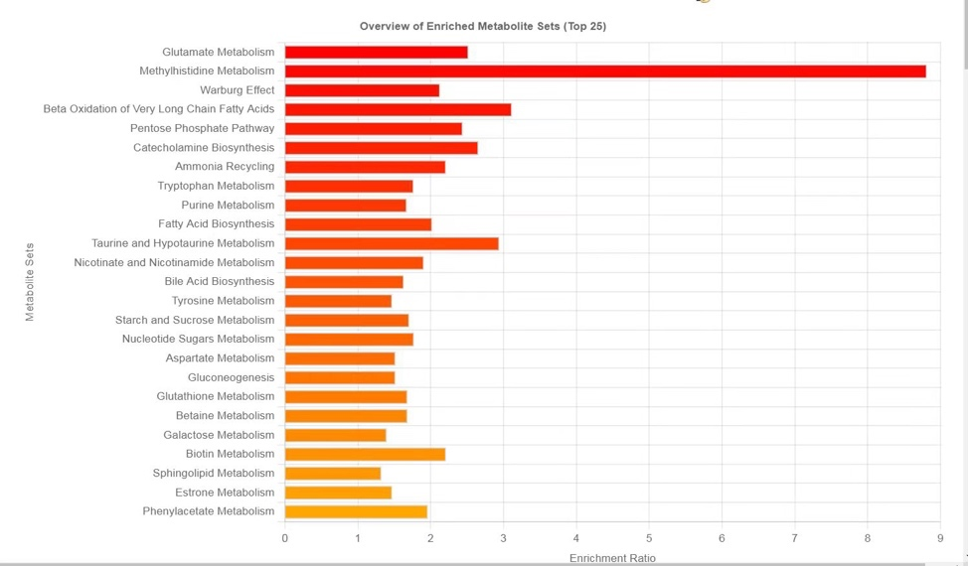
Supplementary Figure 1: Enrichment Analysis of the Differential Metabolites in the Pilot Experiment

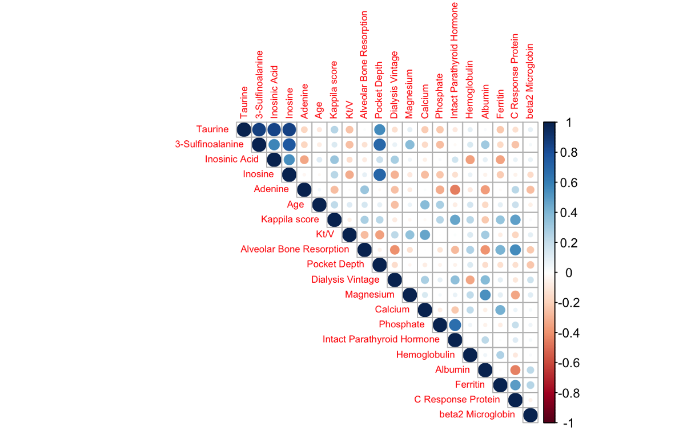
Supplementary Figure 2: Heatmap for Correlation Analysis Between The Differential Metabolites Involved in The Top Two Pathways and Clinical Characteristics.

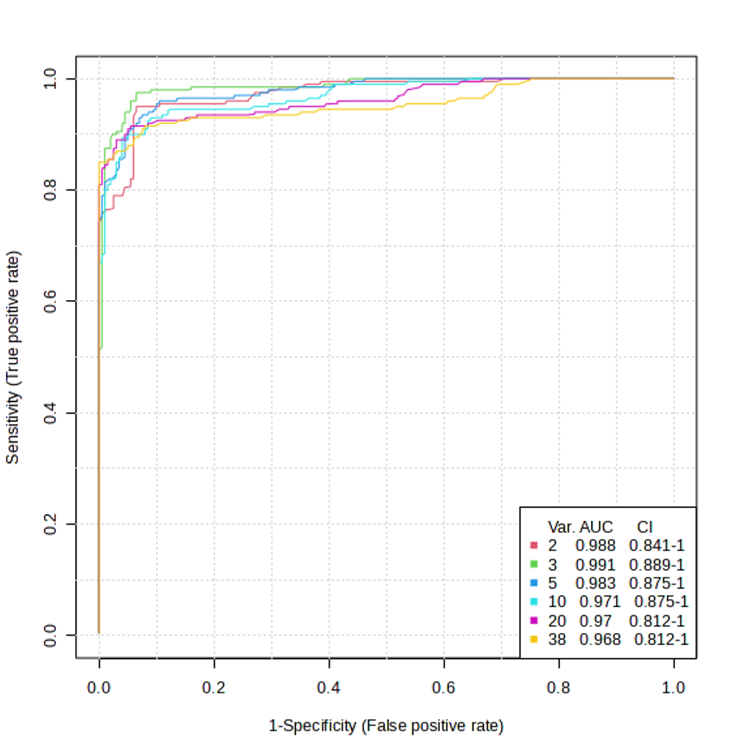
Supplementary Figure 3: Multi-factorial biomarker analysis.

