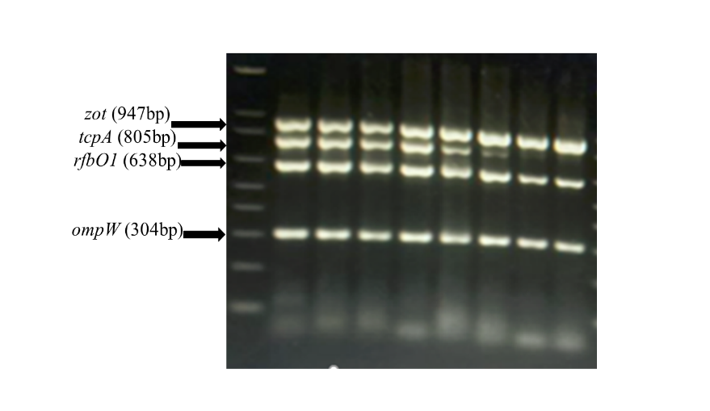
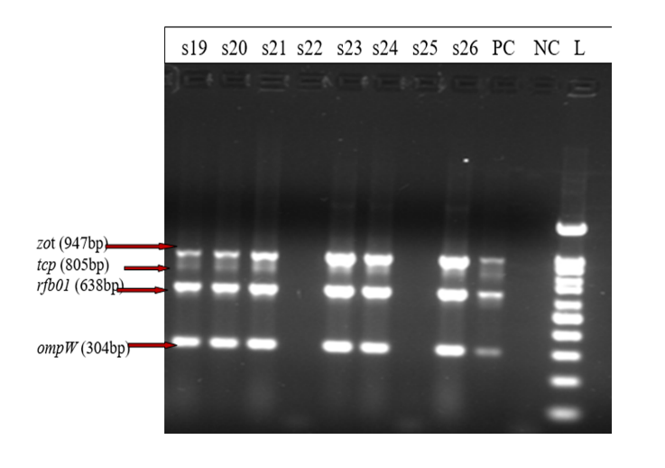

Supplementary figure 1. Gel electrophoresis image showing the amplicon size of the targeted virulence genes of V. cholerae isolated from outbreak sites in Ethiopia

