Supplementary materials
Supplementary table 1. Within-group intervention effects for blood parameters
 | Group | Baseline | Week 8 | p-value
Oral Glucose Tolerance Test (OGTT)
Glucose tAUC  (mmol/L*120min) | PA | 826 ± 46 | 798 ± 55 | 0.421
Glucose tAUC  (mmol/L*120min) | PA-SB | 762 ± 45 | 780 ± 52 | 0.465
Insulin tAUC | PA | 50690 ± 6001 | 38813 ± 5255 | 0.046
(pmol/L*120min) | PA-SB | 42211 ± 5863 | 42281 ± 4977 | 0.980
WBISI | PA | 7.6 ± 1.1 | 9.5 ± 1.6 | 0.037
WBISI | PA-SB | 7.3 ± 1.1 | 7.9 ± 1.5 | 0.486
IGI | PA | 166 ± 38 | 128 ± 28 | 0.285
IGI | PA-SB | 162 ± 38 | 159 ± 27 | 0.818
Fasting blood markers
HOMA-IR | PA | 1.15 ± 0.17 | 1.25 ± 0.17 | 0.387
 | PA-SB | 1.28 ± 0.16 | 1.33 ± 0.17 | 0.621
HOMA B (%) | PA | 67.7 ± 8.4 | 73.0 ± 8.9 | 0.491
HOMA B (%) | PA-SB | 73.8 ± 8.1 | 74.4 ± 8.6 | 0.913
HOMA S (%) | PA | 118.7 ± 14.3 | 108.7 ± 22.5 | 0.641
HOMA S (%) | PA-SB | 93.1 ± 13.8 | 103.6 ± 21.2 | 0.501
Total cholesterol (mmol/L) | PA | 4.8 ± 0.3 | 4.3 ± 0.3 | 0.106
Total cholesterol (mmol/L) | PA-SB | 4.7 ± 0.3 | 4.6 ± 0.3 | 0.766
HDL cholesterol (mmol/L) | PA | 1.3 ± 0.1 | 1.4 ± 0.1 | 0.497
HDL cholesterol (mmol/L) | PA-SB | 1.4 ± 0.1 | 1.4 ± 0.1 | 0.578
LDL cholesterol (mmol/L) | PA | 3.0 ± 0.3 | 2.6 ± 0.2 | 0.071
LDL cholesterol (mmol/L) | PA-SB | 2.8 ± 0.2 | 2.7 ± 0.2 | 0.710
Triglycerides (mmol/L) | PA | 1.0 ± 0.1 | 0.9 ± 0.1 | 0.142
Triglycerides (mmol/L) | PA-SB | 1.0 ± 0.1 | 1.1 ± 0.1 | 0.285
Glucose (mmol/L) | PA | 5.1 ± 0.1 | 5.1 ± 0.1 | 0.757
Glucose (mmol/L) | PA-SB | 5.0 ± 0.1 | 5.0 ± 0.1 | 0.823
Insulin (pmol/L) | PA | 35.6 ± 4.8 | 38.9 ± 5.0 | 0.397
Insulin (pmol/L) | PA-SB | 38.4 ± 4.7 | 40.4 ± 4.8 | 0.651
Data are expressed as mean ± SEM

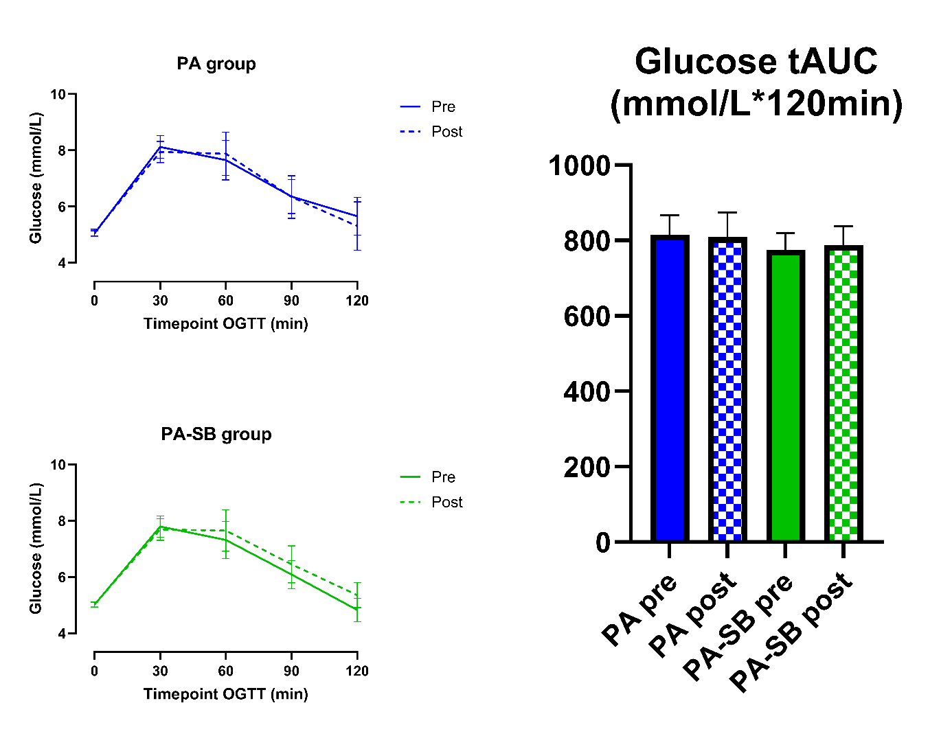
Supplementary Figure 1: Glucose concentration per timepoint during oral glucose tolerance tests (OGTT) before and after the interventions presented for each intervention arm (left panels); Glucose total area under the curve (AUC) during the OGTT (right panel).

