City-specific or generalisable resistances? An urban animal connectivity model performs better when parametrised from two cities
Journal: Urban Ecosystems
Lisa Merkens*, Meret Pundsack*, Anne Mimet*, Damien Gourmelon, Wolfgang W. Weisser
*shared contribution
Corresponding author:
Anne Mimet, Univ Angers, BIODIVAG, F-49000 Angers, France.
anne.mimet@univ-angers.fr

- Supplementary Methods
- 1. Parameterisation of resource locations
To identify resource locations (Fig. 2, Step 2; main manuscipt) and produce the resource map for the connectivity model runs as part of the parameterisation, we employed the approach by Pundsack et al. (2026), which builds on Merkens et al. (2026) and uses Classification and Regression Trees (CARTs) with a prior Principal Component Analysis (PCA). The approach allows us to identify the composition of vegetation types that support the presence of the target species in the urban landscape. The integration of PCA ensures that no resource type is obscured by collinearity among the potential resource types within the landscape (Pundsack et al. 2026). Based on this, we can exclude certain areas from our analysis that generally cannot support the target species even if resource patches are present. Only resources that are within areas where overall vegetation composition is sufficient and suitable for blackbird presence are considered to be resource locations and thus become nodes of the landscape graph in the further analysis. We extended this approach to simultaneously analyse two cities, namely Angers and Munich (Fig. S1). This was done to assess whether pooling the data from both cities leads to different predictions than the single-city approaches.
First, we selected three potential resource types for the common blackbird based on species-specific literature and previous connectivity modelling studies: trees, shrubs, and grass (Schlindwein et al., 2024; Merkens et al., 2026). Secondly, we ran a raster PCA based on the extracted overall vegetation cover for these resource types in Munich and Angers. The combined PCA and the corresponding three principal components (PC1- PC3) thus captured gradients in vegetation composition across Munich and Angers.
In the next step, we extracted PCs from our blackbird observation points in both cities (Angers, n = 68; Munich, n = 104; see Table 2 in the main manuscript). To identify which vegetation compositions (PC1-PC3) best predict blackbird presence/absence (our target variable), we ran CARTs that indicate which thresholds of these vegetation compositions lead to which of the two states (here, presence = 1, absence = 0) (Breiman et al., 1984; Steinberg, 2009). We selected the best decision tree and the corresponding thresholds based on the highest sensitivity, accuracy, and parsimony following Pundsack et al. (2026).

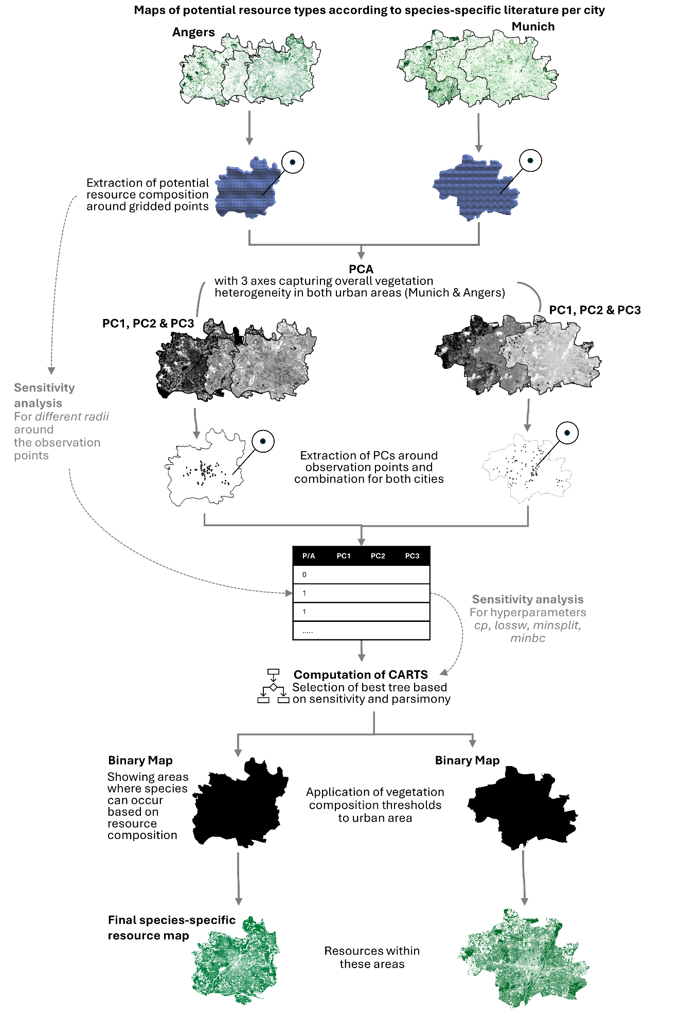
Fig. S1. Resource parameterisation workflow using PCA and CARTs based on Pundsack et al. (2026), extended to two cities, Munich and Angers. Hyperparameters to compute CARTs: lossw (cost matrix penalizing misclassifications, we test for stronger penalization of false negatives i.e. falsely omitted presences), cp (= complexity parameter; determines how much the tree is pruned, higher values = lower complexity), minsplit (minimum number of observations that must exist in a node to consider further splitting, higher value = lower complexity), minbc (= minbucket, minimum number of observations that must exist in a final leaf for it to exist, higher value = lower complexity).
To ensure that our identified vegetation thresholds predicting blackbird occurrences were robust, we conducted a sensitivity analysis (Cariboni et al., 2007). Here, we tested eight spatial scales (radii) ranging from 51 to 170 m to extract vegetation composition for PCA and CARTs and compared the corresponding trees (Pundsack et al., 2026). As part of the sensitivity analysis, we also tested different hyperparameters (Fig S1). Here, we followed Zohman et al. (2014) and equally prioritised sensitivity, the ability to correctly predict presences, over complexity. This was done to prevent the false exclusion of resources that are important for the presence of the common blackbird.
Subsequently, the thresholds from the best tree were then applied to both cities and buffered by 170 m (the maximum home range size of a common blackbird) (Ottaviani et al., 2006) into a binary map depicting areas where blackbird presence is generally possible or not, according to our analysis. Resources of sufficient size within these areas were excluded from the resource map and thus the further connectivity modelling.
For all analyses, we used the following package in R v. 4.4.3 (R Core Team, 2020): rpart (CART construction) (Therneau et al., 2015), rpart.plot (tree visualisation) (Milborrow, 2026), and caret (model evaluation) (Kuhn et al., 2024).
- Supplementary Results
2. 1. Resource parameterisation
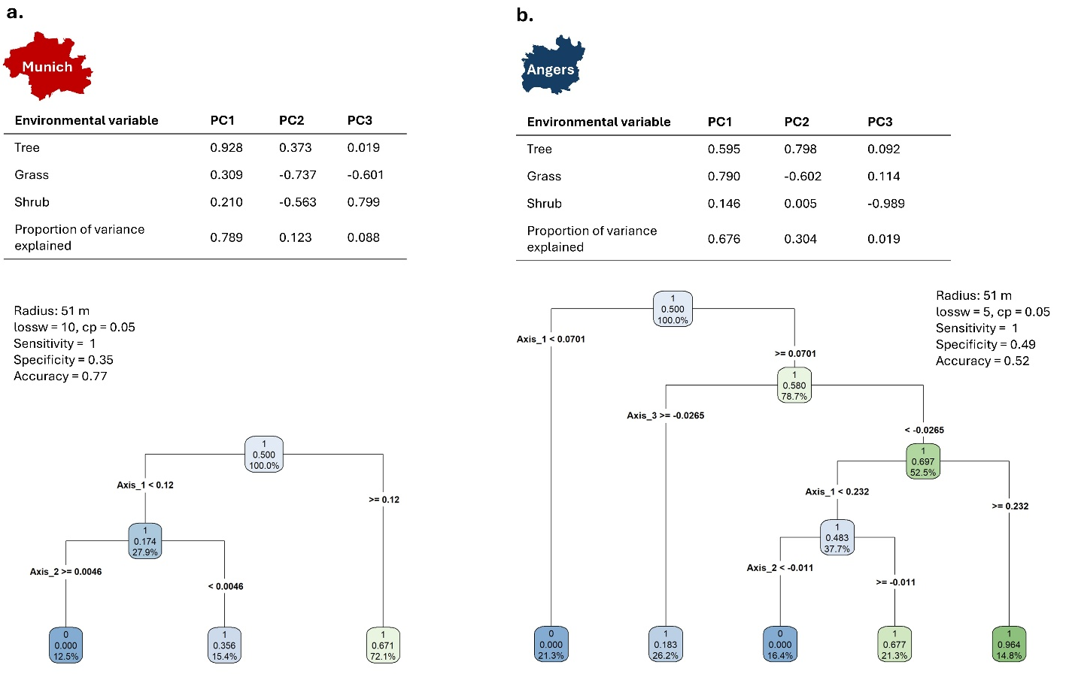
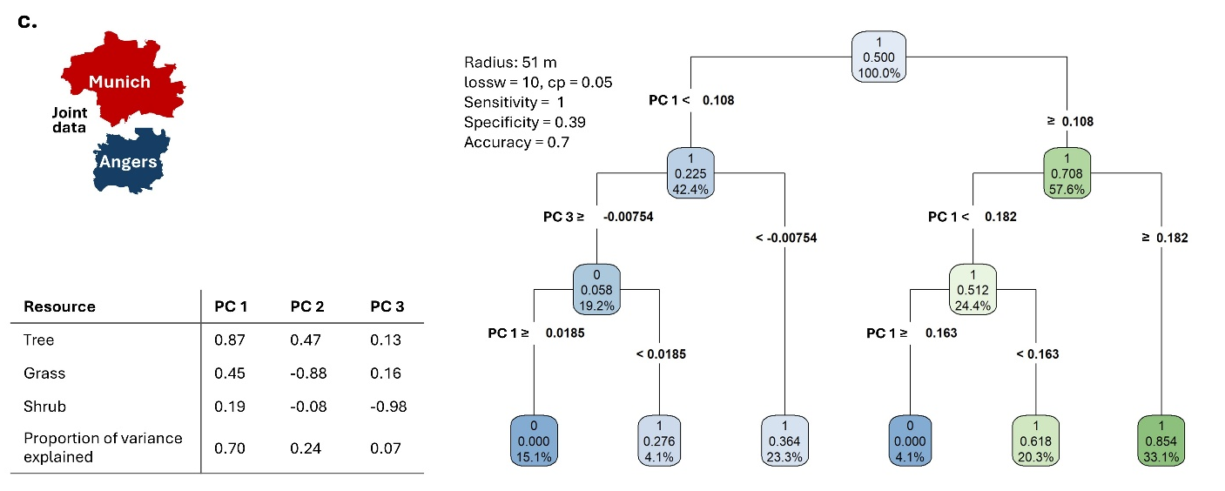
Fig. S2. Results from resource parameterisation for single-city Munich (a.), Angers (b.), and Joint (c.) blackbird presence/absence occurrence data: PCA loadings and selected CARTS decision tree based on highest sensitivity and parsimony. Blackbird presence is predicted with different certainty depending on the resource abundance (indicated by dark green = certain; to light blue = less certain).

2. 2 Resistance parameterisation
Running the resistance parameterisation procedure across the three datasets produced a large number of statistical models and their indicators, which cannot be presented here in detail. However, they are provided within the additional Excel file SupplementaryMaterialS3_ParameterisationResults. For each statistical model obtained per resistance scenario and tested maximum movement distance, we retrieved the coefficients and their standard errors for the predictor variables (connectivity and number of pedestrians for the Angers and Munich datasets, and connectivity, number of pedestrians, and city for the joint datasets). Moreover, we obtained the p-values for each predictor, as well as the AIC and R2 values for the overall statistical model. By ranking all of the statistical models of one dataset within one Monte Carlo repetition, we could identify the resistance maps that best predicted the movement-proxy data (Supplementary Material S3).
This is also how the statistical results are presented in Supplementary Material S3: Each sheet of the Excel file presents the statistical models ordered by AIC-value for one repetition of the parameterisation for one dataset. For Angers, due to data limitations, there is only one sheet, as the dataset could not be split. The repetition and the dataset are indicated in the name of the respective Excel sheet. The rows correspond to different resistance scenarios and movement distances, as indicated in the first two columns. The following columns present the statistical outputs, including the DHARMa tests, for each statistical model based on the respective connectivity map. The best-performing parameter values are summarised in the main manuscript.
Since some authors suggest that the relative order of resistance values is more important for the connectivity result than the absolute resistance values (Beier et al. 2008), we also investigated how the order of resistance values differed between parameterisation from different datasets (Fig. S3). Overall, there was no support for a resistance scenario, suggesting that streets have a higher resistance than buildings. In Angers, the selection tended towards an equal resistance between low buildings and streets, while in the other two datasets, there was some evidence for higher resistance of low buildings (Fig. S3). For Angers and the joint dataset, it was also strongly supported that high buildings have higher resistance than medium buildings, which in turn have a higher resistance than low buildings. In Munich, there was stronger evidence for similar resistance between intermediate and high buildings (Fig. S3).

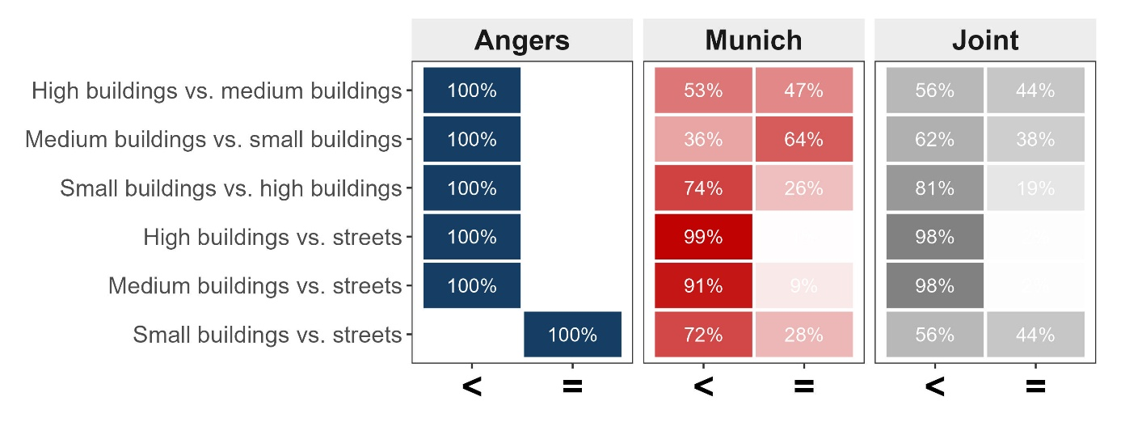
Fig. S3. Evidence for resistance levels relative order for buildings (according to their height) and streets based on the proportion of the relative order of resistance values selected across all 10 folds for the Joint dataset, Munich datasets, and the full Angers dataset (no folds, see Fig. 3). The displayed proportions are normalised within each dataset, totalling 100 % across all three datasets.

2. 3 Validation
The validation also yielded a substantial number of statistical models and indicators, which, for handling reasons, are provided in the Excel file SupplementaryMaterialS4_ValidationResults. Here, for each Monte Carlo repetition, each parameterisation dataset, and each validation dataset, one statistical model was created. Again, for each statistical model, we retrieved the coefficients for all predictor variables, their standard errors, and their p-values. Also, for each model, we extracted R² values and reported the results of the DHARMa tests for the respective statistical model. Again, in Angers, data splitting was not possible, so the results are based on a single statistical model, with no repetition.
The Excel file is structured along different sheets. In every sheet, the statistical models from all repetitions are shown for one parameterisation dataset and one validation dataset. The datasets are indicated by the sheet names. Their names follow the convention: first the parameterisation dataset, followed by “param”; then the validation dataset, followed by “valid”. For example, the Excel sheet named “joint_param_Munich_valid” presents the validation of the parameters from the joint datasets in Munich.
References
Breiman, L., Friedman, J., Olshen, R.A., & Stone, C.J., 1984. Classification and Regression Trees. Chapman and Hall/CRC. https://doi.org/10.1201/9781315139470
Beier P, Majka DR, Spencer WD (2008) Forks in the Road: Choices in Procedures for Designing Wildland Linkages: Design of Wildlife Linkages. Conservation Biology 22:836–851. https://doi.org/10.1111/j.1523-1739.2008.00942.x
Cariboni, J., Gatelli, D., Liska, R., Saltelli, A., 2007. The role of sensitivity analysis in ecological modelling. Ecological Modelling, Special Issue on Ecological Informatics: Biologically-Inspired Machine Learning 203, 167–182. https://doi.org/10.1016/j.ecolmodel.2005.10.045
Kuhn, M., Benesty, M., Weston, S., Williams, A., Keefer, C., Engelhardt, A., Cooper, T., Mayer, Z., Kenkel, B., R Core Team, Benesty, M., Lescarbeau, R., Ziem, A., Scrucca, L., Tang, Y., Candan, C., Hunt, T., 2024. caret: Classification and Regression Training.
Merkens, L., Bae, S., Eberl, E., Lauppe, E., Mesarek, F., Stauffer-Bescher, D., Hauck, T.E., Weisser, W.W., Mimet, A., 2026. Moving from expert opinion to empirical evidence: Data-driven parametrization of urban connectivity models using movement-proxy data. Landsc Ecol. https://doi.org/10.1007/s10980-026-02332-z
Milborrow, S., 2026. rpart.plot: Plot “rpart” Models: An Enhanced Version of “plot.rpart.”
Ottaviani, D., Cairns, S.C., Oliverio, M., Boitani, L., 2006. Body mass as a predictive variable of home‐range size among Italian mammals and birds. Journal of Zoology. https://doi.org/10.1111/j.1469-7998.2006.00060.x
Pundsack, M., Merkens, L., Gourmelon, D., Weisser, W.W., Mimet, A., 2026. Traffic density and noise shape wildlife movement in the city: insights from modeling blackbird connectivity in a dense city [Preprint]. https://doi.org/10.21203/rs.3.rs-9687672/v1
R Core Team, 2020. R: A language and environment for statistical computing.
Schlindwein, X., Randler, C., Kalb, N., Dvorak, J., Gottschalk, T.K., 2024. Seasonal variation in the diurnal activity pattern of Eurasian blackbirds (Turdus merula) in the forest. J Ornithol 165, 137–146. https://doi.org/10.1007/s10336-023-02096-2
Steinberg, D., 2009. CART: Classification and regression trees. In X. Wu & V. Kumar (Eds.), The top ten algorithms in data mining, 179–201. Chapman & Hall/CRC.
Therneau, T., Atkinson, B., Ripley, B., Ripley, M.B., 2015. Package ‘rpart.
Török, J., Ludvig, É., 1988. Seasonal changes in foraging strategies of nesting blackbirds (Turdus merula L.). Behav Ecol Sociobiol 22, 329–333. https://doi.org/10.1007/BF00295101
Zohmann, M., Immitzer, M., Wöss, M., Gossow, H., Nopp-Mayr, U., 2014. Modelling habitat use of Tetrao urogallus L. in Austria for conservation issues. Journal for Nature Conservation 22, 223–234. https://doi.org/10.1016/j.jnc.2014.01.002

