3D Cerium Doped In₂S₃ Immobilised Hydrogel for Efficient Photocatalytic Sulphamethoxazole Degradation And H₂O₂ Production- Mechanistic Insights and Applications
Hritankhi Tripathy, Abhijeet Sahoo, Arvind Kumar*
Environmental Pollution Abatement Laboratory, Department of Chemical Engineering, National Institute of Technology Rourkela, Odisha 769008, India
Email id- arvindkumar@nitrkl.ac.in or hritankhi.tripathy@outlook.com

S1. Materials and Reagents:
Cerious nitrate hexahydrate powder, Ethanol, Indium Suphide powder, Ferric chloride, Carboxy methyl cellulose (CMC), Sulphamethoxazole (SMX), potassium iodidie. Sodium potassium phthalate. Distilled water. All reagents were used as received without any further purification.
S2. Photocatalytic experiment
Preparation of SMX stock solution- Sulfamethoxazole (SMX) solution stock was made and diluted to get the required solution. This was done by mixing 1 mL of SMX solution stock with 99 mL of deionized water in a 250 mL glass beaker. Prior to photocatalysis reaction, synthesized Ce-InS hydrogel photocatalyst was washed with deionized water several times.
To ensure the reproducibility and reliability of the obtained results, each experimental condition, including catalyst dosage and pollutant concentration, was repeated at least three times, and the average values were used for subsequent analysis.

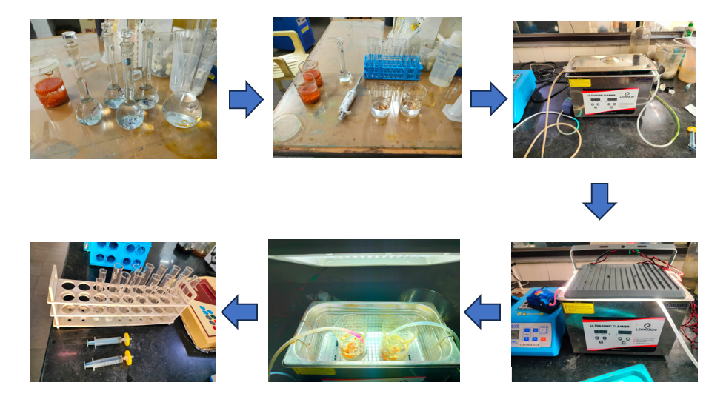
Fig S1: Photocatalytic Experiment of 10 ppm SMX solution using 10 beads

