Supplementary Materials.
Supplementary Figure 1. Schematic diagram explains the xfR5 mAb interaction with CCR5 receptors on T cell binding. A) Multivalent binding of xfR5-D+T NP compared to (B) monovalent binding of free xfR5 mAb.
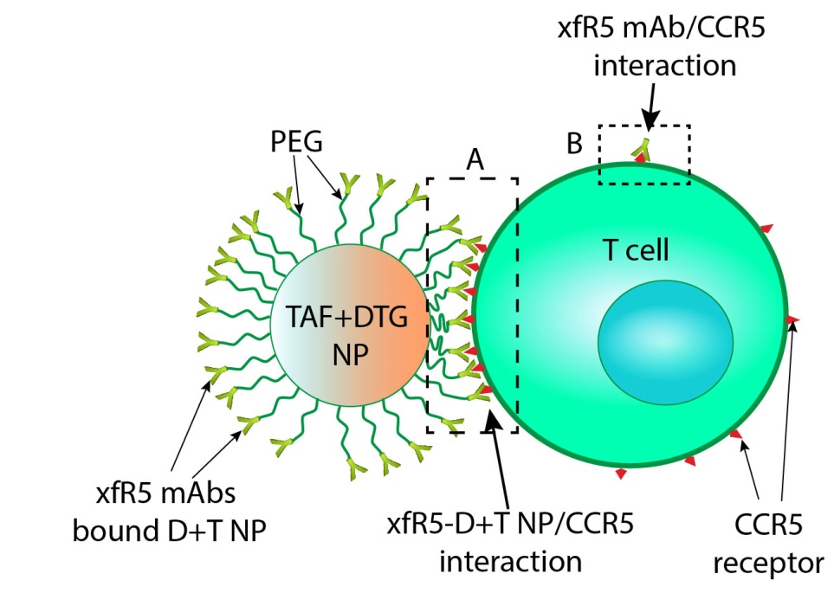

Supplementary Figure 2. Flow cytometry gating strategy to evaluate T cell binding affinity. The flow cytometry plots represent the percentage (%) of the relative number of cells in the respective populations. Primary PBMCs were first gated for (a) lymphocytes (FSC-A vs. SSC-A), from which (b) single cell (FSC-A vs. FSC-H) were gated. Single-cell lymphocytes were further gated for (c) CD2+ vs. CD68+ cells and (d) CD4+ vs. CD8+ cells. The graphical images represents comparative binding potency of xfR5-D+T NPs and xfR5 mAbs (free) after treatment (at 66.5 nM of xfR5 mAb concentration as NP bound or free), with primary CD2+ (dendritic cells or HIV latent T-cells, e), CD68+ (monocytes, f), CD8+ (g), CD8+CD4+ (h) and CD4+ (i) cell-types among PBMCs population. For setting the negative and positive gate, respective isotype controls and several channel markers were used, during each experiment. All samples were compensated during the sample run.
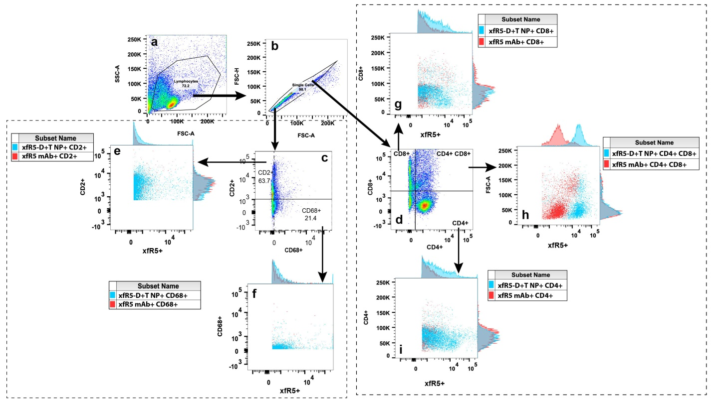

Supplementary Figure 3. Flow cytometry gating strategy to evaluate T cell differentiation pattern upon xfR5-D+T NPs and xfR5 mAbs (free) treatment (at 66.5 nM of xfR5 mAb concentration as NP bound or free). The primary PBMCs were gated against T-lymphocytes (CD3), helper T-cells (CD4), cytotoxic T-cells (CD8), memory T-cells (CD45RO), transition T-cells (CCR7), activated T-cells (CD69), and intermediate memory T-cells (CD27). The flow cytometry plots represent the relative number of cells in the respective populations (% mean). The gating include (a) Live cell; (b) Single cells, (c) T lymphocytes (CD3+). The CD3+ cells were further gated as histogram for CD27+/- cells (d). The CD27+ gated population was then sub-gated for CD45RO+ vs CCR7+ population (e) to determine CM (CCR7+CD45RO+), and naïve (CCR7+CD45RO-). Similarly, CD27- gated population was then sub-gated for CD45RO+ vs CCR7+ population (f) to determine EM (CCR7-CD45RO+), TM (CCR7+CD45RO+) and E (CCR7-CD45RO-) sub-populations. Among EM population, % of CD4+ cells (g) and EM CD8+ cells (i) were evaluated. The E population was further sub-gated for (h) T helper (T_{h}, CD4+) and (k) cytotoxic T lymphocytes (CTLs, CD8+). Activated (i) T helper (aT_{h}, CD4+CD69+) and (l) cytotoxic T lymphocytes (CTLs, CD8+) were estimated among T_{h} and CTLs population, respectively. During each experiment isotype controls and channel marker were used for setting the negative and positive gate, respectively. All samples were compensated during sample run.
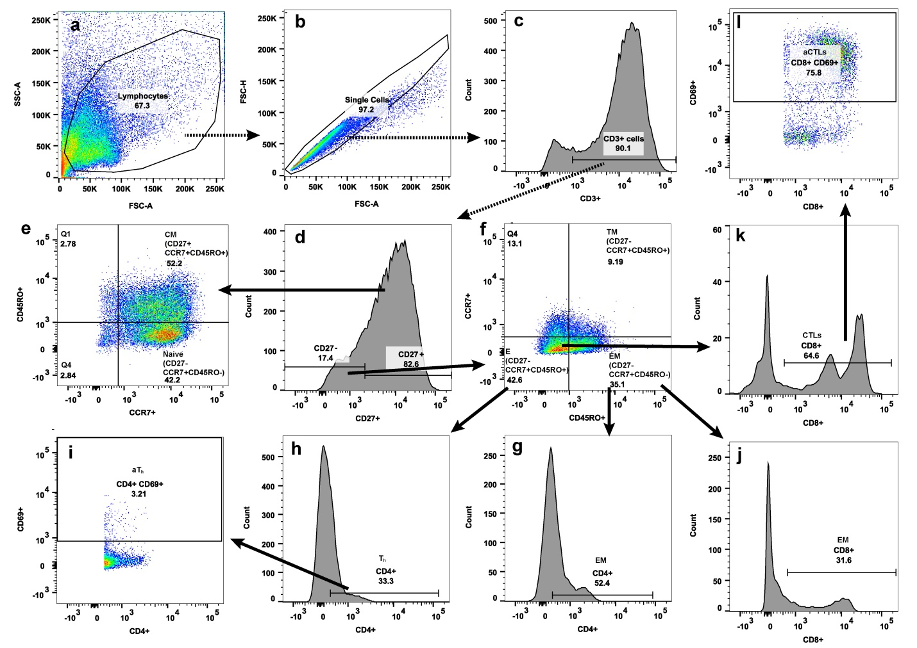

Supplementary figure 4 A graphical presentation of comparative binding potency of Cy3 tagged xfR5-D+T NPs vs different variables (i.e., untreated, xfR5 mAb and xfR5 NPs) on different immune cell type. (ns= non-significant)
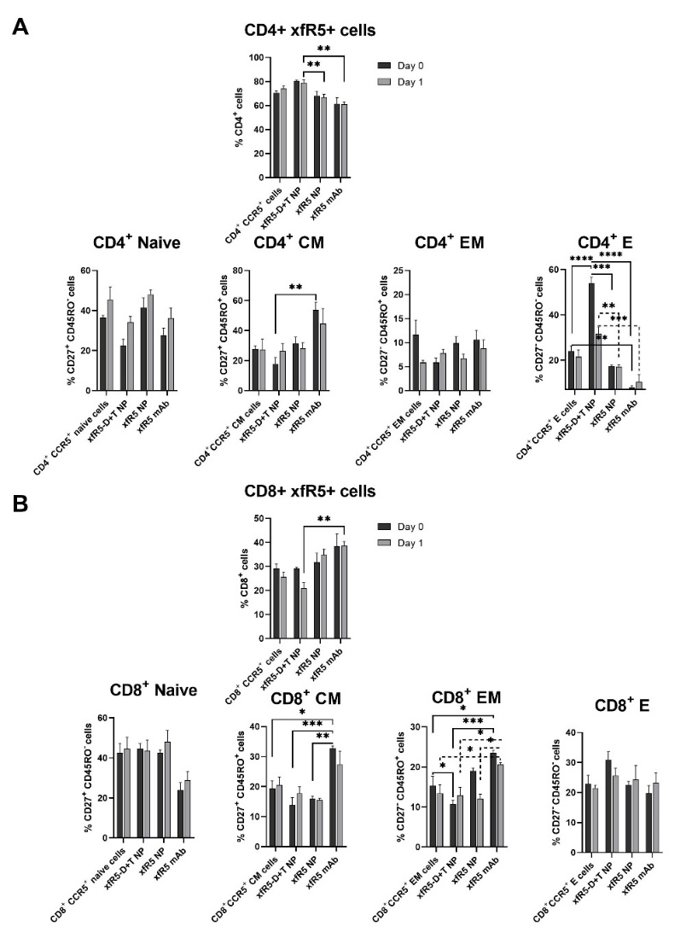
C)
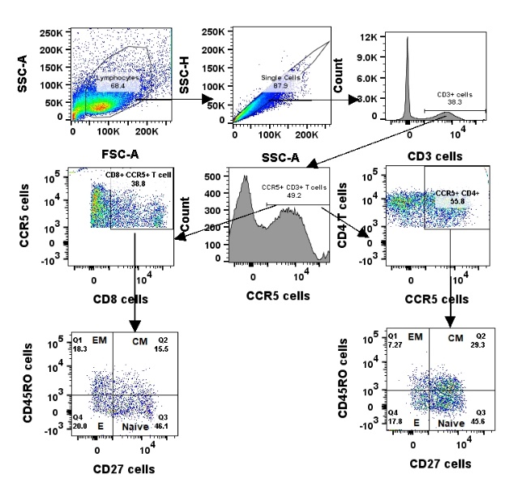
D) ANOVA for (i) CD4+ cells,
Tukey's multiple comparisons test | Significant | Summary | Adjusted P Value
CD4+ CCR5+ cells:Day 0 vs. xfR5-D+T NP:Day 0 | No | ns | 0.2659
CD4+ CCR5+ cells:Day 0 vs. xfR5 NP:Day 0 | No | ns | 0.9979
CD4+ CCR5+ cells:Day 0 vs. xfR5 mAb:Day 0 | No | ns | 0.3612
CD4+ CCR5+ cells:Day 1 vs. xfR5-D+T NP:Day 1 | No | ns | 0.9278
CD4+ CCR5+ cells:Day 1 vs. xfR5 NP:Day 1 | No | ns | 0.6285
CD4+ CCR5+ cells:Day 1 vs. xfR5 mAb:Day 1 | No | ns | 0.0744
xfR5-D+T NP:Day 0 vs. xfR5 NP:Day 0 | No | ns | 0.0943
xfR5-D+T NP:Day 0 vs. xfR5 mAb:Day 0 | Yes | ** | 0.004
xfR5-D+T NP:Day 1 vs. xfR5 NP:Day 1 | No | ns | 0.1206
xfR5-D+T NP:Day 1 vs. xfR5 mAb:Day 1 | Yes | ** | 0.0078
xfR5 NP:Day 0 vs. xfR5 mAb:Day 0 | No | ns | 0.7148
xfR5 NP:Day 1 vs. xfR5 mAb:Day 1 | No | ns | 0.823

(ii) CD4+ Naïve population:
Tukey's multiple comparisons test | Significant | Summary | Adjusted P Value
CD8+ CCR5+ cells:Day 0 vs. xfR5-D+T NP:Day 0 | No | ns | >0.9999
CD8+ CCR5+ cells:Day 0 vs. xfR5 NP:Day 0 | No | ns | 0.998
CD8+ CCR5+ cells:Day 0 vs. xfR5 mAb:Day 0 | No | ns | 0.3571
CD8+ CCR5+ cells:Day 1 vs. xfR5-D+T NP:Day 1 | No | ns | 0.9301
CD8+ CCR5+ cells:Day 1 vs. xfR5 NP:Day 1 | No | ns | 0.3535
CD8+ CCR5+ cells:Day 1 vs. xfR5 mAb:Day 1 | No | ns | 0.0768
xfR5-D+T NP:Day 0 vs. xfR5 NP:Day 0 | No | ns | 0.9978
xfR5-D+T NP:Day 0 vs. xfR5 mAb:Day 0 | No | ns | 0.3535
xfR5-D+T NP:Day 1 vs. xfR5 NP:Day 1 | No | ns | 0.0501
xfR5-D+T NP:Day 1 vs. xfR5 mAb:Day 1 | Yes | ** | 0.0083
xfR5 NP:Day 0 vs. xfR5 mAb:Day 0 | No | ns | 0.708
xfR5 NP:Day 1 vs. xfR5 mAb:Day 1 | No | ns | 0.9773

(iii) CD4+ CM population:
Tukey's multiple comparisons test | Significant | Summary | Adjusted P Value
CD4⁺CCR5⁺ CM cells:Day 0 vs. xfR5-D+T NP:Day 0 | No | ns | 0.8979
CD4⁺CCR5⁺ CM cells:Day 0 vs. xfR5 NP:Day 0 | No | ns | 0.9998
CD4⁺CCR5⁺ CM cells:Day 0 vs. xfR5 mAb:Day 0 | No | ns | 0.0818
CD4⁺CCR5⁺ CM cells:Day 1 vs. xfR5-D+T NP:Day 1 | No | ns | >0.9999
CD4⁺CCR5⁺ CM cells:Day 1 vs. xfR5 NP:Day 1 | No | ns | >0.9999
CD4⁺CCR5⁺ CM cells:Day 1 vs. xfR5 mAb:Day 1 | No | ns | 0.4319
xfR5-D+T NP:Day 0 vs. xfR5 NP:Day 0 | No | ns | 0.6879
xfR5-D+T NP:Day 0 vs. xfR5 mAb:Day 0 | Yes | ** | 0.0073
xfR5-D+T NP:Day 1 vs. xfR5 NP:Day 1 | No | ns | >0.9999
xfR5-D+T NP:Day 1 vs. xfR5 mAb:Day 1 | No | ns | 0.3802
xfR5 NP:Day 0 vs. xfR5 mAb:Day 0 | No | ns | 0.1728
xfR5 NP:Day 1 vs. xfR5 mAb:Day 1 | No | ns | 0.4958

(iv) CD4+ EM population:
Tukey's multiple comparisons test | Significant | Summary | Adjusted P Value
CD4⁺CCR5⁺ EM cells:Day 0 vs. xfR5-D+T NP:Day 0 | No | ns | 0.2382
CD4⁺CCR5⁺ EM cells:Day 0 vs. xfR5 NP:Day 0 | No | ns | 0.9911
CD4⁺CCR5⁺ EM cells:Day 0 vs. xfR5 mAb:Day 0 | No | ns | 0.9997
CD4⁺CCR5⁺ EM cells:Day 1 vs. xfR5-D+T NP:Day 1 | No | ns | 0.987
CD4⁺CCR5⁺ EM cells:Day 1 vs. xfR5 NP:Day 1 | No | ns | >0.9999
CD4⁺CCR5⁺ EM cells:Day 1 vs. xfR5 mAb:Day 1 | No | ns | 0.8914
xfR5-D+T NP:Day 0 vs. xfR5 NP:Day 0 | No | ns | 0.6469
xfR5-D+T NP:Day 0 vs. xfR5 mAb:Day 0 | No | ns | 0.4554
xfR5-D+T NP:Day 1 vs. xfR5 NP:Day 1 | No | ns | 0.9997
xfR5-D+T NP:Day 1 vs. xfR5 mAb:Day 1 | No | ns | 0.9998
xfR5 NP:Day 0 vs. xfR5 mAb:Day 0 | No | ns | >0.9999
xfR5 NP:Day 1 vs. xfR5 mAb:Day 1 | No | ns | 0.9812

(v) CD4+ E population:
Tukey's multiple comparisons test | Significant | Summary | Adjusted P Value
CD4⁺CCR5⁺ E cells:Day 0 vs. xfR5-D+T NP:Day 0 | Yes | **** | <0.0001
CD4⁺CCR5⁺ E cells:Day 0 vs. xfR5 NP:Day 0 | No | ns | 0.5047
CD4⁺CCR5⁺ E cells:Day 0 vs. xfR5 mAb:Day 0 | Yes | ** | 0.0032
CD4⁺CCR5⁺ E cells:Day 1 vs. xfR5-D+T NP:Day 1 | No | ns | 0.0974
CD4⁺CCR5⁺ E cells:Day 1 vs. xfR5 NP:Day 1 | No | ns | 0.8703
CD4⁺CCR5⁺ E cells:Day 1 vs. xfR5 mAb:Day 1 | No | ns | 0.0575
xfR5-D+T NP:Day 0 vs. xfR5 NP:Day 0 | Yes | **** | <0.0001
xfR5-D+T NP:Day 0 vs. xfR5 mAb:Day 0 | Yes | **** | <0.0001
xfR5-D+T NP:Day 1 vs. xfR5 NP:Day 1 | Yes | ** | 0.0076
xfR5-D+T NP:Day 1 vs. xfR5 mAb:Day 1 | Yes | *** | 0.0002
xfR5 NP:Day 0 vs. xfR5 mAb:Day 0 | No | ns | 0.1427
xfR5 NP:Day 1 vs. xfR5 mAb:Day 1 | No | ns | 0.4838

E) ANOVA for (i) CD8+ cells.
Tukey's multiple comparisons test | Significant | Summary | Adjusted P Value
CD8+ CCR5+ cells:Day 0 vs. xfR5-D+T NP:Day 0 | No | ns | >0.9999
CD8+ CCR5+ cells:Day 0 vs. xfR5 NP:Day 0 | No | ns | 0.998
CD8+ CCR5+ cells:Day 0 vs. xfR5 mAb:Day 0 | No | ns | 0.3571
CD8+ CCR5+ cells:Day 1 vs. xfR5-D+T NP:Day 1 | No | ns | 0.9301
CD8+ CCR5+ cells:Day 1 vs. xfR5 NP:Day 1 | No | ns | 0.3535
CD8+ CCR5+ cells:Day 1 vs. xfR5 mAb:Day 1 | No | ns | 0.0768
xfR5-D+T NP:Day 0 vs. xfR5 NP:Day 0 | No | ns | 0.9978
xfR5-D+T NP:Day 0 vs. xfR5 mAb:Day 0 | No | ns | 0.3535
xfR5-D+T NP:Day 1 vs. xfR5 NP:Day 1 | No | ns | 0.0501
xfR5-D+T NP:Day 1 vs. xfR5 mAb:Day 1 | Yes | ** | 0.0083
xfR5 NP:Day 0 vs. xfR5 mAb:Day 0 | No | ns | 0.708
xfR5 NP:Day 1 vs. xfR5 mAb:Day 1 | No | ns | 0.9773

(ii) CD8+ Naïve population:
Tukey's multiple comparisons test | Significant | Summary | Adjusted P Value
CD8⁺ CCR5⁺ naive cells:Day 0 vs. xfR5-D+T NP:Day 0 | No | ns | >0.9999
CD8⁺ CCR5⁺ naive cells:Day 0 vs. xfR5 NP:Day 0 | No | ns | >0.9999
CD8⁺ CCR5⁺ naive cells:Day 0 vs. xfR5 mAb:Day 0 | No | ns | 0.1257
CD8⁺ CCR5⁺ naive cells:Day 1 vs. xfR5-D+T NP:Day 1 | No | ns | >0.9999
CD8⁺ CCR5⁺ naive cells:Day 1 vs. xfR5 NP:Day 1 | No | ns | 0.9991
CD8⁺ CCR5⁺ naive cells:Day 1 vs. xfR5 mAb:Day 1 | No | ns | 0.2636
xfR5-D+T NP:Day 0 vs. xfR5 NP:Day 0 | No | ns | >0.9999
xfR5-D+T NP:Day 0 vs. xfR5 mAb:Day 0 | No | ns | 0.0708
xfR5-D+T NP:Day 1 vs. xfR5 NP:Day 1 | No | ns | 0.9961
xfR5-D+T NP:Day 1 vs. xfR5 mAb:Day 1 | No | ns | 0.327
xfR5 NP:Day 0 vs. xfR5 mAb:Day 0 | No | ns | 0.1268
xfR5 NP:Day 1 vs. xfR5 mAb:Day 1 | No | ns | 0.1077

(iii) CD8+ CM population:
Tukey's multiple comparisons test | Significant | Summary | Adjusted P Value
CD8⁺CCR5⁺ CM cells:Day 0 vs. xfR5-D+T NP:Day 0 | No | ns | 0.735
CD8⁺CCR5⁺ CM cells:Day 0 vs. xfR5 NP:Day 0 | No | ns | 0.9643
CD8⁺CCR5⁺ CM cells:Day 0 vs. xfR5 mAb:Day 0 | Yes | * | 0.0198
CD8⁺CCR5⁺ CM cells:Day 1 vs. xfR5-D+T NP:Day 1 | No | ns | 0.989
CD8⁺CCR5⁺ CM cells:Day 1 vs. xfR5 NP:Day 1 | No | ns | 0.8178
CD8⁺CCR5⁺ CM cells:Day 1 vs. xfR5 mAb:Day 1 | No | ns | 0.5166
xfR5-D+T NP:Day 0 vs. xfR5 NP:Day 0 | No | ns | 0.9984
xfR5-D+T NP:Day 0 vs. xfR5 mAb:Day 0 | Yes | *** | 0.0009
xfR5-D+T NP:Day 1 vs. xfR5 NP:Day 1 | No | ns | 0.9977
xfR5-D+T NP:Day 1 vs. xfR5 mAb:Day 1 | No | ns | 0.1594
xfR5 NP:Day 0 vs. xfR5 mAb:Day 0 | Yes | ** | 0.0027
xfR5 NP:Day 1 vs. xfR5 mAb:Day 1 | No | ns | 0.0514

(iv) CD8+ EM population:
Tukey's multiple comparisons test | Significant | Summary | Adjusted P Value
CD8⁺CCR5⁺ EM cells:Day 0 vs. xfR5-D+T NP:Day 0 | No | ns | 0.3895
CD8⁺CCR5⁺ EM cells:Day 0 vs. xfR5 NP:Day 0 | No | ns | 0.6374
CD8⁺CCR5⁺ EM cells:Day 0 vs. xfR5 mAb:Day 0 | Yes | * | 0.0187
CD8⁺CCR5⁺ EM cells:Day 1 vs. xfR5-D+T NP:Day 1 | No | ns | >0.9999
CD8⁺CCR5⁺ EM cells:Day 1 vs. xfR5 NP:Day 1 | No | ns | 0.998
CD8⁺CCR5⁺ EM cells:Day 1 vs. xfR5 mAb:Day 1 | Yes | * | 0.0472
xfR5-D+T NP:Day 0 vs. xfR5 NP:Day 0 | Yes | * | 0.0177
xfR5-D+T NP:Day 0 vs. xfR5 mAb:Day 0 | Yes | *** | 0.0003
xfR5-D+T NP:Day 1 vs. xfR5 NP:Day 1 | No | ns | 0.9999
xfR5-D+T NP:Day 1 vs. xfR5 mAb:Day 1 | Yes | * | 0.0312
xfR5 NP:Day 0 vs. xfR5 mAb:Day 0 | No | ns | 0.4046
xfR5 NP:Day 1 vs. xfR5 mAb:Day 1 | Yes | * | 0.0144

(v) CD4+ E population:
Tukey's multiple comparisons test | Significant | Summary | Adjusted P Value
CD8⁺CCR5⁺ E cells:Day 0 vs. xfR5-D+T NP:Day 0 | No | ns | 0.5015
CD8⁺CCR5⁺ E cells:Day 0 vs. xfR5 NP:Day 0 | No | ns | >0.9999
CD8⁺CCR5⁺ E cells:Day 0 vs. xfR5 mAb:Day 0 | No | ns | 0.9925
CD8⁺CCR5⁺ E cells:Day 1 vs. xfR5-D+T NP:Day 1 | No | ns | 0.9612
CD8⁺CCR5⁺ E cells:Day 1 vs. xfR5 NP:Day 1 | No | ns | 0.9959
CD8⁺CCR5⁺ E cells:Day 1 vs. xfR5 mAb:Day 1 | No | ns | 0.9998
xfR5-D+T NP:Day 0 vs. xfR5 NP:Day 0 | No | ns | 0.4673
xfR5-D+T NP:Day 0 vs. xfR5 mAb:Day 0 | No | ns | 0.1665
xfR5-D+T NP:Day 1 vs. xfR5 NP:Day 1 | No | ns | >0.9999
xfR5-D+T NP:Day 1 vs. xfR5 mAb:Day 1 | No | ns | 0.9983
xfR5 NP:Day 0 vs. xfR5 mAb:Day 0 | No | ns | 0.9954
xfR5 NP:Day 1 vs. xfR5 mAb:Day 1 | No | ns | >0.9999

Supplementary figure 5: T-cell differentiation phenotype after D+T NP vs xfR5 NPs treatment under (A) protection against HIV challenge (HIV prophylaxis), and (B), HIV infected T-cell treatment (HIV treatment) condition. A) The immunophenotyping pattern were evaluated after cell treatment followed by HIV-1_{ADA} challenge condition. (C) Immunophenotyping pattern evaluation of HIV infected followed by treatment condition. The differentiation pattern was evaluated following naïve (CD27⁺CD45RO⁻ cells), CM (CD27⁺CD45RO⁻ cells), TM, EM, and E sub-population as depicted in x-axis; whereas the y-axis represents respective marker % positive cells. The data presented as mean ± SEM of three independent experiments on healthy donors (n=3). The significance was determined by two-way ANOVA analysis followed by Tukey's multiple comparisons test and the asterisk (*) symbol represents the significance level corresponding to P values <0.05.
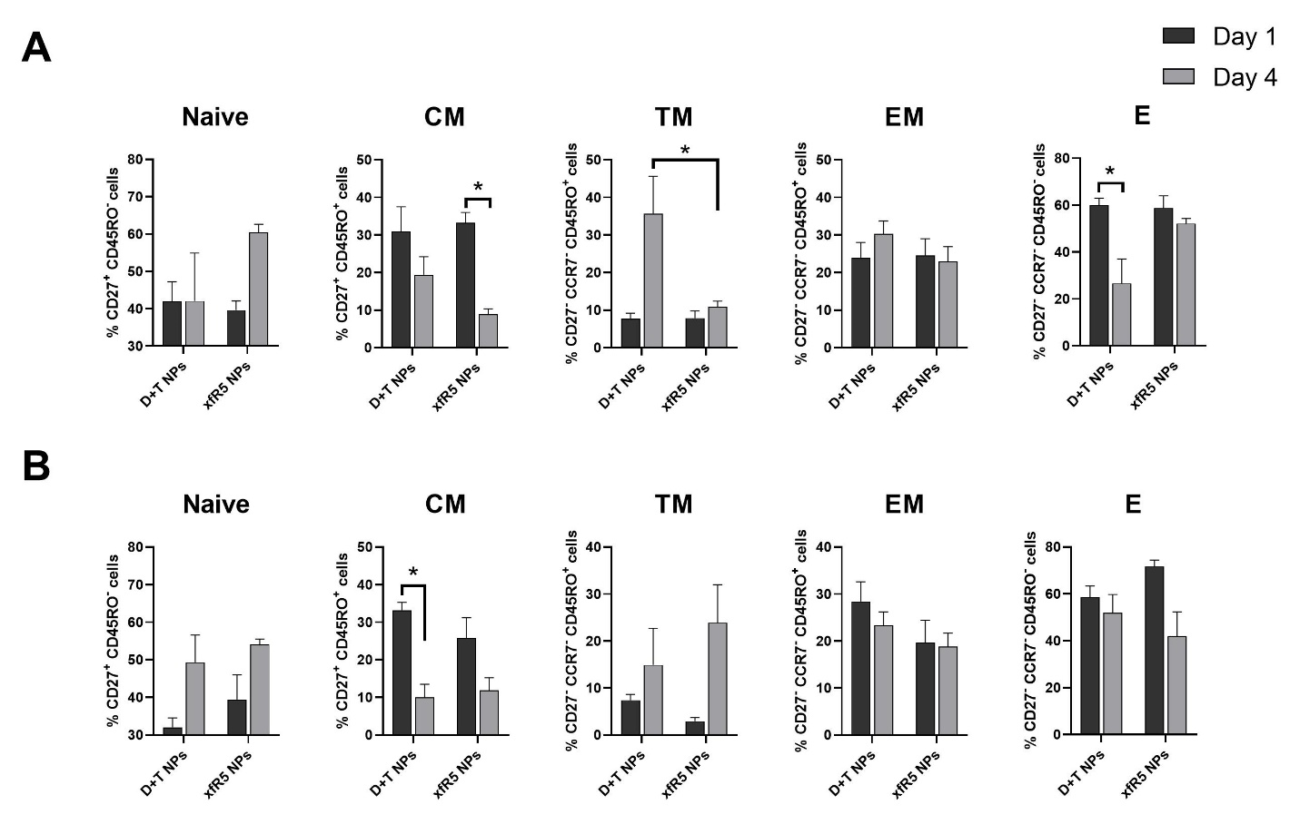

Supplementary figure 6. Early T cell activation (CD69+) profile. A) Early activation of CD4+ and CD8+ T cells upon PHA stimulation. B) Comparative CD4+ T cell activation profile after treatment with D+T NPs, xfR5-D+T NPs, xfR5 NPs, xfR5 mAbs and PHA activation (under HIV-1 protection, left) as well as compared to HIV infected and treated (right). B) Comparative CD8+ T cell activation profile after treatment with D+T NPs, xfR5-D+T NPs, xfR5 NPs, xfR5 mAbs and PHA activation (under HIV-1 protection, left) as well as compared to HIV infected and treated (right). The % early T cell activation marker expressing cells on day 0 (no treatment or activation, white bar), day 1 (after treatment or activation, dark grey) and day 4 (after treatment or activation, light grey). Each data set represents mean ± SEM of three independent experiments on PBMCs obtained from healthy donors (n=3). The significance represented as the asterisk (*) symbol, where, ‘*’, ‘**’, ‘***’and ‘****’ corresponding to P values <0.05, <0.01, <0.001 and <0.0001, respectively.
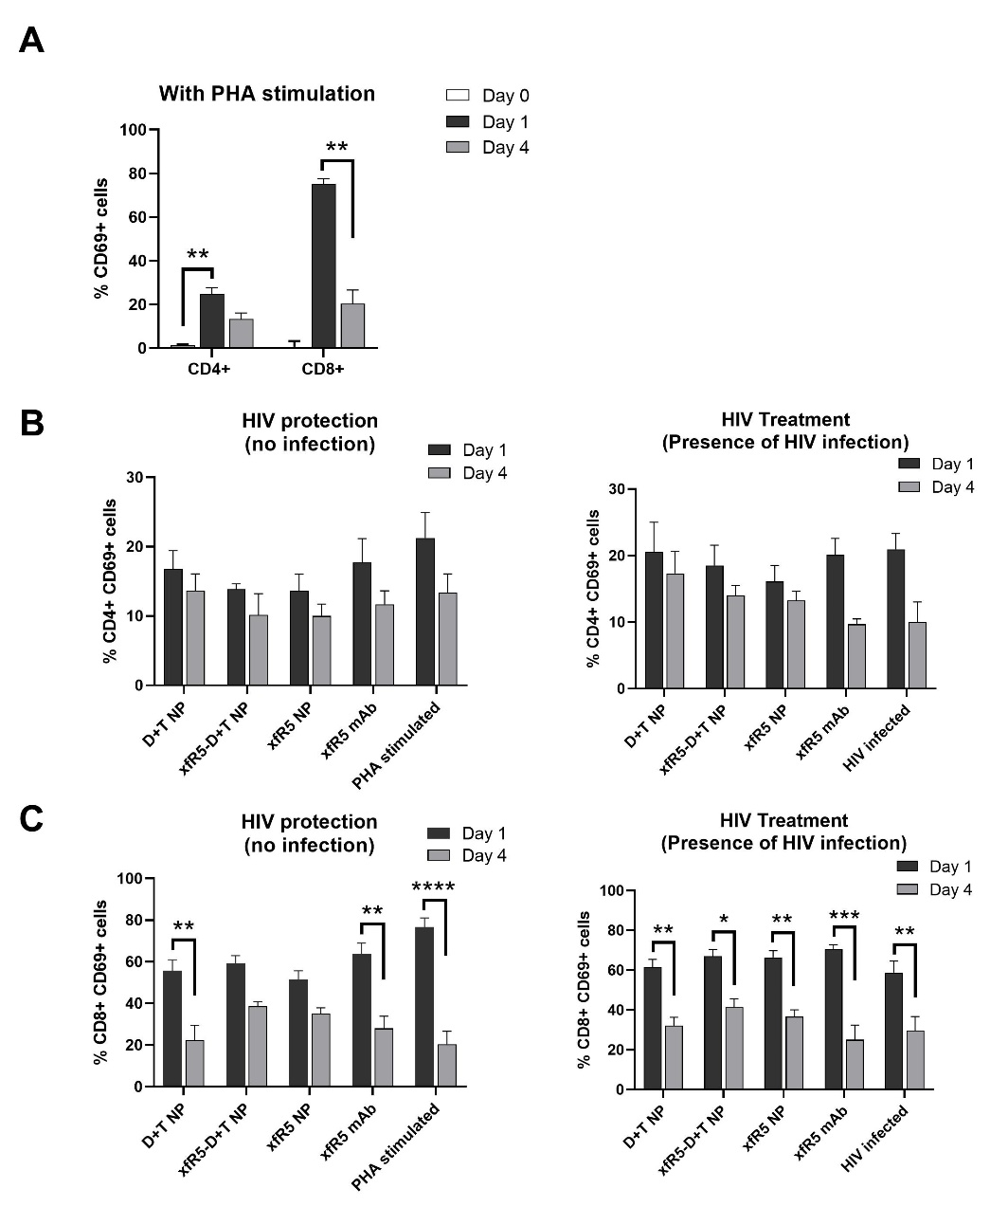

Supplementary Table 1. Comparative one-way ANOVA analysis (using Tukey's multiple comparisons test) of CC₅₀ of TZM-bl and PBMCs (‘ns’= non-significant ‘p’ value).
Cell type | Compared treatment variable | Significant | Summary | Adjusted P Value
TZM-bl | xfCCR5 D+T NPs vs. xfCCR5 NPs | Yes | **** | <0.0001
TZM-bl | xfCCR5 D+T NPs vs. D+T NPs | No | ns | 0.6238
TZM-bl | xfCCR5 D+T NPs vs. xfCCR5 mAb | Yes | **** | <0.0001
TZM-bl | xfCCR5 NPs vs. D+T NPs | Yes | **** | <0.0001
TZM-bl | xfCCR5 NPs vs. xfCCR5 mAb | No | ns | 0.0572
TZM-bl | D+T NPs vs. xfCCR5 mAb | Yes | **** | <0.0001
PBMC | xfCCR5 D+T NPs vs. xfCCR5 NPs | Yes | ** | 0.0027
PBMC | xfCCR5 D+T NPs vs. D+T NPs | No | ns | 0.1649
PBMC | xfCCR5 D+T NPs vs. xfCCR5 mAb | No | ns | 0.7895
PBMC | xfCCR5 NPs vs. D+T NPs | No | ns | 0.0581
PBMC | xfCCR5 NPs vs. xfCCR5 mAb | Yes | ** | 0.0085
PBMC | D+T NPs vs. xfCCR5 mAb | No | ns | 0.5218

Supplementary Table 2. Comparative one-way ANOVA analysis (using Tukey's multiple comparisons test) of IC₅₀ of TZM-bl and PBMCs (‘ns’= non-significant ‘p’ value).
Cell type | Compared treatment variable | Significant | Summary | Adjusted P Value
TZM-bl | xfCCR5 D+T NPs vs. xfCCR5 NPs | No | ns | >0.9999
TZM-bl | xfCCR5 D+T NPs vs. D+T NPs | No | ns | 0.9998
TZM-bl | xfCCR5 D+T NPs vs. xfCCR5 mAb | Yes | **** | <0.0001
TZM-bl | xfCCR5 NPs vs. D+T NPs | No | ns | 0.9999
TZM-bl | xfCCR5 NPs vs. xfCCR5 mAb | Yes | **** | <0.0001
TZM-bl | D+T NPs vs. xfCCR5 mAb | Yes | **** | <0.0001
PBMC | xfCCR5 D+T NPs vs. xfCCR5 NPs | Yes | **** | <0.0001
PBMC | xfCCR5 D+T NPs vs. D+T NPs | Yes | **** | <0.0001
PBMC | xfCCR5 D+T NPs vs. xfCCR5 mAb | Yes | **** | <0.0001
PBMC | xfCCR5 NPs vs. D+T NPs | Yes | *** | 0.0004
PBMC | xfCCR5 NPs vs. xfCCR5 mAb | Yes | **** | <0.0001
PBMC | D+T NPs vs. xfCCR5 mAb | Yes | **** | <0.0001

