Supplementary Material
Excess-Weight Metrics Misrepresent Weight Loss and No Metric Predicts the Metabolic Outcome After Metabolic and Bariatric Surgery

Supplementary Methods: weight-metric usage scan
We checked how the two families of weight-loss metrics are used across disciplines. We searched PubMed at the abstract and title level for bariatric-surgery articles published from 2022 to 2025. Journals were grouped as surgical (Surg Obes Relat Dis, Obes Surg) or internal-medicine and obesity (Obesity [Silver Spring], Obes Rev, Diabetes Obes Metab, Int J Obes [Lond]).
For each journal and year, the denominator was all bariatric-surgery articles. Within that denominator we counted two things separately. First, articles mentioning an excess-weight metric ("excess weight loss" OR %EWL OR EBMIL OR "excess BMI loss"). Second, articles mentioning a total-weight metric ("total weight loss" OR %TWL).
These counts are a within-group prevalence. They show the share of bariatric abstracts in each field that use each metric. They are not a compliance rate against any reporting standard. The two metric groups are not mutually exclusive, because a single article often reports both. The surgical denominator is about ten times the internal-medicine denominator. For that reason only the within-group balance of excess-weight versus total-weight mentions can be compared across disciplines, not the raw counts.
Abstract-level screening undercounts true use, because metrics are usually stated in the Methods or Results rather than the abstract. We therefore treat this scan as directional motivation only. The rigorous full-text benchmark is the ASMBS-guideline reporting audit [4].
Supplementary Results: a disciplinary split on the weight axis
In the surgical journals, excess-weight metrics stayed roughly as common as %TWL and did not decline across 2022 to 2025. Pooled over the four years, 276 of 3,661 bariatric abstracts mentioned an excess-weight metric (7.5 percent) and 371 mentioned a total-weight metric (10.1 percent). The ratio of excess-weight to total-weight mentions was about 0.74, and the excess-weight share held steady over the window.
The internal-medicine and obesity journals looked different. There the total-weight metric was the more common family (24 versus 18 mentions pooled across 455 bariatric abstracts, or 5.3 versus 4.0 percent). Excess-weight mentions stayed in the single digits each year across the four journals combined, between 1 and 7 annually, close to the floor.
The contrast is a split between disciplines on the weight axis alone. It describes how each field prefers to express weight loss. It says nothing about the metabolic axis, which is the question the main analysis addresses.

Supplementary Tables

Supplementary Table S1. Analytic sample sizes.
Sample | N | Notes
Locked cohort (initial SG + RYGB) | 182,826 | SG 130,123 / RYGB 52,703
Paired 6-month BMI (weight axis) | 136,406
Head-to-head (paired HbA1c ∩ BMI) | 27,517 | SG 17,500 / RYGB 10,017
with baseline diabetes | 10,600
Baseline-uncontrolled (HbA1c ≥ 7.0) | 4,220–4,221 | responders 3,282 (77.8%)

Supplementary Table S2. Baseline phenotype by concordance cell.
Cell | n | Age | BMI0 | HbA1c0 | % insulin | % RYGB | mean %TWL
WL non / GLY non | 668 | 51.9 | 44.0 | 8.47 | 74.4 | 29.8 | 13.3
WL non / GLY resp | 1,731 | 48.5 | 44.8 | 8.05 | 35.5 | 37.3 | 14.3
WL resp / GLY non | 270 | 52.5 | 43.8 | 8.44 | 83.3 | 53.3 | 24.5
WL resp / GLY resp | 1,552 | 46.9 | 45.1 | 8.08 | 33.2 | 55.9 | 25.4

Supplementary Table S3. Procedure-stratified replication.
Procedure | Weight-metric AUC range | Severity benchmark AUC | Discordant % | Kappa | Eligible n
Sleeve gastrectomy | 0.60–0.63 | 0.782 | 51.2% | 0.114 | 2,363
Gastric bypass | 0.56–0.60 | 0.759 | 42.5% | 0.098 | 1,857

Supplementary Figures

Supplementary Figure S1. Within-group weight-metric usage in bariatric abstracts, by discipline, 2022 to 2025. Bars show the percentage of each year's bariatric-surgery abstracts that mention an excess-weight metric (%EWL/%EBMIL) versus a total-weight metric (%TWL). Surgical journals are Surg Obes Relat Dis and Obes Surg. Internal-medicine and obesity journals are Obesity (Silver Spring), Obes Rev, Diabetes Obes Metab, and Int J Obes (Lond). The two metric groups are non-exclusive, and the values are within-group prevalence rather than a compliance rate. This is directional motivation only. See Supplementary Methods.
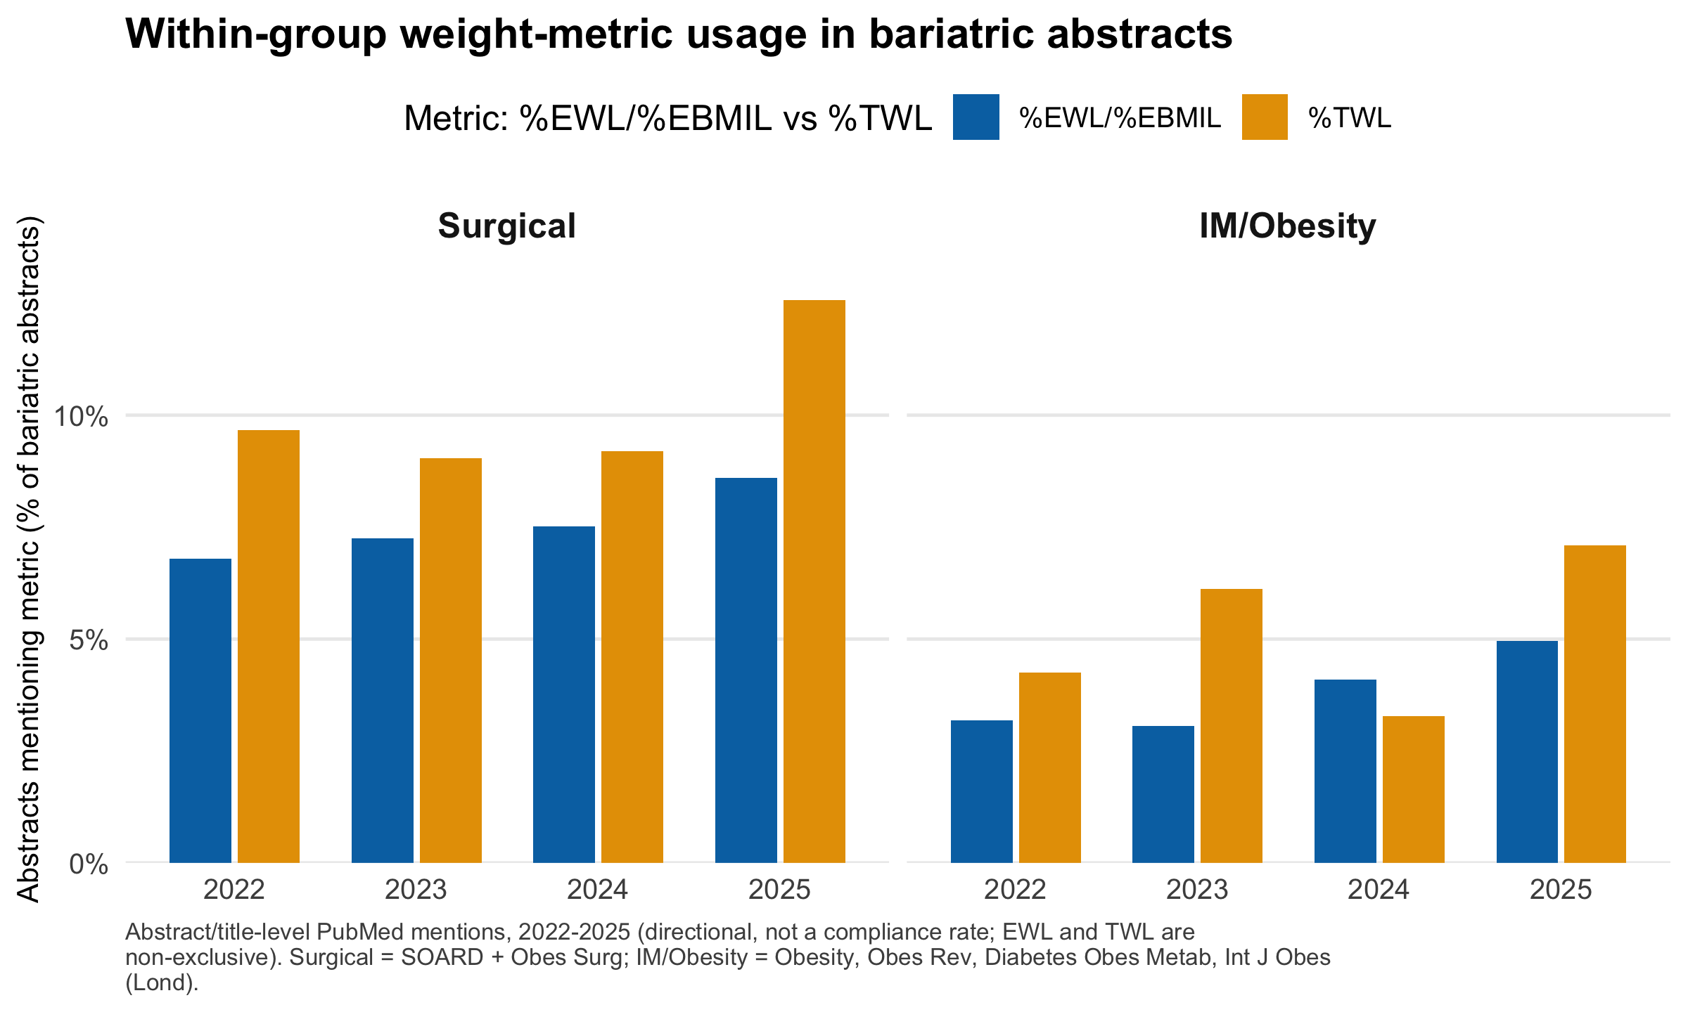

Supplementary Figure S2. Procedure-stratified AUC (SG and RYGB).
