Additional file 1.

Modelling the impact of mass drug administration with ivermectin or moxidectin on human onchocerciasis when there is sub-optimal response of parasites to treatment
Rebecca H. Chisholm^{1,2,*,+}, Shilian Xu^{1,3,4+}, Kwadwo K Frempong⁵, Himal Shrestha^{3,6}, Joseph Kwadwo Larbi Opare⁷, Odame D. Asiedu⁷, Ernest Mensah⁷, Makedonka Mitreva⁸, Warwick N Grant³, Shannon M Hedtke^{3,9*}
¹Department of Mathematical and Physical Sciences, La Trobe University, Bundoora, Australia
²Melbourne School of Population and Global Health, The University of Melbourne, Melbourne, Australia
³Department of Microbiology, Anatomy, Physiology and Pharmacology, School of Agriculture, Biomedicine and Environment, La Trobe University, Bundoora, Australia
⁴Current address: Faculty of Biology, Technion-Israel Institute of Technology, Haifa, Israel
⁵Noguchi Memorial Institute for Medical Research, College of Health Sciences, University of Ghana, Accra, Ghana
⁶Department of Microbiology and Immunology, Microbiological Diagnostic Unit Public Health Laboratory, University of Melbourne, Melbourne, Victoria, Australia
⁷Neglected Tropical Diseases Program, Disease Control and Prevention Department, Public Health Division, Ghana Health Service, Accra, Ghana
⁸Department of Medicine, Washington University in St. Louis and McDonnell Genome Institute, St. Louis, Missouri 63108, USA
⁹La Trobe Institute for Molecular Science, La Trobe University, Bundoora, Victoria, Australia
* Corresponding authors
+ These authors contributed equally to this work
RHC: R.Chisholm@latrobe.edu.au
SX: Shilian.Xu@latrobe.edu.au
KKF: kfrempong@noguchi.ug.edu.gh
HS: himal.shrestha@unimelb.edu.au
JKLO: kwadwolarbiopare@gmail.com
ODA: odame_114@yahoo.com
EM: ernestmenssah1@gmail.com
MM: mmitreva@wustl.edu
WNG: W.Grant@latrobe.edu.au
SMH: S.Hedtke@latrobe.edu.au
Text S1.
Model equations without the effects of MDAi.
The model can be used to simulate transmission in a population with no prior (and no new) exposure to MDAi programs by setting the ivermectin effect functions $λ_{i}\left(τ\right)=ω_{i}\left(τ\right)=σ_{M_{1}}\left(τ\right)=0$ and ${ ψ}_{i}=1$ and the offspring phenotype matrices $C_{i}[x_{0}]$ to be constant in Equations (1)-(4) (i.e., we assume no selection against SOR in the absence of ivermectin).
We simulate the model under these conditions for 300 years for a specific value of the per capita annual biting rate $ABR$ to reach the pre-MDAi endemic equilibrium. The proportion of SOR worms in the population at endemic equilibrium prior to MDAi is determined by the choice of offspring phenotype matrix $C_{i}[x_{0}]$. The total mf prevalence at endemic equilibrium prior to MDAi is independent of the choice of the offspring phenotype matrices $C_{i}[x_{0}]$. This is apparent when we calculate the system of delay differential equations for $N\left(t\right)=N_{GR}\left(t\right)+N_{SOR}\left(t\right)$, $F\left(t\right)=F_{GR}\left(t\right)+F_{SOR}\left(t\right)$, $M\left(t\right)$ and $L\left(t\right)$ under these MDAi-free conditions, which are independent of the phenotype inheritance parameters:
$$\begin{aligned}\frac{dN\left(t\right)}{dt}=\frac{1}{2}βmΩΠ_{H}\left[L\left(t-p\right)\right]L\left(t-p\right)+λ_{0}F\left(t\right)-\left(ω_{0}+σ_{W}\right)N_{i}\left(t\right), \#\#(S1) \\ \frac{dF\left(t\right)}{dt}=ω_{0}N\left(t\right)-\left(λ_{0}+σ_{W}\right)F\left(t\right),\#(S2) \\ \frac{dM\left(t\right)}{dt}=ε ϕ\left[W\left(t\right)\right]F\left(t\right)-σ_{M_{0}}M\left(t\right),\#(S3) \\ \frac{dL\left(t\right)}{dt}=βΩΠ_{V}\left[M\left(t\right)\right]M\left(t\right)-\left(\frac{α_{H}}{g}+σ_{L}+μ_{V}+α_{V}M\left(t\right)\right)L\left(t\right). \#(S4)\end{aligned}$$

Calibration method and results for the variable response model
We calibrated the model (Equations (1)-(4)) parameterised with annual MDAi coverage data over the period 1987-2006 to be consistent with prevalence data from Asubende (Figure S1) and to SOR worm proportion data from a different community in Ghana (as this data was not available for Asubende). Because these data do not originate in the same community, we use a combination of Latin Hypercube Sampling and a simple rejection sampling Approximate Bayesian Computation (ABC) method to identify model parameters consistent with these data [1]. To do this, we set $ABR$, the annual biting rate, to be 65,000 so that the mf prevalence in 1987 is approximately 80% pre-MDAi. Our aim was to identify sets of the unknown model parameters associated with phenotype inheritance ($c_{GR,GR}$, $c_{SOR,SOR}^{0}$, $c_{GR,SOR}^{0}$) and the effects of MDAi on worm fertility ($y, f$) and selection of the SOR phenotype ($s_{GR,GR}$, $s_{GR,GR}$) which satisfy the following beliefs:
- The SOR worm proportion in MDAi naïve populations being between 0.05-0.15, in line with a phenotype-based estimate of 0.12 from a treatment-naïve population in Ghana [2];
- When simulating a 20-year annual MDAi program with coverage levels matching those achieved in Asubende, Ghana between 1987-2006, the post-MDAi total mf prevalence is between 10-12%, in line with the observed mf prevalence of 11% in 2006, down from 80% pre-MDAi in 1987 (Figure S1 and Table S1); and
- Following the same MDAi program, the SOR worm proportion increases by at least 0.1. Data on the change in SOR worm proportion is not available for the Asubende MDAi program between 1987-2006. We choose a target increase of greater than 0.1 in SOR worm proportion based on an estimated increase in SOR worm proportion in Cameroon after 16 rounds of annual MDAi where the proportion increased by at least 0.14 [2]. Given the uncertainty in this estimate, we conduct sensitivity analyses where we choose a smaller target increase of between 0.05 and 0.1 in SOR worm proportion.
We did this in a staged approach:
- We first focused on identifying the phenotype inheritance parameters ($c_{GR,GR}$, $c_{SOR,SOR}^{0}$, $c_{GR,SOR}^{0}$) which satisfy belief 1, above, and which satisfy the assumption $c_{GR,GR}>c_{GR,SOR}^{0}>c_{SOR,SOR}^{0}$, which corresponds to the assumption that pairings between two GR worms should be more likely to lead to GR offspring than mixed phenotype pairings, and mixed phenotype pairings should be more likely to lead to GR offspring than pairings between two SOR worms.
To do this, we generated 1000 sets of these 3 parameters using Latin Hypercube Sampling (LHS) from the uniform distributions: $c_{GR,GR} \sim U\left(0.9, 1\right)$, $c_{SOR,GR}^{0} \sim U\left(0.01, 1\right)$, $c_{SOR,SOR}^{0} \sim U\left(0.01, 1\right)$. For each parameter set, we simulated the model to endemic equilibrium (300 years), and identified the parameter sets which satisfied $c_{GR,GR}>c_{GR,SOR}^{0}>c_{SOR,SOR}^{0}$ and belief 1, above. From the 1000 parameter samples we started with, 157 satisfied these two constraints.

- We then generated 50 sets of the unknown MDAi effect parameters using LHS from the uniform distributions: $s_{SOR,GR}\sim U\left(0, 20\right), s_{SOR,SOR}\sim U\left(0, 20\right)$, $f\sim U(0, 10)$ and $y\sim U(0, 1)$. For each of the remaining 157 inheritance parameter sets for, we then simulated the 20-year annual MDAi program from endemic equilibrium with coverage levels matching those recorded in Asubende, for each set of MDAi effect LHS parameter sets with, and then without the assumption of a cumulative effect of ivermectin on GR worm fertility. We then identified those LHS samples which satisfied beliefs 2-3, above, and additionally $c_{GR,SOR}^{0}>0.5$ and $c_{SOR,SOR}^{0}<0.5$ so the ranges of the piecewise linear functions of $c_{SOR,GR}[x]$ and $c_{SOR,SOR}[x]$ were within [0,1]. From the $157×50=7850$ parameter sets we started with under each assumption about the cumulative effect of ivermectin on worm fertility, 399 satisfied these two further constraints. All of the accepted parameter sets were generated under the model assuming there is a cumulative effect of ivermectin on worm fertility (Figure S2).
The final marginal posterior distributions for the unknown model parameters are shown in Figure S3, and the corresponding distributions for the post MDAi total prevalence and change in SOR worm proportions are shown in Figure S4A. All distributions are also summarised in Table S2. They reveal higher uncertainty for parameters related to phenotype inheritance from pairings involving SOR worms, compared to those related to phenotype inheritance from pairings with just GR worms, reflecting their wider (less certain) prior distributions. The posterior distribution for the relative rate of loss of MDAi effect on worm fecundity for SOR worms compared to GR worms ($f$) is well above 1, suggesting that SOR worms return to fertility at a much faster rate than GR worms following exposure to MDAi.
For the sensitivity analysis, we repeated step 2 above with the alternative belief 3 that stipulates a smaller target increase in SOR worm proportion following MDAi. From the $157×50=7850$ parameter sets we started with under each assumption about the cumulative effect of ivermectin on worm fertility, 544 satisfied the altered criteria 2. Again, all of the accepted parameter sets were generated under the model assuming there is a cumulative effect of ivermectin on worm fertility (Figure S2).

Calibration method and results for the GR-only model
We applied the same calibration approach for the GR-only model, as we did with the variable response model. The $ABR$ is set at the same value (65000) to achieve the same level of endemic mf prevalence (as the response phenotype has no effect in treatment naïve populations). There is effectively only a single free parameter to identify via the calibration of the GR-only model: the parameter $y$, which balances the embryostatic effect on transition rates between fertile and non-fertile female worms due to ivermectin.
Using the same set of 50 LHS samples of $y\sim U(0, 1)$ that were generated in the variable response model calibration, we simulated the 20-year annual MDAi program from endemic equilibrium with coverage levels matching those recorded in Asubende, for each parameter sample with, and then without the assumption of a cumulative effect of ivermectin on GR worm fertility. We then identified those LHS samples which satisfied the constraint related to mf prevalence in belief 2, above. From the $50$ parameter samples we started with under each assumption about the cumulative effect of ivermectin on worm fertility, 3 satisfied this constaint. All of the accepted parameter samples were generated under the model assuming there is a cumulative effect of ivermectin on worm fertility (Figure S1b); these were $y= 0.01246959, 0.02583695, 0.04447304$. Due to the low number of accepted samples, we chose the median value to parameterise the GR-only model.

Supplementary Figures

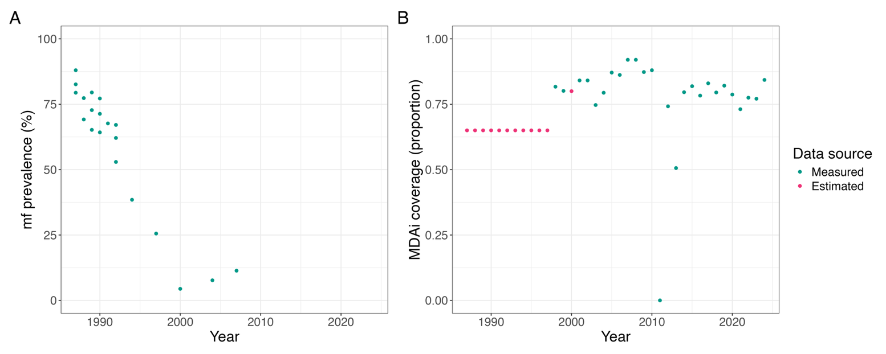
Figure S1. (A) Mf prevalence and (B) MDAi coverage data in Asubende, Ghana between 1987-2024. Coverage data was missing for the annual MDAi’s carried out between 1987-1997. For these years we set the coverage to 65% in line with expert opinion. Data was also missing for the MDAi carried out in 1998. Based on expert opinion we set this to 80%. No MDAi were implemented in 2011.

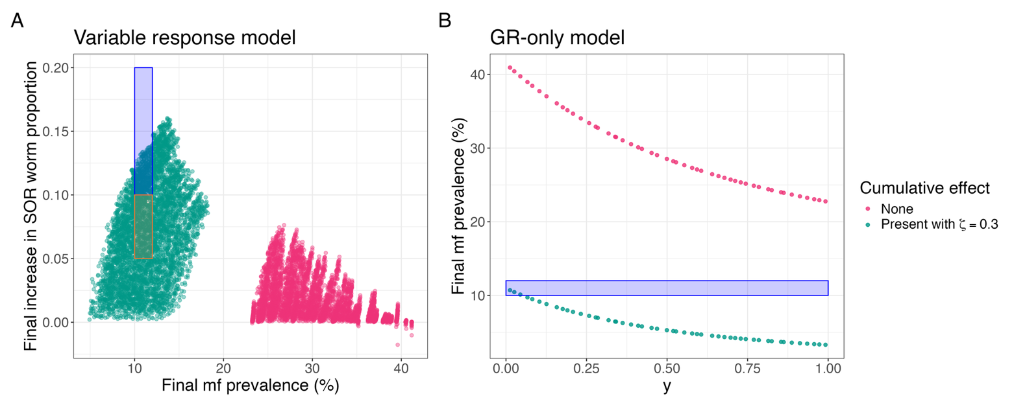
Figure S2. Calibrating the variable response and GR-only models to mf prevalence data from Asubende following a 20-year annual MDAi program. (A) The final mf prevalence (horizontal axis) and final increase in SOR worm proportion (vertical axis) for simulation trajectories of the variable response model; (B) The final mf prevalence (vertical axis) for simulation trajectories of the GR-only model for each sampled value of $y$ (horizontal axis). Points represent the final time of simulations of a 20-year annual MDAi program run for all parameter-set LHS samples from their prior distributions, under the assumption of no-cumulative effect of ivermectin on GR worm fertility (pink) and with a cumulative effect of ivermectin on GR worm fertility (green). The blue boxes indicate the target region (satisfying beliefs 2-3) for accepted parameter-set samples. The orange box indicates the alternative target region used in the sensitivity analysis for belief 3.
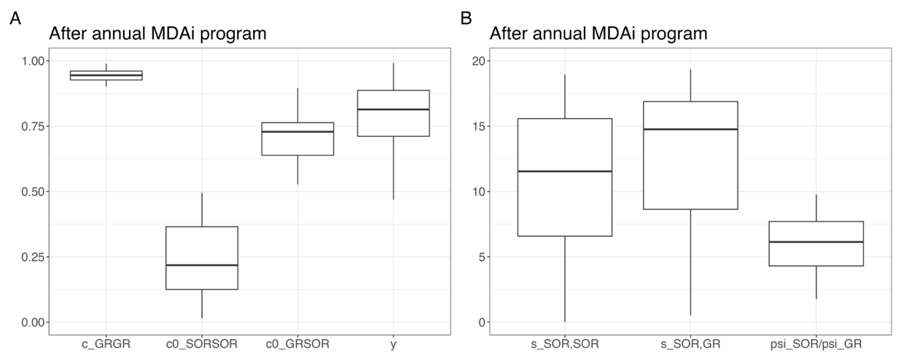
Figure S3. Distributions of accepted parameter values from the variable-response model calibration. Boxplots summarising the final marginal distributions of accepted parameter samples for the variable response model with cumulative effect for the model parameters related to phenotype inheritance and the phenotype-specific effects of ivermectin: (A) $c_{GR,GR}$, $c_{SOR,SOR}^{0}$, $c_{GR,SOR}^{0}$ and $y$; (B) $s_{GR,GR}$, $s_{GR,GR}$ and $f$.
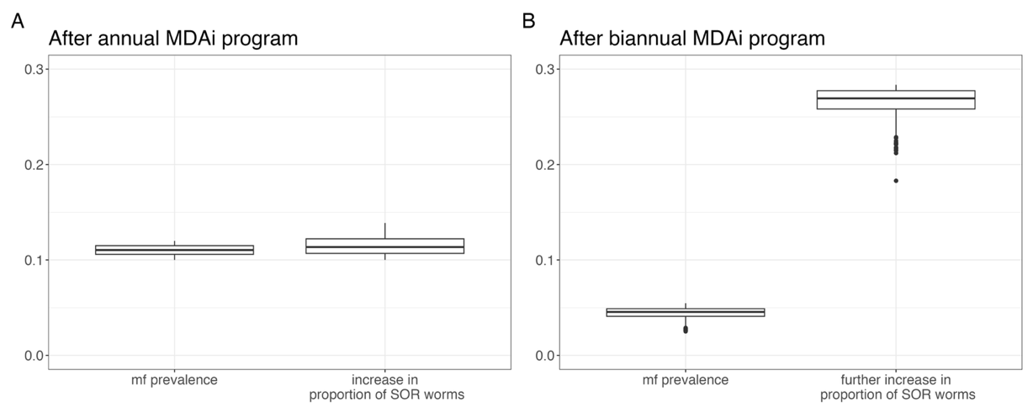
Figure S4. Distributions of summary statistics generated under the variable-response model calibration. Boxplots summarising the distributions for the final mf prevalence (presented as the proportion of the population with positive mf load) and final increase in SOR worm proportion after simulating (A) the 20-year annual MDAi program from endemic equilibrium in Asubende; and (B) the 18-year biannual MDAi program from the end of the 20-year annual MDAi program in Asubende, using the variable response model and accepted parameter samples for the model with cumulative effect.

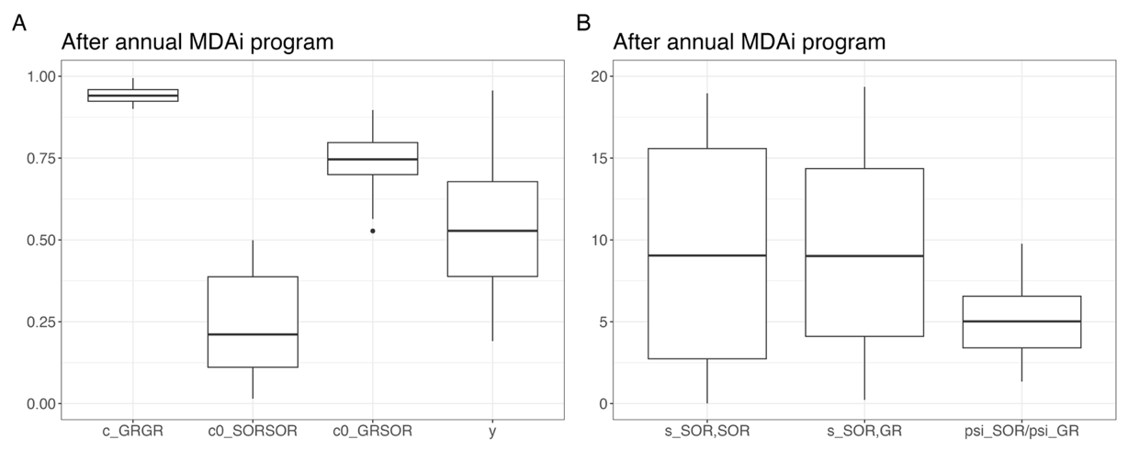
Figure S5. Distributions of accepted parameter values from the sensitivity analysis variable-response model calibration. Boxplots summarising the final marginal distributions of accepted parameter samples in the sensitivity analysis for the variable response model with cumulative effect for the model parameters related to phenotype inheritance and the phenotype-specific effects of ivermectin: (A) $c_{GR,GR}$, $c_{SOR,SOR}^{0}$, $c_{GR,SOR}^{0}$ and $y$; (B) $s_{GR,GR}$, $s_{GR,GR}$ and $f$.
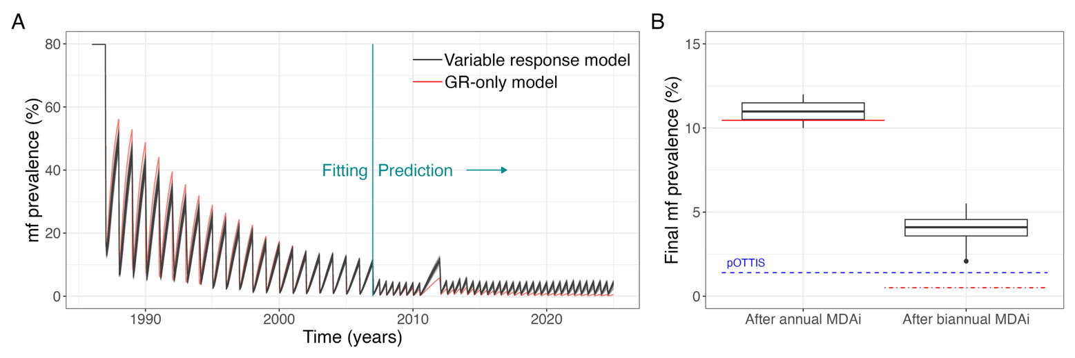
Figure S6. Predictions for mf prevalence following MDAi under the sensitivity analysis for the variable response model and the GR-only model calibrated to the Asubende data from 1987-2006. (A) Accepted trajectories of the mf prevalence (presented as the percentage of the population with positive mf load) over time measured in years following the start of the annual MDAi program that switched to biannual rounds after 20 years (except for two skipped rounds during 2011) under the calibrated variable response (black) and GR-only (red) models. (B) The boxplots summarise the distributions for the final mf prevalence under the variable response model, and the horizontal solid red lines show the predicted final mf prevalence under the GR-only model following (left) the 20-year annual MDAi program from endemic equilibrium in Asubende; and (right) the 18-year biannual MDAi program from the end of the 20-year annual MDAi program in Asubende. The horizontal dashed blue line is positioned where the mf prevalence equals pOTTIS.

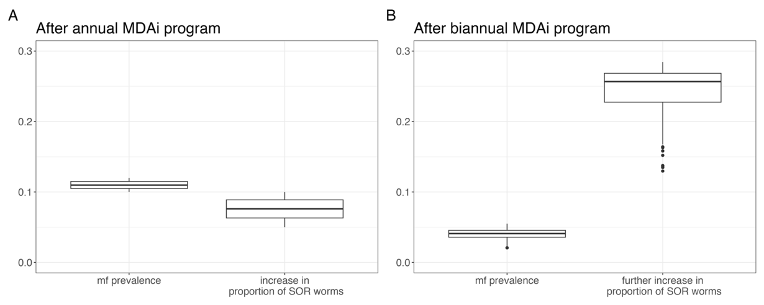
Figure S7. Distributions of summary statistics generated under the sensitivity analysis for the variable-response model calibration. Boxplots summarising the distributions for the final mf prevalence (presented as the proportion of the population with positive mf load) and final increase in SOR worm proportion after simulating (A) the 20-year annual MDAi program from endemic equilibrium in Asubende; and (B) the 18-year biannual MDAi program from the end of the 20-year annual MDAi program in Asubende, using the variable response model and accepted parameter samples in the sensitivity analysis for the model with cumulative effect.

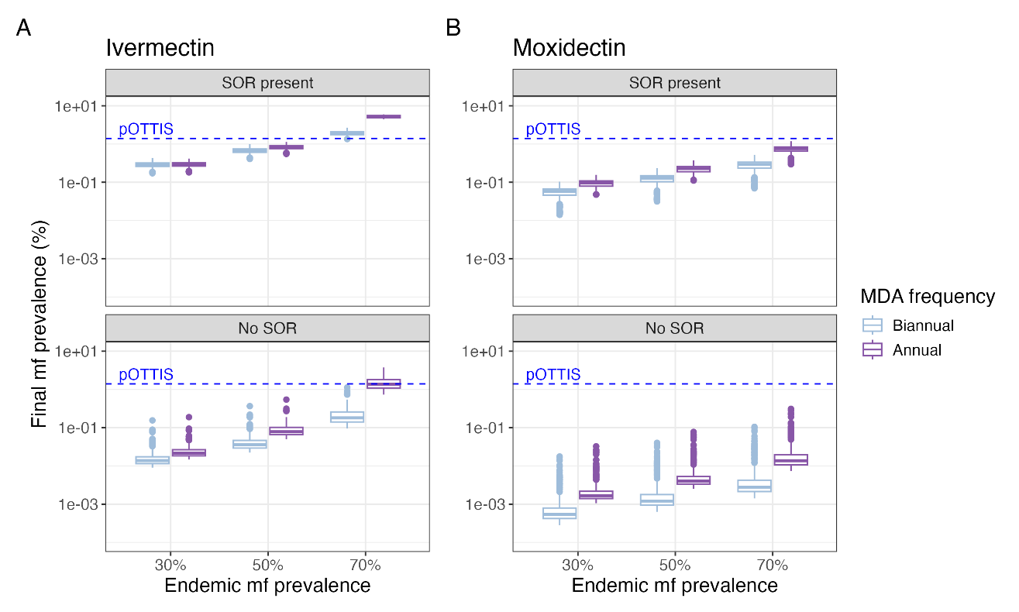
Figure S8. Predictions of mf prevalence following MDA programs in the sensitivity analysis. The boxplots summarise the distributions for the final mf prevalence following (purple) 20-year annual; and (blue) 10-year biannual (A) MDAi; and (B) MDAm, programs in communities that had 30%, 50% or 70% mf prevalence at baseline, with either (top row) SOR and GR worms present at baseline; or (bottom row) only GR present at baseline. The horizontal dashed blue line is positioned where the final mf prevalence equals pOTTIS.
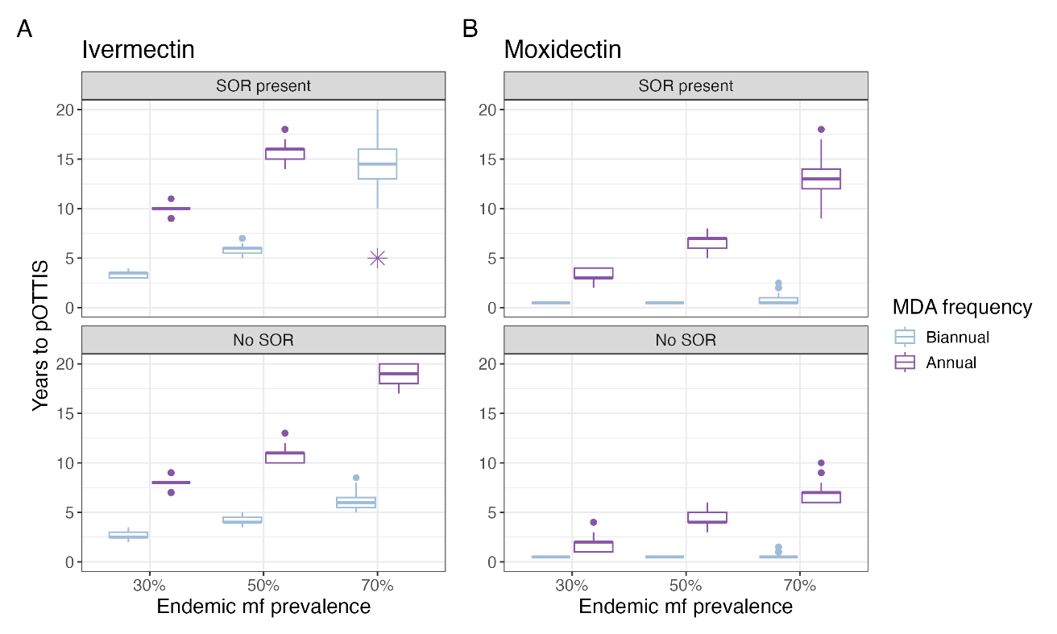
Figure S9. Predictions of time taken to reach pOTTIS by implementing MDA programs in the sensitivity analysis. The boxplots summarise the distributions for the time in years to reach pOTTIS following (purple) annual; and (blue) biannual (A) MDAi; and (B) MDAm, programs in communities that had 30%, 50% or 70% mf prevalence at baseline, with either (top row) SOR and GR worms present at baseline; or (bottom row) only GR present at baseline. Simulations were run for a maximum of 20 years, so box plots represent time to pOTTIS conditional on pOTTIS being reached within 20 years. Some simulations of MDAi scenarios with 70% mf prevalence at baseline did not reach pOTTIS withing 20 years. Specifically, pOTTIS was not reached under any accepted parameter combinations within 20 years for the annual MDAi program with 70% mf prevalence at baseline when SOR was present in the population (indicated by the *), under 49% of simulations in the corresponding scenario without SOR, and in 0.55% of simulations with biannual MDAi and with SOR present.
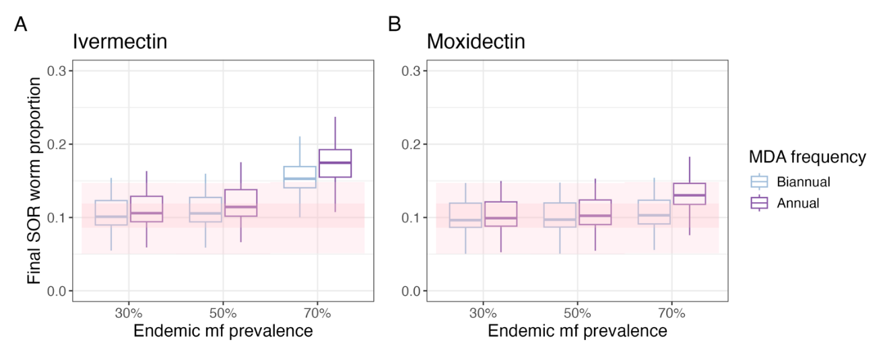
Figure S10. Predictions of final SOR worm proportion following MDA programs in the sensitivity analysis. The boxplots summarise the distributions for the final SOR worm proportion under the variable response model following (purple) 20-year annual; and (blue) 10-year biannual (A) MDAi; and (B) MDAm, programs in communities that had 30%, 50% or 70% mf prevalence at baseline. The pink bands represent the distributions of the initial SOR worm proportion prior to MDA under each scenario, with the darker bands corresponding to the interquartile ranges, and the lighter bands to all values within the distributions, excluding outliers.

Supplementary Tables

Table S1. Model parameters. Parameters are listed in the order in which they appear in the model equations (1)-(4) in the main text.
Symbol | Description | Value / functional form | Reference
$$β$$ | Biting rate on humans per vector | 31.2 bites per vector per year (assuming a human blood index of 0.3) | [3]
$$ABR$$ | Per capita annual biting rate on humans from vectors | 65000 per person per year  27000 per person per year  5350 per person per year  2942 per person per year  Chosen to achieve specific values for the total population prevalence of microfilariae prior to MDA | This work: calibrated so prevalence of mf prior to MDA is either: 80%, 70%, 50%, 30%, respectively
$$m$$ | Ratio of vectors to humans | $m=\frac{ABR}{β}$ vectors per human
$$Ω$$ | Relative exposure rate of humans to vectors in different groups | 1, as no age or sex structure in model
$$Π_{H}[x]$$ | Probability of establishment of larvae in human hosts, when the mean total number of L3 larvae in the vector population in $x$ | $$Π_{H}\left[x\right]=\frac{δ_{H_{0}}+δ_{H_{∞}}c_{H}mβx }{1+c_{H}mβx}e^{-μ_{H}p}$$ | [4]
$$δ_{H_{0}}$$ | Maximum proportion of L3 larvae developing to adult worms within the human host | 0.0854 | [3,4]
$$δ_{H_{∞}}$$ | Minimum proportion of L3 larvae developing to adult worms within the human host | 0.00299 | [3,4]
$$c_{H}$$ | Severity of transmission intensity-dependent parasite establishment within the human host | 0.00586 per L3 larvae per year | [4]
$$μ_{H}$$ | Per capita death rate of humans | 0.04 per year | [4]
$$p$$ | Pre-patent period (from infection with L3 larvae to  presence of detectable microfilariae in the skin) | 2 years | [4]
$$λ_{0}$$ | Per capita rate at which untreated fertile female worms  become non-fertile in the absence of ivermectin | 0.33 per year | [5]
$$λ_{i}(x)$$ | Excess per capita rate at which fertile female worms of phenotype $i$ become non-fertile, $x$ time units after exposure to MDA (embryostatic effect) | MDAi:  $$λ_{i}\left(x\right)=y×32.4 e^{-φ_{i}x}$$  MDAm:  $$λ_{i}\left(x\right)=y×462 e^{-φ_{i}x}$$ | [5]  [6]
$$y$$ | Proportionality constant to balance embryostatic effect on transition rates between fertile and non-fertile female worms | $$y \sim U\left(0,1\right)$$  Here, $U\left(a,b\right)$ represents a uniform distribution with lower bound $a$ and upper bound $b$. | This work: model fitting
$$φ_{i}$$ | Rate of loss of embryostatic effect for female worms of phenotype $i$ | MDAi:  $φ_{GR}=19.6$ and $φ_{SOR}=19.6 f$  MDAm:  $φ_{GR}=4.83$ and $φ_{SOR}=4.83 f$ | [5]  [6]
$$f$$ | Relative rate of loss of embryostatic effect in SOR worms compared to GR worms | $$f\sim U(0, 10)$$ | This work: model fitting
$$ω_{0}$$ | Per capita rate at which untreated, non-fertile  female worms become fertile | 0.59 per year | [5]
$$v$$ | Percentage of population that received MDA each year | Annual for 20 years:  (65.0,65.0,65.0,65.0,65.0,  65.0,65.0,65.0,65.0,65.0,  65.0,81.7,80.1,80.0,84.1,  84.1,74.7,79.4,87.1,86.2)  Biannual for subsequent 18 years:  (92.0,92.0,87.3,88.0,00.0,74.2,  50.6,79.6,81.9,78.3,83.0,  79.5,82.1,78.7,73.1,77.5,  77.1,84.3) | Coverage data from Asubende, Ghana: Neglected Tropical Disease Program, Ghana Health Servie
$$ω_{i}(x)$$ | Reduction in the per capita rate at which non-fertile worms of phenotype $i$ return to fertility, $x$ time units after exposure to MDA | $$ω_{i}\left(x\right)=y×0.59 e^{-φ_{i}x}$$ | This work: model fitting
$$σ_{W}$$ | Per capita death rate of adult worms | 0.1 per year | [3,7]
$$ε$$ | Rate of production of microfilariae per fertile female worm scaled by the total weight (in milligrams) of  microfilariae-bearing skin | 1.1538 per year | [3]
$$ϕ(x)$$ | Mating probability, when the total mean number of worms per host is $x$ | $$1-{\left(1+\frac{x}{k_{W}}\right)}^{-1-k_{w}}$$ | [8]
$$k_{W}$$ | Inverse measure of degree of overdispersion | 0.35 | [9]
$$C_{i}[x]$$ | Offspring phenotype matrices when the mean proportion of SOR worms in hosts is $x$ | $C_{SOR}[x]=1-C_{GR}[x]$,  In populations with no history of MDA:  $C_{GR}[x]=\left(\begin{matrix}c_{GR,GR} & c_{GR,SOR}^{0} \\ c_{GR,SOR}^{0} & c_{SOR,SOR}^{0}\end{matrix}\right)$,  $$c_{GR,GR} \sim U\left(0.9, 1\right)$$  $$c_{SOR,GR}^{0} \sim U\left(0.01, 1\right)$$  $$c_{SOR,SOR}^{0} \sim U\left(0.01, 1\right)$$  In populations with MDA:  $C_{GR}\left[x\right]=\left(\begin{matrix}c_{GR,GR} & c_{GR,SOR}\left[x\right] \\ c_{GR,SOR}\left[x\right] & c_{SOR,SOR}\left[x\right]\end{matrix}\right)$, where  $$c_{SOR,SOR}\left[x\right]=\left\{\begin{aligned}0.5, x≤x_{0}-\frac{0.5-c_{SOR,SOR}^{0}}{s_{SOR,SOR}}, \\ 0.05, x≥x_{0}+\frac{c_{SOR,SOR}^{0}-0.05}{s_{SOR,SOR}}, \\ s_{SOR,SOR}\left(x_{0}-x\right)+c_{SOR,SOR}^{0}, \text{otherwise}\end{aligned}\right.$$  $$c_{GR,SOR}\left[x\right]=\left\{\begin{aligned}1, x≤x_{0}-\frac{1-c_{SOR,GR}^{0}}{s_{SOR,GR}}, \\ \\ 0.5, x≥x_{0}+\frac{c_{SOR,GR}^{0}-0.5}{s_{SOR,GR}}, \\ s_{SOR,GR}\left(x_{0}-x\right)+c_{SOR,GR}^{0}, \text{otherwise,}\end{aligned}\right.$$  and $x_{0}=W_{SOR}(0)/W(0)$ is the mean proportion of SOR worms in hosts prior to an MDA program (at endemic equilibrium). With these formulations, $c_{SOR,SOR}\left[x_{0}\right]=c_{SOR,SOR}^{0}$ and $c_{GR,SOR}\left[x_{0}\right]=c_{GR,SOR}^{0}$ | This work: model fitting
$$s_{SOR,i}$$ | Selection coefficients quantifying the strength of selection for SOR during MDA programs | $$s_{SOR,GR}\sim U\left(0, 20\right)$$  $$s_{SOR,SOR}\sim U\left(0, 20\right)$$ | This work: model fitting
$$ψ_{i}(t)$$ | Mean cumulative effect of ivermectin on fertile worms of phenotype $i$, at time $t$ time units after the initiation of the MDAi program | $$ψ_{SOR}\left(t\right)≔1$$  $$ψ_{GR}\left(t\right):=\frac{W_{GR}^{0}\left(t\right)}{{\overline{W}}_{GR}\left(t\right)}+\frac{1}{{\overline{W}}_{GR}\left(t\right)}\sum_{k=1}^{K}{W_{GR}^{k}\left(t\right){\left(1-ζ\right)}^{k-1},}$$  where $W_{GR}^{k}$ are the solutions of the following system of differential equations tracking the total mean number of GR worms per host that have been exposed to $k$ rounds of MDAi (where $k= \{0,1,2,...,K\}$ and $K$is the current maximum number of MDAi  rounds),  $$\frac{dW_{GR}^{k}\left(t\right)}{dt}=\frac{δ_{k,0}}{2}mβΩΠ_{H}\left[L\left(t-p\right)\right] L_{GR}\left(t-p\right)-σ_{W}W_{GR}^{k}\left(t\right).$$  Here, $δ_{k,0}$ is the Kronecker delta function (it takes the value of 1 if $k= 0$, otherwise it is 0) and ${\overline{W}}_{GR}\left(t\right)=\sum_{k=0}^{K}{W_{GR}^{k}\left(t\right).}$ | [8]
$$σ_{M_{0}}$$ | Per capita death rate of microfilariae in the absence of ivermectin | 0.8 per year | [3]
$$σ_{M_{1}}(x)$$ | Excess per capita death rate of microfilariae $x$ time units following ivermectin treatment (microfilaricidal  effect) | MDAi:  $σ_{M_{1}}\left(x\right)=\frac{1}{{\left(x+0.0096\right)}^{1.25}}$ per year  MDAm:  $σ_{M_{1}}\left(x\right)=\frac{1}{{\left(x+0.04\right)}^{1.82}}$ per year | [5]  [6]
$$Π_{V}[x]$$ | Proportion of microfilariae developing into to the infective stage within the vector per bite when mean number of microfilariae per host is $x$ | $$Π_{V}\left[x\right]=\frac{δ_{V_{0} } }{1+c_{V}x}$$ | [3]
$$δ_{V_{0} }$$ | Maximum proportion of microfilariae developing into to the infective stage within the vector per bite | 0.0207 | [3,4]
$$c_{V}$$ | Severity of density-dependent limitation of larval development within (savannah) vectors | 0.0148 | [3]
$$α_{H}$$ | Proportion of infective, L3 larvae shed per bite | 0.5 | [4]
$$g$$ | Average duration between consecutive blood meals | 0.0096 years | [3]
$$σ_{L}$$ | Per capita death rate of L3 larvae within the vector | - per year | [3,10]
$$μ_{V}$$ | Per capita death rate of uninfected blackflies | 52 per year | [3,10]
$$α_{V}$$ | Parasite-induced death rate of infected blackflies | 0.6 per year | [4]
$$π[x]$$ | Prevalence of mf, as a function of the mean mf load $x$ | $$π\left[x\right]=1-{\left[1+\frac{x}{k_{M}[x]}\right]}^{-k_{M}[x]}$$ | [11]
$$k_{M}[x]$$ | Inverse measure of the degree of overdispersion in the distribution of skin microfilariae among hosts, as a function of the mean mf load $x$ | $$k_{M}\left[x\right]=\frac{k_{0}x}{1+k_{1}x}$$ | [11]
$$k_{0}, k_{1}$$ | Parameters describing the relationship between  $k_{M}\left[x\right]$ and skin mf load $x$ | $k_{0}=0.013.$  $k_{1}=0.025.$ | [11]

Table S2. Statistics of the marginal posterior distributions for the unknown model parameters and the corresponding simulation summary statistics following model calibration to Asubende annual MDAi data. Here, mf prevalence corresponds to the proportion of the human population with at least one microfilaria.
 | Sample quantiles
Parameter | 0.025 | 0.25 | 0.5 | 0.75 | 0.975
$c_{GR,GR}$ | 0.905 | 0.927 | 0.945 | 0.961 | 0.983
$$c_{SOR,SOR}^{0}$$ | 0.017 | 0.125 | 0.218 | 0.365 | 0.495
$$c_{SOR,GR}^{0}$$ | 0.578 | 0.639 | 0.729 | 0.764 | 0.881
$$s_{SOR,SOR}$$ | 0.011 | 6.582 | 11.546 | 15.585 | 18.956
$$s_{SOR,GR}$$ | 1.189 | 8.636 | 14.763 | 16.884 | 19.358
$$f$$ | 2.508 | 4.300 | 6.138 | 7.706 | 8.809
$$y$$ | 0.578 | 0.711 | 0.814 | 0.887 | 0.992
Simulation summary statistic
SOR worm proportion before MDAi | 0.075 | 0.093 | 0.107 | 0.126 | 0.146
Final mf prevalence after annual MDAi | 0.101 | 0.106 | 0.110 | 0.115 | 0.120
Final increase in SOR worm proportion after annual MDAi | 0.101 | 0.107 | 0.114 | 0.122 | 0.135
Final SOR worm proportion after annual MDAi | 0.183 | 0.206 | 0.223 | 0.242 | 0.269
Final mf prevalence after biannual MDAi | 0.028 | 0.041 | 0.046 | 0.049 | 0.053
Further increase in SOR worm proportion after biannual MDAi | 0.222 | 0.258 | 0.269 | 0.277 | 0.282
Final SOR worm proportion after biannual MDAi | 0.452 | 0.476 | 0.489 | 0.503 | 0.522

Table S3. Summary statistics of the distributions of the final mf prevalence post MDAi program in the variable-response model with SOR present for different frequencies of MDAi rounds and levels of endemic mf prevalence at baseline prior to MDAi. Here, mf prevalence corresponds to the percentage of the human population with at least one microfilaria.
Scenario |  | Sample quantiles for final mf prevalence
Frequency of MDAi rounds | Baseline endemic mf prevalence | 0.025 | 0.25 | 0.5 | 0.75 | 0.975
Annual | 30% | 0.241 | 0.278 | 0.303 | 0.331 | 0.366
Annual | 50% | 0.697 | 0.785 | 0.853 | 0.920 | 1.018
Annual | 70% | 4.599 | 4.930 | 5.223 | 5.558 | 5.874
Biannual | 30% | 0.239 | 0.271 | 0.295 | 0.323 | 0.359
Biannual | 50% | 0.556 | 0.626 | 0.682 | 0.745 | 0.829
Biannual | 70% | 1.603 | 1.769 | 1.895 | 2.070 | 2.276

Table S4. Summary statistics of the distributions of the final mf prevalence post MDAi program in the GR-only model without SOR present for different frequencies of MDAi rounds and levels of endemic mf prevalence at baseline prior to MDAi. Here, mf prevalence corresponds to the percentage of the human population with at least one microfilaria.
Scenario |  | Sample quantiles for final mf prevalence
Frequency of MDAi rounds | Baseline endemic mf prevalence | 0.025 | 0.25 | 0.5 | 0.75 | 0.975
Annual | 30% | 0.014 | 0.016 | 0.017 | 0.020 | 0.057
Annual | 50% | 0.048 | 0.054 | 0.061 | 0.071 | 0.174
Annual | 70% | 0.706 | 0.821 | 0.960 | 1.120 | 1.819
Biannual | 30% | 0.009 | 0.010 | 0.011 | 0.013 | 0.050
Biannual | 50% | 0.022 | 0.024 | 0.027 | 0.032 | 0.119
Biannual | 70% | 0.092 | 0.107 | 0.127 | 0.156 | 0.437
Table S5. Summary statistics of the distributions of the final mf prevalence post MDAm program in the variable-response model with SOR present for different frequencies of MDAm rounds and levels of endemic mf prevalence at baseline prior to MDAm. Here, mf prevalence corresponds to the percentage of the human population with at least one microfilaria.
Scenario |  | Sample quantiles for final mf prevalence
Frequency of MDAm rounds | Baseline endemic mf prevalence | 0.025 | 0.25 | 0.5 | 0.75 | 0.975
Annual | 30% | 0.080 | 0.096 | 0.105 | 0.117 | 0.130
Annual | 50% | 0.195 | 0.232 | 0.252 | 0.282 | 0.312
Annual | 70% | 0.622 | 0.796 | 0.875 | 0.946 | 1.050
Biannual | 30% | 0.033 | 0.056 | 0.064 | 0.070 | 0.082
Biannual | 50% | 0.074 | 0.125 | 0.142 | 0.157 | 0.184
Biannual | 70% | 0.165 | 0.285 | 0.324 | 0.354 | 0.413

Table S6. Summary statistics of the distributions of the final mf prevalence post MDAm program in the GR-only model without SOR present for different frequencies of MDAm rounds and levels of endemic mf prevalence at baseline prior to MDAm. Here, mf prevalence corresponds to the percentage of the human population with at least one microfilaria.
Scenario |  | Sample quantiles for final mf prevalence
Frequency of MDAm rounds | Baseline endemic mf prevalence | 0.025 | 0.25 | 0.5 | 0.75 | 0.975
Annual | 30% | 0.001 | 0.001 | 0.001 | 0.002 | 0.016
Annual | 50% | 0.002 | 0.003 | 0.003 | 0.005 | 0.039
Annual | 70% | 0.007 | 0.008 | 0.010 | 0.016 | 0.158
Biannual | 30% | 0.000 | 0.000 | 0.000 | 0.001 | 0.010
Biannual | 50% | 0.001 | 0.001 | 0.001 | 0.002 | 0.022
Biannual | 70% | 0.001 | 0.002 | 0.002 | 0.005 | 0.057

Table S7. Summary statistics of the distributions of the time to pOTTIS (conditional on pOTTIS being reached within 20 years) for MDAi program in the variable-response model with SOR present for different frequencies of MDAi rounds and levels of endemic mf prevalence at baseline prior to MDAi.
Scenario |  | Sample quantiles for time to pOTTIS
Frequency of MDAi rounds | Baseline endemic mf prevalence | 0.025 | 0.25 | 0.5 | 0.75 | 0.975
Annual | 30% | 9 | 9 | 9 | 10 | 10
Annual | 50% | 14 | 15 | 16 | 16 | 17
Annual | 70% | NA | NA | NA | NA | NA
Biannual | 30% | 2.5 | 3 | 3 | 3 | 3.5
Biannual | 50% | 5 | 5.5 | 5.5 | 6 | 6.5
Biannual | 70% | 12 | 13.5 | 15 | 17 | 18.5

Table S8. Summary statistics of the distributions of the time to pOTTIS (conditional on pOTTIS being reached within 20 years) for MDAi program in the GR-only model without SOR present for different frequencies of MDAi rounds and levels of endemic mf prevalence at baseline prior to MDAi.
Scenario |  | Sample quantiles for time to pOTTIS
Frequency of MDAi rounds | Baseline endemic mf prevalence | 0.025 | 0.25 | 0.5 | 0.75 | 0.975
Annual | 30% | 7 | 7 | 7 | 8 | 8
Annual | 50% | 10 | 10 | 10 | 10 | 11
Annual | 70% | 17 | 17 | 18 | 18 | 20
Biannual | 30% | 2 | 2 | 2 | 2.5 | 2.5
Biannual | 50% | 3.5 | 3.5 | 3.5 | 4 | 4
Biannual | 70% | 5 | 5 | 5.5 | 5.5 | 6

Table S9. Summary statistics of the distributions of the time to pOTTIS (conditional on pOTTIS being reached within 20 years) for MDAm program in the variable-response model with SOR present for different frequencies of MDAm rounds and levels of endemic mf prevalence at baseline prior to MDAm.
Scenario |  | Sample quantiles for time to pOTTIS
Frequency of MDAm rounds | Baseline endemic mf prevalence | 0.025 | 0.25 | 0.5 | 0.75 | 0.975
Annual | 30% | 2 | 2 | 3 | 3 | 3
Annual | 50% | 6 | 6 | 6 | 7 | 7
Annual | 70% | 11 | 13 | 14 | 15 | 16
Biannual | 30% | 0.5 | 0.5 | 0.5 | 0.5 | 0.5
Biannual | 50% | 0.5 | 0.5 | 0.5 | 0.5 | 0.5
Biannual | 70% | 0.5 | 0.5 | 0.5 | 0.5 | 0.5

Table S10. Summary statistics of the distributions of the time to pOTTIS (conditional on pOTTIS being reached within 20 years) for MDAm program in the GR-only model without SOR present for different frequencies of MDAm rounds and levels of endemic mf prevalence at baseline prior to MDAm.
Scenario |  | Sample quantiles for time to pOTTIS
Frequency of MDAm rounds | Baseline endemic mf prevalence | 0.025 | 0.25 | 0.5 | 0.75 | 0.975
Annual | 30% | 1 | 1 | 1 | 1 | 1
Annual | 50% | 3 | 4 | 4 | 4 | 4
Annual | 70% | 6 | 6 | 6 | 6 | 7
Biannual | 30% | 0.5 | 0.5 | 0.5 | 0.5 | 0.5
Biannual | 50% | 0.5 | 0.5 | 0.5 | 0.5 | 0.5
Biannual | 70% | 0.5 | 0.5 | 0.5 | 0.5 | 0.5

Table S11. Summary statistics of the distributions of the final SOR worm proportion post MDAi program in the variable-response model with SOR present for different frequencies of MDAi rounds and levels of endemic mf prevalence at baseline prior to MDAi.
Scenario |  | Sample quantiles for final SOR worm proportion
Frequency of MDAi rounds | Baseline endemic mf prevalence | 0.025 | 0.25 | 0.5 | 0.75 | 0.975
Annual | 30% | 0.089 | 0.106 | 0.117 | 0.135 | 0.161
Annual | 50% | 0.101 | 0.118 | 0.129 | 0.149 | 0.176
Annual | 70% | 0.175 | 0.197 | 0.212 | 0.230 | 0.257
Biannual | 30% | 0.081 | 0.099 | 0.112 | 0.130 | 0.151
Biannual | 50% | 0.088 | 0.105 | 0.116 | 0.134 | 0.157
Biannual | 70% | 0.148 | 0.164 | 0.178 | 0.192 | 0.214

Table S12. Summary statistics of the distributions of the final SOR worm proportion post MDAm program in the variable-response model with SOR present for different frequencies of MDAm rounds and levels of endemic mf prevalence at baseline prior to MDAm.
Scenario |  | Sample quantiles for final SOR worm proportion
Frequency of MDAm rounds | Baseline endemic mf prevalence | 0.025 | 0.25 | 0.5 | 0.75 | 0.975
Annual | 30% | 0.079 | 0.097 | 0.111 | 0.129 | 0.149
Annual | 50% | 0.083 | 0.101 | 0.114 | 0.131 | 0.152
Annual | 70% | 0.125 | 0.142 | 0.153 | 0.169 | 0.191
Biannual | 30% | 0.076 | 0.094 | 0.108 | 0.126 | 0.146
Biannual | 50% | 0.077 | 0.095 | 0.109 | 0.127 | 0.147
Biannual | 70% | 0.086 | 0.102 | 0.114 | 0.131 | 0.151

Table S13. Statistics of the marginal posterior distributions for the unknown model parameters and the corresponding simulation summary statistics following sensitivity analysis model calibration to Asubende annual MDAi data. Here, mf prevalence corresponds to the proportion of the human population with at least one microfilaria.
 | Sample quantiles
Parameter | 0.025 | 0.25 | 0.5 | 0.75 | 0.975
$c_{GR,GR}$ | 0.902 | 0.924 | 0.941 | 0.959 | 0.984
$$c_{SOR,SOR}^{0}$$ | 0.031 | 0.111 | 0.211 | 0.387 | 0.485
$$c_{SOR,GR}^{0}$$ | 0.598 | 0.700 | 0.746 | 0.797 | 0.896
$$s_{SOR,SOR}$$ | 0.011 | 2.737 | 9.047 | 15.585 | 18.463
$$s_{SOR,GR}$$ | 0.522 | 4.108 | 9.016 | 14.357 | 19.358
$$f$$ | 1.341 | 3.406 | 5.021 | 6.563 | 9.766
$$y$$ | 0.232 | 0.388 | 0.528 | 0.678 | 0.957
Simulation summary statistic
SOR worm proportion before MDAi | 0.059 | 0.086 | 0.095 | 0.119 | 0.141
Final mf prevalence after annual MDAi | 0.100 | 0.105 | 0.110 | 0.115 | 0.120
Final increase in SOR worm proportion after annual MDAi | 0.051 | 0.063 | 0.076 | 0.089 | 0.099
Final SOR worm proportion after annual MDAi | 0.114 | 0.156 | 0.179 | 0.197 | 0.229
Final mf prevalence after biannual MDAi | 0.023 | 0.036 | 0.041 | 0.046 | 0.051
Further increase in SOR worm proportion after biannual MDAi | 0.171 | 0.228 | 0.257 | 0.268 | 0.281
Final SOR worm proportion after biannual MDAi | 0.349 | 0.399 | 0.426 | 0.450 | 0.486

Table S14. Summary statistics of the distributions of the final mf prevalence post MDAi program in the sensitivity analysis for the variable-response model with SOR present for different frequencies of MDAi rounds and levels of endemic mf prevalence at baseline prior to MDAi. Here, mf prevalence corresponds to the percentage of the human population with at least one microfilaria.
Scenario |  | Sample quantiles for final mf prevalence
Frequency of MDAi rounds | Baseline endemic mf prevalence | 0.025 | 0.25 | 0.5 | 0.75 | 0.975
Annual | 30% | 0.207 | 0.265 | 0.294 | 0.322 | 0.378
Annual | 50% | 0.623 | 0.763 | 0.832 | 0.904 | 1.048
Annual | 70% | 4.562 | 4.901 | 5.216 | 5.555 | 5.877
Biannual | 30% | 0.202 | 0.260 | 0.288 | 0.319 | 0.384
Biannual | 50% | 0.479 | 0.606 | 0.670 | 0.740 | 0.885
Biannual | 70% | 1.492 | 1.761 | 1.927 | 2.093 | 2.438

Table S15. Summary statistics of the distributions of the final mf prevalence post MDAi program in the sensitivity analysis of the GR-only model without SOR present for different frequencies of MDAi rounds and levels of endemic mf prevalence at baseline prior to MDAi. Here, mf prevalence corresponds to the percentage of the human population with at least one microfilaria.
Scenario |  | Sample quantiles for final mf prevalence
Frequency of MDAi rounds | Baseline endemic mf prevalence | 0.025 | 0.25 | 0.5 | 0.75 | 0.975
Annual | 30% | 0.015 | 0.018 | 0.022 | 0.027 | 0.050
Annual | 50% | 0.050 | 0.066 | 0.078 | 0.102 | 0.166
Annual | 70% | 0.735 | 1.087 | 1.370 | 1.814 | 2.601
Biannual | 30% | 0.009 | 0.011 | 0.014 | 0.017 | 0.040
Biannual | 50% | 0.022 | 0.029 | 0.036 | 0.046 | 0.103
Biannual | 70% | 0.096 | 0.141 | 0.181 | 0.258 | 0.459

Table S16. Summary statistics of the distributions of the final mf prevalence post MDAm program in the sensitivity analysis for the variable-response model with SOR present for different frequencies of MDAm rounds and levels of endemic mf prevalence at baseline prior to MDAm. Here, mf prevalence corresponds to the percentage of the human population with at least one microfilaria.
Scenario |  | Sample quantiles for final mf prevalence
Frequency of MDAm rounds | Baseline endemic mf prevalence | 0.025 | 0.25 | 0.5 | 0.75 | 0.975
Annual | 30% | 0.053 | 0.079 | 0.095 | 0.109 | 0.139
Annual | 50% | 0.123 | 0.189 | 0.228 | 0.260 | 0.333
Annual | 70% | 0.329 | 0.648 | 0.756 | 0.842 | 1.047
Biannual | 30% | 0.016 | 0.046 | 0.058 | 0.066 | 0.091
Biannual | 50% | 0.035 | 0.103 | 0.129 | 0.148 | 0.205
Biannual | 70% | 0.078 | 0.234 | 0.292 | 0.336 | 0.465

Table S17. Summary statistics of the distributions of the final mf prevalence post MDAm program in the sensitivity analysis for the GR-only model without SOR present for different frequencies of MDAm rounds and levels of endemic mf prevalence at baseline prior to MDAm. Here, mf prevalence corresponds to the percentage of the human population with at least one microfilaria.
Scenario |  | Sample quantiles for final mf prevalence
Frequency of MDAm rounds | Baseline endemic mf prevalence | 0.025 | 0.25 | 0.5 | 0.75 | 0.975
Annual | 30% | 0.001 | 0.001 | 0.002 | 0.002 | 0.009
Annual | 50% | 0.003 | 0.003 | 0.004 | 0.005 | 0.023
Annual | 70% | 0.008 | 0.011 | 0.014 | 0.020 | 0.095
Biannual | 30% | 0.000 | 0.000 | 0.001 | 0.001 | 0.005
Biannual | 50% | 0.001 | 0.001 | 0.001 | 0.002 | 0.012
Biannual | 70% | 0.002 | 0.002 | 0.003 | 0.004 | 0.034

Table S18. Summary statistics of the distributions of the time to pOTTIS (conditional on pOTTIS being reached within 20 years) for MDAi program in the sensitivity analysis of the variable-response model with SOR present for different frequencies of MDAi rounds and levels of endemic mf prevalence at baseline prior to MDAi.
Scenario |  | Sample quantiles for final SOR worm proportion
Frequency of MDAi rounds | Baseline endemic mf prevalence | 0.025 | 0.25 | 0.5 | 0.75 | 0.975
Annual | 30% | 9 | 10 | 10 | 10 | 10
Annual | 50% | 14 | 15 | 16 | 16 | 17
Annual | 70% | NA | NA | NA | NA | NA
Biannual | 30% | 3 | 3 | 3.5 | 3.5 | 4
Biannual | 50% | 5 | 5.5 | 6 | 6 | 6.5
Biannual | 70% | 11 | 13 | 14.5 | 16 | 18.5

Table S19. Summary statistics of the distributions of the time to pOTTIS (conditional on pOTTIS being reached within 20 years) for MDAi program in the sensitivity analysis of the GR-only model without SOR present for different frequencies of MDAi rounds and levels of endemic mf prevalence at baseline prior to MDAi.
Scenario |  | Sample quantiles for time to pOTTIS
Frequency of MDAi rounds | Baseline endemic mf prevalence | 0.025 | 0.25 | 0.5 | 0.75 | 0.975
Annual | 30% | 7 | 8 | 8 | 8 | 9
Annual | 50% | 10 | 10 | 11 | 11 | 12
Annual | 70% | 17 | 18 | 19 | 20 | 20
Biannual | 30% | 2 | 2.5 | 2.5 | 3 | 3.5
Biannual | 50% | 3.5 | 4 | 4 | 4.5 | 5
Biannual | 70% | 5 | 5.5 | 6 | 6.5 | 7

Table S20. Summary statistics of the distributions of the time to pOTTIS (conditional on pOTTIS being reached within 20 years) for MDAm program in the sensitivity analysis of the variable-response model with SOR present for different frequencies of MDAm rounds and levels of endemic mf prevalence at baseline prior to MDAm.
Scenario |  | Sample quantiles for time to pOTTIS
Frequency of MDAi rounds | Baseline endemic mf prevalence | 0.025 | 0.25 | 0.5 | 0.75 | 0.975
Annual | 30% | 2 | 3 | 3 | 4 | 4
Annual | 50% | 5 | 6 | 7 | 7 | 8
Annual | 70% | 9 | 12 | 13 | 14 | 17
Biannual | 30% | 0.5 | 0.5 | 0.5 | 0.5 | 0.5
Biannual | 50% | 0.5 | 0.5 | 0.5 | 0.5 | 0.5
Biannual | 70% | 0.5 | 0.5 | 0.5 | 1 | 2

Table S21. Summary statistics of the distributions of the time to pOTTIS (conditional on pOTTIS being reached within 20 years) for MDAm program in the sensitivity analysis of the GR-only model without SOR present for different frequencies of MDAm rounds and levels of endemic mf prevalence at baseline prior to MDAm.
Scenario |  | Sample quantiles for time to pOTTIS
Frequency of MDAm rounds | Baseline endemic mf prevalence | 0.025 | 0.25 | 0.5 | 0.75 | 0.975
Annual | 30% | 1 | 1 | 2 | 2 | 3
Annual | 50% | 3 | 4 | 4 | 5 | 6
Annual | 70% | 6 | 6 | 7 | 7 | 8
Biannual | 30% | 0.5 | 0.5 | 0.5 | 0.5 | 0.5
Biannual | 50% | 0.5 | 0.5 | 0.5 | 0.5 | 0.5
Biannual | 70% | 0.5 | 0.5 | 0.5 | 0.5 | 0.5

Table S22. Summary statistics of the distributions of the final SOR worm proportion post MDAi program in the sensitivity analysis for the variable-response model with SOR present for different frequencies of MDAi rounds and levels of endemic mf prevalence at baseline prior to MDAi.
Scenario |  | Sample quantiles for final SOR worm proportion
Frequency of MDAm rounds | Baseline endemic mf prevalence | 0.025 | 0.25 | 0.5 | 0.75 | 0.975
Annual | 30% | 0.0765 | 0.094 | 0.106 | 0.129 | 0.154
Annual | 50% | 0.072 | 0.102 | 0.114 | 0.138 | 0.163
Annual | 70% | 0.115 | 0.155 | 0.175 | 0.193 | 0.222
Biannual | 30% | 0.062 | 0.090 | 0.101 | 0.123 | 0.147
Biannual | 50% | 0.065 | 0.094 | 0.106 | 0.127 | 0.152
Biannual | 70% | 0.109 | 0.140 | 0.153 | 0.169 | 0.195

Table S23. Summary statistics of the distributions of the final SOR worm proportion post MDAm program in the sensitivity analysis for the variable-response model with SOR present for different frequencies of MDAm rounds and levels of endemic mf prevalence at baseline prior to MDAm.
Scenario |  | Sample quantiles for final SOR worm proportion
Frequency of MDAm rounds | Baseline endemic mf prevalence | 0.025 | 0.25 | 0.5 | 0.75 | 0.975
Annual | 30% | 0.061 | 0.088 | 0.099 | 0.121 | 0.145
Annual | 50% | 0.063 | 0.090 | 0.102 | 0.124 | 0.147
Annual | 70% | 0.087 | 0.118 | 0.130 | 0.146 | 0.172
Biannual | 30% | 0.059 | 0.087 | 0.096 | 0.120 | 0.142
Biannual | 50% | 0.059 | 0.087 | 0.097 | 0.120 | 0.142
Biannual | 70% | 0.064 | 0.091 | 0.103 | 0.123 | 0.147

References

Vollert, S.A., et al. (2025) Beyond data: leveraging non-empirical information and expert knowledge in Bayesian model calibration. arXiv:2505.21934. doi: 10.48550/arXiv.2505.21934
- Doyle S.R., et al. (2017) Genome-wide analysis of ivermectin response by Onchocerca volvulus reveals that genetic drift and soft selective sweeps contribute to loss of drug sensitivity. PLoS Negl Trop Dis 11(7):e0005816. doi: 10.1371/journal.pntd.0005816
- Basáñez, M.-G. and M. Boussinesq. (1999) Population biology of human onchocerciasis. Philos Trans R Soc B Biol Sci 354(1384): p. 809-826. doi: 10.1098/rstb.1999.0433
- Filipe, J.A., et al. (2005) Human infection patterns and heterogeneous exposure in river blindness. Proc Natl Acad Sci U S A 102(42): p. 15265-70. doi: 10.1073/pnas.0502659102
- Basáñez M.-G., et al. (2008) Effect of single-dose ivermectin on Onchocerca volvulus: a systematic review and meta-analysis. Lancet Infect Dis 8: p. 310-322. doi: 10.1016/S1473-3099(08)70099-9
- Turner H.C., et al. (2015) The potential impact of moxidectin on onchocerciasis elimination in Africa: an economic evaluation based on the Phase II clinical trial data. Parasit Vectors 8: 167. doi:10.1186/s13071-015-0779-4
- Plaisier, A.P., et al. (1991) The reproductive lifespan of Onchocerca volvulus in West African savanna. Acta Tropica 48(4): p. 271-284. doi: 10.1016/0001-706x(91)90015-c
- Turner H.C., et al. (2013) Uncertainty surrounding projections of the long-term impact of ivermectin treatment on human onchocerciasis. PLoS Negl Trop Dis 7(4): e2169. doi: 10.1371/journal.pntd.0002169
- Bottomley C., et al. (2008) Rates of microfilarial production by Onchocerca volvulus are not cumulatively reduced by multiple ivermectin treatments. Parasitology 135: p. 1571-1581. doi: 10.1017/S0031182008000425
- Basáñez M.-G., et al. (2002) Transmission intensity and the patterns of Onchocerca volvulus infection in human communities. Am J Trop Med Hyg 67: p. 669–679. doi: 10.4269/ajtmh.2002.67.669
- Turner, H.C., et al., (2014) Modelling the impact of ivermectin on River Blindness and its burden of morbidity and mortality in African Savannah: EpiOncho projections. Parasit Vectors 7(1): 241. doi: 10.1186/1756-3305-7-241

