GMCSF modulates Myeloid derived suppressor cells and Tregs activity in decompensated cirrhotic patients with sepsis.
Supplementary Information

Rashi Sehgal^{1,3}, Rakhi Maiwall², Vijayraghavan Rajan², Mojahidul Islam¹, Sukriti Baweja¹, Navkiran kaur³, Guresh Kumar⁴, Gayatri Ramakrishna¹, Shiv K Sarin^{2*}, Nirupama Trehanpati^{1*}

Corresponding Authors:

Dr. Nirupama Trehanpati, PhD
Professor, Department of Molecular and Cellular Medicine
Institute of Liver and Biliary Sciences
D-1 Vasant Kunj, New Delhi 110070, India
trehanpati@ilbs.in, trehanpati@gmail.com
ORCID: 0000-0002-6109-0033

Dr. Shiv K Sarin, MD, DM, DSc (Hony.)
Senior Professor, Department of Hepatology
Institute of Liver and Biliary Sciences
D-1 Vasant Kunj, New Delhi 110070, India
E-mails: shivsarin@gmail.com, shivsarin@ilbs.in
Tel.: +91-11-46300000,
ORCID: 0000-0002-0544-5610

SUPPLEMENTARY METHODS:

Patient criteria
The clinical as well as biochemical assessment of all the enrolled patients with or without SIRS or sepsis was done according to the treating physician’s direction. Patients were recruited based on the following criteria:
Decompensated cirrhosis w/o sepsis was diagnosed when there was no evidence of SIRS or infection on any of the cultures and ultrasonography,
Decompensated cirrhosis with sepsis were diagnosed based on the presence of SIRS, infection, confirmed either by cultures or by imaging.
Four criteria for the diagnosis of SIRS were used [14]:
a) Temperature >38.0°C or <36.0°C
b) TLC <4 or >12 x 109/l
c) Pulse >90 beats/minutes
d) RR (Respiratory rate) >20 or <32 beats/minutes

Blood sampling:
15‐20 mL of peripheral blood was collected in an ethylene diamine tetraacetic acid (EDTA) coated tubes from patients and healthy subjects at the time of recruitment in the study. From part of the blood, plasma was separated and stored at ‐80°C for assessment of cytokines, endotoxin and other circulating analytes.
Multi-parametric whole blood Immune phenotyping
MDSC, T-cells and Tregs were characterized in whole blood using specific antibodies against surface and intracellular markers labelled with different fluorochromes. MDSCs were characterized using anti-CD14 at 1:40 dilution (Clone M5E2, FITC, BD Biosciences 555397), anti-CD11b at 1:100 dilution (Clone ICRF44, APC, Biolegend 301322), anti-CD33 at 1:40 dilution (Clone P67.6, PE-Cy7,Biolegend 366618), anti-HLADR at 1:40 dilution (Clone L243, BV510, Biolegend 307646); Naïve and memory T-cells by anti-CD4 at 1:40 dilution (Clone SK3, PE-Cy7 BD Biosciences 557852), anti-CD8 at 1:40 dilution (Clone SK1,V510,BD Biolegend 344732), anti-CCR7 at 1:20 dilution (Clone G043H7,FITC, Biolegend 353216) and anti-CD45RA at 1:20 dilution (Clone HI100, V410, Biolegend 304130); Tregs by anti-CD4 at 1:40 dilution (Clone OKT4,V410, Biolegend 317434), anti-CD25 at 1:20 dilution (Clone ,PE-Cy5, Biolegend 302608), anti-FOXP3 (Clone 259D/C7,PE, BD Biosciences 560046), anti-CD127 (Clone 259D/C7, APC, Biolegend 351316). Supplementary Table 1 showing the markers for types of T-cells, MDSCs and Tregs.
Briefly, 100-150 µl of whole blood was incubated with appropriate concentrations of surface antibodies for 30 minutes at room temperature in dark. After that, cells were fixed with 200 µl Cytofix (BD Biosciences, #554714) for 10 minutes and washed twice with 1x perm wash. Further, cells were incubated with intracellular antibodies for 30 more minutes at room temperature and washed with 1xPBS. A minimum of 100,000 events were acquired using a BD FACS VERSE and all relevant data was analysed by using FlowJo software version 10.
Analysis of plasma analytes using Cytokine Multiplex Bead Array Assay
To understand the significance of various cytokines and growth factors linked to sepsis as well as MDSC, we investigated the concentrations of forty one plasma cytokines, chemokine and growth factors such as IL‐1RA, IL-1β, IL‐2, IL‐12(p40), IL-27, IL-18, IL‐10, IL‐17A, IFN‐γ, TNF‐α, IL-4, IL-6, IL-33, TGF-β1, IL-8, MIF, MIP-1α, MIP-1β, MIP-3α, ITAC, MCP-1, FRACTALKINE, ENA78, IP-10, EOTAXIN, Angiopoientin, MCSF, G-CSF/CSF3, GM-CSF, HGF, LEPTIN, TPO, VEGF-A, MMP7, MMP8, MMP1, MMP12, MMP13, P SELECTIN, E SELECTIN and TREM1 in different patient groups by using multiplex PROCATAPLEX (THERMOFISCHER, USA), following the complete details on Luminex xponent 3.1TM Rev. 2 (Luminex Corporation, 12212 Technology Boulevard, Austin, Texas, USA). Standard curve was drawn using standards provided in the kit. Values in samples were determined corresponding to the standard curve drawn. The lower detection limit of each cytokine is listed in Supplementary Table 2.
Preparation of MDSCs, T-cells and adherent Monocytes
Part of whole blood collected from patients of different groups were used for sorting total MDSCs CD11b+CD33+ and its subsets i.e. M-MDSCs; CD14+CD11b+CD33+HLADR- and G-MDSC; CD14- CD11b+CD33+HLADR- and CD4+ T-cells. Cells were stained with anti-CD11b APC, anti-CD33 PE-Cy7, anti-HLA-DR V410, and anti-CD4 FITC antibodies and incubated for 30 minutes at RT, dark which is followed by RBC lysis. Sorting of MDSC and T-cells was done using BD FACS ARIA Fusion (BD Biosciences).
However, adherent monocytes were generated using 5x10⁶ isolated PBMCs. Cells were plated in complete RPMI 1640 media with 10% FBS for 2 hrs. After 2hrs, supernatant and non-adherent cell were removed, and adherent monocytes were removed for further experiments.
MDSC Functionality
T-cells Apoptosis
To analyze functional modulatory role of MDSCs, sorted CD4+ T-cells were cultured with or without FACS sorted MDSCs or adherent monocytes for 3 days. For assessment of apoptosis of T-cells cultures, cells were removed after 3 days and stained with ANNEXIN V for 15 minutes followed by propidium iodide (PI). The degree of apoptosis was assessed by flow cytometry using PI and Annexin V. Apoptotic cells were defined as PI-Annexin V+ cells.
T-cells proliferation
Proliferation of T-cells was assessed using a fluorescent cell staining dye i.e. CFSE (Carboxyfluorescein succinimidyl ester). 96 well plate was coated overnight with anti-CD3 (0.5 µg/ml). Sorted CD4+ T-cells were stained with 5 mM of CFSE (SIGMA ALDRICH, #21888) for 15 min dark, cells were centrifuged at 1200 rpm for 7 minutes and supernatant was discarded. CFSE labeling was stopped by the addition of RPMI 1640 medium (GIBCO) supplemented with 10% FBS (GIBCO). After several washes, CFSE-labeled T-cells along with soluble anti-CD28 (1ug/mL) were plated alone, with sorted MDSCs and adherent monocytes in anti-CD3 coated wells which later incubated for 3-5 more days. Percentage of proliferation was assessed by flow cytometry using CFSE.
Generation of Tregs under Th0 and Th17 condition
For Th0 condition, FACS sorted CD4⁺ T-cells were cultured alone or with MDSCs (1:1) for 3 days under Th0 condition [anti-CD3 (1ug/mL) and anti-CD28 (1ug/mL)]. After 3 days, Tregs (CD4+FOXP3+ cells) were determined using flow cytometry.
For Th17 condition, FACS sorted CD4⁺ T-cells were cultured under Th17 proliferating conditions i.e. recombinant TGF-β (5 ng/ml, SANTA CRUZ BIOTECHNOLOGY, INC. #sc-52893) and IL-6 (20 ng/ml, PEPROTECH #200-06) along with anti-CD3 (1 ug/mL) and anti-CD28 (1 ug/mL) for 3 days. After 3 days, these cells were incubated alone or with MDSC (1:1 ratio) for 3 more days in RPMI 1640 complete media. After that, cells were stained with anti-IL-17 PE-Cy7 and anti-FOXP3 PE using intracellular cytometric analysis and determined using flow cytometry.
Inhibition of MDSCs via Inhibitors
To unravel the mechanism of Tregs expanding effect of MDSCs, CD4⁺ T-cells were cultured with MDSCs (at 1:1 ratio) under Th0 condition for 72 hours in the presence or absence of recombinant TGF-β (10 μg/ml, SANTA CRUZ BIOTECHNOLOGY, INC. #sc-52893), L-NMMA (500 μM, SIGMA ALDRICH #M7033), an iNOS inhibitor and nor-NOHA (500 μM, SIGMA ALDRICH #399275), Arg1 inhibitor. After that, cells were stained with anti-FOXP3 PE using intracellular cytometric analysis.
Quantitative RT‐PCR Analysis
FACS sorted MDSCs and adherent monocytes were used to isolate total RNA using miRVANA kit (Thermofischer, #AM1560). cDNA was prepared using High‐Capacity cDNA Kit (ABI, Thermo Fisher Scientific, Waltham, MA; #4368813). Expression of various genes like IL-10, iNOS and Arginase 1 were checked. The primer sequences genes are listed in Supplementary Table 3. 18s RNA served as endogenous control for normalization. Relative expression was analyzed using SYBR Green (Thermofischer, # A25742) in a VIIA7 real‐time PCR machine (ABI; Whitefield, Bangalore, India).

SUPPLEMENTARY TABLES:

Supplementary Table 1: Markers for cell types: T-cells, MDSCs and Tregs.
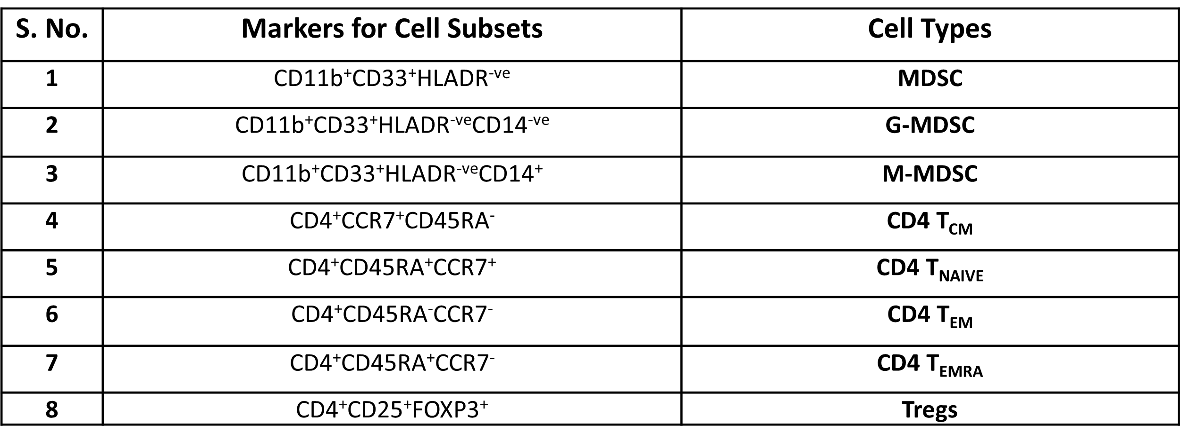

Supplementary Table 2: Lowest detection limit of cytokines, growth factors and others in cytokine bead array
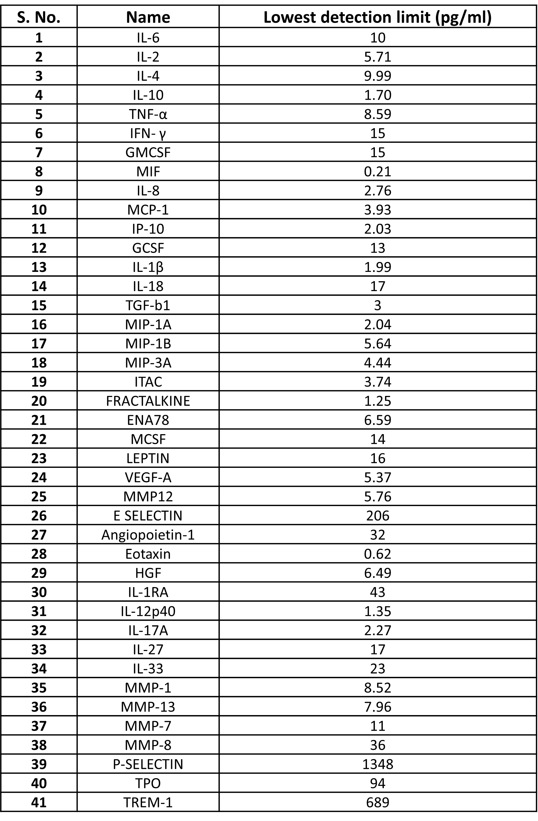
Supplementary Table 3: List of primer sequences for qRT-PCR.
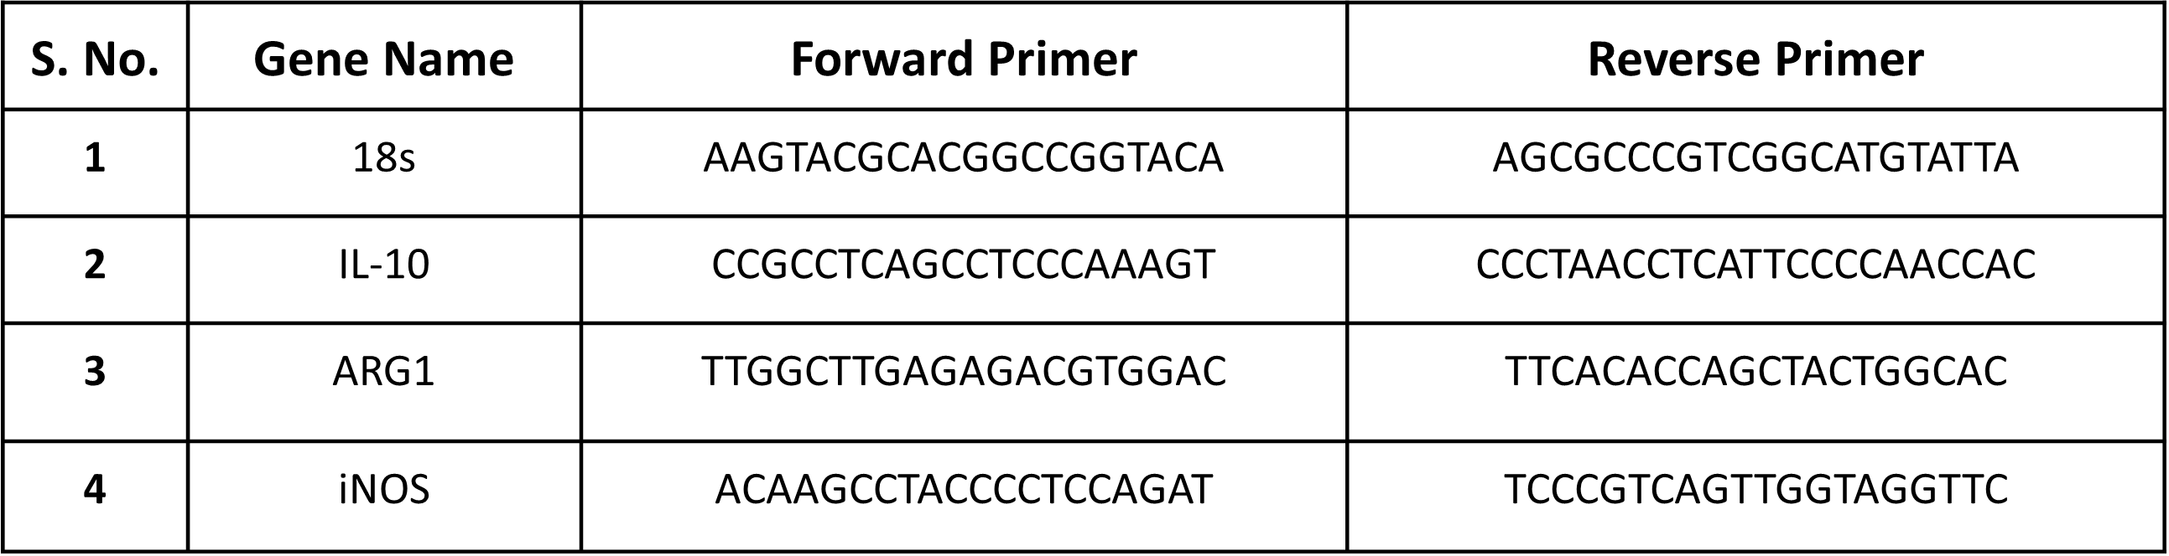

Supplementary Table 4: Patient characteristics of two Sepsis patient groups; without GM-CSF treatment and with GM-CSF treatment with Day 1 and Day 3 follow-up

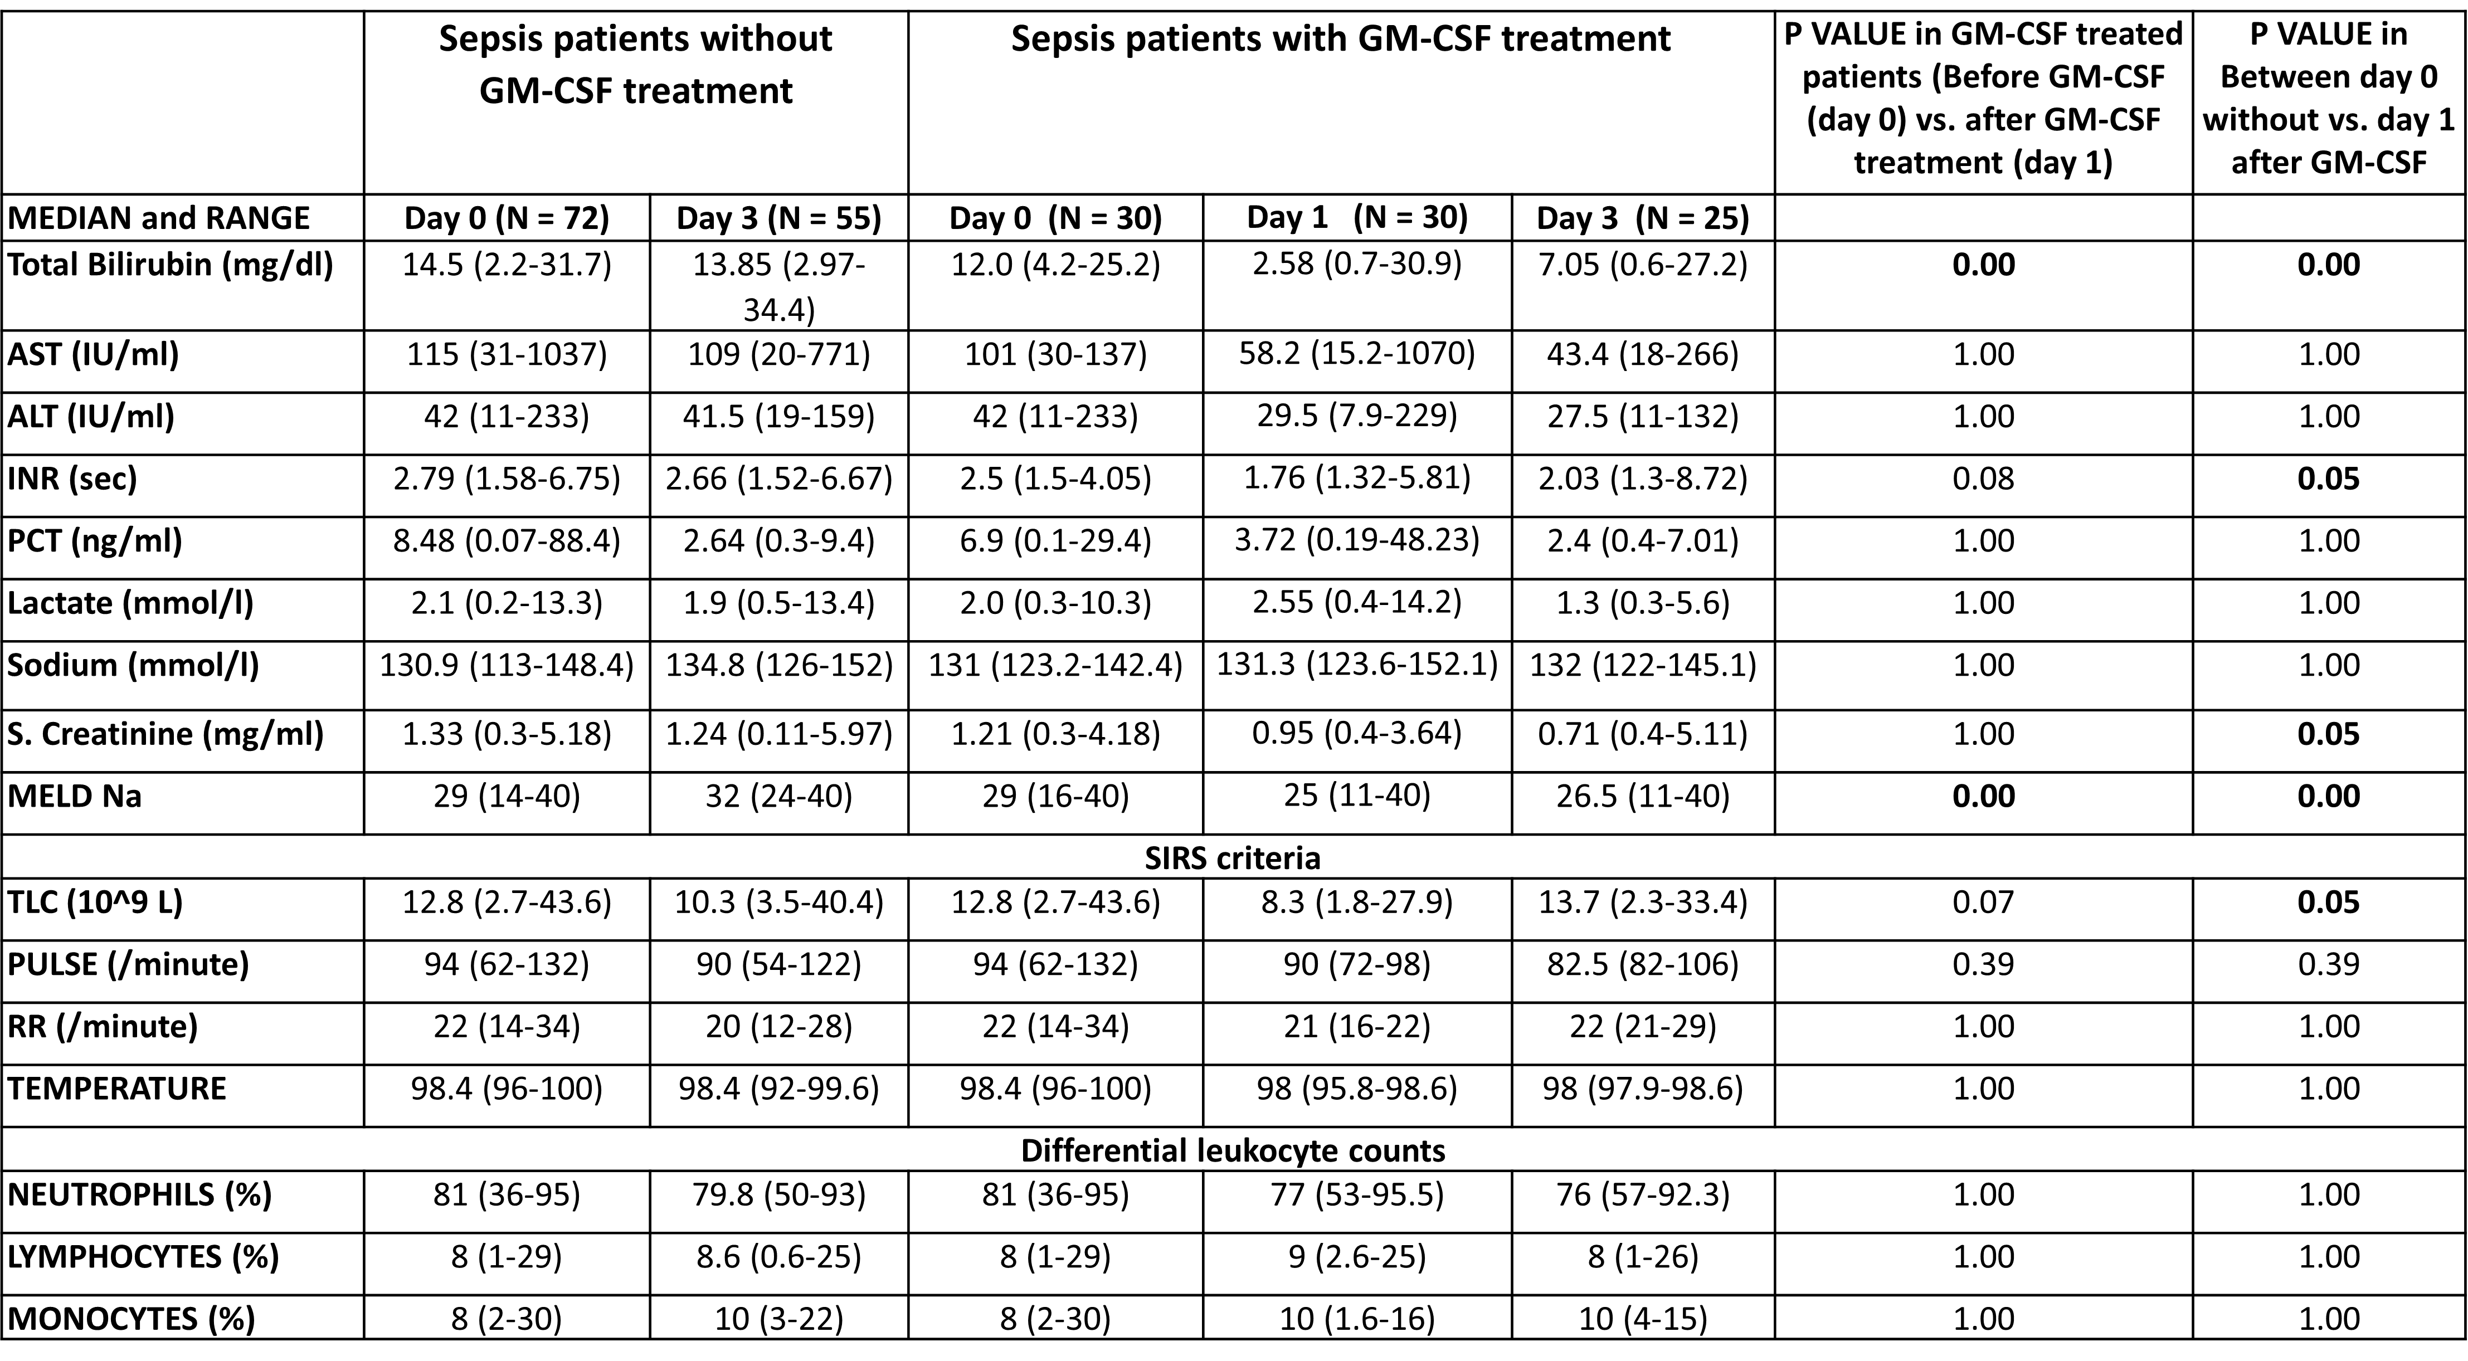

SUPPLEMENTARY FIGURES:

Supplementary Figure 1: Study cohort and study design

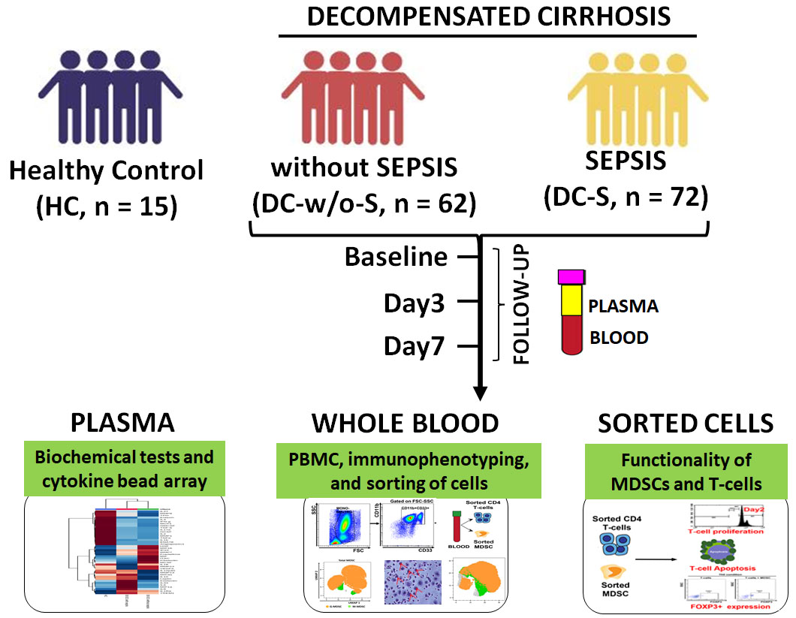

Results: Immune scan
With high dimensional flow cytometry, whole blood immune scan was analyzed for each cell type. Total lymphocyte frequencies were decreased reflecting lymphopenia while neutrophil frequencies were increased reflecting neutrophilia in sepsis patients compared to HC as it coincides with the differential leukocyte count (DLC) of cells of the study groups. No significant difference observed in lymphocytes and monocytes on follow ups, but neutrophils decreased at day7 compared to day0 in sepsis patients
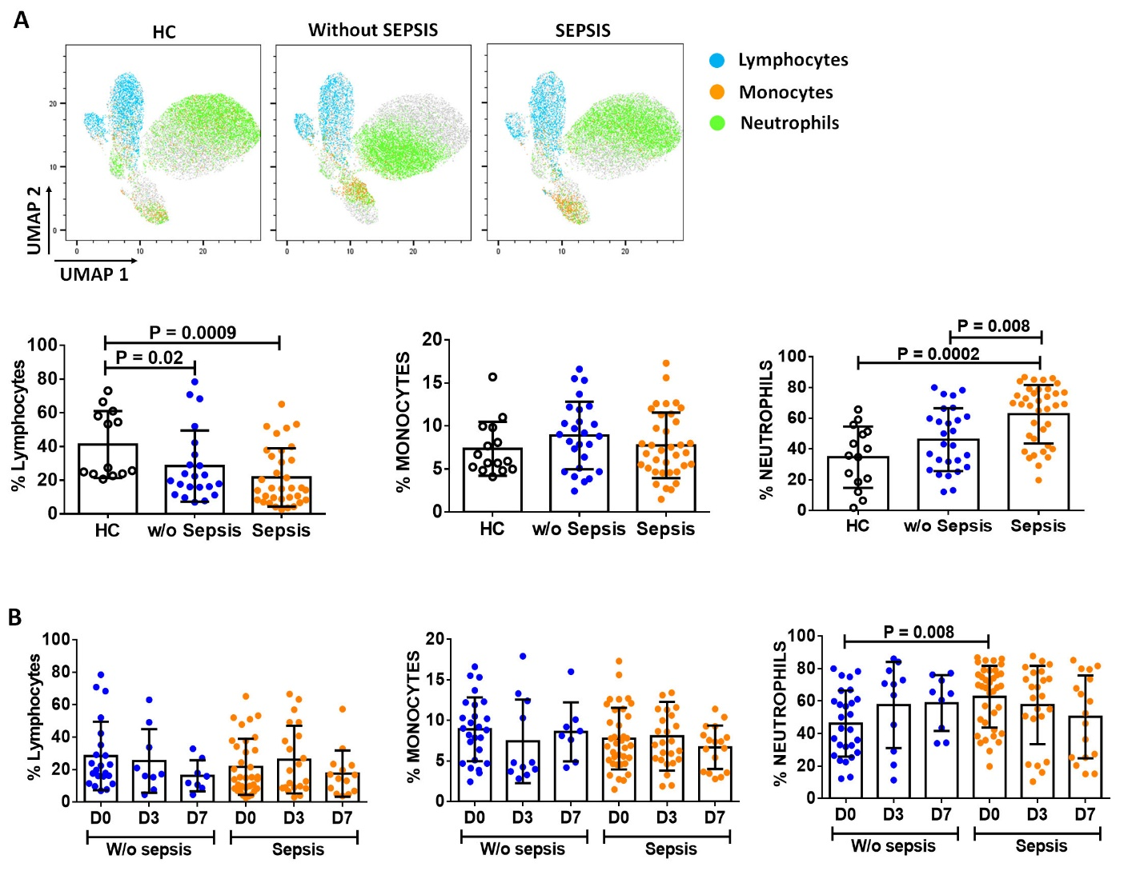
Supplementary Figure 2: Expression of lymphocytes, monocytes and neutrophils A) UMAP visualization of pooled immune cells i.e lymphocytes (light blue color), monocytes (orange color) and neutrophils (green color) and scatter dot plot shows %frequency of lymphocytes, monocytes and neutrophils in HC (black color), w/o sepsis (blue color) and sepsis patients. B) Scatter dot plot shows %frequency of lymphocytes, monocytes and neutrophils at D0, D3 and D7 in w/o and with sepsis group. Results are expressed as the mean ± SD.

Supplementary Figure 3: Scatter dot plot shows %frequency of total MDSC, G-MDSC and M-MDSC in sepsis (orange color) and w/o sepsis (blue color) patients at D0, D3 and D7. Results are expressed as the mean ± SD.

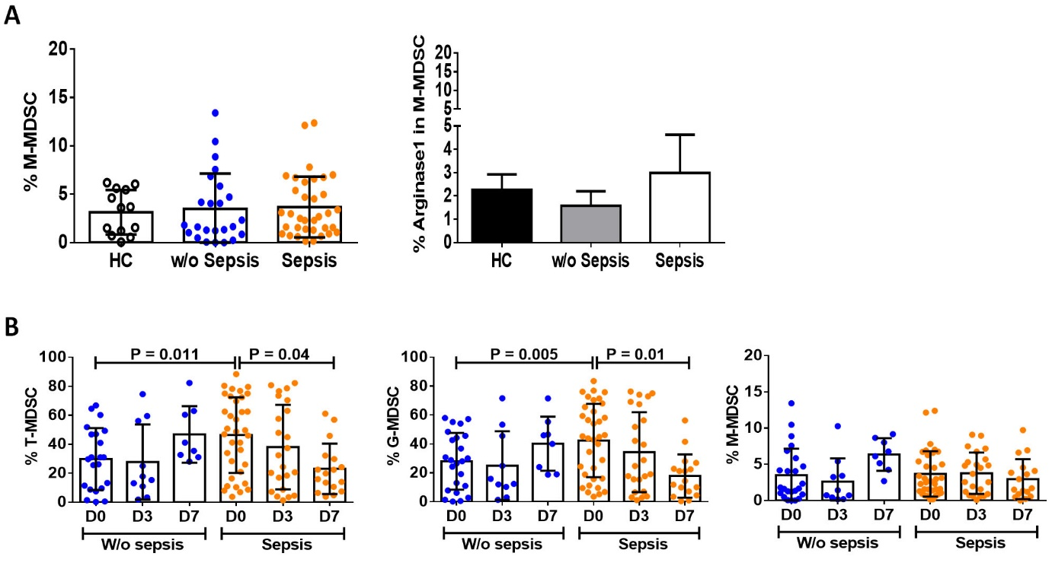

Supplementary Figure 4: Scatter dot plot shows %frequency of A) %CD4 T-cells, and B) CD4 subsets i.e T_{CM}, T_{NAIVE}, T_{EM}, T_{EMRA} in sepsis (blue color) and w/o sepsis patients (orange color) at D0, D3 and D7. C-D) Gating strategy for the expression of Tregs at D0, D3 and D7. Results are expressed as the mean ± SD.

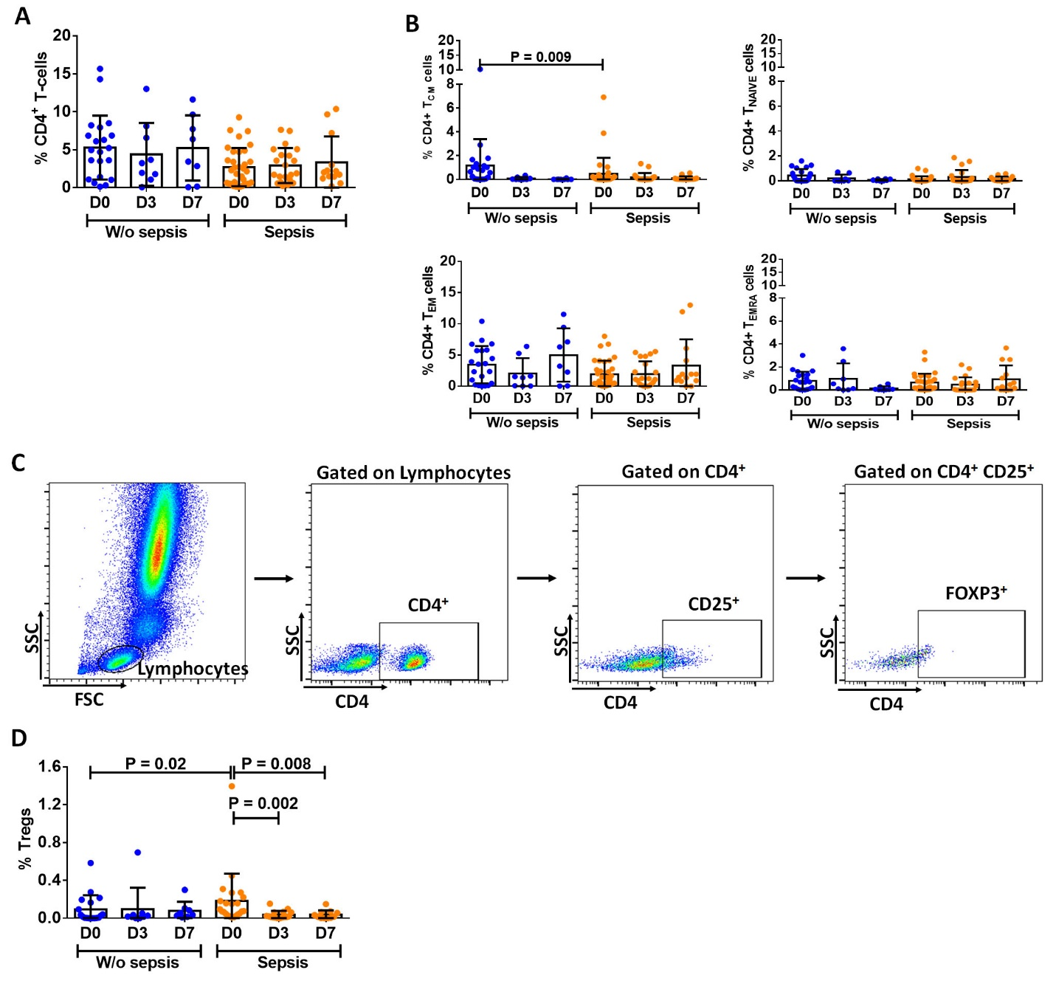

Supplementary Figure 5: Cytokines and growth factors linked with MDSCs. A) Plasma levels of cytokines and growth factors (pg/ml) related to MDSCs in HC, without sepsis and with sepsis. B) Heat Map showing expression of MDSCs related plasma cytokines and growth factors in between the groups. C) Correlation matrix depicting the correlation between cytokines and MDSCs. Correlation matrix was prepared using "corrplot" R package and can be visualized using a correlogram. Red color represents positive correlation and green color represents negative correlation.
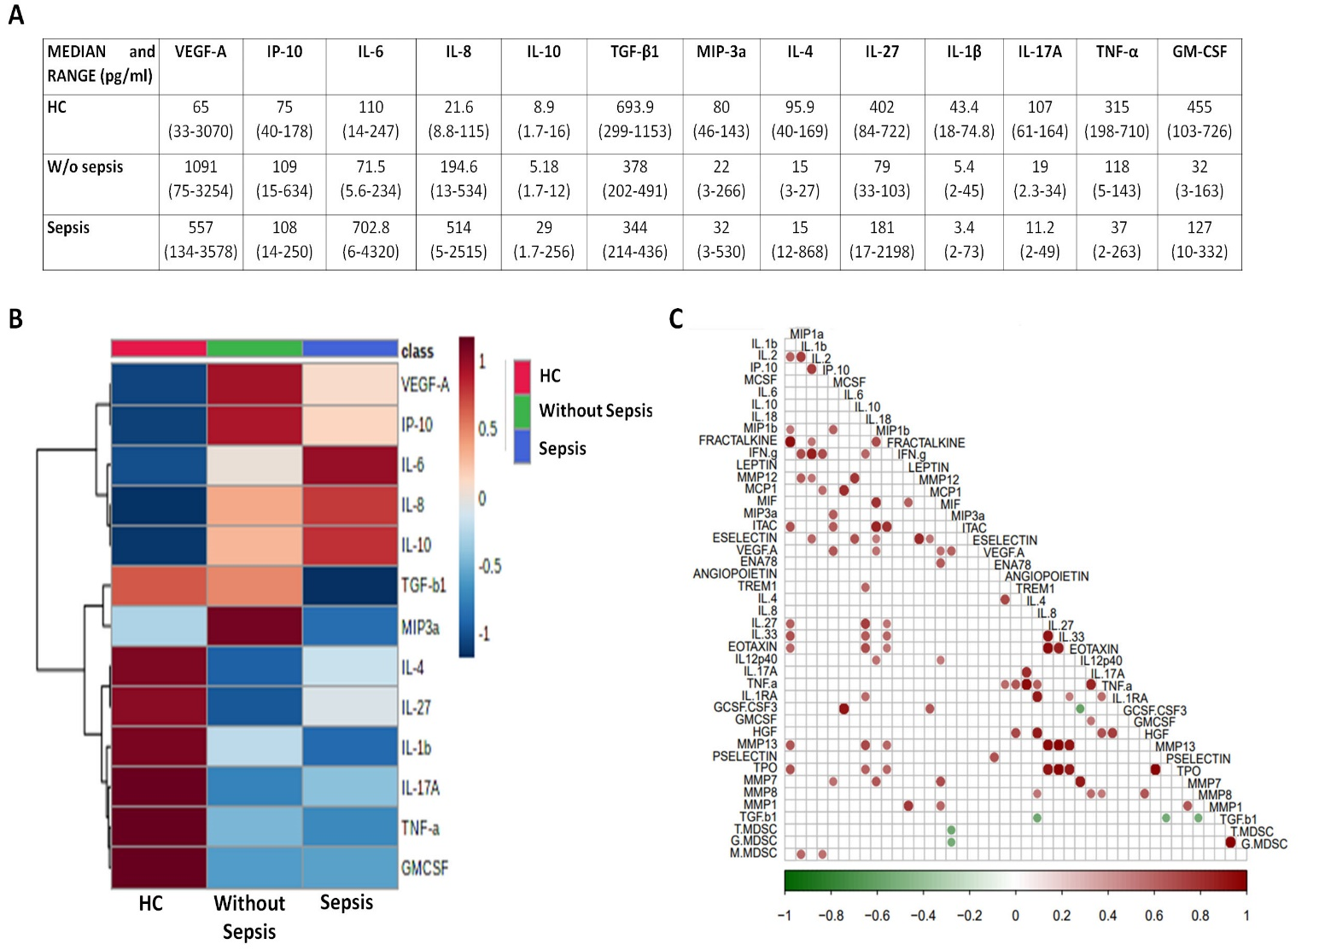

Supplementary Figure 6: Representative experimental scheme used for A) T-cell apoptosis and B) T-cell proliferation.
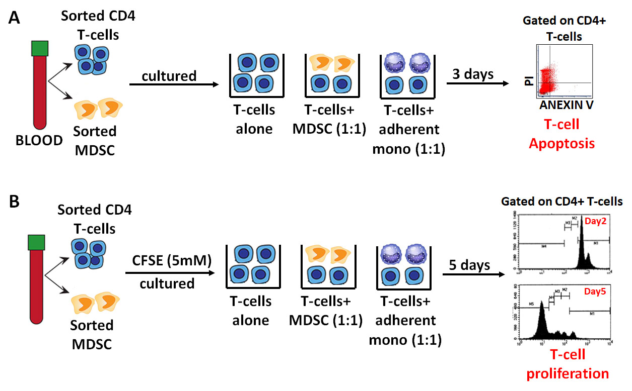

Supplementary Figure 7: Bar diagrams shows A) %Apoptosis and B) %proliferation at different time points in w/o and with sepsis group in T-cells cultured alone (black color), with MDSCs (white color) and with monocytes (grey color). Results are expressed as the mean ± SD.
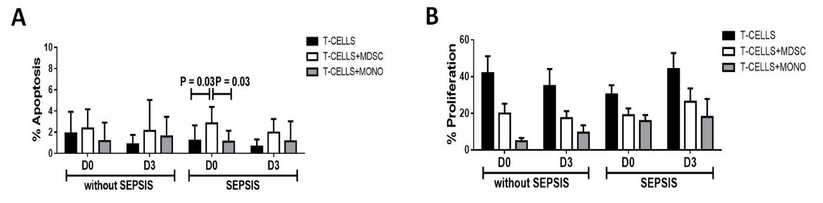

Supplementary Figure 8: Bar diagrams showing expression of % FOXP3⁺ on CD4⁺ T-cells in A) TH0, and B) TH17 condition in T-cells cultured alone (black color), and with MDSCs (white color) at different time points. C) Expression of %FOXP3⁺ on CD4⁺ T-cells in stimulations with rTGF-β, L-NMMA and nor-NOHA in w/o sepsis (grey color), and sepsis (white color) at different time points. Results are expressed as the mean ± SD.
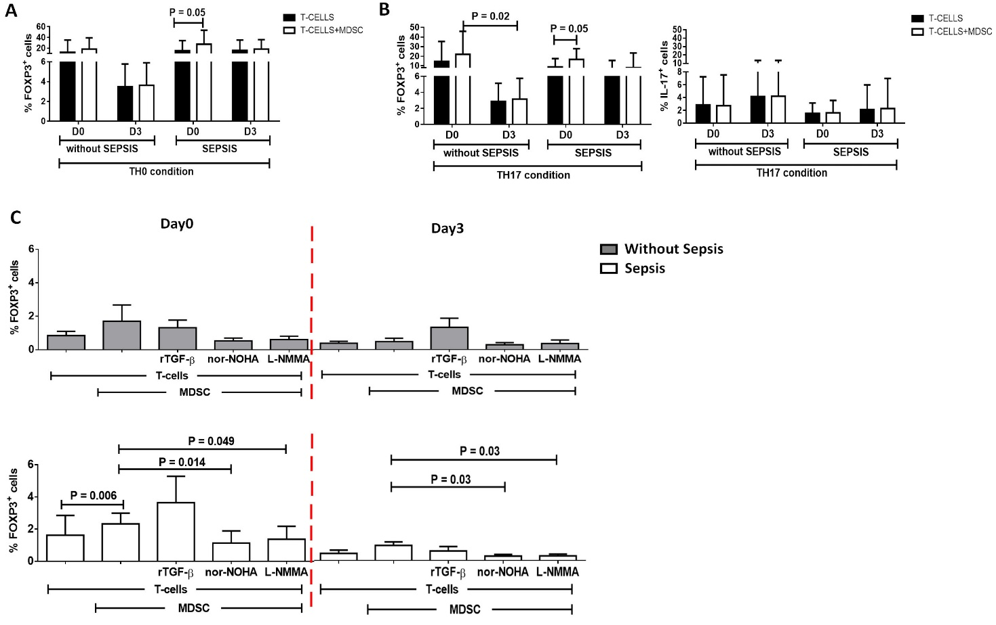

Supplementary Figure 9: Scatter dot plots show the expression of A) %HLA-DR on monocytes and B) %CD11b⁺CXCR1⁺ cells on Neutrophils in sepsis patient without (blue color) and with GM-CSF (orange color) at different time points. Results are expressed as the mean ± SD.
