Supplementary material
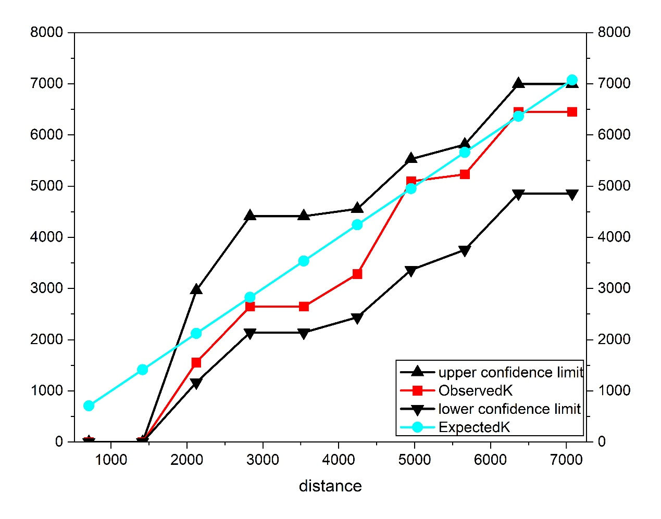
Fig. S1: Ripley’s K analysis for Beixin Culture settlements in XRB. The X‑axis represents the progressively increasing search distance, and the Y‑axis represents the calculated K‑value variable that reflects the degree of spatial clustering. The blue line represents the actual values; the two gray curves (upper and lower) represent the upper and lower bounds of the confidence interval at P = 0.1, generated from 99 simulations; the red curve represents the predicted values.

